June 20, 2014

Mr. Larry Spirgel

Assistant Director

Division of Corporation Finance

Securities and Exchange Commission

100 F Street, N.E.

Washington, DC 20549

Re:

Comcast Corporation

Form 10-K for the fiscal year ended December 31, 2013

Filed February 12, 2014

Response dated May 6, 2014

File No. 1-32871

Dear Mr. Spirgel:

We are writing this letter to respond to the comment letter of the Staff of the Securities and Exchange Commission (the “Staff”) dated May 21, 2014, relating to the review of our Form 10-K for the fiscal year ended December 31, 2013 (the “Form 10-K”). For your convenience, we have reproduced the Staff’s comments preceding our responses below. Please let us know if you have any questions or if we can provide additional information or otherwise be of assistance in expediting the review process.

Form 10-K for the Year Ended December 31, 2013

Item 7: Management's Discussion and Analysis of Financial Condition and Results of Operations, page 46

Critical Accounting Judgments and Estimates, page 71

Valuation and Impairment Testing of Cable Franchise Rights, page 71

- We note your response to comment 1. You indicate in Appendix A that you conduct operating cash flow analysis at the divisional and regional levels. Please tell us in detail what the divisional and regional operating cash flow reports entail and for what purpose are these reports used by management. Tell us which expenses are allocated and not allocated to the divisions and regions.

Response

Divisional and regional operating cash flow reports are prepared on a monthly basis primarily to help Cable Headquarters (“Cable HQ,” i.e., the Cable Communications business segment or “Cable segment”) management monitor and analyze business results based on an organizational span of control structure and the accomplishment of overall Cable segment budgeted operating results and other operational goals.

Securities and Exchange Commission June 20, 2014

The operating cash flow reports focus on division level operating cash flows, with regional level operating cash flows available as supplemental information if Cable HQ management needs additional details on a division’s operating performance. The division and regional operating cash flow reports contain similar information, primarily containing monthly budget to actual variance analysis for significant revenue and expense captions, including:

- Video, Data and Voice revenues

- Programming expenses

- Technical expenses

- Product Support expenses

- Customer Experience expenses

- Sales and Marketing expenses

- Administrative expenses

- Advertising Sales revenue and expenses

As stated in our previous correspondence, expenses for certain Cable HQ operations and administration, which are included in determining the Cable segment’s operating cash flow, are not allocated to the divisions or regions. For 2013, these unallocated expenses totaled approximately $2.1 billion (8.6% of total Cable segment operating expenses, excluding depreciation and amortization). The major components include:

- National sales and marketing

- Technology and product development

- National engineering and technical operations

- Consumer services

- Cable HQ administration (e.g., HR, legal, finance and accounting)

In addition, there are expenses incurred at the divisions that were not allocated to the regions totaling approximately $270 million in 2013 (1.1% of total Cable segment operating expenses, excluding depreciation and amortization).

Cable HQ directs and controls the budget process and provides the divisions and regions with targets/directives regarding customer growth, pricing, packaging, products, capital requirements and the revenue and expense categories included in their operating cash flow reports described above. Utilizing this information, a region prepares its initial annual operating budget and division management reviews and further adjusts the region’s budget to ensure the overall division targets are met. Cable HQ then reviews and adjusts the budgets submitted by the divisions and finalizes the Cable segment annual budget and approves the budgets for the divisions and regions. It should also be noted that the starting point for our budget process is our long-range plan, which is prepared at the Cable segment level only and not at the division or region level.

Divisional and regional management are tasked with executing their annual operating plans to achieve budgeted operating results and other operational goals. Divisional and regional operating cash flow reports are necessary because divisional and regional managements’ incentive compensation bonus plans are partially based on their operating budget achievement in addition to how well they attain other operational goals set by Cable HQ, such as customer retention and customer satisfaction targets.

2

Securities and Exchange Commission June 20, 2014

It is important to understand that Cable HQ establishes the geographic range of the regions based on the span of control of the particular regional manager and not based on a particular geographic area. Thus, based on the strength of a particular manager's abilities and experience, a regional boundary may be either expanded or contracted. Cable HQ utilizes the regional management structure as a means to train future leaders. With over 80,000 Cable segment employees and over 6,000 local cable franchises, Cable HQ views the regional management teams’ autonomous decision-making authority as largely limited to executing the operating plan to achieve budgeted operating results and operational goals set by Cable HQ.

- We note in regard to your response to paragraph 24 (d) of ASC 350-30-35, you state you “would likely test long-lived assets for recoverability at the region level or lower depending on the circumstances.” Please identify your asset group as defined by ASC 360-10-20. Furthermore describe the circumstances which would move you to identify long-lived asset groups at a lower level than the region level, and tell us what that lower level would be.

Response

An asset group under ASC 360-10-20 is defined as “the unit of accounting for a long-lived asset or assets to be held and used, which represents the lowest level for which identifiable cash flows are largely independent of the cash flows of other groups of assets and liabilities.” Accordingly, as discussed with the Staff, our asset groups are our regions because the region is the lowest level where operating cash flow reports are prepared. However, while operating cash flow reports are prepared at the region level, to appropriately reflect the cash flows of each region for the purpose of a long-lived asset recoverability test, expenses incurred at the division and segment levels would need to be allocated to each region. This allocation process would take place outside of our normal operating procedures, as these costs are not ‘pushed-down’ for the purposes of the regions’ operating cash flow reports as noted in our response to Comment #1.

If certain circumstances were to arise, such as a catastrophic event in a specific metropolitan area but not an entire region, we believe that it would be reasonable to look to whether recoverability testing could be performed at a level lower than the regions. To do so, we would need to incorporate various estimates and allocations to determine the cash flows of the particular systems located in the affected area to perform such a cash flow analysis.

- Please provide us with a detailed map of cable franchise areas you would own and the regional structure that would emerge subsequent to the proposed merger with Time Warner Cable and transaction agreement with Charter Communications, Inc. entered into on April 25, 2014.

Response

Below is a detailed map that highlights the expected footprint of Comcast following the merger with Time Warner Cable and assuming completion of the divestiture transactions with Charter based on the current footprint of each company. Comcast supplementally advises the Staff that it is still in the integration planning stages for these transactions. However, Comcast currently expects that the existing organizational structure will not change in any significant way following these transactions, although the components of the various regions and divisions may change.

3

Securities and Exchange Commission June 20, 2014
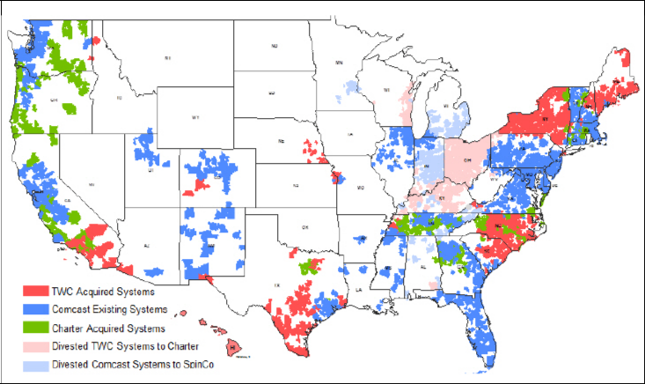

* * *

Please do not hesitate to call me at (215) 286-8514 with any questions you may have with respect to the foregoing.

Sincerely,

/s/ Lawrence J. Salva

Lawrence J. Salva

Senior Vice President, Chief Accounting Officer and

Controller

Comcast Corporation

- Brian L. Roberts, Chairman of the Board and Chief Executive Officer Michael J. Angelakis, Vice Chairman and Chief Financial Officer
Arthur R. Block, Senior Vice President, General Counsel and Secretary

J. Michael Cook, Director and Chairman of Audit Committee

Bruce K. Dallas, Davis Polk & Wardwell LLP

Michael P. Titta, Deloitte & Touche LLP

Michael Morrissey, Deloitte & Touche LLP

4

