SCHEDULE 14A INFORMATION

Proxy Statement Pursuant to Section 14(a) of

the Securities Exchange Act of 1934

Filed by the Registrant |_|

Filed by a Party other than the Registrant |X|

Check the appropriate box:

|_| Preliminary Proxy Statement |_| Confidential, For Use of the Commission Only (as permitted by Rule 14a-6(e)(2))

|_| Definitive Proxy Statement

|_| Definitive Additional Materials

|X| Soliciting Material Under Rule 14a-12

AT&T Corp.

- -------------------------------------------------------------------------------------------------------------------

(Name of Registrant as Specified In Its Charter)

Comcast Corporation

- -------------------------------------------------------------------------------------------------------------------

(Name of Person(s) Filing Proxy Statement, if other than the Registrant)

Payment of Filing Fee (Check the appropriate box):

|X| No fee required.

|_| Fee computed on table below per Exchange Act Rules 14a-6(i)(1) and 0-11.

  - Title of each class of securities to which transaction applies:

- -------------------------------------------------------------------------------------------------------------------

  - Aggregate number of securities to which transaction applies:

- -------------------------------------------------------------------------------------------------------------------

  - Per unit price or other underlying value of transaction computed pursuant to Exchange Act Rule 0-11 (set forth the amount on which the filing fee is calculated and state how it was determined):

- -------------------------------------------------------------------------------------------------------------------

  - Proposed maximum aggregate value of transaction:

- -------------------------------------------------------------------------------------------------------------------

  - Total fee paid:

- -------------------------------------------------------------------------------------------------------------------

|_| Fee paid previously with preliminary materials.

- -------------------------------------------------------------------------------------------------------------------

|_| Check box if any part of the fee is offset as provided by Exchange Act Rule 0-11(a)(2) and identify the

filing for which the offsetting fee was paid previously. Identify the previous filing by registration statement number,

or the form or schedule and the date of its filing.

  - Amount previously paid:

- -------------------------------------------------------------------------------------------------------------------

  - Form, Schedule or Registration Statement No.:

- -------------------------------------------------------------------------------------------------------------------

  - Filing Party:

- -------------------------------------------------------------------------------------------------------------------

  - Date Filed:

- -------------------------------------------------------------------------------------------------------------------

The following presentation was used by Comcast at its quarterly conference call with investors:
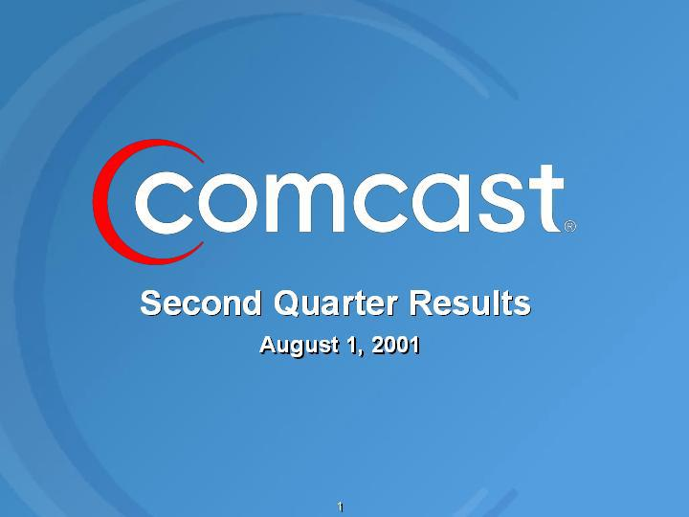

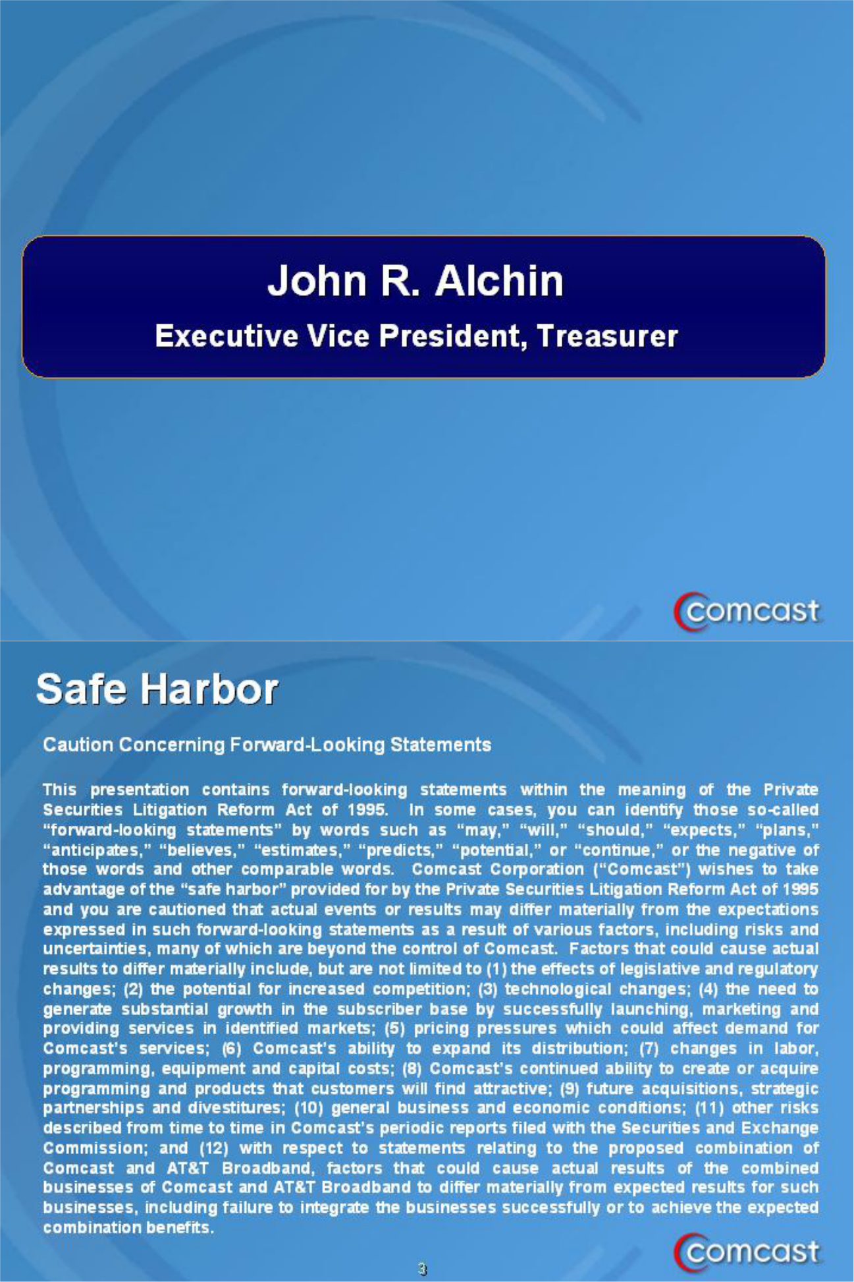

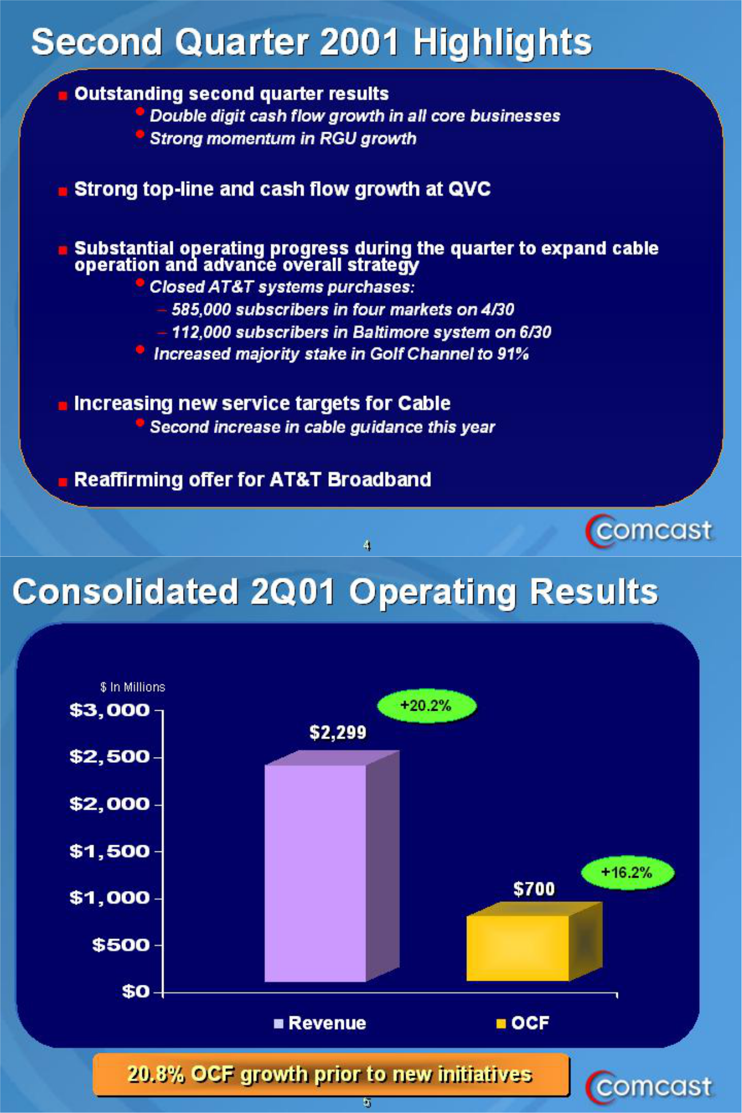

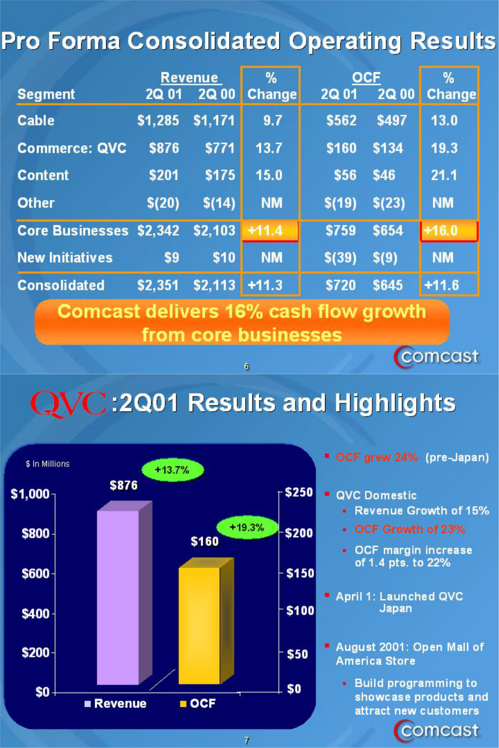

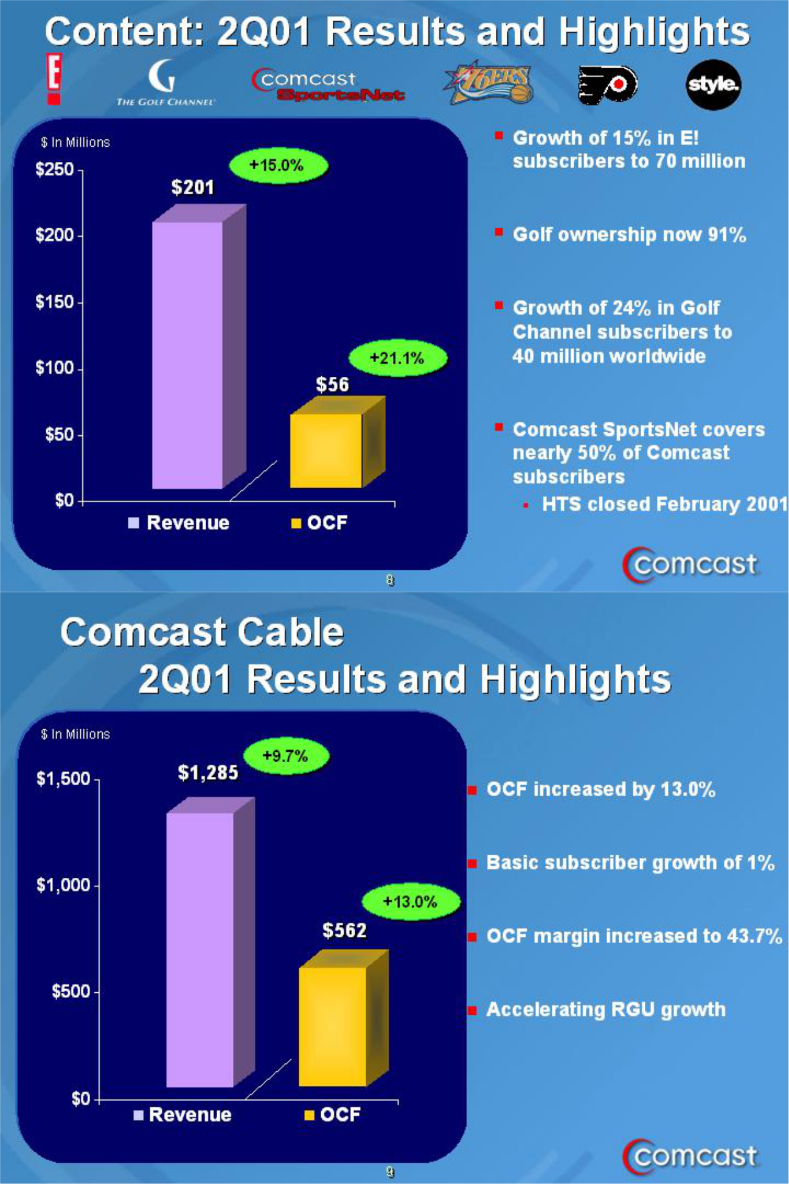

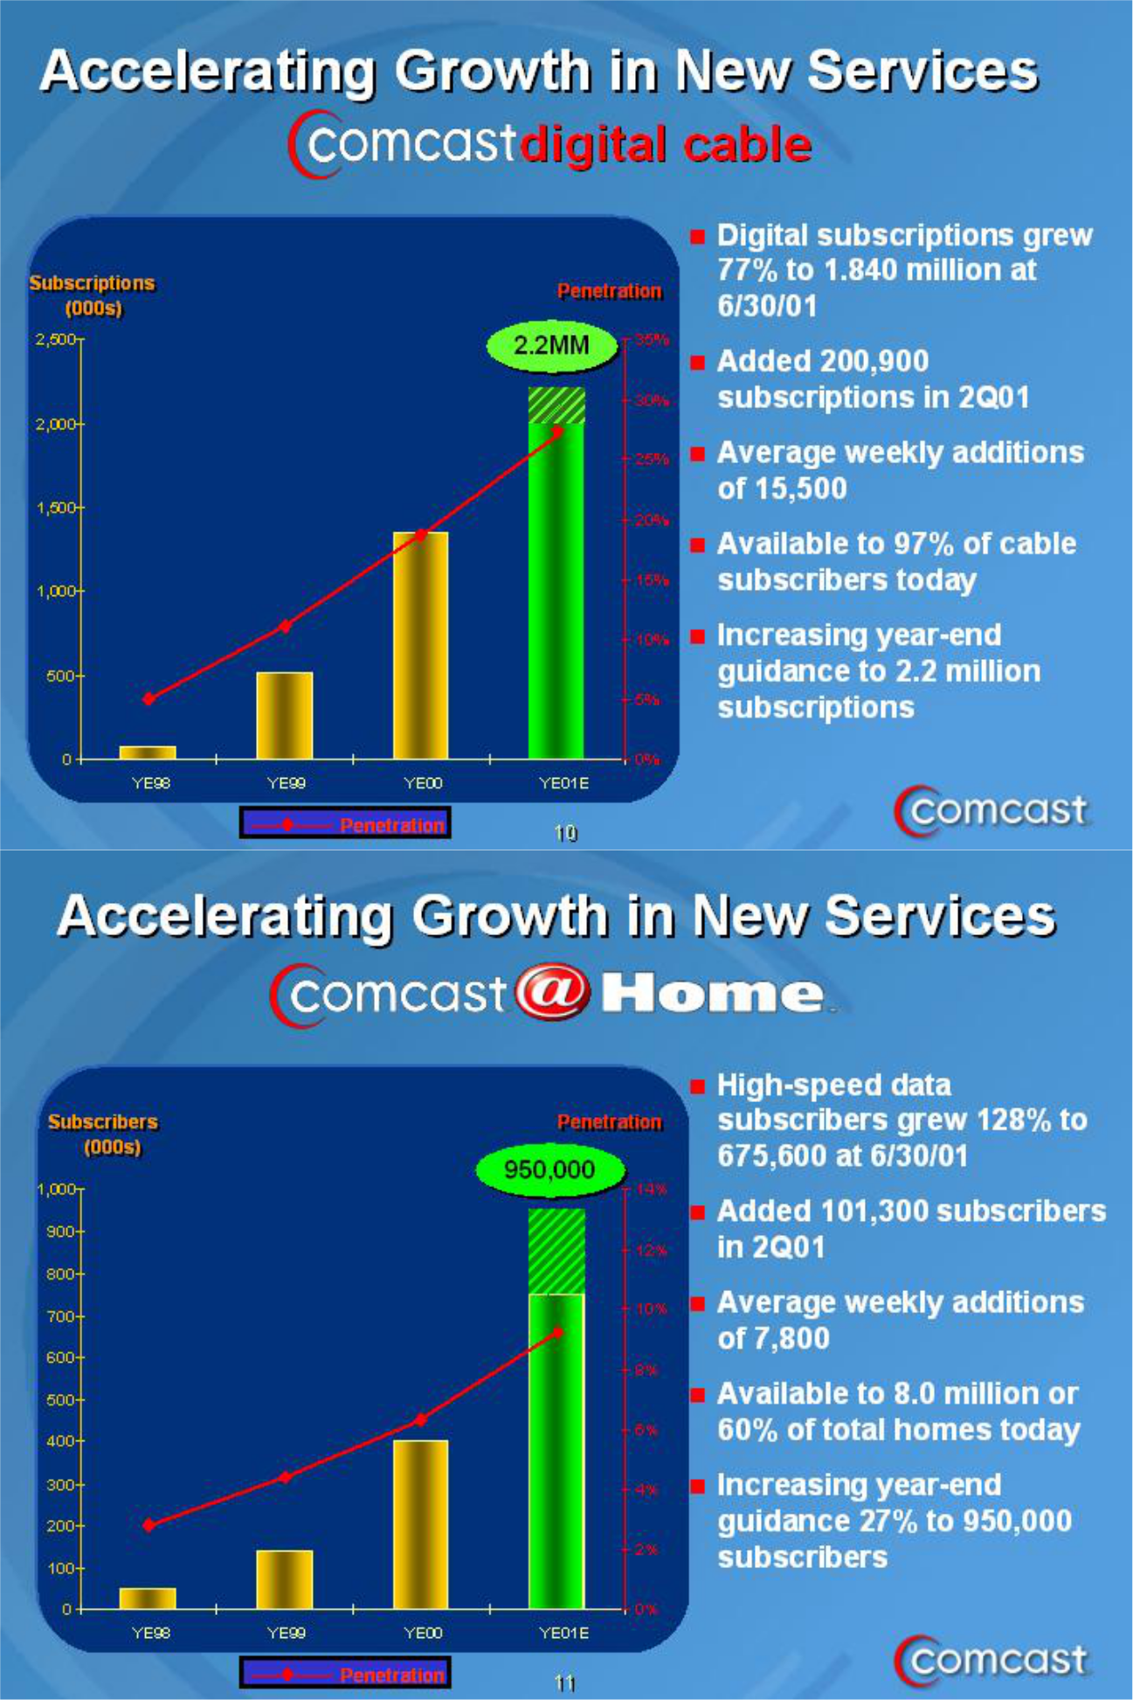

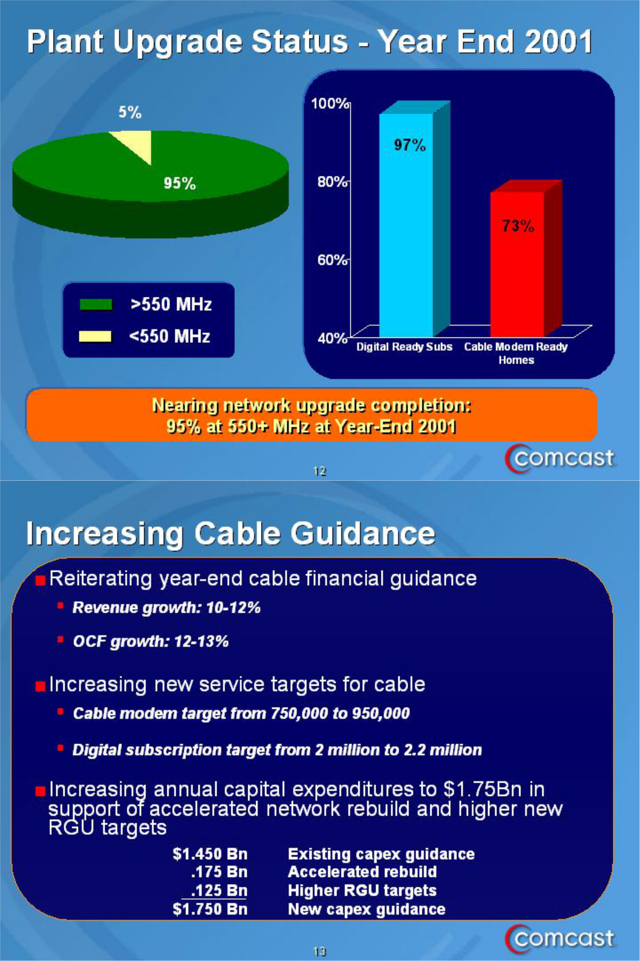

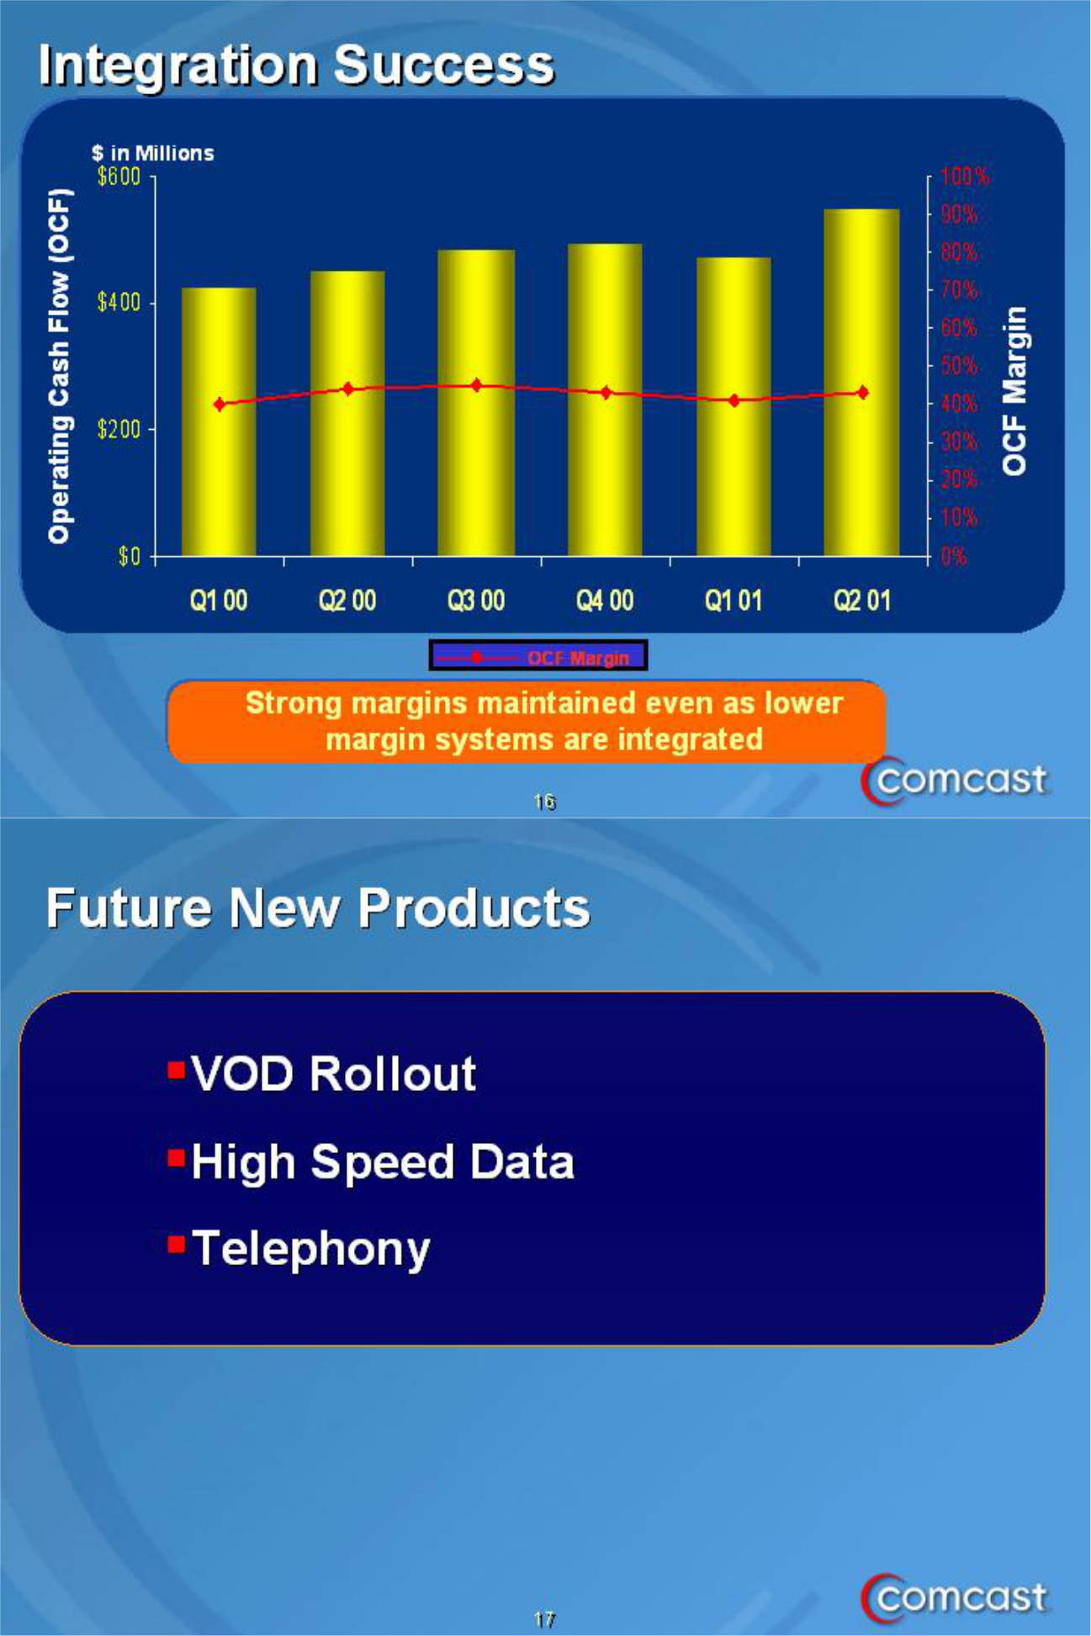

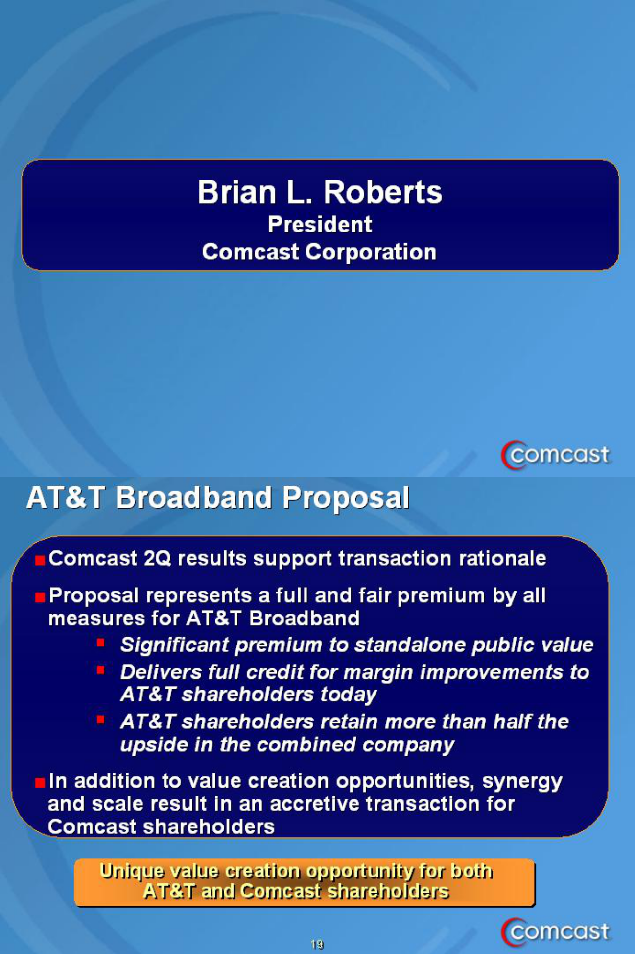

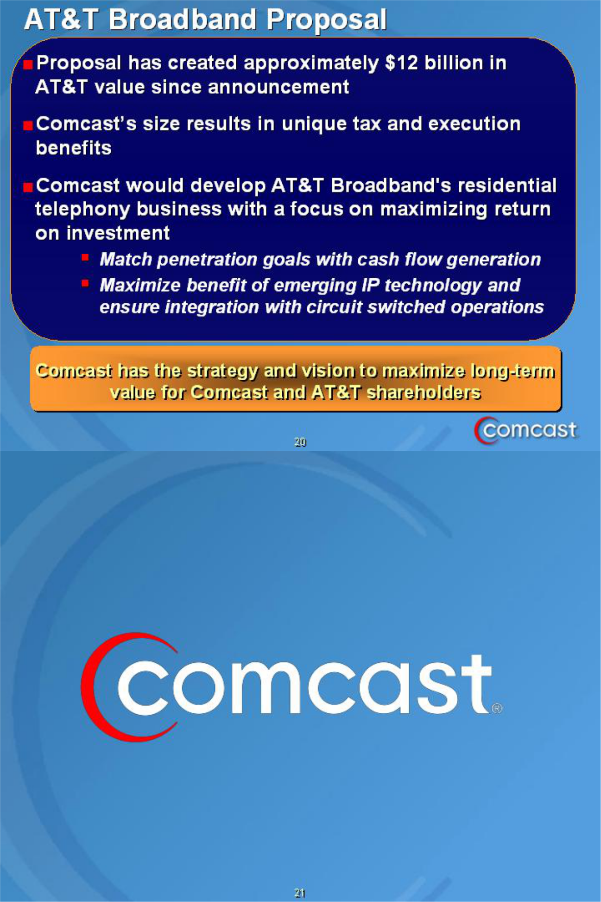

Note: The following notice is included to meet certain legal requirements:

ADDITIONAL INFORMATION

Subject to future developments, Comcast may file with the Commission (i) a preliminary proxy statement for solicitation of proxies from the shareholders of AT&T Corp. (“AT&T”) in connection with AT&T’s broadband tracking stock proposal and (ii) a registration statement to register the Comcast shares to be issued in the proposed transaction. Investors and security holders are urged to read the proxy statement and registration statement (when and if available) and any other

relevant documents filed with the Commission, as well as any amendments or supplements to those documents, because they will contain important information. Investors and security holders may obtain a free copy of the proxy statement and the registration statement (when and if available) and other relevant documents at the Commission’s Internet web site at www.sec.gov. The proxy statement and registration statement (when and if available) and such other documents may also be obtained free of charge from Comcast by directing such request to: Comcast Corporation, 1500 Market Street, Philadelphia, Pennsylvania 19102-2148, Attention: General Counsel.

