Filed by Comcast Corporation

(Commission File No.: 001-32871)

Pursuant to Rule 425 of the Securities Act of 1933

and deemed filed pursuant to Rule 14a-12

of the Securities Exchange Act of 1934

Subject Company: Time Warner Cable Inc.

Commission File No. for Registration Statement

on Form S-4 filed by Comcast Corporation: 333-194698

The following are advertisements of Comcast:

Advertisement 1:


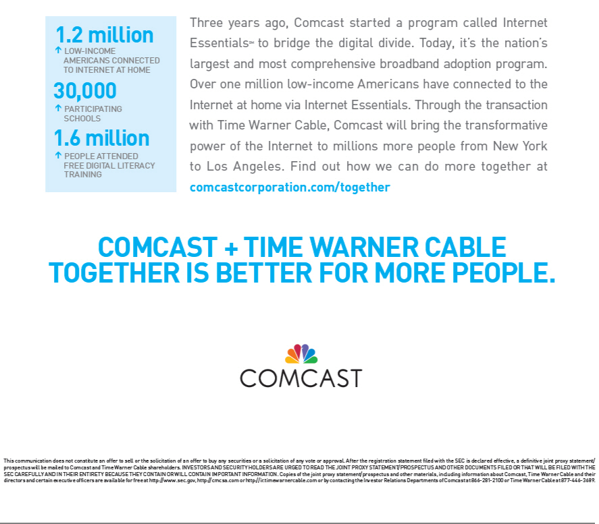

Advertisement 2:




