Filed by Comcast Corporation

(Commission File No.: 001-32871)

Pursuant to Rule 425 of the Securities Act of 1933

and deemed filed pursuant to Rule 14a-12

of the Securities Exchange Act of 1934

Subject Company: Time Warner Cable Inc.

Commission File No. for Registration Statement

on Form S-4: 333-194698

The following Supplement Letter was posted by Comcast on its website:

June 5, 2014

VIA ELECTRONIC FILING

Marlene H. Dortch

Secretary

Federal Communications Commission
445 12th Street, S.W.

Washington, DC 20554

Re: In the Matter of Applications of Comcast Corp. and Time Warner Cable Inc. for Consent to Transfer Control of Licenses and Authorizations, MB Docket No. 14-57

Dear Ms. Dortch:

On June 4th, Comcast Corporation (“Comcast”), Charter Communications, Inc. (“Charter”), and SpinCo filed applications regarding transactions between Comcast and Charter (“Divestiture Transactions”) that mark an important step in the above-captioned Comcast-Time Warner Cable Inc. (“TWC”) merger application by following through on Comcast’s stated willingness to reduce its post-transaction number of managed residential video subscribers to less than 30 percent of national MVPD subscribers.

These Divestiture Transactions will facilitate the Commission’s review of the Comcast-TWC transaction by providing a specific plan regarding divestitures that will yield additional public interest benefits, as detailed in the companion filings.¹ The Divestiture Transactions do not alter any material aspect of the Comcast-TWC transaction or the applications related to that transaction. Nevertheless, Comcast and TWC are submitting this letter to reflect changes to the relevant figures, maps, tables, and statements that the Applicants included in the Public Interest Statement previously filed in this docket² in light of the Divestiture Transactions. This will

- Public Interest Statement of Comcast Corporation and Charter Communications Inc., Charter-to-Comcast Exchange Transaction, MB Docket No. 14-57 (June 4,

2014) (“Charter-to-Comcast Exchange Public Interest Statement”); Public Interest Statement of Charter Communications, Inc. and Comcast Corporation, Comcast-to-Charter Exchange and Sale Transactions, MB Docket No. 14-57 (June 4, 2014) (“Comcast-to-Charter Sale/Exchange Public Interest Statement”); Public Interest Statement of SpinCo, Charter Communications, Inc., and Comcast Corporation, Spin Transaction, MB Docket No. 14-57 (June 4, 2014) (“SpinCo Public Interest Statement”).

- Applications and Public Interest Statement of Comcast Corp. and Time Warner Cable Inc., MB Docket No. 14-57 (Apr. 8, 2014) (“Comcast-TWC Public Interest Statement”). In addition, Comcast and TWC would like to clarify and update the record regarding two programming-related issues. First, the Comcast-TWC Public Interest Statement inadvertently listed the Comcast Sports Southwest network as a current program service owned by NBCUniversal. This is not the case, as this network is no longer in operation; however, the legal entity, in which

Ms. Marlene H. Dortch

June 5, 2014

Page 2

ensure that the Commission and interested parties have a comprehensive picture of the combined company following the closing of both the Comcast-TWC transaction and the Divestiture Transactions.

While the parties respectfully request that the Commission consider and process the applications for the Divestiture Transactions contemporaneously with the Comcast-TWC transaction applications in a single pleading cycle,³ approval of the Comcast-TWC applications as previously filed is still required since that transaction stands on its own and, if approved, will close independently of and prior to the Divestiture Transactions.⁴

Description of the Divestiture Transactions. The Divestiture Transactions consist of the following three transactions: (i) a spin-off of cable systems serving approximately 2.5 million legacy Comcast video customers into a new, independent, publicly traded cable company (“SpinCo”); (ii) an exchange of cable systems serving approximately 1.5 million former TWC video customers for cable systems serving approximately 1.6 million Charter video customers; and (iii) a sale to Charter of cable systems serving approximately 1.5 million former TWC video customers.⁵ These three transactions will result in a net reduction of approximately 3.9 million

Comcast has a 100 percent interest, still exists. See id. at 13. Second, Time Warner Cable Channel 858, one of TWC’s Spanish-language networks, carries certain Dodgers games in addition to Angels and Clippers games as previously noted in the Comcast-TWC Public Interest Statement. See id. at 154 n.407; see also id., Exhibit 5, Declaration of Dr. Gregory L. Rosston and Dr. Michael D. Topper (“Rosston/Topper Decl.”) ¶¶ 37 n.13, 207 n.240.

- The parties note that the Commission has not issued the Public Notice for the above-captioned Comcast-TWC transaction in light of an earlier such request. See Letter from Kathryn A. Zachem, Comcast, to Marlene H. Dortch, FCC, MB Docket No. 14-57, at 1 (Apr. 30, 2014); Letter from Kathryn A. Zachem, Comcast, to Marlene H. Dortch, FCC, MB Docket No. 14-57, at 3 (May 7, 2014).

- A pre-condition of the Divestiture Transactions is the closing of the pending Comcast-TWC transaction. Therefore, Applicants continue to need Commission approval to close on the Comcast-TWC transaction, and request that approvals for the Comcast-TWC transaction and the Divestiture Transactions be granted at the same time. Moreover, it is the parties’ intent to close the Divestiture Transactions as quickly as possible following the closing of the Comcast-TWC transaction. As with all transactions, the Divestiture Transactions agreement contains specific “end date” deadlines. However, if certain delays are encountered either in obtaining financing or in the securing of certain federal, state, or local approvals for the Divestiture Transactions, the parties have additional time under their agreement (up to 240 days under certain circumstances) to complete the Divestiture Transactions. In case the closing of the Divestiture Transactions is delayed for any reason, or in the unlikely event closing does not occur and Comcast needs to find another buyer, Comcast might need the ability to own all of the TWC systems for a period of 12-18 months following the closing of the Comcast-TWC transaction, in order to facilitate and complete the system divestitures in the least disruptive manner possible. This amount of time is reasonable and consistent with well-established Commission precedent, especially since, in this case, there would be no rule violation at issue that would require such system divestitures. See, e.g., UTV of San Francisco, Inc., et al. & Fox Television Stations, Inc., Memorandum Opinion & Order, 16 FCC Rcd. 14975 ¶ 45 (2001) (granting Fox 24 months to divest broadcast station or newspaper to comply with television/newspaper cross-ownership rule); Shareholders of CBS Corp. & Viacom, Inc., Memorandum Opinion & Order, 15 FCC Rcd. 8230 ¶ 22 (2000) (granting Viacom 12 months to divest broadcast stations to comply with national ownership cap); Cox Cable Commc’ns, Inc. & Times Mirror Co., Memorandum Opinion & Order, 10 FCC Rcd. 1559 ¶ 26 (CSB 1994) (granting Cox 18 months to divest cable systems to comply with cable/broadcast cross-ownership rule).

- See Charter-to-Comcast Exchange Public Interest Statement at 3-4; Comcast-to-Charter Sale/Exchange Public Interest Statement at 4-5; SpinCo Public Interest Statement at 5-6.

Ms. Marlene H. Dortch

June 5, 2014

Page 3

residential video customers for the combined company. A list of the Designated Market Areas (“DMAs”) and communities involved in the Divestiture Transactions is included in Attachment 1.

After the Comcast-TWC transaction and the Divestiture Transactions close, the combined company (i) will have a more extensive footprint primarily in California, Georgia, Maryland, New England, New York, North Carolina, Oregon, Tennessee, Texas, Virginia, and Washington; (ii) will no longer have a presence in Minnesota or Wisconsin; and (iii) will have a greatly reduced and only de minimis remaining presence in Alabama, Indiana, Kentucky, Michigan, and Ohio.

Key Effects of the Divestiture Transactions. As detailed in the public interest statements filed along with the applications seeking approval for the Divestiture Transactions, these transactions will preserve and, in certain respects, enhance the demonstrated benefits of the Comcast-TWC transaction for consumers and businesses, and will not pose any public interest harms. However, the divestitures will change certain facts and figures provided in the Comcast-TWC Public Interest Statement. Specifically, following the closing of both the Comcast-TWC transaction and the Divestiture Transactions:

- Further Reduction in Total Number of Video Customers and National Share of MVPD Subscribers. Comcast will increase its video customer base by approximately 7 million video customers after divesting systems serving approximately 3.9 million video customers, for a total of approximately 29 million managed residential video customers. This net divestiture of approximately 3.9 million customers is 900,000 more than the three million video customers Comcast said it was prepared to divest in the Comcast-TWC Public Interest Statement.⁶ After such divestitures, the combined company will serve approximately 29 percent of MVPD subscribers nationwide.

- Presence in Fewer DMAs. Comcast will no longer have a presence in three of the top 20 DMAs represented in the chart on page 151 of the Comcast-TWC Public Interest Statement, namely: (i) Detroit, MI (No. 11), (ii) Minneapolis-St. Paul, MN (No. 15), and (iii) Cleveland, OH (No. 19). Legacy Comcast systems in Detroit and Minneapolis will be divested to SpinCo, while legacy TWC systems in Cleveland will be divested to Charter. These changes are reflected in the revised chart provided in Attachment 2. The net effect of these changes is that, following all transactions, the combined company will operate in the same number of top 20 DMAs (16) as Comcast does today, i.e., prior to any of the transactions (although the makeup of those 16 DMAs will differ somewhat).⁷

- See Comcast-TWC Public Interest Statement at 6-7, 25.

- Likewise, Comcast will no longer have a presence in two of the top 20 Metropolitan Statistical Areas (“MSAs”) represented in the chart on page 142 of the Comcast-TWC Public Interest Statement: The systems in the Detroit-Warren-Livonia, MI (No. 14) and Minneapolis-St. Paul-Bloomington, MN-WI (No. 16) MSAs will be divested to SpinCo. These changes are reflected in the revised chart provided in Attachment 3. The net effect of these changes is that, following all transactions, the combined company will operate in 17 of the top 20 MSAs – two

Ms. Marlene H. Dortch

June 5, 2014

Page 4

- Updated Maps and Continued Illustration of Vibrant Competition. The following maps that were included in the Comcast-TWC Public Interest Statement depicting Comcast’s post-transaction footprint and competitors have been updated to reflect the effect of the Divestiture Transactions (all updated maps are included in Attachment 4): (i) the areas in which the combined company will compete with top 10 ILECs;⁸ (ii) the areas in which the combined company will compete with 4G LTE providers;⁹ (iii) the areas in which the combined company will compete with both top 10 ILECs and 4G LTE providers;¹⁰ and (iv) the number of video service providers operating in the 16 DMAs (within the top 20) where the combined company will have a presence.¹¹ These updated maps show that there will still be vibrant competition to the combined company after all the transactions close. Notably, for example:

- in 98.5 percent of the combined company’s service areas, broadband customers will have a choice between the combined company and one or more top-10 ILEC competitors;

- when one considers the near-ubiquitous availability of top-10 ILECs plus 4G LTE wireless broadband providers, there are virtually no areas of the combined company’s service areas where customers will not have at least one of these options; and

- there will be 11 or more MVPDs in most of the 16 of the top 20 DMAs where the combined company will have a presence, and at least six MVPDs in all of them.

Finally, Comcast has included a new map in Attachment 4 identifying the areas served by Comcast and SpinCo (and the relevant Charter service areas) after the closing of all transactions. This new map highlights the enhancements to the geographic contiguity achieved by the Divestiture Transactions through the transfer of systems that fill in gaps within Comcast’s and Charter’s respective footprints. The public interest statements filed in connection with the applications for approval of the Divestiture Transactions explain the benefits to consumers and businesses that flow from these more contiguous regional footprints.

- Reduction in De Minimis Overlaps. The Comcast-TWC Public Interest Statement noted de minimis overlaps of approximately 2,800 residential or small-or medium-sized business customers, and approximately 215 business customers, in Comcast and TWC service areas.¹² As a result of the system exchanges and other changes in the Divestiture

fewer than the 19 MSAs (within the top 20) in which the combined company would have operated if only the Comcast-TWC transaction were at issue.

- See Comcast-TWC Public Interest Statement at 44.

- Id. at 53.

- Id. at 54.

- Id. at 150.

- Id. at 127 n.307.

Ms. Marlene H. Dortch

June 5, 2014

Page 5

Transactions, these numbers will be further reduced. Specifically, the number of Comcast residential or small- or medium-sized business customers in these areas will decrease from approximately 2,800 to approximately 780, while the number of Comcast and TWC business services customers in these areas will decrease from approximately 215 to approximately 190. Also, there are similarly de minimis overlaps between certain Comcast systems and some of the systems acquired from Charter in the exchange.¹³

- National Broadband Share Essentially Unchanged or Slightly Lower. As Dr. Mark Israel explained in his declaration submitted with the Comcast-TWC Public Interest Statement, the combined company’s share of the national universe of broadband subscribers is irrelevant to whether the combined company could act as a bottleneck or harm edge providers, because broadband competition depends on the choices available to each household in each local area.¹⁴ Nonetheless, based on the latest available data released by the FCC (as of December 2012), Dr. Israel calculated Comcast’s post-transaction share of national broadband subscribers as just under 40 percent of fixed-only connections and just under 20 percent of fixed and mobile connections combined, assuming divestitures of three million video customers.¹⁵ These statements and share percentages remain accurate when taking into account the Divestiture Transactions. Moreover, the fact that Comcast will be divesting a net total of approximately 3.9 million video customers, rather than the assumed three million video customers, means that those previous calculations slightly overstate Comcast’s share of broadband subscribers following all transactions, based on the same December 2012 FCC data.

- Fewer Programming Assets. Comcast will not acquire any additional national, RSN, or broadcast programming assets as a result of the Divestiture Transactions and will actually reduce its programming interests. Specifically, Comcast will divest seven TWC local programming networks to Charter and two Comcast local programming networks to SpinCo as part of the Divestiture Transactions,¹⁶ and will obtain only three small local

- See Charter-to-Comcast Exchange Public Interest Statement at 13 n.31 (noting de minimis overlaps of approximately 2,800 residential or small- or medium-sized business customers between Comcast and Charter, and overlaps of approximately 1,500 such customers between TWC and Charter).

- See Comcast-TWC Public Interest Statement, Exhibit 6, Declaration of Dr. Mark A. Israel ¶¶ 20-23, 42 (“Israel Decl.”); see also Comcast-TWC Public Interest Statement at 158.

- Israel Decl. ¶ 42 & Table 1.

- The seven TWC networks that will be divested to Charter are (i) Time Warner Cable SportsChannel (Cincinnati/Dayton); (ii) Time Warner Cable SportsChannel (Cleveland/Akron); (iii) Time Warner Cable SportsChannel (Columbus/Toledo); (iv) Time Warner Cable Live Radar (Columbus); (v) Time Warner Cable Local Weather (Cleveland/Akron); (vi) Time Warner Cable SportsChannel (Milwaukee, Green Bay); and (vii) cn|2 (Kentucky). The two Comcast networks that will be divested to SpinCo are the Comcast Television Network (Michigan) and Hoosier TV (Indiana).

Ms. Marlene H. Dortch

June 5, 2014

Page 6

networks from Charter that are operated by the local cable systems Comcast will receive in the exchange.¹⁷

As the changes noted above reinforce, the Comcast-TWC transaction remains pro-consumer, pro-competitive, and strongly in the public interest. The Divestiture Transactions will not diminish the key benefits of the Comcast-TWC transaction, and, in fact, will in some ways enhance these benefits while mitigating any potential concerns. Each of the following benefits described in the Comcast-TWC Public Interest Statement will still be realized and will be extended to the new systems and customers that Comcast acquires from Charter:

- additional investment in developing advanced broadband, video, and voice services;

- accelerated and widespread deployment of all-digital systems and more secure and reliable networks, faster broadband speeds, improved Wi-Fi, advanced video services (e.g., X1, DVR with cloud technology, expanded video-on-demand and TV Everywhere), and innovative voice services;

- enhanced competition in the business services market;

- a variety of other public interest benefits, including benefits resulting from the extension of conditions and commitments from the NBCUniversal transaction, notably the Open Internet protections and standalone broadband offerings, as well as Comcast’s commitment to its Internet Essentials broadband adoption program, and to diversity, accessibility, and cybersecurity; and

- broad deployment of next-generation advertising technologies to the benefit of advertisers, content providers, and consumers.¹⁸

As Drs. Rosston and Topper explain in their supplemental economic analysis submitted with the Charter-to-Comcast Exchange Public Interest Statement, the Divestiture Transactions do not change their prior conclusions regarding the substantial public interest benefits and lack of public interest harms from the Comcast-TWC transaction.¹⁹ In particular, Drs. Rosston and Topper conclude that the scale efficiencies, expanded geographic reach, and resulting public interest benefits they previously identified in their April 2014 declaration²⁰ remain in place “because the divestitures are only slightly larger than the level we assumed.”²¹

- These three networks are (i) Charter TV3 in Worcester, MA; (ii) a local origination channel in the Northwest covering Walla Walla, Richland, Pasco, and Kennewick, WA; and (iii) Channel 101/188 in California.

- Comcast-TWC Public Interest Statement at 20-126.

- Supplemental Declaration of Dr. Gregory L. Rosston and Dr. Michael D. Topper ¶ 5 (June 4, 2014) (“Rosston/Topper Supplemental Decl.”) (“The divestiture transactions do not change the conclusions in our April Report that the TWC transaction will generate significant competitive benefits and efficiencies.”).

- See Rosston/Topper Decl. ¶¶ 9-17, 44-50, 52, 56-58.

- Rosston/Topper Supplemental Decl. ¶ 5.

Ms. Marlene H. Dortch

June 5, 2014

Page 7

In fact, as Drs. Rosston and Topper explain, several additional competitive benefits and efficiencies flow from the contiguous regional footprints created by the

Divestiture Transactions. In particular, Drs. Rosston and Topper conclude:

- “By expanding its contiguous service areas in certain regions, Comcast will be able to achieve efficiencies from geographic clustering. Economies of scale at the regional level should lead to greater efficiencies in network infrastructure and upgrades; in operational, marketing, and administrative functions; and in customer service.”

- “After the divestiture transactions, Comcast will expand its contiguous service areas in certain regions, which will allow the benefits of expanded geographic reach described in our April Report to extend more broadly in those regions, including allowing Comcast to serve more regional businesses on its own network. This, in turn, will lead to lower prices and improved service for business customers; and additional investments spurred by new business opportunities will redound to residential customers’ benefit as well. Expansion of its contiguous service areas will also provide Comcast a greater incentive to provide its customers with a more extensive network of Wi-Fi access points.”²²

The combined company will no longer serve systems (including legacy TWC systems) in Minnesota and Wisconsin and will have a greatly reduced or de minimis presence in Alabama, Indiana, Kentucky, Michigan, and Ohio following the Divestiture Transactions (meaning that businesses with locations in these areas will not be served on the combined company’s network). However, as Drs. Rosston and Topper make clear, any such reduced opportunities will be more than offset by enhanced opportunities to better serve other regional, super-regional, and enterprise businesses with a presence in other regions.²³

In addition, the changes resulting from the Divestiture Transactions will preserve and enhance the substantial benefits described in the Comcast-TWC Public Interest Statement without giving rise to any competitive harms. As Drs. Rosston and Topper explain:

- Id. ¶ 5; see also id. ¶¶ 7-19; Charter-to-Comcast Exchange Public Interest Statement at 6-10.

- Rosston/Topper Supplemental Decl. ¶¶ 15-17. The specific regions referenced in the Comcast-TWC Public Interest Statement were illustrative examples. Comcast’s willingness from day one to divest systems serving approximately three million subscribers made clear that some regions within the combined company’s footprint would inevitably be affected by subsequent divestitures. Moreover, the TWC and legacy Comcast systems to be transferred to Charter and SpinCo will maintain and/or enhance those companies’ regional footprints. As a result, some of the examples of enhanced ability to compete for and serve large businesses in particular regions cited in the Comcast-TWC Public Interest Statement will be realized by the new owners of these systems. See also id. at 8 n.29 (“However, the divested areas complement Charter’s and SpinCo’s post-transaction footprints, and Charter and SpinCo should thus be better situated to serve multi-location businesses in those areas.”). As Charter and SpinCo explain, the enhanced geographic rationalization they will enjoy based on the systems they acquire from Comcast/TWC in the Divestiture Transactions, coupled with the ability of Charter and SpinCo to work together in light of Charter’s services agreement with SpinCo, will translate into significant benefits for business and residential customers alike in these regions. See Comcast-to-Charter Sale/Exchange Public Interest Statement at 7-17; SpinCo Public Interest Statement at 10-17.

Ms. Marlene H. Dortch

June 5, 2014

Page 8

“In our April Report, we concluded that the TWC transaction does not raise any competition concerns in video distribution, programming acquisition or selling, or video advertising. The divestiture transactions do not change those conclusions:

- At the national level, the divestiture transactions will reduce Comcast’s national share of MVPD customers. This reduction in national share does not raise any competitive concerns for video distribution, program buying, program selling, or video advertising, especially since the TWC transaction raises no competitive concerns for these services.

- In certain geographic regions, the divestiture transactions will lead to modest increases in customers served by the combined company. . . . [T]his additional clustering does not raise competitive concerns for video distribution, program buying, program selling, or video advertising in any region.”²⁴

* * *

In short, the changes to the combined company as a result of the Divestiture Transactions will not reduce – and in some important respects will enhance – the public interest benefits detailed in the Comcast-TWC Public Interest Statement. They also will not create any public interest harms, and in some important respects will reduce certain potential harms, such as by decreasing the combined company’s shares and/or presence in certain markets. Accordingly, the Divestiture Transactions reinforce the fact that the Comcast-TWC transaction is pro-consumer, pro-competitive, and strongly in the public interest, and Applicants respectfully request that the Commission promptly approve this transaction. We also ask that the Commission process the Divestiture Transactions in a single pleading cycle along with the Comcast-TWC applications and approve all these inter-related transactions at the same time.

Respectfully submitted,

/s/ Kathryn A. Zachem |  | /s/ Steven Teplitz
Senior Vice President, | Senior Vice President,
Regulatory and State Legislative Affairs | Government Relations
Comcast Corporation | Time Warner Cable Inc.

- Rosston/Topper Supplemental Decl. ¶ 6; see also id. ¶¶ 20-53. As Applicants have previously explained, “DMAs are not relevant competitive markets for MVPD services; they are just Nielsen constructs for rating measurement purposes.” Comcast-TWC Public Interest Statement at 150. This remains true, but it bears emphasis that Comcast will now have a presence in 16 of the top 20 DMAs post-transactions, the same number of DMAs as the day before the Comcast-TWC transaction was announced. This change, along with the divestiture of an additional 900,000 customers beyond Comcast’s original proposed divestiture, further ameliorates any potential concerns that the combined company would wield undue leverage against programmers.

Attachment 1

DMAs/Markets Involved in Divestiture Transactions*
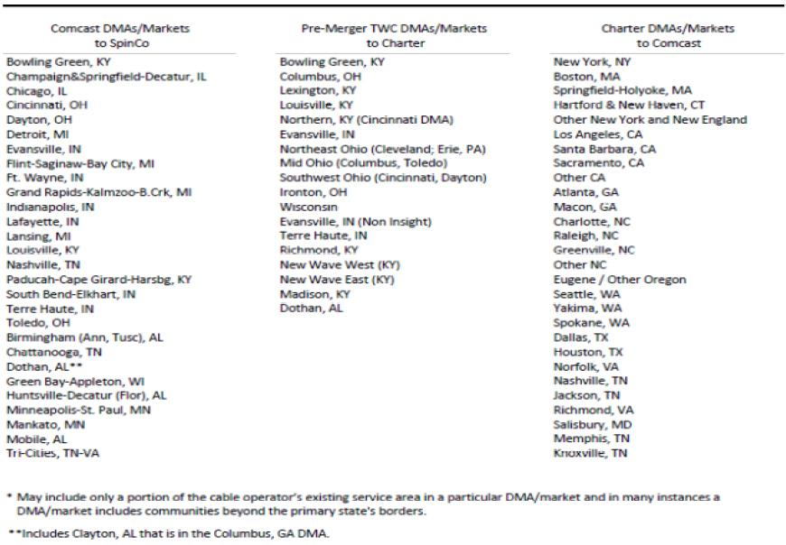

Attachment 2

UPDATE OF CHART ON PAGE 151 OF COMCAST-TWC PUBLIC INTEREST STATEMENT

Video Providers in the Top 20 Designated Market Areas (DMAs)

Rank | DMA | Providers (excluding Comcast and TWC) | Total | Post-Transaction
1 | New York, NY | Dish, DirecTV, Verizon, RCN, Cablevision, and 5 others | 10 | -1 (Charter)
2 | Los Angeles, CA | Dish, DirecTV, Verizon, AT&T, and 16 others | 20 | -1 (Charter)
3 | Chicago, IL | Dish, DirecTV, AT&T, RCN, WOW!, and 7 others | 12 | No Change
4 | Philadelphia, PA | Dish, DirecTV, Verizon, RCN, Atlantic Broadband, and 4 others | 9 | No Change
5 | Dallas-Ft. Worth, TX | Dish, DirecTV, Verizon, AT&T, Cable One, and 27 others | 32 | -1 (Charter)
6 | San Francisco-Oakland-San Jose, CA | Dish, DirecTV, AT&T, WARPSPEED, and 4 others | 8 | -1 (Charter)
7 | Boston, MA (Manchester, NH) | Dish, DirecTV, Verizon, RCN, MetroCast, and 6 others | 11 | -1 (Charter)
8 | Washington, DC (Hagerstown, MD) | Dish, DirecTV, Verizon, RCN, Atlantic Broadband, and 8 others | 13 | No Change
9 | Atlanta, GA | Dish, DirecTV, AT&T, Windstream, WOW!, and 9 others | 14 | No Change
10 | Houston, TX | Dish, DirecTV, AT&T, CenturyLink, Consolidated | 29 | No Change
10 | Houston, TX | Communications, and 24 others | 29 | No Change
11 | Detroit, MI (no Comcast or TWC presence post- | -- | 11 | +1 (SpinCo)
11 | transaction) | -- | 11 | +1 (SpinCo)
12 | Phoenix, AZ (no current Comcast or TWC | -- | 13 | No Change
12 | presence) | -- | 13 | No Change
13 | Seattle-Tacoma, WA | Dish, DirecTV, Frontier, Coast Communications, Wave, and 11 | 16 | No Change
13 | Seattle-Tacoma, WA | others | 16 | No Change
14 | Tampa-St. Petersburg, FL | Dish, DirecTV, Verizon, WOW!, CenturyLink, and 6 others | 11 | No Change
15 | Minneapolis-St. Paul, MN (no Comcast or TWC | -- | 42 | +1 (SpinCo)
15 | presence post-transaction) | -- | 42 | +1 (SpinCo)
16 | Miami-Ft. Lauderdale, FL | Dish, DirecTV, AT&T, Advanced Cable Communications, Atlantic | 7 | No Change
16 | Miami-Ft. Lauderdale, FL | Broadband, and 2 others | 7 | No Change
17 | Denver, CO | Dish, DirecTV, Consolidated Communications, Suddenlink, | 21 | No Change
17 | Denver, CO | Midcontinent, and 16 others | 21 | No Change
18 | Orlando-Daytona Beach-Melbourne, FL | Dish, DirecTV, AT&T, Grande Communications, CenturyLink, and | 12 | No Change
18 | Orlando-Daytona Beach-Melbourne, FL | 7 others | 12 | No Change
19 | Cleveland, OH (no Comcast or TWC presence | -- | 9 | No Change
19 | post-transaction) | -- | 9 | No Change
20 | Sacramento-Stockton-Modesto, CA | Dish, DirecTV, Sierra Nevada Communications, WARPSPEED, | 13 | -1 (Charter)
20 | Sacramento-Stockton-Modesto, CA | Wave, and 8 others | 13 | -1 (Charter)

Source: GeoResults

Changes in the post-transaction column are due to the exchange, sale, and spin-off of systems as part of the Divestiture Transactions.

Attachment 3

UPDATE OF CHART ON PAGE 142 OF COMCAST-TWC PUBLIC INTEREST STATEMENT

Broadband Providers in the Top 20 Metropolitan Statistical Areas (MSAs)

Rank | MSA | Providers (excluding Comcast and TWC) | Total | Post-Transaction
1 | New York-Newark-Jersey City, NY-NJ-PA | AT&T, Cablevision, CenturyLink, RCN, Verizon, and 23 others | 28* | No Change
2 | Los Angeles-Long Beach-Santa Ana, CA | AT&T, Cablevision, Cox, Verizon, and 12 others | 16 | -1 (Charter)
3 | Chicago-Joliet-Naperville, IL-IN-WI | AT&T, RCN, T-Mobile, Sprint, Verizon, WOW!, and 16 others | 22 | No Change
4 | Dallas-Fort Worth-Arlington, TX | AT&T, CenturyLink, Suddenlink, Verizon, and 28 others | 32 | -1 (Charter)
5 | Houston-Sugar Land-Baytown, TX | AT&T, CenturyLink, Suddenlink, Verizon, and 27 others | 31 | -1 (Charter)
6 | Philadelphia-Camden-Wilmington, PA-NJ-DE- | AT&T, Cavalier, Frontier, RCN, Verizon, and 27 others | 32 | No Change
6 | MD | AT&T, Cavalier, Frontier, RCN, Verizon, and 27 others | 32 | No Change
7 | DC-Arlington-Alexandria, DC-VA-MD-WV | AT&T, Cavalier, CenturyLink, Cox, Frontier, RCN, and 31 others | 37 | No Change
8 | Miami-Fort Lauderdale-Pompano Beach, FL | AT&T, CenturyLink, T-Mobile, Sprint, Verizon, and 10 others | 15 | No Change
9 | Atlanta-Sandy Springs-Marietta, GA | AT&T, Frontier, Mediacom, Sprint, Verizon, and 19 others | 24 | -1 (Charter)
10 | Boston-Cambridge-Quincy, MA-NH | AT&T, RCN, Sprint, T-Mobile, Verizon, and 14 others | 19 | -1 (Charter)
11 | San Francisco-Oakland-Fremont, CA | AT&T, Sprint, T-Mobile, Verizon, Windstream and 9 others | 14 | No Change
12 | Phoenix-Mesa-Glendale, AZ | AT&T, CenturyLink, Cox, Mediacom, Verizon, and 25 others | 30 | No Change
13 | Riverside-San Bernardino-Ontario, CA | AT&T, Frontier, Mediacom, Sprint, Verizon, and 11 others | 16 | No Change
14 | Detroit-Warren-Livonia, MI (no Comcast or TWC | -- | 26 | +1 (SpinCo)
 | presence post-transaction)
15 | Seattle-Tacoma-Bellevue, WA | AT&T, CenturyLink, Sprint, T-Mobile, Verizon, and 20 others | 25 | No Change
16 | Minneapolis-St. Paul-Bloomington, MN-WI (no | -- | 41 | +1 (SpinCo)
16 | Comcast or TWC presence post-transaction) | -- | 41 | +1 (SpinCo)
17 | San Diego-Carlsbad-San Marcos, CA | AT&T, Cox, Mediacom, T-Mobile, Verizon, and 7 others | 12 | No Change
18 | Tampa-St. Petersburg-Clearwater, FL | AT&T, CenturyLink, Verizon, WOW!, and 8 others | 12 | No Change
19 | St. Louis, MO-IL (no Comcast or TWC presence) | -- | -- | --
20 | Baltimore-Towson, MD | AT&T, Cavalier, RCN, Verizon, and 22 others | 26 | No Change

Source: National Broadband Map (www.broadbandmap.gov). Includes wireline, terrestrial fixed wireless, terrestrial mobile wireless, and satellite providers in the Top 20 MSAs with a reported “highest advertised download speed” of 3Mbps or more. Chicago-Joliet-Naperville, IL-IN-WI MSA information obtained from Broadband Illinois.

Changes in the post-transaction column are due to the exchange, sale, and spin-off of systems as part of the Divestiture Transactions.

- Note: The Comcast-TWC Public Interest Statement incorrectly identified the New York-Newark-Jersey City, NY-NJ-PA MSA as having 29 broadband providers due to the inadvertent inclusion of Leap Wireless. The correct total (28) has been provided here.

Attachment 4

UPDATE OF MAP ON PAGE 44 OF COMCAST-TWC PUBLIC INTEREST STATEMENT
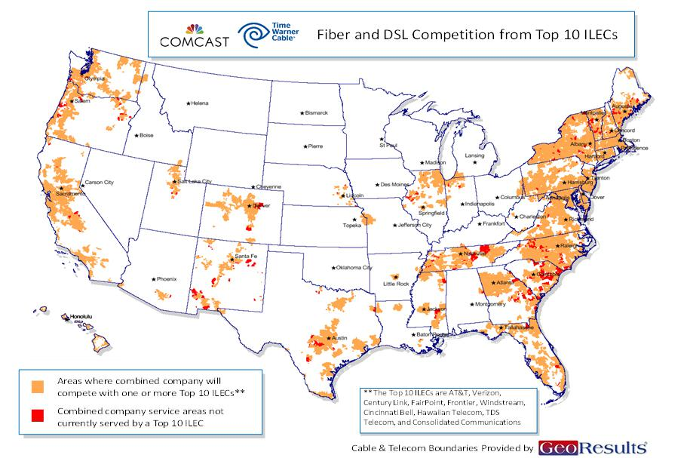

Service areas shown represent areas in which the top 10 ILEC providers offer fiber and/or DSL-based Internet access service of any speed. Service area boundaries have been estimated using census block data, wire center locations, and other publicly available information.

As shown in the map above, in 98.5 percent of the combined company’s service areas (including the systems Comcast receives from Charter), customers have a choice between the combined company and one or more top 10 ILEC competitors. More specifically, the orange in the map represents the service areas of the combined company where a top 10 ILEC offers Internet access service. The red shows the very few areas (representing about 1.5 percent of the combined company’s service areas) not currently served by a top 10 ILEC. (Source: GeoResults)

UPDATE OF MAP ON PAGE 53 OF COMCAST-TWC PUBLIC INTEREST STATEMENT
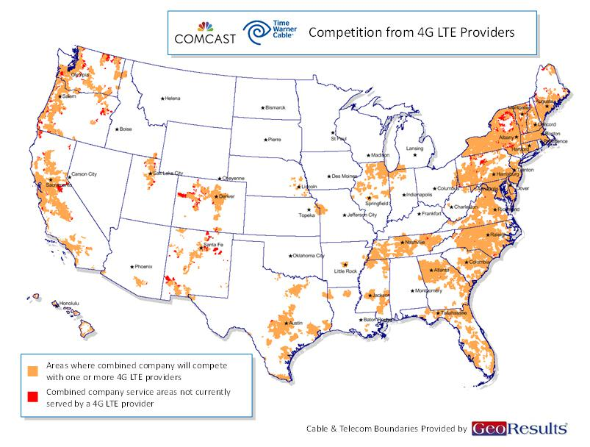

The orange in the above map represents those parts of the service areas of the combined company (including the systems Comcast receives from Charter) where a 4G LTE provider offers Internet access service. The red shows the very few areas not currently served by a 4G LTE provider.

UPDATE OF MAP ON PAGE 54 OF COMCAST-TWC PUBLIC INTEREST STATEMENT
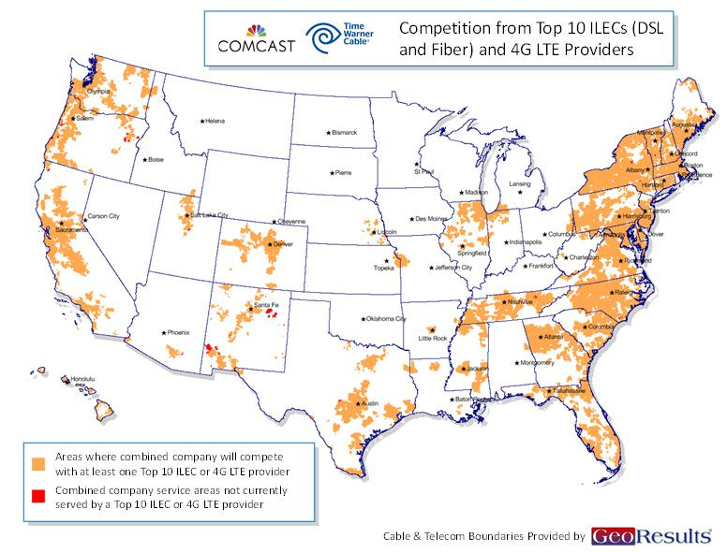

As shown in the above map, when one considers the near-ubiquitous availability of top 10 ILECs plus 4G LTE wireless broadband providers, there are virtually no areas of the combined company’s service areas where customers do not have at least one of these options.

UPDATE OF MAP ON PAGE 150 OF COMCAST-TWC PUBLIC INTEREST STATEMENT
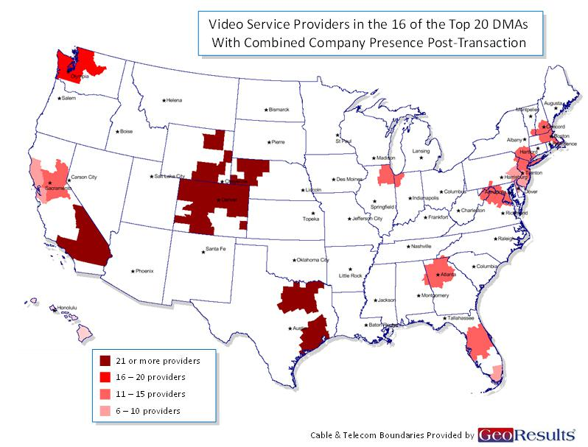

As shown in the above map, there will be 11 or more MVPDs in most of the 16 DMAs (within the top 20) where the combined company will have a presence and at least six MVPDs in all of them.

NEW MAP SHOWING SERVICE AREAS OF COMCAST, CHARTER, AND SPINCO AFTER DIVESTITURE TRANSACTIONS
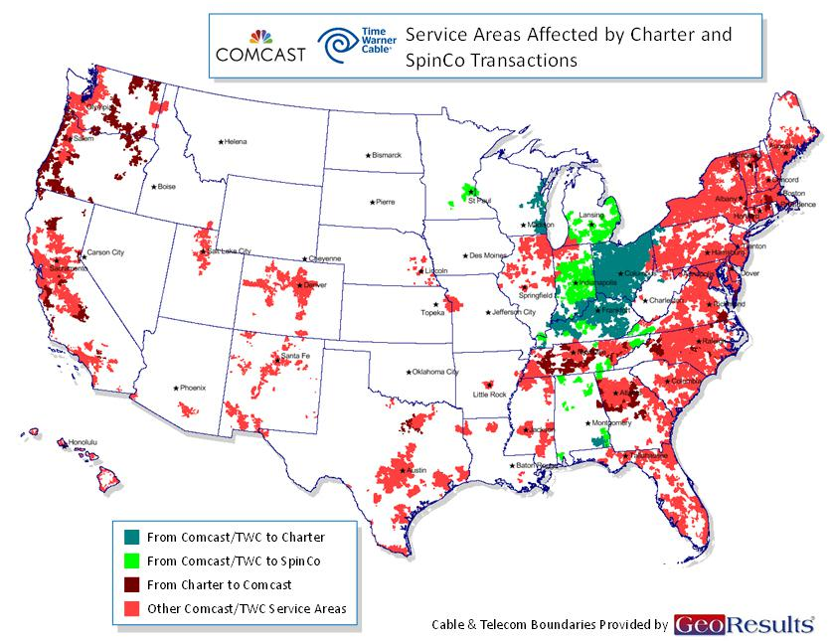

Important Information For Investors And Shareholders

This communication does not constitute an offer to sell or the solicitation of an offer to buy any securities or a solicitation of any vote or approval. In connection with the proposed transaction between Comcast Corporation (“Comcast”) and Charter Communications, Inc. (“Charter”), Charter will file with the Securities and Exchange Commission (“SEC”) a registration statement on Form S-4 that will include a proxy statement of Charter that also constitutes a prospectus of Charter, and a definitive proxy statement/prospectus will be mailed to shareholders of Charter. INVESTORS AND SECURITY HOLDERS OF COMCAST AND CHARTER ARE URGED TO READ THE PROXY STATEMENT/PROSPECTUS AND OTHER DOCUMENTS THAT WILL BE FILED WITH THE SEC CAREFULLY AND IN THEIR ENTIRETY BECAUSE THEY WILL CONTAIN IMPORTANT INFORMATION. Investors and security holders will be able to obtain free copies of the registration statement and the proxy statement/prospectus (when available) and other documents filed with the SEC by Comcast or Charter through the website maintained by the SEC at http://www.sec.gov. Copies of the documents filed with the SEC by Comcast are available free of charge on Comcast’s website at http://cmcsa.com or by contacting Comcast’s Investor Relations Department at 866-281-2100. Copies of the documents filed with the SEC by Charter will be available free of charge on Charter’s website at charter.com, in the “Investor and News Center” near the bottom of the page, or by contacting Charter’s Investor Relations Department at 203-905-7955.

In addition, in connection with the proposed transaction between Comcast and Time Warner Cable Inc. (“Time Warner Cable”), on May 23, 2014, Comcast filed with the SEC an amendment to the registration statement on Form S-4 that was originally filed on March 20, 2014, containing a preliminary joint proxy statement of Comcast and Time Warner Cable that also constitutes a preliminary prospectus of Comcast. The registration statement has not yet become effective. After the registration statement is declared effective by the SEC, a definitive joint proxy statement/prospectus will be mailed to shareholders of Comcast and Time Warner

Cable. INVESTORS AND SECURITY HOLDERS OF COMCAST AND TIME WARNER CABLE ARE URGED TO READ THE JOINT PROXY STATEMENT/PROSPECTUS AND OTHER DOCUMENTS FILED OR THAT WILL BE FILED WITH THE SEC CAREFULLY AND IN THEIR ENTIRETY BECAUSE THEY CONTAIN OR WILL CONTAIN IMPORTANT INFORMATION. Investors and security holders may obtain free copies of the registration statement and the joint proxy statement/prospectus and other documents filed with the SEC by Comcast or Time Warner Cable through the website maintained by the SEC at http://www.sec.gov. Copies of the documents filed with the SEC by Comcast are available free of charge on Comcast’s website at http://cmcsa.com or by contacting Comcast’s Investor Relations Department at 866-281-2100. Copies of the documents filed with the SEC by Time Warner Cable will be available free of charge on Time Warner Cable’s website at http://ir.timewarnercable.com or by contacting Time Warner Cable’s Investor Relations Department at 877-446-3689.

Shareholders of Comcast and Time Warner Cable are not being asked to vote on the proposed transaction between Comcast and Charter, and the proposed transaction between Comcast and Time Warner Cable is not contingent upon the proposed transaction between Comcast and Charter.

Comcast, Time Warner Cable, Charter and their respective directors and certain of their respective executive officers may be considered participants in the solicitation of proxies in connection with the proposed transaction between Comcast and Time Warner Cable, and Comcast, Charter and their respective directors and certain of their respective executive officers may be considered participants in the solicitation of proxies in connection with the proposed transaction between Comcast and Charter. Information about the directors and executive officers of Time Warner Cable is set forth in its Annual Report on Form 10-K for the year ended December 31, 2013, which was filed with the SEC on February 18, 2014, and its proxy statement for its 2014 annual meeting of stockholders, which was filed with the SEC on April 29, 2014. Information about the directors and executive officers of Comcast is set forth in its Annual Report on Form 10-K for the year ended December 31, 2013, which was filed with the SEC on February 12, 2014, and its proxy statement for its 2014 annual meeting of stockholders, which was filed with the SEC on April 11,

2014. Information about the directors and executive officers of Charter is set forth in its Annual Report on Form 10-K for the year ended December 31, 2013, which was filed with the SEC on February 21, 2014, and its proxy statement for its 2014 annual meeting of stockholders, which was filed with the SEC on March 27, 2014. These documents can be obtained free of charge from the sources indicated above. Additional information regarding the participants in the proxy solicitations and a description of their direct and indirect interests, by security holdings or otherwise, are contained in the preliminary joint proxy statement/prospectus of Comcast and Time Warner Cable filed with the SEC and will be contained in the definitive joint proxy statement/prospectus of Comcast and Time Warner Cable and other relevant materials to be filed with the SEC when they become available, and will also be contained in the preliminary proxy statement/prospectus of Charter when it becomes available.

Cautionary Statement Regarding Forward-Looking Statements

Certain statements in this communication regarding the proposed acquisition of Time Warner Cable by Comcast and the proposed transaction between Comcast and Charter, including any statements regarding the expected timetable for completing the transactions, benefits and synergies of the transactions, future opportunities for the respective companies and products, and any other statements regarding Comcast’s, Time Warner Cable’s and Charter’s future expectations, beliefs, plans, objectives, financial conditions, assumptions or future events or performance that are not historical facts are “forward-looking” statements made within the meaning of Section 27A of the Securities Act of 1933, as amended, and Section 21E of the Securities Exchange Act of 1934, as amended. These statements are often, but not always, made through the use of words or phrases such as “may”, “believe,” “anticipate,” “could”, “should,” “intend,” “plan,” “will,” “expect(s),” “estimate(s),” “project(s),” “forecast(s)”, “positioned,” “strategy,” “outlook” and similar expressions. All such forward-looking statements involve estimates and assumptions that are subject to risks, uncertainties and other factors that could cause actual results to differ materially from the results expressed in the statements. Among the key factors that could cause actual results to differ materially from those projected in the forward-looking statements are the following: the timing to consummate the proposed transactions; the risk that a condition to closing either of the proposed transactions may not be satisfied; the risk that a regulatory approval that may be required for either of the proposed transactions is not obtained or is obtained subject to conditions that are not anticipated; the parties’ ability to achieve the synergies and value creation contemplated by the proposed transactions; the parties’ ability to promptly, efficiently and effectively integrate acquired operations into their own operations; and the diversion of management time on transaction-related issues. Additional information concerning these and other factors can be found in Comcast’s, Time Warner Cable’s and Charter’s respective filings with the SEC, including Comcast’s, Time Warner Cable’s and Charter’s most recent Annual Reports on Form 10-K, Quarterly Reports on Form 10-Q and Current Reports on Form 8-K. Comcast, Time Warner Cable and Charter assume no obligation to update any forward-looking statements. Readers are cautioned not to place undue reliance on these forward-looking statements that speak only as of the date hereof.

