Filed by Comcast Corporation

(Commission File No.: 001-32871)

Pursuant to Rule 425 of the Securities Act of 1933

and deemed filed pursuant to Rule 14a-6(b)

of the Securities Exchange Act of 1934

Subject Company: Time Warner Cable Inc.

Commission File No. for Registration Statement

on Form S-4 filed by Comcast Corporation: 333-194698

The following third-party letters were made available on Comcast’s website:
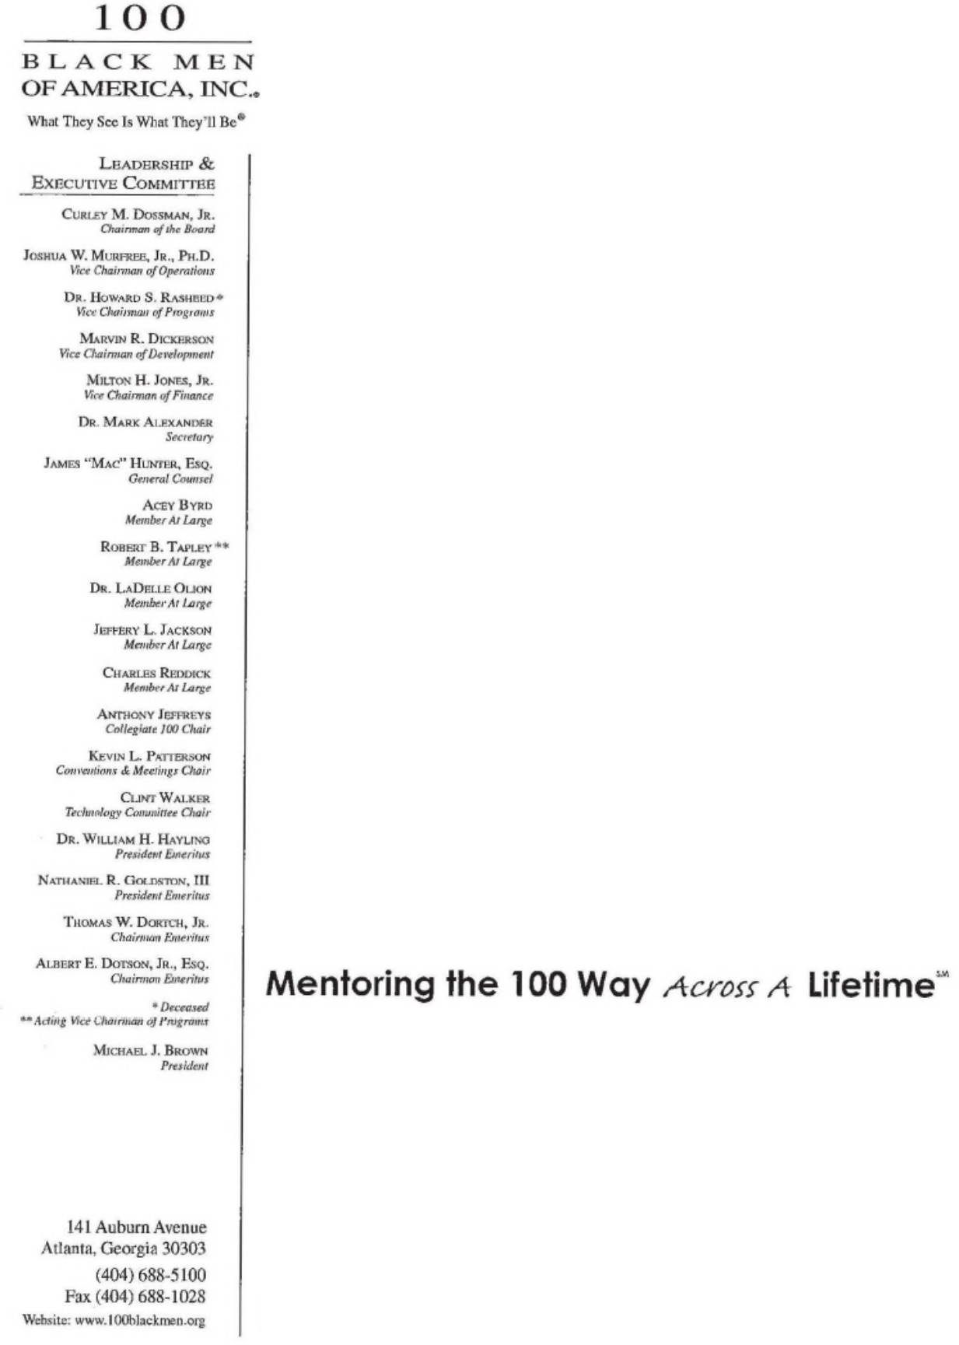

August 25, 2014

Mr. Tom Wheeler, Chairman

Federal Communications Commission
445 12th Street, SW
Washington, DC 20554

Dear Chairman Wheeler:

I write to express my support and share the views of 100 Black Men of America ("the 100") on the proposed merger between Comcast and Time Warner Cable.

The mission of the 100 is to improve the quality of life within our communities and enhance educational and economic opportunities for all African Americans. Comcast has exemplified our values by investing to improve the communities they serve.

The Internet Essentials program is just one example of Comcast's dedication to the community. Over the past three years Comcast has worked to inform the public of their program that provides affordable Internet to low-income homes. As an organization that seeks to improve the education of African American youths and communities, we stand behind Comcast and commend them for their hard work connecting 1.2 million Americans and counting. In this digital age it is imperative for students to have computers and Internet access and we applaud Comcast for their efforts to eradicate the digital divide.

The 100 is most excited about the prospects for new investments in infrastructure that may result from this merger. Comcast has consistently stood out among their competition as a leader in innovation and technology, constantly improving their service quality and increasing their Internet speeds. These investments are valuable not only to consumers but to small and mid-sized businesses and entrepreneurs looking for ways to enhance their services, reach new customers or simply cut costs. Future Comcast markets should be excited to take advantage of these investments.

Our organization is impressed with the efforts Comcast has made in increasing diversity and inclusion practices within the company. Since the merger with NBCUniversal they have introduced new leadership training programs and modified their recruiting practices, all in an effort to entice a more diverse range of employee talent. Externally they work with a diverse range of vendors and have partnered with minority chambers of commerce in different communities to identify potential minority-owned vendors.

Comcast is a passionate member of the communities they serve. They go above and beyond the duties of a service provider seeking to do more than collect money; they truly fight to make their communities better. It is my hope that this is clear to the FCC and they make the right choice and approve this merger.

Sincerely,

/s/ Curley M. Dossman, Jr.

Curley M. Dossman, Jr.

1

How to File a Letter at the FCC on the Comcast/Time Warner/Charter Cable Transactions

The Federal Communications Commission (FCC) has requested public comment on the proposed Comcast/Time Warner Cable/Charter transactions.¹ You can make your voice heard by filing a letter with the FCC, which will then be placed in a public file and made available for review.

All letters should be received by the FCC by August 25.

The FCC has specific procedures for filing in this proceeding. If you do not follow the procedures, your letter may not be formally considered.

- Your letter must include the subject line "RE: MB Docket No. 14-57."

- Your letter must be signed (but it can be electronically signed).

- If filing electronically, submit the letter as a .PDF. You can scan a copy of the letter into .PDF format or convert the document into a .PDF electronically. The FCC prefers electronic filings and the process to do so is explained below.

- If filing by U.S. Mail, you must send the letter to the FCC Secretary, as explained below.

Address the letter in any of the following ways:

 | Chairman Tom Wheeler
 | Commissioner Mignon Clyburn
Tom Wheeler | Commissioner Jessica | Marlene H. Dortch
Chairman | Rosenworcel | Secretary
Federal Communications | Commissioner Ajit Pai | Federal Communications
Commission | Commissioner Michael O'Rielly | Commission
445 12th Street, SW | Federal Communications | 445 12th Street, SW
Washington, DC 20554 | Commission | Washington, DC 20554
 | 445 12th Street, SW
RE: MB Docket No. 14-57 | Washington, DC 20554 | RE: MB Docket No. 14-57
Dear Chairman Wheeler: | RE: MB Docket No. 14-57 | Dear Ms. Dortch:
 | Dear Chairman and | Dear Ms. Dortch:
 | Commissioners:

- The FCC released a Public Notice on July 10, 2014 – titled "Commission Seeks Comment on Applications of Comcast Corporation, Time Warner Cable Inc., Charter Communications, Inc., and SpinCo to Assign and Transfer Control of FCC Licenses and Other Authorizations"- to officially begin the agency's merger-review process.

1

2

To submit your letter electronically, follow these steps.

- Make sure your letter is in .PDF format by either converting it to .PDF or by printing a copy and scanning it.

- Go to http://apps.fcc.gov/ecfs/upload/display?z=5gmag

- Enter the following information in response to the following questions:

  - Proceeding Number? Fill in 14-57

  - Name of Filer? Fill in name of locality/organization/company

    - No need to include other Contact Info (email address, law firm)

  - Type of Filing? Select "Letter"

    - You do not need to enter a File Number, Report Number, or Bureau Identification Number

    - Do not check "Ex parte Presentation"

  - Address? Fill in Address Line(s), City, State, Zip Code

  - In the "Document(s)" field, click on "Browse" and select the letter you have prepared from your computer's files (be sure to upload a .PDF)

- Click on "Continue"

- You will then be asked to review the information you entered and verify that the file you will be uploading is the correct file. If the information looks correct, click on "Confirm" and your letter will be electronically filed. You will then be taken to a confirmation page. If you do not receive a confirmation, there may have been a problem with the FCC's website or your connection. You must resubmit the letter.

2

3

If you do not want to file electronically, you can send your letter by U.S. Mail.

If sending by U.S. Mail, you must include an original and one (1) copy of your letter. To be formally considered in the proceeding, your letter must be mailed to the

Secretary of the FCC at the following address:

Marlene H. Dortch

Secretary

Federal Communications Commission
445 12th Street, SW
Washington, DC 20554

As with electronic filing, to be sure that the Chairman and the Commissioners see your letter, you can send additional hard copies to them by U.S. Mail.

The FCC also asks filers who submit by U.S. Mail to provide an additional copy to each of the following parties, by either email or facsimile (if sent by email, the subject line should include MB Docket No. 14-57, the name of your locality/organization/company, and "Letter"):

Best Copy and Printing, Inc.

fcc@bcpiweb.com (pdf attached to email)

(202) 488-5563 (facsimile)

Vanessa Lemmé

Media Bureau

Vanessa.Lemme@fcc.gov (pdf attached to email)

(202) 418-2053 (facsimile)

Marcia Glauberman

Media Bureau

Marcia .Glauberman@fcc.gov (pdf attached to email)

(202) 418-2053 (facsimile)

William Dever

Wireline Competition Bureau

William.Dever@fcc.gov (pdf attached to email)

(202) 418-1234 (facsimile)

Jim Bird

Office of General Counsel

Jim.Bird@fcc.gov (pdf attached to email)

(202) 418-1234 (facsimile)

3

4

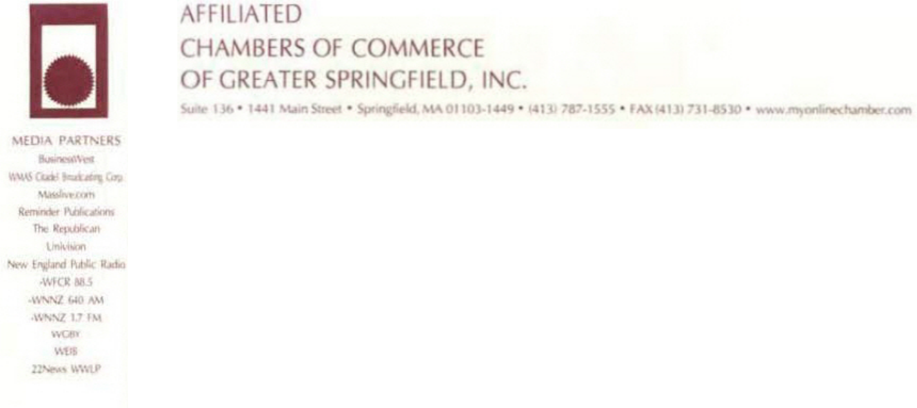

August 25, 2014

Mr. Tom Wheeler

Chairman

Federal Communications Commission
445 12th Street, SW
Washington, D.C. 20554

RE: MB Docket No. 14-57

Dear Chairman Wheeler,

On behalf of the more than 800 business members of the Affiliated Chambers of Commerce of Greater Springfield (ACCGS), a regional chamber of commerce in the greater Springfield, MA area, I am writing in support of the mater in the above docket number.

One of the major parts of this long established chamber of commerce has been to promote economic growth in this area. Comcast has been an active member of this chamber for many years and I believe it is because we share that same mission of assisting businesses in the area and preparing the area for those businesses seeking to locate here. We have worked jointly together on projects throughout the years and therefore, I write this letter in support of the proposed merger between Comcast and Time Warner Cable.

While Comcast is certainly a national business, I am always impressed how focused they are to this area and offer their support on some of our most important programs ranging from our signature Outlook event that is held every year and features prominent speakers on the federal, state, and local levels, giving those 800 businesses in attendance a firsthand report on major issues they all face, to our day at the state house allowing for one on one visits to policy makers. I also know firsthand of the support they give to some of our other member businesses, ranging from early education providers to many of the programs assisting some of our minority communities here in the Springfield area.

This level of support is vital to this chamber and it is reassuring to know that we have such a partner in Comcast. While I would like to think that we are unique in this level of support, I believe this is found in almost every area in which Comcast operates now and will operate in the future. On behalf of the members of the ACCGS, I offer this letter of support of the Comcast and Time Warner Cable merger without reservation and with the belief that their high level of community involvement will only be stronger in future. Please feel free to contact me if I can share any other information with you that you might find helpful.

Sincerely,

/s/ Jeffrey S. Ciuffreda

Jeffrey S. Ciuffreda, President

Affiliated Chambers of Commerce of Greater Springfield

5

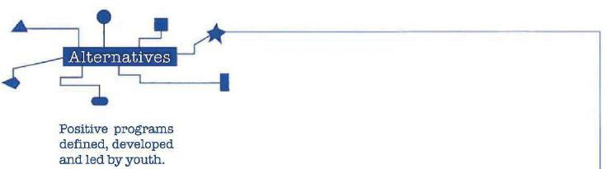

August 25, 2014

Tom Wheeler

Chairman

Federal Communications Commission
445 12th Street, SW
Washington, DC 20554

Re: MB Docket No. 14-57

Dear Chairman Wheeler:

I am writing to voice my support for the transaction between Comcast and Time Warner Cable. As the Executive Director of Alternatives, Inc. in Chicago, our agency has consistently benefited by our partnership with Comcast Corporation. I believe that the Federal Communications Commission's approval would create a greater opportunity for the teens and young adults across the country like – similar to the impact Comcast has afforded Chicago's youth.

Alternatives, Inc. was established in 1971 with the mission to provide at "alternative" programs for at-risk youth so that they would focus their energy into constructive extra-curricular activities while building skills that support their future. As a corporate partner, Comcast has not only embraced our mission but engaged in supporting our work to accomplish our mission. Comcast's involvement with the Digital Connectors program emphasizes the importance of leadership and well-established technical skills. Comcast has been an exemplary corporate representative who engages with the community while building workforce skills.

The Comcast Digital Connections program offers a very broad curriculum to train youth in Internet and computer skills. At the same time the youth are learning technical skills, they are engaged with community service learning projects. Comcast's Digital Connections initiative has been enormously successful with our agency, the youth and the community, and I am confident it will continue as it expands into Time Warner Cable markets.

In addition to its impact on Alternatives' participants in community engagement, Comcast has influenced the environment in which our students learn at home. Internet Essentials – a Comcast broadband adoption initiative for low-income families – has been a great resource for some of our participants to gain access to the Internet and continue their technology education at home. This initiative created an inside and out of the classroom option which made it a great addition to
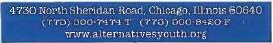

6

the Digital Connectors program and goal to reduce the digital literacy gap. To my knowledge, around 33,000 families are enrolled in Chicago's Internet Essentials program which is a significant achievement.

Comcast's investment and commitment to Alternatives, Inc. as a partner and educator has been at a depth that is important for our agency's growth and young people's development. With the addition of Time Warner Cable, these efforts will continue to improve and grow - benefitting similar organizations, youth and communities. I encourage you to approve this transaction.

Sincerely,

/s/ Judith M. Gall

Judith M. Gall, MSW

Executive Director

Alternatives, Inc.

7


August 20, 2014

Chairman Tom Wheeler

Federal Communications Commission

445 12th Street, SW

Washington, DC 20554

Re: MB Docket No. 14-57

Dear Chairman Wheeler,

The Asian American Education Institute is a non-partisan 501(c)3 non-profit organization dedicated to establishing programs to educate the Asian American community about civics and their voting rights in California. According to the Pew Research Center, Asian Americans have the highest Internet use among all groups in America. 87% of Asian Americans are online every day and 83% of Asian Americans receive their news from online sources. In order to best fulfill our mission, it is essential that the Asian American community has access to the broadest range of Internet access as it has become the dominant channel for the community to receive news about the issues that affect them the most.

As such, the Asian American Education Institute supports the pending merger between Comcast and Time Warner Cable because of the following reasons:

- First and foremost, the merger will improve delivery of broadband services to key Asian American communities in California. Comcast’s cutting edge technology will improve the speed and reliability of broadband services in Time Warner Cable’s current subscriber base in Southern California where Asian Americans are now the largest immigrant group.

- The merger will extend Comcast’s current commitment to net neutrality rules that were a part of its merger with NBCUniversal to Time Warner Cable’s current subscriber base.

- The merger will provide low-cost access to the Internet to more communities through Comcast’s Internet Essentials program. This benefit is particularly important to the Asian American community because of a recent report issued by the National Coalition for Asian Pacific American Community Development (CAPACD) in September of 2013 that showed a dramatic increase in AAPI poverty (45.2%) from 2011 to 2012. The numeric growth of AAPI poverty represents almost a third of the total increase in poverty among the general population.

- Comcast has a proven and recognized record of supporting the Asian American community as a corporate partner. Comcast has consistently invested in programs that support diversity in corporate affairs, supplier diversity, and diversity in media content. DiversityBusiness.com named Comcast and NBCUniversal among its "Top 50 Organizations for Multicultural Business Opportunities" and Equal Opportunity Magazine ranked Comcast among its 2014 "Top 50 Employers."

The expanded access to the Internet through new technology, expanded low-cost services, and extended net neutrality is essential to keeping Asian American communities educated and engaged in the political process. The Asian American Education Institute believes that the merger of Comcast with Time Warner Cable is essential to ensuring an engaged and educated Asian American electorate.

Sincerely,

/s/ James Santa Maria

James Santa Maria

President

515 South Figueroa St., #1110, Los Angeles, CA 90071 ■ FEIN# 20-4919872 ■ www.apavoterproject.org

8

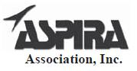

August 19, 2014

Chairman Tom Wheeler

Commissioner Mignon Clyburn

Commissioner Jessica Rosenworcel

Commissioner Ajit Pai

Commissioner Michael O’Rielly

Federal Communications Commission
445 12th Street, SW
Washington, DC 20554

RE: MB Docket No. 14-57

Dear Chairman and Commissioners:

On behalf of the ASPIRA Association, Inc., ASPIRA of Florida, Inc., ASPIRA of New Jersey, Inc., ASPIRA of New York, Inc., and ASPIRA of Pennsylvania, Inc., non-profit organizations dedicated exclusively to the education and development of low-income Latino youth, we write to express our full support of the proposed acquisition of Time Warner Cable by Comcast. The ASPIRA Association, ASPIRA of Florida, Inc., and ASPIRA of Pennsylvania, have a long history and working relationship with Comcast at a national and at statewide levels. ASPIRA of New York and ASPIRA of New Jersey have an equally long-standing relationship with Time Warner Cable. We believe that the combined companies will result in significant benefits for our community, especially in advancing the educational and leadership capabilities of the Latino youth we serve, by further bridging the digital divide. Specifically, the expansion of the Internet Essentials program to the Time Warner footprint, and the deployment of the fastest and most advanced networks in the country in these states, will greatly benefit low-income Latino youth and families that still lack access to affordable broadband.

For several years, ASPIRA has been a national partner with Comcast on a variety of initiatives, but is most proud of its long-standing partnership with Comcast on its Internet Essentials program that provides low cost broadband Internet access and low-cost computers to low income families. Internet Essentials has made great strides in bringing internet access and digital literacy training to low-income children and families across the country, connecting more than 1.2 million individuals and distributing more than 23,000 computers at affordable prices. Through our partnership with Comcast, ASPIRA has been able to provide Internet access to hundreds of families served by ASPIRA, significantly enhancing their children’s education and their overall quality of life. In schools and community centers across South Florida, Philadelphia, and Washington, DC, ASPIRA has actively participated in the program since its inception and has witnessed the benefit to families from Internet Essentials. As we continue to engage these communities and teach skills to thrive in this digital age in these states, we sincerely hope to be able to expand these programs to the families we serve in areas currently served by Time Warner Cable.

Comcast’s support of the Latino community goes beyond Internet Essentials. Comcast has supported numerous local and national programs for youth in our communities, including a host of education initiatives, and ASPIRA’s youth leadership development program, a testament to Comcast’s commitment to communities as a responsible corporate citizen. This commitment will be extended to other areas of the country currently served by Time Warner Cable, broadening opportunities for youth and families. Finally, Comcast has a strong and long-

An Investment In Latino Youth™

1444 I St., NW Suite 800, Washington, DC 20005

9

Chairman Tom Wheeler and FCC Commissioners RE: MB Docket No. 14-57

August 23, 2014 page 2

standing commitment to diversity within the company, providing enormous opportunities for minorities and women at all levels to thrive.

We believe that Comcast’s expanded footprint will foster much enhanced opportunities for education, employment, and quality of life in Latino communities. We urge you to take this into consideration in your approval process.

Sincerely,

/s/ Ronald Blackburn Moreno

Ronald Blackburn Moreno

President and CEO

ASPIRA Association, Inc.

/s/ Carlos Valentin

Carlos Valentin

President and CEO

ASPIRA of New Jersey, Inc.

/s/ Alfredo Calderon

Alfredo Calderon

Executive Director

ASPIRA of Pennsylvania, Inc.

/s/ George M. Cabrera

George M. Cabrera

President and CEO

ASPIRA of Florida, Inc.

/s/ Dr. Mark Gonzalez

Dr. Mark Gonzalez

Chief Program and Development Officer

ASPIRA of New York, Inc.

- [Type the document title]

10



August 22, 2014

Mr. Tom Wheeler, Chairman

Federal Communications Commission
445 12th Street, SW
Washington. DC 20554

RE: MB Docket No. 14-57

Dear Chairman Wheeler:

I am writing to express appreciation for the role Comcast consistently plays in investing in our community. I work at Aurora Public Schools (APS) as a Community Engagement Advocate and also serve as an elected official of Aurora City Council, and have seen the many different ways that Comcast provides valuable support to address community needs. It is because of Comcast's ongoing commitment to investing in and strengthening our community that I believe the proposed transaction between Comcast and Time Warner Cable is worthy of your consideration.

I have seen Comcast provide college scholarships to APS high school seniors every year for the last several years to support their post-secondary educational plans, which has meant a great deal to our Aurora families. More than 70% of all students in our district qualify for the free or reduced school lunch program; with so many of our families living in poverty, paying for college can prove very difficult. Comcast's annual scholarship program has helped make college a reality for many of our young leaders.

Our school district is also grateful for the many opportunities we have had to work in partnership with Comcast to make our families aware of the Internet Essentials program, which makes home Internet service affordable for low-income families. Every year for the last four years, Comcast has sponsored an annual back-to-school event that I help lead for the district, and their support helps us donate backpacks filled with school supplies to 4,000 students in need every August. Comcast staff members have also attended this event each year to share information about Internet Essentials with the nearly 8,000 parents and students who attend.

Comcast also has been a sponsor of the Aurora Public Schools Education Foundation for several years, where I serve as a board member along with a Comcast leader who recently became chair of our board. Comcast's support and participation is helping the Foundation create valuable resources in every APS high school that will enable our students to identify post-secondary education and training opportunities, and help them apply for and secure the financial aid and scholarships that can make those opportunities a reality.

Our school communities have also benefited for many years from Comcast Cares Day projects, as the company has included APS projects as part of this annual day of volunteer service. The Comcast Cares Day projects have served as a wonderful means of bringing together Comcast employees, their families, school district leaders, board of education members, students, teachers, and other members of the Aurora community to work on service projects that have greatly benefited our schools and the students they serve. I have seen these volunteers work hard to clean up school grounds, paint classrooms, install new landscaping for school playground areas, and more. We are grateful for this commitment and support, and delighted to know that another APS project will be included in Comcast Cares Day next April.

11

As a member of Aurora City Council, I also appreciate the strong business relationship Comcast has with our local businesses and our city. including carrying the Aurora Channel 8, which broadcasts City Council meetings for public viewing and offers a variety of local-area programming and news for Aurora citizens. I believe Comcast's culture of investing in communities will continue as the company expands, thereby reaching more families in need through efforts such as Comcast's annual college scholarship program, Internet Essentials, Comcast Cares Day, and more. We are grateful for Comcast's commitment to strengthening Aurora.

Kind regards,

/s/ Debi Hunter Holen

Debi Hunter Holen

Community Engagement Advocate

12



August 25, 2014

Chairman Tom Wheeler

Commissioner Mignon Clyburn

Commissioner Jessica Rosenworcel

Commissioner Ajit Pai

Commissioner Michael O'Rielly

Federal Communications Commission
445 12th Street, SW
Washington, DC 20554

RE: MB Docket No. 14-57

Dear Chairman and Commissioners,

The Austin Chamber of Commerce represents 3,000 business members employing nearly 200,000 Individuals. The Austin area has over 4,000 tech companies that employ 120,000 workers. Austin is the 11th most populated city in the U.S. Austin and is the country's fastest growing MSA over the past 10 years averaging more than 100 new residents moving to the area in the past three years alone. Our metropolitan area also exceeds the U.S. average significantly for percentage of telecommuting employees which makes up 6.5% of our workforce. We have a chamber goal to increase the percentage of work from home employees to 15% by 2020.

Austin is known for its innovative companies and as an incubator for great American technology companies. Time Warner cable has been an excellent community partner and Comcast is a major contributor to the overall Texas economy, spending more than $600 million in Texas last year. We believe that extending Comcast's service to Austin will be a good fit with the tech-savvy lifestyle of our community and for aggressive goal of more telecommuting employees.

We respectfully ask that you approve the proposed Comcast and Time Warner Cable transaction, as we see abundant promise in the proposal.

Comcast offers enhanced access through its secure and reliable network for businesses. With speeds up to 10 GB per second this service would help business owners in the Austin community to boost productivity, provide fast and responsive customer service and move functions into the cloud. Comcast's network is not only fast but is flexible and has the capacity needed to evolve as demand for bandwidth increases.

On the video side, Comcast has gone all digital enabling consumers access to their video services through groundbreaking, access-everywhere technology. Businesses and individuals on the move increasingly depend on the flexibility provided by Internet hotspots to stay in touch, make deals and

Austin Chamber of Commerce • 535 East 5th Street • Austin, Texas 78701 • Ph: 512-478-9383 • austinchamber.com

13

carry out other day-to-day business functions outside of the office. Comcast's Xflnity service could offer just that opportunity for our city.

The proposed transaction seems to us to be a sensible solution for meeting the public's desire for premiere digital broadband and video service throughout Texas and the United States.

Thank you for your consideration of our request for this transaction's approval.

Sincerely,

/s/ Michael W. Rollins

Michael W. Rollins, CCE

President & CEO

14



Chairman Tom Wheeler

Commissioner Mignon Clyburn

Commissioner Jessica Rosenworcel

Commissioner Ajit Pai

Commissioner Michael O'Rielly

Federal Communications Commission

445 12th Street, SW

Washington, DC 20554

RE: MB Docket No. 14-57

August 18, 2014

Dear Chairman and Commissioners:

My name is Constantino Schwarz, and I am the CEO of BabyFirst Americas, as well as a US military veteran, a Kaitz graduate, and a proud father. BabyFirst Americas was founded with the following goals in mind:

- Bring great content, with Latino cultural elements, created by Latinos to all American children, and introduce the beautiful Latino culture to every child in America.

- Help narrow the educational gap by offering Latino parents the ability to help their children integrate into American society, while maintaining a strong connection to their Latino heritage and bilingual communication.

- Promote independent Latino content and talent, in front of and behind the camera, and give them the opportunity to express their work to a major audience.

Comcast's support of BabyFirst Americas demonstrates the collective commitment of both Comcast and the network to bilingual education and entertainment, as well as to viewers seeking content in both English and Spanish. Throughout our relationship, Comcast has been an invaluable and trusted partner, and has over-delivered on their promises to our network. We fully support the proposed merger between Comcast and Time Warner.

Comcast gave BabyFirst Americas a significant boost by providing broad distribution which over time has led to approximately 75% of Comcast's digital tier. Comcast's support for our network over the last two years demonstrates how great Comcast is in supporting diversity and independent channels. This distribution helped validate the network's credibility and value proposition to the rest of the industry. Comcast was the first to offer BabyFirst Americas via a simultaneous dual feed encompassing a Latino tier in Spanish and a concurrent separate tier in English. The dual tier brings the network to both Latinos and the country's mainstream viewing audience.

15

BabyFirst Americas was selected for launch by Comcast from a variety of submissions through a transparent and robust selection process. Key factors supporting the network's selection included its unique mission and strong programming slate; its experienced professional leadership team; and a solid business plan that was fully funded through its existing distribution in Latin America and other countries.

In addition, BabyFirst Americas had many supporters in the Latino community, including; Mary Alice Cisneros, San Antonio City Council and President, American Sunrise; Dr. Eugene E. García, Professor & Vice President Education Partnerships, Arizona State University; Consuelo Castillo Kickbusch, Founder & President, Educational Achievement Services, Inc.; and, Michael L. López, Ph.D., Executive Director, National Center for Latino Child & Family Research, among others.

The network's leadership also met with many other influential members of the Latino community, including educational and cultural thought-leaders, as well as members of Congress, who further helped to guide the channel in the launch phase and continue to support the network.

BabyFirst Americas features content introducing key developmental concepts such as numbers, animals, colors, shapes, music, animals, art and more; programs that reflect the culture of American Latinos, such as childhood songs, games and stories; fitness and nutrition and is developmentally appropriate for babies, toddlers and their parents and supervised by a worldwide advisory board of early childhood education experts. BabyFirst America's content is especially valuable to Latino families in helping overcome the serious verbal deficit of young Latino children, which is a top concern and priority of young Latino families and educators.

The network's shows have been honored with multiple Latin Grammy and Emmy nominations, and have created a vibrant storefront for talented content creators within the Latino community. For example the show Atencion, Atencion, has won the Latino Grammy award and the Company's most recent original production, Dance Time Boys, was directed and produced by Peter Michael Escovedo III, an Emmy nominated Musical Director / Producer, and recognized percussionist, producer, singer, songwriter, and television personality. As of December 2013, the network's ratings numbers had more than doubled with the Latino index among viewers rising simultaneously. Further, 97% of moms were watching with their children, encouraging bonding and interaction between parents and children, and the viewing time of the network had increased to 94.5 minutes a day - outperforming all other women's and preschool networks.

We are hopeful that Comcast's expension will provide us an opportunity to reach even more homes, and introduce this important content to babies, toddlers and their parents nationwide.

Sincerely,

/s/ Constantino Schwarz

Constantino Schwarz

CEO

16



August 21, 2014

Tom Wheeler

Chairman, Federal Communication Commission
445 12th Street, SW
Washington DC 20554

RE: MB Docket No. 14-57

Dear Chairman Wheeler:

This year marks the 26th Anniversary of the Beaverton Education Foundation (BEF) and for more than seven of those years we have worked closely with Comcast.

Because of highly favorable view of the company, we are writing to encourage you to approve Comcast’s proposed merger with Time Warner Cable.

BEF is committed to raising money to provide hands-on innovative academic enrichment and advancement programs and projects for all 51 Beaverton public schools. Our funding supports innovated classroom, summer, and after-school programs. We rely on school families, our community members, and local businesses for supporting the programs that we fund because they are not mandated or funded by the state. Companies like Comcast have been a big help in our effort to support our school system.

Comcast has worked with our organization and our efforts throughout the community for the past seven years. We have worked with Comcast on our “Extended Day” programs, which focus on promoting technology literacy and access in middle schools. The schools this program helps would not otherwise be able to afford to run such a program. We have teamed up with Comcast to help promote their Internet Essentials program to Extended Day participants. We know that children who have access to the Internet are far more likely to succeed in school; it is our goal that every child is afforded the same opportunities to excel.

Our long partnership with Comcast has benefitted our schools and our community and we hope to continue working with them for many more years. In our view, allowing Comcast to grow and serve more communities can only benefit those communities. It is our hope that the Commission recognizes how Comcast’s community-oriented attitude serves the public interest and that it will approve the proposed transaction.

Sincerely,

Kristine Baggett

Executive Director

17

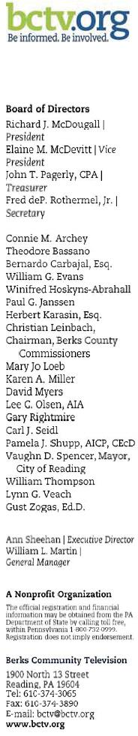

August 25, 2014

Tom Wheeler, Chairman

Federal Communications Commission
445 12th Street, SW
Washington, DC 20554

RE: MB Docket No. 14-57

Dear Chairman Wheeler:

My name is Ann Sheehan and I am the Executive Director of Berks Community Television (BCTV) in Reading, Pennsylvania. BCTV is a nonprofit organization that provides cable programming via the Internet and two cable TV stations. We encourage and invite community members to actively participate in shaping our programs by submitting stories, photographs, event information, opinions and reviews of local entities that would be of interest to the community. Our primary purpose is to enhance the unity and strength of the community by providing a medium for community dialogue and educational opportunities and a forum for the exchange of information and ideas.

BCTV is also the third-party manager of the City of Reading's Community and Government Access Channels. As the Executive Director of BCTV, I have had the opportunity to work closely with Comcast, whose technical assistance, funding and various other kinds of support have been a large part of the success and growth of our organization.

In 2013, thanks to Comcast's carriage of our network, we had the opportunity to expand to Boyertown, in the eastern part of Berks County,. We are hopeful that in reaching new households, relevant and critical information can be shared among neighboring communities.

Local community television stations are present nationwide - and since many of them are community-funded nonprofits, it can be hard to come across both financial and technical support. Comcast has a strong track record of supporting community programming like BCTV, and it is my understanding that through the proposed transaction with Time Warner Cable, Comcast will be able to provide that same support in new markets.

In the nonprofit sector, where technological advancement can often be extremely expensive, we are fortunate to have the unwavering and loyal support of a large partner such as Comcast. I urge you to consider the positive impacts of a transaction between Comcast and Time Warner Cable and to act favorably.

Ann Sheehan

Executive Director

18



Tom Wheeler

Chairman

Federal Communications Commission
445 12th Street, SW
Washington, DC 20554

RE: MB Docket No. 14-57

Dear Chairman Wheeler:

I am contacting the Commission as the Senior Vice-President of External Affairs for Bienvenidos Children's Center to outline the ways that a successful transaction between Comcast and Time Warner Cable would benefit my organization.

Bienvenidos Children's Center was founded in 1986 as an emergency residential facility for children removed from their homes. Since then, we have grown into a multi-faceted social service organization that offers a comprehensive array of services intended to empower children and their families, while also being culturally responsive and effective models of prevention and intervention. In addition to providing quality services, we advocate for a society where our vision of every family being able to provide loving, healthy and secures homes for children to grow and thrive in can be realized.

As a non-profit organization, we rely on good corporate citizens who value our vision and goals and are willing to offer their support and services. Among the many benefits that the addition of a good corporate citizen of Comcast's caliber would bring to our region is its broadband adoption program, Internet Essentials. If the children we work with could have access to the Internet at home, it would be a huge step in the right direction towards giving families the support and resources they need to become strong, resilient, and self-reliant members of society. The children would be able to complete homework assignments using the same tools as their classmates and families would be able to acquire the skills necessary to remain competitive in the workplace.

Our organization currently has nine locations in four Southern California counties - Los Angeles, Orange, Riverside, and San Bernardino. As a non-profit organization with limited means, the prospect of having access to Comcast's business class service is promising for us. All of our locations would be able to operate using one service provider, which would ensure competitive prices and allow for better communications between our offices. Being able to have advanced IT services, virus protection software, and access to cloud computing applications would allow our organization to run more efficiently and smoothly, which would then allow us to dedicate more time to the children with whom we work.

I am certain that other social service organizations in the region could similarly benefit from Comcast's services and programs, and so I hope that you approve this transaction. Thank you.

Regards,

/s/ Deborah Villar

Deborah Villar

Sr. VP External Relations
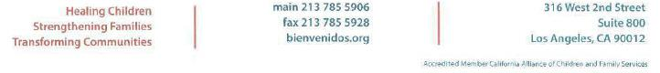

19

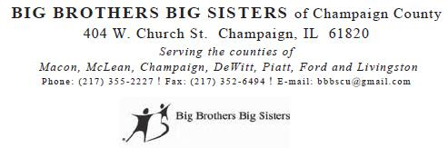

RE: MB Docket No. 14-57

I am the Community Manager for the Champaign County division f Big Brothers Big Sisters of Central Illinois. For more than 14 years, Big Brothers Big Sisters, Champaign County, has matched area children to positive adult role models. Guidance for boys and girls approaching their teen years, especially those who are economically disadvantaged, is such a critical requirement for development of healthy attitudes and behaviors. Yes, due to single-parent families and the tendency for decling supervision of youngsters as they reach middle school, many children lack the proper attention discipline and guidance they need. For more than a century, mentors assigned through Big Brothers Big Sisters have filled that need.

The research show that children who are mentored through Big Brothers Big Sisters earn better school grades are less likely to drop out of school or start using alcohol and illegal durgs, and are even liess likely to hit someone. Our volunteer mentors, or ‘Big’, are the force behind these striking outcomes. In Central Illinois and hundres of locations around the country, the employees of Comcast have been a major source of mentors and critical support for Big Brothers and Sisters. Especially in the last five-pus years, Comcast has made an astounding impact on our organization. I understand that the Commission is considering the Comcast and Time Warner Cable transaction. Please approve the transaction for the benefit of many, not the least of which are ‘Littes’ across the U.S. who have so much to gain.

One of the greatest ways that Comcast supports Big Brothers Big Sisters is through the company’s own program called “Beyond School Walls”. Comcast employee “Bigs” host their “Littles” at company offices for regular visits. The children take part in activities that enrich their academic and social skills and join in fun gatherings arranged by their “bigs”. In addition, year after year Comcast is a major partner for our National Leadership Summit, during which mentors chosen as “Bigs of the Year” are honored. In 2012, because of its outstanding commitment to mentoring children, Comcast received our President’s Award.

Another very important role that Comcast plays in the lives of “Littles”, and other children wherever the company operates is providing links between student and educational opportunities available in the digital world. So much learning now occurs online. Children must have access to fast broadband to keep up with and surpass students across the globe. However, income of the lack thereof sadly plays a role in too many homes, which children lacking access to the Internet and the tools they need to be successful in school. Fortunately, a few years ago, Comcast launched its Internet Essentials program. Low-income families can now affort to connect to the Internet because Comcast gives them a special $9.95 a month rate. It also sells computers that cost less than $150. This isn’t just a nice luxury- children need the Internet because schools require student to complete homework online, send emails to teachers and carry out research on the Internet. Hundreds of thousands of families have benefited from Internet Essentials nationwide, including almost 40,000 in Illinois.

20

I believe that the outcome of a Comcast and Time Warner Cable transaction will be more opportunities for children, more advancement in digital connectivity and more communite growing stronger for having Comcast as a committed corporate partner. Please don’t hesitate to approve this transaction.

Eric M. Batsie

21

Tom Wheeler

Chairman

Federal Communications Commission
445 12th Street, SW
Washington, DC 20554

RE: MB Docket No. 14-57

Dear Chairman Wheeler:

I write to you today to share the perspective of the New York chapter of the National Black Chamber of Commerce (NBCC) on the proposed merger between Comcast and Time Warner Cable.

The NBCC is dedicated to economically empowering and sustaining African American communities by facilitating entrepreneurship and free enterprise activity within New York. Supporting organizations that share our commitment is fundamental to our mission, and Comcast has shown itself to be determined in their pursuit of greater cultural and creative diversity. Their determination is not just theoretical – it has consistently been put into practice.

Since 2011, women and minority hiring has risen to 40 percent of Comcast’s total workforce, and Comcast has launched five new independent cable TV networks and established a diversity advisory council. The results of this speak for themselves: in 2013 its rating as a top place to work for both women and minorities won the company two awards. The idea that this transaction could mean that New Yorkers will benefit from these practices is exciting for us.

Comcast’s reputation for working with minority-owned suppliers represents a tremendous opportunity for our members. Since 2011, Comcast’s spending with minority-owned suppliers and vendors increased by 20%. Their commitment to promoting diversity through economic empowerment has, like their hiring practices, also been awarded; in 2013 DiversityBusiness.com rated Comcast among its Top 50 Organizations for Multicultural Business for the eighth consecutive year. We look forward to assisting Comcast in seeking local Black-owned suppliers.

In every respect Comcast has shown itself to be a champion of cultural diversity and has provided economic opportunity to individuals from all socioeconomic backgrounds. Their leadership in this area has been exemplary, and I encourage you to take this into consideration when reviewing the proposed transaction.

22

Sincerely,

/s/ Tosha Miller

Tosha Miller

Executive Director/President

Black Chamber of Commerce of New York City

23



Tom Wheeler Chairman

Federal Communications Commission

445 12"' Street, SW

Washington, DC 20554

RE: MB Docket No. 14-57

Dear Chairman Wheeler:

As someone who has seen Comcast's devotion to the communities it serves, I am happy to write this letter in support of its transaction with Time Wamer Cable. I am the President and CEO of New England's largest Latino newspaper, El Mundo. We have long been a media partner of Comcast and NBCUniversal and have worked with them on a variety of events and issues to raise the profile of Boston's Hispanic community. Comcast has always been a forward-thinking company -- and one of our strongest supporters. I believe a greater presence nationwide would have a positive impact on the new communities Comcast would serve, Including the minority populations within them.

I come from a mixed Hispanic background: my father was born in Havana, Cuba and my mother is a native of Ecuador. l was raised to believe that, while we all come from a variety of backgrounds, Latinos must speak as one voice in order to make the biggest impression. At El Mundo, we bring together all Hispanic backgrounds to keep our community informed on local news and to raise our profile through annual media events, such as the one noted below.

Anything sports related generally captures the interest of a large portion of our readers so 20 years ago we partnered with the Boston Red Sox to launch a series of Latino outreach events. One of our most popular is the "Latino Youth Recognition Day at Fenway Park". This nationally recognized community outreach program includes a pre-Red Sox game ceremony honoring top Latino academic achievers. To date, the program has honored over l,5OO Latino public school students in Massachusetts for their academic achievements and has given away over 15,000 Red Sox tickets to the Latino community.

Comcast provides generous, annual support for this program and helped us to create the "Comcast Latino Family Festival", also held at Fenway Park, in which proceeds go to charities and non-profits that benefit the Latino community.

Comcast's commitment to improving the economic outlook for Hispanic low-income

24

students and families goes beyond these events and into the hearts of our communities through its "Internet Essentials" program.

This program, which offers low-cost Internet, computers and free bilingual digital training services at local community centers, has helped to level the playing field across our education system. Our students and parents can not only access computers and the internet for the first time through this program, but can also attain free guidance in how to make good use of them . This type of program truly offers solutions for minority and disadvantaged communities to get ahead because these populations are disproportionately on the wrong side of the digital gap, and I am happy to hear that Comcast has extended this program indefinitely.

I am proud of the impact we have made in Boston, but there is still more work to be done here and in many cities across the country. Hispanics make up over 16% of the American population, yet continue to be underrepresented in government, the media and in community leadership programs.

Comcast has already displayed a high level of commitment to promoting Latino communities, and I believe that the proposed transaction with Time Warner Cable will only further this promise.

I encourage the FCC to approve the transaction as soon as possible.

/s/ Alberto Vasallo III

Alberto Vasallo III

President/CEO

25

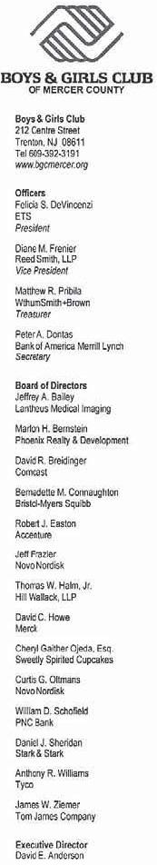

August 25, 2014

Chairman Tom Wheeler

Commissioner Mignon Clyburn

Commissioner Jessica Rosenworcel

Commissioner Ajit Pai

Commissioner Michael O'Rielly

Federal Communications Commission

445 12th Street, SW

Washington, DC 20554

RE: MB Docker No. 14-57

Dear Chairman and Commissioners:

On behalf of the Boys and Girls Club of Mercer County I wou ld like to share our views on the proposed transaction between Comcast and Time Warner Cable.

The Boys and Girls Club of Mercer County is a safe haven for the youths of Trenton, providing them with academic enrichment and recreational activities through various programs. More than 2,300 young people benefit from our programs, including a high school program that prepares teens for life post-graduation with paid internships and job training. Comcast shares our dedication to assisting youths as they forge their futures and has become a strong partner to our Club and other across the country.

We partner with the local Comcast team to help implement the Internet Essentials program in Trenton by spreading awareness about the program among our after school technology program participants. Our efforts are really beginning to bear fruit, having more than doubled the total number or participating households in 2013.

Technology and access to broadband is critical in today's world and it is for that reason we support Comcast's expansion which would provide our sister Clubs in other areas the opportunity to partner with a company such as Comcast who shares their mission of helping youth.

Very truly yours,

/s/ David Anderson

David Anderson

Executive Director

Boys and Girls Club of Trenton/Mercer, Inc.

26

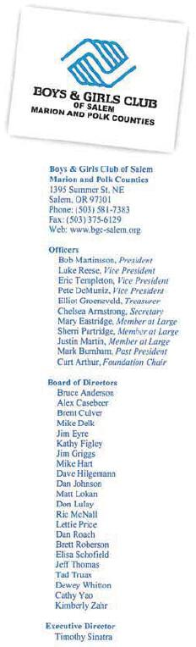

Tom Wheeler

Chairman

Federal Communications Commission

445 12th Street, SW

Washington, DC 20554

People often have a misconception of what the Boys and Girls Club does. It has long been thought that the Club is a space where underprivileged kids can come to stay off the streets when they have nowhere else to go. In some cases this is still true, but our services and mission have grown to be much more comprehensive. As executive director of the Boys and Girls Club of Salem, Oregon I have been a part of this exciting transformation.

Our organizational goal is to develop the full potential of each of our participants through our program services model. Using a 360-degree approach, we first focus on positive development as well as prevention and intervention programs where we see a need. We then ensure that the essential needs including food, health/dental care, safety and supportive relationships are present in each of our children's lives. Once fundamental needs have been met we work with our boys and girls towards academic success, character/citizenship development and maintaining a healthy lifestyle. Our final step is to provide transformational opportunities through creating active learning environments, access to occupational experts and alignment of academic and career pathways. As you can see our reach is extensive and just last year we served nearly 11,900 youth in our community alone. As a nonprofit organization, we need assistance from larger for profit organizations to be able to carry on with our mission. Comcast has been integral to our growth and success and I am urging you to consider the Comcast and Time Warner Cable (TWC) transaction to move forward so children in other communities across the country can experience the same support that ours in Salem, Marion and Polk counties have.

One of my favorite programs offered through the Boys and Girls Club is Club Tech. Club Tech launched in 2000, and through a partnership with Comcast, the Boys and Girls Clubs of America have been able to work to bridge the digital divide. We have even been fortunate enough locally to host a digital literacy night to promote and develop the skills necessary to be successful in today's society. 1cannot stress enough how critical a program like Club Tech is for opening new opportunities for our boys and girls.


27

As if Comcast's sponsorship of Club Tech wasn't enough, they saw a need to provide low-cost Internet and computers to lower income children and their families at home as well. In 2011 Comcast launched their Internet Essentials {IE) program that allows families with one or more children enrolled in free/reduced lunch to access the Internet for just $9.95 per month as well as purchase an Internet ready computer for $149.99. Since its inception IE has grown rapidly with the number of activations increasing by almost 6 times in Oregon between 2011 and 2013. We have been sure to educate our communities about this opportunity and I was happy to read that Oregon is exceeding the national average for eligible activations.

In addition to the technological infrastructure and support Comcast has offered the Club, we have been lucky enough to be a partner for their day of service initiative, Comcast Cares Day. I believe that this day has grown into the largest national day of service amongst any corporation in America. I am thrilled that we've been a part of that for several years and that our children can see what it means to give back to your community.

As a long-running nonprofit organization we know the importance of partnerships with organizations that can help support our mission. Comcast goes above and beyond what is necessary and our children and communities flourish because of their involvement. I ask you to please consider the stories of Boys and Girls Clubs nationwide when considering approving a transaction between Comcast and Time Warner Cable and understand the benefit that it would bring to new clubs, communities and youth.

Sincerely,

/s/ Timothy Sinatra

Timothy Sinatra

Executive Director

28

August 23, 2014

Chairman Tom Wheeler

Commissioner Mignon Clyburn

Commissioner Jessica Rosenworcel

Commissioner Ajit Pai

Commissioner Michael O’Rielly

Federal Communications Commission
445 12th Street, SW
Washington, DC 20554

RE: MB Docket No. 14-57

Dear Chairman and Commissioners:

In my role as the president of the Board of Directors of the Boys & Girls Clubs of Annapolis & Anne Arundel County (BGCAA), Maryland, I often have the opportunity to consider what fosters a strong community and what makes someone a good citizen, or an organization a good corporate citizen, and how those two elements work in tandem. It is with that connection in mind that I encourage you to consider the benefits the proposed Comcast and Time Warner Cable transaction could bring to community-based organizations like the BGCAA.

BGCAA is a nonprofit organization dedicated to ensuring that all youth from the ages of 6 to 18 have access to affordable after-school, and out-of-school, programs. BGCAA reaches more than 2,200 youth every year in four Annapolis Clubs and our Clubs in Pasadena and Severn. BGCAA is part of the Boys & Girls Clubs of America, which annually serves nearly 4 million young people through membership and community outreach in some 4,000 Club facilities throughout the country.

As part of this organization, BGCAA is dedicated to providing a world-class Club Experience that assures success is within reach of every young person who walks through our doors, with all members on track to graduate from high school with a plan for the future, demonstrating good character and citizenship, and living a healthy lifestyle.

It is that mission which brings the Boys & Girls Clubs of Annapolis & Anne Arundel County in line with Comcast's strong record of community involvement, both locally and nationally. The partnership between Comcast and the BGCAA is an active and cooperative one. Comcast employees have served on our board of directors, sponsored our annual Youth of the Year Awards since 2000, helped us promote the clubs via their "Comcast Newsmaker" program and our Bates Club location has hosted multiple Comcast Cares Day events since 2008. Comcast has also supported our "Club Tech" program, a national digital literacy and technology skills initiative that is building our young members' computer skills and seamlessly integrating technology across our program areas.

When Comcast launched the Internet Essentials program, materials were distributed at each of our six clubs, and we hosted a digital literacy training class in conjunction with the program. The potential of Comcast's broadband network expanding through the transaction and the importance of its Internet Essentials program, which provides

29

affordable Internet access to more than 350,000 households, match with the BGCAA's goal of ensuring all of our members have a strategy for success, both in school and in life. Whether in education or job training, access to technology is vital for our members and to the many stakeholders of the community-based organizations with which Comcast partners nationwide.

Whether through the infrastructure needed to expand broadband adoption and provide affordable Internet access to the families in our community, or through its continuing support of our mission, Comcast has already been an example of good corporate citizenship and continued community investment.

Thank you for your time and consideration.

Regards,

/s/ Peter Summers

Peter Summers

BGCAA Board President

30

August 22, 2014
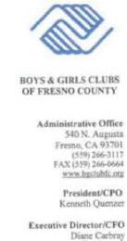

Chairman Tom Wheeler

Commissioner Mignon Clyburn

Commissioner Jessica Rosenworcel

Commissioner Ajit Pai

Commissioner Michael O’Rielly

Federal Communications Commission
445 12th Street, SW
Washington, DC 20554

RE: MB Docket No. 14-57

Dear Chairman and Commissioners:

Today I write to the FCC to share the opinions and views of the Boys & Girls Club of Fresno County on the potential merger between Comcast and Time Warner Cable.
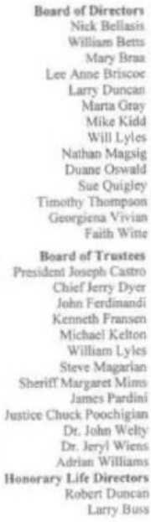

At the Boys & Girls Club of Fresno County our mission is to enable all young people to reach their full potential as productive, caring, and responsible citizens. We have witnessed how Comcast demonstrates responsible corporate citizenship, particularly through Comcast programs that support the communities they serve. Comcast invests heavily in their communities and have provided opportunities for underserved and impoverished youth here in Fresno County.

Our work together to prepare Club youth as participants to succeed in school and in life through tech skills training has been very fruitful. As with other Boys & Girls Club chapters nationwide, we are a Comcast “Internet Essentials” digital literacy training partner, incorporating free skill-building courses into our existing afterschool tech training programs for disadvantaged youth. We have also distributed information and sign-up materials to our participants to bring home. We know our efforts are part of the reason why more than 9,200 homes in the Fresno area have signed up for Internet Essentials.

It is inspiring to see an organization that cares and assist so generously. When you are considering this proposed merger, please think about all of the young men and women who could thrive with the help of Comcast in other markets in California and throughout the country.

Thank you for listening to our input.

Sincerely,


/s/ Diane Carbray

Diane Carbray

Executive Director/CFO

GREAT FUTURES START HERE

31

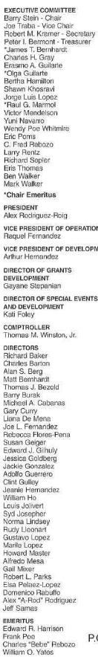


Tom Wheeler

Chairman

Federal Communications Commission
445 12th Street, SW
Washington, DC 20554

RE: MB Docket No. 14-57

Dear Chairman Wheeler:

As President of Boys & Girls Club of Miami-Dade, I am vested in growing and strengthening this organization in order to best serve local children. This growth and success simply would not possible without contributions and support from partners like Comcast. Comcast's commitment and contributions have helped us maintain and expand our programs. As such, I want to express my support of the proposed Comcast and Time Warner Cable transaction as Boys & Girls Clubs of Miami-Dade is committed to further bridging the digital divide and improving the quality of life for America's lower income communities here in South Florida and beyond.

Boys & Girls Clubs of Miami-Dade began in 1946 with humble roots as a single building and site for boys. Today, this organization has five locations serving 10,000 boys and girls year-round. Our Clubs play an integral role in ensuring children have an enriching and safe place to go so that when the school bell rings, the Clubs are in. Our after-school and summer programs offer academic, social and fitness enrichment opportunities. We work hand in hand with schools to ensure that youth have a chance at reaching the American Dream.

Comcast's Internet Essentials program offers families of students who participate in the National School Lunch Program eligibility for discounted Internet service at home. Too many children are at a disadvantage educationally, professionally and personally by being on the wrong side of the digital divide. Internet Essentials demonstrate Comcast's commitment to eradicating these obstacles to 21st century success.

Our Clubs have dived head first to connecting as many families as possible to Internet Essentials. In Miami, approximately 26,000 households are already enrolled. There are still thousands more that are eligible, and Boys & Girls Club of Miami-Dade has no intention of slowing down in promotion of the effort thanks to the support from Comcast. We are truly witnessing positive changes thanks to Internet Essentials. In fact, Miami recently received Comcast's "Gold Medal Recognition" for success in driving broadband adoption. Thanks to this recognition we are developing an Internet

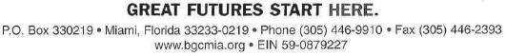

32

Page 2

Essentials learning Zone, where we will provide free trainings on best practices for utilizing technology.

In 2012, we had the privilege of participating in Comcast Cares Day in which Comcast employees turned out en masse to volunteer their time to help assist in refurbishing our local centers. Comcast employees also participated in outreach programs to help our kids. It was an incredible day that sent an inspiring message to our youth about responsibility and giving back. I firmly believe that Comcast offers hope, education and opportunity, which in turn helps organizations like ours grow and prosper.

I urge you to approve the proposed transaction between Comcast and Time Warner Cable, as it has the power to bring technology and positive change to many more communities across the nation.

Sincerely,

/s/ Alex Rodriguez-Roig

Alex Rodriguez-Roig

33

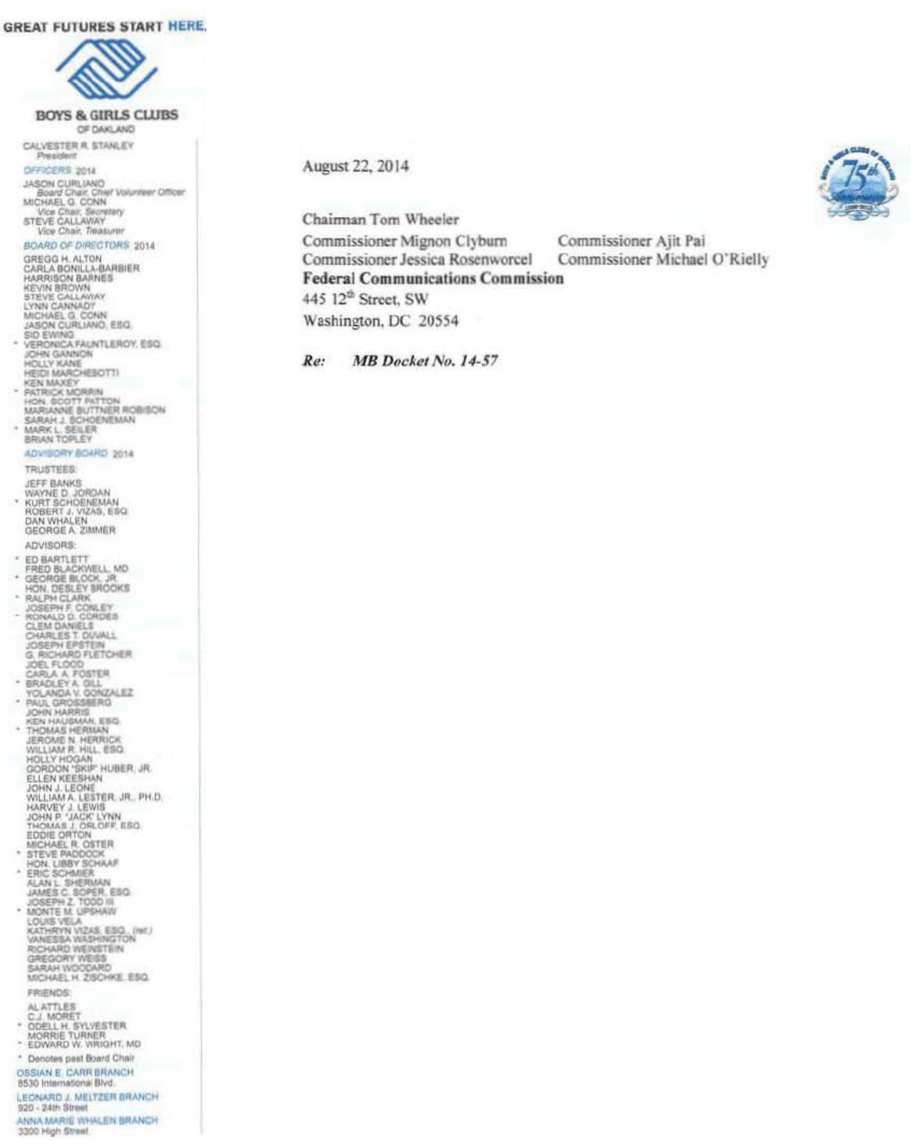

Dear Chairman and Commissioners:

Thank you for accepting my comments which follow below and are made in suppont of Comcast Corporation and Time Wamer Cable. Please forward them to the individuals who will ultimately recommend approval of the transaction.

I have served as President of Boys & Girls Clubs of Oakland (BGCO) since 1992, and I have had the opponunity to work closely with Comcast on technology education and digital skills for deserving children and teens for many years. In today's economy, a young woman or young man who lacks Internet competence simply cannot compete. Comcast has been at the forefront, lending with viable solutions to this issue for years.

I am sure many Americans have written to you to praise the company's Internet Essentials program which has connected over 350,000 American families to the Internet. In California, the program has already served more than 11% of eligible families (those with children eligible for the federal school lunch program). BGCO has helped many of these families to enroll and take advantage of home Internet access for the first time in their lives.

Comcast's commitment to broadening high speed access to the Internet goes well beyond Internet Essentials. Earlier this year, we honored 20 young men and young women who successfully completed the Comcast Digital Connectors Program. This breakthrough effort certifies teenagers as lnternet educators—they learn digital life skills and then put those skills to use teaching senior citizens how to use the Internet themselves, a powerful two-fer which, in turn, gives youth a powerful leg up and helps seniors live richer more connected lives. Thanks to Comcast's support, each successful digital connector receives a netbook laptop computer and a digital video camera upon completion of the curriculum. All told, the Digital Connectors program will graduate 126 students across Northern California this year.

Further, the company leads by example: I'm told that people of color hold a quarter of its management positions, and that forty percent are women.

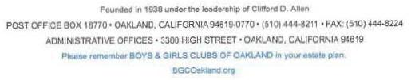

34

In contracting, over $1.25 billion a year is spent doing business with diversity suppliers. These are powerful commitments to true meaningful equality, and to economic opportunity.

Finally, young people in particular are concerned about “Net Neutrality” and ensuring that the Internet remains Open to all users; points of view; and communities. l have seen reports that Comcast is the only Internet Service Provider that is still bound to the FCC's Open Internet rules, and that the expansion into Time Warner Cable cities will bring Net Neutrality to those communities.

l support the expansion of these groundbreaking efforts and pro-diversity policies to new areas via the Comcast Time Warner Cable agreement.

Sincerely,

Boys & Girls Clubs of Oakland

/s/ Calvester R. Stanley

Calvester R. Stanley

President

CRS/cs

35

August 25, 2014
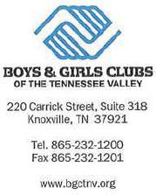

Tom Wheeler

Chairman

Federal Communications Commission
445 12th Street, SW
Washington, DC 20554

RE: MB Docket No. 14-57

Dear Chairman Wheeler:

I write to express my support for the proposed merger between Comcast and Time Warner Cable. As the President and CEO of the Boys & Girls Clubs of the Tennessee Valley ("BGCTNV"), I have seen first-hand Comcast's unparalleled commitment to its communities, and it has been a crucial partner in helping BGCTNV to serve more than 6,300 at-risk boys and girls in the Tennessee Valley.

Comcast has assisted BGCTNV in reaching potential Club members and educating the public about what we do by running a tremendous number of public service announcements over the air. For five years running, Comcast has supported BGCTNV's Club Tech program enabling approximately 300 Club members daily to improve their skills in math, science, and other academic subjects using educational software and to develop the technology skills necessary to succeed in school and the job market. Comcast has also welcomed BGCTNV as a valued partner in its Internet Essentials initiative to connect low-income children to the Internet-a mission critical to our Club who believes that all of our members, no matter their economic circumstances, deserve access to the best technology available to position themselves for academic success and a lifetime of opportunities.

Comcast has also chosen one of BGCTNV's Clubs in each of the last five years as a beneficiary of Comcast Cares Day-local Comcast employees have volunteered to pitch in and get their hands dirty by cleaning and beautifying these Clubs, supporting our goal of providing our members a safe and caring environment in which to learn and grow.

In short, BGCTNV's extensive partnership with Comcast has enabled us to have a real, positive effect on the academic, vocational, and character development of over six thousand children each year. I encourage you to approve the Comcast and Time Warner Cable transaction, so that Comcast can make the same impact in additional communities throughout the country.

Sincerely,

/s/Lisa Hurst

Lisa Hurst

President & CEO, Boys & Girls Clubs of the Tennessee Valley

36

[p40]

August 25, 2014

Tom Wheeler

Chairman

Federal Communications Commission
445 12th Street, SW
Washington, DC 20554

RE: MB Docket No. 14-57

Dear Chairman Wheeler:

Please accept this correspondence in support of the proposed Comcast and Time Warner Cable transaction. As executive director of the Bucks County Community College (BCCC) Foundation in Pennsylvania, our experience with Comcast has been multifold but most notable are its broadband and video services which have been a game-changer in higher education. The growth in interest for BCCC’s online education programs has been possible thanks to comprehensive and high-speed broadband service from Comcast. We host 250 eLearning and Hybrid courses taught by the same professors who teach face-to-face classes. The BCCC virtual learning experience offers 16 programs of study and two certificates that can all be completed online. Comcast Internet speeds have increased yearly, allowing our students to access course work, interact with their professors and fellow students, and complete quizzes and tests at an amazingly swift pace from any remote site. This option, to obtain credits and certifications online, has been essential for students who juggle jobs along with their studies, as well as working adults whose schedules may not permit time to drive to and from campuses to fulfill professional education requirements.

In respect to its charitable and community work, I’ve been made aware that Comcast has donated to more than 1,000 nonprofits across the U.S. At BCCC, Comcast employees have served on our board of directors, volunteered their time and donated thousands of dollars to our events and fund-raising activities. The company routinely sponsors our community breakfasts during which we highlight staff and faculty achievements. Comcast also supports our cause through publicity, hosting our faculty on talk shows, and giving myself and others at BCCC a public forum through Comcast Newsmakers broadcasts. These widely-seen videos are a perfect opportunity to share college news and academic insight and expertise to a wide audience. Also, students who have an interest in broadcasting have been able to tape segments and have them air weekly on TV and the Internet, thanks to Comcast.

High school seniors who work hard can earn a Comcast scholarship to attend BCCC and other community and four-year colleges. According to the most recent numbers, Comcast has helped about 20,000 students seeking higher education. And Comcast has a strong hand in making sure that secondary students who want to find scholarships and apply to colleges using the Internet

37

can do so even if their families can’t afford a computer and a digital connection. Comcast’s Internet Essentials gets these families Internet service for a low monthly rate and a computer for about $150. The company also offers the digital training they need to make the most of these new resources. Tens of thousands of Pennsylvania families are already taking advantage of this service.

Comcast has consistently been a strong partner to educational institutions, like BCCC. Its products are cutting edge and lend a distinct digital advantage to users. The company’s commitment to the less fortunate is evident in every community it serves. I hope the Commission will consider the potential for furthering this kind of community engagement and support by approving the transaction.

Best Regards,

/s/Tobias Bruhn

Tobias Bruhn, CFRE

Executive Director

38



August 25, 2014

Tom Wheeler

Chairman

Federal Communications Commission
445 12th Street, SW
Washington, DC 20554

RE: MB Docket No. 14-57

Dear Chairman Wheeler:

On behalf of the Business and Industry Association of New Hampshire (BIA), I write this letter in support of the proposed transaction between Comcast and Time Warner Cable. The BIA is New Hampshire’s statewide chamber of commerce and leading business advocate. We represent over 400 leading businesses in a variety of industries, with over 86,000 employees across the Granite State. I can personally attest to Comcast’s status as an important member of New Hampshire’s business community and its economy.

Comcast is committed to creating and supporting good job opportunities in New Hampshire. The company employs over 1,700 full-time workers across the state, spends over $125 million in payroll and close to $15 million annually in health-care benefits. Comcast generates over $26 million annually in state and local tax revenue. It also owns and operates 39 properties in New Hampshire. Most recently, Comcast announced plans to open a 127,000 square foot, 600- representative-strong state-of-the-art customer support center in Hudson, New Hampshire. This new facility will create strong economic growth for New Hampshire, and represents Comcast’s continued commitment to investing in tools and technologies that will help drive New Hampshire’s economy going forward.

Beyond Comcast’s support of good employment positions in New Hampshire, the company has also been an important corporate partner to the BIA. Comcast frequently features our members and partners on Comcast Newsmakers, at the company’s own expense, to let the public know what we are doing to stimulate economic growth and attract new businesses to New Hampshire.

Perhaps one of the biggest reasons that BIA supports the proposed transaction with Time Warner Cable is that it will create competition and encourage investment in innovation. If Comcast were to join resources with Time Warner Cable, it will be a stronger competitor for all sizes of businesses. By offering higher-quality products and services at more affordable prices, Comcast will motivate other telecommunications companies to invest more in their own technology and develop innovative services in order to keep up. The result of this free-market process will be a larger variety of affordable and innovative products and services for our consumers and businesses to choose from, which will increase efficiency and foster economic growth.

The FCC should approve the proposed transaction, and let Comcast drive free-market competition.

Best regards,

/s/ Jim Roche

Jim Roche

President

39



August 25, 2014

Tom Wheeler

Chairman

Federal Communications Commission

445 12th Street, SW

Washington, DC 20554

RE: MB Docket No. 14-57

Dear Chairman Wheeler:

On behalf of the California Hispanic Chamber of Commerce, I would like to express our support for the merger between Time Warner Cable and Comcast. We are currently located in a Time Warner Cable region, and we are interested in the benefits that this merger could have for our members.

Our organization was founded in 1978 out of a need for representation of the growing Hispanic business presence in our state. Currently, we represent over 700,000 Hispanic business owners in California and our stated mission is "advocacy, empowerment, and education for California's Hispanic businesses."

If this merger is successful, we predict it will offer many advantages for our members. The entry of Comcast's business offerings into more markets where our members operate will create new competition for telecom services. As a result, our members will have more choices of providers for high-end services, and our larger business members with locations in both the northern and southern parts of the state will be able to better integrate their operations, thus increasing efficiency and lowering operating costs. We also understand that Comcast has undertaken great efforts to increase its dealing with minority-owned vendors. As you can imagine, this is welcome news for thousands of California businesses that have not had an opportunity to work with Comcast within its existing service areas.

Our goal is to make sure our members have access to an improving and hospitable climate for business. We believe this merger creates just that, and we support it.

Sincerely,

/s/ Alice Perez

Alice Perez

President/CEO

California Hispanic Chambers of Commerce

1510 J Street, Suite 110, Sacramento, California 95814 | Tel. 800.299.6033 | Fax. 916.669.2870 | www.cahcc.com

40

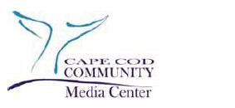

Tom Wheeler

Chairman

Federal Communications Commission

445 12th Street, SW

Washington, DC 20554

RE: MB Docket No. 14-57

Dear Chairman Wheeler:

On behalf of the Cape Cod Community Media Center, I am writing to share my experience working with Comcast and to express my support for the Comcast-Time Warner Cable transaction.

The Cape Cod Community Media Center is a public access cable television resource center that serves as a community communication vehicle for thousands of individuals, groups, and organizations on Cape Cod. For decades I have worked with Comcast to amplify the voice of our programming to reach the broader Cape Cod community. As a result of our partnership, the Media Center received the Overall Excellence Award for community programming and was chosen the top Access Center in the country by the Alliance for Community Media.

Often times large companies' community investment can be seen as half-hearted “window dressing”. That is absolutely not the case with Comcast. Comcast is a true and genuine community leader. Beyond our partnership, Comcast has shown it is dedicated to bettering our community. We have worked on a number of projects collaboratively such as serving the homeless community by providing assistance for over twelve years of the NOAH Shelter Telethons and numerous March of Dimes, Rotary Auctions and major community events..

Comcast is a valued community partner and is always willing to work on a local level for positive community benefit. For these reasons, I hope that you promptly approve the proposed transaction.

Sincerely,

/s/ Terry Duenas

Terry Duenas

Executive Director

Cape Cod Community Media Center

Dennisport, MA

tduenas@capemedia.org

41

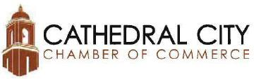

Tom Wheeler, Chairman

Federal Communications Commission
445 12th Street, SW
Washington, DC 20554

RE: MB Docket No. 14-57

Dear Chairman Wheeler:

As the president of the Cathedral City Chamber of Commerce, I write to express our support for the proposed merger between Comcast and Time Warner Cable.

Since 1937, the Chamber has served our area's business community. Our organization provides leadership and direction for the community, serving as a source of information and advocacy in the progress of economic development. We work to expand economic opportunities for business owners, residents, and even visitors by sharing the many attributes of the community and enhancing the quality of life for all citizens. We work in partnership with federal, state, and local government ensuring that our members are fairly represented.

Our goal is to build the economy into a stable environment for our businesses and our citizens. However, this is still very much a work in progress. Many of our citizens are low income, and our unemployment rate is around 10%. It is our belief that Comcast could help to boost our efforts to get our city back on solid ground.

The entrance of Comcast into Cathedral City could make our area a more attractive area for new ventures to set up shop. Beyond their business class services, Comcast also has a variety of community-based programs that would benefit our citizens. Their Internet Essentials program not only offers affordable internet to low-income families; it also provides discounted computers and free digital literacy training. Our citizens will be able to search for new jobs and they will have the necessary skills to acquire a quality job. Comcast also has many after school programs that integrate digital literacy and technology training into our education system, so that our students leave school prepared for a career. Comcast's entrance into our City would not only benefit our businesses but also improve life for everyone in the community.

Comcast will not solve all of our problems, but together Comcast and our community could work together to build our economy into a more healthy environment for everyone. I ask that you please consider our city and how this merger could benefit us.

Sincerely,

/s/ Lynn T. Mallotto

Lynn T. Mallotto

CEO & President
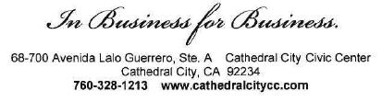

42

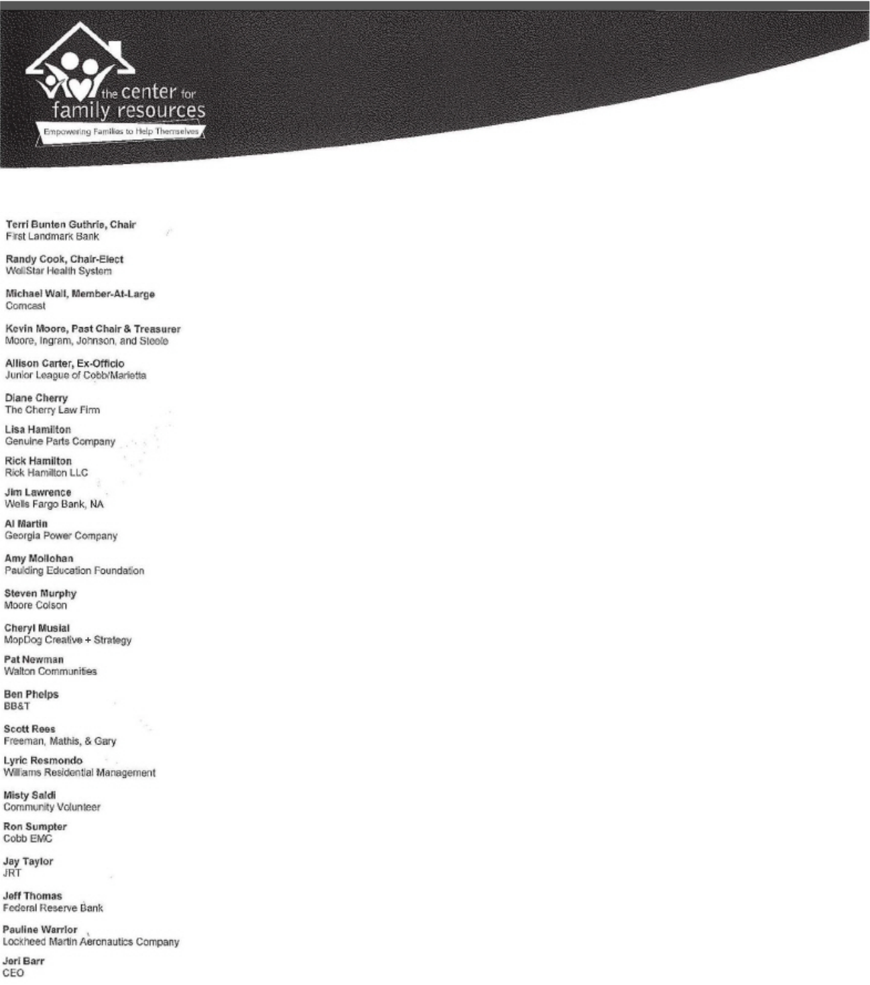

August 12, 2014

Tom Wheeler

Chairman

Federal Communications Commission

445 12th Street, SW

Washington, DC 20554

RE: MB Docket No. 14-57

Dear Chairman Wheeler:

My name is Jeri Barr and I have served as the CEO of The Center for Family Resources (CFR), a comprehensive human service organization, in Marietta, Georgia, since 1984. Our motto, "Empowering Families to Help Themselves", is exemplified by the Comcast Corporation, which is one of our key supporters and community partners.

I believe that the FCC should approve the proposed transaction between Comcast and Time Warner Cable.

Here at The Center for Family Resources, our clients need basic necessities, such as food, shelter and heat, to stabilize their families, but they also need tools to feel empowered and secure their futures. The Internet is a vital instrument for change and growth that is linking Georgia's most vulnerable to jobs, education and health care.

I can tell you firsthand that Comcast is making a difference for our schools and schoolchildren in Marietta. In fact, Marietta Middle School and Marietta High School were among the 156 focus schools to receive Internet Essentials, a comprehensive broadband adoption program spearheaded by Comcast.

The Center for Family Resources supported these efforts, and is encouraging the families we serve to embrace Internet Essentials and its provision of home-based broadband at a deeply reduced cost. Comcast is actively spreading the word in our community too. The company sent representatives to speak to students and their parents about Internet Essentials when my local Kiwanis Club sponsored a Technology Lab at the Marietta High School and Comcast was also there last October when the CFR was educating and registering low-income families for its Thanks for Giving food drive.

995 Roswell Street NE

Suite 100

Marietta, GA 30060

tel: 770.428.2601

fax: 770.423.2234

www.TheCFR.org

43

In Georgia, I understand that more than 21,000 families have benefitted and nearly 12 percent of all eligible households in the state are participating. Given that Internet Essentials is a relatively new program, these promising numbers suggest that the digital divide will continue to narrow. Comcast has also recently announced that it is extending the program indefinitely, and has committed to extending it to any newly acquired areas which include communities like mine which is partially served by Charter Communications.

We stand behind initiatives like Internet Essentials and we are proud to call Comcast our longtime partner. The company leads by example, and is one of our valued supporters. Michael Wall, a Comcast employee, is a current board member who lends governance and expertise but he also is a dedicated volunteer and loves to give back to his community through CFR.

I feel confident that if Comcast and Time Warner Cable's proposed transaction is approved, more impactful collaborations, including innovative programming and services, will be the direct result. The FCC should move forward to approve the great opportunity before it.

Sincerely,

/s/ Jeri Barr

Jeri Barr

Chief Executive Officer

JB/vw

44



August 22, 2014

Chairman Tom Wheeler

Commissioner Mignon Clyburn

Commissioner Jessica Rosenworcel

Commissioner Ajit Pai

Commissioner Michael O'Rielly

Federal Communications Commission

445 12th Street, SW

Washington, DC 20554

RE: MB Docket No. 14-57

Dear Chairman and Commissioners:

As Executive Director of Center for Multicultural Cooperation (CMC), I am writing in support of the Comcast and Time Warner transaction. Comcast is one of the most outstanding corporate citizens in my community of Fresno and Sacramento and I believe its request deserves your approval.

Center for Multicultural Cooperation was founded to educate, engage and empower underserved and underprivileged youth with multimedia and digital skills to succeed. Comcast is a primary supporter of our successful multimedia programs, which each year provides young people with digital learnings and leadership training. We have graduated hundreds of future young leaders from our programs in Fresno and Sacramento since our founding, and the leadership of sponsors such as Comcast has helped us achieve this goal. With the support of Comcast's Internet Essential program, we are also connecting our youth, their families and low-income communities to the internet and digital literacy trainings.

We are a proud partner of Comcast and know first-hand their commitment to our youth and communities. It's for these reasons that we write to ask you to support the Comcast and Time Wamer transaction.

I thank you for the opportunity to share my thoughts on this matter, and I encourage you to approve Comcast's request.

Sincerely,

/s/Maria Madril

Maria Madril

Executive Director

Center for Multicultural Cooperation

45



August 25, 2014

Tom Wheeler

Chairman

Federal Communications Commission

445 12th Street, SW

Washington, DC 20554

RE: MB Docket No. 14-57

Dear Chairman Wheeler:

I am the Chief Executive Officer and Head Start Director of Centro de la Familia de Utah and have had substantial experience in offering the Head Start program to minority children in Utah. I am writing to request that the proposed Comcast and Time Warner Cable transaction be approved. The transaction offers more communities the opportunity to benefit from the economic and community partnerships we have forged with Comcast.

Comcast provides several valuable services to the Hispanic community such as programming provided by minority-owned networks, several Spanish language channels including the BabyFirst Americas network, which is well-known for educational shows that target young children and their parents to ease the transition to English fluency. Comcast is committed to employing minorities at all of its locations in Utah, and strives to be an inclusive employer nationwide.

The company's Internet Essentials program offers minority children and families in need the opportunity to learn and develop through internet access. This program is available to qualified households that include children eligible for government subsidized school meals. As of last year, more than 6,000 families in Utah had signed up for Internet Essentials. For about $10 a month, with no other fees, they get access to the Internet. They can also buy a computer for a low price, and the company includes free computer and Internet training for the children, parents and others in the home.

We have also been pleased to partner with Comcast in the implementation of the company's Digital Connectors program, which provides high potential students with digital literacy training and encourages them to share their knowledge with the community.

I think you will find that this request is well substantiated by the contributions Comcast makes in our region. I hope the matter of the proposed Comcast Time Warner transaction will receive your full support.

Yours truly,

/s/ Gonzalo Palza

Gonzalo Palza

CEO & Head Start Director

525 South 300 West, Salt Lake City, UT 84101 Phone (801) 521-4473 Fax (801) 521-6242

www.cdlfu.org

46

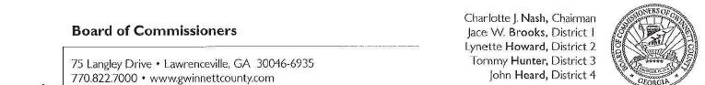

August 22, 2014


Via electronic filing

Chairman Tom Wheeler

Commissioner Mignon Clyburn

Commissioner Jessica Rosenworcel

Commissioner Ajit Pai

Commissioner Michael O'Rielly

Federal Communications Commission
445 12th Street, SW
Washington, DC 20554

RE: MB Docket No. 14-57

Dear Chairman and Commissioners:

As the Commission considers the public interest regarding the proposed merger between Comcast and Time Warner Cable, I ask that the Commission consider this letter in support of the proposed merger. As Chairman of the Gwinnett County Board of Commissioners, I offer my support of the proposed merger based on my experience with Comcast in our community as a driver of economic growth and as an active corporate citizen.

One of my objectives, as Chairman of the Gwinnett County Board of Commissioners, is to attract investment in the County which will fuel job creation and economic growth. In support of this objective, Comcast has made significant infrastructure investments to ensure that Gwinnett businesses have the connectivity they need to compete in a worldwide marketplace and that our residents have access to state of the art broadband services in their homes. This technology infrastructure is a critical element of the County's economic development strategy. Comcast has also strengthened our economy by partnering with Gwinnett-based and Georgia-based businesses. As an example, Comcast purchases modems and other broadband equipment from ARRIS, a technology company based in Suwanee, Georgia within Gwinnett County, to support the enhancement of Comcast's high speed network. As far as Comcast's overall investment in Georgia, my understanding is that Comcast spent more than $700 million in Georgia last year. Comcast's investment in infrastructure and partnerships with our local businesses helps support job creation and economic growth with Gwinnett County and Georgia.

As an active corporate citizen in Gwinnett County, Comcast has partnered with both Gwinnett County and the Gwinnett County School District to ensure that our workforce has the digital literacy skills to support a technology based economy. With more than thirteen percent of our county's residents below the poverty rate, we have a number of students whose families cannot afford to have a computer or pay for internet service. The School District works with Comcast to share information on the company's Internet Essentials program, which supplies an Internet connection and a computer at a very low cost to low-income families. In support of this partnership, Gwinnett County compliments this technology access for low-income families with free basic and intermediate computer classes at the County's libraries and human services centers.

47

Comcast's role as an active corporate citizen in Gwinnett County does not end with helping low-income families obtain access to technology. Comcast is also committed to volunteerism in Gwinnett and its communities. This past April, I was proud to join a group of fifty Comcast employees, family members and other volunteers at the Rainbow Village in Gwinnett County. The efforts of these volunteers at the Rainbow Village to landscape the grounds helped create a more positive environment for Gwinnett residents experiencing difficult times and needing the services this transitional housing facility for homeless families.

Comcast has brought needed digital services to business and school children that help Gwinnett keep pace with other regions. I look forward to the company expanding its footprint in Gwinnett and anticipate similar positive impacts in other markets where Comcast is able to offer its broadband and video products. In making your decision on this merger and the public interest, I hope that the Commission will consider this letter of support and the positive impact that Comcast has made and will continue to make in Gwinnett County and other regions.

Sincerely,

/s/ Charlotte J. Nash

Charlotte J. Nash, Chairman

Gwinnett County Board of Commissioners

- Glenn P. Stephens, County Administrator

48

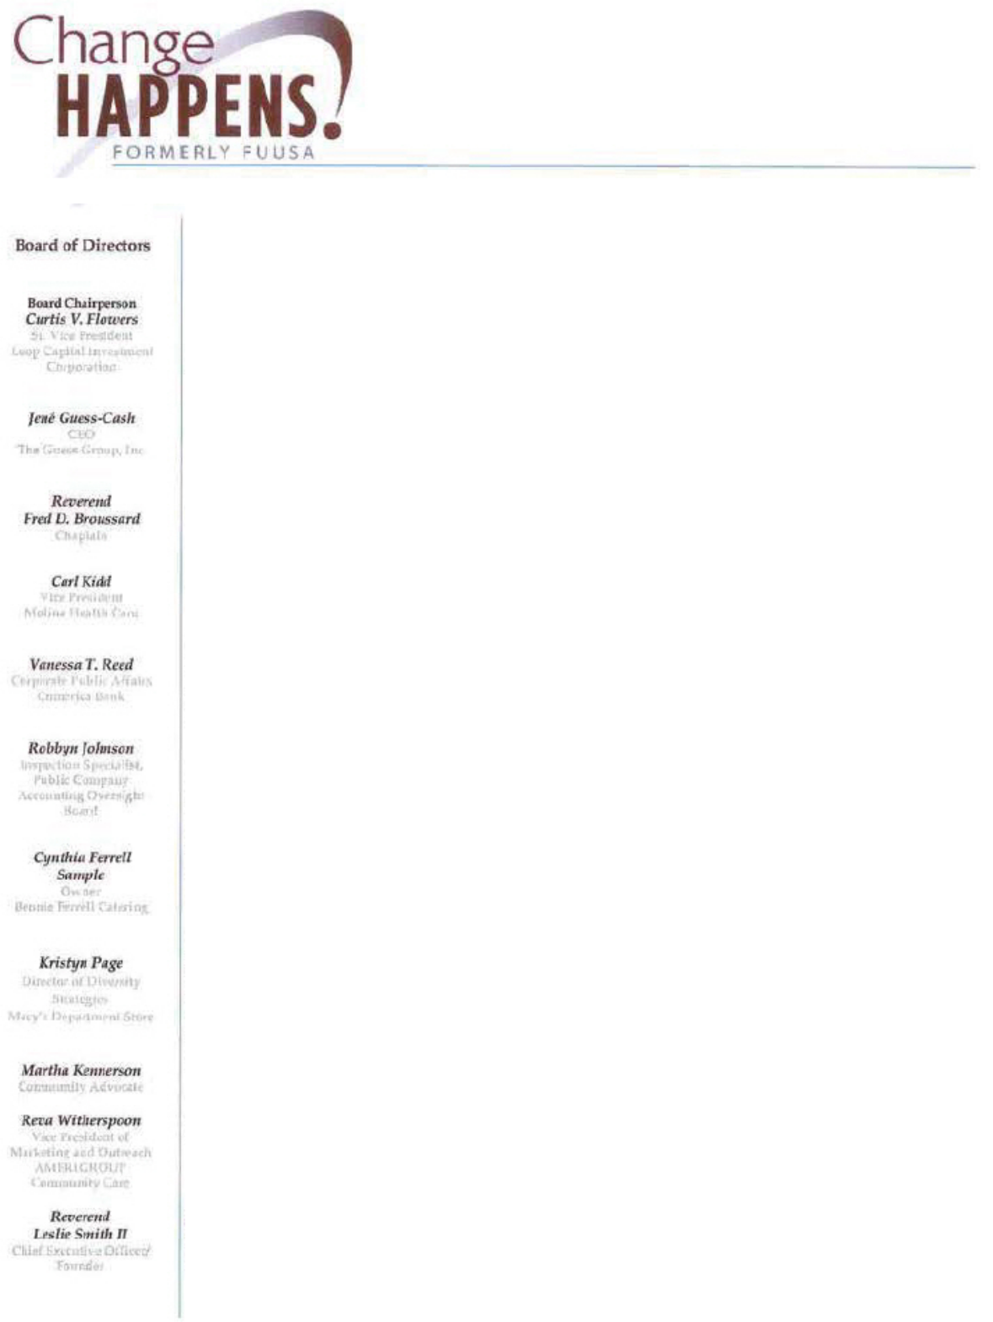

August 25, 2014

Chairman Tom Wheeler

Cornmissioner Jessica Rosenworcel

Commissioner Ajit Pai

Commissioner Michael O'Rielly

Federal Communications Commission

445 12th Street, SW

Washington, DC 20554

RE: MB Docket No. 14-57

Dear Chairman and Commissioners:

After ten years working in the corporate world, I made the decision to transition into community service, satisfying my dream of providing help to people in need. For the past 25 years I have been dedicated to finding the most effective ways to reach and help those people through Change Happens!. Change Happens! (formerly Families Under Urban & Social Attack) is a non-profit community-based organization in Houston, Texas that provides a variety of programs and services aimed at empowering adults and at risk youths to help themselves when faced with challenges.

Our entire organization is founded on the belief that given the right information and opportunities, people in need will be able to help themselves with the challenges they encounter. The first essential step though is being able to access this information and these opportunities, which is where Comcast comes in and why l believe the transaction between Comcast and Time Warner Cable will be beneficial.

Comcast has provided the families of the city of Houston and the state of Texas at large with a variety of useful services. Comcast's Internet Essentials program, which offers affordable broadband service, bas allowed low-income families in need to access information necessary to better their lives. Comcast bas said that it will expand the Internet Essentials program to new areas acquired in the transaction with Time Warner Cable, thus helping more families in need. Further, Comcast's has shown a dedication to diversity and inclusion in its hiring practices that sets a positive example for other companies and our communities.

Since its beginning in 1989, our organization has grown from providing one program to eighteen programs, including HIV Prevention, homeless supportive services, risky behavior (such as drug and alcohol abuse) and teen pregnancy prevention programs, workforce development programs and after school programs. These are issues that face people everywhere across the United States, and the solution is information. The power of information, well communicated and far reaching is undeniable. The services provided by Comcast allow us and other community-based organizations like us to share information with the people who need it the most.

Combining these two companies will allow even more people across the United States to benefit the way that our community has, including Houston's sister-city Dallas (currently serviced by Time Warner Cable). I hope the FCC will act in favor of the transaction.

/s/ Rev. Leslie Smith

Rev. Leslie Smith

CEO & Founder

49



August 14, 2014

To whom it may concern:

I am Chairman of the Chicago City Council Latino Caucus, as well as a Chicago City alderman since 2003. I have spent my career serving families and children, including working as the executive director for the YMCA of Metropolitan Chicago as well as executive director for the Boys and Girls Clubs of Chicago. In my roles I have had multiple interactions with Comcast and I have found the company to be a stalwart supporter of Chicago area organizations and initiatives and the missions we serve.

The proposed transaction between Comcast and Time Warner Cable promises to extend Comcast’s service-minded philosophy to more communities, and for that reason, I respectfully request that the Commission approve the proposed transaction.

Allow me to elaborate on the kinds of activities I have personally witnessed Comcast taking part in, here in Chicago.

Last year, Comcast lent the city one of its own top professionals to work on our Plan for Economic Growth and Jobs. Christopher Nelson, Comcast’s manager of government and regulatory affairs for the Greater Chicago Region, worked for us fulltime as part of our new Fellows program, whereby companies in the area lent us professionals with economic expertise for as long as six months.

As Chairman of the Latino Caucus, I am in regular contact with our Hispanic entrepreneurs and business owners. Comcast devotes a significant portion of its budget on contracts with Hispanic suppliers. And its offerings in Hispanic programming are extensive. Comcast has more than 60 Spanish language networks and offers Xfinity Latino, which carries all the popular Hispanic channels. As far as entertainment goes, you can’t do much better than Hispanic Video on Demand, with films, TV, music and children’s programming. In fact, Comcast’s programming for children in Hispanic communities is very popular with families.

50

I have devoted myself to improving opportunities for our children and here is where Comcast really shines. Its employees spend hours mentoring high school students. During my time at the Boys and Girls Club, Comcast stepped up with donations of computers, software and digital skills training, and its staff served on the organization’s board, among other contributions. And Comcast worked hard to get the word out a few years ago, when it started the Internet Essentials program for low-income families. In fact, last fall, more families in the Chicago area had enrolled in Internet Essentials than any other city in the nation. That means that more of our children now have computers and Internet in their homes. They are better connected to their schools and teachers, and their parents are able to get online and follow their children’s progress as well as apply for jobs.

Comcast has also been a generous sponsor of many of the City’s community events and cultural celebrations and programs. This summer, Comcast was a sponsor for the Rahm’s Readers Summer Learning Challenge at Chicago Public Library’s Douglass Branch, in which children are trying to set records for the number of books read and time spent reading. Comcast is a backer of the Milwaukee Avenue Arts Festival in Logan Square, which is located in the ward I represent.

This kind of collaboration between community and corporate citizens is a model for all regions. I know that wherever Comcast services are offered, there too are benefits for children, families, schools and businesses. My hope is that more communities have the opportunity to experience what we here in Chicago have experienced. I anticipate and welcome the Commission’s support of the proposed transaction.

Sincerely,

/s/ Rey Colon

Chairman Rey Colon

Alderman, 35th Ward

51

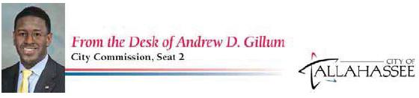

August 21, 2014

Tom Wheeler, Chairman

Federal Communications Commission

445 12th Street, SW

Washington, DC 20554

Re: MB Docket No. 14-57

Dear Chairman Wheeler:

As a representative of the people of Tallahassee, Florida, and a native Floridian whose investment in the growth and advancement of our state is deep and wide-reaching, I am writing to express my support for the proposed Comcast and Time Warner Cable transaction.

Comcast is a strong corporate citizen that currently serves Tallahassee and is invested in the health and welfare of many other Florida communities. The company’s dedication to key infrastructure investments is ensuring an equitable, technology-ready future for the people of my community and our state. Comcast and NBCUniversal spent more than $2.6 billion in our state last year and employed about 17,000 of our residents. I believe the proposed transaction will build on this investment, helping cities like Tallahassee better compete in a global, tech-driven economy.

Comcast and NBCUniversal are true community partners supporting sustainability projects, student scholarships, training, volunteer hours, and other programs. The company's Spanish-speaking Telemundo network is headquartered in our state. The NBCUniversal-Comcast merger allowed a deepening of Comcast’s across-the-board commitment to diverse, accessible programming. The multilingual, multicultural population of our city and state stands to benefit. The proposed transaction will open this opportunity to other diverse areas and populations.

Additionally, Comcast is committed to ensuring that our students have the equipment and access necessary to succeed in the information age. The company’s efforts – including instrumental support for Tallahassee’s Digital Harmony Initiative – have not gone unnoticed in our city. With its support, we have provided 200-plus desktop computers and modems to the families of incoming sixth graders at Nims Middle School. And through the Internet Essentials program, many other underserved members of our community are able to access low-cost, high-speed Internet services, digital literacy training, and ongoing support and outreach to close the digital divide.

The FCC should expeditiously approve Comcast’s transaction proposal, which I believe will benefit more communities across Florida and elsewhere.

Sincerely,

/s/ Andrew D. Gillum

Andrew D. Gillum

City Commissioner, Seat 2
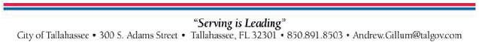

52

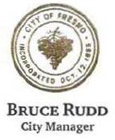

August 25. 2014

Chairman Tom Wheeler

Commissioner Mignon Clyburn

Commissioner Jessica Rosenworcel

Commissioner Ajit Pai

Commissioner Michael O'Rielly

Federal Communications Commission

445 12th Street, SW

Washington, D.C. 20554

Re: MB Docket No. 14-57

Dear Chairman Wheeler and Commissioners:

I write to share my thoughts and perspective on the pending merger between Time Warner Cable and Comcast. I am the City Manager of Fresno, California, which Is the 5"' largest city in California. Comcast has been a valuable community partner who has contributed to and invested in our City.

Improving critical infrastructure is one of the highest priorities of our city. The proposed merger is particularly interesting to me because Comcast has pledged to invest millions of dollars to improve existing broadband networks in the areas it acquires. Fortunately, we are a Comcast service area and the City of Fresno has been well-served by the quality of Comcast's broadband network. Our residents have access to some of the state's fastest speeds – most homes can reach 150 Mbps to 505 Mbps. Our businesses have the ability to purchase services ranging from 1-10 Gbps, giving us a leg up on other cities in the region in terms of attracting and retaining businesses.

Over the years, we have enjoyed a positive working relationship with Comcast. They have been a partner in expanding its broadband footprint in downtown Fresno, where we are in the midst of implementing a comprehensive revitalization plan. In addition, Comcast's Internet Essentials program has enhanced our locally generated content through the “Project Open Voice” public access pilot program. Expanded broadband adoption and increased digital literacy in our workforce will bolster the overall economy. A technology-educated workforce is critical as we compete to attract and retain innovative new businesses to our city. It also gives us the opportunity to retain more of our young talent from our local universities, including California State University Fresno. Earlier this, CSU Fresno's present, Joseph Castro announced a tablet program for university professors and students. Our local school districts have also begun tablet programs. Without the Comcast network, these tablet programs would not be possible.

City Manager's Office • City of Fresno

2600 Fresno Sueet • Fresno, California 93721-3601

- 621-7784 • FAX (559) 621·7776 • Bruce.Rudd@fresno.gov

53

Federal Communications Commission

August 25, 2014

Page 2

Comcast has established itself as an industry leader and wonderful community partner who invests in its local communities. Joining forces with Time Wamer Cable will only enhance this effort and I support the proposed merger that the Commission has before it.

Sincerely,

/s/ Bruce Rudd

Bruce Rudd

City Manager

54



August 25, 2014

Tom Wheeler

Chairman

Federal Communications Commission

445 12th Street, SW

Washington, DC 20554

RE: MB Docket No. 14-57

Dear Chairman Wheeler:

The board, staff and parents of Clayton Early Learning have had the privilege of partnering with Comcast over the last three years for the benefit of the children and families we serve. For more than a century, Clayton Early Learning has provided a better start for vulnerable children in our community. Today, we serve as a vibrant place of learning for children ages 0-5 striving to ensure all children receive the highest quality early childhood experience and are well prepared to start kindergarten ready. The support of Comcast has been invaluable in helping Clayton Early Learning carry out our mission every day to help all children reach their full potential.

We began building our partnership with Comcast in 2012 as Clayton Early Learning was selected as one of the beneficiary sites for Comcast Cares Day. Since then, we have been fortunate to have Comcast return for Comcast Cares Day in 2013 and 2014. Over these last three Comcast days of service, Comcast has brought the people-power of over 1,000 of its employees to our historic campus and worked side-by-side with us to improve and beautify our campus in ways that we would never have been able to do on our own.

Some of the amazing projects the Comcast volunteers have enthusiastically and energetically completed at Clayton Early Learning include the building of two large-scale gardens on our campus that serve as outdoor classrooms and discovery areas for our students. This provides the opportunity for the children in our programs to grow fresh fruits and vegetables and learn about healthy eating and nutrition. Clayton is in a food desert, which makes it even more imperative for our children and their families to have access to fresh food that provides a sustainable and life-long benefit.

The ongoing support of Comcast continued these past few years as Comcast sponsored our annual Moonbeam Harvest event in September. Moonbeam Harvest is a one-of-a-kind evening where the who's who of Denver's top chefs come together to prepare amazingly creative food utilizing the fresh produce grown in the Clayton gardens built by Comcast. Over 700 guests including corporate leaders,


55

government officials, educators and foodies attended to support quality early childhood education for those who need it most.

Clayton Early Learning was also extremely fortunate to have Sarah Gustashaw, Regional Vice President of Finance for Comcast Cable, join our board of trustees in 2013. Sarah's expertise and wisdom has significantly increased the depth of knowledge and breadth of experience that has been a valuable addition to the board. We truly appreciate Sarah's time and dedication.

We also value opportunities to work with Comcast to help the families we serve learn about the Internet Essentials program, which enables low-income families to afford computers and Internet service in their own homes. This program is a great help in empowering families to connect with a variety of resources that will help their children thrive and succeed.

Quality early education changes lives, and we look forward to making a lasting impact alongside the Comcast family that continues well into the future. On behalf of the children and families we serve, we are pleased to express our appreciation for Comcast's partnership and commitment, and we believe the Comcast-Time Warner Cable transaction deserves consideration, as it would enable more communities and more families to benefit from the company's focus on investing in communities. By helping to ensure that all children are prepared for success in school through highly effective early childhood education, Clayton and our partners are investing in the strength of our whole community, and we wish the same opportunities for others who strive to help families succeed as well.

Sincerely,

/s/ Charlotte M. Brantley

Charlotte M. Brantley

President and CEO

/s/ Michael Niyompong

Michael Niyompong

Chief Operating Officer

56

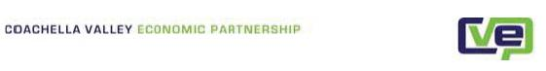
August 22, 2014

Tom Wheeler

Chairman

Federal Communications Commission
445 12th Street, SW
Washington, DC 20554

RE: MB Docket No. 14-57

Dear Chairman Wheeler:

As the President and CEO of the Coachella Valley Economic Partnership (CVEP), I write to support of the merger between Comcast and Time Warner.

CVEP is a regional economic development organization devoted to attracting, retaining, and expanding business while improving the quality of the workforce. It is our hope that if Comcast enters the Coachella Valley our businesses will benefit. Comcast has indicated its intent to upgrade existing networks here to deliver faster Internet speeds, including enterprise services that can reach up to 10 Gbps data connections.

We see several positive economic impacts for local businesses. In general, Comcast’s entry will increase competition for communications services for all businesses in our region no matter what their specific needs, which has great potential for lowering costs and increasing quality. The enhanced services, like hosted voice and cloud collaboration applications, that Comcast provides in other markets will enable businesses to be more efficient and will free smaller outfits from the burdens of large capital outlays for their own phone systems and large file storage facilities. And by offering service throughout the major urban centers of California, Comcast will offer a platform for larger-scale enterprises with locations dotting the state – or elsewhere in the region – to connect on a single network for voice, email, data and other communications needs.

While many municipalities are flirting with the decision to risk taxpayer dollars or leverage public financing to build an infrastructure of this magnitude on their own, Comcast plans to do it with private capital, assuming all of the risk and owning responsibility for future upgrades.

What Comcast proposes makes sense from a local business development perspective. CVEP hopes that the Commission agrees and will permit the deal to move forward.

Sincerely,

/s/ Thomas Flavin

Thomas Flavin

President & CEO

57

August 25, 2014

Tom Wheeler

Chairman

Federal Communications Commission

445 12th Street, SW

Washington, DC 20554

RE: MB Docket No. 14-57

Dear Chairman Wheeler:

As President of the Columbus Area Chamber of Commerce in Columbus, Nebraska, I write this letter in support of the application to merge Comcast and Time-Warner Cable.

The Chamber of Commerce has for many years explained to businesses why they should move to our community. Just a few weeks ago, as we prepared for our Columbus Days festival, I wrote in the Columbus Telegram, "We know that the first impression is an important one as visitors might be thinking about making Columbus home." Today, a visitor's second impression is likely when they ask for your Wi-Fi password.

That is part of the reason I am writing to urge to approve the Comcast-Time Warner Cable merger. I understand that Comcast intends to bring attractive broadband speeds to Columbus and other towns currently served by Time Warner Cable. Columbus is no longer competing only with other towns in Nebraska or even the surrounding states; our businesses compete on a truly global scale and our community competes nation-wide for talent. Infrastructure, including broadband and business grade internet connections - is critically important to our ability to compete. Better speeds and better options mean better opportunities for Columbus businesses.

As a community business leader, I take great pride in ensuring our local businesses not only "give back" to the community but are also an integral part of the community. We have a vibrant volunteer corps at Columbus Area Chamber of Commerce. I understand Comcast is similarly involved in the communities that it serves. We would welcome Comcast to our business community and are hopeful you will approve the proposed merger.

Regards,

/s/ K.C. Belitz

K.C. Belitz

President, Columbus Area Chamber of Commerce

58

August 18, 2014

Honorable Tom Wheeler

Chairman

Federal Communications Commission
445 12th Street, SW
Washington, DC 20554

Re: MB Docket No. 14-57

Dear Chairman Wheeler:

I write to share my perspective on the merger between Comcast and Time Warner Cable.

Since 2012 I have served as Chairman of Comcast’s Hispanic Advisory Council (HAC), overseeing Comcast’s efforts to increase diversity and inclusion within the company. As someone who has assisted various academic institutions and corporations as well as both the Clinton and Obama Administrations in a number of diversity efforts, I have been favorably impressed by Comcast’s execution of its plans to foster a more inclusive workplace and to do business with a growing number of minority-owned suppliers and financial institutions.

Since the merger with NBCUniversal, Comcast has honored and exceeded the promises it made to promote diversity within the combined company. The Joint Diversity Council, which includes the HAC and several other focused advisory councils, has met multiple times each year with Comcast executive leadership. From those meetings, it is clear to me that this is a company that is doing more than paying lip service to the civil rights community – Comcast’s leadership listens to our recommendations and takes the necessary steps to effect change in the company’s hiring and vendor selection processes.

The results to date have been impressive. Comcast increased the number of people of color at the vice president level and above by 32% since the merger with NBCUniversal. Last year alone Comcast spent over $1.3 billion with diverse suppliers, an increase of 44% since 2010. And today women and people of color comprise nearly 60% of its workforce.

Of course there’s more work to be done. But I believe that Comcast is already on solid footing when it comes to workforce and supplier diversity, and I believe that expanding these efforts into current Time Warner Cable markets will be a net positive for the nation.

Sincerely,

/s/ Gilbert F. Casellas

Gilbert F. Casellas

59



August 25, 2014

Chairman Tom Wheeler

Commissioner Mignon Clyburn

Commissioner Jessica Rosenworcel

Commissioner Ajit Pai

Commissioner Michael O'Rielly

Federal Communications Commission

445 12th Street, SW

Washington, DC 20554

RE: MB Docket No. 14-57

Dear Chairman and Commissioners:

Condlsta Networks is a minority-owned company based In Miami which has had a longstanding business relationship with Comcast. Our core business is as an aggregator of Spanish-language TV from countries such as Mexico, Peru, Venezuela, Argentina, Spain, and Colombia. We seek to increase distribution for these channels by partnering them with cable and satellite distributors in the United States. Condlsta currently works with [sixteen] different Spanish-language networks owned by different companies from a variety of countries. Our roster of channels allows Condisla lo reach out lo almost every U.S. Hispanic regardless of his or her country of origin or length of time in the United States.

We supported the Comcast-NBCUniversal transaction in 2010 based on our prior positive experience with Comcast. We began working with Comcast in 2002, during its acquisition of AT&T Broadband, which operated in some of the largest Hispanic markets in the U.S (including Los Angeles, San Francisco, San Jose, Dallas, Chicago, Boston, Denver and Miami). We found that AT&T Broadband had no overall strategy on how to serve Hispanics in those markets and there was no corporate support for Spanish-language programming. As a result, our networks did little business with AT&T Broadband. That changed under Comcast. Since Comcast acquired systems and began operations in these key Hispanic markets, Comcast employees at all levels - whether at the local systems, regions, or corporate offices - have worked with our company to expand the number of Independent, Spanish-language networks available on its systems.

Condista also supported the NBCUniversal transaction because we believed Comcast would continue its well-established support for independent programming after the transaction. And Comcast has, in fact, done so. Of the [sixteen] networks we represent, Comcast carries nine of them and, collectively, has increased carriage of our programming to hundreds of thousands of additional viewers since the close of the NBCUniversal transaction.

Comcast has also been willing to take risks with us on programming. Although not all of these ventures have worked out, this type of support encourages the rest of the industry to consider similar new launches and give worthy independent programmers a chance.

2105 NW 102nd Avenue, 3rd floor, Miami, Florida 33172 • Tel. (305) 227·6000 • Fax (305) 554-6776

60

RE: MB Docket No. 14-57

Page 2

Our experience as a programmer with Comcast is not unique. Comcast carries a large number of Spanish-language channels, including ones offered by large multi-national media companies, as well as many start-up and independent networks. Besides helping independent, minority-owned networks like ours, Comcast is also benefitting the U.S. Hispanic community as a whole - offering more Spanish-language content, packaging options, and services geared to this audience than any other distributor.

We fully expect Comcast's strong support for diverse and independent programming to continue after the merger with Time Warner Cable, just like it did after the NBCUniversal transaction. For these reasons, we also support this latest transaction and believe that the Commission should promptly approve it.

Sincerely,

/s/ Jorge Fiterre

Jorge Fiterre

Founder and Partner

2105 NW 102nd Avenue, 3rd floor, Miami, Florida 33172 • Tel. (305) 227·6000 • fax (305) 554-6776

61



August 20, 2014

Tom Wheeler

Chairman

Federal Communications Commission

445 12th Street, SW

Washington, DC 20554

RE: MB Docket No. 14-57

Dear Chairman Wheeler:

I am writing on behalf of Congreso, a nationally recognized multi-service organization based in Philadelphia, to express our support for the proposed transaction between Comcast and Time Warner Cable.

Congreso is Philadelphia's largest nonprofit agency providing expert services to the Latino community. Our goal is to promote economic self-sufficiency to ensure that our most vulnerable populations have the educational credentials and workforce skills to compete in a global economy. With Comcast's headquarters in Philadelphia, Congreso has been able to see firsthand all of the benefits that Comcast has to offer, including investment in and promotion of diversity and inclusion programs designed to promote workforce development and job growth.

As you might expect, Comcast is an important part of the community here in Philly, but their efforts to invest locally in the workforce are as strong in every other community they serve as they are here. For current employees, the company offers numerous leadership development and training programs, including several geared toward minorities and women. Comcast has also strived to make its recruitment pool more inclusive, working with the national "Hiring Our Heroes" initiative to identify and hire more than 2,000 veterans.

Comcast has also focused resources on preparing young people for the workplace. The company participates in several teen mentorship programs, including a multi-city partnership with Big Brothers Big Sisters of America, that show our young people the ropes

62

and give them the invaluable experience of being around a place of business and having a role model to emulate.

Digital skill building has been a particularly important component to Comcast's workforce development efforts. Comcast programs such as Digital Connectors and Internet Essentials have helped not only to level the playing field for our children at school but also for their families. For students, these programs open doors and create opportunities for jobs later in life. Parents and guardians are able to utilize the digital literacy training classes to become more competitive in the job market Internet Essentials has helped to bridge the digital divide in Comcast's existing markets and, if the proposed transaction is successful, will reach new markets.

I hope that you take my letter into consideration when making a decision on the proposed transaction between Comcast and Time Warner Cable. Thank you in advance for your time and consideration.

Sincerely,

/s/ Cynthia Figueroa

Cynthia Figueroa

President/CEO

63

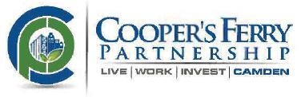

August 25, 2014

Tom Wheeler

Chairman

Federal Communications Commission
445 12th Street, SW
Washington, DC 20554

RE: MB Docket No. 14-57

Dear Chairman Wheeler:

On behalf of the Cooper's Ferry Partnership in Camden, New Jersey, I submit this letter to the FCC in support of the proposed Time Warner Cable/Comcast transaction. Comcast has been an effective community and business partner to our organization for many years, and I am confident that this transaction will encourage more companies nationwide to become better community sponsors.

Cooper's Ferry Partnership is facilitating the revival of the City of Camden by creating an environment where people choose to live, work, and invest. We develop visionary, long-range plans for the redevelopment of Camden's waterfronts and work with private sector, government and community partners to make these plans a reality. We currently are executing the Downtown Camden Strategic Development Plan, developed in 2002, which established the blueprint for anchor institution-led development in Camden. Since that time, we and our private and public partners have been implementing this strategy through a targeted five-part model: clean and safe streets; vibrant commercial corridors; stable neighborhoods; vibrant arts and culture; and human capital programming that build capacity among Camden's residents.

Over recent years, we have sought to expand our partnerships with high-scale tech companies that can provide leadership and collaboration to guide us in our efforts. We secured a connection with Comcast in 2013, when Bill Kettleson, Comcast's Freedom Region RVP of Government & Community Affairs, joined our Board of Directors. With Mr. Kettleson came the backing and support of the Comcast Corporation at large. Since he joined the board, Comcast has quickly become a leading corporate sponsor, having made significant cash & in-kind commitments to support our organization and our city.

Since our initial connection in 2013, Comcast has also proven to be a worthy associate in our efforts to connect city residents with free, outdoor entertainment events. Comcast connected us with its Spotlight business to bring Cartoon Network's "Move It Movement" campaign to the Camden Waterfront in 2013 and did so again in 2014. This event invites local kids ages 6-14 to come enjoy the waterfront and participate in various sports and athletic activities with their families. Comcast is also a major sponsor of our Fourth of July "Freedom Festival," which attracts people all over the region to our waterfront for fun, food, games and music. Connecting the waterfront with popular entertainment options is a must for future development projects, and I am extremely thankful to now have Comcast as a reliable event planner and organizer.

64

The entire City of Camden will soon benefit from a new series of PSAs aimed at improving the image of the city and promoting local events. Comcast recently agreed to use its technological dexterity to create a whole new ad campaign to increase continued visibility of Camden's offerings. With Comcast's creativity and ingenuity, we are confident that this campaign will do Camden justice and will play a major role in reshaping Camden's image across the U.S.

In the last decade, Camden has mostly been known for its struggles with unemployment and crime. As we work to overcome these obstacles, it is helpful to have a strong corporate citizen by our side. I support Comcast in each of its endeavors, and encourage the FCC to work quickly to approve the proposed transaction with Time Warner Cable.

Sincerely,

/s/ Anthony J. Perno III

Anthony J. Perno Ill

Chief Executive Officer

65

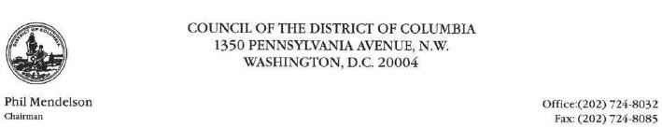

August 25, 2014

The Honorable Tom Wheeler, Chairman

Federal Communications Commission

445 12th Street, S.W.

Washington, DC 20554

RE: MB Docket No. 14-57

Dear Chairman Wheeler:

One factor in the FCC's consideration of the Comcast/Time Warner merger is whether Comcast has been a good corporate citizen. It is in that regard that I write, and do so positively.

For instance, in October 2012, during Hurricane Sandy, District residents most needed to stay in touch with family, co-workers, and news outlets. Comcast responded by opening Xfinity hotspots around our area, allowing anyone who needed an Internet connection free online access. That response in a time of crisis illustrates how Comcast serves as a good corporate citizen and as an important member of our community.

Similarly, Comcast has been a strong partner with the District on education issues, contributing in a variety of ways. For example, Comcast is making sure that low-income children can have a computer and Internet connection in the home. A few years ago, Comcast debuted its Internet Essentials initiative, which offers to connect homes to the Internet for $10 a month and provides discounted computers for $150. The company also provides digital literacy training for anyone in the home receiving Internet Essentials. The company also encourages academic success. Earlier this year, as in previous years, Comcast's Leaders and Achievers Scholarship Program gave scholarships to ten of our high school seniors.

It is this type of response, partnership, and community engagement that we as government leaders hope to see from our corporate citizens. The District bas enjoyed a strong relationship with Comcast. For that reason I ask the Commission to take into consideration all of the important work Comcast has done in the District to enrich the lives of our citizens.

Sincerely,

/s/ Phil Mendelson

Phil Mendelson, Chairman

PM/ms

66

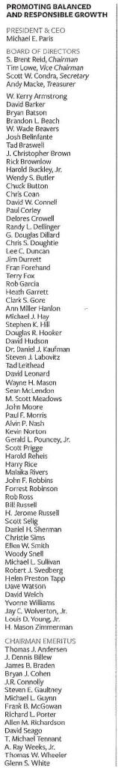
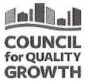

August 25, 2014

Chairman Tom Wheeler

Commissioner Mignon Clyburn

Commissioner Jessica Rosenworcel

Commissioner Ajit Pai

Commissioner Michael O'Rielly

Federal Communications Commission

445 12th Street, SW

Washington, DC 20554

RE: MB Docket No. 14-57

Dear Chairman and Commissioners:

On behalf of the Atlanta-based Council for Quality Growth, I write this letter to ask that you approve the proposed transaction between Time Warner Cable and Comcast. Comcast is a premier member of our council, and as CEO since 2003, I've had ample experience with the company and can personally attest to its commitment to investing in technology and innovation in the Atlanta metro region and statewide.

The Council for Quality Growth is a not-for-profit trade association comprised of a diverse membership of developers, contractors, engineers, architects, and other companies and organizations that are interested in growth and development. We work to ensure continued growth and economic success for future generations by providing advocacy, information and education to our members, and promoting balanced and responsible growth.

Comcast has been a strong and vital cog in our economy, and has promoted economic growth and supported good jobs continuously. I understand that the company employs nearly 4,000 Georgians in full-time positions, with full and quality benefits. The company owns and operates nearly 200 properties across the state and generates roughly $100 million annually in state and local tax revenues.

Most importantly, Comcast provides the infrastructure necessary for economic growth and development in our region. Thanks to Comcast's state-of-the-art network, Comcast Business offers advanced communications solutions for small to mid-sized companies that increase productivity, offering speeds of up to 10 Gbps. And Comcast will continue to develop innovative technology and infrastructure; I hear that the company continues to invest billions in next-generation technologies, and that it doubles the capacity of its network every 18 months.

If the proposed transaction with Time Warner Cable were to be approved, I believe that Comcast would become a stronger company, and that it would use its new scale to drive more innovation and investment that would benefit consumers and businesses.

This kind of investment drives our economic growth, so I hope the FCC will approve the transaction.

/s/ Michael Paris

Michael Paris

President & CEO

Council for Quality Growth

5901-C Peachtree Dunwoody Road, Suite 500 | Atlanta, Georgia 30328 | councilforqualitygrowth.org | 770.813.3370

67

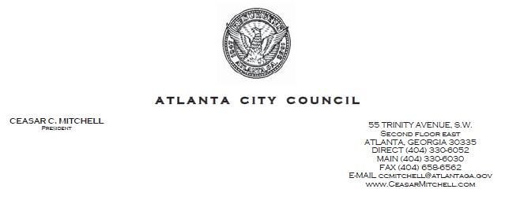

August 25, 2014

Tom Wheeler

Chairman

Federal Communications Commission
445 12th Street, SW
Washington, DC 20554

Subject: RE: MB Docket No. 14-57

Dear Chairman Wheeler:

My name is Ceasar C. Mitchell and I am the president of the Atlanta City Council. As a native Atlantan, I am especially proud to serve our citizens and to safeguard their welfare and prosperity. Atlanta is fortunate to count on good corporate citizens, such as Comcast, whose investments in the metropolitan area are improving our communities and supporting growth. I encourage you to support the proposed transaction between Comcast and Time Warner Cable, which would likely extend the good work that Comcast is already doing in Atlanta.

As someone who is personally invested in the future of our young people, working to generate solutions to the barriers that can derail them from education and career success, I appreciate Comcast's efforts to help underserved communities access the resources of the Internet.

I understand that Internet Essentials, the most comprehensive broadband access program in the country, has already enrolled 1.4 million low-income Americans. They now have the ability to acquire information, advance their educations, and access career opportunities that are sometimes only advertised online - for the affordable price of $9.95 a month.

In Atlanta, 13 percent of the estimated qualifying households are already receiving service, an outcome that is sure to increase, thanks to new measures on the part of Comcast. The company has offered to indefinitely extend the Internet Essentials program - which was initially a three-year project - and recently announced an initiative that offers six months of free Internet service for new households, coupled with some debt forgiveness for families who may have outstanding balances. Through these efforts, Comcast is showing that it is committed to significantly reducing barriers to broadband adoption

68

and helping ensure that more low-income students and families take advantage of 21st century technology.

Finally, Comcast is a principled corporate citizen that is also a leader in the areas of talent diversity and inclusion. To my knowledge, since the completion of its transaction with NBCUniversal, the number of executives of color has increased by 32 percent. The company has also increased business with minority-owned vendors by 20 percent.

At Comcast, it is clear that innovation and technology are the genesis for progress, integrity and community-wide investment. The FCC should not delay its approval of the proposed transaction between Comcast and Time Warner Cable.

Sincerely,

/s/ Ceasar C. Mitchell

Ceasar C. Mitchell

69



August 25, 2014

Chairman Tom Wheeler

Commissioner Mignon Clyburn

Commissioner Jessica Rosenworcel

Commissioner Ajit Pai

Commissioner Michael O'Rielly

Federal Communications Commission

445 12th Street

Washington, ID 20554

Re: Comcast and Time Warner Cable Transaction

Dear Chairman and Commissioners:

Thank you for allowing me the opportunity to comment on the proposed Comcast and Time Warner Cable transaction. Comcast operates television stations, call centers and other facilities and provides cable and Internet services in Illinois, and it has a strong presence in benevolent activities as well. As Chairman of the Board of Winnebago County, Illinois, I request the Commission's approval of the proposed Comcast/Time Warner Cable transaction.

Our County is located in north-central Illinois and the City of Rockford is our county seat. We are home to 278,000 people whose work supports numerous industries, many of which are based in manufacturing. We have a strong highway network, three major hospitals, forests and parks, and a great deal of farmland. Economic development is a top focus for our county, working in concert with surrounding Illinois and Wisconsin communities.

Comcast has proven to be a durable economic partner here. Last year, Comcast invested more than $1 billion in its activities in Illinois. I understand its Illinois payroll is close to $30 million a year at this point. The company provides needed jobs and its hiring policies are among the most inclusive we've seen.

In particular, Comcast is known for its efforts to employ military veterans, a cause that our County Board devotes significant resources to. Our Veterans Assistance Commission helps honorably discharged veterans in need, and we have a role in making job referrals. We know that Comcast actively seeks to hire veterans through several companywide initiatives. For instance, Comcast set a goal a few years ago to hire 2,000 veterans over a roughly two-year period. It met that goal early. Comcast works directly with the U.S. Army at job fairs, and it set up an Internet page where veterans can look up job opportunities and look into advancing their educational and career training. The company also has published an online guide for veterans that explains how they can tap their military training to ace job interviews; and does business with the National Veteran-Owned Business Association, among other pro-veteran activities.

404 Elm Street • Room 533 • Rockford, IL 61101 Phone (815) 319-4225 • Fax (815) 319-4226

E-mail: countyboardchairmansoffice@wincoil.us Website: www.wincoil.us

It is our mission to provide high quality services and promote a safe community for all people in Winnebago County.

70

We also see Comcast officials and employees out in our community in many forums. I am a strong proponent of volunteerism and when it comes to this subject matter, Comcast Cares Day does many projects in Winnebago County. Every year, I wake up early and join hundreds of Comcast employees, friends and family, to kick-off Comcast Cares Day in our communities. It is one of our largest days of service and is something I look forward to annually. I should also mention that Joan Sage, Comcast's Government and Regulatory Affairs Manager has attended several meetings of our Board to talk about Comcast' Internet Essentials program offered to any family with children who are eligible for free and reduced school lunches. This program provides Internet service for a reduced price (along with reduced cost computers) and is another great example of how this corporation sees beyond commerce and does good for those that need it most. If allowed to merge with Time Warner Cable, Comcast has committed to bring this program to more communities, which would surely provide a meaningful benefit to them.

Sincerely.

/s/ Scott Christiansen

Scott Christiansen, Chairman

Winnebago County Board

71

August 25, 2014

The Honorable Thomas Wheeler

Chairman

Federal Communications Commission

445 12th Street, S.W.

Washington, D.C. 20554

RE: MB Docket No. 14-57

Dear Chairman Wheeler:

As President and Chief Executive Officer of Crown Media Family Networks, home to Hallmark Channel and Hallmark Movies & Mysteries, I support the proposed merger of Comcast and Time Warner Cable.

Crown Media is an independent programmer. No multichannel video programming distributor or broadcaster owns an attributable ownership interest in it.

Crown Media is not a media conglomerate with numerous linear channels, and it does not have the leverage resulting from retransmission consent.

Nonetheless, for more than a decade, Comcast has been not only one of the largest, but also one of the most supportive, distributors of Hallmark Channel. Crown Media has had a nationwide distribution agreement with Comcast since 2003. Comcast has launched and distributed Hallmark Channel in highly-penetrated tiers, and it is typically available to subscribers of Comcast's Digital Economy or Digital Starter tiers, with over 19 million subscribers. Likewise, since Hallmark Movies & Mysteries (formerly Hallmark Movie Channel) launched in 2008, Comcast has been one of its most supportive distributors and now delivers over 17 million of the channel's subscribers on digital tiers. Comcast's early and deep distribution of both channels has spurred their growth and increased original programming.

Comcast's distribution of Hallmark Channel and Hallmark Movies & Mysteries contributes substantially to the diversity of programming available to viewers. Both channels offer high quality, family friendly programming, that is informative and entertaining. We strive to offer engaging and inspirational programming that families will watch together. The channels feature numerous original movies and series each year, covering a wide range of genres, including dramas, comedies, mysteries, and westerns. In fact, this year alone, Hallmark Channel will air more than 550 hours of original premiere programming. Its Cedar Cove series has been well-received by viewers and acclaimed by critics such that it presently ranks No. 1 in household viewing on Saturdays in the 8-9 p.m. slot.

72

Hallmark Channel and Hallmark Movies & Mysteries also are the undisputed leaders in family holiday programming, broadcasting over 1250 hours of original and classic holiday movies during the 2013 Christmas season. The channels have featured a mix of original movies and classic holiday offerings, including the annual "Countdown to Christmas" block; recent Christmas in July programming special; romance-themed shows during February; Mother's and Father's Day-related specials; and Halloween special programming as well.

Our family-friendly programming, consistent with the trusted and widely-recognized Hallmark brand, and Comcast's committed distribution have helped make Hallmark Channel one of the most popular general entertainment networks. Comcast's wide-spread distribution of the Hallmark Channel and Hallmark Movies & Mysteries reflects a genuine commitment to programming diversity and to family programming because we do not have other leverage (such as retransmission consent) to force such carriage. One need only look at Comcast's programming schedule to recognize that it similarly distributes other independent channels with diverse programming, whether family-friendly, minority-owned or programmed, or presented in foreign languages.

Given Comcast's long history of being one of the most supportive distributors of unaffiliated and independent programmers, we believe the proposed Comcast-Time Warner Cable merger will be a positive development not only for the Hallmark channels, but also for other unaffiliated and independent networks.

Sincerely,

/s/ William J. Abbott

William J. Abbott

President & Chief Executive Officer

- Commissioner Mignon Clyburn Commissioner Michael O'Rielly Commissioner Ajit Pai Commissioner Jessica Rosenworcel

Mr. Jim Bird, Office of General Counsel (TransactionTeam@fcc.gov)

Mr. William Dever, Wireline Competition Bureau (William.Dever@fcc.gov) Ms. Marcia Glauberman, Media Bureau (Marcia.Giauberman@fcc.gov) Ms. Vanessa Lemme, Media Bureau (Vanessa.Lemme@fcc.gov)

Best Copy and Printing, Inc. {fcc@bcpiweb.com)

-2-

73

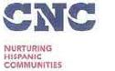

August 21, 2014

Mr. Tom Wheeler Chairman

Federal Communications Commission
445 12th Street, SW
Washington, DC 20554

RE: MB Docket No. 14-57

Dear Chairman Wheeler:

As the President and CEO of the Cuban National Council, Inc., I support Comcast's proposed acquisition of Time Warner Cable.

CNC is a front line community service organization that provides direct human services to needy individuals from diverse racial and ethnic groups with a focus on Hispanics and minorities. While we were founded In the early 1970s to particularly serve Cuban Americans as they transitioned into U.S. life, we now serve all communlties and have expanded from basic subsistence issues into broader questions of education, economic opportunity, and social justice.

The proposed combination of Comcast and Time Warner Cable will bring substantial benefits to the communities we serve. As a company with a record of keeping its promises to the Latino community, Comcast has promised to invest hundreds of millions of new dollars a year in improving broadband service in their new markets. This investment will generate powerful economic opportunities and ensure the life-changing power of high·speed Internet access is available to more and more Americans.

The transaction will bring the benefits of Comcast's Internet Essentials program to thousands of additional American families in the newly acquired areas. CNC has worked on digital literacy and broadband adoption with Comcast for years, and I have seen first-hand how affordable home access to the Internet changes lives. Internet Essentials is the most complete and effective program I have ever to seen to help needy families get online for the first time, combining affordable service and heavily discounted computer hardware with free digital skills training and powerful learning programs like the Khan Academy. As such, Internet Essentials addresses virtually all the leading obstacles to broadband adoption that experts have identified. If we are going to truly close the digital divide in this country, we need to expand these efforts, as Comcast proposes to do through this transaction.

Comcast has also been a strong supporter of a free and open Internet – which is critical to our democracy and especially to online service organizations like CNC. Expanding this commitment to Time

1223 SW 4 Street | Miami, FL 33135

Tel: 305.642.3484 Fax: 305.642.9122

www.cnc.org

74

Warner cable communities is another valuable public good that will make the Internet stronger and more open for all users if the two companies are permitted to combine.

The biggest criticism I hear about the proposed deal is that it will eliminate competition for cable television. But to me the response that Comcast and Time Warner cable already operate in different markets makes sense. How can the transaction eliminate a competitor that does not exist today? I would always support more choices for local communities, but that seems like a different issue since this deal does not increase or lessen choice at all.

I understand that the Commission's job is to determine if this proposal serves the public interest. By improving Internet service, expanding net neutrality protections, increasing minority-focused video options, and Investing in community development programs, I believe it does.

Sincerely,

/s/ Sonia Lopez

Sonia Lopez

President & CEO

SL/jd

1223 SW 4 Street | Miami, FL 33135 | www.cnc.org
Tel: 305.642.3484 Fax: 305.642.9122
 | 75



August 21, 2014

Tom Wheeler

Chairman

Federal Communications Commission
445 12th Street, SW
Washington, DC 20554

RE: MB Docket No. 14-57

Dear Chairman Wheeler:

On behalf of the Dallas Black Chamber of Commerce, where I serve as President/COO, I would like to officially offer my support for the proposed Time Warner Cable/Comcast transaction. I urge your commission to grant its approval.

The mission of the Chamber is to serve as an advocate for the creation, growth and general welfare of African American businesses in Dallas. We have been fortunate to call Time Warner Cable our valued partner, and since 2006, it has made meaningful contributions as our membership body and Greater Dallas community.

I believe that the proposed transaction between Time Warner Cable and Comcast would further advance our goals, considering Comcast's corporate leadership in the areas of diversity and inclusion, and extend many benefits to future markets.

Comcast has made it a priority to encourage diversity throughout its workforce and C-suites. I understand that since the completion of its acquisition of NBCUniversal in March 2013, the company has increased the number of minorities at the executive level by 32 percent. In addition, professionals of color account for 40 percent of total hires - a notable demonstration of Comcast's commitment.

The company is also working with supplier diversity organizations across the country, including the National Minority Supplier Development Council and the National Black Chamber of Commerce. Since 2007, it has partnered with the National Urban League, and was ranked by Black Enterprise Magazine as one of the 40 "Best Companies for Diversity" in the country. Comcast is clearly working to support African American businesses and communities across the U.S., and we would welcome the company's resources - along with its services - here in Dallas.

To my knowledge, 3,000 Texans already call Comcast their full-time employer, and the company's community investment totaled $4.7 million last year.

76

The approval of the proposed transaction between Comcast and Time Warner Cable would be advantageous for our communities and would extend the company's inclusion and diversity practices across Texas. I encourage the FCC to support it.

Best Regards,

/s/ Wilton S. Munnings

Wilton S. Munnings

President & COO

Dallas Black Chamber of Commerce

2838 Martin Luther King Jr. Blvd.

Dallas, Texas 75215

- 421-5200 tel

- 421-5510 fax

Email: wmunn@dbcc.org

77



August 25, 2014

Tom Wheeler

Chairman

Federal Communications Commission

445 12th Street, SW

Washington, DC 20554

RE: MB Docket No. 14-57

Dear Chairman Wheeler:

For almost 150 years, the Denver Metro Chamber of Commerce has served as the leading voice for Colorado's business community. With a membership that includes 3,000 businesses and their 300,000 employees from across the metro region and the state, the Chamber is a powerful and effective advocate for both small and large businesses at the local, state and federal levels. As business leaders committed to creating a healthy business climate, enhancing our state's global competitiveness, and ensuring the highest standards for an improved quality of life, we are keenly aware of the role technology plays in enabling businesses to grow and thrive, and we value Comcast as a leader in investing in our community.

Comcast contributes to the strength of our local economy as a critical service provider to our business community, large employer and key community partner. By lending their expertise to help guide and advise new strategic initiatives, serving on our board and committees, supporting programs and events that enable us to bring together leaders from across our many different industries and sectors, and contributing resources to help tell our story - such as producing videos and donating air time to carry important Chamber messaging - Comcast leaders demonstrate their active, ongoing commitment to strengthening Colorado. Whether donating time and resources to improve our business community, local neighborhoods (Comcast Cares Day) or our schools (Internet Essentials), Comcast is deeply invested in our community.

I look forward to an ongoing relationship with Comcast as it continues to provide better services and products to our business community, expand infrastructure that will benefit every region served by Comcast and make meaningful investments in our community.

Sincerely,

/s/ Kelly J. Brough

Kelly J. Brough

President and CEO

1445 Market Street, Denver, CO 80202 · 303-534-8500 · fax 303-534-3200 · www.denverchamber.org

78

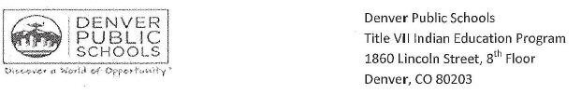

August 22, 2014

To: Federal Communications Commissions

Re: Comment Regarding Merger of Comcast and Time Warner Cable

To Whom It May Concern,

As the executive director of a nonprofit community-based organization, the Denver Indian Center, I had the opportunity to partner with Comcast on several business and community investments. The Denver Indian Center, established in 1983, is a 501c3 organization that serves Colorado's American Indians in workforce development, youth programs and emergency services.

Comcast was a tremendous community partner to the Denver Indian Center by providing grant support, developing public service announcements, providing in-kind air time, and thousands of volunteer hours. This support from Comcast provided youth from diverse backgrounds in Metro Denver and families at Denver Public Schools with valuable resources, programs and opportunities.

Their signature Internet Essentials program has been extremely successful in bridging the digital divide for families who historically haven't had internet access, especially the American Indian.

In my new role in the Denver Public Schools Indian Education Program, I continue to enjoy partnership with and support from Comcast to help address a variety of student needs. It is my experience that Comcast is a company who is committed to their customers and community, and I fully support the merger between Comcast and Time Warner Cable and recommend that the FCC approve. Please do not hesitate to contact me if you need further information regarding this letter of support.

Sincerely,

/s/ Jay Grimm

Jay Grimm

DPS Indian Education Program

Denver Public Schools Core Values: Students First - Integrity - Equity - Collaboration - Accountability - Fun

79



August 25, 2014

Mr. Tom Wheeler, Chairman

Federal Communications Commission
445 12th Street, SW
Washington, DC 20554

Dear Chairman Wheeler & FCC Commissioners:

RE: MB Docket No. 14-57

The Denver South Economic Development Partnership (Denver South EDP) is an organization of government and business leaders committed to the economic vitality and sustainability of the Denver South region. Our area is home to six of Colorado’s Fortune 500 companies, 200,000 workers and over 20,000 businesses. Comcast is the largest private sector employer and an excellent corporate citizen. Denver South EDP supports the proposed transaction between Comcast and Time Warner Cable.

The proposed transaction between Comcast and Time Warner Cable will allow more areas of the country to get access to Comcast’s business class service and community investments. Throughout our years-long partnership with Comcast, they have demonstrated their strong commitment to the Denver metro area through investments in our community that have benefitted local organizations, encouraged innovation and economic growth, and served the families of Colorado. We are confident that Comcast will bring the same level of commitment to their new markets if the proposed transaction is approved.

Thank you for the opportunity to comment on this important Comcast / Time Warner Cable transaction.

Sincerely,

/s/ Lynn Myers

Lynn Myers

VP of Economic Development

80



August 25, 2014

Tom Wheeler

Chairman

Federal Communications Commission
445 12th Street, SW
Washington, DC 20554

RE: MB Docket No. 14-57

Dear Chairman Wheeler:

Since 1955, the Downtown Denver Partnership has been dedicated to making Downtown Denver better in every way. Our organization creatively plans, manages and develops Downtown Denver as the unique, diverse, vibrant and economically healthy urban core of the Rocky Mountain Region that is recognized for being prosperous, walkable, diverse, distinctive and green. We depend upon and value partners like Comcast who are committed to sharing in and advancing this mission.

The Downtown Denver Partnership is a leader, place-maker, convener, idea generator, facilitator, recruiter, team-builder and policy advocate, and each one of these important efforts benefits from Comcast's support through sponsorship, donation of in-kind resources, and the regular involvement of their local leaders. We enjoy a longstanding partnership with Comcast and value the company for demonstrating time and time again a strong commitment to being a responsible, leading and highly-engaged corporate citizen.

Comcast's innovation and industry leading products and services have helped Downtown Denver become a major business center; we have the technology available that both small and large companies are looking for as they seek to start, move, or expand their business. Comcast has also been a longtime supporter of the array of large and small scale events we lead for our city, providing a variety of ways to stay engaged in our organization and participate in shaping our city's success and future opportunities. Comcast leaders have for many years served on our boards and committees and participated in our leadership development programs, providing invaluable perspective and guidance, as well as collaborating with other local leaders to help accomplish our many goals for our city.

We are passionate about Downtown Denver and we are constantly developing ways to make it a better place, and Comcast is a trusted and valued partner in this effort.

We encourage your thoughtful consideration and approval of the Comcast-Time Warner Cable transaction.

Best regards,

/s/ Tamara Door

Tamara Door

President and CEO

81

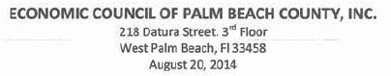

Re: MB Docket No. 14-57

Tom Wheeler

Chairman

Federal Communications Commission

445 12th Street, SW

Washington, DC 20554

Dear Chairman Wheeler:

As president and CEO of the Economic Council of Palm Beach County, Florida, 1am writing to urge the FCC to approve the proposed transaction between Comcast and Time Warner Cable.

Our not-for-profit, nonpartisan organization is dedicated to creating a thriving economic environment in Palm Beach County. To achieve that goal, it is imperative that we support our current businesses and attract new business. All businesses today, large and small, require a reliable provider of broadband services. To that end, we are extremely satisfied with the outstanding service that Comcast provides and can use that as a selling point.

I understand that since 1996, Comcast has invested billions in technology and infrastructure in Florida. That means the services we receive are reliable and of the highest quality. In today's global economy, businesses cannot afford to have customers looking for web sites that are down because of unreliable providers.

Here at the Economic Council, we also value Comcast as an exemplary employer (and a Council member). The company employs almost 17,000 Florida residents, pays them a living wage and, from what I understand, offers one of the best benefit packages around, including healthcare and tuition reimbursement.

But Comcast is more than a business partner. The company has an unmatched record of social responsibility. The most visible example is Comcast Cares Day - which is the largest single-day volunteer effort launched by any company in the country. Last year, Comcast employees and their family members and friends completed the "Great American Cleanup"- picking up trash and landscaping the historic district surrounding the West Palm Beach Salvation Army. This was a massive community effort that serves as a model of volunteer spirit to our young people.

As both a businessman and a Palm Beach County resident, I am grateful to Comcast for everything that the company does to improve our quality of life. I believe that if Comcast extends into new areas, the quality of life will improve there as well.

Sincerely,

/s/ Daniel F. Martell

Daniel F. Martell

President,

Economic Council of Palm Beach County, Inc.

82

August 22, 2014

Chairman Tom Wheeler

Commissioner Mignon Clyburn

Commissioner Jessica Rosenworcel

Commissioner Ajit Pai

Commissioner Michael O'Rielly

Federal Communications Commission

445 12th Street, SW

Washington, DC 20554

RE: MB Docket No. 14-57

Dear Chairman and Commissioners:

I am the Principal and Executive Director of EPIC Academy in Chicago, Illinois. Epic Academy is a nonprofit public college-prep charter school. Our organization aims to provide high-quality and comprehensive college-preparatory education for young men and women, helping them succeed in college and life after college. Our schools are a direct response to the urgent need to reverse abysmal graduation and college completion rates for youth from urban centers. We proudly hold a 98% college acceptance rate among our graduates - predominately individuals of color from low-income families.

I am contacting you to voice my support for the proposed transaction between Comcast and Time Warner Cable. As someone that grew up in, and now works in the Comcast market of Chicago, I can personally attest to the Company's commitment to our communities and toward educating our students so as to put them in the best possible position to succeed in life.

One of the most important reasons that I support Comcast is the company's outstanding efforts to decrease the digital divide through its broadband adoption programs. In 2010, Comcast launched Internet Essentials, a program that brings affordable internet, affordable computers, and free digital literacy training to low-income families that have children that qualify for free or reduced lunch under the National School Lunch Program. Of the approximately 450 students that attend our school, over 95% qualify for free lunch. Statistics have shown that the digital divide has disproportionately affected families of color in low-income neighborhoods; without access to computers and the Internet, these households are at a crucial disadvantage.

In Chicago, the program has experienced a dramatic increase in connections since launching. I have seen statistics showing that by the end of 2013, more than 60,000 individuals' households in the city of Chicago area were connected to the Internet through Internet Essentials. Many of these are families in the neighborhoods our students call home. Comcast even spent time working with our staff to help make parents aware of their services so they could close the digital divide.

There is plenty of work still to be done to bridge the digital divide. But, we have to tackle it. From school work to internship applications, an internet connection is an important tool for our students - and students across the country. Luckily, Comcast has committed to continuing Internet Essentials indefinitely and consistently contributes resources to spreading the word. The proposed transaction between Comcast and Time Warner Cable will allow Comcast to expand its efforts into new and larger markets - cities like New York, Los Angeles, and Dallas - and significantly dent the digital divide in America overall.

83

It is crucial that these cities receive the same efforts from Comcast that Chicago has enjoyed, and the Federal Communications Committee can help this effort by approving the proposed transaction. I hope that you see things the way I do, and realize how exciting Comcast is making the future of education by working to ensure that all students, regardless of race or economic background, have equal access to the tools and technology that are increasingly becoming basic requirements in today's information age.

Sincerely,

/s/ Matthew King

Matthew King

Executive Director and Principal

84

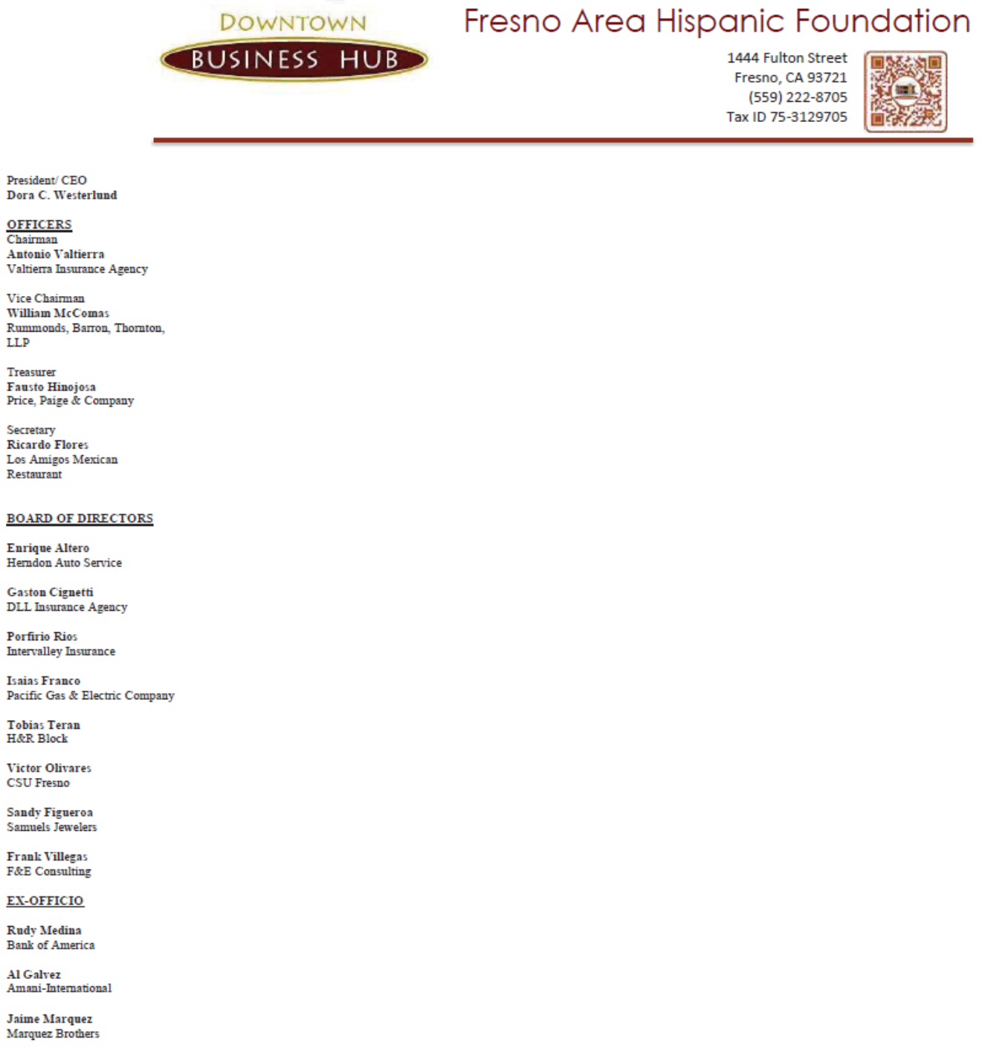

August 25, 2014

Chairman Tom Wheeler

Commissioner Mignon Clyburn

Commissioner Jessica Rosenworcel

Commissioner Ajit Pai

Commissioner Michael O’Rielly

Federal Communications Commission
445 12th Street, SW
Washington, DC 20554

RE: MB Docket No. 14-57

Dear Chairman and Commissioners:

On behalf of the Fresno Area Hispanic Foundation (FAHF), I am pleased to voice our views regarding the Commission's request for comments on the proposed Comcast and Time Warner transaction.

As an organization that is committed to business and workforce development for the success of all members of the community throughout Fresno County in northern California, we are well aware of what is needed to strengthen the social fabric that brings our communities together for the better. After partnering with Comcast in various initiatives including Internet Essentials, I can say unequivocally that Comcast shares our vision for better, culturally diverse future. Not only does the company provide strength to our organization by helping support our programs like the Technical Assistance and Micro-loan Programs.

In part due to our partnership with Comcast and its willingness to host FAHF on the Newsmakers program, FAHF has been able to provide procurement, business development and leadership training, build alliances between communities, raise the visibility of diverse leaders in our County, and educate and inform the diverse communities about key issues that impact their life. The FAHF has evolved to be recognized by County leaders as the voice of the Hispanic and ethnic community that to the platform Comcast has provided us. It's for this reason that we support the transaction.

Thank you again for the opportunity to submit comments for your consideration.

Respectfully,

/s/ Dora Westerlund

Dora Westerlund

President & CEO

85

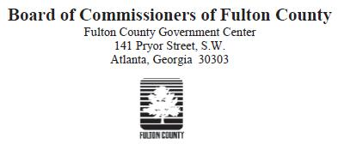

August 22, 2014

Tom Wheeler

Chairman

Federal Communications Commission
445 12Th Street, S.W.
Washington, D.C. 20554

RE: MB Docket No. 14-57

Dear Chairman Wheeler:

As the County Commission Chairman of Fulton County, Georgia, I have had the distinct pleasure of watching local communities across the county benefit from the Comcast Corporation's community investment programs. From improving digital literacy standards to brightening up local community hotspots, Comcast has exceeded the standard of corporate citizenship. I support the continuation of Comcast's outreach efforts and therefore encourage the FCC to approve the proposed transaction with Time Warner Cable.

Fulton County, which houses the state capital of Atlanta, is ever-changing, fast-growing and leading the way as a world-class county. It is imperative that students in our public schools have access to the latest technology tools and education in order to keep up with the rest of the world. Thanks to Comcast's Internet Essentials program, we can see a brighter future across the County for many of our low-income families. The program has so far connected over 100,000 Georgia residents to low-cost internet, computers and free digital literacy training options at service centers across the state. The goal of Internet Essentials is to support digital literacy education programs so that many more children may succeed in the classroom and in life. Because of Comcast's support, many of our students in Internet Essentials households now can continue their classroom learning at home, their teachers can connect with students to improve assignment tracking and homework completion, and their parents can now keep track of household finances and apply for jobs online.

Earlier this month, I attended a a press conference to announce Comcast's plan to provide up to six months of complimentary service for any new family that has not yet applied for Internet Essentials. Over 30 elected officials and community leaders, including Georgia's First Lady

86

Sandra Deal and Atlanta Public Schools Superintendent, Meria Carstarphan, joined Comcast representatives at Peyton Forest Elementary School to make the announcement, donate free laptop computers to all of the school's 4th and 5th graders, and to draw attention to the current digital divide that has left many Georgia families behind. The media attention has helped more families become aware of the real possibility of online access through Internet Essentials.

I have also been able to watch and participate in Comcast Cares Day, the largest single corporate day of service in the nation for several years now. Each year, Comcast employees spread out across the county to landscape and beautify local community centers, parks and public schools. It is an admirable showcase of solidarity and I look forward to seeing these events continue.

Fulton County experiences the same hardships as most metropolitan areas in this country. We are fortunate to have Comcast as a helping hand to create better education and economic opportunities for our residents. I believe that opening up Comcast's excellent community service work to more people will help this entire nation advance to compete in the new, digital age. Thank you for taking my views into account as you review the merger proposal.

Sincerely,

/s/ John H. Eaves

John H. Eaves, Ph.D.

Chairman

Fulton County Board of Commissioners

87



August 15, 2014

Mr. Tom Wheeler

Chairman

Federal Communications Commission

445 12th Street, SW

Washington, DC 20554

Dear Chairman Wheeler,

My name is Chris Clark and I am a native Georgian and the President and CEO of the Georgia Chamber of Commerce, where I work to ensure the competitiveness of the businesses and people of our state. Comcast has brought advances in technology and infrastructure to Georgia, and I support its proposed transaction with Time Warner Cable.

Here at the Georgia Chamber, we are fortunate to count on the leadership and expertise of Michael Wall, an employee of Comcast, who is attuned to the regional nuances and business environment of the Atlanta area and who has taken a strong interest in being a part of and supporting our hard work to create a better business community here.

Comcast is committed to integrity, and I know firsthand that it strongly believes in business competition and supplier diversity to enhance service and benefits for all consumers.

I understand that in 2013, Comcast and NBCUniversal spent $1.3 billion on diverse suppliers, and its supplier diversity program is designed to promote and increase the participation of diverse businesses across its footprint. That means women-owned, minority-owned and veteran-owned businesses – just to name a few – are able to leverage resources and generate growth in their local communities.

Moreover, following its March 2013 acquisition of NBCUniversal, Comcast upheld the promises it made prior to the completion of the union, such as the broad implementation of Internet Essentials, or lntemet Basico, as it is called in Spanish – a comprehensive digital adoption program that has already benefitted 1.2 million Americans.
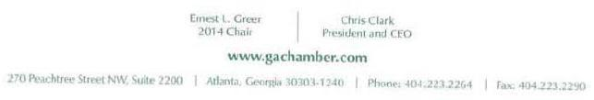

88

Page two

Letter to Chairman Tom Wheeler

August 15, 2014

Broadband and other digital innovations are important ingredients for education, business and economic opportunity in Georgia. I believe that approval of Comcast's transaction with Time Warner Cable will accelerate these and other notable efforts. I hope tbe FCC will approve the proposed transaction before it.

Sincerely,

/s/ Chris Clark

Chris Clark

President and CEO

Georgia Chamber of Commerce

89



August 25, 2014

Tom Wheeler

Chairman

Federal Communications Commission

445 12th Street, SW

Washington, DC 20554

RE: MB Docket No. 14-57

Dear Chairman Wheeler:

We in Delaware are proud to be the First State. We weren't just the first state to ratify the Constitution. We were also the first state to trial Comcast's pioneering Internet Essentials program.

I am the current Governor of Delaware, a former Delaware State Treasurer, and a former Comcast executive. I have gotten a firsthand look at the serious benefits that Comcast continues to bring our state as its major broadband and cable provider. Please approve the proposed Comcast - Time Warner transaction to ensure that these momentous investments don't end with Delaware, but are instead enabled lo better the lives of millions around the country.

Comcast currently serves the majority of my state. The company has around 191,000 subscribers in our state, and nearly 1,300 full-time employees. We have seen Comcast's ongoing commitment to infrastructure and community. Since 1996, Delaware has benefitted from over $350 million in capital investment from Comcast. Our state's businesses can compete throughout the world with state-of-the-art high-speed Comcast broadband technology. The ongoing, substantial investment means that our state's infrastructure will not stagnate. Comcast enables continued growth in all sectors of our economy through their consistent development.

Comcast's development doesn't just serve businesses. Comcast's Internet Essentials program is rapidly closing the Digital Divide. Kuumba Academy Charter School in Wilmington played host to the first trial of the program, which connects low-income families to high-speed internet infrastructure at home. We were proud to provide a successful test of the initiative, which has since provided over 300,000 households nationwide with the access they need to our digital economy. In Delaware, more than 1,500 households have taken advantage of this program, and the number increases every day. A combined Time Warner

90

– Comcast entity could empower more children than ever before to seize their futures through this innovative program.

Comcast's corporate citizenship doesn't operate from 9 to 5. We see their sustained partnerships everywhere we look in our communities. Comcast employees fully participate in making our towns and cities better places to live through corporate programs like Comcast Cares Day and United Way contributions, which drew nearly 1,000 volunteers and 1,000 pledges in 2013 alone, respectively.

Delaware has been the First State since 1787. We have been a model for the rest of the country since this nation's founding. Comcast's investments in Delaware, in our infrastructure and in our communities, is similarly a model of corporate citizenship for our country. I humbly urge your approval of this transaction so that this kind of community citizenship can reach even more communities in our great nation.

Sincerely,

/s/ Jack A. Markell

Jack A. Markell

Governor

91



NEIL ABERCROMBIE
GOVERNOR

August 22, 2014

Chairman Tom Wheeler

Commissioner Mignon Clyburn

Commissioner Jessica Rosenworcel

Commissioner Ajit Pai

Commissioner Michael O'Rielly

Federal Communications Commission

445 12th Street, SW

Washington, DC 20554

Re: MB Docket No. 14-57

Dear Chairman and Commissioners:

I am writing in support of the proposed Comcast and Time Warner Cable merger transaction, which I am confident, will improve Hawai`i’s economic competitiveness and result in community development opportunities.

I am proud to serve as Governor of the State of Hawai`i ("State"), which deserves its reputation as the premiere vacation destination in the world. However, for our State to continue to grow, we must expand our information and research sectors as well as strengthen our tourism industry. The recent recession demonstrated how important it is to achieve a wide balance of economic development, and a strong Internet infrastructure is crucial to this goal and to our growth.

Hawai`i has a unique set of challenges for Internet providers. Comcast has assured me that it will be better positioned to make the capital investments necessary to keep Hawai`i competitive through technological upgrades that will bring long- and short-term economic opportunities for the State. According to recent Census figures, 28.5% of the State does not have Internet access at home. This figure is too high since we want all of·our students to graduate with the skills they need in today's economy.

I have been impressed with Comcast and what it can offer the State, especially its Internet Essentials program, which offers discount Internet service to low income families and has helped to bring low-cost Internet access to more than 1.2 million people. The State could really benefit from having this important service available to

92

Chairman Tom Wheeler

Commissioner Mignon Clyburn

Commissioner Jessica Rosenworcel

Commissioner Ajit Pai

Commissioner Michael O'Rielly

August 22, 2014

Page 2

the people of Hawai`i. Your approval of this transaction should bring this needed service from the mainland to our shores.

At this juncture, the Department of Commerce and Consumer Affairs ("DCCA"), the state agency in Hawai`i tasked with oversight over the proposed transaction, is currently reviewing the matter to ensure that the proposed transaction is in the public interest. I believe that Comcast will diligently work with the DCCA to ensure that the proposed transaction will result in material benefits for the people of Hawai`i.

Sincerely,

/s/ NEIL ABERCROMBIE

NEIL ABERCROMBIE

Governor, State of Hawaii

93

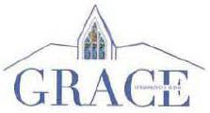

August 25, 2014

Tom Wheeler

Chairman

Federal Communications Commission

445 12th Slteet, SW

Washington, DC 20554

RE: MB Docket No. 14-57

Dear Chairman Wheeler:

As Senior Pastor of Grace Bapllst Church. Chairman of the National Action Network, and a member at large of the Joint Diversity Advisory Council convened to advise Comcast Corporation, I write to urge you to approve the proposed expansion of Comcast into territories currently served by Trme Warner Cable.

Expanding Comcast operations to new territories will be an unqualified public good. Comcast is a diversity leader and one of the most forward looking and civic-minded corporations in the United States. Today, 40% of the combined workforce of Comcast and its partner NBCUniversal are minorities, including 25% of company management. Its Board of Directors is one-third diverse, including two African-American members, Kenneth J. Bacon and Johnathan A. Rodgers.

Many companies speak metaphorically about giving minorities a seat at the table, but Comcast has gone beyond words to action. Its revolutionary Joint Diversity Advisory Councils bring in leaders representing virtually the entire cross-section of Arnerican life to advise on company governance and ensure that all affected communities are heard from when decisions affecting them are made. Expanding this model via the transaction to Time Warner Cable areas will only empower citizens more fully.

The company has also worked hard to bring real economic opportunity to the communities where it is engaged. From banking and other services to suppliers and service contractors, Comcast and NBCUniversal spend well over $1 billion a year with minority vendors.

Finally, and most importantly, Comcast has led the way bringing the life-changing power of the Internet to under-served communities and low-income families. Its Intemet Essentials program has now connected over 1.4 million Americans. and especially school-aged children, with high speed Internet at home. The company has listened when people have suggested improvements to this program, increasing speeds multiple times, expanding the pool of eligible Americans, and recently introducing a forgiveness program for low-income families who owe the company for old bills. In America today, equalizing online opportunity is fundamental to equalizing economic opportunity. And on this point. Comcast and its senior-most leadershlp really get it.

Expanding these pro-social, pro-community policies will serve the public interest and powerfully benefit the communities affected.

Sincerely,

/s/ W. Franklin Richardson

W. Franklin Richardson

94



August 25, 2014

Chairman Tom Wheeler

Commissioner Mignon Clyburn

Commissioner Jessica Rosenworcel

Commissioner Ajit Pai

Commissioner Michael O'Rielly

Federal Communications Commission
445 12th Street, SW
Washington, DC 20554

RE: MB Docket No. 14-57

Dear Chairman and Commissioners:

Since 1914, the Greater Atlantic City Chamber has provided the local and regional business community with meaningful services to create a favorable economic climate. The Chamber works in tandem with member businesses to foster growth of the region's economy and facilitate a higher quality of life for its residents. There is no question that the region's economy Is dealing with its fair share of challenges. Atlantic City is still on the mend from the national economic downturn and is facing increased competition from gaming industries in neighboring states. However, with innovative leadership and collaboration among businesses, Atlantic City's prospects are taking a more positive turn.

Atlantic City is located in a Comcast service area, which has brought great benefit to business and residential communities. Comcast has been an active member of our Chamber and has provided members with access to excellent business services. Residents and businesses alike benefit from Comcast's offering the fastest broadband speeds and Xfinity Wi-Fi hotspots. The company opened these hotspots free of charge to the public immediately after Superstorm Sandy in 2012 to help residents, businesses and emergency responders communicate during this catastrophic event. As Atlantic City works toward a brighter economic future, it is helpful to have a high quality cable and Internet provider as a partner. We encourage the FCC to open the door for more communities to benefit from a Comcast partnership by approving its proposed transaction with Time Warner Cable.

Comcast Corporation has shown a sincere commitment to the Atlantic City community by ensuring that all of Its local business entities take part in Chamber activities: Comcast Business, Comcast Spotlight, Comcast Cable and Global Spectrum, the management company for two important non-gaming venues in Atlantic City - the Atlantic City Convention Center and Boardwalk Hall. Fred DeAndrea, Comcast's Freedom Region Director of Government and Regulatory Affairs, is a member of the board and frequently contributes to the Chamber's regional business plans. Other Comcast team members are regular event sponsors, participants and leaders. This past May, Comcast Spotlight headed up a


95

networking luncheon to help members find solutions to advertise their businesses. This commitment to helping businesses succeed across the board is a major reason why Comcast is truly making an impact on the future of Atlantic City's economy.

Comcast Business Service has become a sought-after office service for the Chamber and its members. This service provides advanced communication solutions to help companies of all sizes be more productive . Comcast Business Ethernet Service additionally delivers high-performance, multi-point connectivity over a national fiber-optic network. For many of our local office parks and convention spaces, this multi-access broadband connectivity has proven to be the most user-friendly system ever used. The Ethernet service also provides high speed connections of up to 10 Gbps, which helps Atlantic City-area businesses compete with the scale of the world's economy.

Finally, the entire community is advanced by Comcast's commitment to providing a sound cable and broadband infrastructure for our region's telecommunications system. We understand that Comcast has invested billions in its network and next-generation technologies and has increased speeds 13 times in the last 12 years. Residential downstream broadband speeds have increased to 505 Mbps and are among the highest in the industry. Comcast has also doubled the capacity of its network every 18 months and has planted Xfinity Wi-Fi hotspots in public spaces all over Atlantic City.

All in all, Comcast has helped provide the Greater Atlantic City region tools to move toward a brighter economic future. With excellent Chamber participation from several Comcast entities, Comcast is truly one of the best corporate partners with which we are associated. We urge the FCC to consider of the examples in this letter and take a step to move America's economy forward by approving the proposed Time Warner Cable/Comcast transaction.

Sincerely,

/s/ Joseph D. Kelly

Joseph D. Kelly, President

96

Chairman Tom Wheeler

Commissioner Mignon Clyburn

Commissioner Jessica Rosenworcel

Commissioner Ajit Pai

Commissioner Michael O’Rielly

Federal Communications Commission
445 12th Street, SW
Washington, DC 20554

RE: MB Docket No. 14-57

August 22, 2014

Dear Chairman and Commissioners:

I have a great deal of experience serving the Greater Atlanta area business and residential communities. In my thirteen years of working in the region, I have worked on behalf of numerous committees and organizations on issues such as healthcare, transportation, education and economic development. I currently hold two positions that allow me to broaden the scope of this work. I am the CEO of the North Fulton Chamber of Commerce and a Georgia State Senator for the 21st district. I write this letter today to mark my support of the proposed Time Warner Cable/Comcast transaction – Comcast has proven itself as an excellent driver of commercial and community success here in the Greater Atlanta area. I believe that areas currently served by Time Warner Cable could greatly stand to benefit from this transaction.

To begin, I have been impressed by the innovation of Comcast’s advanced video services and broadband options. Comcast rejuvenated their network by sticking to a plan that created an entirely new all-digital network in 2012. Consumers and business have inestimably benefited from the faster downstream broadband speeds this network creates: every Comcast broadband device offers at least 25 megabits per second. For current subscribers, it’s never been easier or faster to connect to the digital world an advantage that’s felt by our entire society. I have also had numerous opportunities to use Comcast’s Ethernet services in the workplace. This service allows all users to connect at multiple points to a national fiber-optic network. The service offers speeds of up to 10 Gbps with full-scalability, a service that matches the demands of Atlanta’s bustling and expanding business and conference centers.

Each year, I’m happy to join with our local representatives to recognize recipients of Comcast’s Leaders and Achievers Scholarship. At least four local area high school seniors are selected each year for a $1,000 scholarship to students who strive to achieve their potential and are catalysts for positive change in their communities. Comcast’s Internet Essentials program, which provides digital literacy tools and training to low-income families, is another way that Comcast has put action to words in improving the economic future of our most disadvantaged residents.

Being located in a Comcast service area certainly has a plethora of advantages. The combined community investment and groundbreaking service Comcast offers through its regional programming and local employee engagement is highly admirable.

97

I look forward to seeing more of what this charitable, altruistic company can do if they have the chance to expand their service areas. In that regard, I encourage the FCC to swiftly approve the proposed Time Warner Cable/Comcast transaction.

Sincerely,

/s/ Brandon Beach

Brandon Beach

CEO/President

Greater North Fulton Chamber of Commerce

11605 Haynes Bridge Road, Suite 100

Alpharetta, Georgia 30009

State Senator District #21

98


August 23, 2014

Chairman Tom Wheeler

Commissioner Mignon Clyburn

Commissioner Jessica Rosenworcel

Commissioner Ajit Pai

Commissioner Michael O’Rielly

Federal Communications Commission
445 12th Street, SW
Washington, DC 20554

RE: MB Docket No. 14-57

Dear Chairman and Commissioners:

I write on behalf of the Greater Philadelphia Hispanic Chamber of Commerce, a not for profit organization formed by nearly 600 members, 7.5 full time staff and a board of directors of 18. We submit these comments in favor of Comcast Corporation’s acquisition of Time Warner Cable.

We believe that the Federal Communications Commission should rely on market forces in considering the Time Warner Cable transaction because it is the supply and demand factors what ensures us that consumers are served, and we see no clear evidence that a proposed combination of these companies would harm the public. Comcast and Time Warner Cable are not direct competitors, and the proposed transaction will not limit or lower consumer choice. We find that this merger would enhance the public’s ability to access high quality Internet, cable and video services through the latest technology enhancements available to the public, across all income levels.

Latinos are highly mobile and surpass the general population in wireless and mobile technology regardless of income class. The Comcast Time Warner transaction would enable and enhance access to incredible programming for the Latino community in two of the largest Latino markets in the nation. We support companies that enhance Latino quality of life as Comcast does.

We’ve heard people say that Comcast will shut down competitor websites or somehow act as a gatekeeper over what we see on television or online if this transaction is approved. That sort of misinformation makes no sense at all and in fact, it is used against educated consumers. Being in Comcast’s home market, we’ve learned first-hand that the company is a broadband provider that knows its customers would leave if the company blocked or controlled access to online content – and so it is not doing these things. The critics have not explained why an increase in its subscriber base would somehow lead to illegitimate activities that do not occur today. And as a business organization, we ask how it would benefit Comcast to anger its own customers by unfairly limiting the ways they use the service? If Comcast customers can’t access the websites or shows they want, they aren’t going to remain customers for very long.

Some critics argue that the new company will be too large, but we have seen no explanation of how size alone could hurt consumers. However, Comcast competitors include Verizon, AT&T, and Dish – three large, powerful companies highly regarded across markets. It makes no sense to limit Comcast’s growth when it competes against larger companies such as Google with higher

99

market values and substantially more customers. Another example is Wal-Mart; very big, but it offers very low prices and benefits consumers a great deal. In the Latino retail sales community, Wal-Mart also adds great value to small business owners facing economic and language challenges by allowing them to keep neighborhood jobs in small stores while serving food desert customers.

We believe that Comcast would have an opportunity to boost Time Warner’s markets, particularly low to moderate markets such as some Latino markets in New York and Los Angeles, by retaining existing jobs and creating new jobs while allowing them to train individuals to access new careers in technology as they have done with other mergers. Having experienced Comcast for many years, the one thing that Comcast is not known for is to leave people without jobs; yet well-known at developing professionals. While the supposed harms from this transaction seem flimsy or nonexistent, the promised benefits are concrete and real.

We are told the company has committed to spending hundreds of millions of dollars a year on enhancing service in new territories. That is good for Internet and video users; however, we see incredible value as this kind of investment fuels neighborhood growth and the broader business economy.

The members of the Greater Philadelphia Hispanic Chamber of Commerce are local businesses, and we believe a larger Comcast that reaches places like Charlotte (an emerging Latino market) and New York (a mature Latino market, primary to Philadelphia Latinos) will offer a valuable new choice for business customers. Right now, the options are limited for multi-office enterprises that need business Internet service and want to rely on only one provider. Extending Comcast’s footprint to serve businesses with locations in New York, Los Angeles, and other major cities would open up an attractive option. A Comcast that reaches those markets would be a boon to competition and it would likely produce cost savings for businesses in those new markets.

We lastly want to mention that, Comcast has been a leader in corporate civic responsibility in the Philadelphia region and many communities across the nation. We can attest that Comcast will be a great partner and friend in any community they seek to serve. Perhaps because its business model requires such a large on the ground presence in neighborhoods and communities, the company seems to understand the value of civic investment and local partnerships, and its list of charitable works is long and impressive. These activities are real and of great benefit to the communities involved.

We thank you for the opportunity to express our views on this important subject to the Latino community, to our nation.

Truly,

/s/ Varsovia Fernandez

Varsovia Fernandez

President & CEO

100

Tom Wheeler

Chairman

Federal Communications Commission
445 12th Street, SW
Washington, DC 20554

RE: MB Docket No. 14-57

Dear Chairman Wheeler:

In my role with Partnership Gwinnett, I am responsible for business recruitment and retention efforts for the Gwinnett Chamber of Commerce. I'm also heavily involved with developing and executing on our "Partnership Gwinnett" strategy. The initial phase of this comprehensive economic development plan, designed with input from government, business and community leaders, saw the expansion or relocation here of 250 companies, more than 12,000 jobs and more than $800 million in investment.

The information technology solutions industry is among the top target industries for the Partnership. That's because our existing and future innovation economy relies heavily on technological advancement.

Comcast more than meets the demands of a significant sector of area businesses with its digital broadband and video. And we see the proposed Comcast and Time Warner Cable transaction as the logical next step in the company's technology evolution. It is my hope that the proposed transaction will be approved.

Comcast is a strong economic partner in the region and the state of Georgia. The company is known for offering the fastest available broadband speeds, as well as video, communications and business management services that offer flexibility and allow customization by the user.

A top feature of the company's performance, as far as we are concerned, is Comcast's constant investment in its infrastructure. For instance, its IPv6 is now enabling the addition of new addresses and services our partners want and need. Comcast has increased broadband speeds 13 times in only 12 years. That gives us faith that as demands evolve - and often before a new demand is even made - Comcast will be able to meet them.

Business communities that want to remain competitive must have this kind of forward-thinking and reliable telecommunications provider in order to maximize their own potential. We also appreciate that as a corporate partner, Comcast is consistently willing to get involved in community affairs and share its expertise with budding entrepreneurs.

We back the proposed transaction and hope that it receives your approval. Thank you for a chance to weigh in on this important matter.

Sincerely,

/s/ Nick Masino

Nick Masino

SVP, Gwinnett Chamber &

Partnership Gwinnett

101

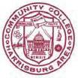

HACC — Central Pennsylvania's Community College
Office of the President | Telephone 717.736.4100
One HACC Drive | Facsimile 717.909.1491
Harrisburg, PA 17110 | Email SKI@hacc.edu
 | www.hacc.edu

August 25, 2014

RE: MB Docket No. 14-57

To whom it may concern:

Thanks to a quality higher education, I was able to alter the cycle of poverty my immigrant family experienced as laborers in our local steel-mill community and attain several college degrees that helped me achieve many of my personal and professional goals. Now, as president of Harrisburg Area Community College (HACC), the Commonwealth’s largest and oldest community college, I see firsthand how engaging business partners in accomplishing our mission of educating many first generation students and immigrants is no longer an option but now an essential “coin of the realm.”

As you review the proposed Comcast-Time Warner Cable transaction, please consider at least the following three contributions Comcast continues to make to improve lives in the areas it serves, especially in our 10-county service region in Central Pennsylvania.

- Comcast has demonstrated its commitment to Central Pennsylvania's neediest families through its pioneering Internet Essentials program. Homes with a child eligible for the National School Lunch Program can now have the untold riches of the Internet available at their fingertips in the home at an affordable price. The educational resources available through the Internet -- not to mention the need to be familiar with technology tools -- are critical to success in school and, later in life, on the job.

- Comcast has offered its Leaders and Achievers scholarship program for nearly 15 years, opening the door to higher education with financial assistance many of our best and brightest students need.

- Comcast is committed to ensuring its employees achieve their post-secondary education by offering a robust tuition reimbursement program for its employees who desire to improve their abilities - either for the job they're in or for other opportunities that match their talents and desires.

In the three years I have been president of HACC, I have been impressed with and grateful for Comcast's commitment to putting education within the reach of so many in our communities who otherwise would not have had an opportunity to achieve their personal and professional goals. Should this transaction be approved, my colleagues throughout the region and nation will learn what we in Pennsylvania already know - that Comcast understands the importance of higher education to success for individuals and vitality of the communities they populate.

That is why I respectively request your favorable review of the Comcast-Time Warner merger.

Sincerely,

/s/ John J. “Ski” Sygielski

John J. “Ski” Sygielski

President
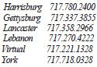

102

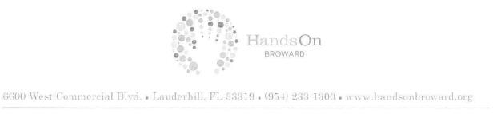

Tom Wheeler

Chairman

Federal Communications Commission

445 12th Street, SW

Washington, DC 20554

RE: MB Docket No. 14-57

Dear Chairman Wheeler:

As President and CEO of HandsOn Broward, one of Florida's largest volunteer organizations, I have seen firsthand the impact of putting people at the center of change. Our mission is to develop volunteer and community investment programs to spread positive change across Broward County. We are lucky to empower more than 600 community non-profits every year. Comcast has been one of our staunchest corporate partners since joining us in 2009. I support the proposed transaction with Time Warner Cable because I believe that Comcast, as a leader in corporate altruism, ought to have the chance to grow.

HandsOn Broward is one large networking agency for activists and beneficiaries. We work to identify causes that require hands-on help, then direct an army made up of individual volunteers and non-profits to reenergize the project. Many of our programs center on youth leadership development. Comcast's youth broadband adoption programs have been a popular option for our local teens and young adults.

Thanks to a generous grant from Comcast, we are now a full-service center for its Digital Connectors Program . This program helps us to target our youth who are looking to serve their communities through technology and leadership. Comcast's Digital Connectors places computer labs and training centers with skilled instructors in dozens of local community hotspots and schools in its service areas. They are safe spaces where students can complete homework assignments and connect to other worlds and ideas. The kids who utilize this program are able to sharpen technical proficiencies and acquire lifelong principles that inspire educational and professional advancement.

Comcast as a company shares in my organization's mission of public service and activism. It hosts the largest, single company day of service each year, called Comcast Cares Day. All over the country, Comcast joins with local organizations and volunteers to clean up local community centers and improve the standard of living for thousands of residents. We have been honored to partner with Comcast on this day for the last several years. Last year we held two events in tandem with Comcast. One was a Human Race 5k Walk and Run that allowed multiple non-profits to participate and fundraise. The other was a park cleanup that included mural painting and landscaping. I am always impressed to see high-level executives roll up their sleeves and work with volunteers from all walks of life to help on these

103

projects. After each year, this day of service brings lasting change to local communities and inspires a new generation of volunteers.

I was proud to name Comcast as our Corporate Partner of the Year in 2010. Since Comcast came aboard in 2009, our organization has advanced on multiple fronts to provide community participants the belief that anything is possible. I look forward to serving hand in hand with Comcast representatives for years to come. I urge the FCC to approve the proposed transaction as quickly as possible so Comcast's community investment programs can continue to expand to other areas.

Sincerely,

/s/ Dale Hirsch

Dale Hirsch

President & CEO

HandsOn Broward

104



Tom Wheeler

Chairman

Federal Communication Commission
445 12th Street, SW
Washington D.C. 20554

Hispanas Organized for Political Equality (HOPE), an advocacy organization that works with legislators, community leaders and nonprofits to advance the interest of Latinas, would like to share with you its experience in working with Comcast. We hope that you take our opinion into consideration as you decide whether or not the Comcast/Time Warner Cable merger should move forward.

Comcast suppons our mission of empowering Latinas, be they young women or seasoned professionals, with digital literacy skills that will alter their future. We have partnered with Comcast to bring its Internet Essentials skills training component to HOPE members and to spread the word about Internet Essentials' availability in our community. Comcast has recently announced that they will be extending Internet Essentials indefinitely. We at HOPE could not be more thrilled by this news as internet access helps all members of a family succeed. Children do better at school and parents have the ability to look for better employment. From our own study "Public Opinion Poll of California Latina Electorate 2009" – Latinas that have access to the Internet and an email address are significantly more likely to be informed about new state laws and the legislative process in Sacramento than Latina voters that are not connected to "new media." They are also more likely to get directly involved in organizations that focus on issues that impact on their careers and the quality of life of their families. We also found that the number one reason a low-income Latino family would purchase a computer and access the internet is to support their child's education, for these reasons ensuring a low cost option to internet access to Latinos is of importance to HOPE.

HOPE applauds Comcast's recent efforts to fulfill their commitment to bringing more diversity into their ranks. In the past three years, the number of women that hold senior-level positions at Comcast has increased by 36 percent. To achieve this Comcast has restructured their recruitment process to attract diversity talent into their hiring pools, directly addressing any shortcomings while many countries would simply claim that they somehow don't attract "the right candidates." Comcast continues to lead the way on the issue of diversity by offering more than 100 internal and external programs such as Comcast's Executive Leadership Career Advancement Program (ELCAP) and Comcast's Women in Leadership program. However, we see this only as a start and would encourage that Comcast not only continue their current diversity efforts but look to recruit a Latina Board member and ensure that in their procurement efforts that they lead the way in contractting with Latina small business owners.

If this proposed transaction is permitted to move forward, we look forward to working with Comcast and regulators to help ensure that there are low cost options to internet access; increased advancement of Latina executives within the Comcast workforce; a Latina to serve on the Comcast board; and increase procurement opportunities are offered to Latina small business owners. HOPE is in support of this merge with the understanding that Comcast will not only continue but grow their current efforts in the Latino community.

Sincerely.

/s/ Helen Iris Torres

Helen Iris Torres

Executive Director

105

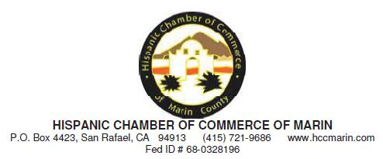

August 25, 2014

Chairman Tom Wheeler

Commissioner Mignon Clyburn

Commissioner Jessica Rosenworcel

Commissioner Ajit Pai

Commissioner Michael O’Rielly

Federal Communications Commission
445 12th Street, SW
Washington, DC 20554

RE: MB Docket No. 14-57

Dear Chairman and Commissioners:

As President of the Hispanic Chamber of Commerce of Marin, I write today to urge the Federal Communications Commission to approve the proposed transaction between Comcast and Time Warner Cable.

The Hispanic Chamber of Commerce of Marin's mission is to support, advance and promote the growth and success of Hispanic businesses and professionals through collaboration, policy-making, networking opportunities and access to resources.

Comcast has been great corporate partner on many of the initiatives that we care deeply about in our community. On the business side, Comcast has invested almost $10 billion in tech and infrastructure in the state since 1996. That outstanding commitment makes growth for all sectors possible and provides valuable business services that empower our community's businesses.

But beyond business, Comcast's corporate citizenship and commitment to the welfare and progress of the Hispanic and other underserved populations in Marin County should be applauded. I have worked closely with Comcast's local leaders as a board member of the Marin and Southern Sonoma Boys and Girls Club and seen how their support of the BGC programs has empowered youth of all walks of life in our community.

1

106

I have also worked very closely with Comcast on the implementation of their Internet Essentials program in our county. In 2013, Comcast, the Hispanic Chamber and other community-based groups organized a digital literacy and broadband adoption outreach campaign to the residents of San Rafael's Canal neighborhood, which is comprised of mainly low-income, Latino families. This campaign culminated in a Family Success Fair at a local school where over 200 local families came and learned about how to access Internet Essentials and find local computer training programs.

As a result of our experience with Comcast and Internet Essentials, and the impact that the program has had on our community, the Hispanic Chamber nominated Comcast for Spirit of Marin Business of the Year Award, which they won. We couldn't have been more pleased.

Now after three years, Comcast's Internet Essentials program has been a resounding success in increasing broadband adoption and digital literacy, not just in our community, but in all of Northern California and has helped more than 35,000 families gain access to the 21st Century broadband technology.

Comcast has demonstrated many times over that cares for our community and places a high value on being a solid corporate citizen.. When considering this proposed merger, please take all of the other families who would benefit with the help of Comcast in other markets in California and throughout the country.

Sincerely,

/s/ Cecilia Zamora

Cecilia Zamora

President

2

107

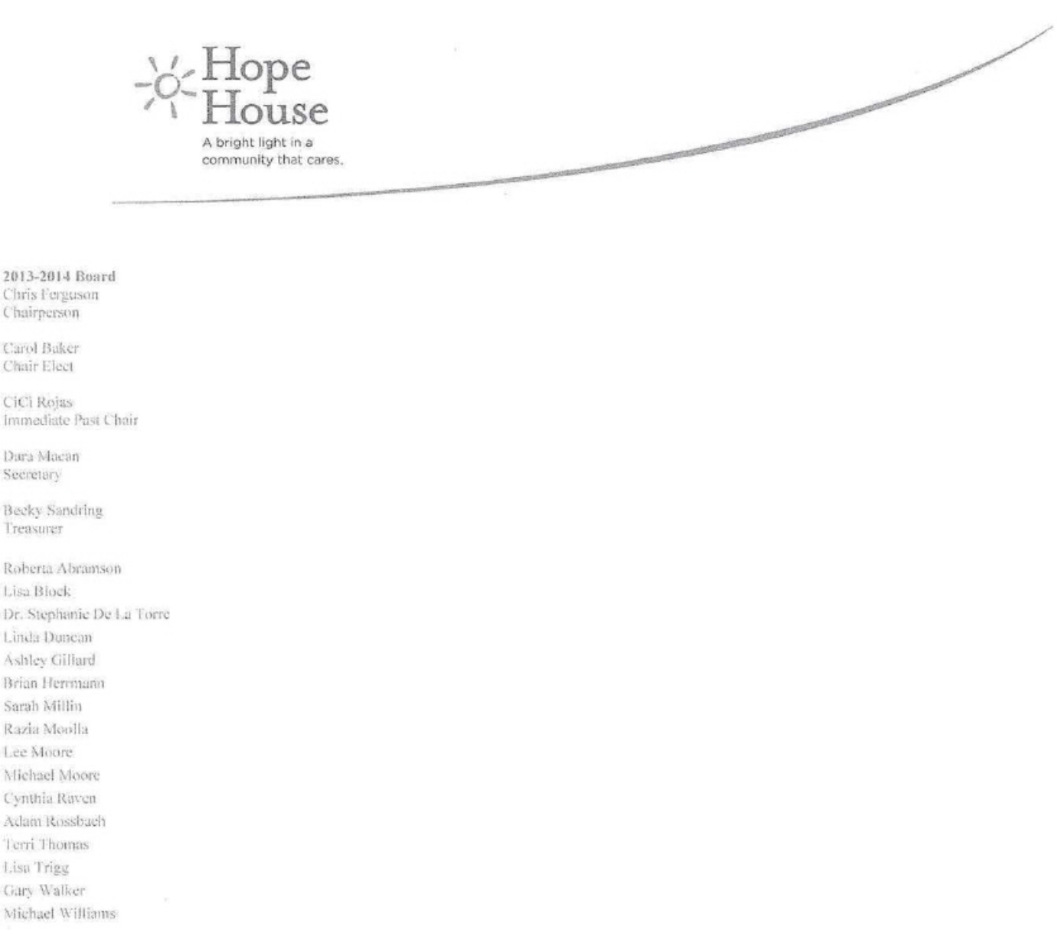

August 22, 2014

Tom Wheeler

Chairman

Federal Communication Commission

445 12th Street, SW

Washington D.C, 20554

RE: MB Docket No. 14-57

Dear Chailman Wheeler:

My name is Maryanne Metheny, and I work as the CEO for Hope House a Domestic Violence Shelter, based in Kansas City. Hope House provides shelter and comprehensive services to survivors of domestic violence, forming a safety net of prevention, education and support for thousands of people traumatized by domestic violence every year.

I write you this letter today to voice my support for the proposed transaction between Comcast and Time Warner Cable. In my time leading Hope House, I've gotten to know Comcast and can personally speak to the company's values as a committed member of the community that really cares about helping out local organizations such as my own.

In our current climate of budget cuts, with an expanding number of clients and a decreasing amount of funding, we rely on volunteer events and fundraising to make sure we are able to function at a high level. I can't tell you how important Comcast's involvement and support has been in helping us accomplish our mission.

Early in 2014, we were lucky enough to be chosen as a recipient for Comcast's annual Comcast Cares Day. Comcast Cares Day is the nation's largest single-day corporate volunteer effort. This year, nearly 175 Comcast employees, as well as their family and friends, came to Hope House to volunteer. The amount of work that the Comcast employees did that day would have taken our staff months to accomplish, as they painted, cleaned, and landscaping work around our site.

P O Box 577

Lee's Summit, Missouri 64063

816 461 4188

hopehouse.net

108

Further, Comcast has given me a platform to broadcast Hope House's message, in the form of Comcast Newsmakers. Comcast has hosted my organization and me several times, to provide airtime at their own expense to promote the messages and spread the word of organizations like mine that are all trying to make positive impacts on their respective communities.

Comcast's efforts have been truly impressive and have made a world of difference at Hope House. I hope that the FCC will approve the proposed transaction so that Comcast will be able to make a wider impact on organizations like mine. As budgets decrease, corporate volunteer work will become increasingly important for nonprofit organizations to flourish, and we need to do everything that we can to encourage and maintain the companies that truly care. I can tell you from firsthand experience that Comcast truly cares.

Sincerely,

/s/ MaryAnne Metheny

MaryAnne Metheny

CEO

109

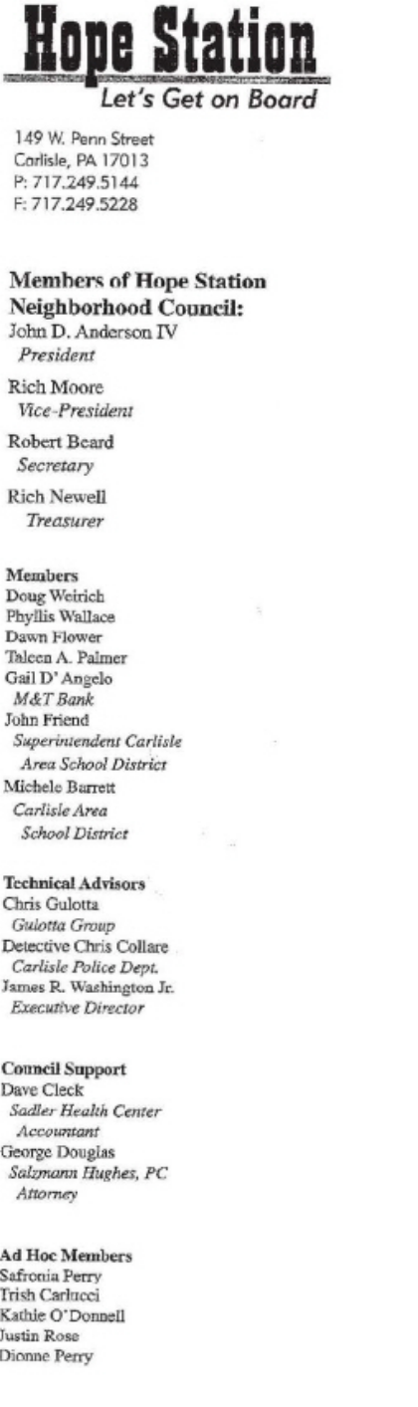

August 23, 2014

Chairman Tom Wheeler

Commissioner Mignon Clyburn

Commissioner Jessica Rosenworcel

Commissioner Ajit Pai

Commissioner Michael O'Rielly

Federal Communications Commission
445 12th Street, SW
Washington, DC 20554

RE: MB Docket No. 14-57

Dear Chairman and Commissioners:

On behalf of the Hope Station Neighborhood Council, I'm writing to support Comcast's offer to purchase Time Warner Cable. Please accept this public comment as we our a community partner of Comcast. They have been a great supporter of Hope Station.

We appreciate giving people like Comcast, who have such a strong concern to help further our mission in the Hope Station Opportunity Area

Thanks for being on "Board"

Sincerely yours,

/s/ James R. Washington, Jr.

James R. Washington, Jr.

Executive Director


110

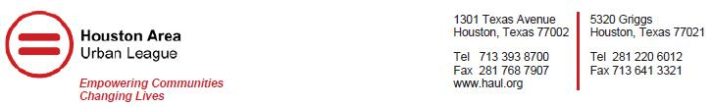

August 22, 2014
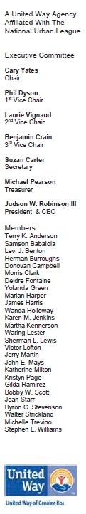

Tom Wheeler, Chairman

Federal Communications

Commission
445 12th Street, SW
Washington, DC 20554

RE: MB Docket No. 14-57

Dear Chairman Wheeler:

At the Houston Area Urban League, Inc. (Urban League), we are proud to affiliate with organization, whether for profit or non-profit, that work to create a more equitable society. The mission of the Urban League is to enable African-American and other minorities to secure economic self-reliance, parity, power and civil rights. We partner with Comcast because their work as servants in the community and aim to educate and uplift directly align with our work. I support the proposed transaction between Comcast and Time Warner Cable because I applaud their work on inclusive media and diversity initiatives.

In America, we know that a better education and better resources are integral parts of securing a better career and life. However, many of our black communities statistically, lag behind. To correct this issue, the Urban League developed a STEM education program to help improve the math and science skills of young people of color. Comcast contributes towards this goal with their Internet Essentials program, which works towards the goal of closing the digital divide with discounted broadband for low-income families. If a student qualifies for free or reduced school lunch, the family qualifies to apply for Internet Essentials, which costs less than ten dollars a month. About 30% of Americans are on the wrong side of the digital divide, many of whom live below the poverty line. This program addresses a boundary which puts too many children at an educational disadvantage. If the proposed transaction was approved, Internet Essentials would become available to many more families in need, including our neighbor to the North, Dallas, TX.

In addition to greater broadband adoption in low income communities, Comcast has helped to broaden our initiatives in healthcare and equal opportunity. In 2011, Comcast provided the National Urban League with airtime for the "I Am Empowered" campaign. This campaign called on community members to pledge their support, time and talent to ensure that every American has access to good jobs, a quality education, affordable housing and quality and affordable healthcare. This message would not have been able to be delivered without the help of our friends at Comcast. Furthermore, Comcast employs their digital literacy training in centers across Houston. Here, families can attend free classes on computer basics in order to learn how to best utilize technology for healthcare, education, employment and communication. Comcast also reflects these goals on a personal level, through the commitment of their employees. Every year, Comcast employees donate their time on "Comcast Cares Day," where we have hosted volunteer activities at the Urban League.

At the Urban League, we are empowered to make a difference; to close the digital divide; to build 21st Century communities; and to educate minority communities that are often disenfranchised. We are grateful to Comcast for being a part of this journey to also educate and empower our people.

I am proud to add my name to those who support Comcast Corporation joining with Time Warner Cable. I know that this transaction would only enhance the company's community partnerships and I urge you to approve this agreement.

Sincerely,

/s/Judson W. Robinson III

Judson W. Robinson III

President & CEO

111


14 Heritage Center

University of Utah

Salt Lake City, Utah 84112

P. 801.587.0825

inclusioncenter.org

August 25, 2014

RE: MB Docket No. 14-57
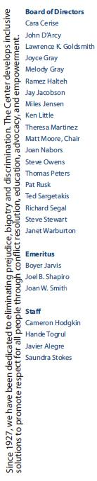

Tom Wheeler, Chairman

Federal Communications Commission

14-57
445 12th Street, NW
Washington, DC 20554

Dear Chairman,

I am Saundra V. Stokes, Executive Director of the Inclusion Center for Community and Justice. The Inclusion Center is committed to bringing individuals and groups from diverse backgrounds together to increase mutual understanding and respect. The purpose of this letter is to encourage the Commission to approve the Comcast and Time Warner Transaction. Through the transaction, more communities will be able to benefit from the accessibility of our services and continue to enjoy the economic benefits we have seen from Comcast which have been investing in closing the digital divide in many neighborhoods.

The programming that Comcast provides is diverse, offering perspectives from many communities and cultures. Many of the networks on Comcast are independent and minority-owned, and its programming evolves to meet the demand for quality content from not only Hispanic communities but other viewers from an array of diverse backgrounds. Comcast is also committed to employing minorities in its locations throughout Utah, and I understand that the company seeks guidance on its efforts to be an inclusive employer nationwide.

In addition, the Comcast's Internet Essentials program is also needed in many of our marginalized communities that have been particularly hit hard by economic strife. Internet Essentials offers home internet access to families that have children who are eligible to participate in the National School Lunch program. Qualified families receive Internet Access at home for $10 dollars a month, and can purchase a low cost computer through the program.

We appreciate Comcast’s support of organizations such as ours along with many other nonprofits in our state, they are a great community partner. The philanthropic support Comcast provides to surrounding communities helps lessen the financial burdens on families and neighborhoods. Again, I encourage you to approve the Comcast and Time Warner Transaction. Thank you for your time and consideration.

Respectfully,

/s/ Saundra V. Stokes

Saundra V. Stokes
Executive Director

Inclusion Center for Community & Justice

112

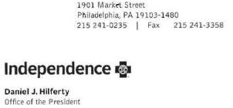

August 12, 2014

Tom Wheeler

Chairman

Federal Communications Commission

445 12th Street SW

Washington, DC 20554

Re: MB Docket No. 14-57

Dear Chairman Wheeler:

Independence Blue Cross, one of America's leading health insurers, strongly supports the proposed transaction between Comcast Corporation and Time Warner Cable, Inc. As a fellow corporate citizen of Philadelphia with a 20 year relationship with Comcast, Independence is in a unique position to tell the Commission aoout Comcast's unrivalled commitment to public service. As president and CEO of a company that serves nearly 9 million people nationwide, I think every day about ways in which we can improve the health and lives of those who live in the communities that we serve. Through our decades-long relationship with Comcast, I know that this is of paramount importance to them as well. Permitting this transaction would allow Comcast to help even more people in more communities across our nation.

Leading in the Community

At Independence we care deeply about ensuring that families in low-income communities have access to health coverage and other critical services. This is a value that we share with Comcast. For example, Comcast has dedicated itself to providing internet access to low-income families across America through its Internet Essentials program. In today's economy, having internet access at home is critical. This program brings broadband internet into the homes of over one million low-income Americans, creating greater access to education and employment. The proposed transaction will allow Comcast to deliver this service to more of our citizens, whose future success in our society is partially dependent on reliable internet access in the home.

Championing Corporate Social Responsibility

Comcast is an integral part of our city and our region, partnering with numerous charitable organizations that provide support and assistance to those in need. In fact, the Comcast Foundation has contributed over $145 million to philanthropic causes just in the last 15 years alone. I am confident that if the Commission approves the proposed transaction, Comcast's commitment to public service and philanthropy will only continue to grow, allowing them to reach even more people in more communities all across America.

113

Letter to Tom Wheeler

August 12, 2014

Page Two

Promoting Diversity

Another shared value between Independence and Comcast is our commitment to diversity, ensuring that the voices of people from a wide variety of backgrounds and cultures are heard throughout America. Comcast celebrates diversity through its hiring practices and numerous charitable efforts, but approval of the proposed transaction with Time Warner will allow it to do so much more. Comcast and Time Warner have committed to supporting ten new cable channels, most minority-owned, giving consumers even more options for enjoying multicultural content that is truly representative of America.

Forging Innovation that Benefits Us All

Like Independence, Comcast has a passion for bold, industry-transforming innovation efforts. Comcast is constantly exploring new, groundbreaking technology that will bring its high-quality services to as many people in as many homes as possible, from urban centers to rural towns. With the promising technological developments in the health care sector, such as electronic medical records and increasing use of informatics, Independence looks forward to collaborating with Comcast, pairing our innovation efforts to fundamentally transform health care, increasing access and quality and lowering costs. Together with Time Warner, Comcast will be able to do even more, bringing new innovations to more Americans and creating a stronger, more reliable national broadband infrastructure that will benefit all of us.

The FCC must determine how the proposed transaction will contribute to the public interest. Independence has partnered with Comcast for over 20 years and we've seen first-hand their commitment to serving our community. Coamcast is such a tremendous champion in Philadelphia and elsewhere that I felt compelled to tell you how strongly I support the company's vision. I urge the Commission to approve the proposed transaction.

Respectfully,

/s/ Daniel J. Hilferty

Daniel J. Hilferty

114



August 22, 2014

Tom Wheeler

Chainnan

Federal Communications Commission

445 12th Street, SW

Washington, DC 20554

RE: MB Docket No. 14-57

Dear Chainnan Wheeler:

This is to express my support of the application for FCC approval of the proposed transaction between Comcast and Time Warner Cable.

As the leader of a Hawaii-based company whose business is dependent upon a healthy economy, I strongly support measures that will lead to strengthening the telecommunications network in our State. Based upon what I have leamed about Comcast's plans for improving Hawaii 's internet infrastructure through expansion of bandwidth and providing greater internet access to citizens throughout the state, I believe the combination of Comcast and Time Warner Cable will facilitate such an outcome.

Because of Hawaii's geographic isolation and with a population dispersed over six non-contiguous islands, operating in this state poses a unique set of challenges for internet providers. Comcast, however, has the financial capacity and long-term vision necessary to make the significant investments required to upgrade the technological resources required to deliver and maintain levels of internet service that will keep Hawaii economic competitiveness on a par with other communities around our nation and the world.

I am particularly impressed with Comcast's experience in expanding access to internet services for low income families through its Internet Essentials program which offers discount internet service. If Comcast can provide low cost access to the estimated 28.5% of our population who currently lack such service, it would be a huge boon to our community. The impact of providing such a large segment of our population with internet service would have tremendous ramifications educationally, economically, and in so many other positive ways.

I therefore believe that the combined Comcast-Time Warner enterprise will bring needed investments and new opportunities for growth to Hawaii's economy. I hope the FCC will speedily approve this transaction so the benefits it offers to our State can be soon realized.

Sincerely,

/s/ Colbert M. Matsumoto

Colbert M. Matsumoto

Chairman & CEO

Island Insurance Company, Ltd.

115

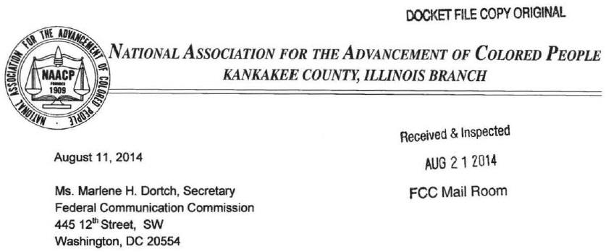

"RE: MB Docket No. 14-57."

Dear Ms. Dortch:

Through my time with the NAACP lllinois Conference of Branches, we've all worked toward the goal of ending racial discrimination and bias, including inequality in jobs, education and opportunity. I'm currently the president of the Kankakee branch and have had the great pleasure of working with Comcast in supporting these goals. I support the proposed transaction with Time Warner Cable in hopes that other communities across the nation will be able to have the benefit of Comcast's partnership.

Comcast is genuinely committed to fostering a diverse employee base. The company has been recognized by organizations like DiversityBusiness.com, Equal Opportunity Magazine, and Diversity Inc. for being a top organization to work for. On a national level, the NAACP praises companies that understand the importance of minority outreach in employee recruitment. Diversity is more than ethnicity - it is also important for unique perspectives and ideas in the workplace. We can confront injustice by supporting companies like Comcast, in turn encouraging corporations across the country to get serious about their dedication to diversity. If the proposed transaction between Comcast and Time Warner Cable is approved, it will carry these practices on to a larger footprint across the country.

Together with Comcast, the Kankakee County NAACP has worked to promote the Internet Essentials program, which provides low cost broadband services to low income families. Greater broadband adoption directly impacts minority communities, and empowers our children through technology. Today a child without computer and Internet access at home is put at a great disadvantage, making it harder to learn outside the classroom. Equal opportunity to education is a right every child should have, no matter their ethnic or income background. Internet Essentials has connected over 350,000 families across the nation who otherwise might not have been able to afford it. In Illinois, I understand that around 40,000 families have been connected.

116

I know the possibility for positive impact of this program could be so much more. I believe that the expanded offering of this program is one of the greatest reasons for approval of the proposed transaction between Time Warner Cable and Comcast so that this program can touch the lives of more families across the nation, in ways that it has right here in Kankakee.

The Kankakee NAACP has been lucky to have Comcast as a partner through its initiatives that improve life for African Americans.

I believe in the positive impact of Comcast, and encourage the approval of the Time Warner Cable transaction.

Sincerely,

/s/ Theodis Pace

Theodis Pace, President

Kankakee County NAACP

117

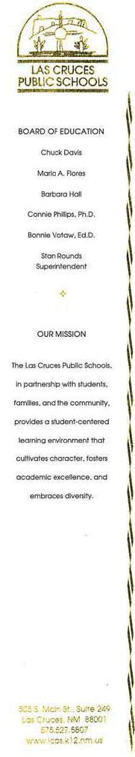

August 25, 2014

Federal Communications Commission

RE: Letter of Support Comcast Cable/Time Warner Cable

Dear Sir or Madam:

Las Cruces, New Mexico houses the second largest public school district in the state, representing 39 schools, approximately 25,000 students, and 3,800 employees. The Las Cruces Public School District is supported by the Las Cruces Public Schools Foundation, a private, non-profit corporation, with a mission to raise funds, provide financial help for student centered projects, and improve the quality of classroom learning experiences.

It has come to my attention that the Federal Communications Commission is currently reviewing Comcast Cable's proposed merger with Time Warner Cable. I write you today in support of the proposed merger. As Superintendent of Schools for the Las Cruces Public School District, I have experienced firsthand the commitment that Comcast Cable has shown toward improving our communities and schools.

One of the most concrete ways that Comcast Cable has shown its commitment has been the annual Comcast Cares Day. 1 have read that Comcast Cares Day is the nation's largest single day corporate volunteer event. I am proud to say, Las Cruces Public Schools held the nation's most attended Comcast Cares Day. in 2013. Held at Doña Ana Elementary School, Comcast and its partners were able to attract 1,500 volunteers, which was the largest number of volunteers at any Comcast Cares Day event in 2013. As Las Cruces is in a Comcast Cable market, we are able to enjoy the benefits that come with a company so invested in community involvement. If Comeast Cable were to merge with Time Warner Cable, the Comcast Cares Day event would reach new school districts near and far.

I would also like to commend the tremendous efforts Comcast Cable has made over the last four years to bridge the digital divide and bring broadband to more of our students. In 2011, John Christopher, New Mexico State Director for Comcast Cable, announced the launch of Internet Essentials, a program that offers discounted Internet service to low-income families. Today, Internet access is an essential and basic requirement for a successful education, as we work to

118

take our curriculums online, and make them instantly accessible from anywhere. Since the 2011 launch of that program, Comcast Cable has experienced exponential growth, and has connected more than 7,000 families in New Mexico to the Internet. Each year there is an increase of families that enroll in the program.

Comcast Cable is leveling the playing field so that all our students can have the resources they need to thrive and succeed. If Comcast Cable were to merge with Time Warner Cable, the Internet Essentials program would be able to reach many more students in cities like El Paso, Los Angeles, Dallas, and New York, and would be able to take a large step in decreasing the digital divide.

Children in New Mexico and communities across the nation deserve equal access to the tools and opportunities that give them the best chances of succeeding and becoming leaders. I know that Comcast Cable has made this one of its main goals, as it recently announced the indefinite extension of Internet Essentials. If a merger between Comcast Cable and Time Warner Cable means that all our students will be supplied with the tools needed for success in today's electronic age, then I support that merger, and I hope that you will too.

Sincerely,

/s/ Stan Rounds

Stan Rounds

Superintendent of Schools

/tg

xc:

Commissioner Ajit Pai

Commissioner Michael O'Rielly

Commissioner Mignon Clyburn

Commissioner Jessica Rosenworcel

119



August 25th, 2014
Chairman Tom Wheeler
Commissioner Mignon Clyburn

Commissioner Jessica Rosenworcel

Commissioner Ajit Pai

Commissioner Michael O’Rielly

Federal Communications Commission
445 12th Street, SW
Washington, DC 20554

RE: MB Docket No. 14-57

Dear Chairman and Commissioners:

I am writing from the Florida-based Latin American Business Association (LABA) to comment on the proposed Comcast and Time Warner Cable transaction.

Comcast has been a very important community partner in the activities that we do to advocate for our 500-plus members on a regional to international level. We respectfully request that you approve this proposal to encourage the growth of partnerships like ours.

The LABA is one of many organizations to have a long-standing and fruitful relationship with Comcast since its arrival in the telecommunications marketplace. Many Comcast executives hold positions on local boards.

This type of commitment is not unusual for Comcast. Their volunteers are more than figureheads - they get things done when it comes to building business connections and leading and volunteering for community improvement projects.

Comcast has also worked very hard to reach out to low-income families who have no computer or Internet service. Its Internet Essentials program started in 2011 and, within just three years, was able to get quality affordable web service into more than 26,000 homes in the Miami region.

The company has longstanding hiring practices that have led to diversity within its staff, managers and top executives. We consider Comcast programming to be very progressive in terms of diversity. It has more Spanish language channels than any other network.

Obviously, one of the most important things for us, as an agency with national and international partners, is Comcast's high-speed connectivity and its advanced network that is capable of handling our ever-changing demands for capacity and custom services.

Comcast has proven itself to be a company that businesses and families can rely on. It is a company that settles into communities and takes an active role in improving things. Please give this proposal the approval it deserves.

Sincerely,

/s/ William J Delgado

William J Delgado

President


120



August 25, 2014

Chairman Tom Wheeler

Commissioner Mignon Clyburn

Commissioner Jessica Rosenworcel

Commissioner Ajit Pai

Commissioner Michael O’Rielly

Federal Communications Commission
445 12th Street, SW
Washington, DC 20554

RE: MB Docket No. 14-57

Dear Chairman Wheeler and Commissioners:

We write to you today from one of the only publications in the country to cover public policy and politics from a specifically Latino perspective. We keep our ears close to the ground, and are intimately acquainted with the challenges and opportunities facing our community in the public sphere.

As you know, Hispanics make up 16.3% of America’s population, or 52 million, and represent America’s largest minority group. Moreover, the rate of growth of the Hispanic community in America will reach 25% within the next generation. That is a fast clip that has daunting implications to America’s communication and cable sytems.

Comcast is a company with a weighty record of collaboration with diverse communities. We understand that their partnerships could expand to the substantial Latino communities of Los Angeles, Dallas, and New York upon approval of the proposed Comcast-Time Warner transaction. Please approve this transaction to help ensure the company's continued devotion to Latinos and people of color nationwide.

When diverse viewers tune into Comcast's cable coverage, they can count on a wide array of programs that highlight our country's diversity. The company is America's largest provider of Spanish cable networks. They offer over 60 dedicated channels, including independent channels created by Hispanic talent, like BabyFirst Americas and El Rey. We understand that Comcast offers more than 160 independent channels, many of them minority-owned. The company has announced plans to add 10 new independent networks following approval of this transaction. We are hopeful that the company will continue to deepen its dedication to the promotion of multicultural talent.

Comcast hires and develops Latino and minority business leaders to deliver their world-class cable and broadband service. We understand that since 2011, Comcast has increased the number of people at and above the VP level over 30%. People of color already make up nearly 20% of the company's upper level management. These established and emerging leaders are committed to excellent supplier contracts from diverse sources. Comcast spent over a billion dollars on diverse top-tier suppliers last year. Comcast has increased spending with minority-owned suppliers and vendors by about 20% since 2011. We are hopeful that this cultivation of vibrant business leadership will enrich our country for years to come.

121

Comcast's vision of an inclusive future shines forth in its efforts to close the digital divide in Internet access between rich and poor. Without home access, young people and families miss out on essential educational and professional opportunities. Comcast's Internet Essentials program has already connected over a million Americans to low-cost home Web service and discounted computer hardware.

Many Latinos unfortunately live in our nation's most underserved urban centers. We understand that Comcast has indefinitely expanded the Essentials program. The number of eligible low-income families will only get bigger following the extension of Comcast service upon approval of the transaction.

Please approve this transaction to give our current and future leaders the tools and networks they need to succeed throughout the country and throughout this century.

Sincerely,

/s/ Jose L. Perez

Jose L. Perez

Publisher

jperez@latinojournal.net

916.752.4386

122



August 18, 2014
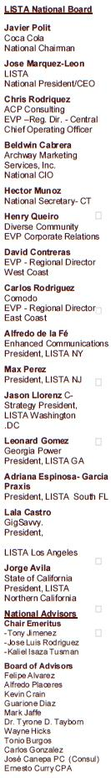

Chairman Tom Wheeler

Commissioner Mignon Clyburn

Commissioner Jessica Rosenworcel

Commissioner Ajit Pai

Commissioner Michael O’Rielly

Federal Communications Commission
445 12th Street, SW
Washington, DC 20554 RE: MB Docket No. 14-57

Dear Chairman and Commissioners:

On behalf of the Latinos in Information Sciences and Technology Association (LISTA), I would like to express our support for the proposed Comcast - Time Warner Cable transaction.

The goal of LISTA is to empower Latino technological and scientific engagement, broaden awareness of the impact Latinos are currently having on these sectors, and represent their overall interests in the digital information age. The thriving technology industry is the future for our country and our community.

At LISTA, we are committed to supporting Latinos who work in the science, health informatics, mathematics, information sciences, new media, telecommunications and technology sectors. Latinos need to grow and evolve in this sector for the U.S. workforce to remain competitive.

When I co-founded LISTA in 2000, I envisioned working with organizations and companies, like Comcast, that not only incorporate diversity and inclusion programs in their business model, but also appreciate the importance of diversity within the industry. LISTA has a strong history of collaboration with Comcast to increase Latinos participation in the workforce, and we are confident that Comcast will continue build upon its record of diversity within its workforce. We admire the work that Comcast has done to increase diversity in the industry, both internally within the company and externally with suppliers.

In addition to its commitment to a diverse workforce, Comcast has demonstrated a commitment to upgrading and modernizing the broadband networks in the areas it would acquire in the proposed transaction with Time Warner Cable, and this would provide meaningful benefits to those communities.

LISTA Mission has always been to educate, motivate and encourage the use of technology for the empowerment of the Latino community in order to conquer the digital divide. LISTA strongly believes that providing education, mentoring, business networking and services that enhance personal growth are the keys to providing professionals, executives, entrepreneurs and students with a pathway from the schoolroom to the boardroom.

LISTA partnership with Comcast’s Internet Essentials initiative, the largest broadband adoption program in the country, is why we recommend this merger happens simply put it goes hand-in-hand with our philosophy and is a step in the right direction towards shrinking the digital divide. Approval of the transaction between Comcast and Time Warner Cable would enable Internet Essentials to have even greater reach and more success throughout the country.

Through Internet Essentials, LISTA has helped thousands of families in Atlanta, New York, Sacramento and Washington, DC and shown them the benefits of broadband as they obtain digital literacy skills to write resumes, access education information and apply for college, as well as start small businesses.

I hope that the Commission takes the work that Comcast has done to promote diversity within the industry into consideration when evaluating the proposed transaction between Comcast and Time Warner Cable.

Thank you in advance for your time and consideration.

Cordially,

/s/ Jose A. Marquez

Jose A. Marquez

National President/CEO and Founder

123

August 25, 2014

Federal Communications Commission

445 12th Street, SW

Washington, DC 20554

RE: MB Docket No. 14-57

Dear Chairman and Commissioners:

Funding for nonprofits is getting tighter and tighter. As the Resource Development & Marketing Director for Lawrence CommunityWorks, I see firsthand the struggle to continue our mission of revitalizing our city. When we need assistance, we can turn to Comcast, and for that reason I am writing today to ask the FCC to approve the pending transaction with Time Warner Cable.

Comcast has been dedicated in finding a way to support organizations like mine. Lawrence CommunityWorks was founded by affordable housing activists, and we are still committed to affordable housing, but we have expanded our mission to include building community, enhancing civic engagement and engaging in collective action for the common good.

The Movement City Youth program is one of our most successful programs. We provide academic support for young people plus different avenues to participate in and experience creative arts and technology. Comcast has become one of the leading sponsors of this program, aimed largely at disadvantaged youth. Our summer program this year included a Theater and Improv Camp, a Sports Camp and a Young Inventors Camp. Applications for these camps increase every year, and we are very grateful for Comcast’s support.

Lawrence is also a site for Comcast Cares Day. A record number of volunteers, largely drawn from Comcast employees, their family members and friends, worked at 50 sites doing beautification projects ranging from trash pick up to painting to landscaping. It was an awe-inspiring day.

We need community partners like Comcast to revitalize our city. We are happy to have Comcast in our corner. I cannot help but feel that if Comcast extends its basic services into new areas, it will extend its philanthropy as well. Please approve the transaction with Time Warner Cable.

Kind regards,

/s/ Kristin A. McCauley

Kristin A. McCauley

Resource Development & Marketing Director

Our House Campus 168 Newbury Street Lawrence, MA 01841

124


Tom Wheeler

Chairman

Federal Communications Commission
445 12th Street, SW
Washington, DC 20554

RE: MB Docket No. 14-57

Dear, Chairman Wheeler:

For the past 5 years, I have served as Vice President and COO of Leadership Greater Washington. I served in that position alongside Tim Kime who, until very recently, was the President and CEO for the last 14 years. Leadership Greater Washington is a community leadership organization devoted to identifying and connecting diverse leaders and stimulating their collaborative efforts through dynamic education and membership programs that promote dialogue, cooperation and involvement, enabling area leaders to find effective solutions to regional challenges.

It has come to my attention that the Federal Communications Commission is currently reviewing the proposed transaction between Comcast and Time Warner Cable Company. I write this letter to voice my support for Comcast and the proposed transaction. In the time I spent at the helm of Leadership Greater Washington, I interacted with Comcast on several levels, and can personally attest to Comcast's commitment to community investment and building tomorrows leaders.

Last year, in 2013, Comcast supported the Youth Leadership Greater Washington career development and community awareness program for high school sophomores and juniors. The six-month program offers instruction on public speaking, interviewing, financial management, dressing for success and securing internships. Comcast even sent two executives to the program to teach basic networking skills to one of our classes.

Comcast's involvement with Leadership Greater Washington represents only a fraction of the community involvement the company has committed to in the D.C. area. Comcast's tireless efforts to decrease the digital divide; expand digital literacy; promote leadership in classrooms, communities, and businesses; and make broadband adoption a feasible goal have had an enormous impact on the area, and I expect the company to continue to broaden the scope of its philanthropic work as time goes on. The proposed transaction I write you in favor of today will only increase Comcast's reach to many more citizens.

As the interim CEO, I look forward to continuing the supportive longstanding relationship with Comcast. It is of vital importance for our community that Comcast continues the philanthropic work it has devoted itself to, and I am confident that it will do so. The proposed transaction, if accepted, will only foster its ability to become a stronger community partner.

Sincerely,

/s/ Mioshi Moses

Mioshi Moses

Interim President and CEO

Leadership Greater Washington

1602 L Street, NW | Suite 950 | Washington, DC 20036

202.465.3200 | www.lgwdc.org

125

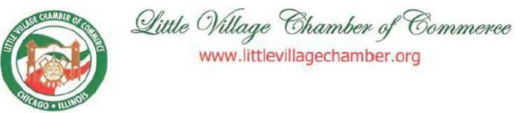

Tom Wheeler

Chairman

Federal Communications Commission

445 12th Street, SW

Washington, DC 20554

Dear Chairman Wheeler:

We write to you today from the largest Mexican community In the Midwest. Little Village is home to more than 1,000 businesses in Chicago's West Side. We at the Little VIllage Chamber of Commerce work to promote our vibrant neighborhood's business community through advocacy, training, and commercial development. Comcast has been a dedicated community partner that supports our residents and their ideas, whether they are rich or poor, young or old, Spanish- or English-speaking.

We urge you to approve the proposed Comcast-Time Warner Cable transaction because it will extend the power of Comcast's business and community collaborations to new communities across the country .

Comcast's enterprise services and cable offerings enable our Chamber's businesses to meet the challenges of our diverse community and country. We understand that Comcast home and business broadband speed is substantially faster than that of competitors at similar tiers of service, including Time Warner Cable. In a city as diverse as ours, businesses need to know who their clients are and where to reach them. Comcast's current and future proposed advertising programs will offer businesses the ability to market to customers with the highest levels of precision, whether the business is a taqueria on 26th Street or a Fortune 500 company. Their industry-leading addressable advertising and digital ad insertion programs enable businesses to connect to the right client base and customers to find services they need on their communities.

These services for business exist alongside services for average cable customers. In our community, many citizens are most comfortable speaking and working with Spanish in their everyday lives. Comcast is the largest provider of Spanish language networks on the country. They also offer more than 160 independent networks, giving Comcast customers easy access to programming tailored to their interests and communities, even in neighborhoods as diverse as the Little Village.

126

The company also has devoted resources to programs that will benefit the Little Village for years to come. Comcast has vigorously deployed its Internet Essentials program in Chicago. Over 30,000 families have already connected to low-cost home Internet services and the opportunity for free training and discounted computer hardware. The children in these families will now be empowered with the technology they need to carry their educations and visions for the future forward in our digital economy. This program builds off of Comcast's more typical community investment. Community programs like Digital Connectors and Comcast Cares Day link residents, businesses, community organizations, and employees to build a more prosperous future city, together.

More communities across the nation will benefit from their association wtlh Comcast if the proposed transaction is allowed to happen. Please grant your approval to make that possible.

Sincerely,

/s/ Jaime di Paulo

Jaime di Paulo

Executive Director

127



August 25, 2014

Mr. Tom Wheeler

Chairman

Federal Communications Commission
445 12th Street, SW
Washington, DC 20554

RE: MB Docket No. 14-57

Dear Chairman Wheeler,

I am writing to voice the support of the Los Angeles Area Chamber of Commerce for the proposed transaction between Comcast and Time Warner Cable. Since 2006, I’ve worked as the President & CEO of the Los Angeles Chamber of Commerce. The Chamber is the largest business association in Los Angeles County. We represent over 1,600 member companies and serve the common interest of over 235,000 businesses in the Los Angeles region. As you know, Los Angeles is currently a major Time Warner Cable market.

We are excited about the economic benefits that the Comcast/Time Warner Cable transaction would bring to Los Angeles. The investments that Comcast has committed to make in upgrading the Time Warner Cable systems will drive other Internet providers in our area to invest in innovation in order to remain competitive. AT&T just recently announced the expansion of their broadband investment to do just that. The Los Angeles Chamber of Commerce has always been committed to supporting free-market competition and promoting collaboration in order to allow its members to grow, and we firmly believe that Comcast’s transaction with Time Warner Cable will benefit the economy of our region.

Comcast has proven itself to be a leader when it comes to investment in innovation and infrastructure development in the business world. Since hearing about the transaction, I’ve been researching the investments Comcast has made over the past several years. What we’ve learned has made me quite optimistic. Comcast has invested billions of dollars in network and next-generation technologies. The company has increased its broadband speeds 13 times in the last 12 years. Every 18 months, Comcast doubles the capacity of its network. Further, Comcast offers faster broadband speeds than Time Warner Cable does, with Comcast’s most popular broadband tier offering 25 Mbps (compared with Time Warner Cable’s 15 Mbps). If approved, Comcast has committed to upgrade the acquired systems, and this can only help Los Angeles businesses maximize efficiency, speed, and communication.

128

Further, Comcast has proven that it will live up to and even exceed the promises it makes. This track record gives us confidence that the company will live up to expectations, if this transaction is approved. In 2010, in advance of its transaction with NBCUniversal, Comcast promised to expand its broadband network by at least 1,500 miles per year for three years. In that time, however, Comcast extended its network by over 6,000 miles, far exceeding the 4,500 miles promised.

We strongly urge you to approve the proposed transaction between Comcast and Time Warner Cable. We are confident that the transaction will have a strong economic impact on business by stimulating growth and good employment opportunities for Los Angeles.

Sincerely,

/s/ Gary L. Toebben

Gary L. Toebben

President & CEO

Los Angeles Area Chamber of Commerce

129

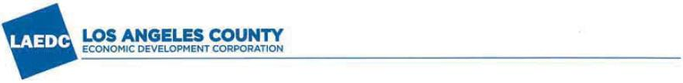

August 21, 2014

Tom Wheeler

Chairman

Federal Communications Commission
445 12th Street, N.W.
Washington, DC 20554

Re: MB Docket 14-57: Comcast acquisition of Time Warner Cable- SUPPORT

Dear Chairman Wheeler:

On behalf of the Los Angeles County Economic Development Corporation (LAEDC), an organization dedicated to promoting job growth, economic expansion and increasing the overall global competitiveness of Los Angeles County and the State of California, please accept this letter in support of the proposed transaction between Comcast Corp. ("Comcast") and Time Warner Cable Inc. ("Time Warner"), under which control of the licenses and authorizations held by Time Warner and its wholly-owned and controlled subsidiaries will be transferred to Comcast.

- Comcast -Time Warner: Converging to Compete

The Comcast-Time Warner transaction can be best summed-up in one word: "convergence." Let's be clear, innovation in the 21st Century doesn't simply happen in R&D labs, research universities, dorm rooms and makeshift office-garages. In today's hyper-connected world, technological innovation is also spurred by different businesses with established track records and emerging specializations coming together and scaling-up in rapidly changing marketplaces to provide consumers with innovative products, more choices and options, and better service at a reduced cost.

At the macro-level, the convergence of industries as diversified (and sophisticated) as entertainment, information technology, broadcasting, cable, publishing, digital media and others is, in large part, responsible for the creation of many new disruptive technologies and entirely new industries that have (over the last 15 years) changed the way we live, play, learn, interact and do business, as well as providing customers with an increasing and dizzying array of choices. According to the Brookings Institution, which recently published a report that looked at this convergence of industries around technology:

"Recent analysis ... found tech industries to be less focused on building new technologies but rather 'applying technology to traditional industries like media.' These shifts reinforce and reinterpret nations of proximity and density... [in other words], today's technology revolution is much less about creating the infrastructure

130

and plumbing far the Internet, but about applying technology to traditional industries. " ¹

No area is more indicative of this phenomenon than the union of media, cable and IT. Convergence in video distribution and communications technologies has changed the competitive landscape dramatically in recent years, with an increasing number of households moving away from traditional cable towards other distribution technologies. Just look at the ever-growing, cash-rich list of competitors to Comcast in DSL, cable, wireless and content distribution, ranging from AT&T and Verizon to DirecTV and Dish to Apple, Yahoo, Netflix, Hulu, Google and Facebook.

And while Comcast has been at the vanguard of innovation for more than a quarter century, we believe the combination of Comcast and Time Warner is necessary (for both entities) to compete and ultimately weather the current upheaval in the cable and Internet industries. By coming together, we expect the combined Comcast-Time Warner entity to use its increased scale and combined specializations to accelerate the pace of technological innovation and application even further for the ultimate benefit of consumers.

- Comcast: A History of Community Stew ardship

This transaction is about more than revenues, market share and stock prices, and Comcast is more than just a broadcasting and cable company. Comcast has proven itself to be an outstanding corporate citizen. Here in Southern California, Comcast's NBCUniversal unit has supported a number of nonprofits such as United Way, Operation School Bell, Chicano Federation of San Diego County and City Year – just to name a few.

Comcast has also devoted capital, expertise and programmatic support to bridging the digital divide, which is an especially insidious problem here in L.A. County between underserved regions and population segments in terms of their Internet and broadband access, usage and adoption. In particular, Comcast currently employs the "Internet Essentials" program, which aims to bring broadband to many households in low income communities at a reduced price.

We – at the LAEDC – know first-hand that too many of Los Angeles County's residents and businesses are on the wrong side of the digital divide; unfortunately, Time Warner does not currently operate a comparable low-cost service program. This puts large numbers of our County's residents, businesses, job seekers, students and many other at-risk populations at a distinct and grave information disadvantage – one that we believe Comcast can resolve.

Comcast also has successful digital literacy training programs, such as "Digital Connector." And like its "Internet Essentials" (broadband access) program, we expect Comcast to deploy these

- Brookings Institution, Metropolitan Policy Program, Bruce Katz and Julie Wagner (dated: May 2014). "The Rise of Innovation Districts: A New Geography of Innovation in America."

131

literacy programs here in Los Angeles to educate and empower more of our residents – many of whom remain digitally illiterate and thus disadvantaged in terms of interacting with others, obtaining critical services, and being employed.

In conclusion, we believe the proposed Comcast-Time Warner transaction is good for competition and good for communities. For all of these reasons, the LAEDC supports the proposed Comcast-Time Warner transaction.

Sincerely,

/s/ Bill Allen

Bill Allen

President & CEO

LAEDC

132

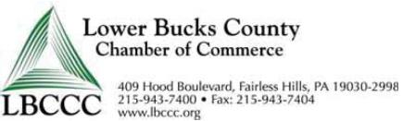

August 22, 2014

Tom Wheeler

Chairman Federal Communications Commission
445 12th Street, SW
Washington, DC 20554

RE: MB Docket No. 14-57

Dear Chairman Wheeler:

On behalf of the Lower Bucks County Chamber of Commerce, I want to express my support for the merger between Comcast and Time Warner Cable. As President of our Chamber, I can confirm the economic benefits that Comcast's services have brought to our area.

Our chamber consists of over 1,000 small, medium, and large businesses in the Lower Bucks County area, and each of them has benefitted from Comcast's strong broadband services. The company offers Internet speeds up to 10 Gbps, which is well ahead of other commercially available solutions. Furthermore, expanding Comcast's reach into other major east coast markets like New York means that local businesses with headquarters, distribution facilities and other types of locations throughout the region have a new option for enterprise-wide communications service providers, which holds out the possibility of real competition on service and price for firms with regional scale.

Comcast has done a lot for the Bucks County economy, and I believe that other areas of the country could benefit from the company's services as well. I hope you will consider this when ruling on the transaction.

Sincerely,

/s/ Dan Bates

Dan Bates, President

133

Dear Chairman Wheeler:

As a growing web-based company, we write in support of the Comcast-Time Warner Cable deal. In 2012, we founded Maker's Row with the goal of making the manufacturing process simple to understand and easy to access. Through our website, www.makersrow.com, anyone with a design idea or concept can search for a factory in the relevant industry, learn about its offerings, and then work with it to mass produce the design.

As a start-up, every individual and organization that you partner with is a critical decision. Comcast Ventures' Catalyst Fund is focused on investing in early-stage technology start-ups led by entrepreneurs of color. With the Catalyst Fund, we knew from the get-go that we'd found an investor who shared our passion and commitment for new business models using the power of the web. From the early stages of our company's development, the Comcast Ventures team dedicated meaningful time, resources, and guidance towards the future of Maker's Row.

We write in support of this deal because we believe this transaction will produce benefits for us and other innovative web-based companies. Combined with Time Warner Cable, Comcast will have added scale to innovate further in the broadband services market and all the other related technologies, making the company a key platform for online start-ups like us for years to come. That is why you should approve this transaction.

Sincerely,

Matthew Burnett

Tanya Menendez

Co-Founders, Maker's Row

/s/ Matthew Burnett

134

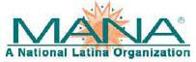


August 22, 2014

Chairman Tom Wheeler

Commissioner Mignon Clyburn

Commissioner Jessica Rosenworcel

Commissioner Ajit Pai

Commissioner Michael O’Rielly

Federal Communications Commission
445 12th Street, SW
Washington, DC 20554

RE: MB Docket No. 14-57

Dear Chairman and Commissioners:

On behalf of the MANA National Board of Directors, and our nationwide coalition of Chapters, Affiliates and Members, I am writing to share my perspective on the proposed merger of Comcast and Time Warner Cable as it relates to Hispanic communities. MANA, A National Latina Organization is the oldest and largest pan-Latina organization in the United States and is comprised of women from Mexican, Caribbean, Central American, South American, and Spanish decent. Our members come from a variety of career fields and range in age from 11 to over 70.

We have a strong focus on advocacy, community service and education in Hispanic-American communities. As an organization we are committed to strengthening Latinas as community leaders, helping Hispanic communities grow, and advancing public policy that promotes societal equality. One of the key issues to address in the Hispanic community is broadband adoption and digital literacy. Recognizing the urgent need to help lessen the digital divide, Comcast has taken a significant leadership role in providing the Internet Essentials program to bring hundreds of thousands of households online with high-speed Internet access.

But it is not enough to simply connect the unconnected; we must also provide effective training programs to allow people to leverage all the benefits that new technology has to offer. Comcast’s Internet Essentials program offers digital literacy services in both English and Spanish. Through my work at MANA, I have seen how education and training services can help a community thrive. One of our main areas of focus has been financial literacy. Today a great deal of billing information, documents and important forms are found online. Many Hispanic Americans already face a language barrier; the lack of training in digital skills can make their transition that much more

135

MANA RE: MB Docket No. 14-57

Page 2 of 2

difficult. It is becoming increasingly important to develop computer skills in today’s world and Comcast’s effort to provide education is refreshing.

In addition to their Internet services, Comcast’s commitment to TV program offerings for Spanish speaking Americans is also worthy of mention. Comcast launched a package containing 40-60 Spanish language channels in major Hispanic markets. They have also increased the amount of Spanish language programming available on their On-Demand service. Additionally, Comcast has made continued investments in Telemundo, allowing for more Spanish language programming and news broadcasts.

The crucial inroads that Comcast has made with the Hispanic community are vital. It is our belief that this merger will enhance the multi-tiered approach Comcast has already taken with regards to facilitating access for and educating Hispanic communities. It is our hope that you will recognize the benefits this merger can have on Hispanic communities and vote accordingly.

Sincerely,

/s/ Amy L. Hinojosa

Amy L. Hinojosa

President and CEO

MANA, A National Latina Organization

136

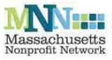

Tom Wheeler

Chairman

Federal Communications Commission
445 12th Street, SW
Washington, DC 20554

RE: MB Docket No. 14-57

Dear Chairman Wheeler:

My name is Rick Jakious and I am the Chief Executive Officer of the Massachusetts Nonprofit Network (MNN), the only statewide organization dedicated to uniting and strengthening the entire nonprofit community in Massachusetts and the voice of the state's nonprofit sector. The nonprofit sector relies on a network of public and private partners that help to advance the common goals of the Commonwealth, ultimately improving the quality of life for everyone who lives and works here. I have worked closely with many of these partners, and I am writing in support of one such partner, Comcast, whose investments in Massachusetts are notable and far-reaching.

Comcast supports MNN by partnering in our efforts to improve the visibility and strengthen the organizational capacity of nonprofits in Massachusetts. They provide support for our annual celebration of Nonprofit Awareness Day, the first-of-its-kind statewide holiday that recognizes the contributions of nonprofits across the state. Comcast also partners with MNN on our annual statewide conference which provides capacity-building products and services for local nonprofit leaders.

Over the last decade, I have worked alongside hundreds of Comcast employees every April on Comcast Cares Day, the company's annual employee service day. Comcast Cares Day, as I understand, has contributed over 3.1 million hours of service benefiting the overall health and capacity of the nonprofit sector across the country.

Comcast has also committed to providing affordable broadband access for low-income students and families. In fact, MNN encourages all of its members to disseminate information about Comcast's Internet Essentials program, which is a promising tool for helping close the digital divide. To my knowledge, 7,700 homes across Massachusetts are participating, and neariy 4,000 were enrolled in 2013 alone.

Comcast has been a corporate citizenship exemplar in Massachusetts. I am deeply grateful for their support and partnership and know that their extensive network of community partners in the Commonwealth share my appreciation. Please do not hesitate to contact me at 617-330-1188 if you have any questions.

Sincerely,

/s/ Rick Jakious

Rick Jakious

CEO, Massachusells Nonprofit Network

89 South Street, Suite 603, Boston, MA 02111 • 617.330.11 BB • www.massnonprofitnet.org

137

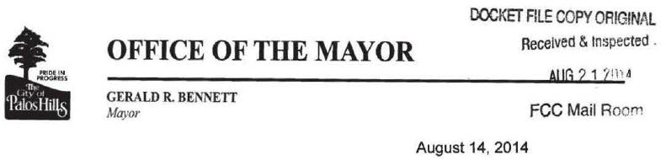

Ms. Marlene H. Dortch

Secretary

Federal Communications Commission
445 12th Street, SW
Washington, DC 20554

RE: MB Docket No. 14-57

Dear Ms. Dortch,

I am pleased to have another opportunity to write to the Commission as a supporter of Comcast. Several years ago, I urged the Commission to approve a proposal regarding Comcast and NBC Universal. That proposal was approved and my town, state and region have seen the promised benefits.

I now respectfully request the Commission's approval for the Comcast and Time Warner Cable transaction. As a lifetime Illinois resident and Mayor of the City of Palos Hills for 33 years, I firmly believe that Comcast's role as a strong economic and philanthropic partner to us and many others will only grow stronger as a result of the proposed transaction.

I believe that I am in a unique position to see both the economic and community impact of Comcast's activities in our region. In addition to serving as Mayor since 1981, I have been president of Bennett Dental Labs, Inc. since 1994 and have been Chairman of the Board of Directors of the Southwest Central 911 Police and Fire Dispatch since 1985. I am active in other Illinois legislative and municipal organizations, currently serving as President of the Southwest Conference of Mayors, as Chairman of the Chicago Metropolitan Agency for Planning, a past President of the Illinois Municipal League and also as an Executive Board member of the Metropolitan Mayors Caucus.

I have had a front row seat as the focus in our state's economy and local industries have changed through the years. Palos Hills is home to about 17,500 residents who have profited from the expansion in technology, especially digital Internet and video offered by Comcast. Many of our residents own their own businesses and they depend on Comcast to provide up-to-date digital services to ensure efficiency and growth in their businesses.
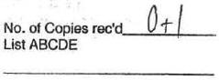

10335 South Roberts Road •. Palos Hills, Illinois 60465 • Telephone (708) 598-3400

138

Ms. Marlene H. Dortch

Federal Communications Commission Page 2

RE: MB Docket No. 14-57

As our resident population has become more diverse, we have seen Comcast respond by providing interesting and relevant programming including Spanish language channels. Also important to my constituents are the volunteering and mentoring programs that Comcast has operated here for many years. Palos Hills is home to Moraine Valley College – the second largest Community College in Illinois. Comcast has demonstrated its commitment to education and civic engagement through financial support to the college's Foundation as well as employee service on the Foundation Board for several years.

Our city benefits from the many economic and community contributions that Comcast makes and I know others in current Time Warner Cable markets will welcome them as well. I hope the Commission will approve the transaction.

Sincerely,

/s/ Gerald R. Bennett

Gerald R. Bennett

Mayor

City of Palos Hills

139

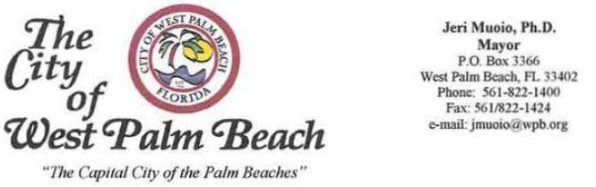

August 25, 2014

Chairman Tom Wheeler

Commissioner Mignon Clyburn

Commissioner Jessica Rosenworcel

Commissioner Ajit Pai

Commissioner Michael O'Rielly

Federal Communications Commission
445 12th Street, sw
Washington, DC 20554

RE: MB Docket No. 14-57

Dear Chairman and Commissioners:

Two years ago, Comcast moved its Florida headquarters to our city of West Palm Beach and solidified its long-standing commitment to our community. Along with adding more than 150 new jobs to our economy, they sparked new enterprise and energy in our business sector and renewed their role as an engaged community partner and catalyst. It is our hope that the proposed Comcast and Time Warner Cable transaction is approved by the Federal Communications Commission so that other communities may experience similar benefits.

Initiatives like Comcast Cares Day, the company's national day of service, have left a valuable legacy in our city's neighborhoods and helped invigorate areas in need of revitalization. This year's event mobilized more than 700 volunteers and community groups to beautify the Progressive Northwest Neighborhood. In 2013, the work of hundreds of Comcast employees at the nonprofit Center for Creative Education enabled the organization to move into a new facility in Northwood and continue its work of incorporating the arts into local classroom education. At Coleman Park, Salvation Army Northwest Community Center, Hispanic Human Resources Council, and other sites in the City of West Palm Beach, Comcast employees and community volunteers have provided free broadband services, established computer labs, painted, landscaped, planted gardens, and made other facility upgrades.

As a result of Comcast's major financial investments and the hands-on involvement of its employees, Comcast Cares Day has added value, empowered residents and community groups, galvanized neighbors, uplifted spirits, and improved our community. In recognition of these contributions, Comcast was presented the Key to the City of West Palm Beach.

"An Equal Opportunity Emplvyer"

140

Before becoming Mayor of the City, I was a school administrator and educator; a perspective that gives me deep appreciation of Comcast's leadership in promoting digital literacy and expanding opportunities for those in our city who are most in need .

The City of West Palm Beach, in conjunction with the Urban League of Palm Beach County and the Palm Beach County Schools, was a founding partner in the launch of the Digital Connectors program funded by Comcast. Now in its fifth year, this comprehensive course teaches leadership and personal development skills, as well as hard skills like software programming and media production, to a new cadre of teens each year. The teens then "pay it forward" by teaching seniors, neighbors, family, and others in their urban communities how to use computers. Digital Connectors leaves these young people well prepared for jobs in technology and ready for the daily challenges in a professional career.

I am extremely proud to say that our city is an anchor partner in Comcast's Gold Medal Digital Learning Zone, an outgrowth of Comcast's Internet Essentials program. Internet Essentials connects low-income families to the digital world through affordable home service and provides free training on using the Internet and computers. Comcast is funding the Digital Learning Zone and convening partners that will share best practices and expand the availability of free computer lab sites, computer courses, and computer-based training in West Palm Beach, including Salvation Army, Boys & Girls Clubs, Urban League and the City.

In all of its initiatives, Comcast is a partner that goes the extra step in its community collaboration and inclusiveness. Its work with the Urban League of Palm Beach County, for instance, has been superb. In addition to supporting many joint digital literacy initiatives, Comcast sponsors a group of inner city students each year in the affiliate's National Achievers Society. Every graduate has gone on to higher education, many in Ivy League institutions. In March, Comcast helped sponsor the Women's Foundation of Palm Beach County's "Raise the Bar'' event to support women and girls in leadership. In conjunction with the Literacy Coalition of Palm Beach County and the Palm Beach County League of Cities, Comcast founded the Mayor's Literacy Luncheon. Next month will be the fourth year that Comcast sponsors this initiative to educate municipal leaders about the importance of literacy in our cities... These are just a sampling of Comcast's support for worthy activities in the community.

Being home to a regional office for a leading broadband and video company has truly enhanced West Palm Beach. Comcast has built lasting partnerships in our community with business, education and nonprofit entities. I'm eager to see Comcast's continued innovation here, and I support the extension of Comcast services and community partnerships elsewhere in the country so that others may also benefit. For that reason I urge you to please approve the proposed transaction.

Sincerely,

/s/ Jeri Muoio

Jeri Muoio

Mayor

"An Equal Opportunity Employer"

141



OFFICE OF THE MAYOR

CITY OF CHICAGO

RAHM EMANUEL

MAYOR

VIA ELECTRONIC & FIRST CLASS MAIL

August 22, 2014

Marlene H. Dortch

Secretary
Federal Communications Commission
445 12th Street, SW
Washington, DC 20554

RE: MB Docket No. 14-57

Dear Ms. Dortch:

I write to provide the City of Chicago's perspective on the proposed merger of Comcast and Time Warner Cable. We understand that the Commission is to consider a number of factors, and nationwide effects, in evaluating a proposed business combination like Comcast's and Time Warner's. This letter does not purport to address all of those factors, or nationwide effects. but rather focuses on how a Comcast/Time Warner merger may affect Chicago.

From our perspective, we do not believe the proposed transaction would reduce choice, elevate prices, or otherwise harm consumers. Further, we are optimistic that the increased resources of the combined corporation will lead to more investment in local network infrastructure and faster Internet speeds. This is critically important to Chicago, as it would help achieve our goal of reducing the digital divide, allowing all Chicagoans to obtain effective access to the information and resources necessary to thrive in today' s high-tech world.

Comcast currently makes considerable contributions in Chicago and we expect those contributions to continue – and increase – if the proposed combination is approved. Through its Internet Essentials program, the company partners with Chicago Public Schools, as well as hundreds of community and faith-based organizations, to provide affordable Internet access. Comcast is also a founding sponsor of 1871, Chicago's entrepreneurial hub for technology start-ups. The company also provides, free of charge, 1871's "backbone" – 500 MB of internet bandwidth. All told, each year Comcast donates more than $15 million in direct and in-kind technological support throughout Chicagoland.

142

However, much remains to be accomplished in the arena of increasing access to technology among low-income and other underserved populations. Comcast has been a good partner with us in addressing these challenges in the past. We look forward to continuing to work with them and their broadband competitors in addressing these challenges in the future, including an even greater commitment of effort and resources to provide affordable access for low-income and other underserved residents. This Administration also places a very high priority on attentiveness to consumers' concerns and responsiveness to their needs, and we expect continued diligence and commitment from Comcast on that score as well. We are optimistic that the greater resources available to the merged entity should enable it to increase its investments and improve service in all of these areas.

In conclusion, we value and appreciate the strong and generous presence Comcast currently maintains in our city, and we are confident that the proposed combined corporation would maintain and enhance that strong and generous presence.

Sincerely,

/s/ Rahm Emanuel

Rahm Emanuel

Mayor

143

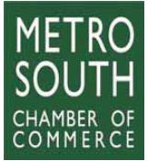
Tom Wheeler

Chairman

Federal Communications Commission
445 12th Street, SW
Washington, DC 20554

RE: MB Docket No. 14-57

Dear Chairman Wheeler:

Since 1913, the Metro South Chamber of Commerce in Brockton, Massachusetts, has been supporting and promoting the local business community through leadership in public advocacy, education, networking, information and community development. Our members' experience working with Comcast leads us to believe that their merger with Time Warner Cable will benefit our local area businesses as well as businesses in the Time Warner Cable markets.

The Chamber serves nearly 1,000 member businesses from virtually all industries from all of the surrounding communities. Our mission is to serve the interests of member businesses while providing community leadership to ensure the economic advancement of the Metro South region.

As an organization focused on helping businesses, we understand the importance of keeping up to date with technology and are so happy to have a provider like Comcast serving our region. Their business class Internet service features multi-gigabit speeds and has helped buoy the Metro South economy. By expanding Comcast's presence into other key regional markets like New York, this merger creates the ability for companies with regionally scaled operations along the East Coast to better integrate their communications services and streamline costs.

The business advantages of having Comcast serve the region - coupled with their key investments in developing the local workforce of the future through their numerous mentorship and internship programs and digital literacy programs like Internet Essentials that build tech skills -are hard to deny. We hope the Commission will approve the merger.

Sincerely,

/s/ Christopher Cooney, CCE

Christopher Cooney, CCE

Chamber President & CEO

Metro South Chamber of Commerce

Sixty School Street ■ Brockton, MA 02301-4087 ■ (508) 586-0500 ■ Fax (508) 587-1340 ■ www.metrosouthchamber. com

A Nationally Accredited Five Star Chamber of Commerce

144



August 25, 2014

Chairman Tom Wheeler

Commissioner Mignon Clyburn

Commissioner Jessica Rosenworcel

Commissioner Ajit Pai

Commissioner Michael O’Rielly

Federal Communications

Commission
445 12th Street, SW
Washington, DC 20554

RE: MB Docket No. 14-57

Dear Chairman and Commissioners:

The Mexican American Opportunity Foundation (MAOF) supports the proposed transaction between Time Warner Cable and Comcast.

Established in 1963, MAOF is a non-profit, community-based organization that works to serve disadvantaged individuals and families in the Los Angeles area. Since then, we have become the largest Latino-oriented, family services organization in the country by providing high quality social services and programs to those communities where the need is the greatest. MAOF strives to provide for the socio-economic betterment of the greater Latino community in California, while also preserving the pride, values, and heritage of the Mexican American culture, through programs in early childhood education and family services, job training, and senior lifestyle development.

We have worked with government agencies, public and private foundations, and Corporate America to ensure that we are providing the best services in the most effective way possible. MAOF recognizes and values strong community partnerships and our Board of Directors works to ensure that we continue our partnerships with both civic and corporate leaders.

MAOF believes that education is a tool for upward mobility as well as greater equality and is always looking for ways to improve the programs we offer to the children in our organization. Our relationship with Time Warner Cable has allowed us to explore options to expand our youth

145

curriculum to include STEM-related programs and technology. We see the proposed transaction with Comcast not as an end to this work, but as an opportunity to further expand our youth curriculum.

Comcast’s emphasis on technology literacy and skill enhancement would be invaluable to us in this regard. We envision a strong partnership with Comcast centered around its Internet Essentials program, through which we could expand our digital literacy training curriculum. Partnering with Comcast on Internet Essentials will enable us both to reach the most at risk children and provide targeted help to those in need.

We look forward to working with Comcast and ensuring that the children we work with benefit from the programs they will bring to our market. For this reason, we urge you to approve the transaction.

Sincerely,

/s/ Martin Castro

Martin Castro

President & CEO

146


August 24, 2014

Tom Wheeler

Chairman

Federal Communications Commission
445 12th Street, SW
Washington, DC 20554

RE: MB Docket No. 14-57

Dear Chairman Wheeler,

I am writing to convey my appreciation for Comcast as a leader in investing in our community. As the Chief Executive Officer and Executive Director of Mi Casa Resource Center, a Metro-Denver nonprofit organization dedicated to advancing the economic success of Latino and working families, I am deeply grateful for the longtime partnership we have enjoyed with Comcast and the many ways our organizations work together to help Latino students and families bridge the digital divide and access important opportunities to achieve personal success.

Mi Casa is committed to providing training for families beginning with programs for youth that inspire academic success, leadership, career exploration, and entrepreneurship. Comcast's ongoing commitment to and investment in our programs help make these goals a reality. Since 2010, Comcast has been our sponsor and partner in offering the "Comcast Digital Connectors" program that our staff leads at the Mi Casa Neighborhood Center at North High School in Denver. This nine-month intensive leadership and technology training program is offered to youth ages 15 to 19, engaging them with in-depth technology and digital literacy training, career exploration related to information technology and digital media, and community service projects designed to help others advance their own skills in utilizing technology.

Mi Casa partners with other community organizations to give the Digital Connectors students an opportunity to practice the technology skills they are learning by teaching others. For example, one partner, the Denver Public Library, hosts Digital Connectors students in their Community Technology Center to help community members set up e-mail accounts, find information online, or access other web-based services and information. Last year, the Digital Connectors class completed more than 500 hours of community service to aid others in the community.

147

We are also grateful for Comcast's support of technology training classes we are able to offer to community members free of charge. A key component of Mi Casa's mission is to provide career and business training to help families prosper through career advancement or business ownership. The classes we have offered with Comcast's support are critical to these goals as well, focusing on such topics as developing skills in using Microsoft Word and Microsoft Excel and utilizing the Internet to search for and apply for jobs. We also are proud to partner with Comcast to help our families learn about the Internet Essentials program at these classes and through other efforts, such as during Family Night events held at our Mi Casa Neighborhood Centers in local schools. Internet Essentials helps low-income families afford home Internet service and personal computers, which in turn empower families to access many opportunities and resources key to advancing their own success. More than 10,000 Denver families have enrolled in Internet Essentials, and I look forward to seeing this number continue to grow in our own community and in others across the country.

Our Mi Casa team has also enjoyed working with Comcast since 2005 on projects for Comcast Cares Day, the company's annual day of service with local community partners. Comcast employees and their families have joined Mi Casa staff, families, and students in completing a wide variety of projects that have greatly benefited our facilities and programs. Projects have transformed the look of our building and grounds, helping us make it a warm and welcoming place for our clients. Volunteers continue to come back year after year - painting, re-plastering ceilings, repairing the parking lot, improving the landscaping on our building's grounds, and more.

We are fortunate to work in true partnership with Comcast in many ways that play a key role in advancing Mi Casa's mission. It is an exemplary organization that deserves your thoughtful consideration.

Sincerely,

/s/ Christine Márquez-Hudson

Christine Márquez-Hudson

CEO/Executive Director

Mi Casa Resource Center

148

August 25, 2014
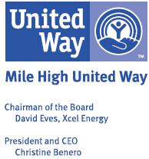

Tom Wheeler

Chairman

Federal Communications Commission
445 12th Street, SW
Washington, DC 20554

RE: MB Docket No. 14-57

Dear Chairman Wheeler:

I am pleased to be writing in support of proposed merger between Comcast and Time Warner Cable.

As the CEO of a non-profit organization, I have experienced first-hand the investments Comcast has made in our community.

Mile High United Way has enjoyed a longstanding partnership with Comcast that has truly helped us live our mission to change lives across our state. Comcast has been a valued partner in helping us tell our story, featuring our representatives on its Comcast Newsmakers program, helping us produce videos highlighting initiatives we lead to address community needs, and donating air time to run PSAs that carry important community messages - such as helping us request the community's volunteer and financial support when terrible fires and floods devastated Colorado over the last few years.

Comcast has been one of our top 20 corporate partners, contributing more than $7 million in company and employee donations over the last several years to help ensure the agencies we support are ready to provide critical assistance to the vulnerable and struggling citizens across our state. We are grateful and proud to have Comcast as the sponsor of our new state-of-the -art community computer lab and free digital literacy training classes in our new community headquarters building, The Morgridge Center for Community Change, a mission-based community hub, that is set to open this fall. And, perhaps most meaningful to all of us are the countless Comcast volunteers who participate not only in annual Comcast Cares Day service projects, but also dedicate their time, energy and expertise as mentors and tutors, emerging leaders, members of women's leadership programs, and serving as members of our Board of Trustees. We have found that Comcast leaders are always ready to say yes, when the need is present.

We were excited to see Comcast recognized with United Way Worldwide's Spirit of America Summit Awards for philanthropy and volunteerism in 2012. Mile High United Way was pleased to help nominate Comcast for this award because of their consistent commitment to and investment in our local communities, and because of the example Comcast sets for other businesses in our region. The Spirit of America Awards represents the very best of what it means to be a corporation who believes in their community and is willing to employ all the resources and tools at their disposal to make a difference. Comcast does that every day for the people who call Colorado home.

I believe that families and community organizations in current Time Warner Cable regions will benefit over time from Comcast's dedication to local communities. I am pleased to encourage the FCC to approve the proposed transaction between Comcast and Time Warner Cable.

Thank you for your consideration.

Best regards,

/s/ Christine Benero

Christine Benero

President and CEO

149

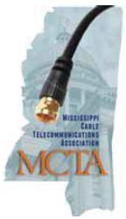

August 22, 2014

Tom Wheeler

Chairman

Federal Communications Commission
445 12th Street, SW
Washington, DC 20554

RE: MB Docket No. 14-57

Dear Chairman Wheeler:

As executive director of the Mississippi Cable Telecommunications Association I represent the cable providers in the state of Mississippi with the intent of providing our residents and businesses with the highest quality broadband and video services possible. I know first hand the good a Comcast Corporation and Time Warner Cable transaction would do for other communities across the nation.

One of the leading cable and broadband providers to the state of Mississippi is Comcast. Comcast serves Jackson, our capitol and largest city, as well as other smaller cities around our state. The company employs around 1,300 full time workers and manages 49 local facilities, including two call centers. I have been fortunate enough to represent and work alongside Comcast and see the good that it does professionally, by providing cutting-edge technology, and personally, through its service-oriented approach to investing in our communities and providing good jobs for our citizens.

In Mississippi and across the United States, there are many families and communities struggling financially. Unfortunately, Mississippi holds the title of having the most school-aged children living in poverty in the country. My productive, working relationship with Comcast has shown me its dedication to education and providing our schools and families with broadband connections at an affordable price. In 2012, the Food and Research Action Center found that over 300,000 students in Mississippi participated in the National School Lunch Program (NSLP). That means that each of these children’s families can apply for Comcast’s Internet Essentials program. Internet Essentials brings Internet Access to low-income families for just $9.95 a month. Furthermore, these families also have the option to purchase an Internet ready computer for just $149.99. Although Mississippi may currently be considered the most “in need” of such a program, I know that there are countless families in Time Warner Cable’s service areas that would benefit from a transaction that would make the program available to them as well.

As executive director I work hard to provide our cable operators with representation and a

150

hospitable venue to insure that they feel supported and their customers will continue to benefit from the highest quality service and technology. Comcast is truly invested in always bringing the most innovative technology into American homes and businesses. Mississippi’s Comcast customers have been fortunate to benefit from Comcast’s $1.6 billion dollar investment in infrastructure here. This kind of investment ensures reliable cable and broadband service, as well as flexibility to plan for the future of what the cable and broadband industries will be able to offer consumers. One step in that direction is Comcast’s new X1 platform. This “operating system” for your TV offers a more personalized entertainment experience for customers and allows them to access Comcast’s on-demand offerings via an easier to use on-screen guide. Through a transaction with Time Warner Cable, Comcast will likely become more efficient and will be able to rollout X1 to more markets more quickly. This is a very exciting prospect for consumers.

It is of the utmost importance to me that the residents and businesses of Mississippi have access to the best broadband services available. Comcast Corporation has always been a reliable provider in our state and the TWC transaction could allow for its positive impact to be experienced elsewhere.

Sincerely,

/s/ Lisa Shoemaker

Lisa Shoemaker

Executive Director, MCTA

151


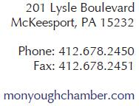

August, 2013

- Proceeding Number 14-57

I am writing on behalf of the Mon Yough Area Chamber of Commerce in Pennsylvania to express my support for the proposed transaction between Comcast and Time Warner Cable.

The Mon Yough Area Chamber of Commerce is committed to sustaining and expanding the region's prosperity by uniting business and community. We have enjoyed working with Comcast and appreciate the active role they have taken as a member of our organization. They have demonstrated that they are a good corporate citizen dedicated to community investment and community-based organizations. Their broadband adoption program, Internet Essentials, has increased the digital literacy of the citizens in our region and made them more competitive in the job market. As a Chamber, one of our most important functions is to promote business and a quality workforce. Internet Essential will help achieve that goal. Our small businesses have been able to grow and remain competitive due to the business class service that Comcast provides. Quality internet is an essential requirement for the success of our local businesses, Comcast has played an important role in providing the infrastructure our region needs to develop and compete.

Comcast's support of our Annual Legislative event has been an important part of keeping our members and the community informed of developments in our region. In addition the Chambers appearances on Comcast Newsmakers have allowed us the opportunity to share critical information needed to help our area continue to grow.

We are confident that Comcast will bring the same level of service and commitment to new markets if the proposed transaction is successful.

Kind regards,

/s/ Maury Burgwin

Maury Burgwin

President, Mon Yough Area Chamber of Commerce

152

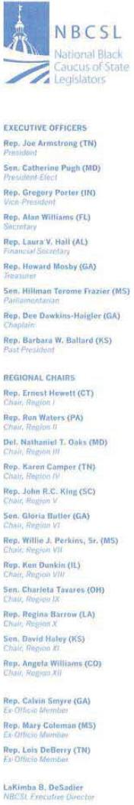
August 25, 2014

Tom Wheeler

Chairman

Federal Communications

Commission
445 12th Street, SW
Washington, DC 20554

RE: MB Docket No. 14-57

Dear Chairman Wheeler:

I write today as the President of the National Black Caucus of State Legislators (NBCSL) and as State Representative for Tennessee's 15th District. I write to urge your approval of the Time Warner Cable and Comcast transaction that sits before you today, because the combined entity ought to be able to continue and expand Comcast's remarkable record of service to the Black community and aJI Americans.

Our body of over 600 legislators at the NBCSL se1ves as a national network for collaboration and exchange of ideas and solutions among African American state legislators, thought leaders, and private panners. We are blessed to represent a diverse array of strong communities. Far too often, however, we are aware of a digital divide between our richest and poorest communities. Far too often, African Americans live in our nation's poorest, most resource-deprived communities.

Comcast's Internet Essentials program is currently making enormous strides towards closing this gap and connecting our most underserved neighborhoods to the Web. Families whose kids are eligible for free- or reduced-price lunches can enroll if they live in Comcast-served areas. They are also connected to a wide variety of empowering services. Comcast provides internet for the affordable rate of $9.95 per month. They go further one more step, by giving subscribers discounted hardware. The company completes the rounded program by building community partnerships to support the program. Free training programs help residents profit from their connection. Digital Connectors gives young people the tools to change their communities for the better with the power of technology. This model public-private partnership has already brought service to over 350,000 homes. Many other cities could be included following the approval of this transaction, including our nation's largest two cities, Los Angeles and New York.

Comcast's inclusive hiring programs are creating a new class of African American business and public leaders. Forty percent of company employees are people of color. Twenty-five percent of the company's managers are people of color. And that proportion continues to expand. Comcast has increased the number of vice presidents and other high-level executives of color by more than 30 percent since they combined with NBCUniversal. The company works with a coalition of national leaders on their large Joint Diversity Council to make this progress.

153

It is yet another example of Comcast's all-encompassing commitments. The company makes sensitive, informed connections with community leaders to deliver the best service to all communities. Please approve this transaction to help continue the forward progress of tbis industry leader's commitments to all American communities.

Sincerely,

/s/ Joe Armstrong

Rep. Joe Armstrong (TN)

President

National Black Caucus of State Legislators

154

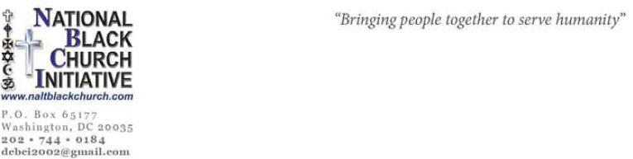

August 21, 2014

Tom Wheeler

Federal Communications Commission
445 12th Street SW
Washington, DC 20554

Dear Mr. Wheeler,

On behalf of the National Black Church Initiative (NBCI), coalition of 34,000 African American churches working to eradicate racial disparities in healthcare, technology, education and housing, I am writing to express our collective enthusiastic support for Comcast’s decision to merge with Time Warner Cable. This merger signals technological innovation and opportunity, which are the building blocks for a strong economy. Lingering unemployment and stagnant wealth recovery in the wake of the Great Recession have disproportionally affected the black community. We hope that this merger will help create and sustain economic recovery, building on Comcast’s record of success not only in business operations but also outstanding track record of minority employment, one that is unmatched in the industry.

The black church and its congregants will directly benefit from a strong and open internet. Allowing companies such as Comcast to freely share its latest technologies helps our churches fulfill their calling to share the Gospel of Jesus Christ, and aids us in serving the poor. Healthy competition also enables a competitive marketplace that helps people in lower socioeconomic brackets purchase the things they need to achieve a decent standard of living.

NBCI has thoroughly analyzed this merger. It is the black church’s opinion that poor and minority populations will not be negatively impacted in any significant way, especially in regards to access. It is for this reason that 34,000 black churches are supporting this merger. In fact, Comcast has done significant work to help close the digital divide through programs such their Internet Essentials Program, and we hope to see this work magnified through this important partnership.

Recently I was joined by Comcast leadership in Atlanta, alongside Georgia’s First Lady Sandra Deal. In kicking off the latest school year, we announced that in less than three years Comcast has connected more than 350,000 families, or more than 1.4 million low-income Americans, to

155

the power of technology. This is more than the population of San Diego or San Antonio, almost the size of Philadelphia, and more than the population of 11 states including Maine, New Hampshire, Alaska, Montana and Hawaii.

Comcast has promised to include up to six months of complimentary service for any new family that has not yet applied for Internet Essentials. Families who are approved for Internet Essentials between August 4th and September 20th, 2014 will receive up to six months of Internet service. There is no more important back to school supply than Internet service at home, and Comcast understands this priority and stands ready to help provide access.

In addition, Comcast announced an amnesty program for low-income families who qualify for the Internet Essentials program but have a past due balance. If customers have an outstanding bill spanning a year but meet all the other eligibility criteria, they can to Internet Essentials and have outstanding debts forgiven. If customers’ outstanding bills are less than a year old, we would like them to settle that debt with us before they are eligible. We are also willing to work with families through payment installments that fit their income and ability.

Comcast is the type of model corporate citizen we need, one who sees the needs within a community and work with nonprofits such as NBCI to create a strong civil society and help it move forward. We hope the FCC and others support your vision for the merger, and offer the support of our faith-based communities as the process moves forward.

NBCI disputes the following claims made by those who oppose the merger:

- The FCC does not have any good options. Regulating the terms of interconnection would be a difficult, error-prone process. Trying to reverse the decade-old mergers that allowed America's broadband market to become so concentrated in the first place would be even more so. But the growing power of residential broadband providers will put growing pressure on the FCC to do something to prevent the abuse of that power.

To the contrary, the FCC does have a great option in approving the merger and choosing innovation over fear. Fear kills innovation and dampens a strong economy.

- Further industry consolidation is a bad decision. The more concentrated the broadband market becomes, the more leverage broadband providers like Comcast and Verizon will have over backbone providers like Cogent. That gives the FCC a good reason to be skeptical of Comcast's proposed acquisition of its largest rival, Time Warner Cable. Blocking that transaction could save the agency larger headaches in the future.

We believe is this is the wrong mindset. This will kill innovation of technology and undermine the enormous benefits the merger would have to the economy.

Both of these claims run counter to the proven benefits of this merger. Comcast is most accurate in its analysis of the merge when it states:

156

This transaction will create a leading technology and innovation company differentiated by our ability to deliver ground breaking products on a superior network. For the past 15 years, Comcast has built scale and operational efficiencies through various cable mergers and acquisitions in a very strategic, disciplined, and financially responsible manner that benefit consumers. In every transaction, we have over-delivered on our public interest commitments.

Importantly, the proposed transaction will not reduce competition in any relevant market. Comcast and Time Warner Cable do not currently compete to serve customers in any zip code in America. This absence of horizontal overlap of the companies’ cable systems means that the transaction will not harm competition or reduce consumers’ choice in any way.

With this acquisition, Comcast intends to build on our extraordinarily successful acquisition of NBCUniversal, and our unparalleled record of keeping our promises to bring new benefits to consumers in prior cable acquisitions.

NBCI recognizes and defends the following pro-consumer benefits of the merger:

Deployment and Development of Advanced Services: Subscribers to Time Warner Cable will benefit from Comcast’s superior service reliability and best-in-class technology and services, such as the X1 Entertainment Operating System and Comcast’s VOD platform which provides 50,000 choices on TV and averages 400 million views each month (32 billion views since VOD’s 2003 launch). Comcast also offers 300,000 plus streaming choices on XfinityTV.com, and Xfinity TV mobile apps that offer 35 live streaming channels plus the ability to download to watch offline later.

Benefits of Scale: The transaction will generate significant cost savings and other efficiencies, which will ultimately benefit customers. Scale enables better customer experiences as demonstrated by Comcast. Our scale has enabled us to create industry leading products like the X1 Entertainment Operating System, increased Internet speeds, comprehensive communications and digital phone products and features, and home management. The scale will also make us a better competitor vis-à-vis national companies like DirecTV, DISH, Verizon, and AT&T.

Broadband Market Benefits: Comcast is a technology leader in broadband and customers will benefit from its commitment to invest in its high-speed data services. Comcast has increased Internet speeds 12 times in the past 12 years across its entire footprint, and led the industry in the deployment of DOCSIS 3.0. Additionally, Comcast has invested tens of billions of dollars in its network and continues to invest in it. Comcast will be investing hundreds of millions of dollars annually to improve Time Warner Cable’s networks, which will bring significant benefits to Time Warner Cable customers, including higher speeds and greater reliability. We also believe the transaction will enhance competition in the broadband market and extend broadband

157

adoption.

Benefits for Business and Enterprise Customers: This transaction will allow Comcast increased ability to offer advanced services, like high-performance point-to-point and multi-point Ethernet services with the capacity to deliver cloud computing, to small and medium-size businesses, as well as backhaul services to wireless carriers. In addition, Comcast will be able to bring to Time Warner Cable business customers enhancements to their package of services that Time Warner Cable does not offer (e.g., hosted voice).

Benefits in Advertising: The transaction will combine complementary advertising platforms and channels and allow Comcast to offer broader and more valuable packages to advertisers. This is especially true in the very competitive and uniquely important New York advertising market.

We understand the need and support for more broadband. This is why over two years ago we held a demonstration in front of the FCC in Washington, DC to advocate for policies that provide more broadband for carriers.

In October 2013 we contributed to the Joint Center for Political and Economic Studies report on Broadband and Jobs: African Americans Rely Heavily on Mobile Access and Social Networking in Job Search. NBCI clearly understands the connection between broadband, advancing new technologies and a strong economy both for our nation and especially for the African American community.

I will close by detailing three compelling reasons why NBCI is supporting this merger, aside from the compelling jobs aspect:

I serve as both the President of the National Black Church Initiative and the Chair of the Board of the National Black Religious Broadcasters (NBRB). NBRB represents over 10,000 African American churches that broadcasts either through television, radio or the internet. Now I hope it is clear to you why we are such huge supporters of broadband. Given the lack of universal broadband in our country, we want to do whatever is necessary to support innovative entities like Comcast to help spur new technologies and more broadband. Many of our churches are on the Comcast Cable system. Many of our members can benefit from both X1 Entertainment Operating System and Comcast’s VOD platform.

NBCI strongly believes that there is not a sufficient concentration of cable providers in key areas. As we understand it, Comcast’s plans would fill in its New Jersey and Connecticut portfolios with Time Warner Cable's New York City customers and add major markets such as Los Angeles and Dallas. Comcast and Time Warner Cable will not compete and Comcast can easily divest a few million subscribers. This absence of horizontal overlap of the companies’

158

cable systems means that the transaction will not harm competition or reduce consumers’ choice in any way.

The merger will also directly help our 70,000 small businesses that are represented in our 34,000 faith communities. Comcast’s increased ability to offer advanced services, such as high-performance point-to-point and multi-point Ethernet services with the capacity to deliver cloud computing, will help make our small businesses more competitive .

NBCI is prepared to publicly support this merger beyond the submission we are making today. Thank you for your consideration of our position and we look forward to seeing a successful merger take hold soon.

Sincerely,

/s/ Anthony Evans

Rev. Anthony Evans

President

159

/s/ Edwin L. Jones

Rev. Edwin L. Jones, Ph.D.

Faith Christian University Church

/s/ Amos Ballenger

Rev. Amos Ballenger

Mt. Zion Baptist Church

/s/ John Norman

Rev. John Norman

Mt. Zion Baptist Church

/s/ Everett Harris

Rev. Everett Harris

Mt. Zion Baptist Church

/s/ Winston C. Ridley, Jr.

Rev. Winston C. Ridley, Jr.

The Greater First Baptish Church

/s/ Gerald L. Martin

Rev. Gerald L. Martin

Morning Star Baptist Church

/s/ Ode H. Hines

Bishop Ode H. Hines

Greater Good Samaritan Baptist Church

/s/ William Calvert

Rev. William Calvert

Heavenly Bound Baptist Church

/s/ Virgil Murphy

Rev. Virgil Murphy

Temple Missionary Baptist Church

/s Robert Wilson

Bishop Robert Wilson

Word Of Truth Church

/s/ Alex L. Lambert

Rev. Alex L. Lambert

St. Paul Baptist Church

/s/ Dr. A.H. Mark Dean

Dr. A.H. Mark Dean

All For Jesus Scripture Art

/s/ Marcus Tillman

Rev. Marcus Tillman

First Baptist Church

/s/ Cynthia T. Turner

Rev. Dr. Cynthia T. Turner

Dayspring Community Church

/s/ Lue Ella Rodgers

Rev. Lue Ella Rodgers

Mt. Zion Baptist Church

/s/ Omar Buchanan

Rev. Omar Buchanan

Mt. Zion Baptist Church

/s/ Harry Strong

Rev. Harry Strong

Mt. Zion Baptist Church

/s/ Jeff Eddy

Rev. Jeff Eddy

National Lay leader

/s/ Tom A. Bailey

Rev. Dr. Tom A. Bailey

Victory Temple Missionary Baptist Church

/s/ Scottie E. Jackson

Bishop Scottie E. Jackson

River of Life Pentecostal Church

/s/ Robert Lawrence Earls, Sr.

Rev. Robert Lawrence Earls, Sr.

St. John Baptist Church

/s/ Thomas P. Beale, Jr.

Bishop Thomas P. Beale, Jr.

Church of the Way

/s/ Rodney Blackmon

Rev. Rodney Blackmon

Christian Unity Baptist Church

/s/ Haru Carter, Jr.

Bishop Haru Carter, Jr.

Zion Baptist Church

/s/ Dr. Anthony Mays

Dr. Anthony Mays

Breakthrough Bible College

/s/ Willie R. Hunt

Elder Willie R. Hunt

New Community Church of God In Christ

160

/s/ Aubrey C. Lewis

Rev. Aubrey C. Lewis, Pastor

St. Luke Baptist Church

/s/ Rudolph White

Rev. Dr. Rudolph White, Pastor

New Southern Rock Baptist Church

/s/ Queen Shepherd

Rev. Queen Shepherd, Pastor

Powerhouse Ministry International

/s/ Darrell Lewis

Rev. Darrell Lewis, Pastor

Family Fellowship Church

/s/ Elijah Sutton

Rev. Elijah Sutton, Pastor

Guildfield Baptist Church

/s/ Lloyd Fennell

Rev. Lloyd Fennell, Assistant Pastor

Guildfield Baptist Church

/s/ Dr. Cleophus W. Atkins

Rev. Dr. Cleophus W. Atkins, Pastor

Restoration Christian Fellowship Church

/s/ Arafa Speaks

Rev. Arafa Speaks

New African Church

/s/ Anthony White

Rev. Anthony White, Youth Minister

New Southern Rock Baptist Church

/s/ Edward Cole

Rev. Edward Cole

Associate Minister

/s/ Milton R. Baker

Rev. Milton R. Baker

Christian Faith Center Ministry, Inc

/s/ Ruth Sutton

Rev. Ruth Sutton

Guildfield Baptist Church

/s/ Ronald Patterson

Rev. Ronald Patterson

Guildfield Baptist Church

/s/ Lanier C. Twyman, Sr.

Rev. Lanier C. Twyman, Sr.

St. Stephens Baptist Church

/s/ Betty Crawford

Rev. Betty Crawford

Guildfield Baptist Church

/s/ Alan Horton

Rev. Alan Horton

Guildfield Baptist Church

/s/ Antonio Lowery

Rev. Antonio Lowery

Guildfield Baptist Church

/s/

Guildfield Baptist Church

/s/ Tommy Lee Gilbert

Rev. Tommy Lee Gilbert

Guildfield Baptist Church

/s/ Denise Mills

Rev. Denise Mills

Guildfield Baptist Church

/s/ Tereasa Blanks

Rev. Tereasa Blanks

Guildfield Baptist Church

/s/ Richard Winston

Rev. Richard Winston

Guildfield Baptist Church

/s/ Mathew Robinson

Rev. Mathew Robinson

Guildfield Baptist Church

/s/ Eugene W. Wilson, Sr.

Rev. Eugene W. Wilson, Sr.

Wilson Ministries

/s/ Walter A. Pettiford, Sr.

Rev. Walter A. Pettiford, Sr.

New Beginning Ministries

/s/ Wilbert & Dolores Gray

Rev. Wilbert & Dolores Gray

PG Sheriff Office Chaplin

/s/ Larry Phillip McCray

Rev. Larry Phillip McCray

Mt. Calvary Missionary Baptist

/s/ Jerome Williams

Rev. Jerome Williams

Williams Ministries

161

/s/ Aubrey C. Lewis

Dr. A.H. Mark Dean

All For Jesus Scripture Art

/s/ Marcus Tillman

Rev. Marcus Tillman

First Baptist Church

/s/ L.D. Williams

Rev. L.D. Williams

Divine Prosperity Baptist Church

/s/ Edrick R. Upshur

Dr. Edrick R. Upshur

New Generation Baptist Bible Church

/s/ William H. Thompson

Bishop William H. Thompson

Greater Praise Temple Ministries

/s/ Frank A. Lee, Sr.

Frank A. Lee, Sr.

Abounding Love Church

/s/ Albert W. Montgomery, Sr.

Rev. Albert W. Montgomery, Sr.

Agape Missionary Baptist Church

/s/ Dr. Anthony Mays

Dr. Anthony Mays

Breakthrough Bible College

/s/ Elder Willie R. Hunt

Elder Willie R. Hunt

New Community Church of God In Christ

/s/ Dekontee L. Johnson

Bishop Dekontee L. Johnson

Blessed Word of Life Ministries

/s/ Dr. Williams Wright

Dr. Williams Wright

Emmanuel Bible Fellowship Church

/s/ Joshua Paul Logan

Bishop Joshua Paul Logan

Promised Land Ministries

/s/ K. J. Rogers

Bishop K. J. Rogers

Unity Cathedral

/s/ M. Preston Stancil

Biship M. Preston Stancil

Providence Harvest Church

162

Note additional signatures

Parks Chapel AME Church

Ever Increasing Faith Ministries

New Hope Baptist Church

Atherton Baptist Church

City of Refuge Church

City of Refuge UCC

Faithful Central Bible Church

Shiloh COGIC

Trinity Baptist Church

McCoy Memorial Baptist Church

Mt. Sinai Missionary Baptist Church

Tabernacle of Faith Baptist Church

Full Gospel Baptist Church

Greater True Light Missionary Baptist Church

Bryant Temple AME Church

According To Prophecy Ministries

Bethel Baptist Church

Christian Life Center

Grand Avenue Church of Christ

Faith Tabernacle COGIC

Grace Covenant Christian Church of the Harvest

Antioch C.O.G.I.C.

Rising Star Baptist Church

Front Land Church

Pilgrim Rest Baptist Church

Roosevelt Community Church

Immanuel Temple Apostolic Church

Integrity Christian Fellowship

Mesa View Baptist Church

New Paradise Baptist Church

Nu-Way International Christian Ministries

St. Stephen's Cathedral COGIC

Total Deliverance Worship Center

Voices of Victory Christian Ministries

Witness of the Word

Word for Life Ministries

Greater Victory Church

Third Baptist Church

Jones Memorial United Methodist Church

Providence Baptist Church

Calvary Hill Community Church

Rock of Ages Baptist Church

Community Baptist Church

First AME Church

Allen Temple Baptist Church

Paradise Baptist Church

Greater St. Paul Church

Temple Missionary Baptist Church

Life COGIC

Center of Praise Ministries

Christ Our Redeemer Church

Evergreen Missionary Baptist Church

Beth Eden Baptist Church

Harmony Missionary Baptist Church

St Andrew Missionary Baptist Church

Cornerstone Missionary Baptist Church

Bethany Baptist Church

Saints Rest Missionary Baptist Church

Victory Baptist Church

Greater St. John Missionary Baptist Church

Cosmopolitan Baptist Church

Crossroads Baptist Church

United Ministries

Bible Fellowship Missionary Baptist Church

Taylor Memorial United Methodist Church

Moriah Christian Fellowship Baptist Church

7th Avenue Baptist Church

Ephesian Missionary Baptist Church

Brookins Community AME Church

Greater Cooper AME Zion Church

St. Paul AME Church

New Vision Ministries

St Paul AME Church

St. John Missionary Baptist

Glorious Day Apostolic Church

St. Paul Baptist Church

Bethel Ministries

Victory Life Bible Church

St. Andrews AME Church

Antioch Progressive Church

Mount Calvary

New Hope Baptist Church

Del Paso Union Baptist Church

New Home Missionary Baptist Church

First AME Church

163

Into the World Ministries The Biblical Alternative | Peace Baptist Church
Friendship Baptist Church | New Beginnings Full Gospel Baptist Ministry
Zoe Christian Fellowship of Long Beach | Big Bethel AME Church
Community of Faith Bible Church | New Birth Missionary Baptist Church
Saint Reed Missionary Baptist Church | Salem Bible Church
Holy Name of Jesus Catholic Church | Destiny Metropolitan Worship Church
First Baptist Church of LA | Faith Christian Center
Grace Baptist Church | The Greater Piney Grove Baptist Church
The Resurrection Life Fellowship Missionary and Evangelistic Church | Changing A Generation Full Gospel Baptist Church
Bread of Heaven Ministries | Elizabeth Baptist Church
Macedonia Christian Fellowship Church | Cascade United Methodist Church
Holy Deliverance Pentecostal Church | Jackson Memorial Baptist Church
Second Baptist Church | Hillside International Truth Church
New Creation Church of San Diego | Berean Christian Church
West Angeles Church | Impact Church
Mt. Zion Baptist Church | Mount Zion Baptist Church
Second Mt. Zion Baptist Church | United for Christ Church
Tabernacle Baptist Church | New Birth Community AME Church
Sixth Episcopal District Headquarters | Antioch Missionary Baptist Church
New Bethel AME Church | Bethel AME Church
Behold the Light Christian Ministries | Ebenezer Baptist Church
Beulah Missionary Baptist Church | Evangel Fellowship C.O.G.I.C.
Friendship Community Church | Lumberton First Baptist Church
New Hope Baptist Church | Friendship Missionary B.C.
New Life Ministries | Lincolnville AME Church
Same Like Faith Family Christian Center Church | Little Rock AME Zion Church
Triumphant Community Church | Night Light Missionary Baptist Church
Friendship Baptist Church | Greater Salem Church
Good Hope Missionary B.C. | St. James AME Church
Greenforest Community Baptist Church | Saint Paul AME Church
Lovejoy Baptist Church | The Park Church
Mount Zion AME Church | Trinity AME Zion
Shaw Temple AME Church | Watts Chapel Missionary Baptist Church
St. James United Methodist Church | Nehemiah Christian Center COGIC
Greater Travelers Rest Baptist Church | Shiloh COGIC
Life Abundantly Christian Church | New Restoration Community Church
Blooming Lighthouse Ministries | Powerhouse COGIC
Fully Rely on God Christian Min. | Macedonia New Life Church
New Testament Christian Church Center | The Fountain of Raleigh
Nazareth Baptist Church | Oberlin Baptist Church
New Unity Christian Fellowship Church | Elevation Baptist Church
Turner Chapel AME | First Baptist Church
Vison For Souls Family Worship Center | First Cosmopolitan Baptist Church
Word of Faith Family Worship Cathedral | Tupper Memorial Baptist Church
The Enon Church | Christian Faith Baptist Church
Word of Faith Love Center | Oak City Baptist Church
World Changers Church International | Wake Chapel Church
 | 164

St. Matthew AME Church | Community Baptist Church
Living Waters AME Church | North East Baptist Church
Union Hill AME Church | Greater New Birth Baptist Church
Emmanuel AME Church | St. Johns Missionary Baptist Church
Gaines Chapel AME Church | Lincoln Memorial-Baptist Church
Holland Chapel AME Zion Church | Mt. Gilead Baptist Church
Fair Promise AME Zion Church | West Durham Baptist Church
Greater Bethel AME Church | New Metropolitan Faith Winners Baptist Church
Macedonia Baptist Church | Mount Level Missionary Baptist Church
First Baptist Church-West | Henderson Grove Missionary Baptist Church
St. Paul Baptist Church | First Baptist Church
Greater Mount Sinai Baptist Church | New Ebenezer Baptist Church
New Zion Missionary Baptist Church | New Hope Missionary Baptist Church
Reeder Memorial Baptist Church | Emanuel AME Church
Greater Providence Baptist Church | 7th District AME Church
New Hope Missionary Baptist Church | Bethel AME Church
New St. John Baptist Church | Francis Burns United Methodist Church
Trinity Park Baptist Church | Friendship Baptist Church
Second Calvary Baptist Church | Union AME Church
Greater Galilee Baptist Church | Cumberland United Methodist Church
Tabernacle Baptist Church | Progressive Church
Walls Memorial AME Zion Church | New Light Beulah Baptist Church
New Covenant AME Church | Silver Bluff Baptist Church
Steele Creek AME Zion Church | First Providence Baptist Church
Orange Grove Missionary Baptist Church | Friendship AME Church
New Bethel Missionary Baptist Church | Bible Way Church
Simon Temple AME Zion Church | Brookland Baptist Church
Piney Grove A.M.E. Zion Church | Genesis Church of God in Christ
Harrison Chapel A.M.E. Church | Zion Baptist Church
St. Joseph AME Church | First Nazareth Baptist Church
Mt. Zion AME Church | Second Nazareth Baptist Church
St. Luke AME Church | Greater St. Luke Baptist Church
St. Julia AME Zion Church | New Ebenezer Baptist Church
Rockwell AME Zion Church | Saint John Baptist Church
Reeves Temple AME Zion Church | Ridgewood Missionary Baptist Church
Metropolitan AME Zion Church | Trinity Baptist Church
Mayfield Memorial Missionary Baptist Church | Gill Creek Baptist Church
Chapel Memorial Baptist Church | Antioch Baptist Church
Springfield Baptist Church | Cornerstone Baptist Church
St. Matthew Baptist Church | Reid Chapel AME Church
Baptist Grove Church | Pine Grove AME Church
Morning Star Missionary Baptist Church | Columbia District AME Church
New Breed Community Church | Bethel AME Church
First Calvary Baptist Church | Allen Temple AME Church
Mount Vernon Baptist Church | Morris Street Baptist Church
Ebenezer Missionary Baptist Church | Morris Brown AME Church
Peace Missionary Baptist Church | St. Peter's AME Church
 | 165

Pleasant Grove Missionary Baptist Church | Southern Heights Church of Christ
Mt. Prospect Baptist Church | Sweet Home Missionary Baptist Church
Corinth Baptist Church | United Christian Church of God
Royal Missionary Baptist Church | Antioch Missionary Baptist Church
Spring Hill AME Church | Greater St. Paul AME Church
Greater Saint James AME Church | Parkway Baptist Church
Moncks Corner AME Church | Logos Baptist Church
Mt. Olive AME Church | 93rd Street Community Baptist Church
Campbell Chapel AME Church | Mt. Hermon AME Church
Mount Carmel AME Church | Mt. Zion AME Church
Adams Chapel AME Church | Saint Paul AME Church
Mt. Lebanon AME Church | Bethel Naples AME Church
Beulah AME Church | Bethel Punta Gorda AME Church
Magnolia AME Church | Martin Memorial AME Church
Greater Saint Paul | Universal Truth Center for Better Living
Spring Hill AME Church | New Jerusalem Primitive Baptist Church
Mount Moriah Missionary Baptist Church | Allen Temple AME Church
Union Baptist Church | St. Paul AME Church
Jerusalem Baptist Church | Wayman Chapel
Victory Missionary Baptist Church | Saint Stephen AME Church
Mount Zion Baptist Church | Mount Olive AME Church
First Mount Zion Baptist Church | Greater Grant Memorial AME Church
Bethel AME Church | First Baptist Church
First AME Church | Bethel Baptist Institutional Church
First Baptist Church | Bible-Based Fellowship Church
Allen Chapel AME Church | Grand Central Progressive Missionary Baptist Church
Ebenezer Baptist Church | Love Fellowship Christian Church
New Mount Zion AME Church | St. Joseph Missionary Baptist Church
Sixth Mount Zion Baptist Church | Zion Hope Primitive Baptist Church
First Baptist Church | Greater Payne AME Church
Breakforth Ministries and Consulting Inc. | Saint Mark AME Church
High Street Baptist | Mount Olive AME Church
Double Anointing COGIC | New Bethel AME Church
Bethel AME Church | Mount Olive AME Church
Mount Zion African Baptist Church | Carter Tabernacle CME Church
Trinity Missionary Baptist Church | Greater Mt. Zion AME Church
Pilgrim Baptist Church | St. James AME Church
Hill Street Baptist Church | Shekinah Glory Church of God in Christ
First Baptist Church | Mt. Zion Progressive Missionary Baptist Church
Mount Zion AME Church | Turner Chapel AME Church
Chapman Grove Baptist Church | Greater Faith AME Church
First Baptist Church | Mt. Zion Primitive Baptist Church
Ebenezer Baptist Church | Allen Chapel AME Church
Jerusalem Church Inc. | Mount Zion Commandment Keeping Church of the First Born
First Timothy Baptist Church | New Mount Zion AME Church
Centurion Apostolic International Ministries | Bethel Missionary Baptist Church
New Birth Baptist Church | Greater Bethel AME Church
 | 166

Greater Friendship Baptist Church | New Bethel Progressive Missionary Baptist Church
Bethel AME Church | First Baptist Church Warrington
New Mount Olive Baptist Church | Zion Hop Missionary Baptist Church
Faith Deliverance Worship Center | New Berean Baptist Church
Judah Worship Word Ministries International | New Covenant Baptist Church
First AME Church | Shiloh Baptist Church
Capital City Baptist Church | Agape Assembly Baptist Church
Fraternity Baptist Church | First Haitian Baptist Church
Antioch Missionary Baptist Church of Liberty City | Mt. Sinai Missionary Baptist Church
New Shiloh Missionary Baptist Church | Southside Church of Christ
Mount Sinai Missionary Baptist Church | Tangelo Baptist Church
Vine Missionary Baptist Church | Mt. Pleasant Missionary Baptist Church
Glendale Missionary Baptist | Greater Refuge Memorial Church
Broadmoor Baptist Church | The New Church of Faith
Second Baptist Church | Antioch Missionary Baptist Church
New Hope Missionary Baptist Church | Shiloh Metropolitan Baptist Church
New Seventh-Ninth Street Word Church Intl. | Abyssina Missionary Baptist Church
South Miami Heights Haitian Baptist Emmanuel Church | St. Paul Church
Goulds Church of Christ | King Solomon United Baptist Church
St James AME Church | Faith Temple Missionary Baptist Church
St Paul AME Church | First Union Missionary Baptist Church
New Bethel AME Church | Central Tampa Baptist Church
Mt. Moriah AME Church | New St. Matthew Missionary Baptist Church
Hurst Chapel AME | Mount Pleasant Missionary Baptist Church
St. Lawrence AME Church | First Baptist Church of West Tampa
Bethel AME Church | Emmanuel Missionary Baptist Church
Saint Paul AME Church | Grace Baptist Sanctuary
Ward Chapel AME Church | Mount Zion Baptist Church
Gregg Chapel AME Church | New Life Worship Center
Harvest AME Church | Mt. Zion Apostolic Church
Saint Paul AME Church | Galilee Baptist Church
Hurst Chapel AME | Greater St. John Missionary B.C.
Talbot Chapel AME Zion Church | Memorial Baptist Church
Spirit of God | New Hope Missionary Baptist Church
New Mt Zion Missionary Baptist Church | Northside New Era
Memorial Temple Missionary Baptist Church | Friendship M.B. Church
Mount Moriah Missionary Baptist Church | Zion Hope Baptist Church
Highland First Baptist Church | Emmanuel Missionary Baptist Church
First Haitian Baptist Church | Bethesda Baptist Church
First New Zion Missionary Baptist Church | Progressive Baptist Church
Friendship Missionary Baptist Church | Greater Northwest Baptist Church
Mount Tabor Missionary Baptist Church | Greater Gethsemane Missionary Baptist Church
St. John Missionary Baptist Church | Davis Memorial AME Church
St. Mark Missionary Baptist Church | First AME Church
Greater Union Baptist Church | Greater St. James AME Church
Greater Union First Baptist Church | Mt. Zion AME Church
New Bethel Missionary Baptist Church | Gary New Covenant
 | 167

Temple of Praise Assembly

St. John AME Church

St. Paul AME Church

Scott United Methodist Church

Allen Chapel Ame Church Care

Bethel African Methodist Episcopal Church

Eastern Star Church

Greater Galilee Institutional Missionary Baptist Church

Holy Angels Catholic Church Indianapolis

Jones Tabernacle AME Church

Providence AME Church

Robinson Community AME Church

St. Philips Episcopal Church

Mount Zion Missionary Baptist Church

Mount Olivet Baptist Church

3rd Episcopal District

McKinley United Methodist Church

Omega Baptist Church

Higher Ground Always Abounding Assemblies, Inc.

Liberty Hill Baptist Church

Mega Church

New Jerusalem Baptist Church

Quinn Chapel AME Church

St. Paul AME Zion Church

Wayman AME Church

Antioch Baptist Church

Morning Star Baptist Church

Mt. Hermon Baptist Church

Olivet Institutional Baptist Church

East Mt. Zion Baptist Church

Providence Baptist Church

Mount Sinai Ministries

Affinity Missionary Baptist Church

Shiloh Baptist Church

Mt. Pleasant Baptist Church

Mount Olive Missionary Baptist Church

Good Shepherd Baptist Church

168

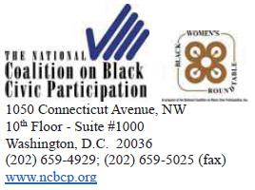

August 22, 2014

Chairman Tom Wheeler

Commissioner Mignon Clyburn

Commissioner Jessica Rosenworcel

Commissioner Ajit Pai

Commissioner Michael O'Rielly

Federal Communications Commission

445 12th Street SW

Washington, D.C. 20554

Re: In the Matter of Applications of Comcast Corp. and Time Warner Cable Inc. For Consent To Assign or Transfer Control of Licenses and Authorizations, MB Docket No. 14-57

Dear Chairman and Commissioners,

I am writing to you to share my perspective on and support of the proposed merger between Comcast and Time Warner Cable. As President and CEO of the National Coalition on Black Civic Participation (NCBCP) and convener of the Black Women's Roundtable (BWR), I have witnessed the significant role Comcast has played in bridging the digital divide and supporting local residents and civic activities within the communities of the markets it serves.¹ Comcast has established a track record as both a key player in and major supporter of successful civic engagement programs, which bodes as a significant indicator of its future commitment to communities in the new markets that would be served as a result of a merger between Comcast and Time Warner Cable.

Historically, Comcast has demonstrated a remarkable commitment to education. From helping to wire schools and libraries for high-speed Internet² to creating mentorship programs for young people to gain

- See Chris Reidy, Comcast Steps Up Its Efforts to Bridge the Digital Divide, boston.com (February 28, 2014), available

at http://www.boston.com/business/news/2014/02/28/comcast-steps-its-efforts-bridge-the-digital-divide/jGdb3TxJLeAEhuz33qlAfM/story.html (last visited August 20, 2014). See also Comcast Awards $68,000 in Scholarships to 59 Virginia High School Seniors, Emporia News (May 23, 2014), available at http://www.emporianews.com/article/comcast-awards-68000-scholarships-59-virginia-high-school-seniors (last visited August 22, 2014). See also, Comcast NBCUniversal Leadership Awards 2014, (The Comcast NBCUniversal Leadership Awards recognized outstanding City Year alumni who are continuing their commitment to strengthening community, inspiring, mobilizing, and empowering others.), available at http://alumni.cityyear.org/?2014Honorees (last visited August 22, 2014).

- See Comcast NBCUniversal Make Million-Dollar Commitment to LIFT to Help Bridge the Digital Divide in Low-169

job experience and professional skills³, Comcast has devoted both financial and human resources to help America's youth to learn and realize their full potential.

This commitment to education is most evident in Comcast's vaunted Internet Essentials program, which offers low-cost Internet access, equipment and training to eligible families.⁴ Through this program, Comcast has connected more than 350,000 families (approximately 1.4 million low-income Americans) to the transformative power of the Internet in their homes.⁵ Additionally, Comcast has pledged to continue the Internet Essentials program indefinitely and to expand the eligibility for the program to include 30% more students.⁶ And, if the merger between Comcast and Time Warner Cable is approved, Comcast has committed to extend the Internet Essentials program to include markets served by Time Warner Cable. This would extend the program to 19 of the 20 largest cities in our nation.⁷

Comcast's response to addressing the lack of broadband connectivity in communities that are most in need is evidence of its tremendous commitment to providing one of our nation's most essential ingredients for economic growth and job creation—broadband adoption.⁸ Every step each of us takes toward making sure that all communities have equal access to the opportunities that broadband provides move us all toward our nation's goal of becoming more competitive in the global economy. The merger of Comcast and Time Warner Cable would represent a large stride towards achieving our nation's goal.

One of the fundamental missions of both the NCBCP and the Black Women's Roundtable is securing a level playing field upon which people of all communities are served equally and have a chance to succeed. For this reason, Comcast's work with regard to diversity strikes a resonating chord with me. From Comcast's commitment to provide a program that encourages more people of color to join the

Income Communities, Money Watch (February 25, 2014), available at http://www.marketwatch.com/story/comcast-nbcuniversal-make-million-dollar-commitment-to-lift-to-help-bridge-the-digital-divide-in-low-income-communities-2014-02-25 (last visited August 22, 2014).

- See T. Charles Pierson, Big Brothers Big Sisters Taps into the Power of Corporate Classrooms for the Ultimate ROI, Inside Philanthropy (September 3, 2013), (Comcast hosts the largest workplace mentoring program in the country.) available at http://philanthropyjournal.blogspot.com/2013/09/big-brothers-big-sisters-taps-into.html (last visited August 22, 2014).

- See Kevin Hardy, Comcast Offers Low-Cost Internet to Some Students, Times Free Press (August 11, 2012), available

at http://www.timesfreepress.com/news/2012/aug/11/comcast-offers-low-cost-internet-to-some/ (last visited August 21, 2014)

- See Ayanna Jones, Comcast Eases Internet Access for Low-Income Families, The Philadelphia Tribune (August 19, 2014), available at http://www.phillytrib.com/news/business/comcast-eases-internet-access-for-low-income-families.html (last visited August 21, 2014).

- See Marguerite Reardon, Comcast Extends 'Internet Essentials' Program Indefinitely, CNet, (March 4, 2014), available at http://www.cnet.com/news/comcast-extends-internet-essentials-program-indefinitely/ (last visited August 21, 2014).

- See id.

- See President obama's Guiding Principles on Technology, available at http://www.whitehouse.gov/issues/technology (last visited August 22, 2014). ("President Obama recognizes that technology is an essential ingredient of economic growth and job creation.")

170

online world - affordably and from home – to its hiring practices to its independently minority-owned programming, Comcast has demonstrated its dedication to diversity.

Since Comcast acquired NBCUniversal, Comcast's workforce diversity has risen to over half of the company's total workforce⁹. At the end of 2013, African Americans accounting for 22% of Comcast's total workforce.¹⁰ And at a total of 57%, women account for the highest percentage of Comcast's net hires and promotions into executive positions.¹¹ And since the Comcast-NBCUniversal merger, Comcast has consistently followed through on its commitment to launch minority-owned program networks— and has launched four minority-owned networks to date.¹² This is highly indicative of Comcast's future commitment to diversity and inclusion in the new markets that would be served by the Comcast-Time Warner Cable merger. The NCBCP and the BWR would whole-heartedly support the extension of Comcast's corporate diversity programs to those new markets.

Based on the reasons stated above, I strongly believe that individuals living in the Time Warner Cable markets will gain a substantial benefit from the Comcast-Time Warner Cable merger. I strongly urge your approval of this merger.

Sincerely,

/s/ Melanie L. Campbell

Melanie L. Campbell

President & CEO and Convener, Black Women's Roundtable

National Coalition on Black Civic Participation

- See Comcast NBCUniversal: Seeing the Bigger Picture (Comcast 2013 Diversity Report), (July 2, 2014) at 5-7, available at http://corporate.comcast.com/images/Comcast_Diversity_Report_060214.pdf , (last visited August 22, 2014). (“At YE 2013, our total workforce was 59% diverse. As we continue to grow and execute upon our strategy for diversity & inclusion, the diversity of our workforce will undoubtedly expand.)

- See id.

- See supra at 8

- See Third Annual Report Of Compliance With Transactions Conditions submitted by Comcast to the Federal Communications Commission, In the Matter of Applications of Comcast Corporation, General Electric Company, and NBC Universal, Inc. For Consent to Assign Licenses and Transfer Control of Licensees MB Docket No. 10-56 at 3, available at http://apps.fcc.gov/ecfs/document/view?id=7521084937, (last visited August 22, 2014). (“With the 2012 launch of AsPIRE and BabyFirst Americas, [Comcast] satisfied the first milestone of its voluntary commitment to launch independent networks with Hispanic American or African American ownership or management. Comcast has now satisfied the second milestone by launching two additional minority owned or operated independent channels during the Reporting Period: First, REVOLT, a new music and pop culture network created by music icon Sean "Diddy" Combs and MTV veteran Andy Schuon, launched in October 2013 and is now available in 25 Comcast markets. Second, in December 2013, Comcast began distributing El Rey, a new network by acclaimed writer-director Robert Rodriguez for Hispanic and general audiences that includes programming that features, and is produced or directed by, Hispanic celebrities and public figures. El Rey is now available in

- Comcast markets.")

171

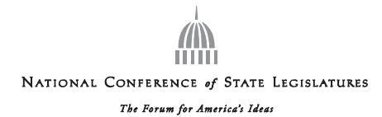

August 25, 2014 | Debbie Smith
 | Senator
 | Nevada
Ms. Marlene H. Dortch | President, NCSL
Ms. Marlene H. Dortch | Margaret Piety
Secretary | Margaret Piety
Federal Communications Commission | Senior Staff Attorney
445 12th Street, S.W. | Indiana
Washington, D.C. 20554 | Staff Chair, NCSL
RE: MB Docket No. 14-57 | Willian T. Pound
Dear Ms. Dortch: | Executive Director

On behalf of the National Conference of State Legislatures (NCSL), I write to register support for the proposed Comcast and Time Warner Cable transaction. NCSL is the bipartisan national organization that represents the legislatures of our nation’s 50 states, its commonwealths and territories. We have a long-standing commitment to minimal government oversight of communications and information services. We are confident that our members and those they represent find this transaction to be in line with that philosophy.

NCSL believes that excessive oversight of the communications and information industry could stifle growth that leads to private investment, innovative and efficient ways to do business, and consumer buy-in to advancements that improve their lives. Comcast, through its various voluntary initiatives, has worked to increase broadband adoption and has been responsive to consumer's technology needs and demands. We see the proposed transaction as vital to progression in the communications marketplace.

This proposal will promote economic development and allow for continued innovation in communications technologies, both of which are crucial for strengthening communities and enhancing individual opportunity. It is our hope that Commission members weigh any restraints on this transaction as potentially unwarranted impediments to healthy and desired economic growth. State legislators, and the citizens and businesses they serve, have enjoyed a fruitful partnership with Comcast because of its investments that are both capital and 'people' oriented.

Please accept our support for the transaction congruent with our mission to promote innovation and infrastructure that moves communities forward. Thank you for your consideration of our viewpoint on this matter. Should you have any questions, please contact James Ward in our Washington, D.C. office at 202-624-8683 james.ward@ncsl.org

Sincerely,

/s/ William T. Pound

William T. Pound

Executive Director


Denver | Washington
7700 East First Place | 444 North Capitol Street, N . W . Suite 515 | Website www . ncsl . org
Denver, Colorado 80230 - 7143 | Washington, D . C . 20001 | Email info@ncsl . org
Phone 303 . 364 . 7700 _ _ Fax 303 . 364 . 7800 | Phone 202 . 624 . 5400 _ _ Fax 202 . 737 . 1069
 | 172

As Chair of the National Council of Negro Women, I thank you for the opportunity to share my views on the proposed merger between Comcast and Time Warner Cable. Based on Comcast's strong track record on diversity and community outreach and initiatives, I believe that the public interest will be served by this transaction, and I urge the Commission to grant its approval.

For nearly 80 years, the National Council of Negro Women has worked to empower and advocate for black women and girls, as well as their communities and families. We promote education initiatives, and advocate for corporate best practices on diversity and hiring that create opportunities for our constituents. Comcast has been a leader in both these areas.

The company's Internet Essentials program is the gold standard for broadband adoption and has helped hundreds of thousands of low-income families get high speed Internet access at home. Educational opportunities simply cannot be equal in this country if poor children do not have ready access to the Internet - far too much learning has moved online for that. And Internet Essentials is critical to leveling the playing field for disadvantaged kids. I understand the transaction will bring this critical program to many new communities and neighborhoods, including critical areas like Los Angeles and New York, and I applaud this.

Comcast has also been a leader in minority hiring, contracting, and workforce practices. I have served as a member of its trail-blazing Joint Diversity Advisory Councils, which gives minority community leaders a direct seat at the table with the most senior company officials. I have seen up close the efforts to launch new independent channels to serve the African American community such as Magic Johnson's Aspire network. The company has been named to DiversityInc's Top 50 organizations the last two years. And its workforce is a remarkable 59% diverse overall - an achievement that holds whether you look at the company overall (59% diverse), leadership positions (46% diverse) or the Board (51% diverse).

Comcast is a good corporate citizen, a leader in broadband adoption and outreach, and a model for workplace diversity. In my opinion, expansion of this socially responsible approach to business is an unqualified public good.

Ingrid Saunders Jones

173

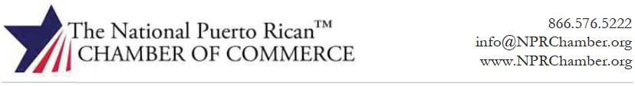

Chairman Tom Wheeler

Commissioner Mignon Clyburn

Commissioner Jessica Rosenworcel

Commissioner Ajit Pai

Commissioner Michael O’Reilly

Federal Communications Commission
445 12th Street, SW
Washington, DC 20554

RE: MB Docket No. 14-57

Dear Chairman and Commissioners:

As the founder and executive director of The National Puerto Rican Chamber of Commerce (NPRChamber), I am writing to you today to express my support for Comcast’s proposed acquisition of Time Warner Cable.

We support this acquisition because it holds the promise of opening myriad avenues of economic and educational opportunity for Hispanics and other minorities throughout Puerto Rico and the U.S. mainland. Of particular interest is Comcast’s potential entry into Los Angeles and New York City markets, two regions with significant Hispanic populations, which also have high concentrations of NPRChamber members.

The availability of broadband Internet has driven entrepreneurship and innovation and Comcast has played a central role in expanding economic opportunities for minorities. Comcast’s commitment to establishing an environment in which minorities can succeed begins with bridging the digital divide with digital education programs such as Internet Essentials. It continues with its concerted effort in contracting with minority suppliers, some of whom are also members of the NPRChamber, as well as investment in minority-owned technology startups. And it finishes with the diverse programming that Comcast uses to inform, entertain, and educate its minority audiences.

It is our sincere opinion that Comcast’s entrance into Los Angeles and New York City would be a boon to Hispanic and minority-owned enterprises in those markets. Between 2010 through 2013, Comcast increased

WWW.NPRCHAMBER.ORG

174

spending on Hispanic-owned suppliers by 24%. This growth has the potential to support both increased financial stability and employment among Hispanics in these new cities, who suffer from disproportionately high levels of unemployment. In addition, by expanding its investments into more advanced broadband services, small businesses and entrepreneurs will have greater access to the technologies needed to compete in today’s increasingly global marketplace.

With respect to the proposed transaction, Comcast’s expansion of its Hispanic-oriented programming will be greatly appreciated in the new markets, as well. Since 2010, the company has significantly expanded its carriage of multicultural networks and has offered nearly 1000 On Demand hours and 1,440 online programming hours designed for Hispanic communities; this has resulted in an 80% increase in its Hispanic audience. Also of note is Comcast’s investment in the production and distribution of the popular Telemundo, the fastest-growing broadcast network in the country, regardless of language.

Comcast has demonstrated its commitment to Hispanic-owned businesses and the Hispanic community at-large over the past several years and we anticipate that even more businesses will have the opportunity to partner with Comcast as the company expands its footprint to cities like New York, which has one of the largest Puerto Rican communities in the country. In addition, the positive impact on services provided to these new communities will ensure greater economic opportunities for Hispanics and their small businesses. This proposed transaction represents a lifeline for many of these enterprises and for these, and other reasons in the public interest, we strongly urge you to approve this merger.

Justin Vélez-Hagan

Executive Director

/s/ Justin Vélez-Hagan

866.576.5222

Cell: 202.630.0787

JustinV@NPRChamber.org

WWW.NPRCHAMBER.ORG

175


August 22, 2014

Federal Communications Commission

445 12th Street sw

Washington, OC 20554

Chairman Tom Wheeler

Commissioner Aj it Pal

Commissioner Mignon Clyburn

Commissioner Jessica Rosenworcel

Commissioner Michael O'Rielly

Re: MB Docket No. 14-57, Applications of Comcast Corp. and Time Warner Cable Inc. for Consent to Transfer Control of Licenses and Authorizations

Dear Chairman Wheeler and Commissioners:

As President and CEO of the New England Sports Network ("NESN"), I write to express NESN's support for the proposed transaction involving Comcast Corporation ("Comcast") and Time Warner Cable Inc. ("TWC").

NESN is owned by the Boston Red Sox and the Boston Bruins and was launched in 1984 as one of the first regional sports networks ("RSN") in the country. We are committed to being a preeminent RSN. In addition to providing coverage of Red Sox and Bruins games, NESN produces and televises other local programs to provide subscribers with New England sports content that entertains and informs.

NESN and Comcast have a long-standing and successful relationship, even though NESN is a competitor of Comcast SportsNet ("CSN"). NESN is delivered to over four million homes throughout the six-state New England region, and nationally as NESN National. Many of those homes are a result of NESN's carriage on Comcast, ensuring that all Comcast customers have access to our programming.

As our experience demonstrates, Comcast has a strong record of supporting independent sports networks—even those that compete with Comcast's own CSN. Indeed, Comcast has never discriminated against NESN in f avor of Comcast affiliated programming. On the contrary, Comcast is a good competitor and negotiates fairly with NESN as to both rates and carriage. This is exemplified by our most recent negotiations that resulted in a long-term carriage deal that is fair to both parties.

176

Given our experience, we believe that Comcast's transaction with Time Warner Cable will be a great development for independent sports networks and for New England sports fans. For these reasons, we fully support the Comcast-TWC transaction.

Sincerely,

/s/ Sean P. McGrail

Sean P. McGrail

President and CEO

177

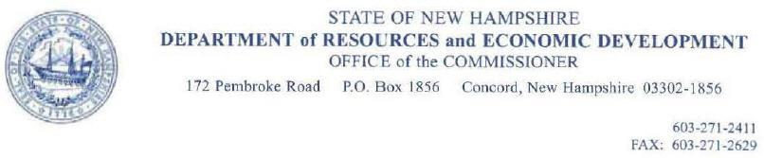

August 25, 2014

Mr. Tom Wheeler

Chairman

Federal Communications Commission

- 12th Street, SW Washington, DC 20554

RE: MB Docket No. 14-57

Dear Chairman Wheeler:

As the Commissioner of New Hampshire's Department of Resources and Economic Development, I am strongly invested in fostering economic development and supporting companies that attract business in our state. Comcast has proven itstelf to be one of these exemplary companies. l write you this letter today because I have heard about the proposed transaction between Comcast and Time Warner Cable and urge your approval. Comcast has been one of the strongest economic drivers in New Hampshire, and a tremendous community and business partner, and I can speak from firsthand experience to the company's commitment to invest in both its employees and cutting-edge technologies that drive competition and innovation.

Comcast has been a strong supporter of jobs in New Hampshire. The company employs over 1,700 full-time workers in our state, and owns and operates 39 properties, generating an annual state and local tax income of more than $26 million dollars. In 2013, the company invested over $150 million in payroll, healthcare benefits, on-rhe-job training and tuition reimbursement for employees. Most recently, Comcast exemplified its commitment to employee investment in our state by announcing plans to build a 127,000 square-foot Customer Support Call Center in Hudson, New Hampshire. Comcast's announcement is great news for New Hampshire, and reiterates what I already knew about the company's status as a great neighbor and corporate partner. The facility will feature state-of-the-art technology and include a cafeteria, gym, and training facilities. It will also hold 600 seats for customer support team members, which represent an exciting employment opportunity for local residems that will surely stimulate positive growth in the local Hudson economy, and hopefully echo such results across the entire state. Comcast's decision shows that New Hampshire is a prime location for growth, expansion, and outside investment.

Comcast's investment in our state is exciting, and I am thrilled to see what the future brings for our partnership. But even more so, I am excited by the potential economic benefits that the proposed transaction with Time Warner Cable could bring our businesses and consumers. I feel that by combining resources, Comcast-Time Warner Cable will be a more cost-effective and stronger competitor to large businesses in lhe broader telecommunications market. This competition will drive other incumbent internet and technology providers to invest more into developing innovative products and services. I'm excited by what l've learned about AT&T's recent announcement of their expanded broadband investment to keep up with leaders like Comcast. The result of this competition will be a range of top-quality resources for our businesses and consumers to choose from more affordable prices. These
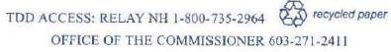

178

products will result in a more efficient and productive local economy in New Hampshire, and foster competition among our state neighbors for attracting businesses.

I urge you to approve the proposed transaction for all of the public interest benefits that it will bring.

Sincerely,

/s/ Jeffrey J. Rose

Jeffrey J. Rose

Commissioner

JR:lc

179

Tom Wheeler

Chairman

Federal Communications Commission

445 12th Street, SW

Washington, DC 20554

RE: MB Docket No. 14-57

Dear Chairman Wheeler:

I am the CEO and Co-Founder of Nextdoor, where we use the power of technology to build stronger, safer, more connected neighborhoods. Nextdoor is a free and private social network designed just for you and your neighbors. To date, over 40,000 neighborhoods across the U.S. Have signed up for Nextdoor and rely on us as the easiest way to communicate with neighbors -- whether that is finding a babysitter, searching for a lost pet, discussing local school issues, banding together to fight crime, or communicating during storms and other natural disasters. As an emerging company in the online space, I appreciate the opportunity to let you know why I support the transaction between Comcast and Time Warner Cable.

Comcast Ventures is one of our investors. As a cable and broadband company uniquely focused on local markets, Comcast saw early the need for and promise of a neighborhood-specific social network. They intuitively understood the problem we are solving and committed to leveraging their own resources to scale our platform and support our success. I am pleased to say that we are delighted to have them as partners, value their strategic insights and look forward to growing a large, profitable business together.

Comcast has proven to be a leading innovator in its industry and a strong and steady partner to startups like ours. We assume that the Time Warner merger will only increase Comcast's ability to support us and others like us by allowing it to invest across an even larger footprint. For these reasons, we are happy to write in support of Comcast and urge you to approve the Time Warner merger.

Sincerely,

/s/ Nirav Tolia

Nirav Tolia

CEO and Co-Founder

Nextdoor

180



The Honorable Tom Wheeler August 18, 2014

Federal Communications Commission
445 12th Street, SW
Washington, DC 20554

Dear Chairman and Commissioners,

RE: MB Docket No. 14·57

On behalf of the Nigerian-American Multi Service Association, I submit this letter in support of the proposed Comcast/Time Warner Cable transaction. We have an expansive mission to improve the standing of the Nigerian community in America, but are particularly focused on strengthening relationships between the Nigerian-American community and other entities, including governmental, educational, and business organizations. Comcast, a company that drives innovation and provides first-rate technology and entertainment options, is also a company that encourages diversity and sponsors inclusion-related efforts. Comcast's support for our organization has been incredibly advantageous to our members, and I support Comcast expanding its services to reach more Nigerian-American groups nationwide.

In the last decade Comcast has always been a willing and supportive participant of our programs. Comcast has continuously made an effort to support our NAMSA scholarship program. Our annual Scholarship Awards dinner provides ten young adults each year with scholarship funds for college and university expenses. So many Nigerian-Amerlcan struggle to be successful at higher education institutions. but thanks to Comcast's assistance, many of them are able to stay in their current programs and thrive.

Comcast is one of the nation's largest employers, and should the transaction be approved, I look forward to seeing Comcast continue its diversity recruitment efforts in its new service areas. Comcast has said that within 120 days of the close of the transaction, it will develop a new master plan that will set forth the vision and goals for the combined company's diversity programs. One of Comcast's central missions is to attract diverse employees, which it does by nurturing top talent through employee leadership, mentoring and sponsorship programs. Nearly 40 percent of all full-time US Comcast employees are diverse and as a Nigerian-American organization leader, I am proud to promote the growth of a company that encourages a leading minority workforce.

Members of my community also have much admiration for Comcast's commitment to providing diverse, independent programming. Xfinity On Demand includes more than 50,000 programming choices, many of which are dedicated to minority interests. Last, year Xfinity connected with members of our organization by hosting the premiere of the Nigerian civil war movie "Half of A Yellow Sun." The film, a source of pride for the Nigerian community, is an excellent tool for educating the public at large about the history and struggles of our nation. Without this type of commitment to providing a wide range of entertainment options, a majority of Americans would be uninformed about different cultures. I appreciate Comcast's commitment to ensuring that more of these stories have a place to be told.

181

It is clear that a transaction between Comcast and Tlme Warner Cable will provide a plethora of new opportuniues and fresh programming for the Nigeria American community at large. I hope that the FCC will take note of this by quickly approving the proposal.

Thank you for allowing us the opportunity to share our opinion on this matter.

Sincerely,

/s/ Jamiu Giwa-Bello

Jamiu Giwa-Bello, President/Executive Director

Nigerian-Amerlcan Multi Service Association, Inc

- Commissioner Mignon Clyburn Commissioner Jessica Rosenworcel Commissioner Ajit Pai Commissioner Michael O'Rielly

182

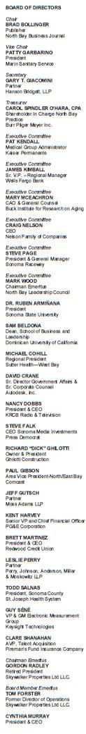
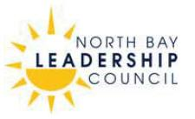

August 22, 2014

Tom Wheeler, Chairman

Federal Communications Commission
445 12th Street, SW
Washington, D.C. 20554

RE: MB Docket No. 14-57

Dear Chairman Wheeler:

As CEO of North Bay Leadership Council, I write today to urge the Federal Communications Commission to approve the proposed transaction between Comcast and Time Warner Cable.

North Bay Leadership Council is an employer-led public policy advocacy organization committed to providing leadership in ways to make the North Bay sustainable, prosperous and innovative. As business and civic leaders, our goal is to ensure economic health by promoting better education, infrastructure, and governance to make our region a better place to live and work.

Comcast has been a valuable partner here in the North Bay and has worked very closely with our organization and on a number of initiatives and priorities that are important to the success of our economy and our communities.

Comcast has invested close to $10 billion in infrastructure over the past 20 years in California and now many of our business can enjoy competitive and top-tier broadband speeds and other business services. Comcast's wide, over 2-million-strong customer base and commitment to innovation that will improve our business climate for all Californians. The extensive and expanding Xfinity hotspot network means that our small business owners and individual entrepreneurs will not have to worry about installations of quality broadband. They can connect wherever, whenever to the information and tools they need to innovate and prosper.

But perhaps more important, Comcast is a leader in our community and invests in many local non-profit organizations. Comcast knows that the key to sustained growth and prosperity depends on investment in education and youth.

There is no better example of Comcast's commitment to the communities it serves than its Internet Essentials program which provides low-cost home internet service, affordable computer options and training to low-income families. Internet Essentials program has been a tremendous success in increasing broadband adoption and digital literacy in Northern California and helping more than 35,000 families gain access to the 21st Century broadband technology.

As you consider this proposed merger, please take into consideration all of Comcast efforts and investments in the community and those who would benefit in California and throughout the country if it were to go through.

Sincerely,

/s/ Cynthia Murray

Cynthia Murray, CEO

North Bay Leadership Council

775 Baywood Dr. , Suite 101 ● Petaluma, CA 94954

707.283.0028 ● Fa x: 7 07.763.3028 ● www.northbayleadership.org

183

August 25, 2014
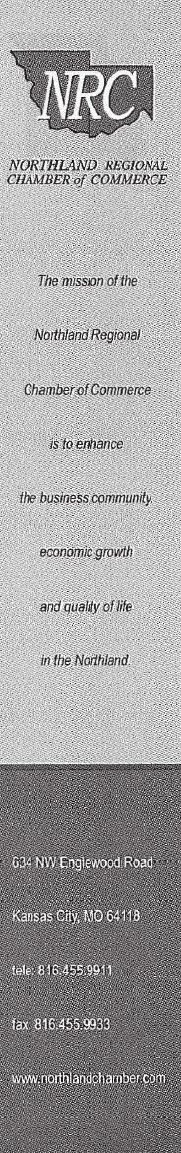

Tom Wheeler, Chairman

Federal Communications Commission
445 12th Street, SW
Washington, DC 20554

RE: MB Docket No. 14-57

Dear Chairman Wheeler:

This letter is submitted regarding the proposed Comcast/Time Warner Cable transaction. I am the President of the Northland Regional Chamber of Commerce, an organization which serves Clay and Platte counties in the metropolitan Kansas City area. The Northland region covers nearly 300,000 Missourians, nearly 30% of Kansas City's population. The Northland Chamber is one of the largest Chamber organizations in the region with a membership of over 700 businesses and 1,200 representatives.

A primary mission of the Northland Chamber is to provide opportunities for members to market their business through networking, special advertising and business referrals. I believe approval of the proposed transaction would be an important step in helping further each of these goals.

Comcast has invested tens of billions in infrastructure over the last two decades, and has committed to continuing to invest significantly in broadband capacity and other network improvements over the next few years. Approval of the transaction would enable the Time Warner Cable systems, and their subscribers, to benefit from these investments. I understand that Comcast already offers broadband service at substantially faster speeds than Time Warner Cable. The local business community would obviously benefit if it had the opportunity to take advantage of these superior capabilities. Comcast has committed to making these upgrades to the Time Warner Cable systems if the transaction is allowed to move forward.

Comcast is also an industry leader in the area of broadband adoption. I understand that Comcast's Internet Essentials initiative is the nation's largest broadband adoption program, offering affordable, quality internet access and computers to families with at least one child that qualifies for the National School Lunch Program. This program has a proven track record in providing families first-time access to the benefits of the Internet and Comcast recently announced that it will extend the initiative indefinitely. Residents of the Northland region would clearly benefit if the Internet Essentials program was made available in their neighborhoods. Local businesses, in turn, would be able to market their services to an expanded, better-informed group of potential customers.

184

Finally, the combination of Comcast and Time Warner Cable would result in a much larger service area footprint. The Northland Chamber anticipates that this development would provide the ability to better serve businesses that span multiple geographic areas.
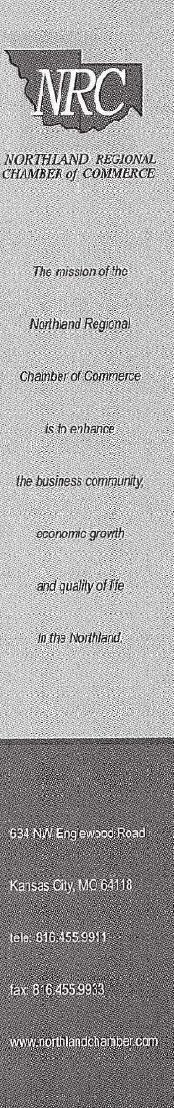

For these reasons, the Northland Regional Chamber of Commerce supports approval of the Comcast/Time Warner Cable transaction.

We thank you for the opportunity to express our views.

Sincerely,

/s/ Sheila Tracy

Sheila Tracy

President

185

August 25, 2014

Tom Wheeler, Chairman

Federal Communications Commission
445 12th Street, SW
Washington, DC 20554

RE: MB Docket No 14-57

Dear Chairman Wheeler:

On behalf of OCA – Asian Pacific American Advocates, a national membership-driven organization of community advocates dedicated to advancing the social, political, and economic well-being of Asian Pacific Americans (APAs), I write to support the merger of Comcast and Time Warner.

OCA represents one of the organizations that signed onto the APIA MOU associated with the NBCUniversal Comcast merger. We have worked with Comcast through its Joint Diversity Council (JDC) to both ensure that Comcast kept it promises and help them achieve a broader set of goals established in consultation with the members of the JDC. We report that all commitments agreed upon in the APIA MOU were met, and in some cases, exceeded the agreed upon time frames.

As one of the organizations on this council, one of our key priorities has always been expanding access to broadband Internet for underserved communities. Asian Pacific Americans include a broad range of socioeconomic statuses. According to a report by the National Coalition for Asian Pacific American Community Development (National CAPACD), almost 2 million APAs live at or below the poverty line the United States^{i}. And though Southeast Asian and Pacific Islander Americans have some of the highest rates of poverty among all racial and ethnic groups in the United States^{ii}, Chinese and Indian Americans have the highest absolute number of individuals living in poverty at 449,356 and 246,399 respectively^{iii}. Comcast’s Internet Essentials program has been one of the primary vehicles for low-income families with children who receive free or reduced-price school lunches to access affordable broadband Internet, particularly in the APA communities.

Geographically, some of the areas with the largest concentration of poor Asian Americans (AA) are located in California and New York. While the largest concentrations of poor Native Hawaiian and Pacific Islanders (NHPI) are in Hawaii^{iv}. By allowing the merger of Comcast and Time Warner, the FCC would allow Comcast to expand a necessary program for low-income APA communities into California and Hawaii, areas in need of affordable broadband Internet. Additionally, we cannot foresee any negative effects to the community because of the merger, given that Comcast has fulfilled all mandates indicated in the MOU signed during the Comcast and NBCUniversal merger. As such, the proposed merger brings more opportunities for improved community service and access than any potential negative consequences.

As president of one of the oldest Asian Pacific American civil rights organizations, I have seen firsthand the importance internet access plays in the economic and academic success of low-income families. Access affects every facet of modern life, from supplementary educational information to online job
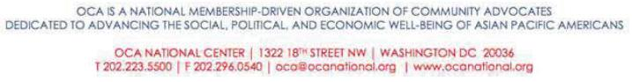

186

applications. The Comcast and Time Warner merger would give hundreds of thousands of APAs without a home broadband internet connection much needed access, and that is vital to their success in the 21st century.

Sincerely,

/s/ Sharon M. Wong

Sharon M. Wong

OCA National President

- National Coalition of Asian Pacific American Community Development (June 2013). Spotlight: Asian American and Pacific Islander Poverty. Retrieved from http://nationalcapacd.org/sites/default/files/u12/aapi_poverty_report-web_compressed.pdf.

- Asian American Center for Advancing Justice (2011). A Community of Contrasts: Asian Americans in the United States. Retrieved from http://www.advancingjustice.org/sites/default/files/Community_of_Contrast.pdf.

- National Coalition of Asian Pacific American Community Development (June 2013). Spotlight: Asian American and Pacific Islander Poverty. Retrieved from http://nationalcapacd.org/sites/default/files/u12/aapi_poverty_report-web_compressed.pdf.

- National Coalition of Asian Pacific American Community Development (June 2013). Spotlight: Asian American and Pacific Islander Poverty. Retrieved from http://nationalcapacd.org/sites/default/files/u12/aapi_poverty_report-web_compressed.pdf.

187

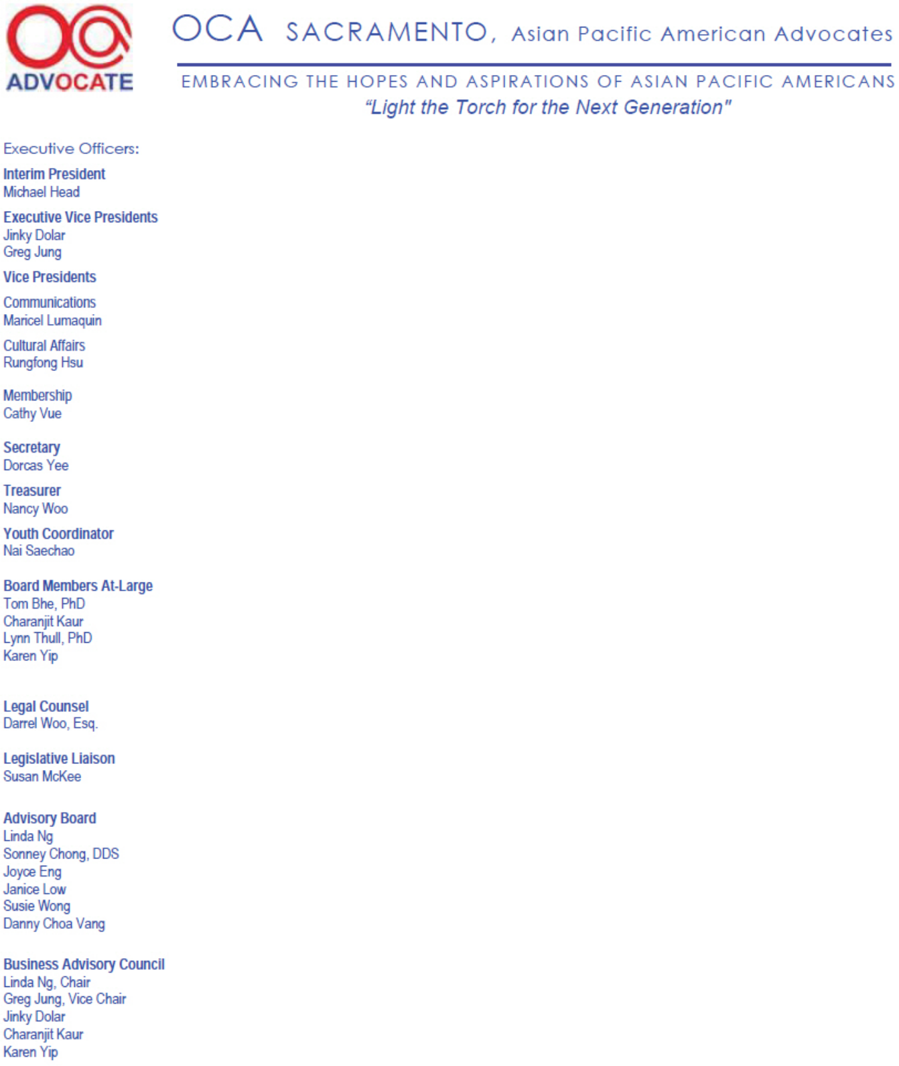

August 25, 2014

Tom Wheeler, Chairman

Federal Communications Commission
445 12th Street, SW
Washington, DC 20554

RE: MB Docket No 14-57

Dear Chairman Wheeler:

On behalf of OCA Sacramento - Asian Pacific American Advocates, I write to support the merger of Comcast and Time Warner. OCA, headquartered in Washington DC, is a national membership-driven organization of community advocates dedicated to advancing the social, political, and economic well-being of Asian Pacific Americans (APAs). OCA Sacramento is one of the organization’s 100 chapters and affiliates across the Nation.

OCA Sacramento provides a wide variety of programs and projects including advocacy, civic participation, economic development, leadership and education throughout the year that benefit both APA and non-APA communities in the Greater Sacramento Region. We have built a positive relationship with Comcast and the Comcast Foundation for over ten years to help the local community.

OCA Sacramento knows firsthand that Comcast is committed to bring Digital Literacy to disadvantaged communities; we partnered with Comcast to promote Internet Essentials, a digital literacy program for low income families with school age children. The program provides low cost internet access, vouchers for discounted laptops and no cost computer classes. The Digital Divide is growing and affects low come students in their ability to succeed in school. Comcast’s Internet Essentials program has been a good start in increasing broadband adoption and Digital Literacy in Northern California and helping more than 35,000 families gain access to the 21st Century broadband technology.

By allowing the merger of Comcast and Time Warner, the FCC would allow Comcast to expand a necessary program for low-income APA communities into California and Hawaii, areas in need of affordable broadband Internet. The proposed merger brings more opportunities for improved community service and access than any potential negative consequences.

Thank you for your consideration and I would urge that you to move expeditiously on this important matter that can help bridge the growing Digital Divide; and improve the lives, the economic well being and the academic future of low income families.

Sincerely,

/s/ Michael Head

Michael Head

OCA Sacramento Interim President

188

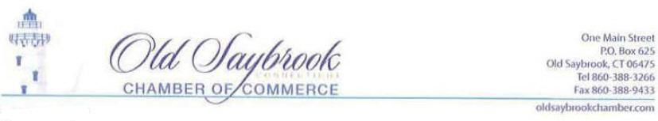

August 24, 2014

Tom Wheeler, Chairman

Federal Communications Commission

445 12th Street, SW

Washington, DC 20554

RE: MB Docket No.14·57

Dear Chairman Wheeler:

I am the Executive Director of the Old Saybrook Chamber of Commerce in Connecticut, where I proudly oversee valuable programs and services for over 500 members and help advance economic vitality and quality of life in Old Saybrook and its surrounding communities. Our membership spans many different businesses, civic and non-profit organizations and individual members. Comcast plays a major role here by serving on committees and working directly with other businesses to improve local services. I am happy to have them as a trustworthy ally in our efforts to keep local business thriving. As a declaration of my support for their excellent work here in Connecticut, I urge the FCC to pass the proposed TWC/Comcast transaction.

Comcast has a long history of business success in Old Saybrook and across Connecticut. Comcast has over 2,300 full-time employees across the state. For our Chamber of Commerce, it is incredibly beneficial to have one of the largest Connecticut employers engage with us in so many ways. Comcast also is a key sponsor of our annual Business EXPO. The EXPO is one of the year's most advantageous events for our businesses - each October all of our members gather to promote business-to-business networking, showcase member products and services, and invite the community to visit each business's booth.

Last November, Comcast Business teamed up with one of our members Ashlawn Farm Coffee, a socially-conscious coffee bean roaster, to provide Comcast Business Internet and Business Wifi to its cafe in Old Saybrook. Ashlawn had long been looking for a way to keep its tech-savvy customers happy, and these excellent Comcast services proved a brilliant solution. Comcast invited the Chamber to join in a ribbon-cutting ceremony at the new cafe to celebrate the grand opening and to announce the expansion of Xfinity WiFi at a number of hotspots across Connecticut. We received an amazing amount of positive feedback for this venture, and our other member businesses were encouraged to see such an excellent outcome for local business through our connections with Comcast.

I look forward to Comcast's ongoing commitment, care and business presence here in Old Saybrook and throughout Connecticut. I strongly hope that the proposed transaction with Time Warner Cable will become a reality and yield positive outcomes for other states and local communities as well.

Sincerely,

/s/ Judy Sullivan

Judy Sullivan

Executive Director


189

August 23, 2014
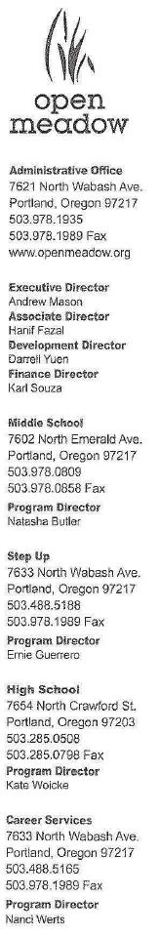

Tom Wheeler

Chairman

Federal Communications Commission

445 12th Street, SW

Washington, DC 20554

RE: MB Docket No. 14-57

Dear Chairman Wheeler:

Thank you for giving me this opportunity to express my support for Comcast and the proposed transaction between the company and Time Warner Cable. I joined Open Meadow Schools in 1995 and currently serve as executive director of this outstanding educational institution. Comcast is one of our strongest partners.

The problems in public education today are overwhelming. Since 1971, Open Meadow has provided an alternative for children who are struggling in public schools. We are a nonprofit, accredited educational institution for middle and high school students.

Many of our students dropped out of public school. Many struggled with attendance, academic, or disciplinary issues. We believe that all of them deserve a quality education .

At Open Meadow, students find

- small community-learning environments

- respectful, caring, and dedicated teachers

- support to overcome previous barriers to success

- classes that accommodate a variety of learning styles and skill levels

Comcast was the inaugural partner for our Step Up program, a tutoring and mentoring program for students at three local public high schools who are at very high risk of dropping out. Step Up also provides leadership training and summer enrichment programs.

Words are not sufficient to express the extent of my gratitude for Comcast's unending support for our programs. For our low-income students, education is the only way they can achieve economic self-sufficiency. Our public schools are overwhelmed. Open Meadow is doing all that it can to help these students, but without sponsors like Comcast, we will not be able to expand our services to meet the growing need.

Comcast is a community partner that can benefit other nonprofits in a similar fashion. lf the company is able to move into the territory now served by Time Warner Cable, I am certain that the company's philanthropy will be extended, too.

/s/ Andrew Mason

Andrew Mason

Executive Director

Engage. Educate. Empower.

190

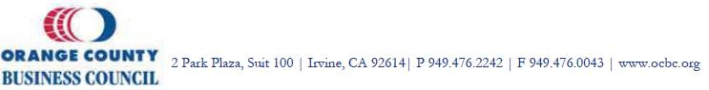

August 25, 2014

Tom Wheeler

Chairman

Federal Communications Commission

445 12th Street, SW

Washington, DC 20554

Subject: MB Docket No. 14-57

Dear Chairman Wheeler:

On behalf of Orange County Business Council (OCBC), I am writing to express our support in regards to the proposed Time Warner Cable-Comcast transaction.

As Orange County’s leading voice of business, OCBC serves a variety of needs for its investors, members and their 250,000 employees in Orange County and 2,500,000 employees worldwide. In addition, OCBC focuses on four initiatives: improving infrastructure, enhancing workforce development, increasing the supply of workforce housing and maintaining a robust economic climate.

Investing in and maintaining a world class communications infrastructure is critical to the success of our businesses. Upon approval of the proposed transaction, it is OCBC’s understanding that Comcast would acquire Time Warner’s broadband and cable access systems; a network that covers as significant portion of Orange County, California. As such, Comcast has demonstrated a strong track record in California, investing upwards of $9.5 billion over the past 20 years in its current service areas.

In addition to its significant investments in the state’s communications infrastructure, Comcast serves as a major employer with over 10,000 fulltime jobs here in California while making significant monetary investments in local community initiatives on an annual basis.

OCBC appreciates your consideration and urges the Commission to approve the Time Warner Cable-Comcast transaction.

Sincerely,

/s/ Matt Petteruto

Matt Petteruto

Vice President, Economic Development

THE LEADING VOICE OF BUSINESS IN ORANGE COUNTY

191



August 25, 2014

Chairman Tom Wheeler

Commissioner Ajit Pai

Commissioner Mignon Clyburn

Conm1issioner Jessica Rosenworcel

Commissioner Michael O'Rielly

Federal Communications Commission

445 12th Street SW

Washington, DC 20554

Re: Applications of Comcast Corp. and Time Warner Cable Inc. for Consent to Transfer Control of Licenses and Authorizations, MB Docket No. 14-57

Dear Chairman Wheeler and Commissioners:

Outside Television supports the merger of Comcast and Time Warner Cable. We believe it will create new distribution opportunities for independent programmers who target smaller but passionate niche audiences.

Outside Television is the only national programming network dedicated to the active outside lifestyle and the more than 141 million Americans who regularly participate in it. Based on Outside Magazine and the concepts behind its critically acclaimed brand, Outside Television embraces running, biking, skiing, sailing, surfing, kayaking and any other adventures involving wind, water, snow and terrain; as well as the full spectrum of people's lives who engage in them. We feature a strong lineup of nearly 50 original shows that tell the incredible stories of the globe's most majestic natural landscapes and the fearless souls who dare to conquer them in the name of sport.

Outside Television is currently available in over 30 million homes through a variety of distributors. This broad carriage is largely due to Comcast's decision to support and carry Outside Television as part of its original national launch in 2012.

Specifically, our network was established in mid-2010. From the start, Outside Television was steered by a seasoned leadership team featuring Emmy award-winning producers, former major sports league executives, and titans of the broadcast industry – all of whom recognized the unique opportunity that Outside Television's programming concept could offer. We had a brand that enabled us to bring a near-instant audience to the systems that carried us, built a significant roster of original programming, and entered into key partnerships with sponsors. And we had truly compelling original content, shot in HD with the world's greatest natural settings as our stage.

33 Riverside Avenue. 4th Floor. Westport. CT 06880 (203) 221-9240

192

Although Comcast already carried a wide variety of sports programming, including NBC SportsNet and regional sports networks, Comcast saw that Outside Television could serve an untapped niche with tremendous upside. We signed an affiliation agreement with Comcast in late 2011 and launched in 2012, with rollout of the network to customers located within Comcast systems near America's coastlines, mountain ranges and the Great Lakes, where so many outside enthusiasts live. At year-end 2013, over 2.6 million Comcast customers were receiving Outside Television.

Comcast has shown that it is not only open to – but enthusiastic about – seeking out new, high quality independent programming that adds value to the choices it offers its customers. As an industry leader in the carriage of independent programming, Comcast has been a willing and valued partner of Outside Television. We are grateful for Comcast's past support and have high hopes for an even greater business relationship as the two companies continue to grow.

That is why Outside Television, as an independent programmer, is very interested in this transaction. If approved, Comcast will be able to entertain further distribution of our network in areas where Outside Television is not currently offered. An expanded Comcast footprint will give us the chance to grow our reach and extend our viewership. We urge the Commission to approve the transaction as quickly as possible.

Thank you for considering our views.

Sincerely,

/s/ Mark Burchill

Mark Burchill

Chief Executive Officer

33 Riverside Avenue. 4th Floor. Westport. CT 06880 (203) 221-9240

193

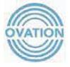

August 22, 2014

Chairman Tom Wheeler

Commissioner Mignon Clyburn

Commissioner Jessica Rosenworcel

Commissioner Ajit Pai

Commissioner Michael O'Rielly

Federal Communications Commission

445 12th Street, SW

Washington, DC 20554

RE: MB Docket No. 14-57

Dear Chairman and Commissioners:

When Comcast announced plans to acquire Time Warner Cable (TWC) earlier this year, many industry critics argued that it would have too much power over consumers, content providers, and others in the media industry. These critics speculated about the possible risks while ignoring the very real advantages this merger would bring to millions of customers in the TWC footprint, such as faster Internet service and more diverse programming.

Comcast's merger with TWC means a robust video experience for more Americans. TWC customers will benefit from Comcast's industry-leading X1 platform, which provides unprecedented choice, control, and access to content on a wide array of IP-connected devices.

Because Comcast and TWC operate in different communities, no customer will see a reduction in competition for Internet, cable, or telephone service. They are merely replacing one cable and Internet provider for another, a swap that will benefit our local communities through access to faster Internet speeds, more programming choices, and Comcast's innovative programs. For instance, Comcast plans to expand its Internet Essentials initiative, which has already brought low-cost broadband to over a million low-income Americans, to current TWC communities.

As the EVP of Content Distribution at Ovation -- the only national, multi-platform network offering arts and cultural programming— I can address the claims raised by some that this merger will have an adverse effect on independent programmers. Ovation has existed since the mid-90s, but was relaunched in 2007. Much of our network's success is due to our outstanding business relationship with Comcast, which has added millions of homes to the network's overall distribution — over 3 million in the last three years, including new carriage in key markets such as Miami, Atlanta, and Chicago. Comcast also added Ovation to its Xfinity on Demand service in 2012, increasing our network's VOD reach to more than 25 million US households, and offers the same Ovation programs to their customers through their various TV Everywhere platforms. In addition, Comcast has been a key partner in numerous local arts education initiatives we have supported, including providing free museum admission and creating awareness of cultural events at community and national levels.

As the nation's only arts network, Ovation believes strongly that every household -- whether in an urban center or a rural community -- deserves access to the arts. Accordingly, Ovation is still seeking full carriage on Comcast given their strong presence in the country's top markets. It's

194

critical that we ultimately secure the broadest carriage in the nation's largest cultural centers in order to have full access to those viewers who are most inclined to value arts programming.

In fact, Comcast has the best record of any pay-TV provider in launching independent networks like Ovation, as well as many minority-owned channels, such as TV One. In conjunction with its NBCUniversal transaction, Comcast made an unprecedented commitment to carry 10 new, independently owned and operated cable networks, and moved quickly into an all-digital platform, at great expense, to free up channel space for the next generation of innovative independent programmers. And unlike other cable MVPDs, Comcast hasn't yet dropped a cable network in a carriage fee dispute.

Over the years, Comcast has proven to be an important distributor of Ovation's quality programming and consistently negotiates fairly. Comcast pays competitive rates to independent programmers like us, and are willing to grow distribution when warranted . In turn, we've provided high-quality, non-duplicative programming focused on art, artists, and artistic storytelling. Given our long-standing relationship, we look forward to reaching full distribution on Comcast, allowing Ovation to invest even further In our brand and original programming.

All in all, I beheve the Comcast/TWC merger would bring positive change to the pay-TV and broadband industry. Customers will see no reductJon in competition, but will benefit from more innovative products and services. Programmers, especially independent programmers, will have more assurances and opportunities to maintain and/or gain carriage.

Mr. Chairman and Commissioners, thank you for ensuring that independent voices like ours are heard.

Sincerely.

/s/ Brad Samuels

Brad Samuels

Executive Vice President of Distribution, Ovation

195



Tom Wheeler, Chairman

Federal Communications Commission

445 12th Street, SW

Washington, DC 20554

RE: MB Docket No. 14-57

Dear Chairman Wheeler,

It is tough to count the many ways that Comcast has made an impact on Portland public school students. From donating school supplies to cleaning up our playgrounds, Comcast employees have truly made a difference in our community. I support the expansion of public/private education partnerships, thus I sign my name in support of the proposed Time Warner Cable/Comcast transaction.

I am the Principal of the Faubion School, a public K-8 school in Portland, OR. In my eight-year tenure as Principal, I have worked tirelessly to engage the community to turn this once failing school into an innovative education center, where students' futures are bright and full of promise. Comcast has played an important role here since before my time through its support of the "Tools for Schools" program, where Comcast partners with Schoolhouse Supplies to provide backpacks filled with new school supplies for every student at our school. Comcast employees volunteer their time to pack and then distribute the backpacks to the kids/families at the school each year, ensuring that each student has the proper tools to succeed in the classroom.

But students need more than well-supplied backpacks to succeed in the 21st century. That's why I was proud to watch Portland Public Schools Superintendent Carole Smith help to launch Comcast's Internet Essentials program in 2011. This program has transformed a community desperately in need of greater broadband adoption. Over 5,000 low-income Portland families have connected to this program that provides low cost internet service and computers, along with free training at local community centers. Access to computers and the Internet helps give these students an equal chance to succeed by connecting them online with their teachers and their school's educational resources. Parents can simultaneously receive digital literacy training so they can apply for jobs online or use the Internet to learn more about healthcare and government services available where they live. Comcast employees frequently stop by our school to hold computer literacy workshops to connect to our families directly.

Visitors to our school always tell me they can't believe how beautiful our building and playgrounds are. Our school is still shining from last year's Comcast Cares Day, the largest national corporate day of service. Our school was the flagship and Executive Tour site for this event in 2013, which brought welcome media attention. Over 150 volunteers came out to paint, clean and fix up the school and its playground/landscape, and Comcast made a generous donation. This project brought out all members of the community to promote the importance of maintaining school properties so our kids can have the best environment to focus on their studies.

Comcast has been a true advocate for us as we champion the needs of our public school students. I recommend expanding Comcast's service areas so more of America's schoolchildren can benefit like the kids of Portland, Oregon.

Sincerely,

/s/ LaShawn Lee

LaShawn Lee, Proudest Principal in PPS

196

8/23/2014

Tom Wheeler

Chairman

Federal Communications Commission

445 12th Street, SW

Washington, DC 20554

RE: MB Docket No. 14-57

Dear Chairman Wheeler:

I am an atomic physicist by training and co-founder and CEO of Quantifind, an analytics platform that helps companies find the signals in their data that tie directly to revenue by forecasting consumer actions in the real world. We use this data to provide our customers with a view into messaging and product strategy for their respective brands.

We are a Comcast Ventures portfolio company, and we made the decision to partner with Comcast because we saw in them a team that understood how the field of marketing analytics is ripe for disruption. Comcast Ventures brings added value to our company through its strategic insights, its knowledge of the marketing industry and its willingness to experiment with cutting edge technology.

As part of this deal, Comcast will be able to advance innovation across a larger footprint. Quantifind will directly benefit from Comcast's increased investment, as I imagine will all the other start-ups in Comcast Ventures's portfolio.

From an entrepreneurs perspective, the FCC should approve Comcast's deal with Time Warner Cable. Thank you.

Sincerely,

/s/ Ari Tuchman

Ari Tuchman

CEO and Co-Founder

Quantifind

197

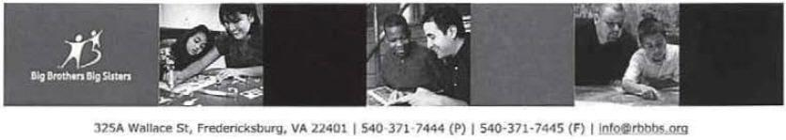

Tom Wheeler, Chairman

Federal Communications Commission
445 12th Slreel, SW
Washington, DC 20554
August 25, 2014

RE: MB Docket No. 14·57

Dear Chairman Wheeler:

This letter is in support or Comcast and their investment in local communities. Here in Fredericksburg Virginia, 23% of children are living below the poverty line and 52% are eligible for free school lunch. Comcast has a particular commitment to helping these children who are facing adversity. Comcast understands that by providing positive direction, these children can have success in school and in life. Through the many efforts of Comcast, children are matched with mentors to improve their school performance, educational expectations and self-esteem.

Comcast is to be commended for their generous financial investment in non-profits that have proven success with helping children reach their potential. In addition, Comcast partners with our organization to provide other types of resources. They advocate for mentoring through their Comcast Newsmakers public service airtime that we utilize to recruit mentors. Their Internet Essentials program is designed to address the digital divide for the children we serve.

Comcast also supports our efforts to help children understand civic engagement and being stewards of our community. The Comcast Cares Day program offers the opportunity to teach these concepts by participating in hands on volunteer activities such as River Clean up organized by Comcast employees.

Comcast is a company that is proactive in supporting our prevention program that changes the lives of children for the better, forever. Comcast is investing in children who have a higher likelihood of failure by providing them with the tools to help them achieve educational success and be prepared for the changing workforce.

Comcast leverages their resources – financial, in-kind, media, employees – to make the best impact to improve not only the lives of individual children but also our community as a whole.

Sincerely,

/s/ Michelle Hedrich

Michelle Hedrich

Executive Director

198

August 22, 2014

Tom Wheeler

Chairman

Federal Communications Commission

445 12th Street, SW

Washington, DC 20554

RE: MB Docket No. 14-57

Dear Chairman Wheeler:

I represent the 24th District in the Georgia House of Representatives and will begin serving in my 5th consecutive term in January. The citizens of the City of Cumming and Forsyth County Georgia expect the absolute best from our corporate community. Accordingly, I am writing this letter in support of the proposed transaction between Comcast and Time Warner Cable.

Comcast has demonstrated a strong investment in Cumming, Forsyth County, and across Georgia. And as a business owner who follows a set of standards, I appreciate the business practices, values and integrity that Comcast has shown here and across its footprint.

Comcast is imbedded in the communities in which its employees and customers live and work. Locally in my district, they operate a technical and construction operations facility where there are 49 local employees reporting to work each day. They have given back to our community and state with both dollars and a robust volunteer program. I understand that the company has 189 properties around Georgia with approximately 4,000 full-time employees.

As both a staffing business owner as well as a legislator, I know firsthand that good employers are extremely important to our economy. We appreciate the outstanding service they provide, I know as I am both a residential and business customer. We also appreciate the economic benefits they bring to our community and Georgia as well as the payroll and benefits provided to it's workers.

Comcast is enhancing the quality of life for many by providing jobs, community investments and great service. It is also committed to offering affordable broadband internet services to many low-income children and families, a measure that is helping to close the digital divide and connecting Georgians to critical resources, including jobs, education and health care.

Georgia consumers would benefit from the increased scale of Comcast when combined with Time Warner Cable. I hope the FCC will not stand opposed to this Merger.

Sincerely,

/s/ Mark Hamilton

Rep. Mark Hamilton

199

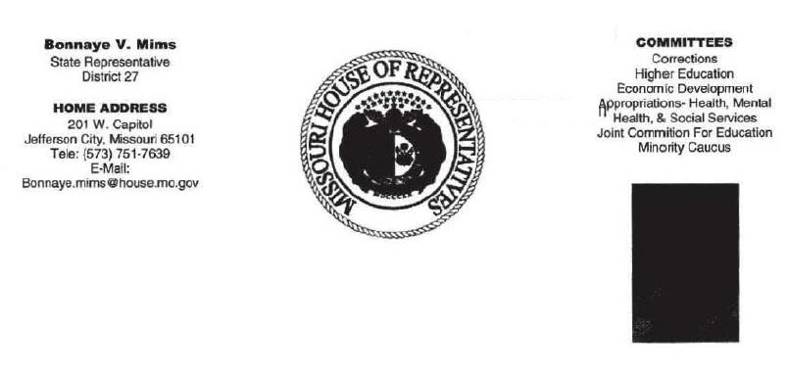

August 15, 2014

Marlene H. Dortch, Secretary

Federal Communications Commission
445 12th Street, SW
Washington, DC 20554

RE: MB Docket No. 14-57

Dear Ms. Dortch:

When I heard about the proposed Comcast/ Time Warner Cable (TWC) transaction, my first thought was how quickly can this be completed? I proudly represent the 27th district of Missouri, an area that encompasses most of southern Kansas City. Our area receives excellent cable offerings from TWC, but I am delighted for the possible opportunity to partner with Comcast on education and youth development efforts in my community. I have seen the true value that Comcast brings to the communities they already serve in Missouri and I am eager for my constituents to have similar access to Comcast's impressive roster of impact programs.

In Kansas City, like so many other cities across the country, the digital divide between the privileged and the underprivileged has steadily increased over the last few years. Our more affluent neighborhoods have modern technology classrooms and nearly 100% broadband access in homes. The less fortunate, including my community in South Kansas City, continue to lag behind with schools that struggle for basic resources and families that cannot afford a computer or internet subscription. Given the opportunities that broadband access offers to students and families, the digital divide is unacceptable as a matter of public policy to all our residents.

I'm at the beginning of my public service career, but I have already come to the conclusion that tackling such an important goal like the digital divide will require the creativity and generosity of the private sector combined with the leadership and resources of the public sector. Comcast came to the same conclusion in 2011 when it

200

began to develop a program in conjunction with major US cities to make a significant impact in low-income schools and communities. The Internet Essentials program provides low-cost broadband service, full-service computers for under $150 and options for free digital literacy training in local community centers and schools. The program is currently offered to families in Comcast service areas with children who are eligible for free or reduced-price school lunches. Thousands of families in my community would qualify if Comcast were to serve South Kansas City.

My first interaction with Comcast occurred earlier this year, when I sat for an interview to discuss the challenges facing urban education for their Newsmakers program. During the program, we discussed the changing needs of students and the commendable efforts of our teachers and families who work hard to meet the needs of our youth in the face of budget cuts and economic insecurity. It is admirable that a company would take the time to engage with community leaders and activists in order to determine the best way they can be of assistance.

When Comcast comes to the neighborhood, they bring a commitment to improving the lives in the communities they serve. It is in the best interest of the South Kansas City community for the FCC to vote in favor of the proposed Comcast/TWC transaction as soon as possible.

Sincerely,

/s/ Bonnaye V. Mims

Bonnaye V. Mims

State Representative, 27th District

201

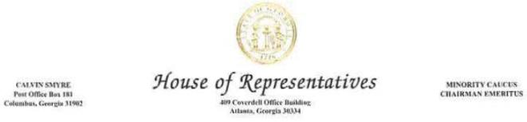

August 25, 2014

Chairman Tom Wheeler

Commissioner Mignon Clyburn

Commissioner Jessica Rosenworcel

Commissioner Ajit Pai

Commissioner Michael O’Rielly

Federal Communications Commission (FCC)

445 12th Street, SW

Washington, DC 20554

RE: MB Docket No. 14-57

Dear Chairman Wheeler and FCC Commissioners:

I am writing to you as a state legislator from Georgia and as President Emeritus of the National Black Caucus of State Legislators to express my support for the proposed merger between Comcast and Time Warner Cable.

Comcast’s track record in supporting diversity and independent programming is second to none and this merger could help ensure that more predominantly Black communities can benefit from the company’s efforts.

In 2011, I wrote in support of the Comcast-NBCUniversal merger, arguing that it would promote diversity in a variety of ways. Since the merger, Comcast has increased hiring of women and people of color to comprise 40 percent of its total workforce, facilitated the creation of five new independent, minority-owned networks and set up a diversity advisory council to advise on matters of importance to the civil rights community.

Recently I requested and read Comcast-NBCUniversal publication, seeing the bigger picture. That publication allowed me to see first-hand their plan for diversity and inclusion across the company post merger. I agree when they say that “diversity and inclusion is Comcast’s Compass for success”.

Comcast states that the Time Warner Cable transaction will be good for economic growth and good for businesses, and I believe that the impact of their previous transactions support this claim, particularly in communities of color. The NBCUniversal transaction boosted contracts with minority-owned suppliers by 20 percent, positively affecting some of the communities hardest hit by the economic downturn. The Time Warner Cable merger could give Comcast the scale it needs to accelerate these industry-leading diversity efforts to more Americans.

202

The company has also promised to invest hundreds of millions of dollars into upgrading networks in the markets it acquires. This will mean that small businesses in urban areas will have access to more advanced services and broadband speeds currently as high as 10 GBPS. These investments are critical to our communities and should be strongly encouraged. The proposed merger promises to create a new national choice for phone and Internet service that offers lowers prices, benefitting both businesses and Individuals.

Comcast has established that it can deliver on its promises, whether it is a commitment to bridge the digital divide or a pledge to increase diversity throughout its employee ranks. I urge the Commission to approve this transaction. If I can be of further service, please feel free to contact me.

Sincerely.

/s/ Calvin Smyre

Rep. Calvin Smyre

Georgia House of Representatives

CS/rgh

203

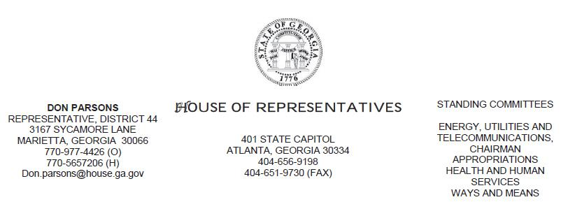

August 25, 2014

Tom Wheeler

Chairman

Federal Communications Commission

445 12th Street, SW

Washington, DC 20554

RE: MB Docket No. 14-57

Dear Chairman Wheeler:

Like you, as a state legislator and Chairman of an active committee in the Georgia House of Representatives, I am constantly looking at proposals that impact our state, staying abreast of the changes in industry and voting on items of importance to taxpayers and consumers. This is why I want to send this letter to express my support for the proposed transaction between Comcast and Time Warner Cable and encourage you to do the same.

In addition to being a good corporate citizen, Comcast is good for Georgia’s bottom line. Comcast contributes nearly $98 million in local and state taxes each year. In the last two decades, the company’s total infrastructure investment has topped $4 billion in our State.

To me, these figures show that Comcast is a company heavily invested in the health and prosperity of Georgia’s future. It lives, works and innovates here. So do its 4,000 full-time employees.

A good corporate citizen keeps its promises, and it also keeps the best interests of the public close at heart. Comcast is that citizen. For example, here in Georgia and nationwide, its digital adoption program, Internet Essentials, is bringing affordable high-speed Internet to children and their families where adoption rates have lagged.

I've seen the latest announcements around back to school here that 1.4 million Americans have already gained service due to the initiative, including approximately 100,000 in Georgia. I believe that the approval of its transaction with Time Warner Cable would see more children and families benefitting from this important solution to the growing digital divide.

Finally, as a Georgian and veteran of the telecommunications industry, I endorse the transaction because I believe that Comcast will continue to be a leader, offering innovative programming, first-rate service and business practices. Georgians have seen so many gains already. Let’s make sure that other regions of the country benefit from Comcast’s corporate citizenship and service.

Sincerely,

/s/ Don Parsons

Don Parsons

Representative of the 44th District

Georgia House of Representatives

204

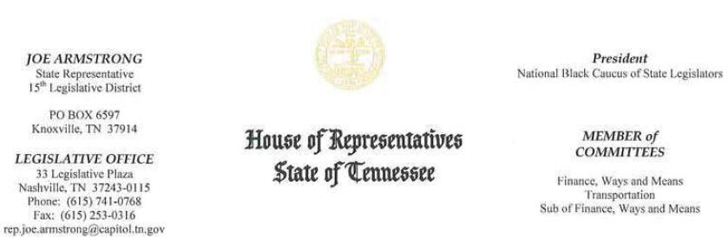

August 25, 2014

Tom Wheeler

Chairman

Federal Communications

Commission

445 12th Street, SW

Washington, DC 20554

Re: MB Docket No. 14-57

Dear Chairman Wheeler:

As State Representative of the 15th House district in Tennessee, I have come to know Comcast as a service provider and a partner in the community, and with that in mind I'm writing you this letter to voice my support for its proposed transaction with Time Warner Cable .

In my time as a public servant l have witnessed Comcast's commitment to education and investment in our communities. The situation now, with the proposed transaction, reminds me of the 2010 union of Comcast and NBCUnivcrsal, for which I also voiced my support. In 2010, I supplied a letter to the FCC in which I expressed my appreciation for how Comcast involves itself as members of the Knoxville community. 1 spoke of Comcast's involvement with many local organizations, such as the Knoxville County Public Library Summer Reading Club, Urban League, and United Way of Greater Knoxville. In 2010, I noted that Comcast has been dedicated to expanding broadband across many parts of our state, so that small businesses could have the access they need to stay connected, keep up with larger competitors, create jobs, and drive innovation.

Today, in 2014, I stand by my assertions. Comcast has consistently committed itself to making broadband more accessible to all, including low-income families. After the NBCUniversal transaction went through, Comcast went forward with its groundbreaking Internet Essentials program, which has worked over the last three years to bring affordable Internet access to our poorest households and decrease the digital divide. The program has been a massive success; I understand that 1.4 million Americans have been connected to the Internet, and over 1.6 million Americans have been brought up to speed with Comcast's free digital literacy training. The program began as a voluntary, three-year venture, but after experiencing success that exceeded expectation, Comcast recently announced that it would extend Internet Essentials indefinitely, solidifying its long-term commitment to decreasing the gap in digital literacy and making sure every child has an equal opportunity at success in the 21st century.

205

Now, again, we face another exciting opportunity for Comcast to expand its reach and substantiate its resources by joining with Time Warner Cable. As someone who has witnessed Comcast's commitment to fulfill (and exceed) promises for several years now, I can't tell you how excited 1 am for the future. Comcast supports employment opportunities- responsible for just under 3,000 jobs in Tennessee- and, more importantly in today's information age, provides affordable access to the Internet and computers, both of which are essential tools for success in today's world. The innovative work that Comcast is doing will continue to aid job searches, and give students the foundation they need to maximize their education and grow into the leaders of tomorrow. I am excited that Comcast will extend Internet Essentials and this transaction will extend the program to many other communities across the nation as well.

I know from personal experience that Comcast lives up to and goes beyond its commitments, and I know it will continue to do so in the future. 1 strongly support the Time Warner and Comcast transaction, and hope you will, too.

Sincerely,

/s/ Joe Armstrong

Representative Joe Armstrong

15th District, Knox County

206

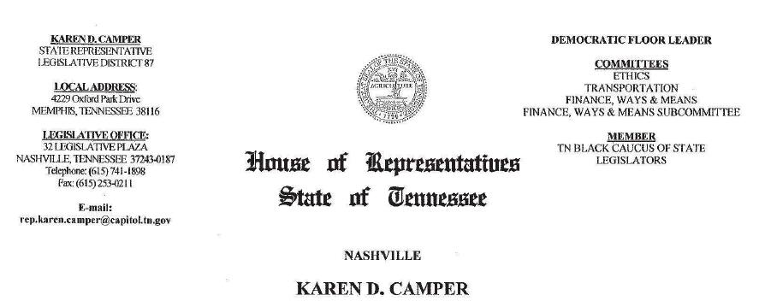

August 25, 2014

Tom Wheeler, Chairman

Federal Communications Commission
445 12th Street, SW
Washington, DC 20554

RE: MB docket No. 14-57

Dear Chairman Wheeler:

I am a Tennessee State Representative, a retired Army officer, an educator, the owner of an artist management company, and a parent. I am writing in reference to the proposed Comcast and Time Warner Cable transaction. It is my hope that the Commission approves this proposal.

Comcast is a longtime investor in Tennessee. Since 1996, it has spent more than $2 billion in facilities and infrastructure in our state. Approximately 2,000 Tennesseans work for Comcast, and state and local revenues from the taxes and fees the company pays were close to $128 million last year.

Comcast employees are top donors to United Way campaigns. These dollars support numerous nonprofit and education initiatives in our state. In Memphis and Nashville, Comcast officials and employees volunteer on government, school and community group committees. They also give untold volunteer hours every year during the April Comcast Cares Day. This year's event featured inspired service for Hume's Prep School and community members, all facilitated by Comcast.

207

More than 17 percent of the Tennessee population lives below the poverty level. Many of these residents are children whose families lack home Internet service. Comcast started a service to remedy that in 2011 .

I understand that the Comcast Internet Essentials program offers broadband service for $9.95 a month to qualifying families whose children receive subsidized school lunches. Families may also choose to purchase a computer for $150. Comcast includes free online or in-person computer and Internet training sessions with the service. In Memphis, we had close to 2,500 families take advantage of Internet Essentials in the first three years of the program and in Nashville, almost 3,800 families signed up. Across Tennessee, the total was more than 8,000 households.

Thousands of children are now able to complete online school assignments in their own home, instead of having to compete for limited time on community or library computers. Their parents are able to enroll in online education programs, apply for jobs and oversee their child's school-home interactions.

With my connection to the entertainment industry, I think it is also worth noting that Comcast's cable and video programming is outstanding. The rich and varied content, independent and minority-owned networks and the many educational and bilingual channels are meeting our residents' appetites for diverse entertainment. The company offers over 160 independently owned programming networks.

Please consider all of the above as you weigh the proposed transaction. I hope it receives your approval.

Sincerely,

/s/ Karen D. Camper

Karen D. Camper

TN House of Representatives, 87th District

208

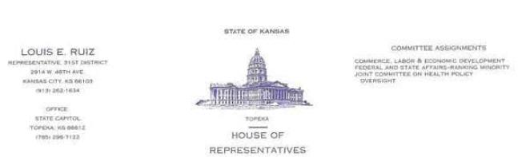

August 24, 2014

Tom Wheeler

Chairman

Federal Communication Commission
445 12th Street, SW
Washington, DC 20554

RE: MB Docket No. 14-57

Dear Chairman and Commissions:

As Kansas State Representative of the 31st District, I have supported legislation to eliminate discrimination and improve equality in Kansas. I agree and encourage the expansion of companies that maintain business policies that support employee diversity and provide excellent benefits and career opportunities for all employees.

In March of this year. I introduced Bill 2761 that would include the LGBT community in the protected classes as defined by Kansas Law to the Federal and State Affairs Committee. I encourage the FCC to approve the proposed transaction between Time Warner Cable and Comcast to expand the company's exemplary commitment to employing qualified candidates of the protected classes.

Comcast and NBCUnivcrsal maintain the highest score possible on the Human Rights Campaign's 2014 Corporate Equality Index due to its inclusive hiring practises and diverse programming. Through its LGBT Employee Resource Groups, Comcast engages people at all levels of the organization to drive exceptional business results while supporting an inclusive company culture. Comcast and NBCU have spearheaded public awareness campaigns in conjunction with major LGBT organizations on both the national and local levels.

Comcast is a unique company that seeks to empower its employees and customers through diversity inclusion. I encourage the FCC to take note of the positive effect of a Comcast expansion in Kansas by approving the proposed transaction with Time Warner Cable.

Sincerely,

/s/ Louis E. Ruiz

Louis E. Ruiz

Representative, State of Kansas #31

209

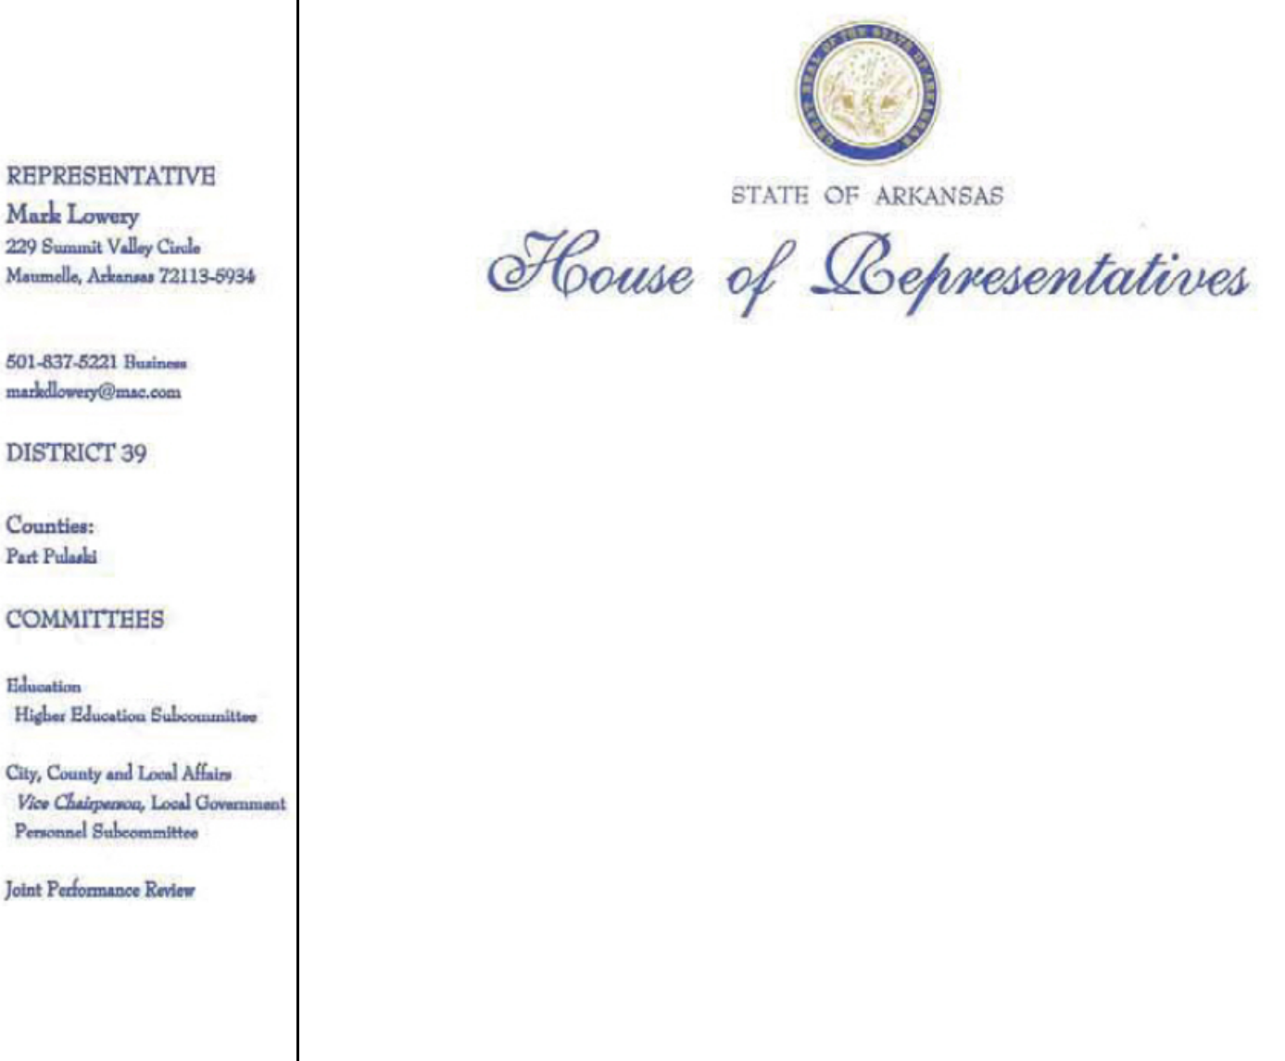

August 25, 2014

Tom Wheeler

Chairman

Federal Communications Commission
445 12th Street, SW
Washington, DC 20554

R£: MB Docket No. 14-57

Dear Chairman Wheeler:

As a State Representative in a state serviced by Comcast, I enthusiastically comment in support of the proposed Comcast and Time Warner Cable transaction.

We are currently tackling the issue of internet connectivity in our schools and have seen the great commitment provided by our private sector providers such as Comcast

ln my capacity as a Legislator for the state of Arkansas and also as an educator I have witnessed on numerous occasions the benefits of a great private sector partner in Comcast. I believe the proposed transaction will enhance that contribution and, as such, I ask for the Commission to give its approval.

Sincerely,

/s/ Mark Lowery

Rep. Mark Lowery (R- Maumelle)

District 39

210

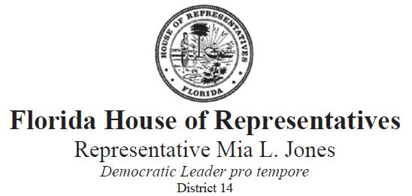

August 12, 2014

Brian Musselwhite

As the recently appointed and first ever Health Commissioner in Jacksonville, Florida charged with enrolling more than 25,000 uninsured Duval County children in Medicaid, a State Representative involved in numerous community events including Comcast Cares Day, and the present special assistant to Mayor Alvin Brown, I am writing to ask that you approve the proposed merger between Comcast and Time Warner Cable.

I have a vested interest in ensuring that all of my constituents, particularly those at risk, underemployed, unemployed and on the fringe of society as a result of their financial status have access to the tools they need to succeed - including broadband. The sad truth in our society is if you aren't online you aren't in the know. Not being able to tap into the Internet could be the difference between getting an interview or not getting that interview, getting an A on a paper or simply scraping by in a class. Simple job searches for those out of work, kids doing research for a school project can make a huge difference. It's estimated presently 100 million Americans right now do not have access to the Internet. That number is absolutely astounding!

I have been intimately involved with the Comcast Internet Essentials program and can personally tout its benefits. Internet Essentials gives families with at least one child enrolled in the National School Lunch Program the opportunity to sign up for low cost Internet access. These are the same children I am presently responsible for enrolling in our Medicaid program so access to broadband is access to health care. That is what Comcast is bringing to our communities...access. Children who can realize good health, proper education and the supportive tools to learn will only benefit our district in a positive way.

With Comcast's present commitment to affordable internet and community presence, its proposed partnership with Time Warner Cable will ensure that more children and families have access - to broadband, to health care, to education, to opportunity. Put simply, your approval of this deal gives thousands (particularly children) a better chance at learning, growing, prospering and giving back to their communities.

I sincerely hope you will favorably consider this proposed transaction.

Sincerely,

District Office: 3890 Dunn Avenue, Suite 901, Jacksonville, FL, 32218| P (904) 924-1615 | F (905) 924-1617

Capitol Office: 316 The Capitol, 402 South Monroe Street, Tallahassee, FL, 32399-1300 | P (850) 717-5014

211

/s/ Mia L. Jones

The Honorable Mia L. Jones

Florida House of Representatives

14th District

District Office: 3890 Dunn Avenue, Suite 901, Jacksonville, FL, 32218| P (904) 924-1615 | F (905) 924-1617

Capitol Office: 316 The Capitol, 402 South Monroe Street, Tallahassee, FL, 32399-1300 | P (850) 717-5014

212

August 24, 2014

Ron Ryckman, Jr
Representative, 78th District
14234 W. 158th St.
Olathe, KS 66062

Tom Wheeler

Chairman

Federal Communications Commission
445 12th Street, SW
Washington, DC 20554

RE: MB Docket No. 14-57

Dear Chairman Wheeler:

I write to you today to express my support for the Comcast and Time Warner Cable transaction, not only as a member of the Kansas House of Representatives and the Olathe City Council, but also as a pleased Comcast customer. Since switching my service from Direct TV, I have appreciated Comcast's high tech products. If approved, this transaction would bring the best in cable and Internet to our neighboring cities, as well as Comcast's commitment to giving back as we have seen here in Olathe.

In my opinion, Comcast is really changing the game for innovative TV and Internet services. They have set a high industry standard, yet continue to push the envelope on new technologies. The X-1 platform allows me to stream video content anywhere, on various devices, showing that Comcast cares about making their services available to their customers when and how they want them. I take pride in helping to build a high quality standard of living here in Olathe, which is made possible by strong partner companies like Comcast.

In addition to its dedication to customers, the citizens of Olathe have seen firsthand the positive impact Comcast has had on the community as a whole. Through their most recent "Comcast Cares Day," an annual day of corporate volunteerism, more than 250 volunteers helped beautify the Hope House and Mahaffie Stagecoach Stop and Farmstead in Olathe. Community involvement has also been seen through their partnership with area non-profits, such as the Easter Seals Caper Foundation, which helps empower disabled children through assistive technology.

213

None of the above would have been possible without real investment on the behalf of Comcast. Government's role should be to encourage private investment that builds infrastructure, creates jobs, and serves the community. That is why I support the proposed merger of Comcast and Time Warner Cable so that our neighbors in Kansas and more communities across the nation have the opportunities in innovation and investment that we in Olathe do. I hope you will approve this transaction.

Sincerely,

Ron Ryckman, Jr.

Kansas State Representative, District 78 Olathe City Councilman

214

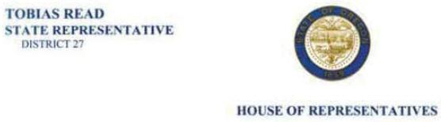

August 25. 2014

Tom Wheeler

Chairman

Federal Communications Commission
445 12th Street, SW
Washington, DC 20554

RE: MB Docket No. 14-57

Dear Chairman Wheeler:

I'm writing to voice support for the proposed merger between Comcast, Time Warner and Charter. As the Oregon State Representative for District 27, I live and serve in one of Comcast's markets. I can testily to some of the positive impacts Comcast has had on our state economy and its investment in our communities.

Comcast supports good jobs for the local economy here in Oregon. It employs 2,000 Oregonians full-time, with quality health-care benefits. In Beaverton, the community I represent, Comcast owns and operates a call center that employs over 600 people. NBC Universal also produces the popular show GRIMM in Portland, which has a large and proud following throughout Oregon. I've seen the way that Comcast has invested in Oregon on a state and local level, and am hopeful that a combined company could do even more to stimulate growth and economic opportunity In Oregon.

Another reason I like the potential of the proposed deal is Comcast's Internet Essentials Program - which offers more affordable broadband access, computers, and free digital literacy training to families whose children qualify for free lunches under the National School Lunch Program. The program addresses a significant need In Oregon, with approximately 7,000 families taking part in Internet Essentials. These families will be able to use the Internet's vital resources to aid job searches, academic work, and make better consumer choices. If approved, the transaction between Comcast, Time Warner and Charter will allow this program to be available to more Oregonians

I'm hopeful that the proposed transaction will be accepted, as I see it as an opportunity to expand the positive effects of Comcast on our community and Oregon as a whole.

Thank you for your consideration and your work.

Sincerely,

/s/ Tobias J. Read

Representative Tobias Read

Oregon House of Representatives, 27th District
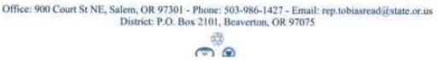

215

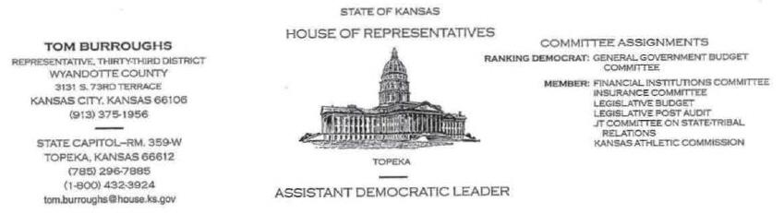

DATE: August 20, 2014

Tom Wheeler, Chairman

Federal Communications Commission
445 12th Street, SW
Washington, DC 20554

RE: MB Docket No. 14-57

Dear Chairman Wheeler:

As a native Kansan and member of the Kansas House of Representatives, I can tell you that Kansas is a wonderful state in which to live, work and raise a family. A thriving business community invested in our people and places buttresses close-knit neighborhoods and schools.

Comcast has planted firm roots in Kansas. I understand that in 2013, it spent $3.8 million on employee and community investments, capital projects, and taxes and fees. These investments in our state, while important in Topeka, our capital, also means a great deal in lesser-known areas, where resources are more thinly spread, and investments like these resonate. While many areas have not yet benefitted from Comcast's resources and innovative programming and services, we would welcome them with open arms. I support the proposed transaction between Comcast and Time Warner Cable, because such a union would give more Kansans topnotch service and proximity to an organization that is a corporate pioneer and responsible citizen.

Comcast's broadband adoption program, Internet Essentials, is bringing high-speed Internet into the homes of many low-income students - who are often most at risk of falling behind in school. Access to the Internet, at the affordable price of $9.95 a month, is coupled with free training and support, ensuring that more children of our state have the right tools for 21st century success.

216

Page Two

August 20, 2014

Comcast's footprint in our state is relatively small, but as of December, 96 households had already gained service. The reach and impact of Internet Essentials will expand to benefit more families, if the transaction with Time Warner Cable is approved.

Comcast is a corporation that is bringing the future of digital media to America, and I want the people of Kansas to be a part of whatever comes next. Consider the proposed transaction between Comcast and Time Warner Cable, to enhance the competition for Kansas consumers.

Sincerely,

/s/ Tom Burroughs

Tom Burroughs

Representative of the 33rd District

Kansas House of Representatives

217

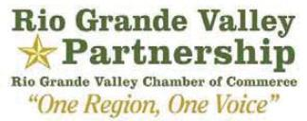

August 22, 2014

Tom Wheeler

Chairman

Federal Communications Commission
445 12th Street, SW
Washington, DC 20554

RE: MB Docket NO. 14-57

Dear Chairman Wheeler:

I write today from the Rio Grande Valley, located in South Texas. My organization, the Rio Grande Valley Partnership, is an umbrella organization uniting diverse groups with a common purpose to increase commerce and improve the quality of life in the region. Located at the southernmost tip of Texas, the Rio Grande Valley lies on the northern bank of the Rio Grande River, which serves as a border to Mexico. The Rio Grande Valley has over 1 million unique residents and our organization has worked effectively to unite these voices to encourage more economic development in our region. We are proud of our economic growth and diversity of industries. A recent example is our help in successfully recruiting Elon Musk’s SpaceX launch facility to the Rio Grande Valley.

Time Warner Cable has invested and built a strong high-speed digital network in the Rio Grande Valley and it is my understanding that Comcast plans to make additional infrastructure investments for advanced services over the next three years if the merger is approved. We would welcome that investment in our region and I urge the FCC to quickly approve the proposed Time Warner Cable/Comcast transaction.

As we look to expand the region’s business portfolio, we will need industry-leading business services to compete on a grander scale. It is our belief that Comcast’s business services will be an option that will benefit our residents and will increase businesses productivity across the board. I encourage the FCC to approve this transaction as soon as possible.

Sincerely,

/s/ Julian Alvarez

Julian Alvarez

President/CEO

P.O. Box 1499 ● Weslaco, TX 78599

Phone: (956) 968-3141 ● Fax: (956) 968-0210

www.valleychamber.com

218

August 22, 2014

Tom Wheeler

Chairman

Federal Communications Commission
445 12th Street, SW
Washington, DC 20554

RE: MB Docket No. 14-57

Dear Chairman Wheeler:

On behalf of the Sacramento Metro Chamber, I wanted to express our support for the prosed merger between Time Warner Cable and Comcast and believe approval of the transaction is in the public interest, not just in the Sacramento region hut across the state. Comcast has been a long time advocate in supporting the businesses of all sizes across the Sacramento region. Comcast has been a strong partner in California and have invested close to $10 billion in infrastructure over the past 20 years in the state. Comcast has over 2-million customers in the State and its continued commitment to innovation will improve the business climate in California.

Businesses served by Comcast can enjoy competitive and top-tier broadband speeds of 25 megabits-per-second on the most popular segment of service. The extensive and expanding Xflnlty hotspot network means that our small business owners and individual entrepreneurs will not have to worry about installations of quality broadband. They can connect wherever, whenever to the information and tools they need to ensure ideas move beyond concepts and into reality.

Comcast also has powerful solutions that could help businesses looking to efficiently market their products across the state. Additionally, this transaction would further support the approximately 10,000 highly trained employees in California.

The potential to appreciably improve both broadband adoption and the speed with which businesses can communicate and compete globally can be enhanced by this transaction. Comcast's Internet Essentials program has been a resounding success in increasing broadband adoption and digital literacy in Northern California and helping more than 35,000 families gain access to the 21st Century broadband technology.

We appreciate the opportunity to comment and believe upon completion this transaction will have numerous benefits to the public. If you have any additional questions please don't hesitate to contact me at kgreene@metrochamber.org or (916) 321-9154.

Sincerely,

/s/ Kevin Greene

Kevin Greene

Director, Government Affairs
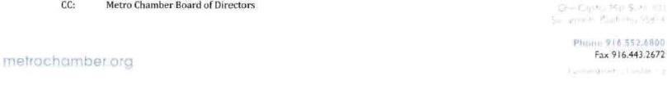

219

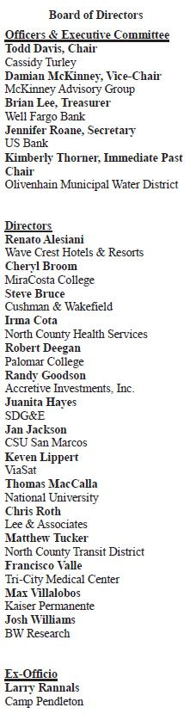


August 25, 2014

Tom Wheeler

Chairman

Federal Communications Commission

445 12th Street, SW

Washington, DC 20554

RE: MD Docket No. 14-57

Dear Chairman Wheeler:

As a leader for economic development in San Diego, an area currently serviced by Time Warner Cable, I look forward to the possibilities the transaction with Comcast will bring to our region. I am the CEO of the San Diego North Economic Development Council, a nonprofit coalition of the public and private sectors working together with community partners to strategically sustain and grow the economic base of North San Diego County. Comcast will bring its excellent business service, high speed broadband offerings and will increase competitiveness of small and medium business. Overall, the transaction will be a welcome inclusion for San Diego industries.

In North San Diego, our business community is generally grouped in to seven categories: Innovation and Specialized Manufacturing, Health Care, BioMedical Devices and Products, BioTech and Pharmaceuticals, Clean Tech, Information, Communications, and Technologies (ICT) and Education. I believe the transaction will fuel each of these industries through more competitive broadband services.

Included in Comcast Business services is its Ethernet Service, which permits all users to connect at several points to a nationwide fiber-optic network. The service offers speeds of up to 10 Gbps with full-scalability, a service that matches the growing demands of San Diego's entrepreneurs. Businesses greatly benefit from the faster downstream broadband speeds this network creates For local companies whose work extends across the world, this benefit encourages faster growth and allows for new, innovative ideas to gain traction. Comcast Business provides advanced communication solutions to help companies of all sizes be more productive, which will help the San Diego business economy continue to grow and flourish.

Our lively local education landscape is highly dependent on robust communications technology: trade schools, community colleges, Cal State University - San Marcos, and National University will all benefit from a new connection to Comcast. When Comcast comes to the neighborhood, it brings its powerful, next generation network, technical and operational expertise, local support resources to ensure that systems of all size and scope maintain their status.

950 Boardwalk Suite 303 San Marcos, CA 92078 www.sdnedc.org (760) 510-3179

220

Introducing Comcast to the North San Diego Community will be extremely advantageous for our current economy and future developments. For this reason, I encourage the FCC to support the proposed Time Warner Cable/Comcast transaction.

Sincerely,

/s/ Carl S. Morgan

Carl S. Morgan

Chief Executive Officer

San Diego North

Economic Development Council

950 Boardwalk Suite 303 San Marcos, CA 92078 www.sdnedc.org (760) 510-3179

221



August 22, 2014

Mr. Tom Wheeler

Chairman

Federal Communications Commission
445 12th Street, SW
Washington, DC 20554

Re: MB Docket No. 14-57

Dear Chairman Wheeler,

As CEO of the San Francisco Chamber of Commerce, I write today to urge the Federal Communications Commission to approve the proposed transaction between Comcast and Time Warner Cable.

The San Francisco Chamber of Commerce is the city's largest and most vibrant business network. The Chamber's mission is to keep San Francisco vibrant and prosperous by attracting, developing and supporting business.

Comcast is a valued member of our business community and has long shared our goals of keeping our local economy vibrant so that businesses of all sizes can grow and prosper. Comcast's investment in local business infrastructure and its ongoing efforts to expand its services is an important component of the sustained success of our local economy.

Comcast knows that businesses of all sizes are now more dependent on technology than ever. It is fitting that a company that places such a strong emphasis on innovation and technology that Comcast has been the sponsor of the Chamber's Innovation in Technology Award given out at our annual Ebbie Awards.

Comcast also appreciates how important it is to invest in underserved communities as is evidenced by its creation of Internet Essentials - a nationwide program designed to help bridge the digital divide. This unique and critical program has enabled low-income families in San Francisco and across the nation to have access to affordable home internet service and computers to better prepare our students and families to compete in an increasingly technology driven society. It is quite an achievement that in just three years Comcast has over 350,000 households nationally and over 46,000 in California, to the internet.

Please consider Comcast's stellar track record of investment, innovation and corporate citizenship when you come to your final decision, and I ask that you ultimately approve the Comcast and Time Warner Cable transaction.

Sincerely,

/s/ Bob Linscheid

Bob Linscheid, President & CEO

San Francisco Chamber of Commerce

222

From: Sarris Candies

Prepared by: Norman Candelore, IT Manager

511 Adams Avenue

Canonsburg, Pa 15317

(724)745-4042

RE: MB Docket No. 14-57

August 24, 2014

To whom it may concern,

We have been made aware that Comcast and Time Warner might be merging and becoming one. We have been a long time Comcast customers with direct services provided to our 3 plants. Comcast and the services they provide us are probably the most important services that directly affect our business and how we do business. We strongly support the merger of Comcast and Time Warner. Businesses and customers are doing more over the internet and there are more daily transactions handled electronically and this will continue to grow. It is important that the service providers are ready for not just today’s needs but the growing needs of tomorrow. It is important that our providers of these services are able to maintain and manage the needs of both Businesses and customers. The merger of Comcast and Time Warner will allows for this to continue and improve day to day business and the many transactions associated with doing business. What we do today will affect our tomorrows and we need to be ready for the future.

Thank you

/s/ Norman Candelore

Norm Candelore

IT Manager Sarris Candies

223

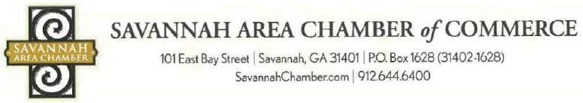

August 25, 2014

Mr. Tom Wheeler

Chairman

Federal Communications Commission
445 12th Street, SW
Washington, DC 20554

RE: MB Docket No. 14-57

Dear Chairman Wheeler:

I am proud to address this letter to the FCC to voice my support of the proposed Time Warner Cable/Comcast transaction. I am President & CEO of the Savannah Area Chamber of Commerce, an organization of over 2,200 members that represent Savannah's business community. Comcast has been a long time community partner, providing guidance and technical and financial support to major education and economic initiatives. With Comcast's strong record of commitment and support, our organization has been able to achieve its mission of building a legacy of lasting leadership and economic development in Savannah.

The Savannah Area Chamber's central mission is to mobilize and connect businesses to drive community development and public policies that promote sustainable growth. However, our Chamber takes a more active role in pursuing grassroots community development opportunities, as well as driving public policy on matters such as education and transportation. Comcast has been a key supporter, providing funding for activities such as our networking events with local elected officials and small businesses as well as joining in our efforts to honor military veterans.

Education is a focal point at our Chamber. Comcast's support and nationwide programming has helped us move steadily forward in improving local public education standards. Through collaborative efforts with the Savannah-Chatham County Public School System, Comcast's Internet Essentials program has become an oft-utilized tool for many area students, offering them a chance to pick up highly desirable computer and internet skills. With a shared goal of closing the digital divide, Savannah-Chatham Schools and Comcast recently partnered to host a Digital Literacy Expo for students and their families. The event drew more than 100 attendees and emphasized the importance of digital literacy as it is a necessary component to effective education as well as workforce and economic development.

Comcast's commitment to education within the Savannah community is further evidenced through its signature scholarship program, Leaders and Achievers. The program rewards young people for getting involved in their schools and making positive change in their communities. Since its Inception in 2001,

Visit Savannah • Ambassadors Council • CEO Council • Forward Savannah Task Force • Governmental Affairs Council Greater Savannah Sports Council • LaunchSAVANNAH • Leadership Savannah • Manufacturers Council • Military Affairs Council Owners Council • PR Council • Small Business Council • Trustees Council • Tybee Island Tourism Council • Workforce Development Council

224

numerous Savannah area students have been recognized as Comcast Leaders and Achievers. Most recently in 2014, eleven local awardees each received a scholarship of $1,000 to further their college education. To date, Comcast has awarded close to $20 million to nearly 20,000 Leaders and Achievers Scholarship winners throughout the country.

Comcast also has shown a dedicated commitment to improving its infrastructure to ensure that all users have continual access to a safe and secure network. Comcast has invested billions in its network, and has increased broadband speeds 13 times in the last twelve years. It also doubles the capacity of its network every 18 months. Comcast has always supported its core mission, which is to provide the fastest, most secure and most accessible broadband speeds to its consumers. I am also impressed by Comcast's pursuit to expand their Xfinity Wi-Fi hotspots. For customers, being able to log in to Comcast services in major public areas encourages productivity for business and personal projects.

Here in Savannah, Comcast is a key business advocate for creating a local entrepreneurial ecosystem that helps create jobs and foster growth. Through excellent business-class service options to a dedicated commitment to improving our local economy, I am continually impressed by the vision that drives the company. It is my hope that the FCC will give favorable consideration to this proposed transaction between Comcast and Time Warner Cable. I believe that this transaction will be a major advancement for businesses on a local level and for those operating in many regions across the nation.

Sincerely,

/s/ William W. Hubbard

William W. Hubbard

President & CEO

Savannah Area Chamber of Commerce

225


August 25, 2014

Chairman Tom Wheeler

Commissioner Mignon Clyburn

Commissioner Jessica Rosenworcel

Commissioner Ajit Pai

Commissioner Michael O'Rielly

Federal Communications Commission

445 12th Street, SW

Washington, DC 20554

RE: MB Docket No. 14-57

Dear Chairman and Commissioners:

As the current president and CEO of the Savannah Economic Authority, and former vice president and CFO of the Savannah Chamber of Commerce, I have witnessed first-hand the positive economic impact that Comcast has made on our community. I am confident that if Comcast is permitted to expand into new areas, they will receive the same economic boosts that we have enjoyed.

Just by providing affordable broadband and telephone packages for our small business communities, Comcast enables entrepreneurs to compete in a global economy.

Thanks to Comcast services, Mom-and-Pop businesses have the same access and ability as the big players have to display and market their merchandise and services online.

Comcast is also one of our finest employers. The company has almost 4,000 full time employees in the State of Georgia - not including contractors and suppliers. Comcast employees have access to a great benefits package, which includes healthcare, training, tuition reimbursement and free cable. These employees are also Georgia taxpayers, who support our state's economy.

The key to building our economy is closing the digital divide and providing all of our children with the tools they need to succeed in school and find employment. Comcast's Internet Essentials program allows low-income families with at least one child in the National School Lunch Program to obtain broadband services at home for just $9.95 a month. The program also offers training, and the ability for a family to purchase a computer for less than $200. This year, almost 500 Savannah families are participating in the program. lf Comcast is permitted to expand into the Time Warner service area, those families will also be able to benefit from this fantastic program.

226



Page -2

I understand that since 1996, Comcast has invested more than $4 billion in technology and infrastructure in Georgia alone. As Savannah continues to thrive, we are pleased to have Comcast as our partner. I anticipate that Comcast will bring all the economic benefits of a strong, vital company to current Time Warner customers.

Sincerely,

/s/ Hugh "Trip" Tollison

Hugh "Trip" Tollison

President and CEO

Savannah Economic Development Authority

227

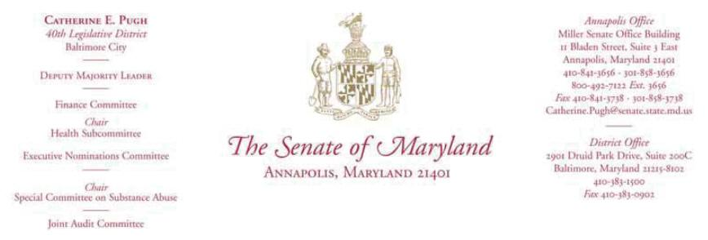

August 22, 2014

Chairman Tom Wheeler

Commissioner Mignon Clyburn

Commissioner Jessica Rosenworcel

Commissioner Ajit Pai

Commissioner Michael O’Rielly

Federal Communications Commission
445 12th Street, Southwest
Washington, DC 20554

RE: MB Docket No. 14-57

Dear Chairman and Commissioners:

Our African American community has always been resilient. We have always been self-advocates, self-starters, and believers and achievers in the American Dream. Yet as recent events such as those currently unfolding in Ferguson show, our community needs strong leaders and partners for continued positive growth and achievement. Comcast has been just such a nationwide leader through its dedication to our country’s most underserved communities and through its commitment to inclusive hiring.

I write today as the President-Elect of the National Black Caucus of State Legislators (NBCSL) and as State Senator for Maryland’s 40th district. I write to urge your approval of the Time Warner Cable and Comcast transaction that sits before you today, because the combined entity ought to be able to continue and expand Comcast’s remarkable record of service to the African American community and all Americans.

Our body of over 600 legislators at the NBCSL serves as a national network for collaboration and exchange of ideas and solutions among African American state legislators, thought leaders, and private partners. We are blessed to represent a diverse array of strong communities. Far too often, however, we are aware of a digital divide between our richest and poorest communities. Far too often, African Americans live in our nation’s poorest, most resource-deprived communities.

228

Chairman and Commissioners

August 22, 2014

Page 2

Comcast’s Internet Essentials program is currently making enormous strides towards closing this gap and connecting our most underserved neighborhoods to the Web. Families whose kids are eligible for free-or reduced-price lunches can enroll if they live in Comcast-served areas. They are then connected to a wide variety of empowering services. Comcast provides Internet for the affordable rate of $9.95 per month. They go further one more step, by giving subscribers discounted hardware. The company completes the rounded program by building community partnerships to support the program. Free training programs help residents profit from their connection. Digital Connectors gives young people the tools to change their communities for the better with the power of technology. This model public-private partnership has already brought service to over 350,000 homes. Many other cities could be included following the approval of this transaction, including our nation’s largest two cities, Los Angeles and New York.

Comcast’s inclusive hiring programs are creating a new class of African American business and public leaders. Forty percent of company employees are people of color. Twenty-five percent of the company’s managers are people of color. And that proportion continues to expand. Comcast has increased the number of vice presidents and other high-level executives of color by more than 30 percent since they combined with NBCUniversal. The company works with a coalition of national leaders on their large Joint Diversity Council to make this progress. This is yet another example of Comcast’s all-encompassing commitments. The company makes sensitive, informed connections with community leaders to deliver the best service to all communities.

Please approve this transaction to help continue the forward progress of this industry leader’s commitments to all American communities.

Sincerely,

/s/ Catherine E. Pugh

Senator Catherine E. Pugh

President-Elect

National Black Caucus of State Legislators

229

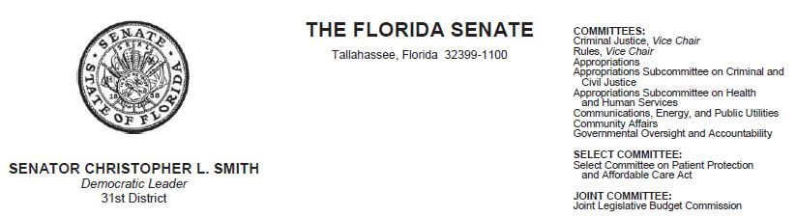

August 20, 2014

Tom Wheeler, Chairman

Federal Communications Commission
445 12th Street, SW
Washington, DC 20554

RE: MB Docket No. 14-57

Dear Chairman Wheeler:

All successful businesses thrive because they change, grow and develop a pragmatic approach to their future. As a longtime supporter of local business and current Senator of the 31st district in Florida I know good businesses remember the citizens they serve. Such is the case with Comcast, a stand out company that has provided great programs to many Florida citizens. That is why I write today to urge your approval of the proposed merger between Comcast and Time Warner Cable.

As a young man I spent my early years actively involved in many youth organizations including the Fort Lauderdale Branch of the National Association for the Advancement of Colored People (NAACP) Youth Council, ascending to the position of president. As president, I began the Annual Christmas Toy Giveaway, providing toys to underprivileged children throughout Broward County. Even in those formidable years I recognized not everyone had the opportunity that I did to succeed, to go to school, to learn, to engage and to be heard. Comcast has provided a platform for those very citizens I helped long ago. Its Internet Essentials programs give those who qualify a reduced monthly rate for high speed internet access. It has and will open doors for the many underserved constituents in my district. I am heartened to know that through a merger with Time Warner Cable, Comcast will expand the scope of this program and its impact on more families that need digital access the most.

Comcast has also proven its leadership in the community through its Comcast Cares volunteer initiative and its employee contribution program to our local United Way. It's not just a business, it is a company that has taken a stake in our citizens.

REPLY TO:

- 2151 NW 6th Street, Fort Lauderdale, Florida 33311 (954) 321-2705 FAX: (954) 321-2707

- 200 Senate Office Building, 404 South Monroe Street, Tallahassee, Florida 32399-1100 (850) 487-5031

 | Senate’s Website: www.flsenate.gov
DON GAETZ | GARRETT RICHTER
President of the Senate | President Pro Tempore
 | 230

August 20, 2014

Page 2

As a member of the Senate Communications, Energy and Public Utilities Committee I am keenly aware of the challenges we are facing as we advance in our pursuit of new

technology. I know that Comcast is aware of those challenges too, and is actively working with us to help address them. Its investments in infrastructure in Florida are truly

impressive - from what I have heard, they have totaled well over $6 billion since 1996. Those investments will help us and our workforce succeed well into the 21st century.

Comcast is a proven doer and leader. I hope you will strongly consider Comcast's proposed merger with Time Warner Cable for the new opportunities it will bring to so many others.

Sincerely.

/s/ Christopher L. Smith

Senator Christopher L. Smith

Florida State Senate, District 31

231



August 20, 2014

Chairman Tom Wheeler

Commissioner Mignon Clyburn

Commissioner Jessica Rosenworcel

Commissioner Ajit Pai

Commissioner Michael O'Rielly

Federal Communications Commission

445 12th Street, SW

Washington, DC 20554

RE: MB Docket No. 14-57

Dear Chairman and Commissioners:

I am writing to voice my support for the Comcast and Time Warner cable transaction. As both a Kansas State Senator and a working teacher, I know firsthand the importance of investing in education.

My district is currently served by Time Warner Cable. My district would be lucky to be covered by the combined force of Comcast and Time Warner. This kind of investment in the Kansas City metro area would better enable us to engage students in world-class digital advancement that is currently not available with Time Warner Cable alone. Comcast has a proven track record of providing new learning opportunities and digital development through its Internet Essentials program and corporate partnerships.

Science, technology, engineering and mathematics - a.k.a STEM - education is widely considered the backbone of 21st-century education. America's students need to be trained with technical skills that

232

will make them exceptional future workers in the midst of vigorous global competition. Comcast's Digital Connectors program has supplied hundreds of community computer labs and trained countless students on basic digital literacy skills. School districts in my senate district are expanding their technology outreach. The need for increased bandwidth and services will be critical to support this education initiative. We can see the expansive success of the program in a cramped portion of Kansas. Approval of this transaction will give the Digital Connectors program room to breathe in current Time Warner Cable markets -and connect more students than ever.

Too often, children lack access to simple educational necessities. In the year 2014, Internet access is an educational necessity. There is a Digital Divide in this country. Some children stand on one side, and can access a global network of resources and opportunity. Too many children In Kansas and the United States stand on the other side, across a wide chasm from future prosperity.

In addition to its commitment to STEM education, Comcast provides disadvantaged students and eligible families with quality Internet access at an affordable price through its Internet Essentials initiative. If the merger is approved, low income families in our area would be eligible to purchase home Internet service for only $9.95 per month, access free digital skills training. and have the ability to purchase a subsidized computer. The program has served 1.2 million people so far. This isn't a small-scale or token program. It's a program that would transform our children's futures. 1 can't miss this opportunity to fight for my constituents and urge your approval of this transaction.

I am encouraged about the educational opportunities of having Comcast as a service provider in Overland Park and a corporate partner to our schools. I ask you to consider all of the potential benefits this combination of companies will bring to my constituents and citizens around the nation. I respectfully ask you to join me in supporting this transaction.

Regards,

/s/ Greg Smith

Sen. Greg Smith

Kansas State Senate, 21st District

233

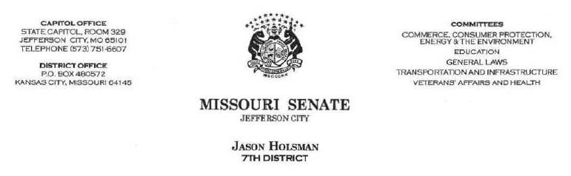

Tom Wheeler

Chairman

Federal Communications Commission
445 12th Street, SW
Washington, DC 20554

RE: MB Docket No. 14-57

Dear Chairman Wheeler:

Kansas City is one of the few communities in Missouri serviced by two separate cable television and Internet providers, Comcast and Time Warner Cable ("TWC").

I am writing to express my support for the proposed transaction between these companies. In several ways, Comcast has outperformed TWC and this merger will unquestionably deliver better and faster services to our Kansas City constituents.

One specific benefit that I would like to see available throughout my district is "Internet Essentials''. Internet Essentials is Comcast's program to expand Internet access to low-income families. It's a good example of the private sector partnering with communities to make progress. The program allows qualified families to purchase home Internet service for only $9.95 per month. It also includes free digital skills training, and the option to purchase a heavily-subsidized computer. I want all Kansas City residents to have access to these options, and Comcast has pledged to expand this program to the TWC areas it acquires.

On top of Internet Essentials, Comcast has an exceptional history of underwriting technology-based essentials in education. This type of investment, if it were available throughout Kansas City, would expose more students to digital advancement opportunities. For example, Comcast's Digital Connectors program bas equipped community computer labs with top notch technology. It has also supported training in simple and advanced digital literacy skills to thousands of young adults in U.S. cities. That kind of initiative has the capability to close the digital divide that is as much a worry in Kansas City as it is anywhere.

234

This merger between Comcast and Time Warner Cable will benefit Kansas City families and students alike. I hope that the Commission will approve this transaction expeditiously

Sincerely,

/s/ Jason R. Holsman

Jason R. Holsman

Missouri State Senate – 7th District

Jackson County

235

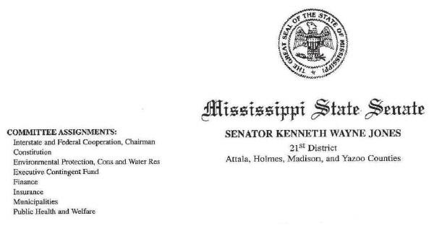

August 25, 2014

Marlene H. Dortch, Secretary

Federal Communications Commission
445 12th Street, SW
Washington, DC 20554

Re : MB Docket No. 14-57

Dear Ms. Dortch:

Please be advised that I support the proposed Comcast-Time Warner transaction. As a State Senator since 2008 and as Chairman of the Mississippi Legislative Black Caucus, I was very pleased to be made aware of their focus on providing the best possible service to their customers and how they give back to the communities they serve through the Internet Essentials Program for low-income families.

Also, 1 was equally impressed with the manner in which Comcast recruits, manages and sustains their workforce here in Mississippi; and I am hopeful that with your approval of the proposed transaction, many other communities nationwide will benefit from having Comcast as a part of their communities as well. Therefore, I urge you to complete the Comcast-Time Warner transaction.

If you have any questions, or need any additional information, do not hesitate to contact me at (601) 359-3232.

Sincerely,

/s/ Kenneth Wayne Jones

Kenneth Wayne Jones, Chairman

Mississippi Legislative Black Caucus

KWJ/mpa

State Capitol: Post Office Box 1018 • Jackson, MS 39215-1018 • Office (601) 359-3232 • Fax (601) 359-5957

236

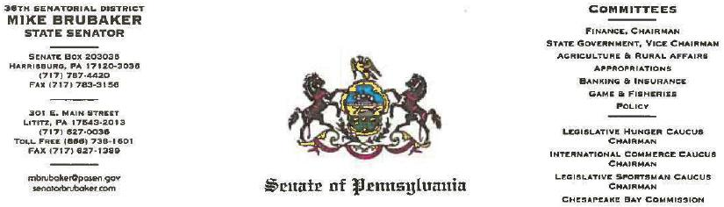

August 25, 2014

Chairman Tom Wheeler

Commissioner Mignon Clyburn

Commissioner Jessica Rosenworcel

Commissioner Ajit Pai

Commissioner Michael O'Rielly

Federal Communications Commission
445 12th Street, SW
Washington, DC 20554

RE: MB Docket No. 14-57

Dear Chairman and Commissioners:

As I watched volunteers harvest yet another bounty of vegetables from the Capitol Hunger Garden in Harrisburg last week, I was reminded of how much is possible in our local communities through the generosity of volunteers. I have seen this play out time and again through my eight years as a State Senator. It is how seemingly insurmountable tasks are accomplished and people .maintain hope in the worst of times.

As a Pennsylvania State Senator, I would like to take this opportunity to express my appreciation and the support our region's experiences with one company. Their volunteer hours and donations have aided more groups than I can count - in my district, across Pennsylvania and the United States. Comcast has lent an earnest, expert and steady hand to many events and in doing so, has moved innumerable ideas from hopeful dream to real achievement.

If the proposed Comcast and Time Warner Cable transaction receives Commission approval that type of partnership and community cooperation would be reproduced in yet more communities.

While a number of Comcast's services fail under the realm of its typical expertise with broadband and video - such as providing our youngsters with free technology training and our poorest families with deeply discounted Internet service - many are contributions of sheer grit and employee commitment.

For instance, in early 2012, in the aftermath of Tropical Storm Lee, Lancaster County was confronted with flooding damage that destroyed facilities and rendered community recreation sites unusable. That April, hundreds of local Comcast employees and officials rolled up their

237

Page 2, August 25,2014

sleeves and turned out on a Saturday to clean up the beautiful Little Chiques Park along the Susquehanna, and make repairs to Lancaster County's Rainbows End Youth Center in Mount Joy Borough. I was there that day and can say that everyone volunteering was in awe of the help and daylong dedication.

Comcast has also been a strong leader in advancing our educational interests. In fact, thanks to Comcast, we've seen a jump in the numbers of previously unconnected youth who now have Internet in their home. In Pennsylvania, close to 15,000 low-income homes have Internet service through Comcast's Internet Essentials program. The program charges just $10 a month for broadband service and offers a computer for just $150. It also provides free computer training for family members. For these students, it means being able to complete online homework assignments in the safety and comfort of their homes, as opposed to waiting for limited computer time at a library or community center.

Of course, we've also benefitted from the steady development of Comcast's network and high-speed Internet. Hundreds of government, commercial and nonprofit groups in Pennsylvania rely on the fast and reliable services Comcast provides here.

Lancaster County and the Commonwealth of Pennsylvania have definitely benefited from having Comcast as a digital technology partner and a partner within the community. I support this transaction and look forward to hearing how Comcast is assisting to lay the foundation for more partnerships and positive futures.

Sincerely,

/s/ Mike Brubaker

Mike Brubaker

State Senator

36th Senatorial District

MWB/jaf

238

Tom Wheeler

Chairman

Federal Communications Commission

445 12th Street, SW

Washington, DC 20554

RE: MB Docket No. 14-57

Dear Chairman Wheeler:

I am the Co-Founder of Shuddle, Inc., a new ride service for families on the go. Using a full-featured mobile app, parents can schedule rides for their kids to and from home, school and activities with drivers and vehicles that are rigorously screened to ensure that each Shuddle ride will be fun, safe and reliable.

I am writing to lend my support for the Comcast-Time Warner Cable deal. Comcast Ventures has been a valuable partner to Shuddle, helping fund us along with other early-stage companies in the web-based apps market. Comcast’s investment is of course important to us, but so too is its insight and experience as we continue to innovate and develop our service.

Since we are an app-based company, our business plan relies on ubiquitous, fast, and reliable broadband service. Comcast’ s broadband service is best-in-class, as is its robust WiFi network. and its combination with Time Warner Cable will allow other parts of the country to enjoy these great services, which in turn will give Comcast a larger footprint to sustain more investments. The continued growth and pervasiveness of broadband will boost the operating environment for web-based businesses like Shuddle.

Thank you for the opportunity to express my thoughts about the proposed Comcast-Time Warner Cable deal. I hope you will act favorably on this deal.

Sincerely,

/s/Nick Allen

Nick Allen

Co-Founder

Shuddle, Inc.

239

August 25, 2014
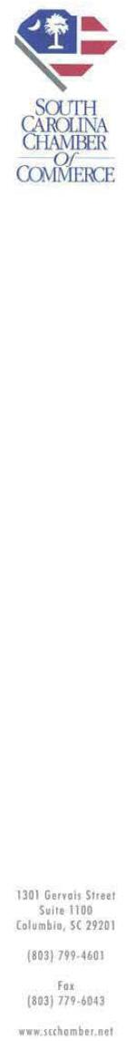

Chairman Tom Wheeler

Commissioner Mignon Clyburn

Commissioner Jessica Rosenworcel

Commissioner Ajit Pai

Com missioner Michael O'Rielly

Federal Communications Commission

445 12th Street, SW

Washington, DC 20554

RE: MB Docket No. 14-57

Dear Chairman and Commissioners:

On behalf of the South Carolina Chamber of Commerce, the state's unified voice of business, l am writing to voice my support for the proposed transaction between Comcast and Time Warner Cable. The South Carolina Chamber works to create prosperity for all citizens by advocating for a more productive and globally competitive economy. As President and CEO of the Chamber, I can personally speak to Comcast's status as a strong corporate citizen and partner in South Carolina. I believe that the proposed transaction with Time Warner Cable will increase both competition and productivity in the economy and significantly benefit the public interests of South Carolina businesses and consumers.

Comcast has shown itself to be a supporter of good jobs and employment opportunities in South Carolina. The company employs nearly 400 full-time workers in the state, with a payroll of over $17 million each year. Comcast also invests in its employees; the $17 million spent annually on payroll is part of $24 million Comcast spent in 2013 on total employee investment, which included health benefits and tuition reimbursements, among other competitive incentives.

Further, Comcast owns and operates 24 properties within South Carolina, including a Call Center that provides many employment opportunities to local residents in tlte Charleston area. The company generates over $20 million in annual state and local taxes and fees, which has positively benefited our economy. Considering the fact that South Carolina currently only has Comcast markets in Charleston, Aiken and part of Beaufort, with the rest of the state split between Time Warner Cable and Charter, I am optimistic that Comcast will be able to increase its investment when it serves a larger share of the market.

Beyond Comcast's commitment to support local economies, another reasons I support the proposed transaction is that I believe it will increase competition and spur innovation within the telecommunications industry. By combining resources, Comcast and Time Warner Cable will be able to form a stronger and more cost-efficient competitor for the small, medium and large businesses in South Carolina. Comcast will be able to bring its cutting-edge technologies, infrastructure. and products to supplement those of Time Warner Cable, and as a result, other competing broadband providers will likely invest more heavily in innovation and product development in order to remain competitive. The end result of this competition will be a larger variety of high-quality services and products from which our businesses and consumers can choose.

240

The proposed transaction will allow for the most cutting-edge products and technologies for businesses to utilize, which will lend to improved efficiency, spur competition and have a largely positive net impact on the local economy. I hope that the FCC sees all of the potential that such a transaction presents, and I look forward to a future where Comcast can continue can provide solutions that attract businesses to our state.

Sincerely,

/s/ Otis Rawl

Otis Rawl

President and Chief Executive Officer

241


Tom Wheeler

Chairman

Federal Communications Commission
445 12th Street, SW
Washington, DC 20554

RE: MB Docket No. 14-57

Dear Chairman Wheeler:

I write to voice my support for the Comcast-Time Warner Cable transaction.

I am CEO of SundaySky, the creator of SmartVideo — a video marketing tool — and Comcast Ventures recently led our Series C raise.

We are living in a screen culture in a visual, always-on society with shorter attention spans and a higher excitement threshold. Consumers have become discerning viewers, preferring to absorb content that addresses their personal interests content that matters to them. SundaySky created SmartVideo to help customer-centric brands engage people with personalized, real-time video experiences at every step of the customer lifecycle. The SundaySky platform generates hundreds of thousands of SmartVideos daily, powering customer acquisition, support, growth and loyalty initiatives.

We are delighted to have Comcast Ventures as a key investor and Comcast as an early customer of SundaySky. As a Comcast Ventures portfolio company, we have seen how Comcast values the need for startups to experiment and look ahead of the curve in the marketplace. Not only did Comcast invest in our company, they agreed to be one of our pilot customers, allowing us to establish credibility in the marketplace.

We support the Comcast-Time Warner merger, which will provide Comcast with additional scale to drive innovation into its broadband network a platform that allows companies like SundaySky to reach our customers and their customers with leading-edge speed and throughput. We believe a larger Comcast will not only translate into more support for our burgeoning business, but for other young start-ups, like us, as well.

Sincerely,

Shmulik Weller

CEO

/s/ Shmulik Weller

SundaySky

SundaySky | 226 W. 37th St. Floor 12, New York, NY 10018
T (212) 929 8111 | F (212) 929 8113 | www.sundaysky.com

242



August 22, 2014

Federal Communications Commission

445 12th Street SW

Washington, DC 20554

Re: Applications of Comcast Corp. and Time Warner Cable Inc. for Consent to Transfer Control of Licenses and Authorizations, MB Docket No. 14-57

Dear Chairman Wheeler and Commissioners:

I am writing on behalf of Television Korea 24, Inc. (TVK24), a leading Korean broadcaster in the United States, headquartered in Los Angeles, California. TVK24 owns and operates two digital 24-hour television networks that aggregate and broadcast the best programming from Korea-based networks in combination with TVK24 original programming such as daily news, cooking shows, golf shows, auto shows, sporting events, weekly lifestyle and community related shows and local reality and documentary series. The majority of TVK24 sourced content is exclusive to TVK services.

TVK24 has enjoyed strong business relationships with both Comcast Cable and Time Warner Cable. Comcast Cable has carried TVK in major metropolitan areas with significant Korean-American populations, first launching our network in the greater Southern California area in March 2005, followed by the Greater Washington D.C. area (Maryland, Virginia, and D.C.) in July 2007, and the San Francisco-Bay Area in January 2008. More recently, in May 2013, TVK and TVK2 launched on Time Warner Cable systems in its New York/New Jersey service area.

TVK24 greatly appreciates the support that Comcast Cable and Time Warner Cable have given to our networks by distributing our programming to millions of households in the United States. Both companies have demonstrated a commitment to accommodate diverse, quality programming in their channel lineups that meets the needs and interests of viewers and communities of different backgrounds. For TVK24, in particular, carriage of our networks provides the Korean-American community with many popular shows, as well as news and sports, available 24-hours-a-day.

Based on our experience with Comcast and Time Warner Cable. we strongly support the proposed merger. We are confident that Comcast will continue to demonstrate the same commitment to diverse programming serving different communities, including Korean-American viewers, after the transaction. We hope that the Commission will consider Comcast's proven record of support for independent programmers in promptly approving the transaction.

Sincerely,

/s/ Eric S. Yoon

Eric S. Yoon

Founder & C.E.O.
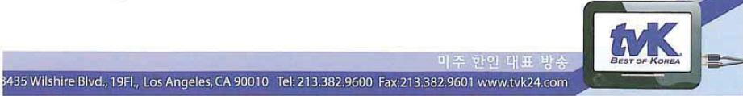

243

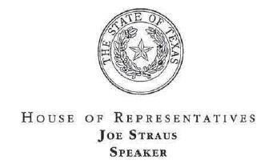

August 25, 2014

Mr. Tom Wheeler

Chairman

Federal Communications Commission
445 12th Street, SW
Washington, DC 20554

RE: MB Docket No. 14-57

Dear Chairman Wheeler:

Comcast and Time Warner Cable, two recognized leaders In telecommunications and technology, have served the people of Texas well. Both have invested substantially in our state as our population and our economy have continued to grow. The merger of these two companies will support further expansion of our economy and offer a number of benefits to Texas consumers. I respectfully encourage you to approve this proposed transaction.

These companies have invested billions of dollars in capital expenditures over the years to deliver a better product, and a merger would allow more Texans to benefit from those investments. For example, Comcast's Internet Essentials program, an effort to provide low-cost broadband service to low-income residents, has already served more than 50,000 people in Texas. This transaction would allow that program to reach an even larger share of our population. Overall, a merger would create economies of scale to facilitate even greater investment in broadband deployment, adoption, speeds, and competition.

These companies play an important role in the daily lives of millions of Texans, and this transaction would benefit the people of this state.

Sincerely,

/s/ Joe Straus

Joe Straus

Speaker

P.O. Box 2910 • AUSTIN, TEXAS 78768-2910 • (512) 463-1000 • FAX (512) 463-0675

244

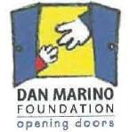

August 15, 2014

Tom Wheeler

Chairman

Federal Communications Commission

445 12th Street, SW

Washington, DC 20554

RE: MB Docket No. 14-57

Dear Chairman Wheeler:

Since 2000, I've worked as the CEO of The Dan Marino Foundation, an organization dedicated to serving individuals with autism and other developmental disabilities. Located in South Florida the Foundation makes a difference in the lives of children, teens and young adults with disabilities by providing therapies, quality of life research, post-secondary education, and employment programs. My prior positions include teacher, Director of Daybridge Learning Centers, and CEO of the South Broward County YMCA. Most recently I have held positions on the Florida Governor's Autism Task Force and President Obama's Developmental Disability Committee.

I write you today to voice my support for the proposed transaction between Comcast and Time Warner Cable. Throughout my career, I've developed a strong appreciation for companies that work to include people with disabilities and promote programs and resources that help them achieve success and advancement in their lives. I can speak from personal experience when I say that Comcast stands out in its commitment to helping those with special needs.

The Dan Marino Foundation has counted Comcast as a strong supporter and partner, and together we've worked to bring Comcast's Digital Literacy Program and the Internet Essentials Program, to eligible families affected with Autism and other developmental disabilities. Comcast's partnership has helped young people with disabilities to bridge the digital divide by providing students with digital literacy training and tools to find jobs and succeed in the future. Comcast has partnered with our Foundation to support the Marino Virtual Career Lab (Virtual Employment Interviewing Tool) and Marino Campus, a post-secondary school for young adults with autism and other developmental disabilities.

400 North Andrews Ave. • Fort Lauderdale, FL 33301 · P: 954.368.6000 • F: 954.530.4325 · www.danmarinofoundatlon.org

245

Comcast's Newsmakers Program has provided The Dan Marino Foundation a means to bringing awareness to the needs of the disability community and information on available resources. Comcast has also shown itself to be committed on a national scale to promoting diversity and inclusion for disabled people. In the winter of 2014, Comcast and NBCUniversal announced a three-year commitment and partnership with The Arc, an advocate for the rights of the disabilities community.

Comcast's commitment to those with disabilities extends to its programming and services as well. NBC Universal offers several primetime programs that feature lead characters with disabilities, and Comcast provides several programming options that advance the cause for those with disabilities; in 2012, Comcast Newsmakers teamed up with AADP to create awareness of the unemployment rate in the disabled community, and in October of 2013, Comcast celebrated National Disability Awareness Month with a collection of programming that positively portrays people living with disabilities. Comcast has also launched a dedicated customer service team specifically for people with disabilities that need support in customizing their Xfinity services for use by hearing or visually impaired.

I encourage you to approve the transaction between Comcast and Time Warner Cable. Comcast has been a strong supporter of The Dan Marino Foundation, but Comcast's community outreach is limited to the areas where it has a corporate footprint. Approving the proposed transaction with Time Warner Cable will allow Comcast to positively impact the lives of those with autism and other disabilities, through programming and community investment efforts within the Time Warner markets.

Sincerely,

/s/ Mary Partin

Mary Partin

CEO

The Dan Marino Foundation

246

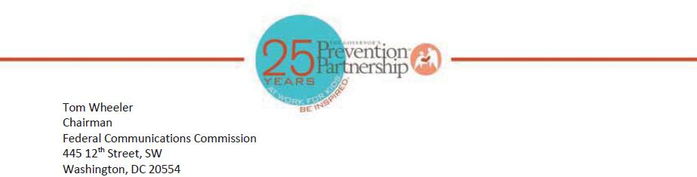

RE: MB Docket No. 14-57

Dear Chairman Wheeler:

The Governor's Prevention Partnership is a public-private nonprofit organization dedicated to developing prevention programs that address emerging and dangerous issues affecting youth. For 25 years, our focus has been on keeping Connecticut’s kids safe and drug-free as well as empowering them for future success and the success of our state as a whole.

As President and CEO of The Governor's Prevention Partnership, I am writing to express my support for the proposed Comcast and Time Warner Cable merger because I have seen firsthand that Comcast understands the critical importance of delivering prevention programs, whether it be at the workplace or in an educational setting. Comcast has proven itself, time and again, as a valuable corporate citizen in our community, and its services - be it broadband internet services including Internet Essentials or its community-based investments and involvements such as mentoring and Comcast Cares Day - have been immensely influential in our state.

Comcast's video production team has supported The Governor's Prevention Partnership’s mission and programs through in-kind production and airing of Public Service Announcements. Not only has Comcast helped us spread the word about our work, it has also sponsored several of our community events including a 2010 Town Hall on drug prevention and our 25th Anniversary Corporate Mentoring Honor Roll Breakfast earlier this year. I should note, Comcast's Western New England Regional Vice President Mary McLaughlin, serves as co-chair along with Governor Dannel P. Malloy. Her support and leadership have been valuable to our success.

It is also my understanding that the transaction between Comcast and Time Warner Cable will expand Comcast's broadband adoption program Internet Essentials - which already reaches over one million low-income Americans - to even more families in need.

Comcast has proudly supported The Partnership and therefore, we seek to jointly support them in this new endeavor. I hope this transaction is approved and more organizations like ours can benefit from such a committed corporate partner.

Thank you,

/s/ Jill K. Spineti

Jill K. Spineti

President & CEO

The Governor’s Prevention Partnership
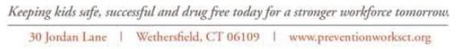

247

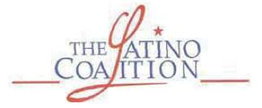

August 25, 2014

Tom Wheeler

Chairman

Federal Communications Commission
445 12th Street, SW
Washington, DC 20554

RE: MB Docket No. 14-57

Dear Chairman Wheeler:

I write today on behalf of the Latino Coalition to outline the ways in which we think that the proposed transaction between Time Warner Cable and Comcast would benefit Latino businesses.

The Latino Coalition was founded In 1995 by a group of Hispanic business owners from across the country to develop initiatives and partnerships that will foster economic equivalency and enhance overall business, economic and social development of Latinos. We believe that this transaction enables precisely those kinds of opportunities.

Competition in the market for technology and communications services for businesses is sorely needed in many markets today. Cable companies have entered many markets and injected real competition for the first time, and Comcast has led the pack in terms of service quality, Gigabit Internet speeds and price. This merger would expand access to Comcast's business service offerings to new cities.

During the NBCUniversal transaction four years ago, Comcast pledged to promote diversity in vendor selection, and to date the company has made good on every single one. Some results worth noting include:

- Spending $1.25 billion with diverse suppliers In 2013

- Spending more than $4 billion with minority-owned businesses from 2010-2013

- Increasing spending with minority-owned suppliers by 20% since 2010

As Comcast seeks to expand its footprint in heavily Latino markets like the greater Los Angeles area, we believe that our membership will both benefit from Comcast's business service offerings and can help Comcast take its commitment to engaging minority-owned businesses to new heights. We urge the Commission to approve this transaction.

Sincerely,

/s/ Allen Gutierrez

Allen Gutierrez

National Executive Director

248

Jay M. Fidell

Pioneer Plaza, 900 Fort Street Mall, Suite 30

Honolulu, Hawaii 96813 Telephone 780-9254

August 24, 2014

Chairman Tom Wheeler

Commissioner Mignon Clyburn

Commissioner Jessica Rosenworcel

Commissioner Ajit Pai

Commissioner Michael O’Rielly

Federal Communications Commission

445 12th Street, SW

Washington, DC 20554

Re: MB Docket No. 14-57

Comment Regarding the Transfer Application Submitted by Time Warner Cable and Comcast Corporation for the Transfer of Control of Oceanic Time Warner Cable LLC’s Oahu Franchise

Dear Chairman and Commissioners:

I am a founder and president of ThinkTech Hawaii, Inc., a Hawaii non-profit corporation that seeks to raise public awareness about the importance of technology to Hawaii. As such, I have followed telecom and convergence in Hawaii over the past several years.

I am writing to express my views regarding the proposed merger between Comcast and Time Warner Cable. I believe this merger would provide significant Internet and television infrastructure improvements to the State of Hawaii, benefiting our residents and local businesses in a variety of ways.

I believe that the key to continuing this technological revolution is through state-of-the-art infrastructure. Access to reliable high-speed Internet and all related new technology is essential to solving problems and fostering future development and innovation.

Criticism regarding Comcast’s merger with Time Warner Cable is not justified. In fact, I understand Comcast will offer connection speeds of up to 505 mbps. This enhanced speed will be most helpful for cable customers and especially the tech community.

Comcast has indicated that it will spend billions to improve the systems that Time Warner Cable has in place. These infrastructure improvements will provide benefits for residents and businesses alike.

249

Chairman Tom Wheeler, et al.

August 24, 2014

Page 2

I also understand that customers will have access to Comcast’s cloud services, more entertainment options with cutting-edge user interfaces and increased connectivity with mobile devices like cell phones and tablets.

Comcast has said it is committed to providing additional services and education to underserved communities through its Internet Essentials project, and that will also be very desirable.

On balance, it appears that the merger between Comcast and Time Warner Cable will bring increased speeds, reliability, features and program offerings. I believe these benefits will improve the lives of the people of Hawaii, and I hope you will consider approving the deal.

Sincerely,

Jay M. Fidell

250


August 25, 2014

VIA ECFS

Ms. Marlene H. Dortch

Federal Communications Commission

Office of the Secretary
445 12th Street, SW
Washington, D.C. 20554

Re: TiVo Comments on Applications of Comcast Corporation, Time Warner Cable Inc., Charter Communications, Inc. and Spinco to Assign and Transfer Control of FCC Licenses and Other Authorizations; MB Docket No. 14-57

Dear Ms. Dortch:

Given Comcast’s history of working with TiVo to enable innovation in retail set-top boxes, TiVo believes that approval of the above-referenced transaction should benefit consumers that wish to use retail devices to access their pay-TV programming. TiVo offers the following comments in support of the transaction.

TiVo views this transaction through the lens of whether the transaction will enhance or degrade the ability of consumers to have a choice of retail set-top boxes. TiVo is focused on ensuring that a successor-solution emerge to replace the standard CableCARD interface for QAM-delivered content. Such a solution is critical (i) for retail consumers to have an innovative alternative to operator-supplied equipment, (ii) for small and mid-sized operators by providing for efficiencies, allowing them to buy set-top boxes from multiple vendors and to avoid being locked into a single vendor’s proprietary, non-interoperable conditional access system, and (iii) to ensure a smooth migration to IP-delivered content (where QAM-delivered content is likely to also co-exist for many years). TiVo is also focused on ensuring that CableCARDs are provided and supported by all cable operators while such post-CableCARD solution is developed and deployed as CableCARD remains the only option consumers currently have to use a retail device to access all of their linear cable channels.

Among pay-TV providers, Comcast has been the most supportive of enabling innovation in retail set-top boxes, thereby allowing consumers to have a robust retail alternative to an operator-leased set top box.¹ Over the course of the past several years, Comcast has partnered with TiVo to enable the

- This is not to say that consumers do not have CableCARD provisioning and support issues with Comcast, as consumers do with all cable operators. However, Comcast has been more willing than most other operators to address such issues and work with TiVo on ways to improve CableCARD provisioning and support.

251

Ms. Marlene H. Dortch

August 25, 2014

Page 2 of 3

provision of Xfinity On Demand to TiVo Premiere and TiVo Roamio customers in all of Comcast’s current markets.² Under this arrangement, Comcast customers are able to use a TiVo Premiere or TiVo Roamio box purchased at retail to enjoy a fully-integrated offering of Comcast’s robust library of Xfinity On Demand content, along with linear television and a range of broadband services, all accessible through TiVo’s user interface and search capabilities. By integrating Xfinity on Demand, TiVo is able to provide its customers with a unique offering of being able to search for content across linear and video-on-demand cable services, as well as Internet-delivered services such as Netflix, Hulu Plus, YouTube, and more. This deployment demonstrates that providing retail devices with the full array of pay TV content can be achieved in innovative ways that do not undermine pay TV operators’ business models.

More recently, Comcast has again partnered with TiVo to work on a two-way non-CableCARD security solution that will enable retail devices to access the full Comcast lineup of linear and VOD programming, whether QAM- or IP-delivered. This effort promises to facilitate continued innovation to consumers. TiVo appreciates Comcast’s leadership and vision in creating a post-CableCARD solution for use by both operator-supplied and retail devices and hopes that other operators will follow Comcast’s lead and adopt the solution which Comcast has agreed to license to other operators on commercially reasonable terms.³ Importantly, Comcast has also agreed to continue to provide and support CableCARDs in retail devices notwithstanding the D.C. Circuit’s EchoStar decision last year vacating certain CableCARD rules. Comcast will ensure that all CableCARD-enabled devices will continue to have access to all linear channels in all Comcast markets.⁴ The significance of Comcast’s continued commitment to CableCARD provisioning and support cannot be overstated.

Based on Comcast’s history of working with TiVo to facilitate innovation, TiVo believes that the above-referenced transaction should benefit consumers that wish to use retail devices to access their pay-TV programming as we would expect Comcast’s leadership and supportive policies to continue and expand. In addition, we believe the transaction should help the industry more quickly transition to

²See Letter from Matthew Zinn, Senior Vice President, General Counsel, and Chief Privacy Officer, TiVo Inc., to Marlene H. Dortch, Secretary, Federal Communications Commission (May 9, 2011) and Letter from Matthew Zinn, Senior Vice President, General Counsel, and Chief Privacy Officer, TiVo Inc., to Marlene H. Dortch, Secretary, Federal Communications Commission (May 9, 2012).

- Letter from Jordan Goldstein, Vice President, Regulatory Affairs, Comcast Corporation, and Matthew Zinn, Senior Vice President, General Counsel, and Chief Privacy Officer, TiVo Inc., to Marlene H. Dortch, Secretary, Federal Communications Commission (July 14, 2014).

- It would serve the public interest for the Commission to ensure that all non-Comcast cable systems subject to this transaction also agree to continue to support and provide (to new and existing customers) CableCARDs in retail devices notwithstanding the D.C. Circuit’s EchoStar decision.

252

Ms. Marlene H. Dortch

August 25, 2014

Page 3 of 3

a post-CableCARD solution allowing for additional innovation to the benefit of consumers and small and medium-sized cable operators.

Please contact me with any questions about this matter.

Respectfully submitted,

/s/ Matthew Zinn

Matthew Zinn

Senior Vice President, General Counsel, Secretary & Chief Privacy Officer

253

The Honorable Tom Wheeler

Chairman

Federal Communications Commission

445 12th Street, SW

Washington, DC 20554

August 25, 2014
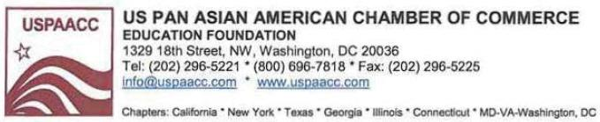

Re: MD Docket No. 14-57

Dear Chairman Wheeler:

On behalf of the US Pan Asian American Chamber of Commerce Education Foundation (USPAACC), I write to express our support for Comcast's acquisition of Time Warner Cable. Founded in 1984, USPAACC is the oldest and largest national, non-profit, non-partisan organization representing a single and unified voice for the Pan Asian American and Asian American-related groups in business, sciences, the arts, sports, education, public and community services.

Over the years, we have seen Comcast's efforts in promoting business opportunities for Pan Asian professionals and business owners. Following the approval of the NBCUniversal merger, Comcast has aligned with USPAACC to identify top-caliber Pan Asian American suppliers and vendors as it strives to make good on its pledge to diversify its supply chain.

By most key measures, Comcast has surpassed our expectations. Since 2010, the company has directed some $4 billion in resources to diverse suppliers, and has worked with Pan Asian American-owned companies to support functional areas such as advertising, call center support, computers, construction, furniture, IT staffing, marketing, production, security installation, and software.

An essential element of USPAACC's core mission is to advocate for a free market philosophy – creating parity and greater access for our constituents that reflect the principles of fair competition. We believe that healthy competition will usher in new products, services and technologies. In the long run, this would give consumers greater selection and better products. A diverse supplier base is paramount to this process, and USPAACC is working assiduously with Comcast to ascertain that our constituents are included in all opportunities that are open to small and minority businesses.

254

By expanding Comcast's reach to additional cities and towns, we believe that Comcast will extend contract and job-related opportunities to even more Pan Asian businesses and professionals. We can assure the Commission that we will continue to monitor Comcast's progress on these important diversity initiatives and will certainly assist the company in expanding these efforts as it grows – to benefit the Pan Asian community, as well as the wider public.

Thank you for your time and consideration of our views on this important transaction.

Sincerely,

US Pan Asian American Chamber of Commerce

Education Foundation (USPAACC)

/s/ Susan Au Allen

Susan Au Allen

National President & CEO

Founded in 1984 as a national non-profit non partisan organization, USPAACC has been the single, unified voice advocating for equal opportunities for Asian Americans in the United States. We promote and propel economic growth by opening doors to business, professional and educational opportunities for Asian Americans and their business partners in Fortune corporations, government at the federal, state, and local levels, and the small and minority community. For 29 years, USPAACC has served and will continue to serve as the gateway to Asian American suppliers, and information about Asian Americans and the dynamic Asia market.

Headquartered in Washington DC, USPAACC reaches its nationwide network of Asian American businesses through regional chapters in California, Texas, New York, Georgia, Illinois, and the National Capital Area of Virginia-Maryland-DC.

255

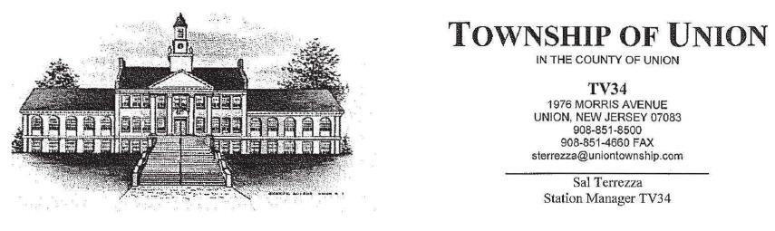

Tom Wheeler, Chairman

Federal Communications Commission
445 12th Street, SW
Washington, DC 20554

RE: MB Docket No. l4-57

Dear Chairman Wheeler:

As Station Manager of UnionTV34, I am writing in support of the Comcast/Time Warner Cable transaction. Over the years, I have seen our local cable access channel in Union Township, New Jersey grow from a small, one-studio set to one with custom virtual sets. We were also one of the first access channels to have a fully HD studio. Originally, UnionTV34 was simply intended to film local events such as High School graduations, school plays, township committee meetings, and zoning and planning board meetings. We have proudly grown beyond that.

We are proud to cover all public meetings for our residents, and additionally we provide our community with Spotlight on Union, which shares community events such as library events, girl/boy scouts, sports, and community club events. We also air programs such as Story Time, Cooking with George, Wining and Dining, and other specialized entertainment programs. In 2008 UnionTV34 expanded even further, adding more channels, made possible in large part due to Comcast.

For over ten years, UnionTV34 has had a great relationship with Comcast. They have provided us with a platform from which we are able to provide information and special programming to the residents of Union Township. As a community-driven network, it is important to us that our partners share the same values, and Comcast has proven to be a valuable member of our community. In addition to their cable, broadband, and Triple Play packages, Comcast has invested millions of dollars into the state of New Jersey through their initiatives such as Comcast Cares Day, Big Brothers and Big Sisters scholarships, education programs and employment opportunities, among others.

It is my understanding that the transaction between Time Warner Cable and Comcast will allow for Comcast to further improve and expand the services that have so greatly benefited Union Township and New Jersey. It is for this reason that I ask you to move in favor of this transaction between Comcast and Time Warner Cable. I appreciate your consideration of this matter.

Sincerely,

/s/ Sal Terrezza

Sal Terrezza

Station Manager TV34

Township of Union

256


August 22, 2014

Marlene H. Dortch

Secretary

Federal Communications Commission
445 12th Street, SW
Washington, DC 20554

RE: MB Docket No. 14-57

Dear Ms. Dortch:

Many are familiar with the tradition of annual Workforce United Way campaign, a practice that has become entrenched in the business world. Each year, millions of workers are inspired to donate a part of their salaries knowing that they are lending a hand to others who often desperately need the help.

Comcast is among the top 50 corporate partners throughout the U.S. to this campaign. The United Way Worldwide recognized this outstanding generosity last year with two of its Summit Awards, bestowed for volunteer and philanthropic engagement. Comcast contributions have improved life for so many, and it is my belief the Federal Communications Commission should approve the proposed Comcast and Time Warner Cable transaction and expand the number of communities which can reap the benefits of a successful and community-engaged company.

The United Way of the National Capital Area and our 560 nonprofit members supply short-term and long-term relief to those in the District, and in Northern Virginia and Montgomery and Prince George's counties in Maryland. We raise about $30 million annually to target critical needs in education, economic stability and wellness. In addition to annual campaign donations from its employees, Comcast has sponsored our member conferences and such fundraisers and events as this summer's "Do More 24" crowdfunding campaign.

Also important among Comcast's community support is its pledge to reflect the communities it serves in programming. The District of Columbia is a true melting pot of races, ethnicities and cultures and thanks to the Comcast lineup, TV viewers have access to relevant educational, informative and entertaining programs. The Aspire network highlights the accomplishments of African Americans, the BabyFirst Americas bilingual network has been well-received by young Latino children and their parents, and the Xfinity.com/LGBT portal offers dedicated and award-winning LGBT programming.

In addition to access to great, culturally diverse programming, what would truly be an asset for communities now served by Time Warner Cable would be their ability to take advantage of such Comcast offerings as Internet Essentials. I have seen statistics indicating that nearly 10 percent of eligible homes in the District have signed up for this wonderful program and that number is expected to jump as awareness grows. Today's children rely on home Internet for schoolwork and their parents rely on it for job searches.

I thank the Commission for its consideration of all that I have shared as it moves toward a decision on the proposed transaction. Please approve the transaction and allow other communities the chance to benefit from the strong corporate partnership and initiatives that Comcast has to offer.

Sincerely,

/s/ Rosie Allen-Herring

Rosie Allen-Herring

President and Chief Executive Officer
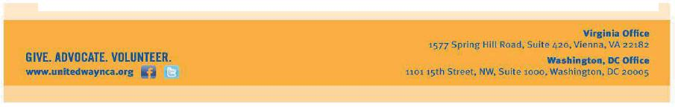

257

Tom Wheeler

Chairman

Federal Communications Commission

445 12th Street, SW

Washington, DC 20554

RE: MB Docket No. 14-57

August 25, 2014

Dear Mr. Wheeler,

As president and CPO of the United Way of Tri-County, in Framingham, Mass., I am pleased to support Comcast’s proposed transaction with Time Warner

Cable. Comcast’s leadership as a good corporate citizen has greatly benefitted our constituents, and this transaction will help bring that leadership to more communities across the country.

The United Way of Tri-County is focused on bringing the community together to address our most pressing needs, particularly in the areas of education, financial stability, health and basic human needs. Our mission is to increase the organized capacity of people to care for each other.

Our strategic approach to problem solving is accomplished with the support of many partners, including Comcast, which invests locally on a number of key initiatives.

As our valued collaborator, Comcast is working with us, along with other statewide partners, on “Massachusetts 2-1-1,” a resource hotline connecting residents to essential services, such as after school programs, food banks, and elderly care services.

Moreover, across the country and here in Massachusetts, Comcast is working to narrow the digital divide through its Internet Essentials program, a comprehensive digital adoption initiative providing free training and affordable service and computers to low-income children and families. Access to at-home broadband service is connecting disadvantaged individuals and communities to the education, jobs and health care resources of the future — ultimately allowing them to tap into the resources that are essential for 21st century success.

I understand that since the Internet Essentials program was implemented three years ago, nearly 8,000 households have received service. Internet Essentials is making a meaningful difference in the lives of students and families who most need easy access to critical resources, and we are grateful that Comcast has indefinitely extended the program – which started as a three-year project – so that it can continue to reach new residents across our state. Comcast has committed to offering Internet Essentials in communities served by the Time Warner Cable systems it would acquire in the transaction. I believe that these other communities would benefit substantially from this and therefore recommend that the Commission approve the Comcast-Time Warner Cable transaction.

Paul Mina

President & Chief Professional Officer

258


August 25th, 2014

Marlene H. Dortch

Secretary

Federal Communications Commission

445 12th Street, SW

Washington, DC 20554

RE: MB Docket No. 14-57

Dear Ms. Dortch:

As a professor in 4-H Extension Youth Development and Science and Technology Specialist at the University of Nebraska-Lincoln, I study informal learning and develop strategies to inspire youth to pursue science, technology, engineering, and math (STEM) in 4-H clubs, afterschool programs and at home. My particular area of study is instructional technology, which involves information technology in education. I understand the critically important roles that a home Internet connection and digital literacy can play in children's lives. I support the Comcast-Time Warner Cable transaction because I believe it will expand the opportunities for youth and families with the Internet Essentials and Digital Connectors programs - to Lincoln and other communities in Nebraska.

Internet Essentials could provide access to families in Lincoln with a child who qualifies for the National School Lunch Program. Internet access in the home enables students to participate in on-line learning opportunities, and not just for certain periods at school. The Digital Connectors program, moreover, provides the types of opportunities for young adults to develop technological skills and apply those to community efforts.

I am also supportive because the program provides whole families access to quality Internet service. Before joining the University of Nebraska faculty, I produced interactive media at Nebraska Educational Telecommunications for nearly a decade. In that role, I developed First Connections, a multifaceted, comprehensive online program offering education about infants and toddlers to teachers and parents. Potentially Internet Essentials would enable even more individuals to pursue on-line learning opportunities such as First Connections benefiting both parents and children.
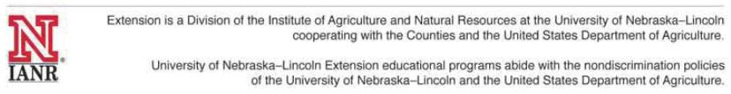

259

I also understand that Comcast's goal is to bring its industry-leading speeds to Time Warner Cable's service areas. Greater speeds will aid all of Lincoln and other parts of Nebraska. I support the Comcast-Time Warner Cable merger.

Sincerely,

/s/ Bradley Barker, Ph.D.

Bradley Barker, Ph.D.

Associate Professor and 4-H Youth Development Specialist

State 4-H Office

114 Agricultural Hall

Lincoln, NE 68583-0700

402-472-9008

260

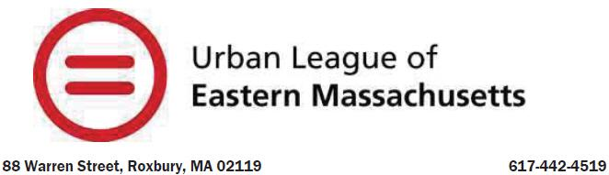

RE: MB Docket No. 14-57

Ms. Marlene H. Dortch, Secretary

Federal Communications Commission
445 12th Street, SW
Washington, DC 20554

Dear Secretary Dortch:

The Urban League of Eastern Massachusetts (ULEM) is committed to helping black families achieve economic prosperity. Technology skills are essential for any person hoping to make a good living for themselves and their family - whether a person wants to prepare a résumé, create a PowerPoint presentation or simply use email.

As President and CEO of the ULEM, I have been proud to partner with the Comcast Corporation to help close the digital divide. I am writing to support the proposed transaction between Comcast and Time Warner Cable because it will put the company on the path to continued investment in communities all over the U.S.

Comcast has demonstrated a clear commitment to the communities it serves by using its resources to boost the missions of organizations like ULEM. With Comcast’s support, ULEM operates three tech centers that teach individuals how to better market themselves as potential employees, as well as programs to enhance students’ digital skills.

In addition, Comcast has a firm understanding of the importance of being well-versed in digital literacy and it provides programs such as Internet Essentials, which allows lower-income households to purchase internet access for less than $10 per month. This program allows low-income families to provide their children access to 21st century tools. Further, the company offers digital literacy training.

In the state of Massachusetts it is estimated that over 88,000 households are eligible for this program, which means underserved students will be able to do homework, projects and research in the privacy of their own homes. Internet Essentials is just one example of how Comcast invests in the communities it serves. The Urban League of Eastern Massachusetts

261

works diligently to provide the best circumstances for the individuals we serve and some of our programs would not be available without Comcast’s help.

Comcast’s record of support for diversity reaches from the classroom to the boardroom. The company includes associates and executives of all backgrounds, races, genders, and those with disabilities in all of its departments. Comcast has reached out to Equal Opportunity Publications to help it with recruiting diverse candidates, and has created scholarship support with the American Association of People with Disabilities among other diversity initiatives. Comcast thrives because it ensures that everyone is included through each branch of their company and that is something to be admired.

It is my pleasure to voice support of the Comcast Corporation and Time Warner Cable transaction. The benefits will offer promising futures for students, businesses, households, and communities all over. I hope you will take all of these factors into consideration when making your decision.

Sincerely,

/s/ Darnell L. Williams

Darnell L. Williams

President & CEO

262

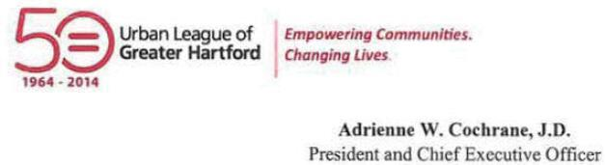

August 25, 2014

Tom Wheeler

Chairman

Federal Communications Commission

445 12th Street, SW

Washington, DC 20554

RE: MB Docket No. 14-57

Dear Chairman Wheeler:

On behalf of the Urban League of Greater Hartford I would like to share the experiences we have had with Comcast in the hopes that it aids your review of its transaction with Time Warner Cable.

For the past 50 years the Urban League of Greater Hartford has sought to achieve educational, occupational, and economic equality throughout the area. Comcast's support of our organization has been instrumental in achieving our goals of empowering the communities and families, while strengthening the education and digital literacy in the communities we serve.

Over the years Comcast has supported our community on many levels. Their Internet Essentials program has effectively connected hundreds of local households to the Internet for the first time (and connects more and more each year of the program). The program is helping to create an even playing field in the digital age for the families in our communities. ln addition, since their merger with NBCUniversal Comcast has successfully attracted a more diverse range of talented employees. I understand that last year more than 40 percent of all full-time U.S. employees at Comcast and NBCUniversal were people of color.

Ultimately our organization is impressed with Comcast's ability to inspire growth and community investment. We know about this firsthand as Comcast has played an active role in the success of our organization. Their employees have donated their time and resources to our organization to support the League and its programs. These investments in time signify that this is a company that is committed to the community.


263

Comcast delivers more than communications services; they deliver incomparable community benefits that we would like to see extended to other cities across America.

Kind regards,

/s/ Adrienne W. Cochrane

Adrienne W. Cochrane, J.D.

264

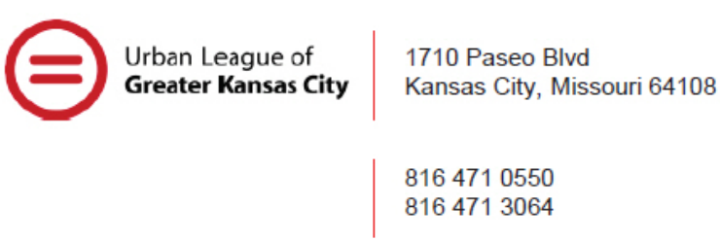

August 25, 2014

Empowering Communities.

Chairman Tom Wheeler Changing Lives.

Commissioner Mignon Clyburn

Commissioner Jessica Rosenworcel

Commissioner Ajit Pai

Commissioner Michael O’Rielly

Federal Communications Commission

445 12 Street, SW

Washington, DC 20554

Re: MB Docket No. 14-57

Dear Chairman and Commissioners:

On behalf of the Urban League of Greater Kansas City, I am writing to express our support to the Federal Communications Commission for the Comcast-Time Warner Cable merger. Our mission is clear: we seek to enable African Americans and other disadvantaged persons to secure economic self-reliance, parity, power and civil rights. The Urban League's Strategy focuses on: 1) ensuring that children are well-educated and equipped for economic self-reliance;
- helping adults to attain economic self-sufficiency through good jobs, entrepreneurship and wealth creation; and 3) securing civil rights by eradicating all barriers to equal participation in the economic and social mainstream of America.

By approving this transaction, the FCC will help to advance all three of these goals. First, Comcast is committed to expanding broadband access to children and low-income individuals through programs like Internet Essentials and the Comcast Digital Connectors programs. Since 2011, Internet Essentials has provided affordable internet services to more than one million people. In today's world, internet access is an essential component of education at any age and the Urban League hopes the program can continue to flourish. Similarly, the Digital Connectors program provides after-school and summer digital literacy training to groups of diverse, low-income youth while also providing important mentoring from Comcast employees.

Second, the Urban League applauds Comcast's commitment to diversity and equality, which can be seen in the company's hiring practices, supplier selection and charitable endeavors. The company has implemented a wide range of practices to recruit, attract and develop diverse talent. The Urban League considers these types of corporate practices essential to developing a level playing field with economic opportunity for all people.

Finally, Comcast is a strong proponent of supporting minority-owned businesses and startups. For instance, the company has spent millions of dollars through a venture capital fund known as the Catalyst Fund to sponsor a variety of minority-led technology startup companies, which further contributes to the Urban League of Kansas City's overall mission.

265

Federal Communications Commission

Page Two

In short, the Urban League of Greater Kansas City recommends the FCC approve the Comcast-Time Warner Cable merger because it promises to produce significant benefits to numerous communities and disadvantaged segments of the population. We appreciate your consideration of our perspective on the matter.

Sincerely,

/s/ Gwendolyn Grant

Gwendolyn Grant

President & CEO

266

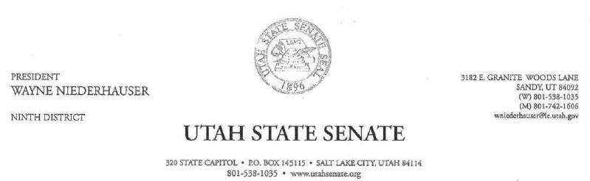

August 22, 2014

Chairman Tom Wheeler

Commissioner Mignon Clyburn

Commissioner Jessica Rosenworcel

Commissioner Ajit Pai

Commissioner Michael O'Rielly

Federal Communications Commission
445 12th Street, SW
Washington, DC 20554

Re: MB Docket No. 14-57

Dear Chairman and Commissioners:

I am pleased to provide this letter of support in favor of the Comcast and Time Warner Transaction. Every American – politician, small business owner, student, or citizen – worries about jobs and their economic future. Whether I'm in my office at the Utah Capitol acting as Senate President, or behind the desk at my family accounting business, I'm no different. Comcast understands those priorities. They have been an enthusiastic innovator for economic expansion here in Utah for years. I write to urge your support of the proposed merger – a vehicle by which we can extend the same progress that Utah has seen to our fellow states.

Utah is lucky to receive coverage from Comcast throughout the state. Our state has benefitted from $1.4 billion in Comcast technology and infrastructure investment since 1996. That level of development encourages the growth of businesses and jobs that meet the challenges of the 21st century. Our state was ranked #I for technology concentration and dynamism from the Milken Institute. We enjoy being on top, but we shouldn't stand alone. Other states can have the same sort of innovation success that we have had if the FCC approves this transaction.

About 1,400 Utahns show up to work at Comcast every day. The company paid nearly $75 million in salaries last year. Those career investments are constantly returned to our community in various ways. The skills and money Utahns gain are passed along to our state's businesses, and thus our state's citizens.

Comcast's 280,000 subscribers in our state have seen that investment pay off every day. The Xfinity Hotspots Program enables customers and businesses to connect on the go, without

267

worrying about long-term or fixed-location subscriptions. Comcast has ensured that Utah's continued demand for services is supported by continued technological capacity growth.

This year marked the fifth that Comcast in Utah held their Leaders & Achievers Scholarship Capitol Ceremony, where I had the pleasure of providing the keynote address. Comcast invites all scholarship students, their families, their school administrators, and their state legislators to the Utah State Capitol for the award ceremony and luncheon. We also invited community partners to the ceremony. Comcast provided 36 Utah students with $60,000 total in college scholarships through the 2014 Leaders and Achievers Scholarship Program. Ten of the winning students were also given laptop computer to use at college. This year, four of the students were surprised with $5,000 President's Scholarships, and one student was surprised with a $10,000 Founders Scholarship at the ceremony.

The Utah Legislature is continually seeking to improve our state's competitive free marketplace. Comcast's commitment to innovation improves the competitive playing field in Utah and around the country. Your approval of this transaction will help us to continue these competitive improvements.

Please approve this transaction. America's consumers will enjoy improved service, improved infrastructure, and improved economic prospects. Utah has seen these improvements already with the support of Comcast's infrastructure and service.

I thank you for considering this request and I humbly urge your support.

Sincerely,

/s/ Wayne Niederhauser

Wayne Niederhauser

Utah Senate President

268

Tom Wheeler

Chairman

Federal Communications Commission
445 12th Street, SW
Washington, DC 20554

August 24, 2014

RE: MB Docket No. 14-57

Dear Chairman Wheeler:

I am the CEO of Versa, a startup innovating on business models for news with the first native marketing platform that allows brands and organizations to share substantive messages, instantly, within the context of relevant news. It’s the power placement of an op-ed with the immediacy of a tweet.

We believe a thriving press is essential to an informed and engaged public. That’s why we enable organizations of all sizes and publishers from blogs to newspapers to engage readers with high-quality, content-driven perspectives from issue experts and thought leaders. We are a burgeoning young company making a difference.

I am proud to say that Versa is funded by Comcast Ventures’ Catalyst Fund, a venture fund investing in early-stage technology startups led by minority entrepreneurs. The Catalyst Fund is a pioneer. With incredible leadership at its helm, it is unique in its ability not only to make a difference through its investments in the communications landscape of our future, but also in how the doors of opportunity are opened to the breadth of thinkers, creators, doers, and makers who are looking to turn ideas into reality.

Through the Catalyst Fund, Comcast has made an invaluable commitment to our success, not only with its capital but also with its investment of time, networks, mentorship and insights. As a company it has demonstrated its commitment to supporting startups and innovative businesses, recognizing the value of new business models and the need to evolve ahead of the marketplace.

I ask the Commission to consider these comments as you evaluate the decision before you.

Sincerely,

/s/ Keya Dannenbaum

Keya Dannenbaum

CEO

Versa

269

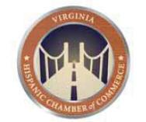

August 25, 2014

Marlene H. Dortch

Secretary

Federal Communications Commission

445 12th Street, SW

Washington, DC 20554

RE: MB Docket No. 14-57

Dear Ms. Dortch:

Nearly 15 years ago, I founded the Virginia Hispanic Chamber of Commerce as a way to network with and showcase businesses in the Latino community. From its very start, I have been able to count on support from Comcast, and I wish to express my support for your consideration of Comcast in its plan to merge with Time Warner Cable.

Why do I urge this? It is because of the many ways in which Comcast assists our Chamber in getting its message across, helps our members with carefully developed business technology services, and reaches out to the people in communities where our members operate their businesses. This is how Comcast has always conducted itself and I believe any community would be fortunate to have this company as a local corporate citizen.

Comcast helped us launch and now is a signature sponsor of our annual FERIA DE LA OPPORTUNIDAD (community resource fair). Every year, thousands of Latinos attend to learn of services that are available to meet various needs. Food, music, workshops, kids crafts, a job fair and demonstrations–all free–create a festival atmosphere that draws people who might not otherwise take an opportunity to access information about health, educational and housing services that would improve their lives.

When we started our literacy program, Passport to Education, which works to keep Hispanic students on the path to higher education, Comcast helped publicize it. Then, through its own program, Internet Essentials, Comcast helped many of our school families get Internet service at home so their children could do homework, send messages to their teachers, complete research and apply to colleges– all while in their home rather than having to wait for limited Internet time at a library or a community center. In the first two years of Internet Essentials in Virginia, more than 17,000 people were able to have a home broadband connection and buy a computer at drastically reduced prices. This kind of connectivity is very important to us in the Latino community.

270

Also important is having TV programming where we can see people and lifestyles that represent our culture. Comcast has more Spanish language channels than any other cable provider and this is perceived among many as an important commitment to our community.

Comcast shares many of our values and goals, especially when it comes to our future business leaders of tomorrow, and this company philosophy has only grown stronger through the years. Thank you very much for allowing me the opportunity to express my thoughts on this proposed merger.

Sincerely,

/s/ Michel Zajur

Michel Zajur

President and CEO

Virginia Hispanic Chamber of Commerce

271



August 25, 2014

Tom Wheeler

Chairman

Federal Communications Commission

445 12th Street, SW

Washington, DC 20554

RE: MB Docket No. 14-57

Dear Chairman Wheeler:

Since joining VISIT DENVER in 1993, I have seen Comcast demonstrate its commitment to the Metro Denver area on many occasions and in many ways. Through our longstanding partnership with Comcast and observation of the company's role as a leader in the local business community, I am confident that Comcast's transaction with Time Warner Cable will bring similar benefits to numerous communities around the country.

I currently serve as the President & CEO of VISIT DENVER. Our organization is responsible for marketing the Denver area as a convention and leisure destination. In my role, I pay close attention to local business practices and business development, and have seen firsthand Comcast's valuable presence in our community. Not only is Comcast an organization that supports our local economy, but it is also a local, socially conscious corporate citizen as evidenced by its longstanding partnerships with many local non-profit organizations.

Comcast is a valuable member of the Colorado community. Since 1996 Comcast has invested more than $6 billion in infrastructure in our state, providing our businesses and residents with cutting edge services. This is an important factor when businesses are making determinations about where to grow or to locate their operations, and is also an important factor in maintaining Denver's excellent quality of life that attracts new residents and visitors.

Comcast has also supported the VISIT DENVER organization directly. Cindy Parsons, Comcast's Vice President of Public Relations for the Mile High Region, has served for several years on our board of directors, and was recently appointed to serve as the board's chair. We are grateful for Comcast's support as Ms. Parsons brings her acute business acumen and expertise to help our organization continue to grow and thrive, and to further develop the potential of the greater Denver area.


272

I believe that Comcast will bring its commitment to advancing local business growth and assisting local community needs to any new region it enters. It is because of this commitment and the willingness to partner with organizations like VISIT DENVER that I am pleased to support the Comcast transaction with Time Warner Cable.

Sincerely,

/s/ Richard W. Scharf

Richard W. Scharf

President & CEO

VISIT DENVER

273

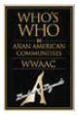

August 24, 2014

Chairman Tom Wheeler

Commissioner Mignon Clyburn

Commissioner Jessica Rosenworcel

Commissioner Ajit Pai

Commissioner Michael O’Rielly

Federal Communications Commission

445 12th Street, SW

Washington, DC 20554

RE: MB Docket No. 14-57

Dear Chairman and Commissioners:

Diversity is one of the primary sources of our country’s dynamism. Immigrants have made our nation run from the days of the Revolution to the days of Real Housewives. I know these truths as well as anyone else. I am a proud Japanese American. I was one of the first Asian American anchors for CNN’s Headline News. I am also the founder of “Who’s Who in Asian American Communities” Alliance Foundation (WWAAC), a non-profit foundation dedicated to recognizing and honoring the lives of Asian Americans and Pacific Islanders (AAPIs). Fortunately, companies like Comcast also recognize the strength of our country’s diversity.

I urge you to support the proposed Comcast – Time Warner transaction to strengthen our minority communities and build a stronger America for all, regardless of ancestral origin, accent, or skin color.

WWAAC hosts an annual awards ceremony in Georgia to honor prominent and dedicated AAPIs. Comcast has been a committed and generous sponsor of the event.

Moreover, Comcast understands that money isn’t everything. Comcast makes minority coverage and programming a consistent priority.

Our awards event is broadcast to Comcast subscribers around the nation on Cinema Asian America. Comcast already carries more than 160 independent channels. Upon approval of this transaction, the company would carry 10 additional channels, most of them minority owned. As one of the first Asian-American faces on TV in Georgia, I know the power of having diverse voices and faces in our media.

The expanded impact of Comcast’s commitments will be felt in key AAPI communities upon approval of the transaction, from AAPI-plurality Hawaii to the vibrant Chinatowns, Koreatowns, and Japantowns of the New York and Los Angeles areas.

The WWAAC Alliance Foundation, Inc.

2434 Waleska Highway 108

Suite 100

Jasper, GA 30143

678 528 3444

www.WWAAC.com

274

These commitments come on top of Comcast’s outstanding track record of philanthropy and positive corporate citizenship. Many residents of my home state of Georgia, benefit from Comcast’s high-speed service. Many residents also benefit from the over $17 million invested by Comcast in our communities last year. Many residents know and appreciate one of the over 4,000 2013 Comcast Cares Day volunteers. These investments don’t just help the Asian community or Black community. These investments help all communities.

I humbly ask for your approval of the Comcast – Time Warner Cable transaction to better the lives of all Americans.

Sincerely,

/s/ Sachi Koto

Sachi Koto

Founder

The WWAAC Alliance Foundation, Inc.

2434 Waleska Highway 108

Suite 100

Jasper, GA 30143

678 528 3444

www.WWAAC.com

275

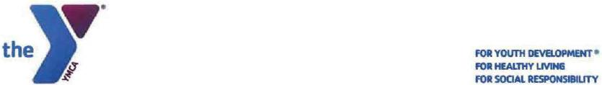

August 21, 2014

Chairman Tom Wheeler

Commissioner Mignon Clyburn

Commissioner Jessica Rosenworcel

Commissioner Ajit Pai

Commissioner Michael O'Rielly

Federal Communications Commission
445 12th Street, SW
Washington, DC 20554

RE: MB Docket No. 14-57

Dear Chairman and Commissioners:

I am writing to you today to share the perspective of the YMCA of Honolulu on the proposed transaction between Comcast and Time Warner Cable.

As a company, Comcast has shown itself to be committed to giving back to the local communities it serves and has focused on investing in the areas in which its expertise can make the greatest impact. First and foremost among these efforts are its programs that help to expand digital literacy in low-income communities. These are not hollow efforts, or simply a commitment to fund a few programs, but a strategic, thoughtful and powerful program to address the digital divide. This program, called Internet Essentials, bas already connected more than 1.2 million economically disadvantaged Americans in less than three years since its inception. Comcast has promised to continue expanding initiatives like Internet Essentials after the proposed transaction – this can only be good news for the people of Hawaii.

Comcast has also developed a network of partnerships with YMCAs around the country which helps focus its efforts to strengthen the local communities. I was amazed to learn that just this year alone, more than 80,000 Comcast employees volunteered for over 800 projects across the country and, since 2001, more than half a million people have contributed over 3 million volunteer hours in service of through their Comcast Cares Day volunteer program.

276

Tom Wheeler

Chairman

Federal Communications Commission

August 21, 2014

Page 2 of 2

The proposed transaction will mean that our community will be able to enjoy the benefits of the company's dedication with the extension of Comcast's local and corporate partnerships, which is why we are supportive of this transaction.

Yours sincerely,

/s/ Michael T. Chinaka

Michael T. Chinaka CPA

Senior Vice President & CFO

YMCA of Honolulu

Important Information For Investors And Shareholders

This communication does not constitute an offer to sell or the solicitation of an offer to buy any securities or a solicitation of any vote or approval. In connection with the proposed transaction between Comcast Corporation (“Comcast”) and Time Warner Cable Inc. (“Time Warner Cable”), Comcast has filed with the Securities and Exchange Commission (“SEC”) a registration statement on Form S-4, including Amendments No. 1, 2, 3, 4, 5 and 6 thereto, and a definitive joint proxy statement of Comcast and Time Warner Cable that also constitutes a prospectus of Comcast. INVESTORS AND SECURITY HOLDERS OF COMCAST AND TIME WARNER CABLE ARE URGED TO READ THE DEFINITIVE JOINT PROXY STATEMENT/PROSPECTUS AND OTHER DOCUMENTS FILED OR THAT WILL BE FILED WITH THE SEC CAREFULLY AND IN THEIR ENTIRETY BECAUSE THEY CONTAIN OR WILL CONTAIN IMPORTANT INFORMATION. Investors and security holders may obtain free copies of the registration statement and the definitive joint proxy statement/prospectus and other documents filed with the SEC by Comcast or Time Warner Cable through the website maintained by the SEC at http://www.sec.gov. Copies of the documents filed with the SEC by Comcast are available free of charge on Comcast’s website at http://cmcsa.com or by contacting Comcast’s Investor Relations Department at 866-281-2100. Copies of the documents filed with the SEC by Time Warner Cable are available free of charge on Time Warner Cable’s website at http://ir.timewarnercable.com or by contacting Time Warner Cable’s Investor Relations Department at 877-446-3689.

In addition, in connection with the proposed transaction between Comcast and Charter Communications, Inc. (“Charter”), Charter will file with the SEC a registration statement on Form S-4 that will include a proxy statement of Charter that also constitutes a prospectus of Charter, and a definitive proxy statement/prospectus will be mailed to shareholders of Charter. INVESTORS AND SECURITY HOLDERS OF COMCAST AND CHARTER ARE URGED TO READ THE PROXY STATEMENT/PROSPECTUS AND OTHER DOCUMENTS THAT WILL BE FILED WITH THE SEC CAREFULLY AND IN THEIR ENTIRETY BECAUSE THEY WILL CONTAIN IMPORTANT INFORMATION. Investors and security holders will be able to obtain free copies of the registration statement and the proxy statement/prospectus (when available) and other documents filed with the SEC by Comcast or Charter through the website maintained by the SEC at http://www.sec.gov. Copies of the documents filed with the SEC by Comcast are available free of charge on Comcast’s website at http://cmcsa.com or by contacting Comcast’s Investor Relations Department at 866-281-2100. Copies of the documents filed with the SEC by Charter will be available free of charge on Charter’s website at charter.com, in the “Investor and News Center” near the bottom of the page, or by contacting Charter’s Investor Relations Department at 203-905-7955.

277

Shareholders of Comcast and Time Warner Cable are not being asked to vote on the proposed transaction between Comcast and Charter, and the proposed transaction between Comcast and Time Warner Cable is not contingent upon the proposed transaction between Comcast and Charter.

Comcast, Time Warner Cable, Charter and their respective directors and certain of their respective executive officers may be considered participants in the solicitation of proxies in connection with the proposed transaction between Comcast and Time Warner Cable, and Comcast, Charter and their respective directors and certain of their respective executive officers may be considered participants in the solicitation of proxies in connection with the proposed transaction between Comcast and Charter. Information about the directors and executive officers of Time Warner Cable is set forth in its Annual Report on Form 10-K for the year ended December 31, 2013, which was filed with the SEC on February 18, 2014, its proxy statement for its 2014 annual meeting of stockholders, which was filed with the SEC on April 29, 2014, and its Current Report on Form 8-K, which was filed with the SEC on June 13, 2014. Information about the directors and executive officers of Comcast is set forth in its Annual Report on Form 10-K for the year ended December 31, 2013, which was filed with the SEC on February 12, 2014, its proxy statement for its 2014 annual meeting of stockholders, which was filed with the SEC on April 11, 2014, and its Current Report on Form 8-K, which was filed with the SEC on July 1, 2014. Information about the directors and executive officers of Charter is set forth in its Annual Report on Form 10-K for the year ended December 31, 2013, which was filed with the SEC on February 21, 2014, its proxy statement for its 2014 annual meeting of stockholders, which was filed with the SEC on March 27, 2014, and its Current Report on Form 8-K, which was filed with the SEC on May 9, 2014. These documents can be obtained free of charge from the sources indicated above. Additional information regarding the participants in the proxy solicitations and a description of their direct and indirect interests, by security holdings or otherwise, are contained in the definitive joint proxy statement/prospectus of Comcast and Time Warner Cable filed with the SEC and other relevant materials to be filed with the SEC when they become available, and will also be contained in the preliminary proxy statement/prospectus of Charter when it becomes available.

Cautionary Statement Regarding Forward-Looking Statements

Certain statements in this communication regarding the proposed acquisition of Time Warner Cable by Comcast and the proposed transaction between Comcast and Charter, including any statements regarding the expected timetable for completing the transactions, benefits and synergies of the transactions, future opportunities for the respective companies and products, and any other statements regarding Comcast’s, Time Warner Cable’s and Charter’s future expectations, beliefs, plans, objectives, financial conditions, assumptions or future events or performance that are not historical facts are “forward-looking” statements made within the meaning of Section 27A of the Securities Act of 1933, as amended, and Section 21E of the Securities Exchange Act of 1934, as amended. These statements are often, but not always, made through the use of words or phrases such as “may”, “believe,” “anticipate,” “could”, “should,” “intend,” “plan,” “will,” “expect(s),” “estimate(s),” “project(s),” “forecast(s)”, “positioned,” “strategy,” “outlook” and similar expressions. All such forward-looking statements involve estimates and assumptions that are subject to risks, uncertainties and other factors that could cause actual results to differ materially from the results expressed in the statements. Among the key factors that could cause actual results to differ materially from those projected in the forward-looking statements are the following: the timing to consummate the proposed transactions; the risk that a condition to closing either of the proposed transactions may not be satisfied; the risk that a regulatory approval that may be required for either of the proposed transactions is not obtained or is obtained subject to conditions that are not anticipated; the parties’ ability to achieve the synergies and value creation contemplated by the proposed transactions; the parties’ ability to promptly, efficiently and effectively integrate acquired operations into their own operations; and the diversion of management time on transaction-related issues. Additional information concerning these and other factors can be found in Comcast’s, Time Warner Cable’s and Charter’s respective filings with the SEC, including Comcast’s, Time Warner Cable’s and Charter’s most recent Annual Reports on Form 10-K, Quarterly Reports on Form 10-Q and Current Reports on Form 8-K. Comcast, Time Warner Cable and Charter assume no obligation to update any forward-looking statements. Readers are cautioned not to place undue reliance on these forward-looking statements that speak only as of the date hereof.

278

