Filed by Comcast Corporation

(Commission File No.: 001-32871)

Pursuant to Rule 425 of the Securities Act of 1933

and deemed filed pursuant to Rule 14a-12

of the Securities Exchange Act of 1934

Subject Company: Time Warner Cable Inc.

Commission File No. for Registration Statement

on Form S-4 filed by Comcast Corporation: 333-194698

The following are advertisements of Comcast:

Advertisement 1:



This communication does not constitute an offer to sell or the solicitation of an offer to buy any securities or a solicitation of any vote or approval. After the registration statement filed with the SEC is declared effective, a definitive joint proxy statement/prospectus will be mailed to Comcast and Time Warner Cable shareholders. INVESTORS AND SECURITY HOLDERS ARE URGED TO READ THE JOINT PROXY STATEMENT/PROSPECTUS AND OTHER DOCUMENTS FILED OR THAT WILL BE FILED WITH THE SEC CAREFULLY AND IN THEIR ENTIRETY BECAUSE THEY CONTAIN OR WILL CONTAIN IMPORTANT INFORMATION. Copies of the joint proxy statement/prospectus and other materials, including information about Comcast, Time Warner Cable and their directors and certain executive officers are available for free at http://www.sec.gov, http://cmcsa.com or http://ir.timewarnercable.com or by contacting the Investor Relations Departments of Comcast at 866-281-2100 or Time Warner Cable at 877-446-3689.

Advertisement 2:
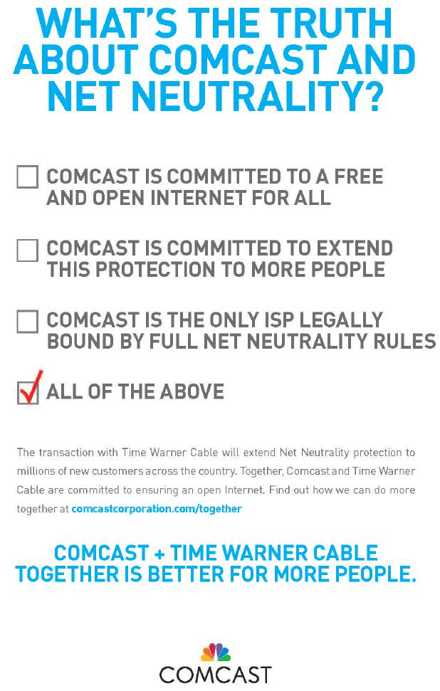

This communication does not constitute an offer to sell or the solicitation of an offer to buy any securities or a solicitation of any vote or approval. After the registration statement filed with the SEC is declared effective, a definitive joint proxy statement/prospectus will be mailed to Comcast and Time Warner Cable shareholders. INVESTORS AND SECURITY HOLDERS ARE URGED TO READ THE JOINT PROXY STATEMENT/PROSPECTUS AND OTHER DOCUMENTS FILED OR THAT WILL BE FILED WITH THE SEC CAREFULLY AND IN THEIR ENTIRETY BECAUSE THEY CONTAIN OR WILL CONTAIN IMPORTANT INFORMATION. Copies of the joint proxy statement/prospectus and other materials, including information about Comcast, Time Warner Cable and their directors and certain executive officers are available for free at http://www.sec.gov,

http://cmcsa.com or http://ir.timewarnercable.com or by contacting the Investor Relations Departments of Comcast at 866-281-2100 or Time Warner Cable at 877-446-3689.

