Filed by Comcast Corporation

Pursuant to Rule 425 under the

Securities Act of 1933 and deemed

filed pursuant to Rule 14a-12 under

the Securities Exchange Act of 1934

Subject Company: AT&T Corp.

Commission File No. 1-1105

Date: August 1, 2001

The following presentation was used by Comcast at its quarterly conference call with investors:
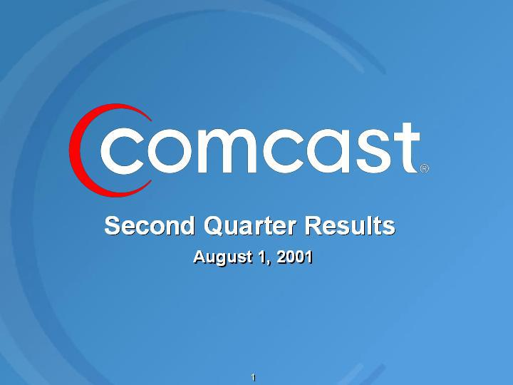

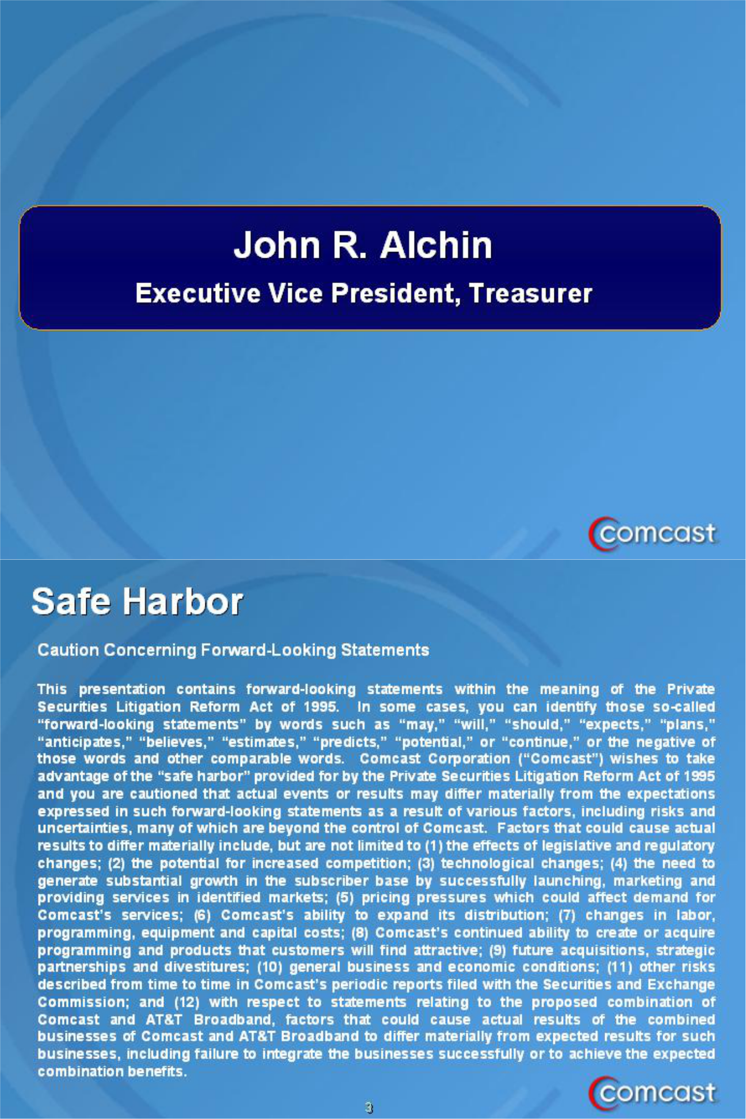

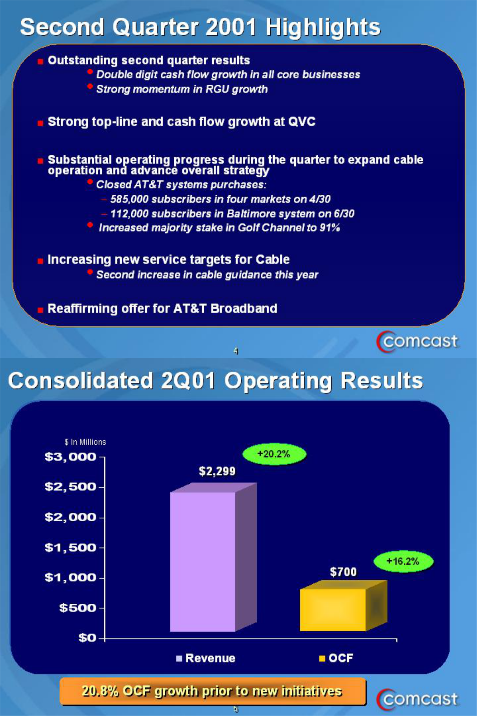

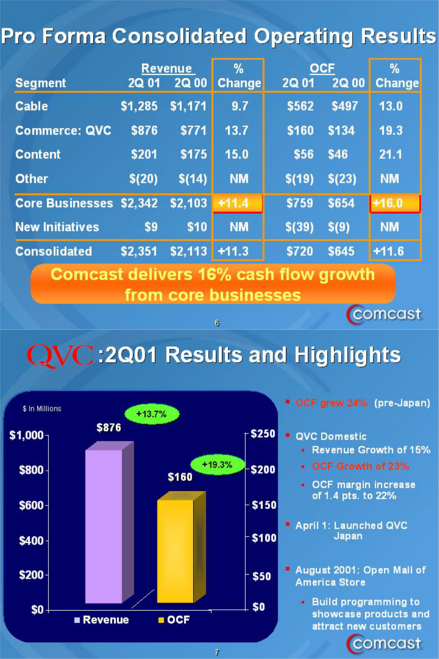

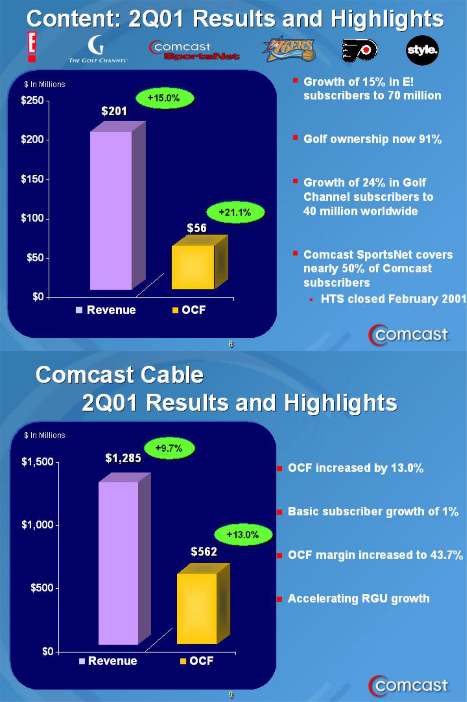

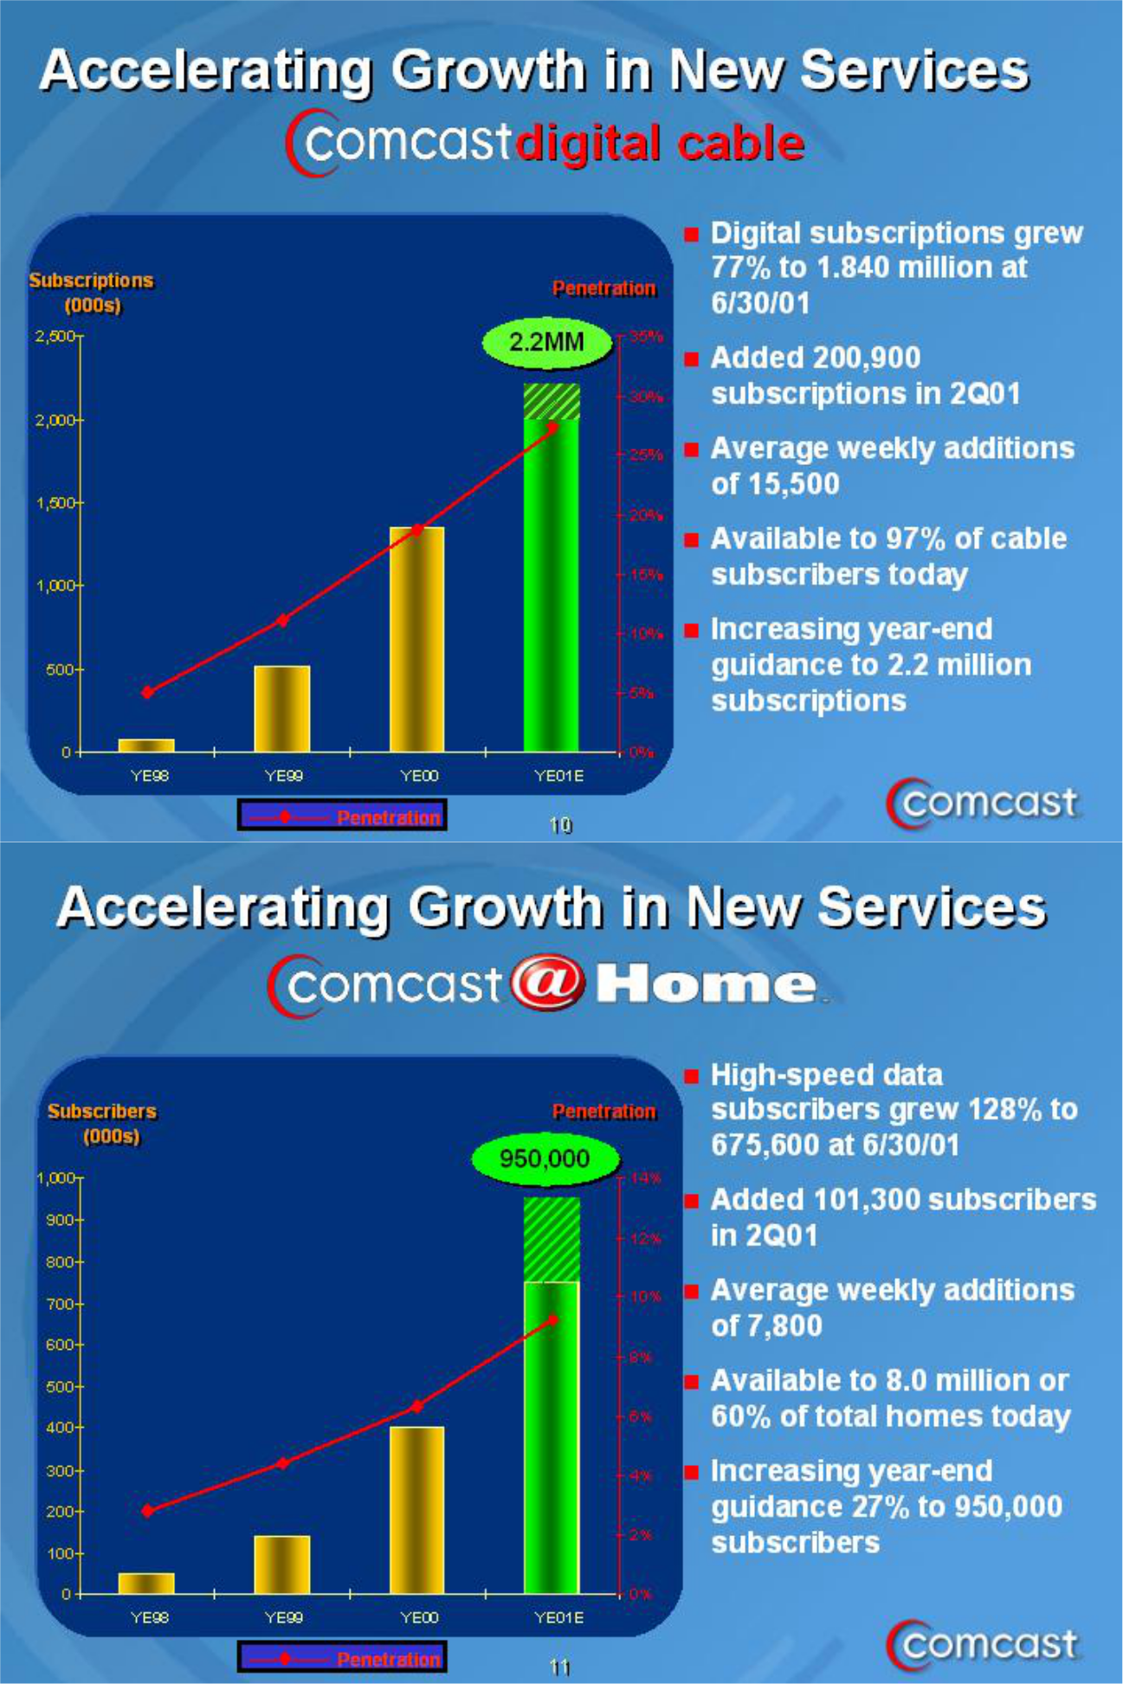

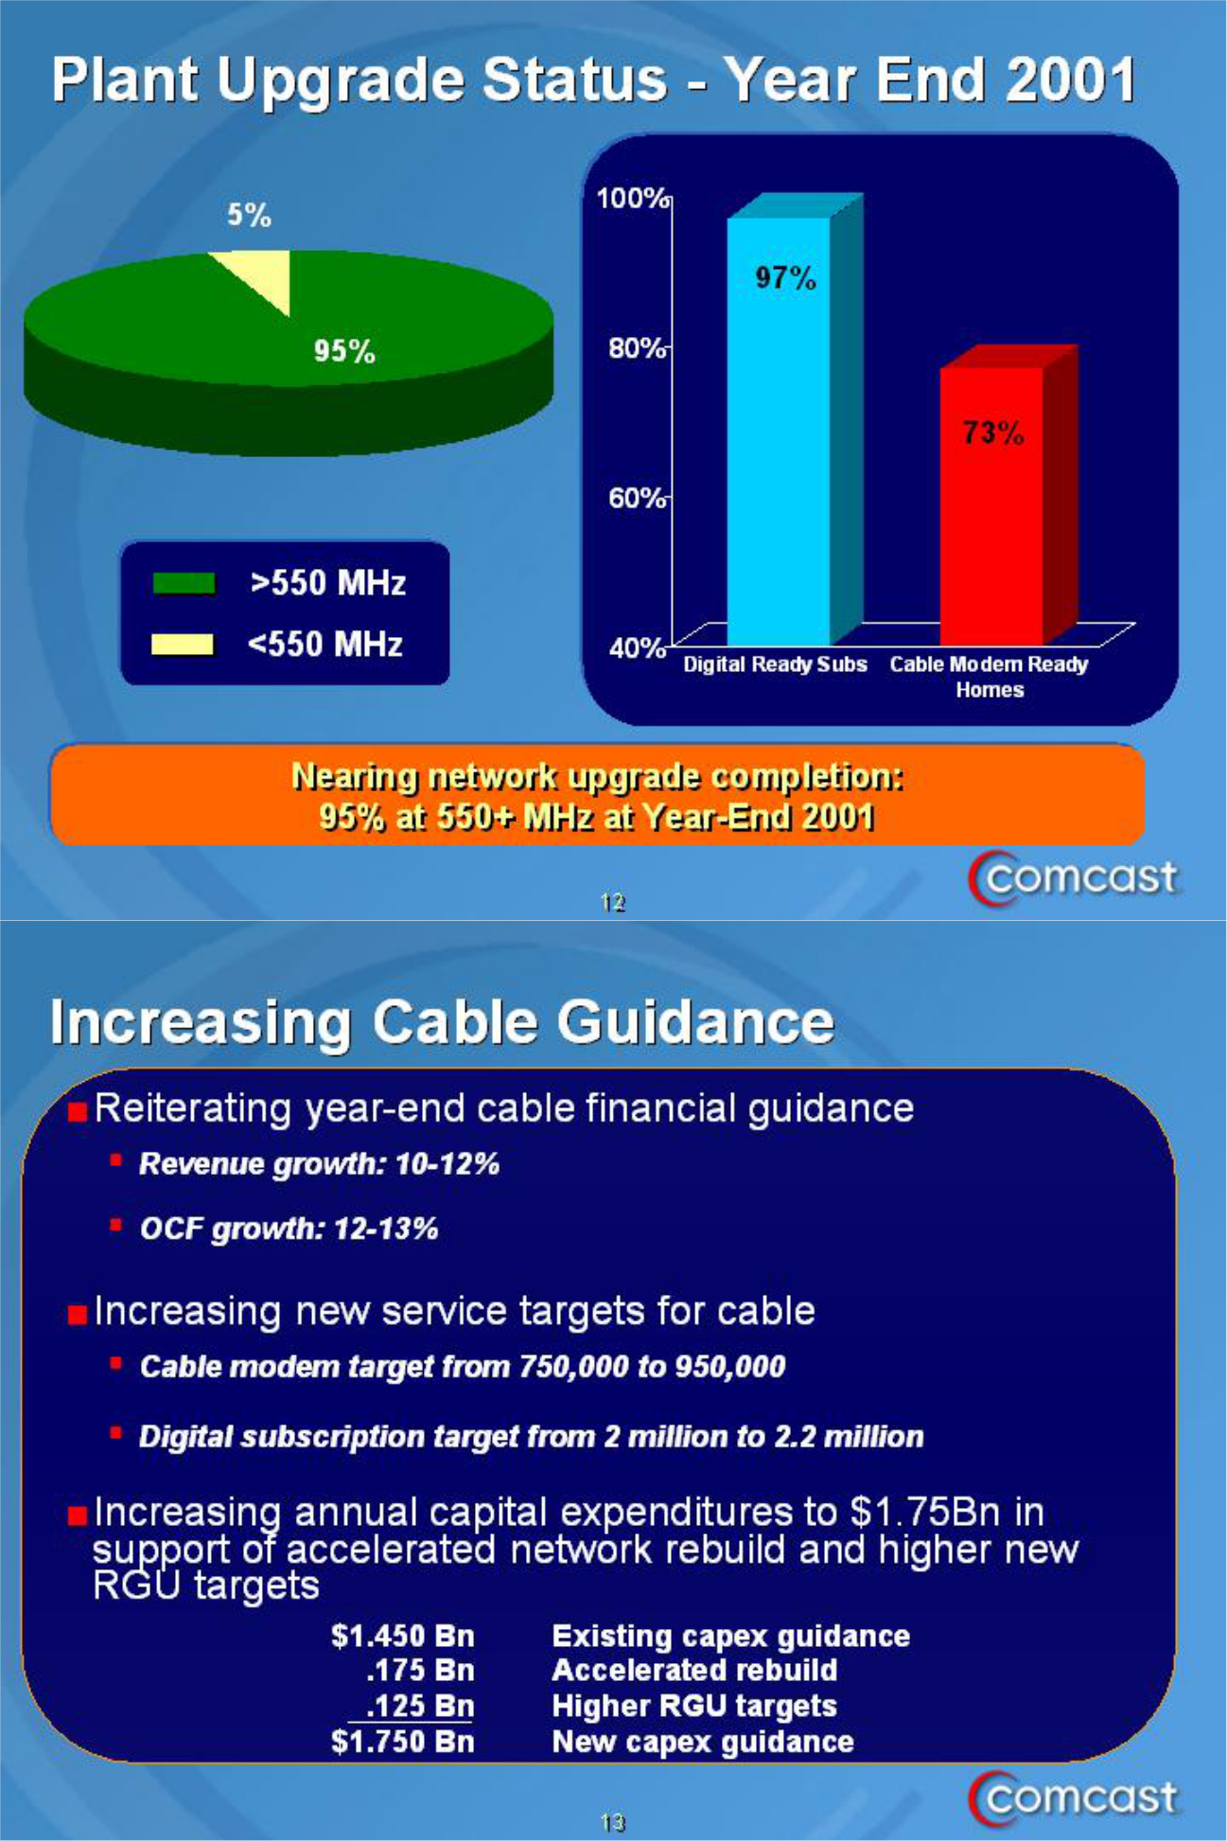

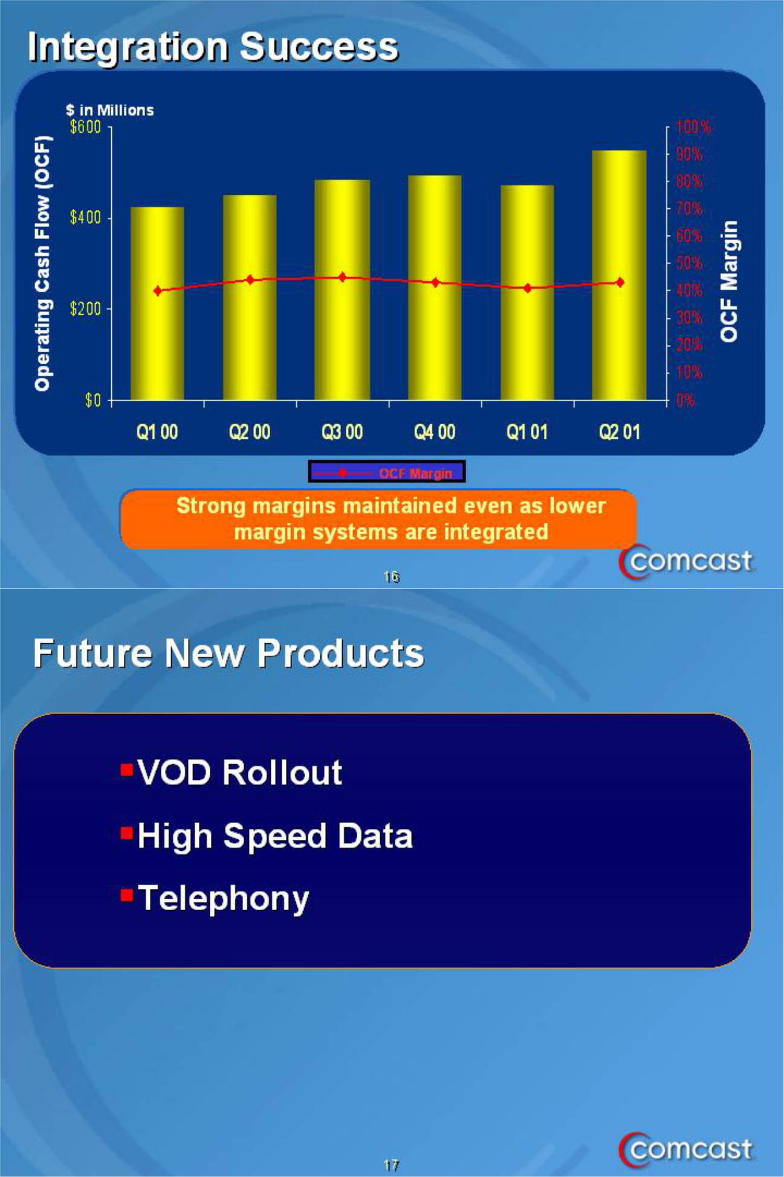

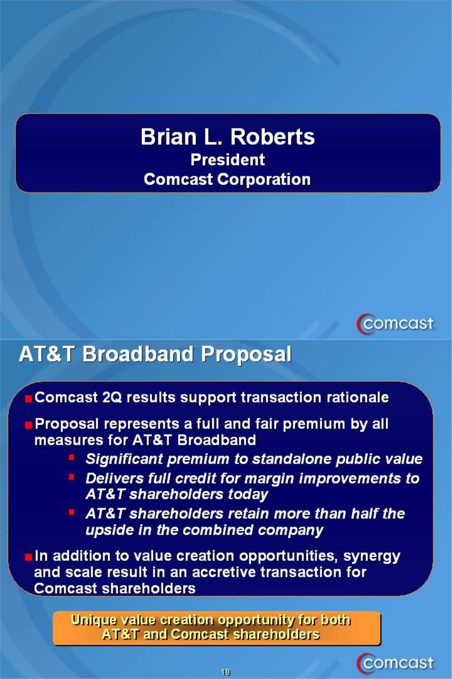

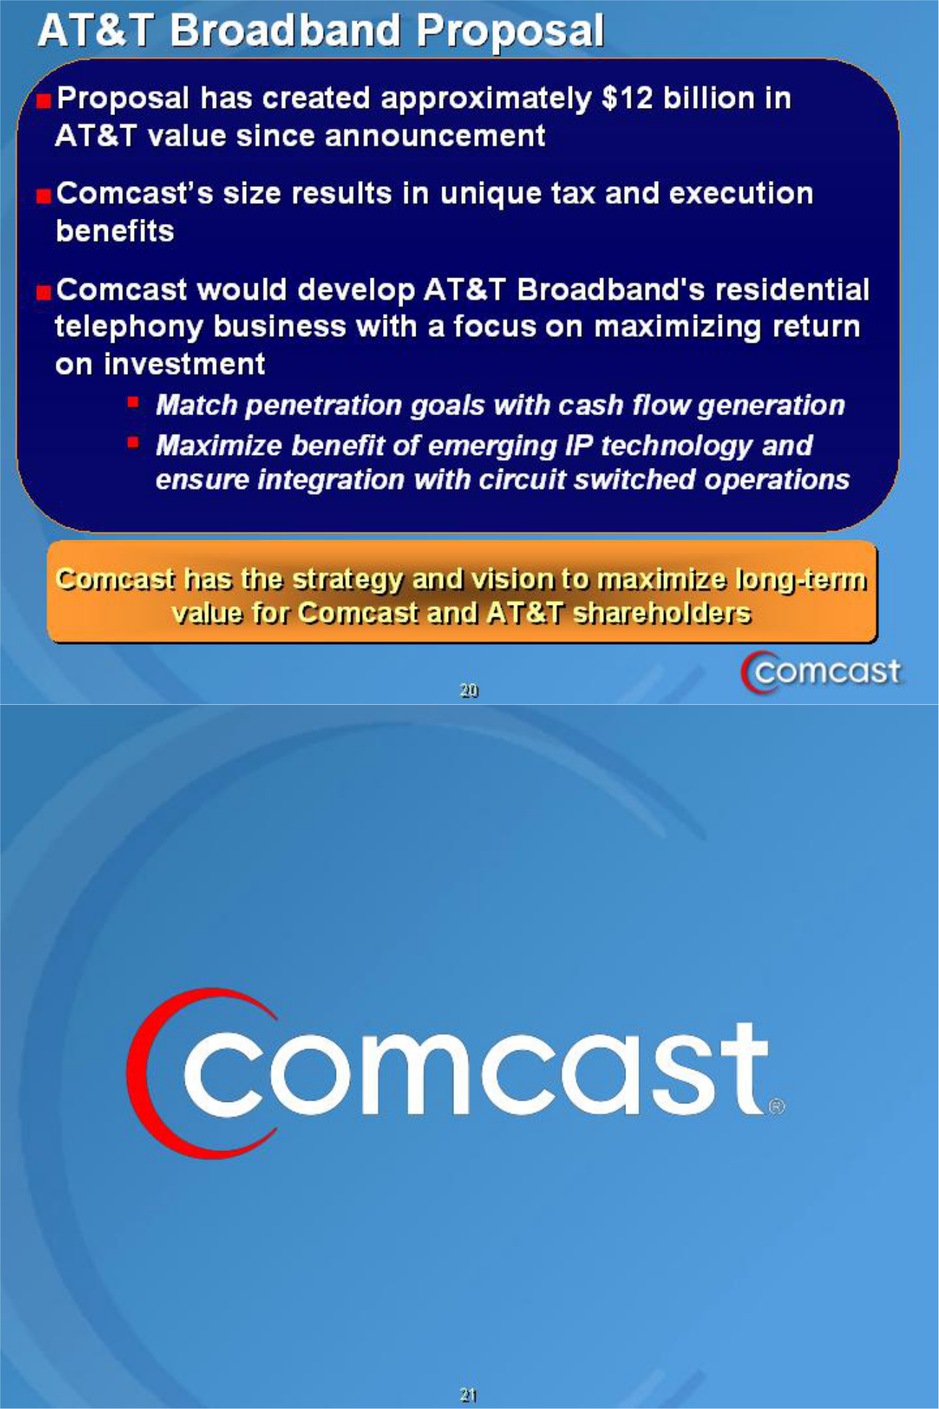

Note: The following notice is included to meet certain legal requirements:

ADDITIONAL INFORMATION

Subject to future developments, Comcast may file with the Commission (i) a preliminary proxy statement for solicitation of proxies from the shareholders of AT&T Corp. (“AT&T”) in connection with AT&T’s broadband tracking stock proposal and (ii) a registration statement to register the Comcast shares to be issued in the proposed transaction. Investors and security holders are urged to read the proxy statement and registration statement (when and if available) and any other relevant documents filed with the Commission, as well as any amendments or supplements to those documents, because they will contain important information.

Investors and security holders may obtain a free copy of the proxy statement and the registration statement (when and if available) and other relevant documents at the Commission’s Internet web site at www.sec.gov. The proxy statement and registration statement (when and if available) and such other documents may also be obtained free of charge from Comcast by directing such request to: Comcast Corporation, 1500 Market Street, Philadelphia, Pennsylvania 19102-2148, Attention: General Counsel.

Comcast, its directors and certain other Comcast employees and advisors may be deemed to be “participants” in Comcast’s solicitation of proxies from AT&T’s shareholders. A detailed list of the names, affiliations and interests of the participants in the solicitation is contained in a filing made by Comcast with the Commission pursuant to Rule 14a-12 on July 9, 2001.

