UNITED STATES

SECURITIES AND EXCHANGE COMMISSION
Washington, D.C. 20549

SCHEDULE 14A

Proxy Statement Pursuant to Section 14(a) of the

Securities Exchange Act of 1934 (Amendment No. )

☑ Filed by the Registrant ☐ Filed by a party other than the Registrant

CHECK THE APPROPRIATE BOX:

- Preliminary Proxy Statement

- Confidential, for Use of the Commission Only (as permitted by Rule 14a-6(e)(2))

- Definitive Proxy Statement
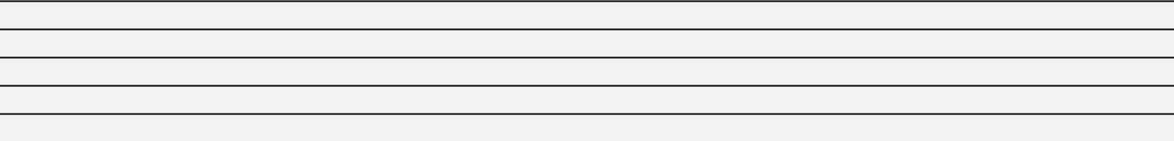

- Definitive Additional Materials

- Soliciting Material under §240.14a-12


Comcast Corporation

(Name of Registrant as Specified In Its Charter)

(Name of Person(s) Filing Proxy Statement, if other than the Registrant)

PAYMENT OF FILING FEE (CHECK ALL BOXES THAT APPLY):

- No fee required

- Fee paid previously with preliminary materials

- Fee computed on table in exhibit required by Item 25(b) per Exchange Act Rules 14a-6(i)(1) and 0-11


Your Vote Counts!

COMCAST CORPORATION

2024 Annual Meeting
Vote by June 9, 2024

11:59 PM ET



ONE COMCAST CENTER
PHILADELPHIA, PA 19103


V38967-P08085

You invested in COMCAST CORPORATION and it’s time to vote!

You have the right to vote on proposals being presented at the Annual Meeting. This is an important notice regarding the availability of proxy materials for the shareholder meeting to be held on June 10, 2024.

Get informed before you vote

View the Notice of Internet Availability of Proxy Materials, the Proxy Statement and the Annual Report online OR you can receive a free paper or email copy of the material(s) by requesting prior to May 24, 2024. If you would like to request a copy of the material(s) for this and/or future shareholder meetings, you may (1) visit www.ProxyVote.com, (2) call 1-800-579-1639 or (3) send an email to sendmaterial@proxyvote.com. If sending an email, please include your control number (indicated below) in the subject line. Unless requested, you will not otherwise receive a paper or email copy.

For complete information and to vote, visit www.ProxyVote.com

Control #

Vote Virtually at the Meeting*
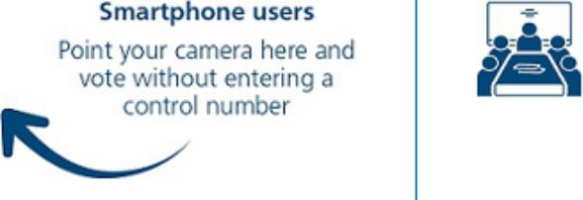

June 10, 2024

9:00 a.m. Eastern Time

Virtually at:

comcast.onlineshareholdermeeting.com

- In lieu of voting before, you may vote at the meeting. Please check the meeting materials for any special requirements for meeting attendance.

Vote at www.ProxyVote.com

THIS IS NOT A VOTABLE BALLOT

This is an overview of the proposals being presented at the upcoming shareholder meeting. Please follow the instructions on the reverse side to vote these important matters.

 |  |  |  |  |  | Board
Voting Items |  |  |  |  |  | Recommends
1. | Election of Directors
 | Nominees:
 | 01 | - Kenneth J. Bacon | 05 | - Edward D. Breen | 09 - David C. Novak | For
 | 02 | - Thomas J. Baltimore, Jr. | 06 | - Jeffrey A. Honickman | 10 - Brian L. Roberts
 | 03 | - Madeline S. Bell | 07 | - Wonya Y. Lucas
 | 04 | - Louise F. Brady | 08 | - Asuka Nakahara
2. | Ratification of the appointment of our independent auditors |  |  |  |  | For
3. | Advisory vote on executive compensation |  |  |  |  | For
4. | Shareholder proposal to report on political expenditures misalignment with company values |  |  |  |  | Against
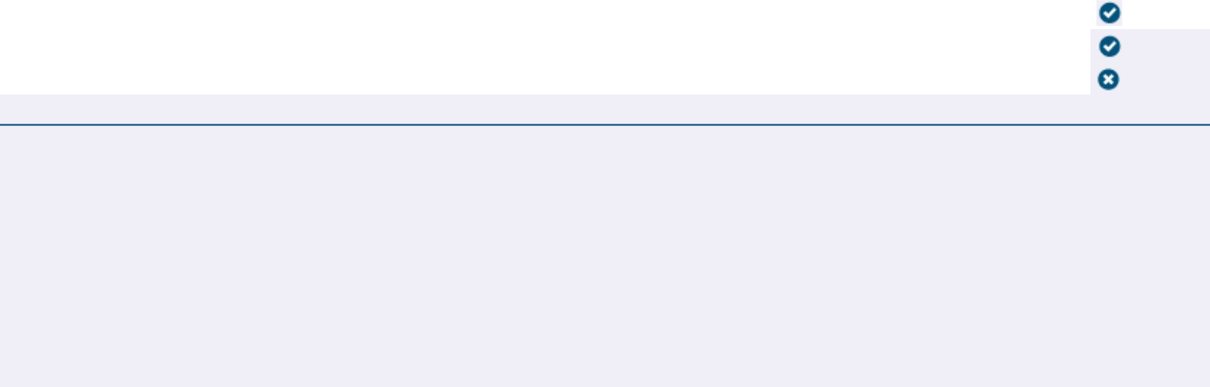
Please refer to page 1 of this notice to view the voting instructions.

Prefer to receive an email instead? While voting on www.ProxyVote.com, be sure to click “Delivery Settings”.

V38968-P08085

