UNITED STATES

SECURITIES AND EXCHANGE COMMISSION
Washington, D.C. 20549

SCHEDULE 14A

Proxy Statement Pursuant to Section 14(a) of the

Securities Exchange Act of 1934 (Amendment No. )

☑ Filed by the Registrant ☐ Filed by a party other than the Registrant

CHECK THE APPROPRIATE BOX:

- Preliminary Proxy Statement

- Confidential, for Use of the Commission Only (as permitted by Rule 14a-6(e)(2))

- Definitive Proxy Statement
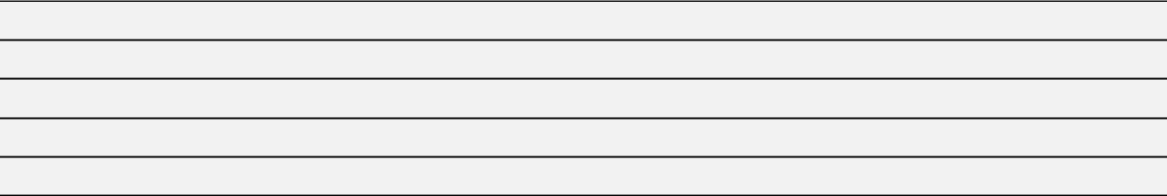

- Definitive Additional Materials

- Soliciting Material under §240.14a-12


Comcast Corporation

(Name of Registrant as Specified In Its Charter)

(Name of Person(s) Filing Proxy Statement, if other than the Registrant)

PAYMENT OF FILING FEE (CHECK ALL BOXES THAT APPLY):

- No fee required
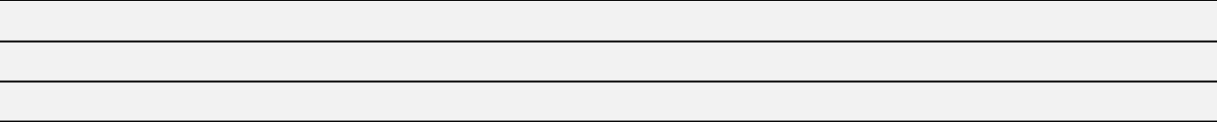

- Fee paid previously with preliminary materials

- Fee computed on table in exhibit required by Item 25(b) per Exchange Act Rules 14a-6(i)(1) and 0-11



