Table of Contents

UNITED STATES
SECURITIES AND EXCHANGE COMMISSION

Washington, D.C. 20549

SCHEDULE 14A

Proxy Statement Pursuant to Section 14(a) of the
Securities Exchange Act of 1934 (Amendment No. )

☑ Filed by the Registrant ☐ Filed by a Party other than the Registrant

CHECK THE APPROPRIATE BOX:

- Preliminary Proxy Statement

- Confidential, For Use of the Commission Only (as permitted by Rule 14a-6(e)(2)) ☑ Definitive Proxy Statement

- Definitive Additional Materials

- Soliciting Material Under Rule 14a-12
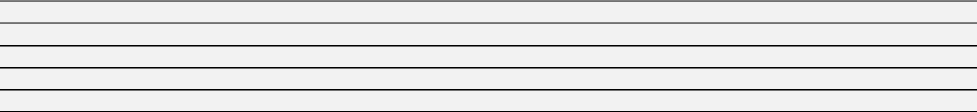


Comcast Corporation

(Name of Registrant as Specified In Its Charter)
(Name of Person(s) Filing Proxy Statement, if Other Than the Registrant)

PAYMENT OF FILING FEE (CHECK THE APPROPRIATE BOX):

- No fee required.
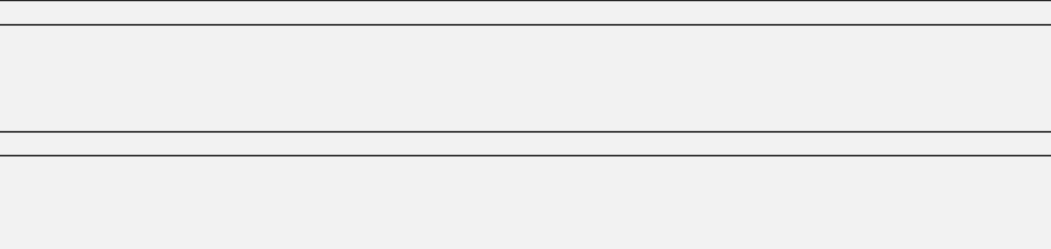

- Fee computed on table below per Exchange Act Rules 14a-6(i)(1) and 0-11.

  - Title of each class of securities to which transaction applies:
  - Aggregate number of securities to which transaction applies:
  - Per unit price or other underlying value of transaction computed pursuant to Exchange Act Rule 0-11 (set forth the amount on which the filing fee is calculated and state how it was determined):
  - Proposed maximum aggregate value of transaction:
  - Total fee paid:

- Fee paid previously with preliminary materials:

- Check box if any part of the fee is offset as provided by Exchange Act Rule 0-11(a)(2) and identify the filing for which the offsetting fee was paid previously. Identify the previous filing by registration statement number, or the form or schedule and the date of its filing.

  - Amount previously paid:
  - Form, Schedule or Registration Statement No.:
  - Filing Party:
  - Date Filed:

Table of Contents

Notice of 2021 Annual Meeting of Shareholders and Proxy Statement

Table of Contents

2020 Company Highlights

Strong Execution on Key Strategic Priorities



Broadband

$15 billion

investment in Comcast Cable’s broadband network since the beginning of 2017 enabled us to stay ahead of demand

2 million

broadband customer net additions in the U.S. in 2020

#1 provider in U.S. / #2 in U.K.

in terms of internet customers

Aggregation

Further deployed X1, Flex & Sky Q

with 47 million devices deployed, provide more of our customers with our best aggregation platforms

90+ new apps

added in 2020 on Xfinity X1, Flex and Sky Q, adding more great content and value

Streaming

Launched Peacock with 33 million sign-ups in the U.S. after 6 months

NBCUniversal strategically entered the streaming market with a differentiated, free, ad-supported service that leveraged technologies and capabilities across our businesses to launch more quickly and effectively

NOW gained new users

Sky’s streaming offering, NOW, added new users streaming the latest TV, movies and live sports through Sky Cinema and Sky Sports

Supporting through COVID-19

Employee Response

$500 million+

in support for our employees where operations were closed or impacted by COVID-19 in 2020

Customer Support

1.5 million

public WiFi hotspots in our network were opened for free

Community Impact

1,000 WiFi-Connected Lift Zones

in community centers across the U.S. for low-income students planned by the end of 2021, with 375+ launched to date

Working Toward Equity

Diverse Board

50% Director Diversity

by gender, race or ethnicity, with 30% gender and 30% racial and ethnic diversity

Building a More Inclusive World

$100 million

incremental commitment to fight injustice and inequality against any race, ethnicity, gender identity, sexual orientation or ability

Addressing Digital Inequities

5 million

low-income students connected to the internet through Internet Essentials, which we believe is the largest and most comprehensive broadband adoption program for Americans, since 2011


NOTE ABOUT FORWARD-LOOKING STATEMENTS AND WEBSITE REFERENCES

This Proxy Statement includes estimates, projections and statements relating to our business plans, objectives and expected operating results and statements regarding environmental, social and governance-related plans and goals that are “forward-looking statements” within the meaning of the Private Securities Litigation Reform Act of 1995, Section 27A of the Securities Act of 1933, and Section 21E of the Securities Exchange Act of 1934. Forward-looking statements may appear throughout this report. These forward-looking statements generally are identified by the words “believe,” “project,” “expect,” “anticipate,” “estimate,” “intend,” “potential,” “strategy,” “future,” “opportunity,” “commit,” “plan,” “may,” “should,” “could,” “will,” “would,” “will be,” “will continue,” “will likely result” and similar expressions. Forward-looking statements are based on current expectations and assumptions that are subject to risks and uncertainties that may cause actual results to differ materially. In evaluating these statements, you should consider various factors, including the risks and uncertainties we describe in the “Risk Factors” sections of our Forms 10-K and 10-Q and other reports we file with the Securities and Exchange Commission (“SEC”). Readers are cautioned not to place undue reliance on forward-looking statements, which speak only as of the date they are made. We undertake no obligation to update or revise publicly any forward-looking statements, whether because of new information, future events or otherwise. Website references throughout this document are provided for convenience only, and the content on the referenced websites is not incorporated by reference into this document.

2

Table of Contents

Message from Our Chairman, President and CEO and Our Lead Independent Director

Dear Shareholders,

The past year and the COVID-19 pandemic brought with it unprecedented societal and business challenges – the most difficult we have faced in our nearly 60-year history. We are immensely proud of Comcast’s performance under the Board of Directors’ stewardship and grateful for a leadership team that adapted and innovated to keep our people, customers and communities safe and supported. Our focus, expertise and passion led to a strong year for our organization and we believe positions us for continued long-term success.

The products and services we provide were more important than ever, as millions relied on our broadband to work and learn from home and turned to our entertainment, news and sports platforms for information and enjoyment. Comcast Cable’s results this year were strong, highlighted by record total customer and broadband additions, and impressive growth in adjusted EBITDA. NBCUniversal responded quickly to the pandemic, accelerating the reorganization of its television businesses, releasing new films direct to consumers by creating a premium video on demand window and reopening the parks safely, while successfully launching the new Peacock streaming service, which surpassed 33 million sign-ups in just over its first six months. Sky also reacted swiftly and effectively, and as a result, revenue and customer relationships at the end of the year returned to pre-COVID levels.

The core values of our organization – entrepreneurial spirit, doing the right thing and acting with integrity, respect for each other and giving back to the community – guided us as we worked diligently to accelerate key initiatives that would help those that were hardest hit by the pandemic. With the full support of our Board, we moved the vast majority of our employees to work from home to keep them and their families safe and provided more than $500 million to support employees where operations were closed. We expanded Internet Essentials, which we believe is America’s largest and most successful broadband adoption program, to reach even more low-income families, and launched WiFi-enabled Lift Zones in hundreds of community centers to help those without a home connection get online.

In response to the urgently needed national dialogue around race and inequity, our company mobilized, building on a long-standing commitment to diversity, equity and inclusion, with an additional $100 million commitment to fight inequality and racism against any race, ethnicity, gender identity, sexual orientation or ability. These efforts, which are outlined in greater detail in the pages that follow, will remain key focus areas of our Board and our business as we continue to work hard to make a difference.

As we look ahead to 2021, we do so with renewed confidence and optimism. We have entered the year with a strong balance sheet and a continued strategic focus on broadband, aggregation and streaming. We will continue to oversee and operate our organization for the long term, with support for our employees, customers and communities, and drive overall value for our company and shareholders.

Thank you for your investment in Comcast and for your commitment. We are excited about the promise of the year ahead and the opportunity to serve you and our company as directors.

Sincerely,


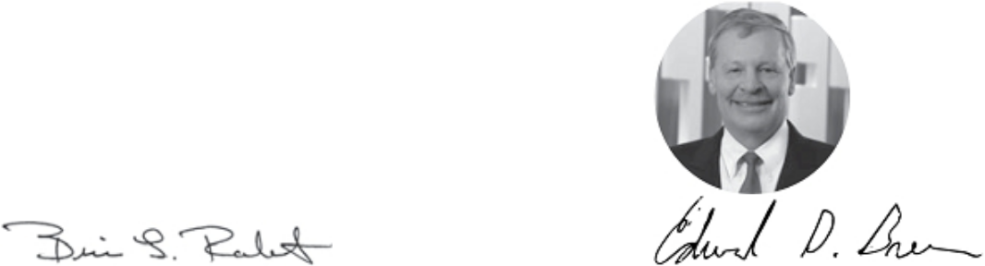

Brian L. Roberts

Chairman, President and Chief Executive Officer

Edward D. Breen

Lead Independent Director

2021 Proxy Statement | 3

Table of Contents

Notice of 2021 Annual Meeting of Shareholders of Comcast Corporation


DATE

June 2, 2021

TIME

Online check-in opens: 8:45 a.m.

Eastern Time Meeting begins: 9:00 a.m.

Eastern Time

PLACE

Meeting live via the internet:

comcast.onlineshareholdermeeting.com

WHO CAN VOTE

Shareholders of record on April 5, 2021

Voting Items | Board Voting
Voting Items | Recommendation
PROPOSAL 1 | FOR each director nominee
Elect directors | FOR each director nominee
PROPOSAL 2
Advisory vote to approve | FOR
executive compensation | FOR
PROPOSAL 3
Ratify appointment of | FOR
independent auditors | FOR
PROPOSAL 4
Vote on one shareholder | AGAINST
proposal | AGAINST

Only shareholders of record on April 5, 2021 may vote and participate during the meeting. If the meeting is adjourned because a quorum is not present, then shareholders who attend the reconvened meeting will constitute a quorum for the purpose of acting upon the matters presented at that meeting pursuant to the rules described in “Voting Securities and Principal Holders — Outstanding Shares and Voting Rights” in the attached proxy statement.

The Notice of Internet Availability of Proxy Materials is being mailed, and the attached proxy statement is being made available, to our shareholders beginning on or about April 23, 2021.

Your vote is important. Please vote your shares promptly. To vote your shares, you can:



Use the internet, as described in the Notice of Internet Availability of Proxy Materials and on your proxy card.

April 23, 2021

THOMAS J. REID

Secretary

Call the toll-free telephone number set forth in the attached proxy statement and on your proxy card.

Complete, sign and date your proxy card and return your proxy card by mail.

Important Notice Regarding the Availability of Proxy Materials for the Annual Meeting of Shareholders to Be Held on June 2, 2021: Our proxy statement and our Annual Report on Form 10-K for the fiscal year ended December 31, 2020 are available at www.proxyvote.com.

4

Table of Contents

Table of Contents

Message from Our Chairman, President and CEO and Our
Lead Independent Director | 3
Notice of 2021 Annual Meeting of Shareholders of Comcast
Corporation | 4
About Comcast | 6
Our COVID-19 Response | 9
Diversity, Equity and Inclusion at Comcast | 10
Corporate Governance and Board Matters | 12
PROPOSAL 1: Election of Directors
Board of Directors | 12
Board Structure and Responsibilities | 20
Corporate Governance Practices, Policies and Processes | 24
Executive Compensation | 27
PROPOSAL 2: Advisory Vote to Approve Executive
Compensation
Letter from the Compensation Committee | 28
Compensation Discussion and Analysis | 29
Compensation Committee Report | 46
Executive Compensation Tables | 47
Audit Committee Matters | 56
PROPOSAL 3: Ratification of Appointment of Independent
Auditors
Report of the Audit Committee | 57

Shareholder Proposal | 59
Proposal 4: Shareholder Proposal to Conduct
Independent Investigation and Report on Risks Posed
by Failing to Prevent Sexual Harassment
Information about Stock Ownership | 62
Compensation of Directors | 64
Related Party Transactions Policy and Certain Transactions | 66
Other Information | 67
Appendix A: Reconciliations of Non-GAAP Financial
Measures | A-1

2021 Proxy Statement | 5

Table of Contents

About Comcast

Our Company

Comcast Corporation (“Comcast,” the “Company,” “we,” “our” or “us”) is a global media and technology company that connects people to moments that matter. We are principally focused on broadband, aggregation and streaming with over 56 million customer relationships across the United States and Europe. We deliver broadband, video and wireless services through our Xfinity, Comcast Business and Sky brands; create, distribute and stream leading entertainment, sports and news through Universal Filmed Entertainment Group, Universal Studio Group, Sky Studios, the NBC and Telemundo broadcast networks, Peacock, NBC News, NBC Sports, Sky News and Sky Sports; and provide memorable experiences at Universal Parks and Resorts in the United States and Asia.

Our Core Values

ENTREPRENEURIAL | DOING THE RIGHT | RESPECT FOR EACH | GIVING BACK TO THE
SPIRIT | THING & ACTING WITH | OTHER | COMMUNITY
 | INTEGRITY
Our Strategy

We have three strategic priorities:


1

Provide our customers with a fast and differentiated broadband experience

2

Offer our customers the entertainment they want by aggregating our own content along with the best from others, and provide them with multiple ways to access this content

3

Use the reach of our platforms to offer the best in streaming video content

We aim to be a leader in each of the markets in which we compete and create value through the complementary and reinforcing aspects of our businesses. This includes providing the best consumer proposition in broadband, aggregation and streaming by utilizing our direct-to-customer relationships, premium content and other assets from across our company. In doing this, our core competencies in innovation and operational excellence, along with a strong culture of entrepreneurship and collaboration, enable us to deliver more value to our customers. The complementary nature and resiliency of our business have enabled us to attract and develop top talent, make significant positive impacts within the communities we serve and around the world and generate superior long-term total shareholder returns.

2020 Performance Overview

We operate and seek to succeed in intensely competitive, rapidly changing and, in most instances, highly regulated industries. Our uniquely positioned company enabled us to execute against our strategy in 2020. We delivered solid results in a year wrought with previously unimaginable challenges. Our fast decision-making and strong execution enabled us to respond, innovate and manage throughout the global pandemic in ways that benefited our employees, customers, communities, suppliers and investors now and for the long term. Our operational and financial results, and the resiliency of our business, were driven by our strategic focus on broadband, aggregation and streaming, which we believe delivers better experiences for our customers and value for our shareholders and puts us on a trajectory to emerge from this challenging environment in an even stronger position.

6

Table of Contents

During 2020, some of our businesses were forced to reinvent their day-to-day experiences, and in some instances temporarily ceased operations and productions, while others had record growth. For example, Comcast Cable continued its strong financial and operating performance in 2020, and the significant investments we have made in our technology and network over the years to stay ahead of demand and to maintain speed and reliability enabled us to successfully manage the largest sustained traffic surge in history during the peak of COVID-19. This achievement, combined with further enhancing our broadband offering by making Flex and Peacock available for free to customers, helped lead to 2 million net new broadband customers and 1.6 million total net new customer relationships this year – our best results on record.

The impact of the global pandemic placed significant pressure on NBCUniversal and Sky given the nature of these businesses, yet our leadership teams responded quickly and effectively. NBCUniversal, leveraging Sky’s technology infrastructure and Comcast Cable’s customer base, launched Peacock, our new streaming service. Even without the benefit of the Olympics, Peacock quickly surpassed our internal expectations, signing up 33 million customers in the United States in just over its first six months. NBCUniversal also reorganized its television and streaming businesses to optimize its content creation, distribution and monetization model and introduced a new “premium video on demand” strategy, making our films available in the home and enabling our Filmed Entertainment business to profitably release new titles despite theater closures due to COVID-19. Comcast Cable and Sky played a leadership role in distributing these films. Our theme parks business found creative solutions to open safely in Orlando, Florida and Osaka, Japan. Meanwhile, Sky successfully increased its penetration of customers in Europe with Sky Q, launched Sky broadband in Italy, leveraging Comcast Cable’s xFi platform, and maintained strong customer loyalty throughout the pandemic. At the end of 2020, Sky returned to 99% of pre-COVID customer levels.

Financial Performance

The COVID-19 pandemic negatively impacted our financial results in 2020 as many of our operations were closed, paused or restricted during the year. Despite this, our overall financial results were solid and our performance against our strategic initiatives was strong as outlined above. While we expect 2021 will be a challenging year given the continued impacts of the COVID-19 pandemic, we are encouraged by the performance of our businesses as we exited 2020.

REVENUE | NET INCOME ATTRIBUTABLE | ADJUSTED EBITDA⁽¹⁾
($ in billions) | TO COMCAST | ($ in billions)
 | ($ in billions)
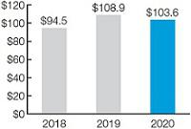
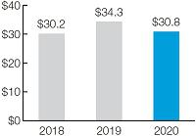

NET CASH PROVIDED | FREE CASH FLOW⁽¹⁾
BY OPERATING ACTIVITIES | ($ in billions)
($ in billions)
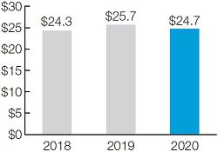
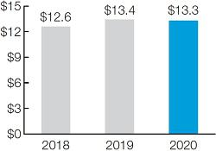

- Reconciliations of consolidated Adjusted EBITDA to net income attributable to Comcast Corporation and consolidated Free Cash Flow to net cash provided by operating activities are set forth in Appendix A.

2021 Proxy Statement | 7

Table of Contents

2020 key reported results across our three primary businesses included:

- Comcast Cable (whose results are reported in our Cable Communications segment) Adjusted EBITDA increased 8.6% to $25.3 billion.

- NBCUniversal Adjusted EBITDA decreased 28.5% to $6.3 billion.

- Sky Adjusted EBITDA decreased 37.0% to $2.0 billion. Excluding the impact of currency, Sky Adjusted EBITDA decreased 37.6% (see Appendix A for a reconciliation).

In addition, we made four cash dividend payments totaling $4.1 billion in 2020 and announced an increase to the planned annual dividend by $0.08 per share, or 9%, to $1.00 per share on an annualized basis for 2021 – the 13th increase in 13 years.

Stock Performance

Our stock performance over the short and long term is reflected below, with our performance over the long term outperforming the S&P 500.

TOTAL SHAREHOLDER RETURNS: CMCSA VS. S&P 500
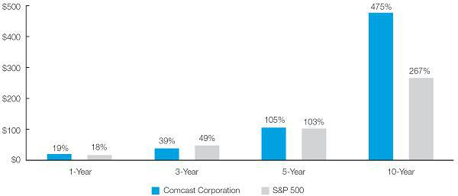

8

Table of Contents

Our COVID-19 Response

COVID-19 had a tremendous impact on nearly every aspect of our daily lives in 2020. Across Comcast Cable, NBCUniversal and Sky, we worked hard to support our customers, employees and communities.


Making Employee Safety Our First Priority

At the onset of the pandemic, we moved the vast majority of our employees to work from home, while enhancing safety measures for our frontline, news and production teams. We also committed more than $500 million to support employees where operations were paused or impacted.

Keeping Customers Connected as Millions Work and Learn from Home

With millions relying on our broadband services to work and attend school from home, our teams worked overtime to keep customers connected. The Comcast network ran superbly, despite an unprecedented surge in internet use of over 50% in some markets. Our engineers have continued to run 700,000+ diagnostic speed tests most days for network reliability.

Expanding the Reach and Impact of Internet Essentials

We sought to keep those communities hardest hit by the pandemic connected. Building on our long-standing commitment to digital equity, we expanded Internet Essentials, which we believe is America’s largest and most comprehensive broadband adoption program, which has connected more than five million low-income students since 2011. Through partnerships with cities, public school districts, philanthropies and other organizations, we provided students with access to the tools they needed to participate in virtual learning. We also increased speeds for Internet Essentials customers, with current speeds at 50/5 Mbps.

Launching WiFi-Connected Lift Zones Nationwide

Working with non-profit partners and city leaders, we provided high-capacity WiFi in hundreds of community centers around the country to help students get online, participate in distance learning and do their schoolwork. We plan to open 1,000 Lift Zones by the end of 2021 and are on track to meet that goal by having already opened over 375.

Supporting Small Businesses through Comcast RISE

Comcast RISE, a multi-year, multi-faceted initiative, was designed to help thousands of Black, Indigenous and people of color (“BIPOC”)-owned small businesses impacted by COVID-19 by providing marketing and technology services and equipment. In 2020, 700+ small businesses received support through this program in more than 280 cities in almost 30 states, and so far in 2021 we have supported hundreds more with $5 million of grant funding.

Keeping Audiences Informed through a Pivotal Year

Our NBCU News Group and Sky News teams worked hard to keep the world informed and bring news and information to even more people by expanding free access to traditionally subscription-only content, curating special COVID-19 information destinations and hosting countless special reports on the pandemic.

2021 Proxy Statement | 9

Table of Contents

Diversity, Equity and Inclusion at Comcast

We believe that a diverse, equitable and inclusive company seeds innovation and success, and we embrace diversity of background, perspective, culture and experience throughout our business. Our commitment to Diversity, Equity and Inclusion (“DE&I”) is longstanding, and our efforts and progress in this regard are reviewed and discussed by our Board and/or its committees, our external Joint Diversity Advisory Council and management, including the Company’s Chief Diversity Officer.

Board of Directors and Workforce (U.S. full-time employees as of YE 2020)
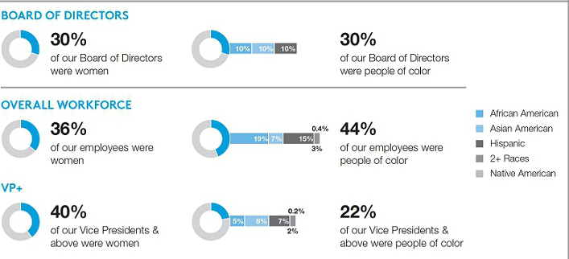

- Diverse Pipeline: We seek to hire, promote and develop people with diverse backgrounds and experiences. In 2020 alone, we:

  - launched NBCU Academy, an innovative, multiplatform journalism training and development program offering training and education to students at historically Black colleges and universities, Hispanic-serving institutions and colleges with significant Latino, Asian, Black, Indigenous and tribal populations;

  - created Female Forward, designed to give female directors an entry into scripted television; and

  - offered the Alternative Directors Program, which gives female and ethnically diverse directors the opportunity to learn new directing styles.

- Employee Education: Designed to educate and inspire, our DE&I Speaker Series is a monthly employee-facing engagement featuring scholars, thought leaders, bestselling authors and expert speakers discussing a variety of DE&I topics, from racism to allyship.

DE&I Strategic Initiatives

As a media and technology company, we have a unique opportunity to use our collective platforms, programs and talent to help create a more equitable industry and society. We have identified key areas aligned with our businesses – digital equity, small businesses and media, education and awareness – where we aspire to be a leader in effecting sustainable change.

- Addressing Digital Inequities: Over the last decade, we have connected a cumulative total of more than 10 million low-income Americans to the internet through our Internet Essentials program. We have partnerships with equity-focused organizations like Black Girls Code, Reboot Representation and Per Scholas designed to bring educational resources and digital skills training to underrepresented communities to unlock new opportunities and economic mobility.

- $100 Million Social Justice Initiative: In 2020, we announced a comprehensive, multiyear plan to allocate an incremental $100 million to accelerate our work to fight injustice and inequality, which included our commitments to launch 1,000+ new Lift Zones and to support thousands of BIPOC-owned small businesses impacted by COVID-19 through Comcast RISE, in each case as described above.

10

Table of Contents

- Media, Education & Awareness: We seek to empower diverse content creators and use our storytelling platforms to deliver programming representative of the audiences we serve. In 2020, NBCUniversal secured content deals with diverse creators and developed a new series of ‘The More You Know’ public service announcements launched during ‘TODAY’ to address systemic racism, speak up for social justice, equality and equity, and focus on important issues. We have also created a broad ecosystem of diverse content, including curated On Demand special collections like Black Voices Black Stories, Echando Palante Juntos, Celebrate Diwali, Asian American and Pacific Islander Heritage Month and Native American Heritage Month.

2.6 million+ | 100+ | 70,000+
visits to curated On Demand cultural | diverse networks on | employees participated in
content special collections in 2020 | Xfinity platforms | first-ever DE&I Day
Additional information on our company and values is available on our website, www.comcastcorporation.com,
 | including through our annual Values Report.
 |  | 2021 Proxy Statement 11

Table of Contents

Corporate Governance and Board Matters

Proposal 1: ELECTION OF DIRECTORS

Our Board unanimously recommends that shareholders vote “FOR” the election of each of the nominees for director.

Board of Directors

Board Snapshot
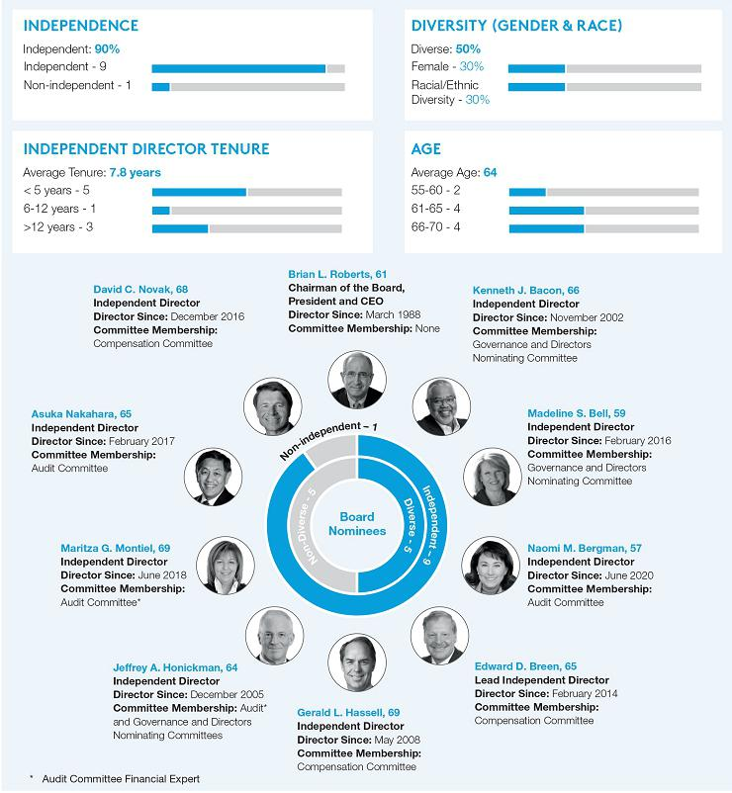

12

Table of Contents

Director Skills and Experience

As baseline director qualifications, our Board seeks, and each of our directors possesses, key attributes that we deem critical in being a director, including strong and effective decision-making, communication and leadership skills; high ethical standards, integrity and values; and a commitment to representing the long-term interests of our shareholders. Our Board then strives to balance the need to have directors with a diversity of skills, backgrounds, experiences, perspectives and viewpoints, areas of expertise and knowledge, while maintaining gender and racial and ethnic representation.

Our Board and each of its committees perform an annual self-assessment which, among other things, evaluates the overall composition of our Board, including the diversity of skills and backgrounds of our directors. Our Governance and Directors Nominating Committee focuses on certain specific director qualifications and skills, including those highlighted below, to select directors that bring to the Board a diversity of experience, qualifications, skills, viewpoints and perspectives to oversee and address the current issues facing our company. Our Governance and Directors Nominating Committee considers these qualifications, including with respect to gender and racial and ethnic diversity, as it seeks to identify and evaluate potential new directors.
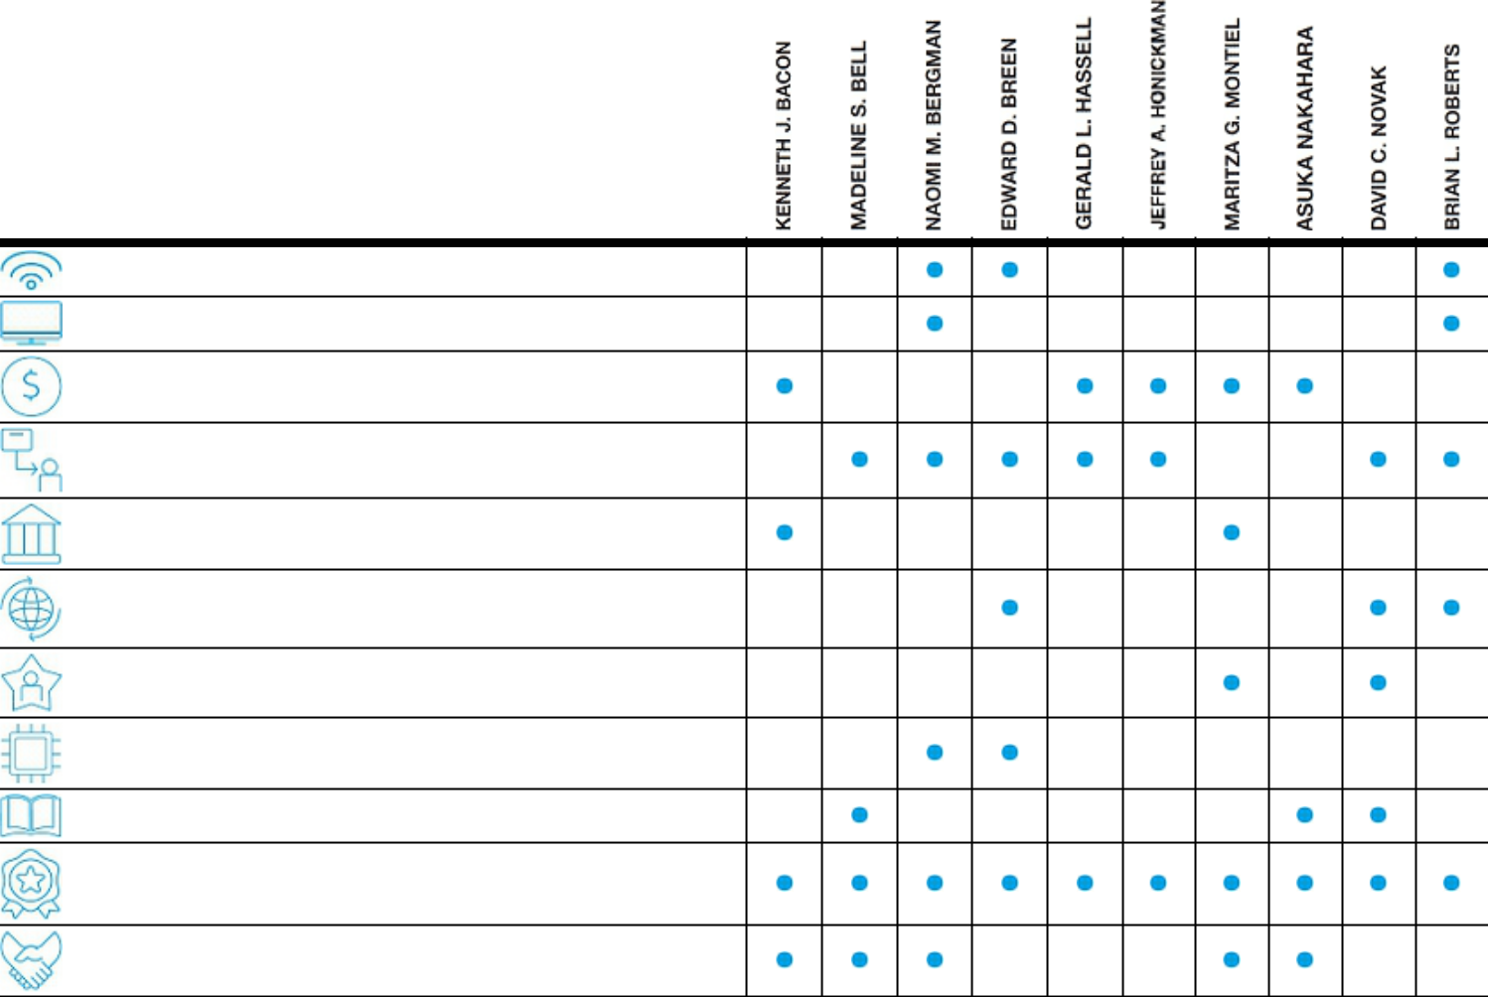

Internet/Video/Wireless Industry

Media Industry

Financial/Accounting

Consumer Products/Customer-Oriented

Government Affairs

International

Talent Management

Technology

Non-Profit/Educational/Philanthropic

Current/Former CEO/President/

Executive Officer

Diversity (Gender/Race/Ethnicity)

2021 Proxy Statement | 13

Table of Contents

Director Nominee Biographies
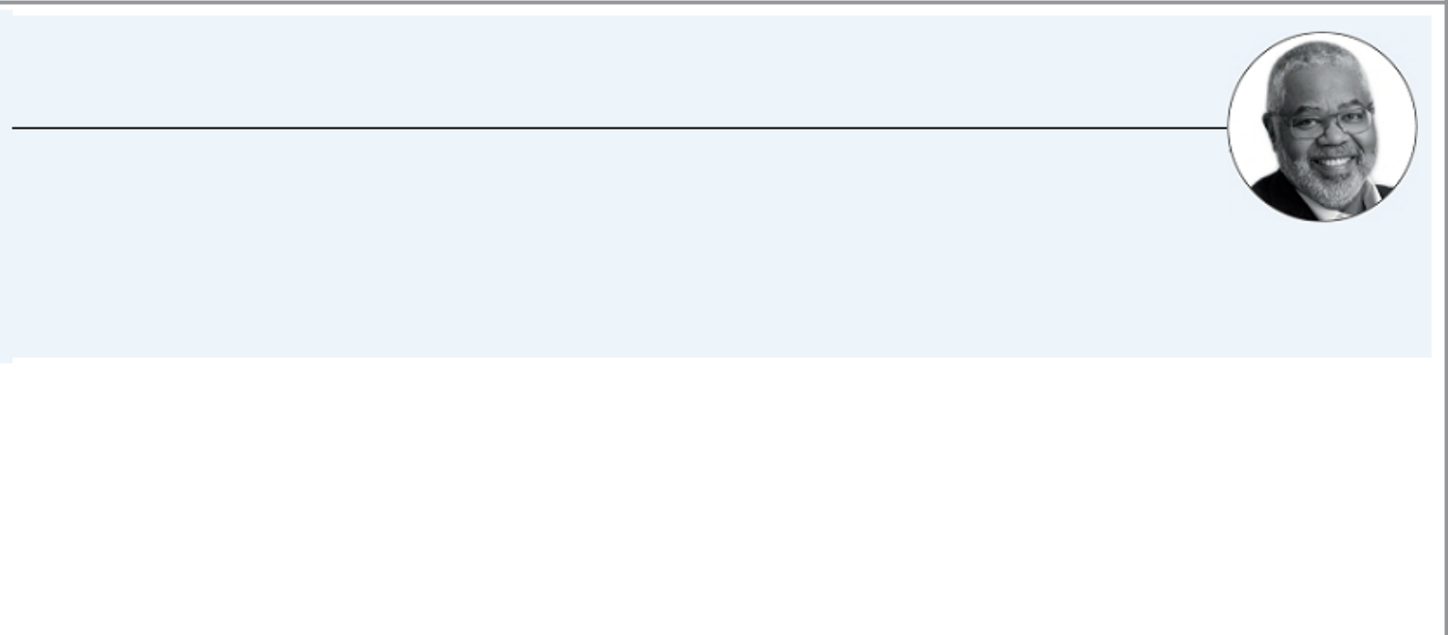

Kenneth J. Bacon

INDEPENDENT

Partner at RailField Partners

Age: 66

Director since: November 2002

Committees: Governance and Directors Nominating

OTHER CURRENT PUBLIC COMPANY DIRECTORSHIPS:

Ally Financial Inc., Welltower Inc., Arbor Realty Trust, Inc.

FORMER PUBLIC COMPANY DIRECTORSHIPS:

Forest City Realty Trust

CAREER HIGHLIGHTS:
- Partner, RailField Partners, a financial advisory and asset management firm, 2012 – Present

- Executive Vice President of the multifamily mortgage business, Fannie Mae, 2005 – 2012

- Interim Executive Vice President, Housing and Community Development, January 2005 – July 2005

- Member, National Multifamily Housing Council

QUALIFICATIONS:
We believe that Mr. Bacon’s significant experience in government affairs and the financial and housing industries renders him qualified to serve as one of our directors.
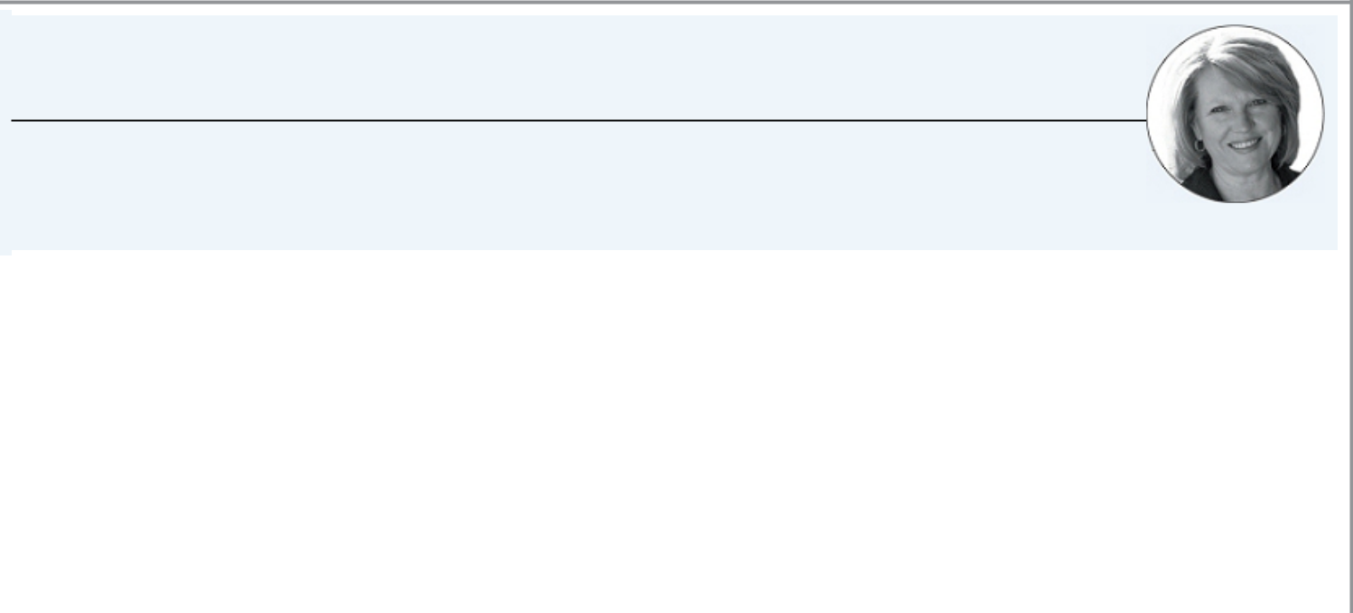

Madeline S. Bell

INDEPENDENT

President and Chief Executive Officer of The Children’s Hospital of Philadelphia

Age: 59

Director since: February 2016

Committees: Governance and Directors Nominating

CAREER HIGHLIGHTS:
- President and Chief Executive Officer, The Children’s Hospital of Philadelphia (“CHOP”), a top-ranked children’s health system and research institute with 20,000 employees and over $3.2 billion of annual revenue, 2015 – Present

- Multiple Leadership Roles, including Chief Operating Officer, CHOP, 1995 – 2015

- Began career as a pediatric nurse in 1983, moved from a variety of different nursing roles into hospital administration in 1989 and holds a Master of Science in Organizational Dynamics from the University of Pennsylvania

- Board Member, Federal Reserve Bank of Philadelphia

- Board Member, Leonard Davis Institute of Health Economics and Solutions for Patient Safety

- Executive Committee Member, Greater Philadelphia Chamber of Commerce and CEO Council for Growth

QUALIFICATIONS:
We believe that Ms. Bell’s experience and leadership of CHOP and her experience in the non-profit community render her qualified to serve as one of our directors.

14

Table of Contents


Naomi M. Bergman

INDEPENDENT

Senior Executive of Advance

Age: 57

Director since: June 2020

Committees: Audit

OTHER CURRENT PUBLIC COMPANY DIRECTORSHIPS:

Visteon Corporation

FORMER PUBLIC COMPANY DIRECTORSHIPS:

Cable One, Inc.

CAREER HIGHLIGHTS:
- Senior Executive, Advance, a private business that invests in a broad range of media, entertainment, technology, communications and education companies, 2016 – Present

- President, Bright House Networks, a cable company, 2010 – 2016

- Multiple leadership roles, Bright House Networks and Time Warner Cable

- Member of Technological Advisory Committee, Federal Communications Commission

- Board Member, The Cable Center and Adaptive Spirit

QUALIFICATIONS:
Ms. Bergman’s role in Advance is to provide strategic guidance to Advance’s operating companies and investments, with a focus on corporate development. We believe that Ms. Bergman’s extensive experience and leadership in the cable industry and in providing strategic guidance to Advance companies render her qualified to serve as one of our directors.
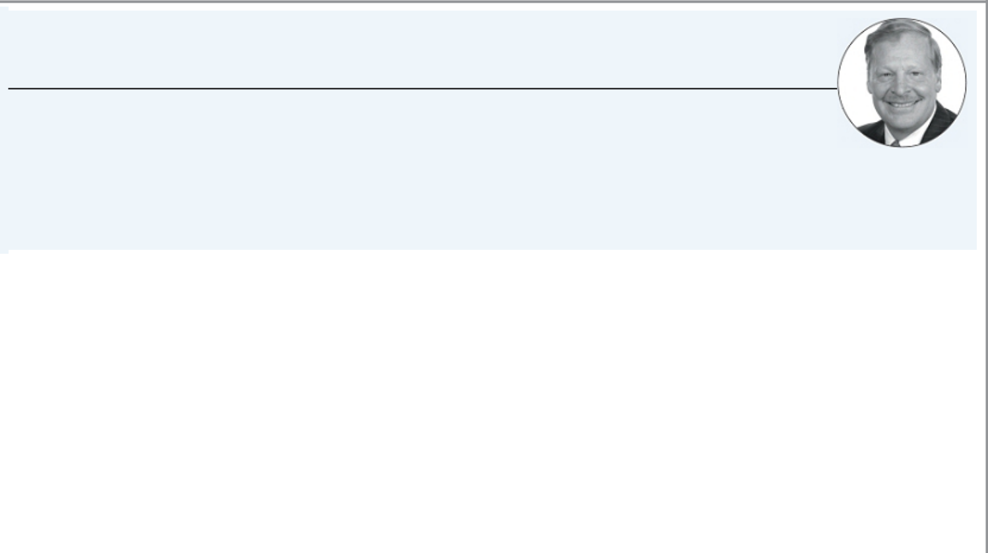

Edward D. Breen

LEAD INDEPENDENT DIRECTOR

Chief Executive Officer and Executive Chairman of DuPont de Nemours, Inc.

Age: 65

Director since: February 2014

Committees: Compensation

OTHER CURRENT PUBLIC COMPANY DIRECTORSHIPS:

DuPont de Nemours, Inc., International Flavors & Fragrances, Inc.

FORMER PUBLIC COMPANY DIRECTORSHIPS:

Corteva, Inc., DowDuPont Inc., Tyco International Ltd.

CAREER HIGHLIGHTS:
- Chief Executive Officer (since 2020) and Executive Chairman (since 2019), DuPont de Nemours, Inc., a provider of technology-based materials, ingredients and solutions

- Chief Executive Officer and Chairman, DowDuPont and predecessors, 2015 – 2019

- Chief Executive Officer, Tyco International Ltd., 2002 – 2012; Chairman until 2016

- Previous President and Chief Operating Officer, Motorola, and multiple leadership roles, Motorola’s Networks Sector and Motorola’s Broadband Communications Sector

- Chairman, President and CEO, General Instrument Corporation, 1997 – 2000

- Previously a director of Comcast from 2005 – 2011

- Member of the Advisory Board, New Mountain Capital

QUALIFICATIONS:
We believe that Mr. Breen’s extensive experience in the technology, equipment supplier and consumer product sectors, notably as those sectors relate to the internet, video and wireless industries, including his various experiences as a president and chief executive officer, renders him qualified to serve as one of our directors.

2021 Proxy Statement | 15

Table of Contents
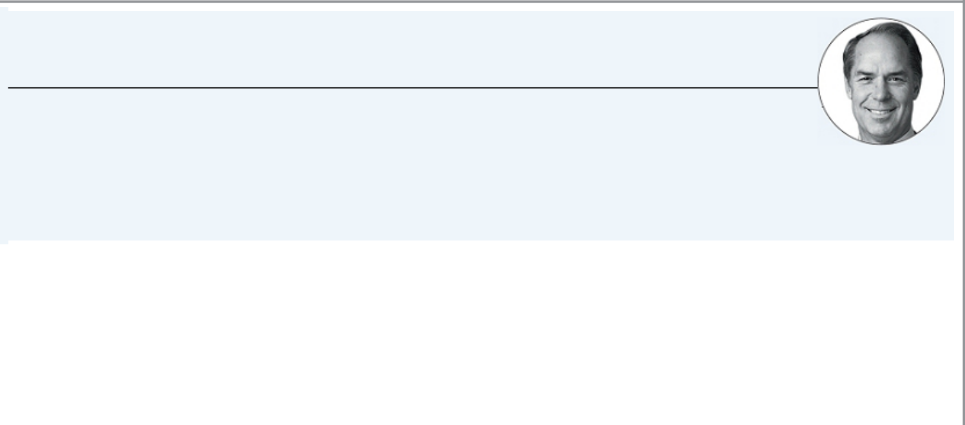

Gerald L. Hassell

INDEPENDENT

Former Chief Executive Officer of The Bank of New York Mellon

Age: 69

Director since: May 2008

Committees: Compensation

OTHER CURRENT PUBLIC COMPANY DIRECTORSHIPS:

MetLife, Inc.

FORMER PUBLIC COMPANY DIRECTORSHIPS:

The Bank of New York Mellon

CAREER HIGHLIGHTS:
- Chief Executive Officer and Chairman, The Bank of New York Mellon, a financial services corporation, 2011 – 2017

- President, The Bank of New York Company, Inc. and The Bank of New York, 2007 – 2011

- Member of the Board of Trustees, Duke University

- Member of the Board of Directors, Duke University Health System

QUALIFICATIONS:
We believe that Mr. Hassell’s significant experience and leadership in the financial industry, including with respect to consumer financial products, as well as his prior experience as a president and chief executive officer, render him qualified to serve as one of our directors.
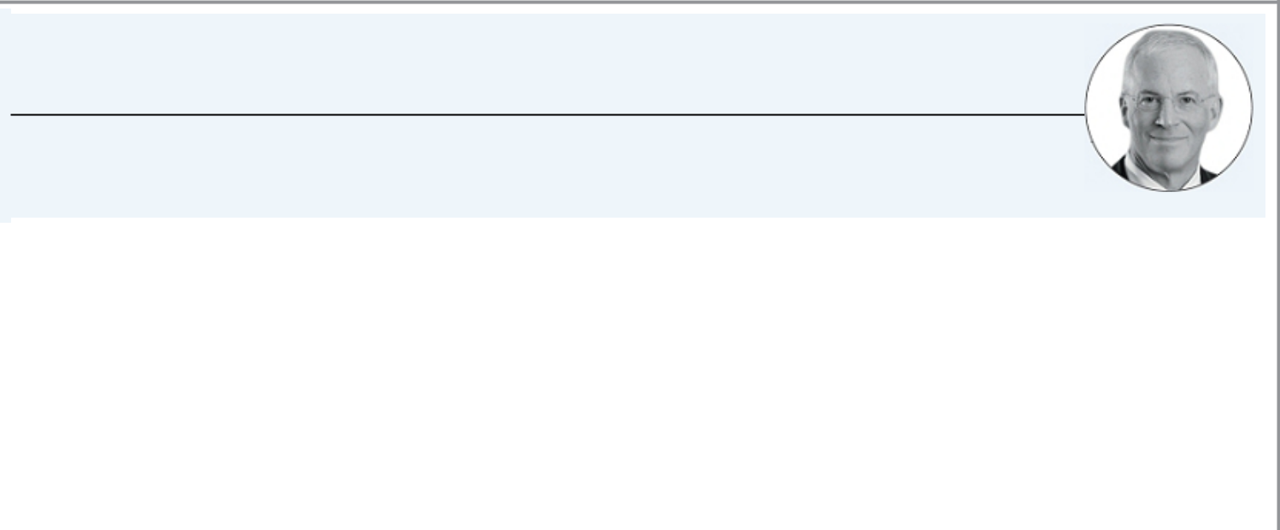

Jeffrey A. Honickman

INDEPENDENT

Chief Executive Officer of Pepsi-Cola & National Brand Beverages

Age: 64

Director since: December 2005

Committees: Audit and Governance and Directors Nominating

CAREER HIGHLIGHTS:
- Chief Executive Officer, Pepsi-Cola & National Brand Beverages, Ltd., a bottling and distribution company, which includes among its affiliates Pepsi-Cola Bottling Company of New York, Inc. and Canada Dry bottling companies from New Jersey to Virginia, 1990 – Present

- Vice President and Secretary of Antonio Origlio Inc., a beverage distributor based in Philadelphia, Pennsylvania, which does business as Origlio Beverages

- Chairman of the Board of Directors, American Beverage Association

- Member of Board of Trustees, Barnes Foundation

- Member of President’s Advisory Counsel, Sidney Kimmel Cancer Center, Jefferson Health

QUALIFICATIONS:
We believe that Mr. Honickman’s significant experience in the wholesale and consumer products industries, including his experience as a chief executive officer, renders him qualified to serve as one of our directors.

16

Table of Contents
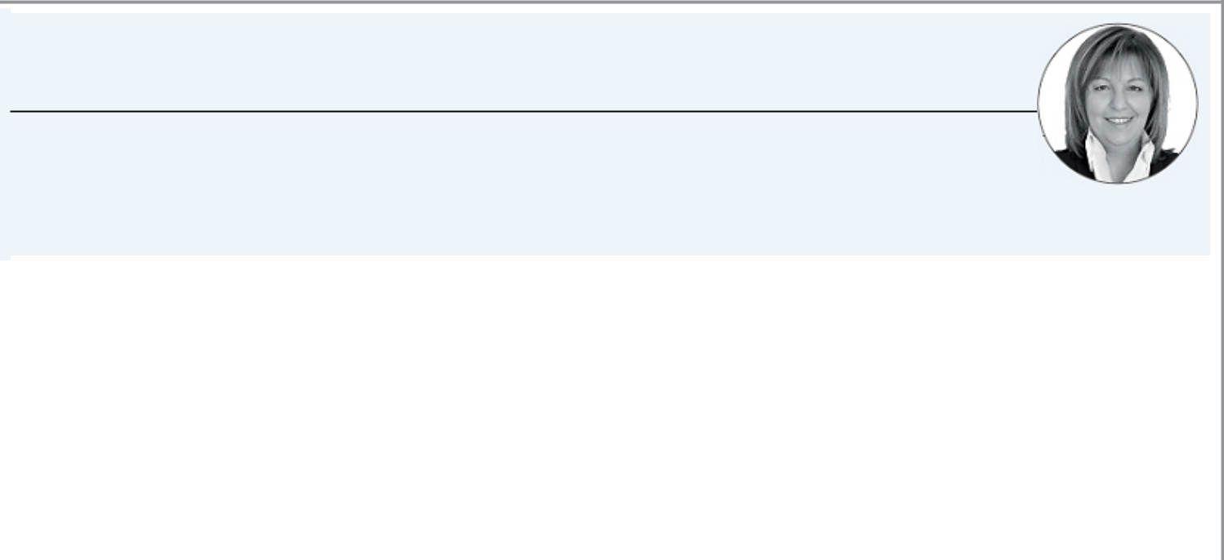

Maritza G. Montiel

INDEPENDENT

Former Deputy Chief Executive Officer and Vice Chairman of Deloitte LLP

Age: 69

Director since: June 2018

Committees: Audit

OTHER CURRENT PUBLIC COMPANY DIRECTORSHIPS:

AptarGroup, Inc., McCormick & Company, Incorporated, Royal Caribbean Cruises Ltd.

CAREER HIGHLIGHTS:
- Deputy Chief Executive Officer and Vice Chairman, Deloitte LLP, 2011 – 2014

  - Numerous senior management roles at Deloitte, including:

  - Managing Partner (Leadership Development and Succession, Deloitte University), 2009 – 2011

- Regional Managing Partner, 2001 – 2009

- Advisory Partner for many public company clients where Deloitte was the principal auditor

- Member of Deloitte’s U.S. and Global Board of Directors

QUALIFICATIONS:
As Deputy Chief Executive Officer of Deloitte, among other things, Ms. Montiel led a variety of strategic initiatives, including the transformation of the firm’s Federal Government Services Practice. We believe that Ms. Montiel’s extensive experience and leadership in the accounting profession, including her experience as the former Deputy Chief Executive Officer and Vice Chairman of Deloitte, render her qualified to serve as one of our directors.
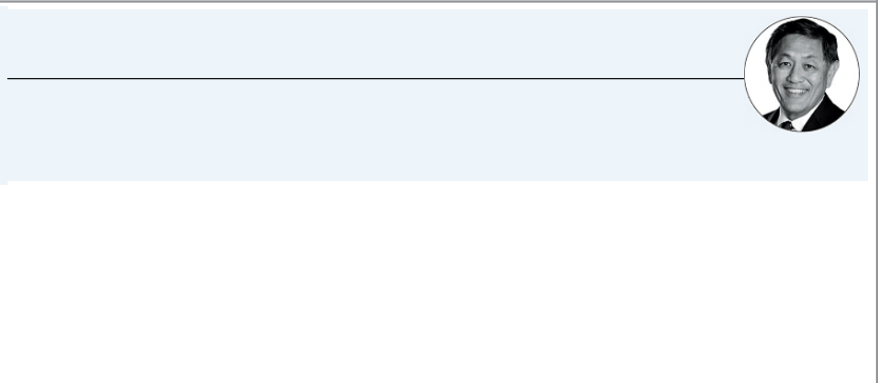

Asuka Nakahara

INDEPENDENT

Partner at Triton Atlantic Partners

Age: 65

Director since: February 2017

Committees: Audit

OTHER CURRENT PUBLIC COMPANY DIRECTORSHIPS:

CBRE Clarion Global Real Estate Income Fund

CAREER HIGHLIGHTS:
- Partner, Triton Atlantic Partners, a real estate advisory firm and investment vehicle that he co-founded, 2009 –Present

- Associate Director, Zell-Lurie Real Estate Center, Wharton School of the University of Pennsylvania

- Trammell Crow Company, various leadership roles including Chief Financial Officer (overseeing finance, capital markets, mergers and acquisitions, marketing, Trammell Crow University, human resources and other new business initiatives), 1996 – 1999

- Board Member and Chair of the Investment Committee, United States Golf Association

- Board Member, PGA of America

QUALIFICATIONS:
We believe that Mr. Nakahara’s extensive knowledge of real estate and general advisory matters, including his leadership and academic experiences, as well as his prior experience as a chief financial officer, render him qualified to serve as one of our directors.

2021 Proxy Statement | 17

Table of Contents


David C. Novak

INDEPENDENT

Founder of David Novak Leadership, LLC

Age: 68

Director since: December 2016

Committees: Compensation

CAREER HIGHLIGHTS:
- Founder of David Novak Leadership, LLC, which provides online leadership training to transform managers into confident, capable, engaging leaders

- Executive Chairman of the Board, YUM! Brands, Inc., 2015 – 2016

- Chairman of the Board, YUM! Brands, Inc., 2001 – 2014

- Chief Executive Officer, YUM! Brands, Inc., 2000 – 2014

- Board Member, Lift-a-Life Novak Family Foundation

QUALIFICATIONS:
We believe that Mr. Novak’s extensive knowledge of customer service-oriented business practices and talent management, as well as his prior experience as a chief executive officer and chairman, render him qualified to serve as one of our directors.
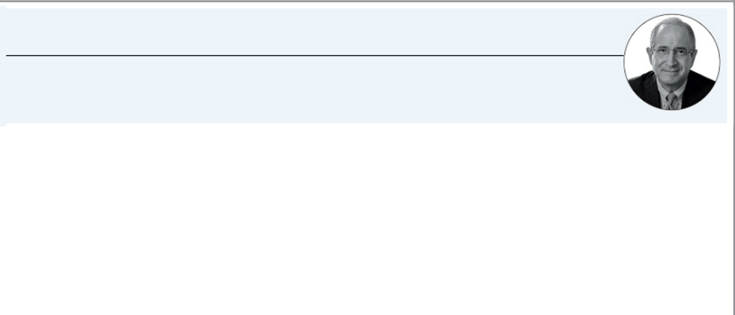

Brian L. Roberts

Chairman, President and Chief Executive Officer of Comcast

Age: 61

Director since: March 1988

Committees: None

CAREER HIGHLIGHTS:
- Chairman of the Board, Comcast, 2004 – Present

- Chief Executive Officer, Comcast, 2002 – Present

- President, Comcast, 1990 – Present

- Director, National Cable and Telecommunications Association, the principal trade association of the cable industry

- Director Emeritus, CableLabs, the cable industry’s research and development consortium

As of December 31, 2020, Mr. Roberts, through his ownership of our Class B common stock, had sole voting power over 33 1/3% of the combined voting power of our two classes of voting common stock.

QUALIFICATIONS:
We believe that Mr. Roberts’ extensive experience and leadership in the internet, video, phone, media and entertainment and wireless industries, including as our Chairman, President and Chief Executive Officer, render him qualified to serve as one of our directors.

18

Table of Contents

Independence Determinations

Our Board has determined that each of our nine nonemployee directors is independent in accordance with the director independence definition specified in our corporate governance guidelines, which are posted under “Corporate Governance” in the Investors section of our website at www.comcastcorporation.com, and in accordance with applicable Nasdaq rules. In making its independence determinations, our Board considered transactions and relationships between each director or any member of his or her immediate family and us, including those reported under “Related Party Transactions Policy and Certain Transactions” below. The Board also considered that in the ordinary course of business we have, during the current year and the past three fiscal years, sold products and services to, purchased products and services from, and/or made charitable donations (including by certain of our executive officers) to companies and organizations at which some of our directors are currently an executive officer or a significant shareholder. In each case, the amount paid or donated to or received from these companies and organizations each year was below 1% of the recipient company’s or organization’s total consolidated gross revenues, which is far below the 5% limit prescribed by Nasdaq rules.

Our Board also considered director tenure in connection with its independence determinations, even though neither our corporate governance guidelines nor Nasdaq rules deem a long-tenured director not independent. Following the annual meeting of shareholders, if all director nominees are elected to serve as our directors, the average tenure of our independent directors will be 7.8 years.

Retirement Age, Director Tenure and Director Emeritus Program

Our corporate governance guidelines require that our independent directors not stand for re-election to the Board after reaching the age of 72. We believe that our retirement policy and natural turnover achieve the appropriate balance between maintaining longer-term directors with deep institutional knowledge and refreshing the Board with new directors and different areas of expertise and knowledge, while maintaining gender and racial and ethnic representation.

Our Board has created a director emeritus program to avail itself of the counsel of retiring directors who have made and can continue to make a unique contribution to the deliberations of the Board. A director emeritus may provide advisory services as requested from time to time and may be invited to attend meetings of the Board, but may not vote, be counted for quorum purposes or have any of the duties or obligations imposed on our directors or officers under applicable law or otherwise be considered a director. Sheldon M. Bonovitz was designated as a director emeritus following our 2020 annual meeting.

Director Nominations

Our Governance and Directors Nominating Committee will consider director candidates nominated or recommended by shareholders and will evaluate any such candidates in a similar manner as any other candidates. In identifying and evaluating candidates, whether recommended by the Committee or by shareholders, the Committee will consider an individual’s professional knowledge, business, financial and management expertise, industry knowledge, entrepreneurial background and experience, as well as applicable independence requirements. The committee also gives significant consideration to the current composition and diversity of our Board, including with respect to skills, age, backgrounds, experiences, perspectives, viewpoints and gender and racial and ethnic representation.

To submit a nomination, shareholders must provide a written notice in accordance with the requirements in our by-laws within the following time periods. For the election of directors at the 2022 annual meeting of shareholders, if such meeting is called for a date between May 3, 2022 and July 2, 2022, we must receive written notice at the address given on page 68 on or after February 2, 2022 and on or before March 4, 2022. If such meeting is called for any other date, we must receive written notice by the close of business on the tenth day following the day we mailed notice of, or announced publicly, the date of the meeting, whichever occurs first.

In addition, a shareholder or group of up to 20 shareholders owning at least 3% of the aggregate number of our outstanding shares of common stock continuously for at least three years may nominate and include in our proxy materials director nominees constituting up to the greater of 20% of our Board or two directors, provided the shareholder(s) and nominee(s) satisfy the requirements in our by-laws. Notice of proxy access director nominees for the election of directors at the 2022 annual meeting of shareholders, if such meeting is called for a date between May 3, 2022 and July 2, 2022, must be received on or after November 24, 2021 and on or before December 24, 2021. If such meeting is called for any other date, we must receive written notice by the later of the close of business on the date that is 180 days prior to such meeting or the tenth day following the date the meeting is first publicly announced or disclosed.

2021 Proxy Statement | 19

Table of Contents

Shareholders can obtain a copy of our by-laws by writing to Thomas J. Reid, Secretary, Comcast Corporation, at the address given on page 68. A copy of our by-laws is filed with the SEC as an exhibit to our Annual Report on Form 10-K for the year ended December 31, 2020 and is posted on our website under “Corporate Governance” in the Investors section of our website at www.comcastcorporation.com.

Board Structure and Responsibilities

Board Leadership Structure

Our Board does not believe it should be constrained by adopting an inflexible, formal requirement that the offices of Chairman and Chief Executive Officer be separated, but believes instead that we and our shareholders are best served by maintaining the flexibility for the Board to decide what is in the best interests of our company at a given point in time. To that end, our Board regularly reviews our Board leadership structure.

Our Board believes that we and our shareholders are best served by having Mr. Roberts serve as both our Chairman and Chief Executive Officer. Mr. Roberts is a strong and effective leader, at both the company and Board levels, who provides critical leadership in carrying out our strategic initiatives and confronting our challenges. Mr. Roberts serves as an effective bridge between the Board and management, facilitating strong collaboration and encouraging open lines of communication with the Board.

Our independent directors are led by our Lead Independent Director, who ensures a strong, independent and active Board. Our independent directors provide guidance and oversight of senior management and regularly meet without management as part of Board and committee meetings to review, among other things, our strategy, performance, management effectiveness and succession planning. As part of our annual Board assessment process, our independent directors also provide input on key business and director educational topics for the following year’s Board and committee meeting agendas.


Edward D. Breen

LEAD INDEPENDENT DIRECTOR

In accordance with our corporate governance guidelines, our Board has a strong Lead Independent Director position, currently filled by Mr. Breen. The Lead Independent Director:

- Chairs meetings of the Board at which the Chairman is not present.

- Facilitates communication between the Chairman and the independent directors and encourages director participation by fostering an environment of open dialogue and constructive feedback among independent directors.

- Communicates periodically as necessary between Board meetings and executive sessions with our independent directors, following discussions with management and otherwise on topics of importance to our independent directors.

- Consults with our independent directors concerning the need for an executive session in connection with each regularly scheduled Board meeting.

- Is authorized to schedule meetings of the independent directors, including executive sessions of the independent directors.

- Consults, reviews and has the opportunity to provide input on meeting agendas and meeting schedules for the Board.

- With the Compensation Committee, organizes the annual Board evaluation of the performance of our Chief Executive Officer and senior management.

- With the Governance and Directors Nominating Committee, reviews and approves the process for the annual self-assessment of our Board and its committees.

- Represents independent directors in communications with external constituencies, as appropriate.

The role of Lead Independent Director is filled by an independent director recommended by the Governance and Directors Nominating Committee, which is composed entirely of independent directors, and appointed by the Board annually.

20

Table of Contents

In addition to the Lead Independent Director position, our Board believes that Board independence and oversight of management are effectively maintained through the Board’s composition, where 90% of our director nominees are independent, and through our Audit, Compensation and Governance and Directors Nominating Committees, which are composed entirely of independent directors. Moreover, having one individual perform the roles of Chairman and Chief Executive Officer is not restricted or prohibited by current laws or regulations, and all of our directors, including our Chairman, are bound by fiduciary obligations under law to act in a manner that they believe to be in the best interests of our company.

Board Meetings and Attendance

Our Board of Directors and various committees of the Board meet throughout the year. During 2020, there were seven meetings of our Board and a total of 19 committee meetings. Each director attended more than 75% of the aggregate number of Board meetings and the number of meetings held by all of the committees on which he or she served.

We require our directors to participate in the annual meeting of shareholders, barring unusual circumstances. Each director then in office participated in the 2020 annual meeting of shareholders.

Our independent directors have the opportunity to meet separately in executive session following each regularly scheduled Board meeting and, under our corporate governance guidelines, are required to meet in executive session at least two times each year. In 2020, executive sessions were held at each regularly scheduled Board meeting, and most regularly scheduled committee meetings.

Committees of Our Board

Our Board has three standing committees composed entirely of independent directors. Committee charters are posted under “Corporate Governance” in the Investors section of our website at www.comcastcorporation.com.

 |  |  |  | GOVERNANCE
 |  |  |  | AND DIRECTORS
 |  | AUDIT | COMPENSATION | NOMINATING
 |  | COMMITTEE | COMMITTEE | COMMITTEE
Kenneth J. Bacon
Madeline S. Bell
Naomi G. Bergman
Edward D. Breen
Gerald L. Hassell
Jeffrey A. Honickman
Maritza G. Montiel
Asuka Nakahara
David C. Novak
Meetings Held in 2020 |  | 9 | 5 | 5
Chair | Member | Audit Committee Financial Expert

Each member of our Audit Committee, Compensation Committee and Governance and Directors Nominating Committee is independent under Nasdaq rules. Each member of our Audit Committee is financially literate for audit committee purposes, and our Board has concluded that Jeffrey A. Honickman and Maritza G. Montiel qualify as audit committee financial experts. Each member of our Compensation Committee qualifies as a “non-employee director” (under Rule 16b-3 under the Securities Exchange Act of 1934, as amended (the “Exchange Act”)) and an “outside director” (as defined in Section 162(m) of the Internal Revenue Code of 1986).

2021 Proxy Statement | 21

Table of Contents

Board and Committee Strategy, Risk and Environmental, Social and Governance (“ESG”) Oversight Responsibilities

Our Board and its committees provide guidance to and oversight of management with respect to our business strategy throughout the year. Various elements of strategy are discussed at every Board meeting, and our management is charged with executing the business strategy and updating the Board on progress and execution throughout the year.

While active risk management is primarily the responsibility of our management, our Board understands the significant risks facing our company, including those related to relevant ESG issues, and exercises, as a whole and through its committees, an appropriate degree of risk oversight. Our management, with involvement and input from our Board, performs a companywide enterprise risk management (“ERM”) assessment to identify key risks and to manage and mitigate the significant strategic, operational and legal risk areas for our company. Our executive management team has the overall responsibility for, and oversight of, this process, and an ERM steering committee composed of legal, financial, accounting and business executives manages the process, with one or more senior business executives then monitoring and managing each of the identified risks. Regular business presentations and discussions throughout the year at the Board or its committees highlight significant relevant risks and exposures, including those listed below as core enterprise risks identified through our ERM process.

Our Board and its committees exercise their respective roles in strategy and risk oversight and oversight of ESG matters in a variety of ways, including the following:

Board


- Oversees core enterprise risks identified through our ERM process for Board-level oversight (either as a whole or as delegated to its committees):

  - Competitive risks

  - Reputational risks

  - Succession planning

  - Capital allocation

  - Cybersecurity and privacy

  - Legal and regulatory risks

- Reviews other significant risks facing our company identified through the ERM process. Among these are significant strategic, operational and legal risks, human capital risks and business continuity risks.

Audit Committee


- Reviews the quality and integrity of our financial statements.

- Reviews the financial statements and “Management’s Discussion and Analysis of Financial Condition and Results of Operations” in our Forms 10-Q and 10-K and our quarterly earnings press releases.

- Monitors our internal control over financial reporting and disclosure controls and procedures.

- Reviews the performance and responsibilities of our internal audit function and activities.

- Appoints and evaluates the qualification, performance and independence of our independent auditors.

- Reviews financial risk assessment and management, cybersecurity and significant business continuity risks.

- Reviews process with respect to our ERM assessment.

- Reviews risks facing our company as disclosed in “Risk Factors” in our Forms 10-K.

- Reports its discussions to the full Board for consideration and action when appropriate.

22

Table of Contents

Compensation Committee


- Oversees and sets compensation for our senior executives.

- Performs an annual review of our compensation philosophy, executive compensation programs and the performance of senior executives, including our NEOs.

- Evaluates annually whether there are any risks associated in our executive compensation program.

- Reviews compensation and benefit plans and policies generally, including with respect to recruitment, development, promotion, retention and compensation of our senior executives and other employees.

- Reviews results of employee engagement surveys.

- Oversees succession planning for senior management.

- Reports its discussions to the full Board for consideration and action when appropriate.

Governance and Directors Nominating Committee


- Provides general oversight of corporate governance.

- Oversees culture of compliance and ethical business conduct, including compliance program.

- Reviews significant legal and regulatory compliance risks, such as privacy.

- Oversees, monitors and receives reports on workplace harassment and discrimination matters.

- Reviews and assesses our corporate social responsibility report and significant environmental and social issues, risks and trends, including by receiving periodic reports on DE&I initiatives and matters.

- Oversees our approach to political and lobbying activities, including by receiving periodic reports on our compliance program for political contributions, lobbying and trade association activities.

- Reports its discussions to the full Board for consideration and action when appropriate.

2021 Proxy Statement | 23

Table of Contents

Corporate Governance Practices, Policies and Processes

Corporate Governance Highlights

As described in more detail elsewhere in this proxy statement, below are highlights of our corporate governance structure.

Board Independence/Composition


- Strong Lead Independent Director, with Defined Role and Responsibilities

- 90% of Director Nominees are Independent

- Director Tenure Considered in Annual Board Director Independence Determinations

- All Members of Key Board Committees are Independent

- Opportunity for Executive Sessions at Every Board and Committee Meeting

- 50% of Director Nominees are Diverse by Gender or Race

  - 30% Female

  - 30% Racial/Ethnic Diversity

- Compensation Committee Directly Retains Independent Compensation Consultant

Board Performance


- Annual Board and Committee Evaluations

- Board/Committee Oversight of Significant Company Risks and ESG Matters

- Annual Board and Compensation Committee Discussion of Succession Planning for CEO and Senior Executives

- Director Education on Key Company Topics and Issues, Including as Requested by Independent Directors

Corporate Governance


- 5 New Independent Directors within Past 5 Years

- Average Tenure of Independent Directors is 7.8 Years

- Mandatory Independent Director Retirement at 72

- Robust Shareholder Engagement Program

  - Met with over 55 investors owning over 50% of Class A common stock on Governance, Compensation and other ESG matters

- Annual Director Elections

- Proxy Access By-Law

- Recoupment (“Clawback”) Policy for Executive Compensation

- No Automatic Acceleration of Vesting in Connection with a Change in Control

Stock Ownership Requirements


- Robust Stock Ownership Requirements, with NEO Beneficial Shareholdings Significantly Exceeding Thresholds

  - CEO = 10x Salary

  - Other NEOs = 3x Salary

  - Nonemployee Directors = 5x Annual Cash Retainer

- No Dividend Equivalents Paid on Unearned Restricted Stock Units (“RSUs”) or on Any Stock Options

- Prohibition on Hedging and Pledging Comcast Stock

24

Table of Contents

Succession Planning

Ensuring that we have the appropriate senior management talent to successfully pursue our strategies is one of the Board’s primary responsibilities. To this end, at least once a year, the Board discusses succession planning for our CEO and the remainder of our senior executive management team. To help fulfill the Board’s responsibility, our Compensation Committee is required, pursuant to our corporate governance guidelines, to ensure that we have in place appropriate planning to address CEO succession both in the ordinary course of business and in emergency situations. Our CEO succession planning includes criteria that reflect our business strategies, such as identifying and developing internal candidates. Our corporate governance guidelines also require that our Compensation Committee ensure that we have appropriate succession planning for the remainder of our senior executive management team, including our NEOs. Each year, our Board and Compensation Committee discuss succession planning for our senior executive management team and their respective direct reports.

Two significant leadership transitions occurred in 2020 with the retirements of Stephen B. Burke, CEO of NBCUniversal, and David L. Cohen, Senior Executive Vice President. While Messrs. Burke and Cohen had shaped and guided our company for many years, our next generation of leaders have seamlessly stepped in and continued to help us navigate evolving consumer, technological and regulatory trends and address competitive challenges. Our succession planning facilitated this smooth transition, including with respect to our response to the COVID-19 pandemic.

Human Capital and Talent Management

Recruiting, developing, promoting and retaining top talent is a key priority for our company. Throughout the year, our executive management team, as well as a broader array of executives throughout our businesses, make presentations to the Board and its committees and interact with our directors informally outside of regularly scheduled Board meetings.

In 2020, over 45 employees, ranging from Vice Presidents to Executive Vice Presidents to heads of business units, attended meetings of our Board and its committees.

This engagement between directors and our current and future leaders gives our directors meaningful insight into our current pool of talent, what attracts and retains our executives and our company culture.

Board and Committee Evaluations

Each year, our Board and each of its committees perform a self-assessment to evaluate their effectiveness. As part of these assessments, each director completes a detailed questionnaire for the Board and any committees on which he or she serves, addressing topics such as Board structure and composition, Board responsibilities, Board meetings and materials, Board and management interactions and ethics and compliance. The questionnaire seeks responses based on numerical ratings and also seeks qualitative comments on each question and any other general comments. The Governance and Directors Nominating Committee reviews and approves the process and the questionnaires to be used, with outside counsel also reviewing the questionnaires. The results of the assessments are compiled anonymously and are reviewed and discussed with the Board and the Governance and Directors Nominating Committee (as it relates to both the Board and all committees), each committee (as it relates to such committee) and, as appropriate, any individual director. The Governance and Directors Nominating Committee develops action plans for items that may require follow-up, and it also coordinates recommendations for key business and director educational topics for the following year’s Board and committee meeting agendas.

Corporate Governance Guidelines and Code of Conduct

Our Board has adopted corporate governance guidelines that address items such as the standards, qualifications and responsibilities of our directors and director candidates and corporate governance policies and standards applicable to us in general. We also have a code of conduct that applies to all of our employees, including our executive officers, and our directors. Both the guidelines and the code of conduct applicable to our executive officers and directors are posted under “Corporate Governance” in the Investors section of our website at www.comcastcorporation.com. We will disclose under “Corporate Governance” in the Investors section of our website any amendments to, or any waivers under, the code of conduct that are required to be disclosed by the rules of the SEC.

2021 Proxy Statement | 25

Table of Contents

Shareholder Engagement

We have an active, broad-based and year-round investor relations outreach program to solicit input and to communicate with shareholders on a variety of topics. In addition to our regular investor relations program that reviews our business and strategy with buy-side investors and securities analysts, we engage with investors on various corporate governance, compensation and other environmental and social (“E&S”) topics. This dialogue provides an opportunity to discuss governance matters generally, including our directors’ skills and tenure, Board oversight roles and responsibilities, E&S initiatives and executive compensation.

The key elements of our investor relations outreach program are below:
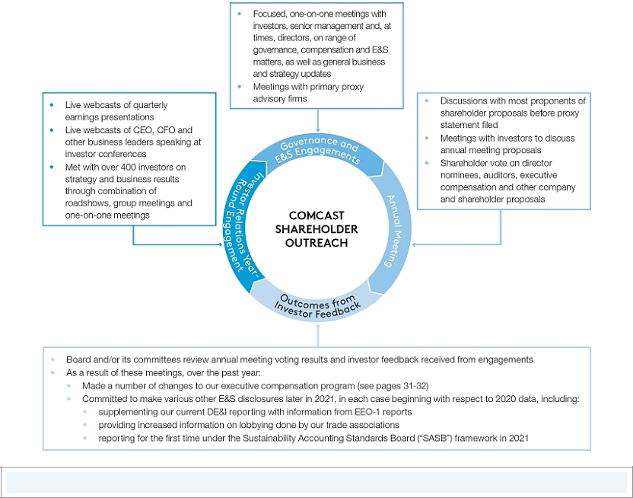

Over past year, met with over 55 investors owning over 50% of Class A common stock on governance, compensation and E&S matters.

Our Board has established a process for shareholders and other interested parties to communicate with its members. Correspondence may be addressed to the Board, the Lead Independent Director, any other particular director, any committee of the Board or any other group of directors, in care of Thomas J. Reid, Secretary, Comcast Corporation, at the mailing address provided on page 68 or the following e-mail address: audit_committee_chair@comcast.com. The Secretary, or his designee, promptly reviews all such correspondence and, as appropriate, forwards it to the Board or other addressee based on the subject matter of the correspondence. Any such correspondence relating to accounting, internal accounting controls or auditing matters is handled in accordance with procedures established by the Audit Committee.

26

Table of Contents

Executive Compensation


Proposal 2: ADVISORY VOTE TO APPROVE EXECUTIVE COMPENSATION

The following proposal gives our shareholders the opportunity to cast a non-binding, advisory vote to approve the compensation of our NEOs. This vote is not intended to address any specific item of compensation, but rather the overall compensation of our NEOs and our compensation philosophy, policies and practices, as disclosed below.

We encourage shareholders to review detailed information on our executive compensation program and the 2020 compensation of our NEOs as set forth in “Executive Compensation — Compensation Discussion and Analysis,” starting below. Shareholders are being asked to vote “FOR” the adoption of the following resolution:

“RESOLVED, that the compensation paid to Comcast Corporation’s named executive officers, as disclosed pursuant to Item 402 of Regulation S-K, including the Compensation Discussion and Analysis, compensation tables and narrative discussion, is hereby APPROVED.”

While we intend to carefully consider the voting results of this proposal, this vote is advisory in nature, and, therefore, is not binding on us or our Board. Our Board and Compensation Committee value the opinions of all of our shareholders and will consider the outcome of this vote when making future compensation decisions for our NEOs.

Our Board unanimously recommends that shareholders vote “FOR” approval of the compensation of our named executive officers.

2021 Proxy Statement | 27

Table of Contents

Letter from the Compensation Committee

Dear Shareholders,

2020 marked a year of unprecedented challenges with the COVID-19 pandemic, yet the Company’s senior leadership team – led by our named executive officers (“NEOs”): Brian L. Roberts (Chairman, President and CEO), Michael J. Cavanagh (CFO), Jeff Shell (CEO of NBCUniversal), David N. Watson (CEO of Comcast Cable) and Thomas J. Reid (Chief Legal Officer and Secretary) – worked seamlessly and tirelessly together. With their management teams, they successfully executed on our strategy and adapted to find safe and creative solutions to navigate the pandemic to benefit employees, customers, communities, suppliers and shareholders now and for the long term. Our company’s solid operational and financial results underscore the overall resiliency of our business, and we believe we will emerge from this challenging environment in a strong position due to our ability to execute on our strategic focus on broadband, aggregation and streaming.

As you will see described in the following “Compensation Discussion and Analysis,” our Committee decided not to apply discretion to adjust any financial performance goals in the short- and long-term incentive programs designed for NEOs, believing that the long-term nature of our overall compensation structure would continue to incent and reward the NEOs for managing our company for the long term.

While we believe that our executive compensation program aligns the long-term interests of our NEOs and shareholders, we are committed to continually reviewing our compensation program. Underscoring this commitment, our company is highly engaged with shareholders, meeting with over 55 shareholders owning over 50% of the Company’s Class A common stock over the past year to discuss governance, compensation and E&S matters. We received feedback on our compensation program structure and have taken significant steps in response to this feedback, further aligning our overall pay-for-performance structure.

The enhancements made to our compensation program are discussed in more detail below under “Shareholder Feedback on Executive Compensation and

Compensation-Related Changes,” and include the following:

- Eliminated above-market interest earnings on deferred compensation (beginning in August 2020 for directors and March 2021 for NEOs)

- Redesigned the structure of performance-based restricted stock units (“PSUs”) granted in 2021 to include a three-year performance period, with new equally-weighted performance goals of absolute return on invested capital (“ROIC”) and adjusted earnings per share (“EPS”) relative to the S&P 100, and a total shareholder return (“TSR”) modifier (which will not be applied positively if TSR is negative)

- Increased the weighting of the financial metrics portion of the annual cash bonus program from 50% to 70% for 2021

- Our annual cash bonus program has incentivized NEOs for our continuing focus on critical DE&I initiatives for over 10 years now and will continue to do so in 2021 – with a new dedicated portion to be based solely on stakeholder and sustainability initiatives such as further progress on our DE&I initiatives and continued leadership in addressing the “digital divide”

We believe that these improvements build on our efforts to thoughtfully align the interests of our NEOs with the interests of our shareholders over the long term. We welcome your feedback on our compensation program reflected in the following pages.

Sincerely,

The Compensation Committee

Edward D. Breen (Chair)

Gerald L. Hassell

David C. Novak

28

Table of Contents

Compensation Discussion and Analysis

This discussion and analysis describes our executive compensation philosophy, process, plans and practices and gives the context for understanding and evaluating more specific compensation information in the tables and related disclosures that follow.

Executive Overview

Overall Performance

Mr. Roberts and our senior leadership team successfully navigated our organization through the severe challenges of 2020, executing on our strategy where it remained viable, adapting our strategy where it needed to adapt and finding safe and creative solutions to navigate the COVID-19 pandemic to benefit our employees, customers, communities, suppliers and shareholders now and for the long term. Our solid operational and financial results, and the resiliency of our business, were driven by our strategic focus on broadband, aggregation and streaming, which we believe delivers better experiences for our customers and value for our shareholders, positions our company to outperform and puts us on a trajectory to emerge from this challenging environment in an even stronger position. Mr. Roberts and our senior leadership team executed at the highest level, working together across our complementary, high-performing businesses at Comcast Cable, NBCUniversal and Sky to continue to accelerate convergence in media and technology.

Comcast Cable continued its strong financial and operating performance in 2020, driven by our differentiated broadband experience. The significant investments we have made in our technology and network over the years to stay ahead of demand and to maintain speed and reliability enabled us to successfully manage the largest sustained traffic surge in history during the peak of COVID-19. This achievement, combined with further enhancing our broadband offering by making Flex and Peacock available for free to customers, helped lead to 2 million net new broadband customers and 1.6 million total net new relationships this year – the best results on record.

The impact of the global pandemic placed significant financial pressure on NBCUniversal and Sky given the nature of their businesses, yet their leadership teams transformed the difficulties into opportunities. NBCUniversal, leveraging Sky’s technology infrastructure and Comcast Cable’s customer base, launched Peacock, its new streaming service. Even without the benefit of the Olympics, Peacock quickly surpassed our internal expectations, signing up more than 33 million customers in the United States in just over its first six months. With movie theaters closed, NBCUniversal also introduced a new “premium video on demand” strategy to make our firms available in the home and enable our Filmed Entertainment business to profitably release new titles. Our theme parks business found creative solutions to open safely in Orlando, Florida and Osaka, Japan. Meanwhile, Sky successfully increased its penetration of customers in Europe with Sky Q, launched Sky broadband in Italy, leveraging Comcast Cable’s xFi platform, and maintained strong customer loyalty throughout the pandemic. At the end of 2020, Sky returned to 99% of pre-COVID customer levels.

Our Board credits Mr. Roberts and our other NEOs for successfully leading the company during this unprecedented period. Their steadfast integrity and intense focus on protecting our employees, promoting collaboration and innovation across our company and realigning our business to better compete in the long term underscores the resiliency of our business, enabling us to deliver strong results in 2020 and positioning us well for 2021 and beyond.

COVID-19 Response

In response to the global pandemic, Mr. Roberts and our senior leadership team moved quickly to help our employees, customers and communities.

- We committed over $500 million to support our employees where operations were closed or impacted due to the pandemic, made work from home options as broadly available as possible, including to most of our call center employees, and enhanced safety measures for customer-facing employees.

- Our teams worked tirelessly to ensure that our broadband network and services delivered the broadband capacity needed to keep our customers productive, informed and entertained throughout the year.

- We helped our customers facing economic hardship maintain their broadband service and offered our network of out-of-home, public WiFi hotspots for free to everyone.

2021 Proxy Statement | 29

Table of Contents

- We increased speeds for all Internet Essentials customers, with current speeds at 50/5 Mbps, offered new Internet Essentials customers two free months of service, kicked off our initiative to launch 1,000 WiFi-connected Lift Zones in community centers nationwide and introduced our Internet Essentials Partnership Program to connect large numbers of low-income students to the internet to support distance learning.

- Our NBC and Sky news teams worked hard to keep the world informed, while our Xfinity team curated news and education resources to provide quick access to tools and information while expanding free access to traditional subscription-only content.

Beyond our own company initiatives, Messrs. Roberts, Cavanagh, Watson and Shell personally donated six months of their salaries to charities to support COVID-19 relief efforts.

Social Justice Response

Mr. Roberts and our senior leadership team mobilized our company to accelerate our work in DE&I and pledge an additional $100 million over three years to fight injustice and inequality through a coordinated cross-company effort. Our key focus areas include partnering with, and providing significant grants to, organizations working to eradicate injustice and inequity; accelerating our internal efforts in all areas of DE&I; leveraging our company’s media resources to highlight Black voices and Black stories; deepening our long-standing commitment to addressing digital inequities; and committing funds to small businesses that have been affected by extended closures in the wake of COVID-19, with a substantial portion of those funds allocated to businesses owned by people of color.

Compensation Decisions for Achievement of 2020 Performance Metrics

In making compensation decisions for achievement of performance goals in our short- and long-term incentive programs, which goals were established in February 2020 before the COVID-19 pandemic was declared, the Compensation Committee, among other things, considered the exceptional performance of our NEOs in managing the long-term sustainability of our company through the pandemic for the benefit of our stakeholders – including our employees, customers, suppliers, shareholders and the communities where we operate – and the overall resiliency of our business. At the same time, it was mindful of negative COVID-19 impacts on some of our businesses such as our theme parks, our employees and our customers. The impacts of COVID-19 upon our business negatively affected in particular the achievement of financial performance goals relating to revenue and adjusted EBITDA for our annual cash bonus program and relating to adjusted EBITDA for PSUs granted in 2020. See “Financial Performance” on page 7 for information on our 2020 financial and operational performance.

Taking these factors into consideration, the Compensation Committee decided not to apply discretion to adjust any financial performance goals in our short-and long-term incentive programs designed for NEOs, believing that the long-term nature of our overall compensation structure would continue to incent and reward our NEOs for managing our company for the long-term. As a result, the first tranche of PSUs granted in 2020 did not vest and were forfeited. In addition, while no portion of the revenue or adjusted EBITDA components of our annual cash bonus program were achieved, metrics relating to free cash flow and key strategic operational priorities were achieved, resulting in the Compensation Committee awarding Messrs. Roberts, Cavanagh and Shell 75% of their target annual cash bonus for 2020. Given Comcast Cable’s exceptional financial and operating performance in 2020, its relative contribution to Comcast’s overall financial performance in 2020 and its expansion of Internet Essentials and other programs to provide assistance for customers facing economic hardship, Mr. Watson was awarded 100% of his annual cash bonus. See “Compensation Decisions” below for additional information.

30

Table of Contents

Shareholder Feedback on Executive Compensation and Compensation-Related Changes

At our 2020 annual meeting, our shareholders approved by 77% of the votes cast, on an advisory basis, the 2020 compensation of our NEOs. The Compensation Committee has carefully considered the results of this advisory vote and has discussed our executive compensation program and our voting results with Korn Ferry, its independent compensation consultant. The Compensation Committee also considered feedback on our compensation program received through our corporate governance roadshows, where we have met with over 55 shareholders owning over 50% of our Class A common stock over the past year, as well as two proxy advisory firms. (See “Shareholder Engagement” on page 26 for additional details on our shareholder engagement program.) Informed by these meetings, we have taken significant steps to address the feedback received about our compensation program and have significantly enhanced our overall pay-for-performance compensation structure. As a result of these steps, total performance-based compensation of our NEOs (excluding Mr. Roberts) increased from an average of 76% in 2019 to 86% in 2020, with Mr. Roberts’ increasing from 71% to 89%.
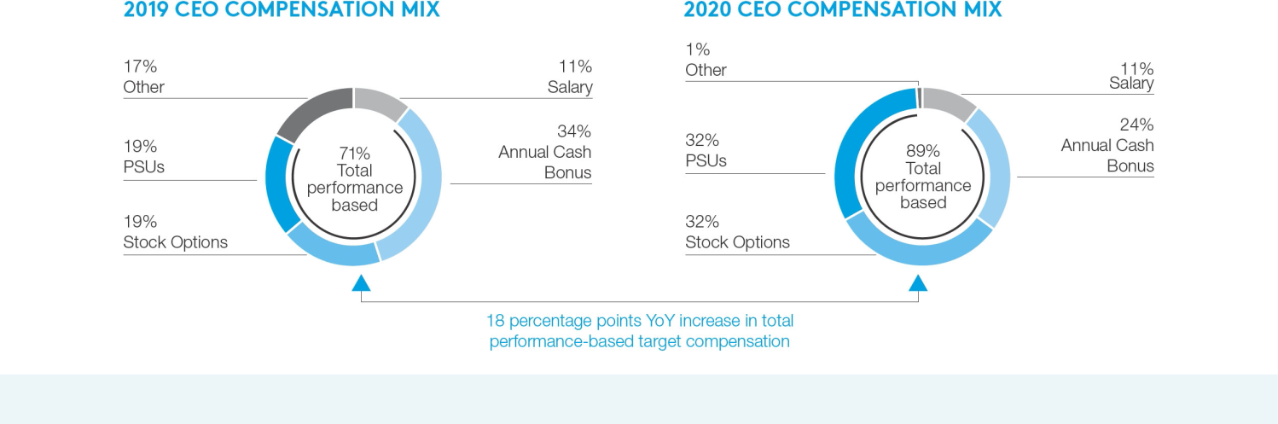

WHAT WE HAVE HEARD WHAT WE HAVE DONE

DEFERRED COMPENSATION


Concerns relating to “above-market” interest in deferred compensation program

Made significant changes to our deferred compensation plans over the past two years to eliminate above-market interest earnings for NEOs and directors:

- NEOs and directors may only invest deferred compensation in third-party mutual or exchange funds or a Comcast stock fund, resulting in the elimination of all above-market interest earnings (effective as of March 2021 for NEOs and August 2020 for directors)

- NEOs surrendered contractual entitlement to company contributions to their deferred compensation accounts beginning in 2020

LONG-TERM INCENTIVE COMPENSATION DESIGN

Consider having a multi-year PSUs granted in 2021 will have a 3-year cumulative performance period, with performance goals determined at the

performance period for PSUs beginning of the 3-year period and measured at the end of the three-year period; previously PSUs had five individual 1-year performance periods

2021 Proxy Statement | 31

Table of Contents

WHAT WE HAVE HEARD |  |  | WHAT WE HAVE DONE
LONG-TERM INCENTIVE COMPENSATION DESIGN (CONT’D)
Consider using a relative |  |  | PSUs granted in 2021 will have two relative performance metrics relating to adjusted EPS growth and TSR and will
performance metric |  |  | include an ROIC performance metric; none of these metrics are used in our annual cash bonus program
Consider incenting NEOs with a |  |  | Specifically:
capital allocation performance
metric |  |  | • PSUs will be earned based on achievement of two primary performance metrics, each weighted 50%: (1) an
Consider a PSU performance |  |  | absolute ROIC metric (calculated for each year during the three-year period and averaged to yield an average
 |  |  | ROIC for the cumulative three-year period) and (2) relative adjusted EPS growth to the S&P 100 over the three-
metric not also used in the |  |  | year period
annual cash bonus program |  |  | • Attainment of primary performance metrics is subject to a relative TSR modifier, interpolated for performance
 |  |  | between the bottom and top quartiles (25th – 75th percentile), with no positive modifier applied if TSR is negative
 |  |  | over the performance period
ANNUAL CASH BONUS
Consider aligning relative |  |  | Quantitative financial metrics will increase from 50% (in 2020) to 70% (in 2021) of the target bonus; revenue,
weighting of quantitative |  |  | adjusted EBITDA and free cash flow will remain as the metrics used
financial performance metrics
closer to market |  |  | Strategic operational performance goals such as success in the continuing development of Peacock will be
 |  |  | reduced from 30% (in 2020) to 15% (in 2021) of the target bonus
Consider improving the |  |  | In 2020, the discretionary portion of the bonus was 20% and was determined based on each NEO’s role in creating
transparency and objectivity of |  |  | a strong workplace culture that emphasizes integrity, respect and our continuing focus on critical DE&I initiatives (in
non-financial performance |  |  | addition to overall management of the company and financial results)
metrics
 |  |  | In 2021, 15% of the target bonus will be discretionary based solely on stakeholder and sustainability initiatives
 |  |  | such as further progress on our DE&I initiatives and continued efforts to address the “digital divide”
 |  |  | We have provided more detailed disclosure about factors the Compensation Committee considered in determining
 |  |  | attainment of strategic operational priorities and discretionary performance below in “Compensation Decisions –
 |  |  | Annual Cash Bonus”

The Compensation Committee considered our executive compensation program holistically as it evaluated how to further enhance our program design while ensuring that the resulting structure will attract, retain and motivate our senior executives and align them with shareholders over the long term. With this view in mind, it determined that, in addition to the changes described above, the vesting terms of our PSUs and options should be reduced to align with broader market practice, with PSUs vesting 100% in 3 years and options vesting over 5 years, and that the potential payout of PSUs should be increased to up to 250% of target to reward senior executives for outperformance against rigorous goals.

Our Compensation Committee and management team are committed to continued engagement with shareholders to understand their viewpoints and to discuss and demonstrate the important connection between our compensation program, on the one hand, and our business strategy, goals and financial and operating performance, on the other hand. Our Compensation Committee, with the assistance of Korn Ferry, continues to evaluate our compensation program design. The Compensation Committee believes that its policies and decisions are consistent with our compensation philosophy and objectives and align the interests of our NEOs with our long-term goals and the interests of our shareholders without incenting inappropriate risk taking.

32

Table of Contents

Our Approach to 2020 Compensation

In designing the compensation program for 2020, we evaluated both our business objectives and the need to attract and retain uniquely talented and experienced individuals who think strategically for the long term and perform for our highly competitive businesses, particularly in light of the challenging and evolving competitive, technological and regulatory environments in which we operate. We employ a variety of elements that further our shareholders’ interests by securing our executives’ services in an exceedingly competitive talent market and aligning the long-term interests of our executives to create shareholder value.

- To motivate and retain our executives, we provide pay opportunity levels that are highly competitive.

- Our compensation program is designed in a straightforward manner to achieve an appropriate balance of elements to reward our NEOs for their performance and create long-term shareholder value. In addition to fixed compensation, we provide short-term and long-term performance-based compensation, which when viewed holistically – understanding the rigor and relevance of our performance conditions and the vesting periods for NEOs to ultimately realize any value from their long-term incentive awards – strongly align the interests of our NEOs with those of our shareholders over the long term.

  - Our short-term annual bonus program includes quantitative financial performance goals that are based on a rigorous and in-depth enterprise-wide consolidated budget that is prepared annually and takes into consideration the cyclicality of working capital in our business, capital spending plans for the upcoming year, target product rollout numbers and other relevant factors.

  - Our annual long-term incentive program is composed of grants of PSUs and stock options. PSUs awarded in 2020 have a meaningful performance condition for vesting based on an annual increase in adjusted EBITDA (excluding Peacock) – one of the most important financial metrics in creating shareholder value. Stock options are inherently performance-based in that our stock price must appreciate for the options to deliver any value.

  - The primary financial quantitative metrics used in our incentive compensation program reflected those used both internally to measure our performance and externally to report to investors. These measures are tied to cash generation, which is critical not only to maintain our existing businesses, but to make growth and strategic capital investments as we seek to proactively anticipate technological and consumer behavior changes in a rapidly changing competitive environment. Cash generation is also critical to our financial resiliency as we address the financial challenges of the COVID-19 pandemic and seek to reduce indebtedness. As a result, the financial metrics used in our 2020 executive compensation program were:

    - Revenue – Serves as the top line component to cash generation.

    - Adjusted EBITDA – Reflects the operational performance of our businesses, taking into account the costs of operating these businesses.

    - Free cash flow – Measures, among other things, cash remaining after capital investments that allows us to repay indebtedness, make strategic investments and return capital to shareholders.

  - Consistent with this view, free cash flow and adjusted EBITDA were the top two metrics used for valuing our company, according to an investor perception study of 47 buy-side investors and 10 sell-side analysts conducted by an unaffiliated third party on our behalf in 2019. We believe that our performance on these financial metrics is strongly correlated to shareholder returns in both the short and long term.

  - We set company-specific performance goals that are directly linked with the NEOs’ management of our businesses to motivate them.

Taken together, the interplay of these elements provided a pay program in respect of 2020 that is strongly aligned with shareholder interests and long-term value creation, retains a high-quality executive team and compensates the executive team when it does the right things to help our businesses succeed. We believe that the significant changes to our compensation program for 2021, as discussed above in “Shareholder Feedback on Executive Compensation and Compensation-Related Changes,” further enhance the performance-based nature of our executive compensation program.

2021 Proxy Statement | 33

Table of Contents

Executive Compensation Best Practices

What We Do

Employ rigorous PSU performance conditions.

Maintain robust stock ownership guidelines. A person not in compliance cannot sell or otherwise dispose of stock until the applicable ownership requirement is met. All of our NEOs’ and directors’ beneficial shareholdings exceed these thresholds significantly.

- CEO = 10x base salary

- NEOs = 3x base salary

- Nonemployee directors = 5x annual cash retainer

Prohibit our executive officers and directors from (i) pledging Comcast stock as collateral or holding it in margin accounts and (ii) using any strategies or products to hedge against potential changes in the value of our stock.

Have an incentive compensation recoupment (or “clawback”) policy applicable to our executive officers.

Require our NEOs to reimburse us for any benefits that would be considered perquisites.

Compensation Committee directly engages Korn Ferry as its own independent compensation consultant.

Use net-settled options, which results in fewer shares issued and less dilution to our shareholders than stock options exercised with a cash payment.

34

What We Don’t Do


Do not permit the repricing of options of any kind.

Do not maintain any defined benefit pension plans or supplemental executive retirement plans for our NEOs.

None of our equity plans has automatic (“single-trigger”) accelerated vesting provisions in connection with a change in control. Mr. Roberts’ employment agreement has a “double-trigger” change in control provision. No other NEO has any change in control provisions in his employment agreement.

Do not pay dividends or dividend equivalents in respect of any unearned PSUs, RSUs or on any stock options.

Do not provide premium payments or reimbursements, or tax payments, to our NEOs under any life or any other insurance policies.

Do not provide for any excise tax gross-ups for our executive officers.

Table of Contents

Design and Structure of 2020 Executive Compensation

Elements of Our 2020 Compensation Program

We view the executive compensation program on a “portfolio” basis to achieve an appropriate balance of compensation elements to motivate and reward our NEOs for their performance and create long-term shareholder value. The following chart illustrates our view of the significant aspects of the portfolio used for 2020. (See “Shareholder Feedback on Executive Compensation and Compensation-Related Changes” for information about enhancements to our compensation program design for 2021.)
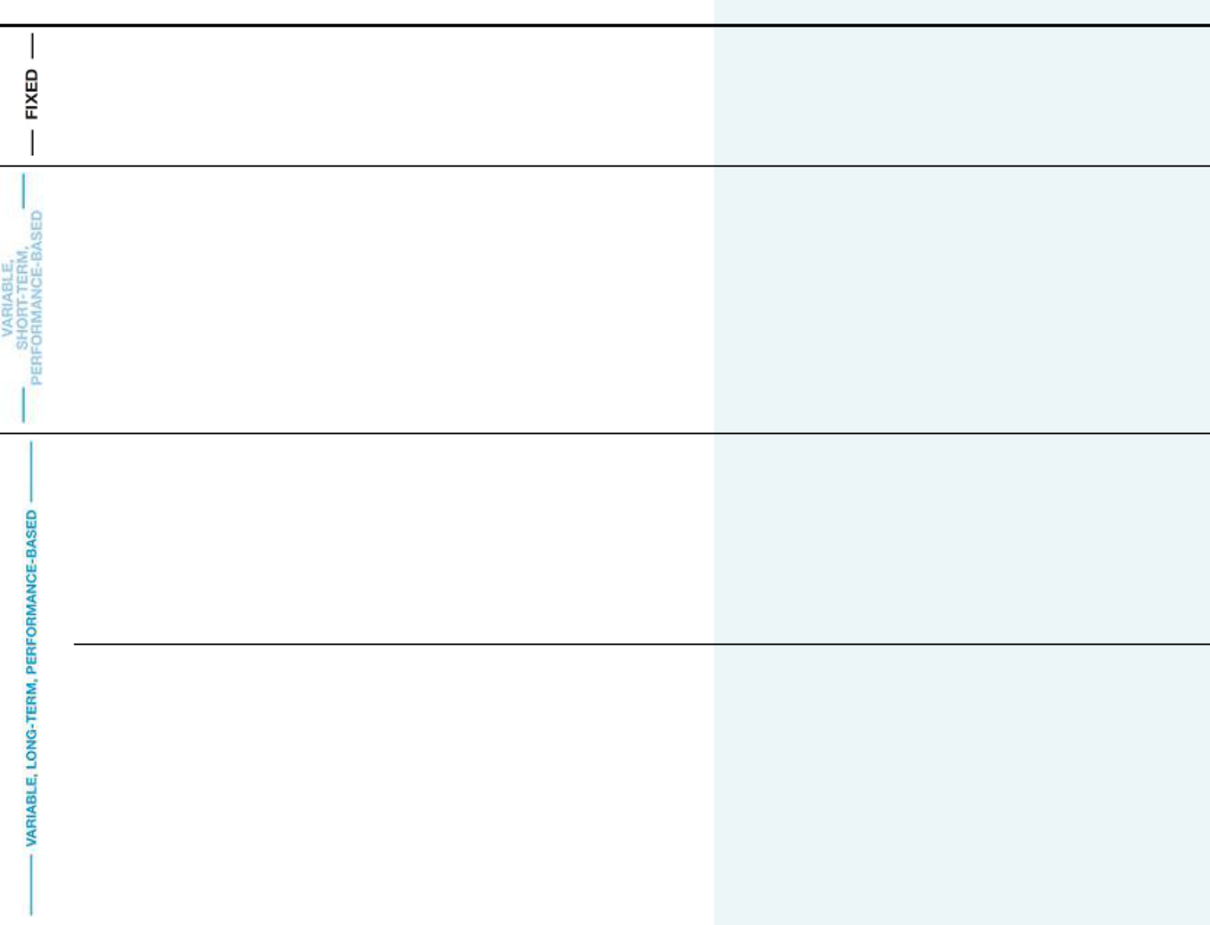

TYPE ELEMENT WHY WE USED IT COMPENSATION HIGHLIGHTS

Base Salary • Necessary to attract and retain our NEOs.

- Serves as a baseline measure of an NEO’s value.

- Guaranteed compensation in exchange for investing in a career with us.

- Salary level is based on individual performance, position within the organization and any increase in duties and responsibilities.

Annual Cash • Provides a competitive annual cash bonus opportunity

Bonus and completes our competitive total annual cash

compensation package.

• Target bonus is based on the Compensation

Committee’s assessment of the optimal mix of base salary and annual cash bonus compensation.

• Supports our objective that NEOs must balance

achieving satisfactory or better current year (short-term)

results with long-term value creation.

- Based on objective quantitative financial performance metrics and quantitative and qualitative goals relating to key operational initiatives.

- Includes a qualitative portion based on overall management and role in creating a strong workplace culture that emphasizes integrity, respect and our continuing focus on critical DE&I initiatives.

Annual • Fosters a long-term commitment, motivates executives

Stock Option to improve the long-term market performance of our

Grants stock and focuses them on the long-term creation of

shareholder value.

• Links the NEOs’ decision-making with the long-term

outcomes of those decisions.

• Long vesting period creates a significant retention tool

and ties value ultimately realized to our long-term performance.

- Vest over a 9.5-year period: 30% on the 2nd anniversary of the date of grant, 15% on each of the 3rd through 5th anniversaries, 5% on each of the 6th through 9th anniversaries and 5% on the 9.5-year anniversary.

- Stock price must appreciate for stock options to deliver value.

- Options are net settled, resulting in fewer shares issued upon exercise.

Annual PSU • Fosters a long-term commitment, motivates executives

Grants to improve the long-term market performance of our

stock and focuses them on the long-term creation of shareholder value.

• Links the NEOs’ decision-making with the long-term

outcomes of those decisions.

• Back-end weighted vesting term used for most PSU

grants creates a meaningful retention tool.

• Uses one of the longest vesting periods among our

peers for most grants to create a significant retention

tool and tie value ultimately realized to our long-term

performance.

- Vest over a 5-year period and are back-end weighted: 15% vest after 13 months, 15% on each of the 2nd through 4th anniversaries and 40% on the 5th anniversary.

- Vesting is dependent upon achievement of one or more robust performance goals that are tied to value creation.

- Ultimate value of shares acquired upon vesting depends on stock price.

2021 Proxy Statement | 35

Table of Contents

Emphasis on Performance

- Total performance-based compensation in 2020 (using the grant date value of stock options and PSUs) increased significantly as a percentage of the NEOs’ total compensation.
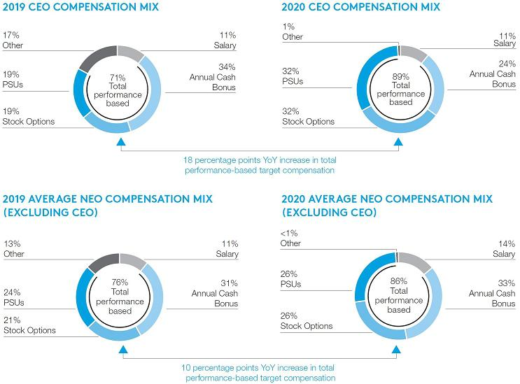

- Our equity-based compensation program aligns the NEOs’ compensation with our shareholders’ interests in that both the achievement of our operating, investing and capital goals and the level at which the awards ultimately pay out would be expected to be reflected to some extent in the market price of our stock. Because a significant portion of compensation for each NEO is in the form of equity, a significant portion of each NEO’s compensation is inherently tied to stock price movement and the achievement of long-term shareholder value creation.

- While our 2020 performance measures were “absolute” in nature, the Compensation Committee also reviewed (i) our performance measures on a “relative” basis compared to our peers over time and (ii) the amount of compensation paid to the NEOs relative to our adjusted EBITDA and free cash flow, as compared to our peers.

- The Compensation Committee reviews the nature and mix of compensation elements, as well as compensation plan design and award terms, to ensure that our compensation program does not include inadvertent incentives for our NEOs to take inappropriate business risks by making decisions that may be in their best interests but not in the best interests of our shareholders. In conducting this review, the Compensation Committee also considers specific business risks identified through our ERM process.

- Based on these reviews, we believe the design of the compensation program for 2020 is appropriate.

- See also “Shareholder Feedback on Executive Compensation and Compensation-Related Changes” for information about changes to our executive compensation program for 2021 that further enhance its performance-based nature, including the use of relative performance metrics.

36

Table of Contents

Compensation Decisions

Base Salary

In March 2020, the Compensation Committee did not increase the base salaries of NEOs other than those of Messrs. Watson and Reid.

In response to the COVID-19 crisis in 2020, Messrs. Roberts, Cavanagh, Watson and Shell donated 100% of their salaries for six months to charities that support COVID-19 relief efforts.

Annual Cash Bonus

Our short-term incentive program includes meaningful performance-based elements tied to financial and operational goals.

- The target bonus opportunity in 2020 was 300% of salary for Messrs. Roberts, Cavanagh and Shell, was 200% of salary for Mr. Reid and increased from 250% to 300% of salary for Mr. Watson in April 2020.

- NEO target bonuses were designed for the NEOs other than Mr. Reid based 80% on quantitative financial goals and a blend of quantitative and qualitative performance relative to strategic operational priorities. The maximum bonus achievable was 175%.

- Below are the target weightings for each element of the NEO cash bonus plan:
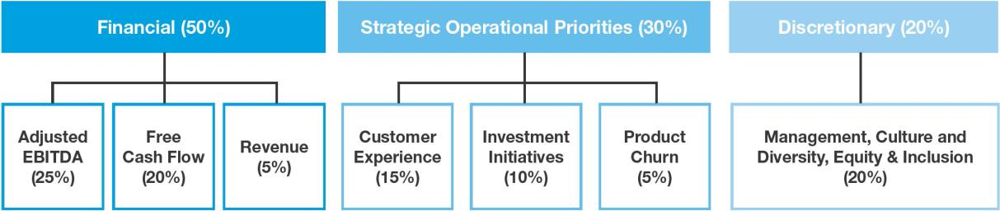

Financial and operational goals are based on a rigorous and in-depth enterprise-wide consolidated budget that is prepared annually and takes into consideration economic factors, the projected operating environment for our businesses in generating profits, working capital and capital expenditure needs for the upcoming year, target product rollout numbers and other relevant incentive factors.

Financial Results

We delivered solid financial and operational results on a consolidated basis in 2020, demonstrating the resilience and strength of our company through the global COVID-19 pandemic. However, due to the negative impacts of COVID-19 on our financial performance in 2020, adjusted EBITDA and revenue financial goals were not achieved, primarily due to closures and/or limited capacity operations of our theme parks, movie theater closures worldwide and the postponement or cancellation of certain sporting events that negatively impacted both our advertising revenues globally and Sky’s revenue from sports package customers, as well as the overall negative economic impacts of the pandemic. The free cash flow performance goal was achieved above target in part due to effective expense and capital spending management in response to the pandemic.

No discretionary adjustments were made to the financial metrics below on account of the impacts from the pandemic.

2021 Proxy Statement | 37

Table of Contents

2020 FINANCIAL METRICS AND RESULTS⁽¹⁾
($ in billions)

 |  |  |  |  | % OF
 |  |  |  | ACTUAL | TARGET
 | THRESHOLD | TARGET | MAXIMUM | ACHIEVEMENT | ACHIEVED
Adjusted EBITDA | $34.55 | $35.261 – $35.461 | $35.95
(excluding Peacock⁽²⁾) | 10% – <25% | 25% | >25% – 37.5% | $31.64 | 0%
Revenue | $113.30 | $114.907 – $115.207 | $116.25
Revenue | 4% – <10% | 10% | >10% – 15% | $102.70 | 0%
Free Cash Flow⁽³⁾ | $11.45 | $12.25 – $12.45 | $13.00
(excluding Peacock⁽²⁾) | 8% – <20% | 20% | >20% – 30% | $14.76 | 30%

- Amounts reflected have been adjusted to reflect Sky results on a constant currency basis.

- Amounts reflected for the threshold, target, maximum and actual achievement exclude the impact of Peacock, which was launched in 2020 and is a component of the strategic operational portion of the annual cash bonus.

- Threshold, target and maximum amounts were established based on a consolidated budget for 2020 that included incremental NBCUniversal and Sky investments, such as launching broadband in Italy and investing in our theme parks, which had significant negative impacts on free cash flow in 2020.

Operating Results

Our operating performance in 2020 was strong, even with the COVID-19 pandemic headwinds. The factors below were evaluated in determining the achievement of strategic operational priorities in the table below:

- Comcast Cable, while keeping employees safe, kept millions of internet customers connected to work and learn from home while maintaining speed and reliability and enabling us to successfully manage the largest sustained traffic surge in history during the peak of COVID-19 in 2020. As described in further detail in “NEO Performance in 2020,” Comcast Cable also helped customers facing economic hardship and expanded our Internet Essentials program. As a result of these efforts, it attained record high residential customer satisfaction scores.

- Comcast Cable’s customer relationships increased by a record 1.6 million and Comcast Cable added a record 2 million net new internet customers.

- Comcast Cable rolled out over 2.6 million Flex boxes, one of its key strategic investment priorities.

- NBCUniversal launched Peacock in 2020 without the anticipated benefit of the Olympics, with 33 million sign-ups in the United States in just over its first six months, ahead of internal goals.

- NBCUniversal reorganized its television and streaming businesses with a centralized structure designed to optimize content creation, distribution and monetization and introduced a new “premium video on demand” strategy to bring movies directly to consumers given movie theater shutdowns.

- NBCUniversal found creative solutions to open its theme parks safely in Orlando, Florida and Osaka, Japan, while attaining strong customer satisfaction scores.

- Sky customer relationships at the end of 2020 returned to 99% of pre-COVID levels.

- Sky successfully executed key initiatives, including expanding Sky Q penetration to over 60% in the United Kingdom, launching Sky broadband in Italy, leveraging Comcast Cable’s xFi platform, and repositioning content investments in Germany.

38

Table of Contents

2020 STRATEGIC OPERATIONAL PRIORITIES⁽¹⁾

 |  |  |  | % OF TARGET | % OF TARGET | % OF TARGET
 |  |  |  | ACHIEVED | % OF TARGET | % OF TARGET
 |  |  |  | (ROBERTS, | ACHIEVED | ACHIEVED
 | THRESHOLD | TARGET | MAXIMUM | CAVANAGH) | (WATSON⁽²⁾) | (SHELL⁽³⁾)
Customer Experience | 0% | 15% | 30% | 16% | 30% | 11%
Product Churn | 0% | 5% | 10% | 5% | 10% | 5%
Investment Initiatives
(Peacock, Flex, Sky initiatives) | 0% | 10% | 20% | 15% | 15% | 25%
Total | 0% | 30% | 60% | 36% | 55% | 41%

- Based in part on whether we have met or exceeded expectations of achievement of quantifiable strategic operational priorities. Customer experience includes our relational net promoter score, unique contact rate and other customer experience metrics. Product churn relates to the stability of our cable customer base and customer net additions. Investment initiatives relate to the success of several company initiatives, including the launch of Peacock, the rollout of Flex and the launch of broadband services in Italy. Further details are not disclosed due to competitive concerns.
- 5% of the 10% target for investment initiatives for Mr. Watson was allocated solely to the rollout of Flex.

- Mr. Shell’s target for customer experience was lower at 10% (with a maximum of 20%) given his role at NBCUniversal, and his target for investment initiatives was higher at 15% (with a maximum of 30%), with 10% of the target being allocated solely to the launch of Peacock.

NEO Performance in 2020

In evaluating the NEOs for the discretionary, qualitative portion of the annual cash bonus, the Compensation Committee considered the contribution of each NEO to the overall management and financial results of our company and to creating a strong workplace culture that emphasizes integrity, respect and our continuing focus on critical DE&I initiatives.

Each of the NEOs successfully led our company during this unprecedented period and managed our company with a view towards the long-term sustainability of our business. In addition to the operational accomplishments described above:

- Mr. Roberts led our company’s strategic focus on broadband, aggregation and streaming, which we believe will position our company to outperform and put us on a trajectory to emerge from this challenging environment in an even stronger position. Mr. Roberts set the tone for our businesses to execute at the highest level, to work together across our complementary, high-performing businesses at Comcast Cable, NBCUniversal and Sky and to continue to accelerate convergence in media and technology. At the same time, he guided our company’s overall response to the pandemic, as well personally leading our social justice commitments, with a focus on doing the right thing for all of our stakeholders and society at large during this unprecedented time.

- Mr. Cavanagh led our businesses to quickly mobilize and analyze how to mitigate key strategic, operational and financial impacts from the pandemic. As well as ensuring our general business continuity, Mr. Cavanagh protected our company by maintaining our current credit ratings, balance sheet strength and liquidity so that we could commit funds to help our customers, employees and other stakeholders during this unprecedented time. He framed key determinations on critical strategic opportunities and operational challenges. He led important decisions about capital spending projects, such as our decision to pause construction on a fourth theme park in Orlando, and the lowering of the weighted average interest cost of our borrowings by 0.18% in 2020 through opportunistic refinancings to take advantage of record low interest rates. In 2020, our company generated consolidated adjusted EBITDA of $30.8 billion and free cash flow of $13.3 billion. Finally, he played a leading role in shaping changes to our compensation programs.

- Mr. Watson successfully led our company’s pledge to keep America connected throughout the pandemic, from mobilizing most employees to work from home virtually overnight, to keeping employees safe, to helping with the challenges faced by our customers and communities working and learning from home. This pledge was made possible in part due to the flexible and reliable broadband network that we have invested significantly in over the years under Mr. Watson’s leadership. These investments have allowed us to proactively manage our network, increase broadband speeds, expand our Internet Essentials program for low-income households and offer new innovative products like Flex and Peacock for free to high-speed internet services customers. Comcast Cable’s financial and operational performance in 2020 outperformed many of our own expectations set before the pandemic, setting record numbers of customer relationships and net high-speed customer additions, while delivering an unparalleled customer experience throughout the pandemic. For these reasons, Mr. Watson was awarded the maximum amount of the customer experience and product churn portions of his cash bonus. Comcast Cable served as a strong anchor for our company overall in 2020, with its revenue increasing by 3.4% to $60 billion and its adjusted EBITDA increasing by 8.6% to $25.3 billion.

2021 Proxy Statement | 39

Table of Contents

- Mr. Shell, in his first year as CEO of NBCUniversal, effectively led, realigned and mitigated negative COVID-19 impacts on NBCUniversal. He successfully launched Peacock, which had over 33 million sign-ups in the United States in just over its first six months without the anticipated benefit of leveraging the Olympics. He also introduced a new “premium video on demand” strategy to bring movies directly to consumers given movie theater shutdowns and realigned how the television, streaming and production businesses should operate to more effectively compete as more consumers shift to viewing streaming content. He encouraged the theme parks in Orlando and Osaka to find innovative and safe solutions for reopening and oversaw the development of Universal Beijing, which is on schedule to open in 2021.

- Mr. Reid led our company’s legal functions to several successes in 2020 including in the face of the difficulties arising from COVID-19 and, having assumed responsibility in January 2020 for overseeing our Government, Political and External Affairs functions at the federal, state and local levels, he counseled the businesses on successful navigation of unique challenges in the face of the pandemic and the 2020 electoral season. Mr. Reid has led our thinking as a new administration takes shape in Washington, D.C. and as the company prepares to act as a constructive partner with government on issues of broadband deployment and affordability. He leads with, and continuously reinforces, his commitment to integrity, and he champions our legal DE&I and pro bono initiatives.

Each of the NEOs worked together to find safe and creative solutions to navigate the COVID-19 pandemic to benefit our employees, customers, communities, suppliers and shareholders now and for the long term. Among other initiatives and accomplishments described above in 2020:

- We committed over $500 million to support our employees where operations were closed or impacted due to the pandemic, made work from home options as broadly available as possible and enhanced safety measures for customer-facing employees and their customers.

- We helped our customers facing economic hardship maintain their broadband service, increased speeds for all Internet Essentials customers, expanded the Internet Essentials program by offering two free months of broadband service and made 1.5 million out-of-home, public WiFi hotspots available for free across the United States.

- Beyond our longstanding commitment to DE&I initiatives, we pledged an additional $100 million over three years to fight injustice and inequality through a coordinated cross-company effort. To date, we have made meaningful progress on this pledge, including by hosting a companywide DE&I day where over 70,000 employees participated; committing funds to BIPOC-owned small businesses that have been affected by extended closures in the wake of COVID-19; leveraging our media resources to highlight Black voices and Black stories; and deepening our longstanding commitment to address digital inequities, including by announcing plans to launch 1,000 WiFi-connected Lift Zones in community centers nationwide and by launching the Internet Essentials Partnership Program to connect large numbers of low-income students to the internet to support distance learning.

NEO Annual Cash Bonus Achievement

As a result of the metrics and performance achievement described above, below is a summary of actual achievement for the 2020 annual cash bonus. Despite the strong individual performance of Messrs. Roberts, Cavanagh, Watson and Shell, the Compensation Committee negatively adjusted their achievement of the discretionary portion of their bonuses given overall company financial performance; Mr. Watson earned more of his discretionary portion relative to the other executives given the relative contribution of Comcast Cable to Comcast’s overall financial performance in 2020 and the exceptional operating performance of Comcast Cable.

 | ROBERTS | CAVANAGH | WATSON | SHELL
Financial Results | 30% | 30% | 30% | 30%
Strategic Operational Priorities | 36% | 36% | 55% | 41%
Discretionary | 9% | 9% | 15% | 4%
Total (% of Target) | 75% | 75% | 100% | 75%
Total Cash Bonus | $7,738,301 | $5,374,040 | $5,943,951 | $5,882,702

Mr. Reid’s bonus was not based on the above bonus structure for NEOs and instead was achieved at 100% based on company and his overall individual performance.

40

Table of Contents

Equity-Based Incentive Compensation

Equity-based incentive compensation granted through 2020 extended vesting periods for options and PSUs over a longer time period than most other large public companies – with options having 10-year terms and vesting over 9.5 years, and PSUs vesting over 5 years and being back-end weighted.

YEAR | 1 | 2 | 3 | 4 | 5 | 6 | 7 | 8 | 9 | 9.5
PSU Vesting
PSU Vesting | 15% | 15% | 15% | 15% | 40%
Option Vesting
Option Vesting | 0% | 30% | 15% | 15% | 15% | 5% | 5% | 5% | 5% | 5%

In determining the total value of equity-based compensation, the Compensation Committee considers, among other things, the overall performance mix of an NEO’s total direct compensation and the value of awards made to other executives, as well as the value of equity-based compensation awarded to comparable NEOs at our peer companies. While the grant date value of equity-based compensation in our annual award program may fluctuate somewhat from year to year, the target value of PSUs the Compensation Committee awards to NEOs is at least equal to or higher than the target value of stock options.

Before the COVID-19 pandemic was declared, the Compensation Committee increased the value of PSUs and stock options, which were granted to the NEOs on March 2, 2020, to place more emphasis on performance-based awards as an overall component of their total compensation.

- The performance condition for PSUs granted in 2020 was not achieved, and therefore the first tranche, representing 15% of such PSUs, did not vest and was forfeited. The performance condition for 2020 was based on growth in year-over-year adjusted EBITDA (excluding Peacock), with 25% to 125% of the number of PSUs subject to vesting if growth had been within specified ranges.

Vesting for each subsequent tranche of PSUs is based on the highest vesting percentage of any prior vesting tranche, or such higher vesting percentage as may be attained for such subsequent tranche based on the same performance condition and achievement ranges provided for in the applicable PSU award. Any portion of PSUs that fails to vest in a year is permanently forfeited. For PSUs that were granted in 2017 through 2019, the fourth, third and second tranches, respectively, vested at the same percentage level as their respective first tranche.

As described above in “Shareholder Feedback on Executive Compensation and Compensation-Related Changes,” the Compensation Committee significantly enhanced the overall equity compensation design for our NEOs in 2021 by moving to a cumulative three-year performance period and incorporating performance metrics into our PSU awards. It believes this new overall design, including changes that will align the NEOs’ equity vesting terms with broader market practice, with PSUs 100% cliff vesting based on payout levels three years following grant date and options vesting over a two- to five-year period, will continue to achieve a long-term focus, strong retention benefits, serve as a valuable tool to attract talent and align our NEOs’ and shareholders’ incentives.

Deferred Compensation

Beginning in March 2021, amounts that our NEOs have deferred under our deferred compensation plans must be notionally invested in either a company stock fund, which tracks the value of our Class A common stock, or several third-party mutual and exchange funds, which will eliminate above-market interest earnings that had previously been earned through investments in an income fund with a fixed rate of return. Our deferred compensation plan is described in more detail below in the “Nonqualified Deferred Compensation in and as of Fiscal Year-End” table.

2021 Proxy Statement | 41

Table of Contents

Procedures for Determining Compensation

Compensation Committee’s Role, Process and Validation

The Compensation Committee approves the nature and amount of compensation paid to, and the employment and related agreements entered into with, our executive officers, and oversees broad-based cash bonus and equity-based plans, approving guidelines for grants of awards under these plans and determining and overseeing our compensation and benefits policies generally.

In 2020, the Compensation Committee reviewed for our NEOs:

- The nature and amounts of all elements of our NEOs’ compensation, both separately and in the aggregate, using comprehensive tally sheets that include the current value of PSU and stock option awards (as compared to their grant date value).

- Each element of our NEOs’ compensation for internal consistency.

- Various analyses provided by its independent compensation consultant, including:

  - an assessment of the composition of our peer groups;

  - a competitive pay assessment (comparing NEO compensation to that of executives holding comparable positions at our peer group companies as disclosed in proxy statements and to broad groups of companies in published surveys, and analyzing components of pay compared to those of our peer group companies (e.g., fixed vs. variable, components of long-term equity));

  - a financial performance review (comparing our performance relative to our peer group companies with respect to growth in adjusted EBITDA, free cash flow, revenue and total shareholder return, based on financial data from a third-party source);

  - a compensation sharing analysis (analyzing the actual pay delivered to our NEOs as a percentage of our adjusted EBITDA and free cash flow as compared to our peer group companies);

  - an incentive compensation design analysis (analyzing various annual bonus and long-term incentive design elements); and

  - an analysis of equity dilution resulting from, and annual usage rates in, our equity-based compensation plans as compared to our peer group companies (i.e., overhang and burn rates).

- After taking into account the analyses above, the Compensation Committee evaluated our financial performance, as compared to our peers over time, as it related to our strongly competitive compensation philosophy.

- The Compensation Committee also reviews, but does not give significant weight to, aggregate amounts realized or realizable from prior years’ compensation when making decisions regarding current compensation. It believes that value realized on prior years’ compensation from stock appreciation is the reward for the NEOs’ work over that period and reflects the achievement of our long-term goals and, conversely, that lesser amounts realized on prior years’ compensation reflect a lack of achievement of our long-term goals. As such, the Compensation Committee believes that realized or realizable equity compensation is inherently aligned with our long-term performance and shareholders’ interests.

Following these reviews and assessments, and with these goals in mind, the Compensation Committee determines what it believes to be an appropriate current year compensation package for each NEO. This process includes subjective criteria and involves the exercise of discretion and judgment.

Role of Compensation Consultants

The Compensation Committee has directly engaged Korn Ferry as its own independent compensation consultant. In determining 2020 compensation, the Compensation Committee directed Korn Ferry to provide it with various compensation analyses as described above; Korn Ferry did not recommend or determine compensation levels or elements, performance targets or compensation plan design.

The Compensation Committee assessed Korn Ferry’s work as required under SEC rules and concluded that its work for the Compensation Committee in 2020 did not raise any conflicts of interest. Our Compensation Committee reached this determination by reviewing fees paid to Korn Ferry and evaluating its work under applicable SEC and Nasdaq rules on conflicts of interest.

42

Table of Contents

Compensation Consultant Services

Korn Ferry provides research, analysis and input as to the form and amount of executive and director compensation, which generally includes market research utilizing information derived from proxy statements, surveys and its own consulting experience and insight, as well as the provision of other methodological standards and policies in accordance with its established procedures. This research, analysis and input has been provided to both our Compensation Committee and to management. The Compensation Committee collaborated with Korn Ferry to determine and approve the parameters used to conduct the assessment work, including items such as the composition of peer groups, the relevant market statistical reference points within the data (e.g., median) and the elements of compensation. Korn Ferry did not determine or recommend the form or amount of compensation of our NEOs for 2020.

In 2020, we paid Korn Ferry approximately $524,000 for services related to executive and director compensation and approximately $831,000 for leadership and talent consulting and executive search services.

As part of their job responsibilities, certain of our executive officers participate both in gathering and presenting facts related to compensation and benefits matters as requested by the Compensation Committee and in formulating and making recommendations to the Compensation Committee in these areas. These executives, together with our employees who work in the compensation area, also conduct research and consult with compensation consultants, legal counsel and other expert sources to keep abreast of developments in these areas. All decisions, however, regarding the compensation of our NEOs are made by the Compensation Committee and are reviewed by the Board, following reviews and discussions held in executive sessions.

Use of Competitive Data

While peer group and various compensation survey analyses are considered important and valuable by the Compensation Committee, the Compensation Committee does not make any determination of, or change to, compensation in reaction to market data alone. Rather, it uses this information as one of several considerations to inform its decision and put it in context in determining compensation levels (and when to change compensation levels).

Peer Groups

In 2020, we used two core peer groups.

- Entertainment/Media Peer Group. The Compensation Committee historically has paid particular attention to the entertainment/media peer group because it had special relevance with respect to competition for executive talent. The business expertise of employees in this industry is highly correlated to our needs. Media companies continue to look for new ways to distribute and monetize their content, both directly to consumers through the internet and indirectly through traditional and virtual video distributors.

- Transmission/Distribution Peer Group. Comcast Cable and Sky are leading providers of high-speed internet, video, voice and wireless services in the United States and Europe. Many companies in this peer group are among our primary competitors and we compete with each other for executive talent. We also believe our stock price has a strong correlation with certain of these peer group companies.

Below are the companies in our peer groups for 2020; companies in bold were added to our peer groups in 2020.
ENTERTAINMENT/MEDIA |  |  | TRANSMISSION/DISTRIBUTION
• |  | Alphabet, Inc. | • | AT&T Inc.
• |  | Discovery, Inc. | • | Lumen Technologies, Inc. (f/k/a CenturyLink, Inc.)
• |  | Facebook, Inc. | • | Charter Communications, Inc.
• |  | Fox Corp | • | DISH Network Corporation
• |  | Netflix, Inc. | • | Netflix, Inc.
• |  | The Walt Disney Company | • | T-Mobile US, Inc.⁽¹⁾
• |  | ViacomCBS Inc. | • | Verizon Communications Inc.
(1) | In 2020, Sprint Corporation merged with T-Mobile, with T-Mobile as the surviving company.
 |  |  |  | 2021 Proxy Statement | 43

Table of Contents

- Our peer group analyses indicate that overall, our “pay at risk” practices are generally aligned with peer group practices.

- Comparisons for (i) Mr. Roberts were made to peer chief executive officers for the peer groups, (ii) Mr. Cavanagh were made to peer chief financial officers for the peer groups, (iii) Mr. Watson were made to peer chief executive officers of, and by ordinal rank (i.e., the position in the Summary Compensation Table) for, the transmission/distribution peer group, and (iv) Mr. Shell were made to peer chief executive officers of, and by ordinal rank for, the entertainment/media peer group.

- As a supplemental reference point to further inform the Compensation Committee, comparisons were made to general industry peer groups with revenues similar in size to our business as a whole and our business units.

- The Compensation Committee does not determine an NEO’s target compensation solely based on a specific reference point within our peer groups; instead, it reviews our peer group analyses, as well as the other analyses discussed in “Compensation Committee’s Role, Process and Validation,” both to validate our compensation program design and to inform its judgment in determining target compensation.

- The Compensation Committee generally seeks compensation to be competitive (around the median) with the entertainment/media peer group and generally seeks compensation to be in the upper quartile for the transmission/ distribution peer group as a supplemental point of reference.

- The compensation we provide varies when compared among the peer groups and individual companies within a group in its relationship to the reference points above. In reviewing target compensation levels for 2020, Mr. Roberts’ target total remuneration (which includes base salary, target annual cash bonus and equity-based compensation) fell just below the median of that in the entertainment/media peer group. Otherwise, our NEOs’ total compensation for 2020 generally met or exceeded the reference points.

- The Compensation Committee, advised by Korn Ferry, reviewed the criteria for selecting members of the peer groups during 2020, and determined to combine the entertainment/media and transmission/distribution peer groups given the accelerating convergence in media and technology and the complementary nature of, and consolidation in, the media and distribution industries.

Assessing NEO Performance

In determining an NEO’s individual compensation, the Compensation Committee:

- Sets specific factors to be used in evaluating Mr. Roberts, and Mr. Roberts discusses with the Compensation Committee the performance of our other NEOs.

- Assesses each NEO’s responsibilities and roles with respect to overall corporate policy-making, management, operations and administration, as well as the importance of retaining the NEO.

- Evaluates each NEO’s prior year performance, both in terms of his contribution to our performance and as compared to his individual performance goals.

- Evaluates our overall prior year performance, both in terms of financial results and progress on strategic initiatives, including a comparison of our performance to our competitors.

The Compensation Committee employs a rigorous process to evaluate our NEOs’ performance that informs its compensation decisions for the year, including those related to an NEO’s base salary and annual equity awards and the attainment of qualitative objectives for our annual cash bonus. This design allows our Compensation Committee to employ a holistic evaluation process with extensive performance reviews, taking into account factors in and out of management’s control, while balancing it with our financial and shareholder outcomes, to get to a better result than a purely formulaic calculation would provide.

Each year, our Compensation Committee establishes a set of defined objectives for the qualitative portion of our annual cash bonus, which may be tied to an NEO’s or our company’s overall performance, company culture or key company initiatives, such as DE&I and customer experience initiatives, at the time it determines the quantitative metrics. In determining payout levels on the qualitative metrics, the Compensation Committee critically evaluates our company and NEO performance and progress based on the defined objectives.

See “Compensation Decisions” above for information on NEO performance and decisions made in respect of 2020.

44

Table of Contents

Other Compensation Policies and Considerations

Executive Stock Ownership Policy

We have a stock ownership policy for members of our senior management, including our NEOs, that is designed to increase our executives’ ownership stake in our company and align their interests with those of our shareholders.

 | MULTIPLE OF BASE SALARY | COMPLIANCE STATUS AS OF
 | REQUIRED | DECEMBER 31, 2020
Brian L. Roberts | 10x | In compliance
Michael J. Cavanagh | 3x | In compliance
David N. Watson | 3x | In compliance
Jeffrey Shell | 3x | In compliance
Thomas J. Reid | 3x | In compliance

“Ownership” includes (i) stock owned directly or indirectly, (ii) shares credited under our employee stock purchase plan, which must be held for one year from the date credited, and (iii) 60% of deferred vested shares, shares deemed invested in the company stock fund under our deferred compensation plans and the pre-tax net number of shares deliverable upon the exercise of vested stock options. In determining compliance, the Compensation Committee may consider any noncompliance that occurs solely or primarily from a decline in the market price of our stock. If an executive is not in compliance, he or she is prohibited from selling our stock (unless a hardship exemption is granted).

Policies Regarding Trading Activities and Prohibitions on Hedging and Pledging

Our trading policy prohibits our executive officers, certain other high-level employees and directors from buying or selling any of our securities during specified blackout periods, and, when outside of those blackout periods, they may only buy or sell our securities with prior approval in accordance with internal procedures. This seeks to ensure that our executive officers and directors will not trade in our securities at a time when they are in possession of material, nonpublic information.

Our executive officers and directors are prohibited from using any strategies or products (including derivative securities, such as put or call options, or short-selling techniques) to hedge against potential changes in the value of our stock. Executive officers and directors are also prohibited from holding our stock in margin accounts or pledging our stock as collateral for a loan.

No Automatic Payments in Connection with a Change in Control

We generally do not have any benefits, such as accelerated vesting of equity awards, that are “triggered” automatically as a result of a “change in control” (a “single trigger”) or the occurrence of one or more specified events (a “double trigger”) that may follow a change in control, such as termination of employment without cause. Instead, we believe it is in the best interests of our company for our Board and Compensation Committee, who are subject to fiduciary obligations to act in a manner they believe to be in the best interests of our company and shareholders, to retain the discretion to determine whether it is appropriate to accelerate the vesting of stock options and/or stock units or provide other benefits in connection with a particular change in control transaction.

Mr. Roberts’ employment agreement provides that if his employment is terminated following a change in control, that termination will be treated as a termination without cause for the purpose of determining his benefits in those circumstances under his employment agreement. The Compensation Committee approved this provision as a fair and reasonable protection for our Chief Executive Officer in the event of a change in control.

Payments in Connection with a Termination of Employment

Payments to our NEOs upon a termination of employment are described under the “Potential Payments upon Termination or Change in Control” table below. These compensation arrangements are contained in each NEO’s employment or other agreements and are not a factor in the Compensation Committee’s determination of current year compensation elements. These arrangements were arrived at as a result of arm’s-length negotiations in connection with entering into each such agreement, based on the Compensation Committee’s decision that it was appropriate to provide more favorable arrangements than those offered to nonexecutive employees upon termination of employment.

2021 Proxy Statement | 45

Table of Contents

Recoupment (or “Clawback”) Policy

We have an incentive compensation recoupment (or “clawback”) policy providing that, if it is determined by our Board that gross negligence, intentional misconduct or fraud by one of our executive officers or former executive officers caused or partially caused the restatement of all or a portion of our financial statements, the Board, in its sole discretion, may, to the extent permitted by law and our benefit plans, policies and agreements, and to the extent it determines in its sole judgment that it is in our best interests to do so, require repayment of all or a portion of any annual cash bonus, vested stock units (time- or performance-based) or other incentive-based compensation paid to such executive officer or former executive officer (and/or effect the cancellation of unvested stock units) if: (i) the amount or vesting of the incentive-based compensation was calculated based upon, or contingent on, the achievement of financial or operating results that were the subject of or affected by the restatement and (ii) the amount or vesting of the incentive-based compensation would have been less had the financial statements been correct. Our Compensation Committee and the Governance and Directors Nominating Committee review this policy from time to time, and they will review it following the SEC’s adoption of a final rule under the Dodd-Frank Act regarding incentive-based compensation recoupment.

Award Timing

Our annual equity incentive awards are granted in accordance with pre-established grant date schedules. In 2020, our annual equity incentive awards were granted before the COVID-19 pandemic was declared.

Tax and Accounting Considerations

The Compensation Committee considers accounting and tax implications of our compensation and benefit programs, including with respect to the tax deductibility of our executive compensation. Section 162(m) of the Internal Revenue Code generally limits the tax deductibility of compensation paid by public companies to certain executive officers to $1 million. In the exercise of its business judgment and in accordance with its compensation philosophy, the Compensation Committee has previously awarded, and continues to have the flexibility to award, compensation that is not tax deductible if it determines that such award is in our shareholders’ best interests.

In addition, the Internal Revenue Code limits the amount that companies can deduct for the personal use of Company-provided aircraft to the amount recognized as income by the executives who used the aircraft. In 2020, the total amount of our disallowed tax deduction resulting from the personal use of Company-provided aircraft by our NEOs and any guests was approximately $3.6 million.

Other Considerations

The Compensation Committee is aware that Mr. Roberts is our shareholder with the greatest beneficial voting power. The Compensation Committee maintains an objective stance toward Mr. Roberts’ compensation. The Compensation Committee uses the same methods, tools and processes to determine Mr. Roberts’ compensation as it does for our other NEOs.

Compensation Committee Report

We, the members of the Compensation Committee of the Board of Directors, have reviewed and discussed with management the Compensation Discussion and Analysis. Based on this review and discussion, we have recommended to the Board of Directors that the Compensation Discussion and Analysis be included in this proxy statement.

Members of the Compensation Committee

Edward D. Breen (Chair)

Gerald L. Hassell

David C. Novak

46

Table of Contents

Executive Compensation Tables

Summary Compensation Table

Our NEOs are: our Chairman of the Board, President and Chief Executive Officer (Mr. Brian L. Roberts), our Chief Financial Officer (Mr. Michael J. Cavanagh) and our next three most highly compensated executive officers (Messrs. David N. Watson, Jeffrey Shell and Thomas J. Reid). Information is presented only for 2020 for Messrs. Shell and Reid, who first became NEOs with respect to 2020.

 |  |  |  |  |  | CHANGE IN
 |  |  |  |  |  | PENSION
 |  |  |  |  |  | VALUE AND
 |  |  |  |  |  | EARNINGS ON
 |  |  |  |  | NON-EQUITY | NONQUALIFIED
 |  |  | STOCK | OPTION | INCENTIVE PLAN | DEFERRED | ALL OTHER
NAME AND |  | SALARY⁽¹⁾ | AWARDS⁽²⁾ | AWARDS⁽³⁾ | COMPENSATION⁽⁴⁾ | COMPENSATION⁽⁵⁾ | COMPENSATION⁽⁶⁾ | TOTAL
PRINCIPAL POSITION | YEAR | ($) | ($) | ($) | ($) | ($) | ($) | ($)
Brian L. Roberts | 2020 | 3,439,245 | 10,585,278 | 10,600,149 | 7,738,302 | 150,134 | 200,159 | 32,713,267
Chairman of the Board,
Chairman of the Board, | 2019 | 3,291,832 | 5,330,304 | 5,350,324 | 9,974,249 | 7,560,231 | 4,863,243 | 36,370,183
President and Chief
Executive Officer | 2018 | 3,196,313 | 5,328,517 | 5,351,060 | 10,739,611 | 5,695,338 | 4,715,368 | 35,026,207
Michael J. Cavanagh | 2020 | 2,388,462 | 7,039,868 | 7,050,441 | 5,374,039 | 3,335,892 | 62,088 | 25,250,790
Chief Financial Officer | 2019 | 2,285,908 | 6,725,376 | 4,749,955 | 6,926,300 | 3,831,120 | 2,280,818 | 26,799,477
 | 2018 | 1,955,231 | 3,983,004 | 4,001,855 | 6,569,575 | 2,952,011 | 2,240,023 | 21,701,699
David N. Watson | 2020 | 2,039,794 | 4,195,048 | 4,199,443 | 5,943,952 | 3,285,243 | 25,651 | 19,689,131
CEO of Comcast Cable | 2019 | 1,813,904 | 3,237,696 | 3,251,010 | 4,580,108 | 2,522,306 | 1,534,454 | 16,939,478
 | 2018 | 1,538,914 | 2,740,992 | 2,748,460 | 4,188,344 | 2,015,073 | 1,521,216 | 14,752,999
Jeffrey Shell | 2020 | 2,614,534 | 3,744,972 | 3,750,179 | 5,882,702 | 545,769 | 10,000 | 16,548,156
CEO of NBCUniversal
Thomas J. Reid | 2020 | 1,594,904 | 2,246,134 | 2,250,891 | 3,189,808 | 329 | 10,000 | 9,292,066
Chief Legal Officer and
Secretary

- Salary amounts for 2020 include 27 bi-weekly pay periods compared to 26 in 2019. From April 1, 2020 to September 30, 2020, Messrs. Roberts, Cavanagh, Watson and Shell donated 100% of their 2020 salaries to charities to support COVID-19 relief efforts. Salary amounts for 2020 include the following salary donations by Messrs. Roberts, Cavanagh, Watson and Shell: $1,655,933, $1,150,000, $1,000,000 and $1,250,000, respectively.

- Amounts represent the aggregate grant date fair value of PSUs or RSUs granted to the NEOs in accordance with Financial Accounting Standards Board Accounting Standards Codification Topic 718, Compensation — Stock Compensation (“FASB ASC Topic 718”). These amounts, which do not correspond to the actual value that may be realized by the NEOs, were calculated using the valuation assumptions discussed in the “Share-Based Compensation” footnote to the financial statements in our Annual Reports on Form 10-K for the years ended December 31, 2018, 2019 and 2020. The amounts were determined by multiplying the Class A common stock closing price on the date of grant by the number of shares subject to the grant and, for PSUs as defined in the Glossary to FASB ASC Topic 718, taking into account the probable outcome of the PSUs’ performance conditions as of the date of grant and excluding the effect of estimated forfeitures in accordance with SEC rules. The amounts were also discounted to consider that dividend equivalents that accrue during the vesting period are not paid out until the underlying shares vest. The following are the values of the PSUs as of their grant date assuming attainment of the maximum level of performance: Mr. Roberts ($13,231,470), Mr. Cavanagh ($8,799,750), Mr. Watson ($5,243,810) and Mr. Shell ($4,681,130).

- Amounts represent the aggregate grant date fair value of stock options granted to the NEOs in accordance with FASB ASC Topic 718. Under SEC rules, the amounts shown exclude the impact of estimated forfeitures. These amounts, which do not correspond to the actual value that may be realized by the NEOs, were calculated using the Black-Scholes option pricing model, based upon the following valuation assumptions for options granted in March 2020 to our NEOs for their annual option awards: an expected volatility of 21.0%, an expected term to exercise of 6.0 years, an interest rate of 0.95% and a dividend yield of 2.16%. For information on valuation assumptions with respect to grants made before 2020, refer to the footnotes in the “Summary Compensation Table” in our definitive proxy statements filed with the SEC in 2019 and 2018. See the “Grants of Plan-Based Awards” table below for additional information on options granted in 2020.

- Amounts represent annual performance-based bonuses earned by our NEOs under our cash bonus plans. See the “Grants of Plan-Based Awards” table below and “Compensation Discussion and Analysis — Design and Structure of 2020 Executive Compensation — Compensation Decisions — Annual Cash Bonus” above for additional information on these bonuses and the achievement of specified metrics in 2020.

- Amounts represent the dollar value of interest earned on compensation deferred in “income funds” under our deferred compensation plans in excess of 120% of the long-term applicable federal rate. See “Nonqualified Deferred Compensation in and as of Fiscal Year-End” below.

- Amounts for 2020 include: (a) company contributions in January 2020 to our retirement-investment plan accounts in the amount of $10,000 for each NEO; and (b) amounts on account of personal use of Company-provided aircraft (Mr. Roberts, $190,159; Mr. Cavanagh, $52,088; and Mr. Watson, $15,651).

For security and business reasons, Company practices and policy strongly encourage, and in some cases may require, Mr. Roberts to use Company-provided aircraft for business and personal travel. Our other NEOs also have access to Company-provided aircraft for personal travel, as it affords all of our NEOs greater security, allows travel time to be used productively and enables them to be immediately available to respond to business priorities from any location.

2021 Proxy Statement | 47

Table of Contents

Our policy allows an NEO to bring guests, such as family members, on flights on Company-provided aircraft. The NEOs are required to pay us for personal use of Company-provided aircraft in amounts determined by Company policy. The NEOs are imputed income for costs related to use of Company-provided aircraft when required under Internal Revenue Code guidelines. We do not reimburse the NEOs for any taxes incurred as a result of imputed income. In addition, the Internal Revenue Code limits the amount that we can deduct for the personal use of Company-provided aircraft to the amount recognized as income by our executives who use the aircraft; the amounts in the table above do not include our 2020 disallowed tax deduction of $3.6 million resulting from the personal use of Company-provided aircraft by our NEOs and any guests.

The amounts reflected for each NEO on account of personal use of Company-provided aircraft indicate the extent to which the incremental cost of such use exceeds the amount paid to us by the NEO. The aggregate incremental cost for a personal flight on a charter plane is the cost of the flight as charged to us by the charter company. The aggregate incremental cost for a personal flight taken on a third party-owned plane that is serviced by us includes all variable costs attributable to that flight (including for repositioning flights), such as fuel, trip and allocable maintenance expenses and third-party lease payments. The aggregate incremental cost for a personal flight on a Company plane includes all variable costs for the year, such as fuel, maintenance and other trip expenses, to arrive at a variable cost per hour that we then multiply by the number of hours the NEO used the aircraft for personal travel (including the hours for repositioning flights). These methodologies exclude fixed costs, as these costs do not change based on usage.

For all other benefits that would otherwise be considered perquisites, our NEOs are required to pay us in full (and have paid us in full) for such benefits.

Grants of Plan-Based Awards

The table below provides information about equity and non-equity awards granted to our NEOs in 2020 as follows: (1) the grant date for equity awards; (2) the estimated future payouts under non-equity incentive plan awards (columns (a), (b) and (c)); (3) the estimated future payouts under equity incentive plan awards, which consist of PSUs (columns (d), (e) and (f)); (4) RSU awards that were not performance-based (column (g)); (5) option awards, which consist of the number of shares underlying stock options (column (h)); (6) the exercise price of the stock option awards, which reflects the closing price of our Class A common stock on the date of grant (column (i)); and (7) the grant date fair value of each equity award computed in accordance with FASB ASC Topic 718 (column (j)).

 |  |  |  |  |  |  |  |  | ALL OTHER | ALL OTHER |  | GRANT
 |  |  |  |  |  |  |  |  | STOCK | OPTION | EXERCISE | DATE
 |  | ESTIMATED FUTURE PAYOUTS UNDER |  |  |  |  |  |  | AWARDS: | AWARDS: | OR BASE | FAIR VALUE
 |  | NON-EQUITY INCENTIVE PLAN |  |  |  | ESTIMATED FUTURE PAYOUTS |  |  | NUMBER | NUMBER OF | PRICE OF | OF STOCK
 |  |  | AWARDS⁽¹⁾ |  |  | UNDER EQUITY |  |  | OF SHARES | SECURITIES | OPTION | AND OPTION
 |  |  | ($) |  |  | INCENTIVE PLAN AWARDS⁽²⁾ |  |  | OF STOCK | UNDERLYING | AWARDS | AWARDS⁽⁴⁾
 | GRANT | THRESHOLD | TARGET | MAXIMUM |  | THRESHOLD | TARGET | MAXIMUM | OR UNITS⁽²⁾ | OPTIONS⁽³⁾ | ($) | ($)
NAME | DATE | (a) | (b) | (c) |  | (d) | (e) | (f) | (g) | (h) | (i) | (j)
Brian L. | — | 2,063,547 | 10,317,735 | 18,056,036
Roberts | 3/2/2020 |  |  |  |  | 62,322 | 249,300 | 311,622 |  |  |  | 10,585,278
 | 3/2/2020 |  |  |  |  |  |  |  |  | 1,623,300 | 42.52 | 10,600,149
Michael J. | — | 1,433,077 | 7,165,386 | 12,539,426
Cavanagh | 3/2/2020 |  |  |  |  | 41,448 | 165,800 | 207,248 |  |  |  | 7,039,868
 | 3/2/2020 |  |  |  |  |  |  |  |  | 1,079,700 | 42.52 | 7,050,441
David N. | — | 1,223,876 | 6,119,382 | 10,708,919
Watson | 3/2/2020 |  |  |  |  | 24,700 | 98,800 | 123,500 |  |  |  | 4,195,048
 | 3/2/2020 |  |  |  |  |  |  |  |  | 643,100 | 42.52 | 4,199,443
Jeffrey | — | 1,568,720 | 7,843,602 | 13,726,304
Shell | 3/2/2020 |  |  |  |  | 22,048 | 88,200 | 110,248 |  |  |  | 3,744,972
 | 3/2/2020 |  |  |  |  |  |  |  |  | 574,300 | 42.52 | 3,750,179
Thomas J. | — | 574,165 | 3,189,808 | 5,661,909
Reid | 3/2/2020 |  |  |  |  |  |  |  | 52,900 |  |  | 2,246,134
 | 3/2/2020 |  |  |  |  |  |  |  |  | 344,700 | 42.52 | 2,250,891

- Represents annual performance-based bonus awards granted under our cash bonus plans. The actual amounts earned with respect to these bonuses are included in the “Summary Compensation Table” above under the “Non-Equity Incentive Plan Compensation” column.

- The amounts in columns (d) through (f) represent shares of Class A common stock underlying PSUs granted under our 2002 Restricted Stock Plan that vest based on the achievement of the performance condition as described above in “Compensation Discussion and Analysis — Design and Structure of 2020 Executive Compensation — Equity-Based Incentive Compensation.” The RSUs in column (g) vest as follows: 15% on the 13-month anniversary and the second, third and fourth anniversaries of the date of grant and 40% on the fifth anniversary of the date of grant. Dividend equivalents accrue on shares underlying PSUs, although the amounts will only be paid (without interest) if and when the shares underlying PSUs vest.

48

Table of Contents

- The amounts in this column represent shares of our Class A common stock underlying stock options granted under our 2003 Stock Option Plan. Options become exercisable as follows: 30% of the shares become exercisable on the second anniversary of the date of grant, 15% on each of the third, fourth and fifth anniversaries of the date of grant, 5% on each of the sixth through ninth anniversaries of the date of grant and 5% on the nine-and-a-half-year anniversary of the date of grant.

- The amounts in this column represent the grant date fair value of PSUs, RSUs and stock options computed in accordance with FASB ASC Topic 718. These amounts do not necessarily correspond to the actual value that may be realized by the NEOs. The grant date fair value of PSUs and RSUs was determined as described in footnote (2) to the “Summary Compensation Table.” Amounts with respect to stock options were calculated using the Black-Scholes option pricing model, based upon the assumptions set forth in footnote (2) to the “Summary Compensation Table.”

Outstanding Equity Awards at Fiscal Year-End

The following table provides information on the holdings of stock options and stock awards by our NEOs as of December 31, 2020. This table includes unexercised vested and unvested options to purchase shares of Class A common stock (see columns (a), (b), (c) and (d)), unvested RSUs with respect to shares of Class A common stock (see columns (e) and (f)) and unvested PSUs with respect to shares of Class A common stock (see columns (g) and (h)). The vesting schedules for these grants are disclosed in the footnotes to this table. The market value of stock awards is based on the closing market price of a share of our Class A common stock as of December 31, 2020, or $52.40.

 |  | OPTION AWARDS |  |  |  |  | STOCK AWARDS
 |  |  |  |  |  |  |  |  | EQUITY
 |  |  |  |  |  |  |  | EQUITY | INCENTIVE
 |  |  |  |  |  |  |  | EQUITY | PLAN AWARDS:
 |  |  |  |  |  |  |  | INCENTIVE | MARKET VALUE
 |  |  |  |  |  |  |  | PLAN AWARDS: | OR PAYOUT
 |  |  |  |  |  |  |  | NUMBER OF | VALUE OF
 |  |  |  |  |  |  | MARKET | UNEARNED | UNEARNED
 | NUMBER OF | NUMBER OF |  |  |  | NUMBER OF | VALUE OF | SHARES, | SHARES,
 | SECURITIES | SECURITIES |  |  |  | SHARES OR | SHARES OR | UNITS OR | UNITS OR OTHER
 | UNDERLYING | UNDERLYING | OPTION |  |  | UNITS OF | UNITS OF | OTHER | RIGHTS THAT
 | UNEXERCISED | UNEXERCISED | EXERCISE | OPTION |  | STOCK THAT | STOCK | RIGHTS | HAVE
 | OPTIONS | OPTIONS | PRICE | EXPIRATION |  | HAVE NOT | THAT HAVE | THAT HAVE | NOT VESTED
 | EXERCISABLE | UNEXERCISABLE⁽³⁾ | ($) | DATE |  | VESTED⁽⁴⁾ | NOT VESTED | NOT VESTED⁽⁴⁾ | ($)
NAME | (a) | (b) | (c) | (d) |  | (e) | (f) | (g) | (h)
Brian L. Roberts |  |  |  |  |  |  |  | 680,894 | 35,678,846
 | 1,678,000 | — | 12.510 | 03/24/2021
 | 1,179,000 | 131,000 | 14.995 | 03/22/2022
 | 1,030,200 | 181,800 | 20.610 | 03/21/2023
 | 772,000 | 193,000 | 25.000 | 03/20/2024
 | 680,700 | 226,900 | 29.725 | 03/19/2025
 | 560,880 | 373,920 | 29.880 | 03/17/2026
 | 345,960 | 422,840 | 37.460 | 03/16/2027
 | 224,520 | 523,880 | 35.830 | 03/15/2028
 | — | 676,400 | 40.470 | 03/14/2029
 | — | 1,623,300 | 42.520 | 03/01/2030
Michael J.
Cavanagh |  |  |  |  |  |  |  | 609,148 | 31,919,355
 | 536,220⁽¹⁾ | 178,740 | 28.320 | 05/14/2025
 | 419,520⁽²⁾ | 279,680 | 29.880 | 03/17/2026
 | 258,615⁽²⁾ | 316,085 | 37.460 | 03/16/2027
 | 167,910⁽²⁾ | 391,790 | 35.830 | 03/15/2028
 | — | 600,500 | 40.470 | 03/14/2029
 | — | 1,079,700 | 42.520 | 03/01/2030
 |  |  |  |  |  |  |  | 2021 Proxy Statement |  | 49

Table of Contents

 |  | OPTION AWARDS |  |  |  |  | STOCK AWARDS
 |  |  |  |  |  |  |  |  | EQUITY
 |  |  |  |  |  |  |  | EQUITY | INCENTIVE
 |  |  |  |  |  |  |  | EQUITY | PLAN AWARDS:
 |  |  |  |  |  |  |  | INCENTIVE | MARKET VALUE
 |  |  |  |  |  |  |  | PLAN AWARDS: | OR PAYOUT
 |  |  |  |  |  |  |  | NUMBER OF | VALUE OF
 |  |  |  |  |  |  | MARKET | UNEARNED | UNEARNED
 | NUMBER OF | NUMBER OF |  |  |  | NUMBER OF | VALUE OF | SHARES, | SHARES,
 | SECURITIES | SECURITIES |  |  |  | SHARES OR | SHARES OR | UNITS OR | UNITS OR OTHER
 | UNDERLYING | UNDERLYING | OPTION |  |  | UNITS OF | UNITS OF | OTHER | RIGHTS THAT
 | UNEXERCISED | UNEXERCISED | EXERCISE | OPTION |  | STOCK THAT | STOCK | RIGHTS | HAVE
 | OPTIONS | OPTIONS | PRICE | EXPIRATION |  | HAVE NOT | THAT HAVE | THAT HAVE | NOT VESTED
 | EXERCISABLE | UNEXERCISABLE⁽³⁾ | ($) | DATE |  | VESTED⁽⁴⁾ | NOT VESTED | NOT VESTED⁽⁴⁾ | ($)
NAME | (a) | (b) | (c) | (d) |  | (e) | (f) | (g) | (h)
David N. Watson |  |  |  |  |  | 35,090 | 1,838,716 | 322,300 | 16,888,520
 | 79,314 | — | 12.630 | 02/24/2021
 | 330,000 | — | 12.510 | 03/24/2021
 | 138,000 | 31,000 | 14.995 | 03/22/2022
 | 171,240 | 42,660 | 20.610 | 03/21/2023
 | 180,480 | 45,120 | 25.000 | 03/20/2024
 | 159,300 | 53,100 | 29.725 | 03/19/2025
 | 107,660 | 87,440 | 29.880 | 03/17/2026
 | 80,775 | 98,725 | 37.460 | 03/16/2027
 | 115,320 | 269,080 | 35.830 | 03/15/2028
 | — | 411,000 | 40.470 | 03/14/2029
 | — | 643,100 | 42.520 | 03/01/2030
Jeffrey Shell |  |  |  |  |  | 216,769 | 11,358,696 | 110,248 | 5,776,995
 | — | 303,040 | 44.090 | 12/19/2029
 | — | 574,300 | 42.520 | 03/01/2030
Thomas J. Reid |  |  |  |  |  | 119,200 | 6,246,080
 | — | 344,700 | 42.520 | 03/01/2030
- Mr. Cavanagh assigned to a family trust a portion of these options representing 321,732 shares.

- Mr. Cavanagh assigned these options to a family trust.

- The expiration date occurs one day prior to the tenth anniversary of the grant date. Shares underlying stock options as of the respective grant date had the following vesting schedule: 30%, 15%, 15%, 15%, 5%, 5%, 5%, 5% and 5% on the second, third, fourth, fifth, sixth, seventh, eighth, ninth, and nine and a half anniversaries of the grant date, respectively.

50

Table of Contents

- The number of shares underlying each outstanding stock unit^{(a)} for the NEOs that remain subject to vesting are as follows:

 | BRIAN L. | MICHAEL J. | DAVID N. | JEFFREY | THOMAS J.
GRANT DATE | ROBERTS | CAVANAGH | WATSON | SHELL | REID
03/01/2016 | — | — | — | 29,728 | —
03/18/2016 | — | 53,600^{(b)} | 16,720 | — | —
03/01/2017 | — | — | — | 36,586 | —
03/17/2017 | 98,175^{(c)} | 73,425^{(c)} | 18,370 | — | —
04/14/2017 | — | — | 46,282^{(d)} | — | —
03/01/2018 | — | — | — | 47,894 | —
03/16/2018 | 130,636^{(e)} | 97,650^{(e)} | 67,200^{(e)} | — | —
03/01/2019 | — | — | — | 54,349 | —
03/15/2019 | 140,461^{(f)} | 177,225^{(f)} | 85,318^{(f)} | — | —
07/05/2019 | — |  | — | — | 66,300
12/20/2019 | — | — | — | 48,212 | —
03/02/2020 | 311,622^{(g)} | 207,248^{(g)} | 123,500^{(g)} | 110,248 | 52,900

- Except as otherwise described in footnote (b), all stock units granted as of the respective grant date had the following vesting schedule: 15%, 15%, 15%, 15% and 40% on the 13-month, second, third, fourth and fifth anniversaries of the grant date, respectively.

- The PSUs granted as of the grant date had the following vesting schedule: 25.6%, 25.6%, 25.6%, 6.3% and 16.8% on the 13-month, second, third, fourth and fifth anniversaries of the grant date, respectively.

- Reflects the number of shares underlying PSUs that, as of December 31, 2020, may be achieved assuming maximum attainment of a performance condition, which would result in 125% vesting of the award. In February 2018, the Compensation Committee certified performance for the first tranche of PSUs, resulting in attainment of 114.5% of the award as follows: Mr. Roberts, 163,502 shares; and Mr. Cavanagh, 122,282 shares. The second through fourth tranches were earned at the same percentage level as the first tranche, because the attainment of the performance condition for those tranches was not above 114.5%. Because the performance condition for these tranches was deemed achieved at 114.5% (rather than at maximum performance of 125%), (i) 10.5% of the target shares underlying these four PSU tranches that would have vested were not achieved and (ii) 10.5% of the target shares underlying the last tranche may be earned based on achievement of the maximum performance conditions.

- Reflects the number of shares underlying PSUs that, as of December 31, 2020, may be achieved assuming maximum attainment of a performance condition, which would result in 125% vesting of the award. In May 2018, the Compensation Committee certified performance for the first tranche of PSUs, resulting in attainment of 100% of the award (67,320 shares). The second through fourth tranches were earned at the same percentage level as the first tranche, because the attainment of the performance condition for those tranches was not above 100%. Because the performance condition for these tranches was deemed achieved at 100% (rather than at maximum performance of 125%), (i) 25% of the target shares underlying these four PSU tranches that would have vested were not achieved and (ii) 25% of the target shares underlying the last tranche may be earned based on achievement of the maximum performance conditions.

- Reflects the number of shares underlying PSUs that, as of December 31, 2020, may be achieved assuming maximum attainment of a performance condition, which would result in 125% vesting of the award. In February 2019, the Compensation Committee certified performance for the first tranche of PSUs, resulting in attainment of 108.3% of the award as follows: Mr. Roberts, 161,688 shares; Mr. Cavanagh, 120,861 shares; and Mr. Watson, 83,173 shares. The second and third tranches were earned at the same percentage level as the first tranche, because the attainment of the performance condition for these tranches was not above 108.3%. Because the performance condition for these tranches was deemed achieved at 108.3% (rather than at maximum performance of 125%), (i) 16.7% of the target shares underlying these three PSU tranches that would have vested were not achieved and (ii) 16.7% of the target shares underlying the remaining two tranches may be earned based on achievement of the maximum performance conditions.

- Reflects the number of shares underlying PSUs that, as of December 31, 2020, may be achieved assuming maximum attainment of a performance condition, which would result in 125% vesting of the award. In February 2020, the Compensation Committee certified performance for the first tranche of PSUs, resulting in attainment of 100% of the award as follows: Mr. Roberts, 132,200 shares; Mr. Cavanagh, 166,800 shares; and Mr. Watson, 80,300 shares. The second tranche was earned at the same percentage level as the first tranche, because the attainment of the performance condition for the second tranche was not above 100%. Because the performance condition for these tranches was achieved at 100% (rather than at maximum performance of 125%), (i) 25% of the target shares underlying these two PSU tranches that would have vested were not achieved and (ii) 25% of the target shares underlying the remaining three tranches may be earned based on achievement of the maximum performance conditions.

- Reflects the number of shares underlying PSUs that, as of December 31, 2020, may be achieved assuming maximum attainment of a performance condition, which would result in 125% vesting of the award. In February 2021, the Compensation Committee certified 0% performance for the first tranche of PSUs. Because no shares underlying the first tranche were achieved, 125% of the target shares underlying the remaining four tranches of the PSUs may be earned based on achievement of the maximum performance conditions.

2021 Proxy Statement | 51

Table of Contents

Option Exercises and Stock Vested

The following table provides information, for each of our NEOs, on the number of options exercised and the value realized upon such exercise, and the number of shares of Class A common stock resulting from the vesting of stock awards and the value realized before payment of any applicable withholding tax during 2020.

 | OPTION AWARDS |  |  | STOCK AWARDS
 | NUMBER OF | VALUE |  | NUMBER OF | VALUE
 | SHARES | REALIZED ON |  | SHARES | REALIZED ON
 | ACQUIRED ON | EXERCISE |  | ACQUIRED | VESTING
NAME | EXERCISE | ($) |  | ON VESTING | ($)
Brian L. Roberts | 1,166,000 | 41,725,310 |  | 68,608⁽¹⁾ | 2,548,306
Michael J. Cavanagh | — | — |  | 138,103⁽¹⁾ | 5,031,223
David N. Watson | 470,000 | 13,291,600 |  | 62,699 | 2,262,014
Jeffrey Shell | 712,000 | 23,336,045 |  | 78,896 | 3,340,307
Thomas J. Reid | — | — |  | 11,700⁽¹⁾ | 494,793

- Mr. Roberts deferred the vesting of 21,615, 21,857 and 17,673 of these PSUs on March 16, 2020, March 17, 2020 and April 15, 2020, respectively, Mr. Cavanagh deferred the March 18, 2020 vesting of 20,100 of these PSUs and Mr. Reid deferred the August 5, 2020 vesting of 11,700 of these RSUs. The value of the stock units realized on vesting is based on the value of a share of Class A common stock on the original vesting date, regardless of whether the vesting had been deferred. The actual value of the stock units realized upon settlement may be different than the value reflected in this table. The value realized on vesting also is reflected in the “Executive Contributions in Last FY” column of the “Nonqualified Deferred Compensation in and as of Fiscal Year-End” table immediately below; see footnote (5) to that table for additional information regarding these deferrals.

Nonqualified Deferred Compensation in and as of Fiscal Year-End

The table below provides information on the nonqualified deferred compensation of our NEOs in and as of the end of 2020.⁽¹⁾

 |  | EXECUTIVE | AGGREGATE | AGGREGATE | AGGREGATE
 | TYPE OF | CONTRIBUTIONS | EARNINGS IN | WITHDRAWALS/ | BALANCE AT
 | INVESTMENT | IN LAST FY⁽²⁾ | LAST FY⁽³⁾ | DISTRIBUTIONS | LAST FYE⁽⁴⁾
NAME | FUND | ($) | ($) | ($) | ($)
Brian L. Roberts | Income Fund | 11,767,720⁽⁵⁾ | 341,750 | (19,108,550) | 1,480,812
 | Market Funds | 14,218,577⁽⁵⁾ | 13,118,242⁽⁵⁾ | (1,793,471)⁽⁵⁾ | 117,618,534
Michael J. Cavanagh | Income Fund | 811,059⁽⁵⁾ | 4,156,794 | (77,813,426) | —
 | Market Funds | 78,452,812⁽⁵⁾ | 2,141,077⁽⁵⁾ | (811,0559) | 79,782,830
David N. Watson | Income Fund | 203,979 | 3,840,243 | — | 37,301,412
Jeffrey Shell | Income Fund | 3,881,500 | 669,227 | (23,088,519) | 8,669,948
Thomas J. Reid | Income Fund | — | 13,391 | — | 13,391
 | Market Funds | 494,793⁽⁵⁾ | 118,287⁽⁵⁾ | — | 613,080

- Amounts in this table have been deferred under our deferred compensation plans, except for deferrals of stock units with respect to shares of Class A common stock under our restricted stock plan, as more fully described in footnote (5) to this table. Eligible employees and directors may participate in these plans. As of March 1, 2021, amounts credited to an NEO’s account may only be invested notionally in a third-party mutual or exchange fund or our company’s common stock fund, although for 2020, NEOs were permitted to invest amounts instead in an income fund, subject to a cap on the amount that could be invested in the income fund. The interest crediting rate in the income fund was 9%, or 12% for certain grandfathered amounts.

Under our restricted stock plan, eligible employees may defer the receipt of shares that may, subject to an award of stock units, vest in the future. Upon vesting, deferred stock units are invested in our company stock fund. An employee who has elected to defer stock units may also make a “diversification election” of the shares subject to such stock units (or such greater percentage authorized by the Compensation Committee) to have the value of such stock units transferred to our deferred compensation plans.

During 2020, (i) the annual rates of return under the third-party mutual or exchange funds were as follows: 1.92%, 7.41%, 10.71%, 18.4%, and 20.64%, and (ii) the annual rate of return under our company stock fund was 19.16%.

52

Table of Contents

- These amounts (other than amounts related to deferrals of PSUs) are reported as compensation in the “Summary Compensation Table” above under the columns “Salary” and “Non-Equity Incentive Plan Compensation.”

- The portion of these amounts that represents interest earned in excess of 120% of the long-term applicable federal rate is reported as compensation in the “Summary Compensation Table” above under the column “Change in Pension Value and Earnings on Nonqualified Deferred Compensation.”

- All amounts contributed in prior years under our deferred compensation plans have been reported in the Summary Compensation Table in previously filed proxy statements in the year earned to the extent an individual was an NEO for purposes of the SEC’s executive compensation disclosure. The grant date fair value of stock units deferred under our restricted stock plan has been reported in the year granted in the Summary Compensation Table in previously filed proxy statements.

- Pursuant to our restricted stock plan, as described in footnote (1) to this table, (i) Mr. Roberts deferred the vesting of 21,615 PSUs on March 16, 2020, 21,857 PSUs on March 17, 2020 and 17,673 PSUs on April 15, 2020, Mr. Cavanagh deferred the March 18, 2020 vesting of 17,920 PSUs and Mr. Reid deferred the August 5, 2020 vesting of 11,700 RSUs. Pursuant to diversification elections for 2020, deferred PSUs were deemed invested in an income fund instead of our stock fund for Messrs. Roberts and Cavanagh. These amounts are included in the “Market Funds” row of the “Aggregate Withdrawals/Distributions” column and are also included in the amount shown in the “Income Fund” row of the “Executive Contributions in Last FY” column to reflect the value deemed invested in the income fund and aggregated with the respective NEO’s cash deferred compensation accounts on their respective diversification dates. The amounts shown in the “Market Funds” row of the “Executive Contributions in Last FY” column reflect the aggregate value of (i) stock units that were deferred in 2020 as of their respective vesting dates and (ii) amounts deemed invested in third-party mutual or exchange funds that were first made available to executive officers at the end of 2019; the amounts shown in the “Market Funds” row of the “Aggregate Earnings in Last FY” column reflect the value of any aggregate gain or loss in 2020 of deferred stock units.

Agreements with Our Named Executive Officers

Each of our NEOs has an employment agreement with us that has the following key provisions. Mr. Roberts’ agreement was effective as of August 1, 2017 and provides for an initial term of employment through July 31, 2020, which term will be extended automatically by one additional day for each day that elapses after August 1, 2017 (so that the term of the agreement will always be three years), unless otherwise terminated by either party in accordance with the employment agreement. Mr. Cavanagh’s agreement was entered into on December 21, 2018 and secures his employment through December 31, 2023. Mr. Watson’s agreement was entered into on March 1, 2018 and, as amended, secures his employment through June 30, 2025. Mr. Shell’s agreement was entered into on February 19, 2020 and secures his employment through December 31, 2024. Mr. Reid’s agreement was entered into on April 15, 2019 and secures his employment through December 31, 2023.

Each of the employment agreements provides for a base salary either as specified in the agreement or otherwise then in effect. An NEO’s salary may not be reduced, except under an overall plan to reduce the salary on a basis consistent with other senior executives at their respective levels. The NEOs also are eligible to receive an annual performance bonus, payable in cash, of a percentage of their respective base salaries for the applicable year. Messrs. Roberts’, Cavanagh’s, Watson’s and Shell’s target bonus opportunity may not be less than 300% of their respective base salaries if all performance targets are achieved (200% of base salary in the case of Mr. Reid). Our NEOs are also entitled to receive certain severance benefits under their respective agreements in the event of a qualifying termination of employment as described under the “Potential Payments upon Termination or Change in Control” table below.

Under the agreements, each NEO has agreed not to compete with us during his employment and, in the event his employment terminates other than by us without cause or by him with good reason, for one year after termination of his employment. For our NEOs (other than Mr. Roberts), if we have not renewed the executive’s employment agreement and he terminates his employment after the end of the initial term of the agreement (other than for good reason), we may elect to have the noncompetition provisions apply in exchange for providing him with one year’s base salary and bonus. Notwithstanding the foregoing, as Mr. Reid is an attorney, he may engage in the practice of law.

Each of our NEOs has agreed not to solicit our employees or customers for one year after termination of his employment and is subject to confidentiality covenants. Each has agreed to maintain the confidentiality of our information and not to use such information, except for our benefit, at all times during and after his employment with us.

Potential Payments upon Termination or Change in Control

The table below describes the payments and benefits to which each of our NEOs would have been entitled (i) had his employment terminated on December 31, 2020 (a) by us without cause or by him with good reason, (b) because of his death, (c) due to his disability or (d) upon his retirement or (ii) upon a change in control. In addition to the specific payments and benefits described below for each NEO, our NEOs also would have been entitled to receive any benefits due under the terms of our benefit plans and programs, including our deferred compensation plans described in further detail in the “Nonqualified Deferred Compensation in and as of Fiscal Year-End” table above. All amounts are estimates only, and actual amounts will vary depending upon the facts and circumstances applicable at the time of the triggering event.

2021 Proxy Statement | 53

Table of Contents

 |  |  |  | ACCELERATION/
 |  |  |  | CONTINUED
 |  |  |  | VESTING & | ACCELERATION/
 |  |  |  | EXERCISABILITY | CONTINUED
 |  | ANNUAL | ACCRUED | OF UNVESTED | VESTING OF | HEALTH
 | BASE SALARY | CASH BONUS | ANNUAL CASH | STOCK | UNVESTED | BENEFIT
 | CONTINUATION | CONTINUATION | BONUS | OPTIONS⁽¹⁾ | STOCK UNITS⁽¹⁾ | CONTINUATION | TOTAL
NAME | ($) | ($) | ($) | ($) | ($) | ($) | ($)
Brian L. Roberts
Without Cause/With Good | 9,935,598 | 29,806,794 | 10,317,735 | 68,638,890 | 29,594,420 | 33,123 | 148,326,560
Reason⁽²⁾
Death⁽³⁾ | — | — | 10,317,735 | 68,638,890 | 29,594,420 | 209,778 | 108,760,823
Disability⁽⁴⁾ | 9,935,598 | 29,806,794 | 10,317,735 | 68,638,890 | 29,594,420 | — | 148,293,437
Retirement⁽⁵⁾ | — | — | — | — | — | — | —
Change in Control⁽⁶⁾ | — | — | — | — | — | — | —
Michael J. Cavanagh
Without Cause/With Good | 4,600,000 | 6,900,000 | 7,165,386 | 8,050,936 | 7,333,956 | 28,335 | 34,078,613
Reason⁽⁷⁾
Death/Disability⁽⁸⁾ | 575,000 | — | 7,165,386 | 39,648,124 | 26,883,244 | — | 74,271,754
Retirement⁽⁵⁾ | — | — | — | — | — | — | —
Change in Control⁽⁶⁾ | — | — | — | — | — | — | —
David N. Watson
Without Cause/With Good | 4,000,000 | 6,000,000 | 5,943,951 | 5,728,575 | 3,729,256 | 22,082 | 25,423,864
Reason⁽⁷⁾
Death/Disability⁽⁸⁾ | 500,000 | — | 5,943,951 | 24,115,861 | 15,583,341 | — | 46,143,153
Retirement⁽⁵⁾ | — | — | — | 24,115,861 | 15,583,341 | — | 39,699,202
Change in Control⁽⁶⁾ | — | — | — | — | — | — | —
Jeffrey Shell
Without Cause/With Good | 5,000,000 | 7,500,000 | 7,843,602 | 755,479 | 4,260,015 | 36,742 | 25,395,838
Reason⁽⁷⁾
Death/Disability⁽⁸⁾ | 625,000 | — | 7,843,602 | 8,192,346 | 15,980,376 | — | 32,641,324
Retirement⁽⁵⁾ | — | — | — | — | — | — | —
Change in Control⁽⁶⁾ | — | — | — | — | — | — | —
Thomas J. Reid
Without Cause/With Good | 3,090,000 | 3,090,000 | 3,189,808 | — | 1,028,874 | 22,082 | 10,420,764
Reason⁽⁷⁾
Death/Disability⁽⁸⁾ | 386,250 | — | 3,189,808 | 3,405,636 | 6,246,080 | — | 13,227,774
Retirement⁽⁵⁾ | — | — | — | — | — | — | —
Change in Control⁽⁶⁾ | — | — | — | — | — | — | —

- Based on the closing market price of a share of our Class A common stock as of December 31, 2020 ($52.40), minus, in the case of stock options, the exercise price and, in the case of PSUs granted in 2020, is based on the target vesting.

- Mr. Roberts’ termination without cause or with good reason would entitle him to (i) payment of his base salary on a monthly basis for three years after the termination date, (ii) payment of his annual cash bonus (appropriately prorated for partial calendar years), assuming full achievement of performance goals, on an annual basis for three years and (iii) vesting of his unvested stock options and stock units in accordance with their terms as if his employment had continued. Mr. Roberts’ receipt of the payments and benefits is subject to his execution of our standard agreement containing certain mutual releases. Mr. Roberts is also entitled to receive a prorated annual cash bonus for the year of his termination, assuming full achievement of the performance goals, and to continued health and welfare benefits for three years after the termination date.

- Upon Mr. Roberts’ death, his unvested stock options and stock units will vest in full and his options will remain exercisable for the remainder of their terms. His spouse or his or her estate will receive payment of his annual cash bonus, prorated to reflect the number of days he was employed during the year of his death (assuming full achievement of the performance goals), and his spouse will receive health and welfare benefits during her lifetime.

54

Table of Contents

- If Mr. Roberts’ employment is terminated by reason of his disability, we must continue to pay his base salary on a monthly basis for three years, his annual cash bonus (appropriately prorated for partial calendar years), assuming full achievement of performance goals, on an annual basis for three years, and his unvested stock options and stock units will vest in full and his options will remain exercisable for the remainder of their term. In the event of Mr. Roberts’ death prior to the end of such three-year period, no remaining payments will be made.

- Upon reaching the age of 62, certain senior executives, including our NEOs, are entitled to (i) the continued vesting and exercisability of options following termination for (a) 36 and 39 months, respectively, with 10 years of service, (b) 60 and 63 months, respectively, with 15 years of service and (c) 114 and 117 months, respectively, with 20 years of service, provided that no option will be exercisable after the 10th anniversary of the date of grant; and (ii) the continued vesting of stock units following termination for (x) 36 months with 10 years of service, (y) 48 months with 15 years of service and (z) 60 months with 20 years of service.

- None of our NEOs’ employment agreements provides for the automatic accelerated vesting of equity awards in connection with a change in control (a “single trigger”), and none of our NEOs’ employment agreements, other than Mr. Roberts’, provides for the automatic accelerated vesting of equity awards upon the occurrence of one or more specified events that may follow a change in control, such as a termination of employment (a “double trigger”). Under Mr. Roberts’ employment agreement, if we were to terminate Mr. Roberts’ employment following a change in control transaction, it would be treated as a termination without cause and he would be entitled to the same amounts set forth in the “Without Cause/With Good Reason” category, as described in footnote (2) to this table.

- If we terminate such executive’s employment without cause or he terminates with good reason, he will receive his then-current base salary and continued health benefits for a period of 24 months. If he becomes reemployed, these payments will be reduced by the amount of any compensation earned or received by him in respect of such period and we will stop providing health and welfare benefits.

Such executive will receive the full (non-prorated) amount of the current year’s annual cash bonus (assuming full achievement of performance goals) and the following year’s target annual cash bonus (prorated for time employed during the year of termination and assuming full achievement of performance goals). Stock options and stock units will continue to vest in accordance with their respective terms for 12 months following termination, and vested stock options will remain exercisable for a period equal to the lesser of 15 months or the end of the stock options’ term. Mr. Watson, who is over the age of 62, is entitled to receive retirement-related compensation as set forth in footnote (5) to this table.

The executives’ receipt of the payments and benefits described above are subject to execution of our standard agreement containing certain mutual releases.

- ’If such executive’s employment terminates due to his death or disability, he or his estate will receive three months of base salary and payment of his annual cash bonus, prorated for time employed during the year of such termination (assuming full achievement of performance goals), and his stock options and stock units will fully vest, with stock options remaining exercisable for the remainder of their terms.

Equity Compensation Plan Information

The following table summarizes our equity plan information as of December 31, 2020.

 |  | WEIGHTED-AVERAGE | NUMBER OF SECURITIES
 |  | EXERCISE PRICE | REMAINING AVAILABLE FOR
 | NUMBER OF SECURITIES TO | OF OUTSTANDING | FUTURE ISSUANCE UNDER
 | BE ISSUED UPON EXERCISE | OPTIONS, WARRANTS | EQUITY COMPENSATION PLANS
 | OF OUTSTANDING OPTIONS, | AND RIGHTS⁽²⁾ | EXCLUDING SECURITIES
 | WARRANTS AND RIGHTS⁽¹⁾ | ($) | REFLECTED IN COLUMN (A)⁽³⁾
PLAN CATEGORY | (a) | (b) | (c)
Equity compensation plans approved by
security holders | 260,088,696 | 35.96 | 540,459,353
Equity compensation plans not approved by
security holders | — |  | —
Total | 260,088,696 |  | 540,459,353

- Includes shares of Class A common stock under the following plans: 2003 Stock Option Plan, 2002 Restricted Stock Plan (under which RSUs and PSUs have been granted), Comcast Corporation 2002 Employee Stock Purchase Plan, Comcast-NBCUniversal 2011 Employee Stock Purchase Plan and 2019 Omnibus Sharesave Plan. Also includes our 2002 and 2005 Deferred Compensation Plans (under which shares of Class A common stock have been credited to participants’ accounts).
- The weighted-average exercise price only reflects stock options under our 2003 Stock Option Plan.

- The number of shares available for issuance includes the following number of shares of Class A common stock: 417,739,337 shares available for issuance under the 2003 Stock Option Plan; 87,509,705 shares available for issuance under the 2002 Restricted Stock Plan; 6,053,567 shares available for issuance under the 2019 Omnibus Sharesave Plan; 1,025,740 shares that were issued in connection with the fourth quarter 2020 purchase period under the Comcast Corporation 2002 Employee Stock Purchase Plan, 16,952,666 shares available for issuance under the Comcast Corporation 2002 Employee Stock Purchase Plan; and 269,129 shares that were issued in connection with the fourth quarter 2020 purchase period under the Comcast-NBCUniversal 2011 Employee Stock Purchase Plan and 10,909,209 shares available for issuance under the Comcast-NBCUniversal 2011 Employee Stock Purchase Plan.

2021 Proxy Statement | 55

Table of Contents

CEO Pay Ratio

We are required under SEC rules to provide a pay ratio comparing Mr. Roberts’ 2020 compensation to our median employee’s 2020 compensation (excluding Mr. Roberts). To identify the median employee, we engaged an unaffiliated third-party advisory services firm to conduct a statistical sampling of approximately 177,000 full-time, part-time, seasonal and temporary employees as of December 31, 2020 (which included approximately 51,000 non-U.S. employees) based on comparisons of base wages.

All of our part-time, seasonal and temporary employees as of December 31, 2020, including in our theme park and entertainment production businesses, were required to be taken into account for purposes of identifying our median employee under SEC rules. SEC rules do not permit us to annualize the compensation paid to these workers as if they were full-time employees, which has the effect of reducing the level of our median employee’s total compensation relative to what it would have been had the rules permitted us to annualize compensation across our entire workforce or to use only full-time U.S. employees. As a result, the impact of this rule may be different for us than some companies in our peer groups given the composition of our workforce across our uniquely diversified company, and year-over-year comparisons may not be meaningful. We believe putting into context how our median employee was identified highlights why that employee’s compensation and the resulting pay ratio, and year-over-year changes thereto, should not be compared on an “apples-to-apples” basis.

We have estimated that our pay ratio for 2020 is 380 to 1, calculated by dividing Mr. Roberts’ 2020 total compensation set forth in the Summary Compensation Table, adjusted as described below ($32,727,220), by $86,206, which represents the annual total compensation of our median employee. Our median employee’s annual total compensation was determined using the same methodology we used to determine the annual total compensation of our NEOs, which, along with Mr. Roberts’ compensation, was then adjusted to include the cost to the Company of specified employee benefits provided on a non-discriminatory basis, including group health and welfare benefits and the value of courtesy cable services.

As permitted under SEC rules, we adjusted our total employee population for purposes of identifying our median employee by excluding approximately 1.4% of our employee population as follows (all amounts are approximate): 200 in Brazil; 90 in Canada; 1,060 in India; 960 in Ireland; 160 in Mexico; 10 in Peru; and 50 in Russia.

Audit Committee Matters


Proposal 3: RATIFICATION OF APPOINTMENT OF INDEPENDENT AUDITORS

Our Board unanimously recommends that shareholders vote “FOR” ratification of the appointment of Deloitte & Touche LLP as our independent auditors.

Selection of Independent Registered Public Accounting Firm

The Audit Committee is directly responsible for the appointment, compensation, retention and oversight of our independent auditors, Deloitte & Touche LLP (“Deloitte”). Deloitte, together with its predecessors, has served as our independent auditors since 1963. The lead engagement partner from Deloitte is required to be rotated every five years, and for 2021, a new lead engagement partner was selected in connection with this rotation process. The process for selection of a new lead engagement partner included a meeting between the Chair of the Audit Committee and the candidate for this role, as well as discussion by the full Audit Committee and meetings with senior management.

Each year, the Audit Committee, along with our management and internal auditors, reviews Deloitte’s performance as part of the Audit Committee’s consideration of whether to reappoint the firm as our independent auditors. As part of this review, the Audit Committee considers (i) the continued independence of Deloitte, (ii) its quality of service provided on prior audits, (iii) evaluations of Deloitte by our management and internal auditors, (iv) Deloitte’s effectiveness of communications and working relationships with the Audit Committee and our management and internal auditors, (v) the length of time Deloitte has served as our independent auditors and (vi) the quality and depth of Deloitte and the audit team’s expertise and experience in our industries in light of the breadth, complexity and global reach of our businesses.

56

Table of Contents

Following the Audit Committee’s review of Deloitte’s performance, the Audit Committee appointed Deloitte to serve as our independent auditors for the year ending December 31, 2021. The Audit Committee and our Board recommend that you ratify this appointment, although your ratification is not required. A partner of Deloitte will be present at the annual meeting and will be available to respond to appropriate questions.

Fees of Independent Registered Public Accounting Firm

Set forth below are the fees paid or accrued for the services of Deloitte, the member firms of Deloitte Touche Tohmatsu and their respective affiliates in 2020 and 2019.

 | 2020 | 2019
 | ($ IN MILLIONS)
Audit fees | 21.5 | 28.0
Audit-related fees | 1.2 | 1.5
Tax fees | 1.6 | 0.7
All other fees | — | 0.1
Total | 24.3 | 30.3

Audit fees consisted of fees paid or accrued for services rendered to us and our subsidiaries for the audits of our annual financial statements, audits of our internal control over financial reporting (as required by Section 404 of the Sarbanes-Oxley Act of 2002), reviews of our quarterly financial statements and audit services provided in connection with other statutory, regulatory or contractual requirements.

Audit-related fees consisted of fees paid or accrued for financial due diligence services and attestation services related to contractual and regulatory compliance.

Tax fees consisted of fees paid or accrued for domestic and foreign tax compliance services, including review of tax returns and tax examination assistance.

There were no fees paid or accrued in 2020 and 2019 for tax planning.

Other fees included fees paid or accrued for subscription services, and in 2019 primarily consisted of consulting fees paid or accrued relating to previous Sky engagements.

Preapproval Policy of Audit Committee of Services Performed by Independent Auditors

The Audit Committee’s policy requires that the committee preapprove all audit and non-audit services performed by the independent auditors to assure that the services do not impair the auditors’ independence. Unless a type of service has received general preapproval, it requires separate preapproval by the Audit Committee. Even if a service has received general preapproval, if the fee associated with the service exceeds $1 million in a single engagement or series of related engagements, it requires separate preapproval. The Audit Committee has delegated its preapproval authority to its Chair.

Report of the Audit Committee

The Audit Committee (as used in this section, “we” or “our”) is composed solely of independent directors meeting the requirements of applicable SEC and Nasdaq Global Select Market rules. Each member also is financially literate for audit committee purposes under the Nasdaq rules, and the Board has concluded that Jeffrey A. Honickman and Maritza G. Montiel qualify as audit committee financial experts. The key responsibilities of our committee are set forth in our charter, which was adopted by us and approved by the Board and is posted under “Corporate Governance” in the Investors section of Comcast’s website at www.comcastcorporation.com.

2021 Proxy Statement | 57

Table of Contents

We serve in an oversight capacity and are not intended to be part of Comcast’s operational or managerial decision-making process. Comcast’s management is responsible for the preparation, integrity and fair presentation of information in Comcast’s consolidated financial statements, the financial reporting process and internal control over financial reporting. Deloitte, Comcast’s independent auditors, is responsible for auditing Comcast’s consolidated financial statements and internal control over financial reporting. Our principal purpose is to monitor these processes.

In this context, at each regularly scheduled in-person meeting, we met and held discussions with management, Comcast’s internal auditors and the independent auditors. Management represented to us that Comcast’s consolidated financial statements were prepared in accordance with generally accepted accounting principles applied on a consistent basis.

Prior to their issuance, we reviewed and discussed the quarterly and annual earnings press releases, consolidated financial statements and disclosures under “Management’s Discussion and Analysis of Financial Condition and Results of Operations” (including the presentation of non-GAAP financial information and critical accounting judgments and estimates) with management, Comcast’s internal auditors and the independent auditors. We also reviewed Comcast’s policies and practices with respect to financial risk assessment, as well as its processes and practices with respect to enterprise risk assessment and management. We discussed with the independent auditors critical audit matters identified during the course of the audit and other matters required to be discussed by Public Company Accounting Oversight Board (“PCAOB”) AS 1301, Communications with Audit Committees, and Rule 2-07, Communication with Audit Committees, of Regulation S-X.

We discussed with the independent auditors the overall scope and plans for their audit and approved the terms of their engagement letter. We also reviewed Comcast’s internal audit plan. We met with the independent auditors and with Comcast’s internal auditors, in each case with and without other members of management present, to discuss the results of their respective examinations, the evaluations of Comcast’s internal controls and the overall quality and integrity of Comcast’s financial reporting. Among other things, in our discussions with the independent auditors, we sought their perspectives on the appropriateness of the accounting principles selected by management and their assessment of risk in financial reporting.

Additionally, we reviewed the performance, responsibilities, budget and staffing of Comcast’s internal auditors. We also have established, and oversaw compliance with, procedures for Comcast’s receipt, retention and treatment of complaints regarding accounting, internal accounting controls or auditing matters and its employees’ confidential and anonymous submissions of concerns regarding questionable accounting or auditing matters.

We discussed with the independent auditors the auditors’ independence from Comcast and its management, including the matters required to be discussed by the applicable requirements of the PCAOB and SEC. We also reviewed Comcast’s hiring policies and practices with respect to current and former employees of the independent auditors. We preapproved, in accordance with our preapproval policy described above, all services provided by the independent auditors and considered whether their provision of such services to Comcast is compatible with maintaining the auditors’ independence.

Based on the reviews and discussions referred to above, we recommended to the Board, and the Board approved, that the audited consolidated financial statements be included in Comcast’s Annual Report on Form 10-K for the year ended December 31, 2020, filed with the SEC.

In addition, as in prior years, we, along with Comcast’s management and internal auditors, reviewed Deloitte’s performance as part of our consideration of whether to appoint the firm as independent auditors for 2021 and recommend that shareholders ratify this appointment. As part of this review, we considered the continued independence of Deloitte, the quality of service provided on prior audits, the results of an evaluation of Deloitte by Comcast’s management and internal auditors and Deloitte’s effectiveness of communications and working relationships with us, management and the internal auditors. We also considered the period of time that Deloitte has served as Comcast’s independent auditors and evaluated the quality and depth of the firm and the audit team’s expertise and experience in our industries in light of the breadth, complexity and global reach of Comcast’s businesses. Following this review, we have appointed Deloitte as Comcast’s independent auditors for 2021 and are recommending that Comcast’s shareholders ratify this appointment.

Members of the Audit Committee

Jeffrey A. Honickman (Chair)

Naomi M. Bergman

Maritza G. Montiel

Asuka Nakahara

58

Table of Contents

Shareholder Proposal

We received the following shareholder proposal. The proponent has represented to us that it has continuously held at least $2,000 in market value of our Class A common stock for at least one year and will continue to hold these securities through the date of the annual meeting. We will provide the name, address and share ownership of the shareholder who submitted a Rule 14a-8 stockholder proposal upon a shareholder’s request. To be voted upon at our 2021 annual meeting of shareholders, the proponent, or a representative of the proponent qualified under Pennsylvania law, must be present at the meeting to present the proposal.

Other than adding a brief title, we have included the text of the proposal and the shareholder’s supporting statement. Following the proposal, we explain why our Board recommends a vote AGAINST it.


Proposal 4: SHAREHOLDER PROPOSAL TO CONDUCT INDEPENDENT INVESTIGATION AND REPORT ON RISKS POSED BY FAILING TO PREVENT SEXUAL HARASSMENT

Our Board unanimously recommends that shareholders vote “AGAINST” this shareholder proposal.

Supporting Statement

WHEREAS: Comcast and its subsidiaries are under intense public scrutiny for an alleged failure to protect employees from sexual harassment in the workplace, failing to hold those culpable accountable, and for lacking transparency. NBC attracted global attention when it fired “Today” host Matt Lauer for ongoing sexual harassment of employees. In 2019, Ronan Farrow alleged that NBC covered up accusations against Lauer.

Controversy has focused on NBC’s insistence on conducting an internal investigation led by management, rather than independent advisors. Six presidential candidates called on the Democratic National Committee to demand Comcast conduct an independent investigation into its toxic culture.

In 2019, NBC News’ digital editorial staff formed a union, the NBC News Guild, noting “serious questions” about NBC News’ treatment of women and people of color and how it handled workplace sexual misconduct and its “opaque” procedures for “exposing powerful predators.”

Failure to provide a safe workplace extends to Comcast call centers, where employees have described a hostile culture of sexual harassment. In 2018, Comcast fired three call center employees who filed complaints. One filed a complaint at the U.S. Equal Employment Opportunity Commission (EEOC).

Fear of retaliation in reporting harassment is of concern. An EEOC study of harassment in the workplace found that 75 percent of employees reporting harassment experienced retaliation and that 87 to 94 percent of harassment victims did not file a formal complaint.

Workplace harassment can harm shareholder value. Google committed 310 million dollars to settle a shareholder lawsuit alleging the board mishandled sexual misconduct by executives, notably paying Andy Rubin 90 million dollars after sexual misconduct claims led management to ask for his resignation. The market capitalization of Wynn Resorts dropped 3 billion dollars the two days following harassment allegations against CEO Steve Wynn. 21st Century Fox agreed to a 90 million dollar settlement with shareholders alleging that directors failed to hold accountable senior executives who perpetuated sexual harassment.

Comcast and its subsidiaries rely on consumers to trust their brands. A Harvard Business Review study found a single sexual harassment claim can make a company seem less equitable and more problematic than financial misconduct or fraud and would “be enough to dramatically shape public perception of a company and elicit perceptions of structural unfairness.”

To avoid legal and reputational risk, as the employer of 184,000 workers, Comcast must create a culture of accountability and transparency, and protect employees from harassment and discrimination.

2021 Proxy Statement | 59

Table of Contents

RESOLVED: Shareholders urge the Board of Directors to conduct an independent investigation into and prepare a report (at reasonable expense, omitting confidential and proprietary information) on risks posed by the Company’s failures to prevent workplace sexual harassment.

SUPPORTING STATEMENT: Proponents suggest that the report assess steps Comcast could take to do a better job of holding employees who cause harm accountable, such as integrating metrics on creating a sexual harassment-free workplace into the performance measures of the CEO and senior leadership.

Company Response to Shareholder Proposal

This proposal, in nearly identical form, appeared in our 2020 proxy statement. Our Board concluded then, and continues to believe now, that this proposal is not in the best interest of our shareholders, and a substantial majority of our shareholders also did not support this proposal.

Below is our response to this proposal, exactly as it appeared in last year’s proxy statement, with only one update – to further underscore the commitment of our Board and senior management team to oversee our efforts to combat harassment and discrimination of all forms and to further strengthen our compliance program when possible, in 2020 we consolidated Board oversight of harassment and discrimination issues with the Governance and Directors Nominating Committee and updated its charter to reflect this oversight. The Governance and Directors Nominating Committee oversees and monitors workplace harassment and discrimination, receives regular reports on our compliance program and receives reporting regarding complaints involving harassment and discrimination.

Our company has been built on a foundation of respect, integrity and trust, and we are committed to creating and fostering a work environment that promotes those values. Any allegation of harassment or discrimination is viewed seriously and investigated, and we take appropriate action in response, including by seeking to further strengthen our compliance programs. While we unequivocally share the proponent’s underlying concerns, we do not believe that overriding the Board’s and management’s ordinary business roles and mandating an independent investigation is necessary or appropriate at this time for the reasons below.

The proposal requests that we perform “an independent investigation into and prepare a report … on risks posed by the Company’s failures to prevent workplace sexual harassment.” Importantly, the proposal does not request that we conduct an investigation into any specific allegation of sexual harassment. Instead, the proposal seeks an independent investigation into risks posed from past allegations or incidents of sexual harassment. This request, however, is deeply embedded in our day-to-day business. We devote significant time and resources in the ordinary course of our business to combat harassment and discrimination of any type and have a robust process to help identify, manage and mitigate risks relating to sexual and other harassment with appropriate Board oversight. Moreover, in recognizing the importance of transparency, many of our policies, practices and procedures, and efforts and enhancements made to further combat these issues, are publicly disclosed.

Existing Company Policies, Practices and Procedures

- Company Policies. We have clearly defined, and widely communicated, policies that prohibit all forms of harassment and discrimination, sexual or otherwise, as well as other inappropriate conduct that does not rise to the level of harassment or discrimination under the law, including as described in our Code of Conduct, which our Board approves and is available in the “Corporate Governance” section of the Investors section of our website at www.comcastcorporation.com.

- Employee Hotlines and Training Programs. We have an open door policy and culture so employees can report any questions or concerns— whether involving a workplace issue, a concern about suspected illegal or unethical conduct or any other matter—trusting that the company will take their concerns seriously and without fear of retaliation.

  - We have, and frequently communicate with employees to raise awareness about, various ways to report concerns, including through programs called Comcast NBCUniversal Listens and Sky Listens, which have helplines and online portals managed by an independent third-party company and are available 24/7 for employees to report a concern. We encourage and expect those who witness discriminatory, harassing, offensive, abusive, threatening or retaliatory conduct or other behavior inconsistent with a respectful workplace to speak up.

  - Based on various employee engagement surveys, a significant majority of Comcast NBCUniversal employees are aware of how to report ethical concerns or observed misconduct and believe they may report such matters without fear of retaliation.

60

Table of Contents

  - We have comprehensive and mandatory anti-harassment training programs for employees, including for all new employees and repeat trainings for all employees periodically thereafter.

- Process and Procedures. Our legal, human resources and compliance teams design our policies, procedures and practices with a view toward enabling our employees to recognize the importance of behaving respectfully toward each other and encouraging them to come forward if they believe that they have been subject to, or become aware of, inappropriate behavior. We treat allegations with care and have internal investigative teams that handle investigations into any such alleged wrongdoing and the remedies and penalties imposed after due investigation. We continually assess our policies, procedures and practices, including with a view toward how they can be further enhanced to protect against future incidents or wrongdoing. For example:

  - In light of allegations of sexual harassment in our NBC News division in 2017, NBCUniversal conducted a comprehensive internal investigation and culture assessment and publicly released the results of its investigation. The investigation team was independent of NBC News and led by NBCUniversal’s General Counsel, composed of persons outside of the News Division, and two outside law firms were consulted. The results of this investigation were reported to and discussed with our Board.

  - In response to that investigation’s findings and to bolster our long-standing policies, procedures and trainings, we strengthened our policies, procedures and trainings as they relate to allegations of sexual harassment and similar misconduct including as follows:

    - Increased the availability and visibility of reporting mechanisms, including by creating a button to “Raise a Concern” on the landing page of NBCUniversal’s intranet site and increasing the frequency of its “Speak Up” campaign communications.

    - Provided enhanced respectful workplace trainings, including expanding in-person trainings, required respectful workplace trainings even for employees who had recently completed their required trainings, and increased the frequency of required trainings for employees.

    - Issued a revised companywide policy, “Providing a Respectful Working Environment,” at NBCUniversal that combined, enhanced and expanded existing anti-discrimination, anti-harassment and anti-retaliation policies.

    - Revised procedures for the handling of sexual harassment complaints, including by centralizing oversight of all sexual harassment investigations at Comcast Cable by its Labor & Employee relations team and creating a new Fair Employment Practices Group at NBCUniversal.

Oversight

- Senior management and our Board of Directors oversee our efforts to combat harassment and discrimination of all forms. Our Governance and Directors Nominating Committee oversees, monitors and receives reports on workplace harassment and discrimination matters. If there were ever any allegation or investigation into a serious claim of discrimination or harassment involving one of our senior executives whose compensation our Compensation Committee approves, the Governance and Directors Nominating Committee would be informed. Our Board, through its committees, receives regular updates from management about significant other matters involving our company in the normal course, including those relating to workplace issues and receives periodic reports on our Comcast NBCUniversal Listens and Sky Listens programs and employee engagement surveys.

- Our Board and senior management team are committed to, and management is incentivized through our executive compensation program to create, a strong workplace culture with values of integrity and respect and to foster our company’s diversity and inclusion efforts.

Looking Ahead

We will continue to take any allegation of harassment or discrimination seriously, investigate it, take appropriate action and seek ways to further strengthen our compliance program whenever possible.

We are committed to creating an engaged workforce through proactive listening and constructive dialogue. We believe, based on the results of our annual employee engagement surveys, that our employees value our workplace culture and recognize us as an employer of choice.

For the foregoing reasons, our Board believes that implementing the proponent’s proposal is not in the best interests of our shareholders.

2021 Proxy Statement | 61

Table of Contents

Information about Stock Ownership

Outstanding Shares and Voting Rights

At the close of business on April 5, 2021, the record date, we had outstanding 4,584,844,820 shares of Class A common stock and 9,444,375 shares of Class B common stock.

On each matter to be voted on, the holders of Class A common stock and Class B common stock will vote together. As of the record date, each holder of Class A common stock is entitled to 0.0618 votes per share and each holder of Class B common stock is entitled to 15 votes per share.

We must have a quorum to carry on the business of the annual meeting of shareholders. This means that, for each matter presented, shareholders entitled to cast a majority of the votes that all shareholders are entitled to cast on that matter must be represented at the meeting, either by proxy or by attending the meeting. If the meeting is adjourned for one or more periods aggregating at least five days due to the absence of a quorum, those shareholders who are entitled to vote and who attend the adjourned meeting, even though they do not constitute a quorum as described above, will constitute a quorum for the purpose of electing directors at such reconvened meeting. If the meeting is adjourned for one or more periods aggregating at least 15 days due to the absence of a quorum, shareholders who are entitled to vote and who attend the adjourned meeting, even though they do not constitute a quorum as described above, will constitute a quorum for the purpose of acting on any matter described in this proxy statement other than the election of directors.

The director candidates who receive the most votes will be elected to fill the available seats on our Board. Approval of the other proposals requires the favorable vote of a majority of the votes cast. Only votes for or against a proposal count for voting purposes. Withheld votes in regard to the election of directors, abstentions and broker nonvotes count for quorum purposes. Broker nonvotes occur on a matter when a bank, brokerage firm or other nominee is not permitted by applicable regulatory requirements to vote on that matter without instruction from the owner of the shares and no instruction is given. Absent instructions from you, your broker may vote your shares on the ratification of the appointment of our independent auditors, but may not vote your shares on the election of directors or any of the other proposals.

Principal Shareholders

This table sets forth information as of December 31, 2020 about persons we know to beneficially own more than 5% of any class of our voting common stock.

 | NAME AND ADDRESS OF | AMOUNT | PERCENT
TITLE OF VOTING CLASS | BENEFICIAL OWNER | BENEFICIALLY OWNED | OF CLASS
Class A common stock | The Vanguard Group | 388,640,351⁽¹⁾ | 8.5%
 | 100 Vanguard Blvd.
 | Malvern, PA 19355
Class A common stock | BlackRock, Inc. | 318,279,577⁽²⁾ | 7.0%
 | 55 East 52nd Street
 | New York, NY 10055
Class B common stock | Brian L. Roberts | 9,444,375⁽³⁾ | 100%
 | One Comcast Center
 | Philadelphia, PA 19103

- This information is based upon a Schedule 13G filing with the SEC on February 10, 2021 made by The Vanguard Group setting forth information as of December 31, 2020.

- This information is based upon a Schedule 13G filing with the SEC on February 5, 2021 made by BlackRock, Inc. setting forth information as of December 31, 2020.

- Includes 9,039,663 shares of Class B common stock owned by a limited liability company of which Mr. Roberts is the managing member and 404,712 shares of Class B common stock owned by certain family trusts of which Mr. Roberts and/or his descendants are the beneficiaries. The shares of Class B common stock beneficially owned by Mr. Roberts represent 33 1/3% of the combined voting power of the two classes of our voting common stock, which percentage is generally non-dilutable under the terms of our articles of incorporation.

Under our articles of incorporation, each share of Class B common stock is convertible at the shareholder’s option into a share of Class A common stock. For information regarding Mr. Roberts’ beneficial ownership of Class A common stock, see the table immediately below, “Security Ownership of Directors and Executive Officers.”

62

Table of Contents

Security Ownership of Directors and Executive Officers

This table sets forth information as of February 16, 2021 about the amount of common stock beneficially owned by (i) our current directors, (ii) the NEOs listed in “Executive Compensation Tables – Summary Compensation Table” and (iii) our directors and executive officers as a group. No shares of common stock held by our directors or executive officers are held in margin accounts or have been hedged or pledged.

 | AMOUNT BENEFICIALLY
NAME OF BENEFICIAL OWNER | OWNED⁽¹⁾ |  |  | PERCENT OF CLASS
NAME OF BENEFICIAL OWNER | CLASS A⁽²⁾ | CLASS B |  | CLASS A⁽²⁾ | CLASS B
Kenneth J. Bacon | 37,579 | — |  | * | —
Madeline S. Bell | 33,706⁽³⁾ | — |  | * | —
Naomi M. Bergman | 15,639⁽⁴⁾ | — |  | * | —
Edward D. Breen | 135,954⁽⁵⁾ | — |  | * | —
Michael J. Cavanagh | 2,162,784⁽⁶⁾ | — |  | * | —
Gerald L. Hassell | 165,843 | — |  | * | —
Jeffrey A. Honickman | 327,688⁽⁷⁾ | — |  | * | —
Maritza G. Montiel | 14,677⁽⁸⁾ | — |  | * | —
Asuka Nakahara | 39,297 | — |  | * | —
David C. Novak | 361,152⁽⁹⁾ | — |  | * | —
Thomas J. Reid | 7,935 | — |  | * | —
Brian L. Roberts | 32,060,403⁽¹⁰⁾ | 9,444,375⁽¹¹⁾ |  | * | 100 | (11)
 |  |  |  |  | %
Jeff Shell | 396,526 | — |  | * | —
David N. Watson | 2,149,439⁽¹²⁾ | — |  | * | —
All directors and executive officers as a group (17 | 38,276,162⁽¹³⁾ | 9,444,375 |  | * | 100%
persons)

- Less than 1% of the outstanding shares of the applicable class.
- Beneficial ownership as reported in the above table has been determined in accordance with Rule 13d-3 under the Exchange Act.

- Includes beneficial ownership of the following number of shares for which the following persons hold options exercisable on or within 60 days of February 16, 2021: Mr. Cavanagh, 1,837,455; Mr. Roberts, 5,583,710; Mr. Shell, 59,650; Mr. Watson, 1,245,070; and all executive officers as a group, 8,850,065.

Includes beneficial ownership of the following number of shares underlying stock units held by the following persons that vest on or within 60 days of February 16, 2021: Mr. Cavanagh, 115,091; Mr. Reid, 7,935; Mr. Roberts, 68,608; Mr. Shell, 59,650; Mr. Watson, 10,535; and all executive officers as a group, 337,520.

Includes the following number of share equivalents that will be paid at a future date in stock under our deferred compensation plans for the following persons: Ms. Bell, 25,140; Ms. Bergman, 4,857; Mr. Breen, 3,003; Mr. Hassell, 174,223; Mr. Honickman, 229,705; Ms. Montiel, 3,869; Mr. Nakahara, 38,373; and Mr. Novak, 34,809.

- Includes 2,200 shares held jointly by her and her spouse and 400 shares held by her spouse. ⁽⁴⁾ Includes 300 shares held by a family trust.
- Includes 53,937 shares held by a grantor retained annuity trust of which he is a trustee.

- Includes 100,000 shares and 1,167,777 shares underlying options held by a trust of which his spouse is a trustee. ⁽⁷⁾ Includes 20,000 shares held by a grantor trust of which he is a trustee and 154 shares owned by his daughters. ⁽⁸⁾ Includes 425 shares held in an individual retirement account.
- Includes 500 shares held by family trusts.

- Includes 286,044 shares owned by his spouse; 480 shares owned by his daughter; 1,081,336 shares owned by a family charitable foundation of which his spouse is a trustee; 13,712,646 shares owned by limited liability companies of which he is the managing member; and 8,114,490 shares owned by certain family trusts. Does not include shares of Class A common stock issuable upon conversion of Class B common stock beneficially owned by him; if he were to convert the Class B common stock into Class A common stock, he would beneficially own 41,504,778 shares of Class A common stock, representing approximately 1% of the Class A common stock.
- See footnote (3) under “— Principal Shareholders” above.

- Includes 140 shares owned by his spouse; 5,328 shares owned by his children; and 440,842 shares held in family trusts.

- Includes 25 shares held by a family trust.

2021 Proxy Statement | 63

Table of Contents

Delinquent Section 16(a) Reports

Our directors and executive officers file reports with the SEC pursuant to Section 16(a) of the Exchange Act indicating the number of shares of any class of our equity securities they owned when they became a director or executive officer and, after that, any changes in their ownership of our equity securities. Based on our review of such reports and written representations from the individuals required to file the reports, we believe that all filings required to be made by our reporting persons for 2020 were made on a timely basis, other than a late filing filed on behalf of Daniel C. Murdock, which was subsequently reported.

Compensation of Directors

Director Compensation Program

From time to time, the Compensation Committee directs an independent compensation consultant to provide analyses with respect to various nonemployee director compensation data. Korn Ferry last provided this analysis in 2020. For 2020, our nonemployee directors received annual compensation as follows:

DIRECTOR FEES COMMITTEE MEMBERSHIP FEES
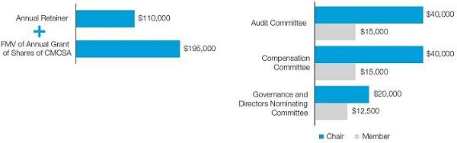

The annual retainer may be received, at the election of the nonemployee director, in shares of Class A common stock, the receipt of which may be deferred in whole or in part. The receipt of the annual stock grant also may be deferred in whole or in part under our restricted stock plan. Any fees received by a director may be deferred in whole or in part under our deferred compensation plans. As of August 1, 2020, any deferred fees must be invested notionally in a third-party mutual or exchange fund or our Class A common stock fund (with dividends being reinvested in Comcast stock), and as a result, no director will have any above-market interest earnings in 2021.

Our directors emeritus receive an annual cash payment equal to the fair market value of our annual stock grant and the same annual Board retainer as provided above for nonemployee directors and remain eligible for participation in our deferred compensation plans during and for one year following service as a director emeritus.

Nonemployee directors and directors emeritus are reimbursed for travel expenses for meetings attended and are provided with our high-speed internet, video, voice and home security and automation services at two residences, if in our service areas, at no cost during the time they serve, and for five years thereafter.

Director Stock Ownership Policy

Our nonemployee director stock ownership policy requires our nonemployee directors to hold a number of shares of our common stock having a value equal to five times the director’s annual cash retainer. Each nonemployee director has a period of five years following his or her first year of service to reach this ownership requirement. For purposes of this policy, “ownership” includes 60% of any deferred shares. In determining compliance, the Compensation Committee may consider any noncompliance that occurs solely or primarily as a result of a decline in the market price of our stock. All nonemployee directors satisfied the requirements of our stock ownership policy in 2020.

64

Table of Contents

Director Compensation

The following table sets forth specified information regarding the compensation of our nonemployee directors in 2020. No information is provided for Mr.

Roberts, who is an employee director and does not receive compensation for his services as a director.

 |  |  | CHANGE IN
 |  |  | PENSION VALUE
 | FEES |  | AND NONQUALIFIED
 | EARNED |  | DEFERRED
 | OR PAID | STOCK | COMPENSATION
 | IN CASH⁽¹⁾ | AWARDS⁽²⁾ | EARNINGS⁽³⁾ | TOTAL
NAME | ($) | ($) | ($) | ($)
Kenneth J. Bacon | 130,000 | 195,008 | 90,465 | 415,473
Madeline S. Bell | 130,000 | 195,008 | 15,851 | 340,859
Naomi M. Bergman | 93,760 | 292,518 | 108 | 386,386
Sheldon M. Bonovitz⁽⁴⁾ | 58,750 | — | 672,496 | 731,246
Edward D. Breen | 150,012 | 195,008 | 40,272 | 385,292
Gerald L. Hassell | 130,012 | 195,008 | 154,423 | 479,443
Jeffrey A. Honickman | 162,512 | 195,008 | 250,622 | 608,142
Maritza G. Montiel | 125,012 | 195,008 | 8,794 | 328,814
Asuka Nakahara | 125,012 | 195,008 | 11,416 | 331,436
David C. Novak | 125,012 | 195,008 | 11,294 | 331,314

- This column represents all cash retainers and meeting fees earned by our nonemployee directors in 2020, regardless of whether deferred as described below. Mses. Bergman and Montiel and Messrs. Breen, Hassell, Honickman, Nakahara and Novak elected to receive 50% of their annual retainer in the form of equity. Each such director earned 753 share units with respect to Class A common stock (other than Ms. Bergman, who earned 353 share units), which all (other than Mr. Breen) deferred.

- The amounts in this column represent the aggregate grant date fair value for each award of shares of Class A common stock granted in 2020, in accordance with FASB ASC Topic 718. The amounts in this column were calculated using the valuation assumptions discussed in the “Share-Based Compensation” footnote to the financial statements in our Annual Report on Form 10-K for the year ended December 31, 2020. The amounts were determined by multiplying the Class A common stock closing price on the date of grant, November 20, 2020 (and June 3, 2020 in the case of Ms. Bergman), by the number of shares subject to the grant.

- Amounts represent the dollar value of interest on previously earned compensation that had been deferred through July 31, 2020 that is in excess of 120% of the long-term applicable federal rate. Effective as of August 1, 2020, nonemployee directors are prohibited from deferring compensation under our deferred compensation plans into an income fund with a fixed rate of return and, instead, may only invest in third-party mutual or exchange funds or a Comcast stock fund. As a result, in 2021, there will be no above-market interest earnings for any directors. Had this prohibition been effective on January 1, 2020, our current nonemployee directors’ total compensation in 2020 on a pro forma basis would have been as follows:

 | PRO FORMA TOTAL
NAME | ($)
Kenneth J. Bacon | 325,008
Madeline S. Bell | 325,008
Naomi M. Bergman | 386,278
Edward D. Breen | 345,020
Gerald L. Hassell | 325,020
Jeffrey A. Honickman | 357,520
Maritza G. Montiel | 320,020
Asuka Nakahara | 320,020
David C. Novak | 320,020

- Mr. Bonovitz did not stand for election at our 2020 annual meeting of shareholders and was appointed by our Board as a director emeritus on June 3, 2020 for a period of one year. Amounts in this table include compensation earned while he was a director.

2021 Proxy Statement | 65

Table of Contents

Related Party Transactions Policy and Certain Transactions

We review all transactions, except for certain de minimis transactions as set forth in our related party transactions policy, involving us in which any of our directors, director nominees, significant shareholders and executive officers and their immediate family members are participants, to determine whether such person has a direct or indirect material interest in the transaction. All directors, director nominees and executive officers are required to promptly notify our Chief Legal Officer of any proposed transaction involving us in which such person has a direct or indirect material interest. The proposed transaction is then reviewed by either the independent members of our Board as a whole, the Governance and Directors Nominating Committee or the Audit Committee to determine whether the proposed transaction is a related party transaction under our policy. In reviewing any related party transaction, the independent members of the Board as a whole, the Governance and Directors Nominating Committee or the Audit Committee will determine whether or not to approve or ratify the transaction based on all relevant facts and circumstances, including the following:

- the materiality and character of the related person’s interest in the transaction;

- the commercial reasonableness of the terms of the transaction;

- the benefit and perceived benefit, or lack thereof, to our company;

- the opportunity costs of alternate transactions; and

- the actual or apparent conflict of interest of the related person.

If the reviewing body determines that a transaction has potential conflict of interest issues and other circumstances warrant, it may also recommend that a special committee review the transaction. After such review, the reviewing body approves or ratifies the transaction only if it determines that the transaction is in, or not inconsistent with, the best interests of our company and our shareholders. Our related party transactions policy is posted under “Corporate Governance” in the Investors section of our website at www.comcastcorporation.com.

Related Party Transactions

In connection with Mr. Roberts’ use of an aircraft he leases from a third party, we have agreed to provide various operational services for the aircraft for Mr. Roberts and his immediate family members, including by providing pilots and performing general operational and maintenance services. Pursuant to this agreement, Mr. Roberts is responsible for reimbursing us for the costs we incur in operating and maintaining the aircraft. For 2020, Mr. Roberts paid us an aggregate of approximately $418,000 related to this agreement.

Mr. Roberts’ son is an employee of Comcast Spectacor, one of our business units. He received approximately $435,000 in compensation from us and also participated in our employee benefit plans on the same basis as other similarly situated employees in 2020.

As previously disclosed in the proxy statement for our 2017 annual meeting of shareholders, in 2016, an LLC controlled by Mr. Roberts and his wife (the “Roberts LLC”) purchased three residential condominium units for $7.6 million, $3.6 million and $3.2 million from a partnership, which at the time was owned by us and an unaffiliated third party, Liberty Property Trust (“LPT”), in a building that an affiliate of LPT was developing as our Comcast Technology Center and a hotel. At the time, the Company obtained two independent appraisals of the fair market value of the condominium units, and the purchase price paid by Mr. Roberts exceeded each of those values.

The Roberts LLC commenced development of the three condominium units into a single Four Seasons residence constituting the entire 45th floor of the Comcast Technology Center. In July of 2020, Mr. Roberts began to explore a potential sale of the combined units. The hotel that the partnership had developed, which hotel is now owned entirely by the Company, subsequently expressed interest in buying the units. Supported by advice received from the unrelated third-party manager of the hotel, the Company intends to use the three combined units for purposes of creating additional suites for the hotel. In addition to negotiating on arm’s-length terms with Mr. Roberts, the Company obtained two independent appraisals. One appraisal stated that the fair market value of the combined condominium units was $13.5 million, while the other appraisal stated that the fair market value was $16 million. In April 2021, the Company purchased the combined condominium units from the Roberts LLC for the lower of the two appraisals at $13.5 million, which represents a loss of approximately $820,000 compared with the purchase price the Roberts LLC paid for the three units in 2016.

66

Table of Contents

Other Information

Who May Vote

Holders of record of Class A and Class B common stock of Comcast at the close of business on April 5, 2021 may vote at the annual meeting of shareholders. The Notice of Internet Availability of Proxy Materials (the “Notice”) is being mailed, and this proxy statement is being made available, to our shareholders beginning on or about April 23, 2021.

Participating and Voting at the Meeting

Attendance at the meeting for purposes of voting and asking questions is limited to shareholders of record on April 5, 2021. Please be sure to have your proxy voting card or notice with you so that you may access your 16-digit control number to log on to the meeting. If your shares are held in the name of your bank, brokerage firm or other nominee, please have your voting instruction form received from your bank, brokerage firm or other nominee, which will contain the relevant control number.

If you encounter any difficulties accessing the virtual meeting, please call the technical support number that will be posted on the meeting login page.

Conduct of the Meeting

The Chairman of our Board (or any other person designated by our Board) has broad authority to conduct the annual meeting of shareholders in an orderly manner. This authority includes establishing rules of conduct, which will be available at the meeting online, for shareholders who wish to participate in the meeting. Questions may be submitted during the meeting in the online question box provided at the meeting. Questions submitted in accordance with the rules of conduct generally will be addressed in the order received (both with respect to specific agenda items and the general question and answer session) and will be read as submitted, unless the question is duplicative of a question already asked and answered or is deemed profane or otherwise inappropriate, in which case the question may be edited or paraphrased.

How to Vote

You may vote at the meeting or by proxy before the meeting. We recommend that you vote by proxy even if you plan to participate in the meeting. You can always change your vote at the meeting.

How Proxies Work

Our Board of Directors is asking for your proxy. Giving us your proxy means you authorize us to vote your shares at the meeting in the manner you direct.

You may vote for all, some or none of our director candidates. You also may vote for or against the other proposals or abstain from voting.

You can vote by proxy before the meeting in any of the following ways:




Internet

Go to www.proxyvote.com or scan the QR code on your Notice or proxy card with a smartphone or tablet, and then follow the instructions outlined on the secure website.

Telephone

Call toll free 1-800-690-6903 and follow the instructions provided on the recorded message. If you hold shares beneficially, through a broker, brokerage firm, bank or other nominee, please refer to the instructions your broker, brokerage firm, bank or other nominee provided to you regarding voting by telephone.

Mail

Complete, sign and date your proxy card and return it in the enclosed envelope.

If you vote via the internet or by telephone, your vote must be received by 11:59 p.m. Eastern Time on June 1, 2021.

If you give us your signed proxy but do not specify how to vote, we will vote your shares (i) in favor of (a) the director candidates, (b) the approval, on an advisory basis, of our executive compensation and (c) the ratification of the appointment of our independent auditors; and (ii) against the shareholder proposal.

2021 Proxy Statement | 67

Table of Contents

Matters to be Presented

We are not aware of any matters to be presented at the meeting other than those described in this proxy statement. If any matters not described in this proxy statement are properly presented at the meeting, the proxies will use their own judgment to determine how to vote your shares. If the meeting is postponed or adjourned, the proxies will vote your shares on the new meeting date in accordance with your previous instructions, unless you have revoked your proxy.

Revoking a Proxy

You may revoke your proxy before it is voted by:

- submitting a new proxy with a later date, including a proxy given via the internet or by telephone;

- notifying our Secretary in writing before the meeting at the address given below; or

- voting in person at the meeting.

Notice of Electronic Availability of Proxy Materials

Pursuant to the rules of the SEC, we are making this proxy statement and our Annual Report on Form 10-K available to our shareholders electronically via the internet. In compliance with this e-proxy process, on or about April 23, 2021, we mailed to our shareholders of record and beneficial owners the Notice containing instructions on how to access this proxy statement and our Annual Report on Form 10-K via the internet and how to vote online. As a result, you will not receive a paper copy of the proxy materials unless you request one. All shareholders may access the proxy materials on the website referred to in the Notice and in this proxy statement and request to receive a set of the proxy materials by mail or electronically, in either case, free of charge. If you would like to receive a paper or electronic copy of our proxy materials, you should follow the instructions for requesting such materials in the Notice. By participating in the e-proxy process, we reduce the impact of our annual meeting of shareholders on the environment and save money on the cost of printing and mailing documents to you. See “Electronic Access to Proxy Materials and Annual Report on Form 10-K” below for further information on electing to receive proxy materials electronically.

Additional Information on the Annual Meeting of Shareholders

If you have questions or would like more information about the annual meeting of shareholders, you can contact us in any of the following ways:

• | Via the internet: | Go to www.proxyvote.com or scan the QR code on | • By writing: | Thomas J. Reid, Secretary Comcast
 |  | your Notice or proxy card with a smartphone or |  | Corporation One Comcast Center
 |  | tablet. |  | Philadelphia, PA 19103

- By telephone:Call toll free 1-866-281-2100

Shareholder Proposals for Next Year

Any shareholder proposals intended to be presented at our 2022 annual meeting of shareholders and considered for inclusion in our proxy materials under Rule 14a-8 under the Exchange Act (“Rule 14a-8”) must be received by close of business on December 24, 2021 and must comply with the procedures and requirements of Rule 14a-8. Shareholder proposals failing to comply with the procedures of Rule 14a-8 under the Exchange Act will be excluded. If the date of our 2022 annual meeting is more than 30 days from June 3, 2022, we will publicly announce a different submission deadline from that set forth above, in compliance with SEC rules.

Any shareholder proposals (other than those proposals seeking to nominate directors) that are intended to be presented at the annual meeting of shareholders in 2022 but not to be included in our proxy materials must comply with the advance notice provision in Section 2.09 of our by-laws. If we call the 2022 annual meeting of shareholders for a date between May 3, 2022 and July 2, 2022, we must receive notice of the proposal on or after February 2, 2022 and on or before March 4, 2022. If we call the 2022 annual meeting of shareholders for any other date, we must receive notice of the proposal by the close of business on the tenth day following the day we mailed notice of, or announced publicly, the date of the meeting, whichever occurs first. If notice is not received by March 4, 2022 (or the tenth day following the day we mail notice of, or announce publicly, the date of our 2022 annual meeting of shareholders, if such meeting is not called for a date between May 3, 2022 and July 2, 2022), the shareholder proposals will be deemed “untimely.”

Shareholders who wish to nominate directors for election must comply with the procedures described under “Corporate Governance and Board Matters — Board of Directors — Director Nominations.”

All shareholder proposals should be directed to Thomas J. Reid, Secretary, Comcast Corporation, at our address listed above.

68

Table of Contents

Solicitation of Proxies

We pay the cost of this proxy solicitation. Pursuant to SEC rules, we are making this proxy statement and our Annual Report on Form 10-K available to our shareholders electronically via the internet. In addition to soliciting proxies by the internet and mail, we expect that a number of our employees will solicit shareholders personally and by telephone. None of these employees will receive any additional or special compensation for doing this. We have retained D.F. King & Co., Inc. to assist in the solicitation of proxies for aggregate fees of approximately $32,500 plus reasonable out-of-pocket costs and expenses. The agreement with D.F. King contains customary indemnification provisions. We will, on request, reimburse banks, brokerage firms and other nominees for their expenses in sending proxy materials to their customers who are beneficial owners of our common stock and obtaining their voting instructions.

Electronic Access to Proxy Materials and Annual Report on Form 10-K

Shareholders can access this proxy statement and our Annual Report on Form 10-K via the internet at www.proxyvote.com or by scanning the QR code on the Notice or proxy card with a smartphone or tablet, and then following the instructions outlined on the secure website. For future annual meetings of shareholders, shareholders can consent to accessing their proxy materials, including the Notice, the proxy statement and the annual report, electronically in lieu of receiving them by mail. To receive materials electronically, you will need access to a computer and an e-mail account. You will have the opportunity to revoke your request for electronic delivery at any time without charge.

If you are a registered shareholder and you have not already done so, you can choose this electronic delivery option by following the instructions provided when voting via the internet and provided on the proxy card. Your choice will remain in effect unless you revoke it by contacting our transfer agent, Equiniti Trust Company D/B/A EQ Shareowner Services (“EQ Shareowner Services”), at 1-888-883-8903 or P.O. Box 64854, St. Paul, MN 55164-0854. You may update your electronic address by contacting EQ Shareowner Services.

If you hold your shares through a bank, brokerage firm or other nominee and you have not already done so, you can choose this electronic delivery option by contacting your nominee or by following the instructions provided when voting via the internet. Your choice will remain in effect unless you revoke it by contacting your nominee. You may update your electronic address by contacting your nominee.

Important Notice Regarding Delivery of Shareholder Documents

Under SEC rules, delivery of each Notice or a single proxy statement and annual report, as applicable, in a single envelope to two or more shareholders sharing the same mailing address is permitted under certain conditions. This procedure, called “householding,” is available if all of the following criteria are met:

- you have the same address as other shareholders registered on our books;

- you have the same last name as the other shareholders; and

- your address is a residential address or post office box.

If you meet this criteria, you are eligible for householding and the following terms apply. If you are not eligible, please disregard this notice.

How do I consent to, or discontinue, the householding process of receiving just one set of annual disclosure materials?

To give your consent to, or to discontinue, householding, please notify our transfer agent, EQ Shareowner Services, at 1-888-883-8903 or by mail at P.O. Box 64874, St. Paul, MN 55164-0854 if you are a registered shareholder, or your bank or broker if you are a beneficial shareholder. Registered and beneficial shareholders may also discontinue householding by contacting Broadridge by phone at (866) 540-7095 or by mail at Broadridge, Householding Department, 51 Mercedes Way, Edgewood, NY 11717.

The householding consent is considered perpetual, which means you will continue to receive a single envelope containing each Notice for the household or a single proxy statement and annual report, as applicable, in the future unless you discontinue this process.

2021 Proxy Statement | 69

Table of Contents

Appendix A: Reconciliations of Non-GAAP Financial Measures

We believe that the presentation of financial measures not in accordance with generally accepted accounting principles in the United States (“GAAP”) provides useful information to investors regarding our results of operations and financial condition. Our non-GAAP financial measures should be considered in addition to, but not as a substitute for, operating income, net income, net income attributable to Comcast Corporation, earnings per common share attributable to Comcast Corporation shareholders, net cash provided by operating activities or other measures of performance or liquidity reported in accordance with GAAP.

We define Adjusted EBITDA as net income attributable to Comcast Corporation before net income (loss) attributable to noncontrolling interests and redeemable subsidiary preferred stock, income tax expense, investment and other income (loss), net, interest expense, depreciation and amortization expense, and other operating gains and losses (such as impairment charges related to fixed and intangible assets and gains or losses on the sale of long-lived assets), if any. From time to time we may exclude from Adjusted EBITDA the impact of certain events, gains, losses or other charges (such as significant legal settlements) that affect the period-to-period comparability of our operating performance. Additional information and reconciliations of Adjusted EBITDA to net income attributable to Comcast Corporation for the years ended December 31, 2018, 2019 and 2020 are set forth in “Item 7: Management’s Discussion and Analysis of Financial Condition and Results of Operations – Non-GAAP Financial Measures” on page 57 of our Annual Report on Form 10-K for the year ended December 31, 2020, as filed with the SEC on February 4, 2021 (the “10-K”).

Constant currency and constant currency growth rates are calculated by comparing the prior year results adjusted to reflect the average exchange rates from the current year rather than the actual exchange rates that were in effect during the respective prior year. Additional information and a reconciliation of Sky’s constant currency Adjusted EBITDA growth rate for 2020 is set forth in “Item 7: Management’s Discussion and Analysis of Financial Condition and Results of Operations – Non-GAAP Financial Measures” on pages 57-58 of the 10-K.

We define Free Cash Flow as Net Cash Provided by Operating Activities (as stated in our Consolidated Statement of Cash Flows) reduced by capital expenditures and cash paid for intangible assets. From time to time, we may exclude from Free Cash Flow the impact of certain cash receipts or payments (such as significant legal settlements) that affect period-to-period comparability. Cash payments related to certain capital or intangible assets, such as the construction of Universal Beijing Resort, are presented separately in our Consolidated Statement of Cash Flows and are therefore excluded from capital expenditures and cash paid for intangible assets for Free Cash Flow. We believe Free Cash Flow provides a meaningful measure of liquidity and a useful basis for assessing our ability to repay debt, make strategic acquisitions and investments, and return capital to investors through stock repurchases and dividends. It is also a significant performance measure in our annual incentive compensation programs. Additionally, we believe Free Cash Flow is useful to investors as a basis for comparing our performance and coverage ratios with other companies in our industries, although our measure of Free Cash Flow may not be directly comparable to similar measures used by other companies. Free Cash Flow has certain limitations, including that it does not represent the residual cash flow available for discretionary expenditures since other non-discretionary payments, such as mandatory debt repayments, are not deducted from the measure.

RECONCILIATION FROM NET CASH PROVIDED BY OPERATING ACTIVITIES TO FREE CASH FLOW ($ in millions)

 | YEAR ENDED DECEMBER 31,
 | 2020 | 2019 | 2018
Net cash provided by operating activities | 24,737 | 25,697 | 24,297
Capital expenditures | (9,179) | (9,953) | (9,774)
Cash paid for capitalized software and other intangible assets | (2,455) | (2,475) | (1,935)
Adjustments related to legal settlements | 177 | 125 | —
Free Cash Flow | 13,280 | 13,394 | 12,588
A-1

Table of Contents



Table of Contents




SCAN QR BARCODE

VIEW MATERIALS & VOTE

VOTE BY INTERNET

ONE COMCAST CENTER Before The Meeting - Go to www.proxyvote.com or scan the QR Barcode above

PHILADELPHIA, PA 19103

Use the Internet to transmit your voting instructions up until 11:59 P.M. Eastern Time on June 1, 2021. Please
have your proxy card in hand when you access the website and follow the instructions to obtain your records and

create an electronic voting instruction form.

During The Meeting - Go to comcast.onlineshareholdermeeting.com

You may attend the Meeting and vote during the Meeting when the polls are open via the Internet. We
recommend, however, that you vote before the Meeting even if you plan to participate in the Meeting, since you

can change your vote during the Meeting by voting when the polls are open. Have the information that is printed

in the box marked by the arrow available and follow the instructions.

VOTE BY PHONE - 1-800-690-6903

Use any touch-tone telephone to transmit your voting instructions up until 11:59 P.M. Eastern Time on June 1,
2021. Please have your proxy card in hand when you call and then follow the instructions.

VOTE BY MAIL

Mark, sign and date your proxy card and return it in the postage-paid envelope we have provided or return it to
Vote Processing, Comcast Corporation, c/o Broadridge Financial Solutions, 51 Mercedes Way, Edgewood, NY
11717.

TO VOTE, MARK BLOCKS BELOW IN BLUE OR BLACK INK AS FOLLOWS:
D41982-P54393 | KEEP THIS PORTION FOR YOUR RECORDS
 | DETACH AND RETURN THIS PORTION ONLY
THIS PROXY CARD IS VALID ONLY WHEN SIGNED AND DATED.
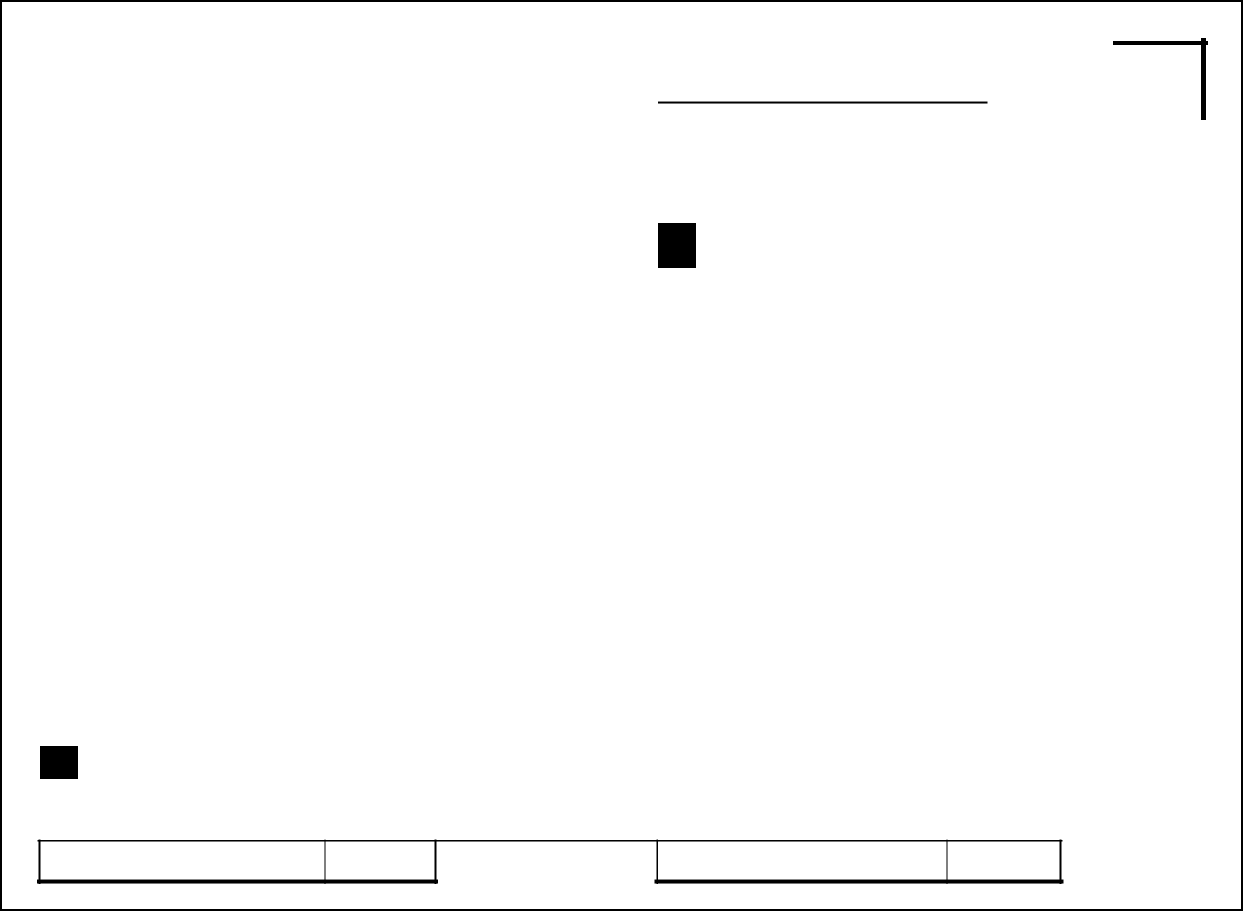

COMCAST CORPORATION |  |  | For | Withhold | For All To withhold authority to vote for any individual
 |  | Company Proposals — The Board of Directors | All | All | Except nominee(s), mark “For All Except” and write the
 | A | Company Proposals — The Board of Directors |  |  | number(s) of the nominee(s) on the line below.
 | A | recommends a vote “FOR” all the nominees listed in
 |  | Proposal 1: | o | o | o
- Election of Directors

01 - | Kenneth J. Bacon | 06 - | Jeffrey A. Honickman
02 - | Madeline S. Bell | 07 - | Maritza G. Montiel
03 - | Naomi M. Bergman | 08 - | Asuka Nakahara
04 - | Edward D. Breen | 09 - | David C. Novak
05 - | Gerald L. Hassell | 10 - | Brian L. Roberts

The Board of Directors recommends a vote “FOR” Proposals 2 |  | For | Against | Abstain
and 3:
2. | Advisory vote on executive compensation | o | o | o
3. | Ratification of the appointment of our independent auditors | o | o | o

Shareholder Proposal — The Board of Directors
B recommends a vote “AGAINST” Proposal 4 if For Against Abstain properly presented at the annual meeting:

4. | To conduct independent investigation and report on risks | o | o | o
 | posed by failing to prevent sexual harassment

- Authorized Signatures — This section must be completed for your vote to be counted — Date and Sign Within the Box Below

Please sign as name(s) appear(s) hereon. Give full title if you are signing for a corporation, partnership or other entity, or as an attorney, administrator, executor, guardian, trustee or in any other representative capacity.

Signature [PLEASE SIGN WITHIN BOX] Date Signature (Joint Owners) Date

Table of Contents

2021 Annual Meeting of Shareholders

Wednesday, June 2, 2021

9:00 a.m. Eastern Time

comcast.onlineshareholdermeeting.com

ELECTRONIC DELIVERY OF FUTURE PROXY MATERIALS

If you would like to reduce the impact on the environment and save our company money on the costs incurred in mailing proxy materials, you can consent to receiving all future Notices of Internet Availability of Proxy Materials, proxy statements, proxy cards and Annual Reports on Form 10-K electronically via e-mail or the Internet. To sign up, please follow the instructions on the reverse side to vote by Internet before the Meeting and, when prompted, indicate that you agree to receive or access shareholder communications electronically in future years. For further details regarding electronic delivery, please see the “General Information — Notice of Electronic Availability of Proxy Materials” section of our proxy statement.

Important Notice Regarding the Availability of Proxy Materials for the Annual Meeting:

The Notice of Internet Availability of Proxy Materials, the Proxy Statement and the Annual Report are available
at www.proxyvote.com.

▼ IF YOU HAVE NOT VOTED VIA THE INTERNET OR TELEPHONE, FOLD ALONG THE PERFORATION, DETACH AND RETURN THE BOTTOM PORTION IN THE ENCLOSED ENVELOPE. ▼

D41983-P54393


COMCAST CORPORATION

THIS PROXY IS SOLICITED ON BEHALF OF THE BOARD OF DIRECTORS
FOR THE ANNUAL MEETING OF SHAREHOLDERS ON JUNE 2, 2021.

I hereby appoint Michael J. Cavanagh and Thomas J. Reid, and each of them acting individually, as proxies, with the powers I would possess if personally present, and with full power of substitution, to vote all shares in Comcast Corporation at the annual meeting of shareholders to be held live via the Internet at comcast.onlineshareholdermeeting.com at 9:00 a.m. Eastern Time on June 2, 2021, and at any adjournment or postponement thereof, upon all matters described in the proxy statement that may properly come before the meeting, in accordance with my instructions on the reverse side of this proxy card. In the event that any other matter may properly come before the meeting, or any adjournment or postponement thereof, the proxies are each authorized to vote on such matter in their discretion, including for any replacement nominee nominated for director by the Board of Directors of Comcast Corporation if a director nominee on this proxy card becomes unavailable to serve. I hereby revoke all previous proxies given to vote at the annual meeting or any adjournment or postponement thereof.

I acknowledge receipt of the notice of annual meeting of shareholders, the proxy statement and the Annual Report on Form 10-K of Comcast Corporation.

The shares represented by this proxy card will be voted in accordance with your instructions if the card is signed and returned. If you are voting with this proxy card, please mark your choices on the other side of this proxy card, sign it where indicated on the other side and return it promptly to Vote Processing, Comcast Corporation, c/o Broadridge Financial Solutions, 51 Mercedes Way, Edgewood, NY 11717. If your card is signed and returned without instructions, the shares will be voted in favor of all of the director nominees and any replacement nominee, in favor of Proposals 2 and 3, and against Proposal 4. If you are voting shares held in the Comcast Employee Stock Purchase Plan or the Comcast-NBCUniversal Employee Stock Purchase Plan, voting by Internet, telephone, mail or in person by ballot will vote all of the shares held by you in such plans, as well as any shares held by you as a shareholder of record. If you hold shares that are not represented by this proxy card, you will receive additional proxy card(s) by mail that will allow you to vote the remaining shares.

Continued and to be signed on reverse side

