May 30, 2013

Mr. Larry Spirgel

Assistant Director

Division of Corporation Finance

Securities and Exchange Commission

100 F Street, N.E.

Washington, DC 20549

Re:

Comcast Corporation

Form 10-K for the fiscal year ended December 31, 2012

Filed February 21, 2013

File No. 1-32871

Dear Mr. Spirgel:

We are writing this letter to respond to the comment letter of the Staff of the Securities and Exchange Commission (the “Staff”) dated May 16, 2013, relating to the review of our Form 10-K for the fiscal year ended December 31, 2012 (the “Form 10-K”). For your convenience, we have reproduced the Staff’s comments preceding our responses below. Please let us know if you have any questions or if we can provide additional information or otherwise be of assistance in expediting the review process.

Form 10-K for the fiscal year ended December 31, 2012

Item 7. Management's Discussion and Analysis of Financial Condition and Results of Operations, page 44

Introduction and Overview, page 44

- With respect to your Cable Communications Segment, we note your reference to your operations being in intensely competitive markets, which may be a contributing factor to the loss of residential video customers. Please expand your business section to identify the specific geographic market areas in which you compete and the number of customers in each of those market areas. Refer to item 101(c) (1) (x) of Regulation S-K. Please provide us with your proposed disclosures.

Response

Comcast Cable Communications, which comprises our Cable Communications Segment, is the nation’s largest provider of video, high-speed Internet and voice services to residential customers, offering these services in 39 U.S. states and the District of Columbia. Because of our geographical reach throughout the United States, our Cable Communications operations are not concentrated in any one market or cluster of markets and, therefore, we do not believe that individual market by market customer information would be material to investors. However, beginning in our Form 10-K for the fiscal year ending December 31, 2013, we will include, in an appropriate section of Item I. Business, an illustration of our footprint and

Securities and Exchange Commission | May 30, 2013

our key markets in the United States. Our proposed disclosure will be similar to information that was last included in Management’s Discussion and Analysis of

Financial Condition and Results of Operations in our Form 10-K for the fiscal year ended December 31, 2009, as reflected below:

The Areas We Serve

The map below highlights our 40 major markets with emphasis on our operations in the top 25 U.S. TV markets.¹
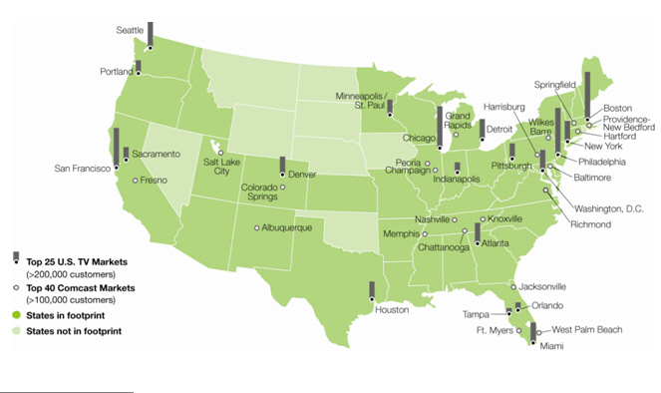

- The information in this map is based on information as of December 31, 2009.

2

Securities and Exchange Commission | May 30, 2013

- We note your disclosure regarding your calculation of the average monthly total revenue per video customer that increased from $127 in 2010 to $138 in 2011 to $149 in 2012. Please tell us the components used in the numerator and denominator in deriving the metric. Please provide us with your average monthly total revenue per video customer calculation.

Response

The below table includes the components of our average monthly total revenue per video customer calculation for the amounts included in our Form 10-K for the fiscal year ended December 31, 2012.

 |  |  |  | 2012 |  |  |  | 2011 |  |  | 2010
 | Total Cable Communications revenue (in millions) | $ |  | 39,604 |  | $ |  | 37,226 |  | $ | 35,363
 | Divided by 12 months:
 | Total average monthly Cable Communications revenue (in millions) | $ |  | 3,300 |  | $ |  | 3,102 |  | $ | 2,947
 | Divided by:
 | Average number of video customers (in thousands) |  |  | 22,163 |  |  |  | 22,561 |  |  | 23,168
 | Average monthly total revenue per video customer | $ |  | 149 |  | $ |  | 138 |  | $ | 127

We derive the average number of video customers used in the above calculation by taking the average of the number of residential and business video customers as of the beginning and ending date of the respective reporting period. For example, for 2012, the average number of video customers was calculated as follows:

(in thousands) |  | 2012
 | Total video customers as of December 31, 2011 | 22,331
 | Total video customers as of December 31, 2012 | 21,995
 |  | 44,326
 | Divided by 2 (to derive average):
 | Average number of video customers | 22,163

Average monthly total revenue per video customer (“ARPU”) is a metric that has been historically used across the cable industry. As stated in our first quarter 2013 analyst call, we plan to change our method of how we report video customers that are billed under bulk contracts from an FCC equivalent basis to a billable units methodology at the end of this year once we have compiled the necessary data for this change. Coinciding with this change, we plan to change the above ARPU calculation to use total customer relationships rather than video customers as the denominator. A customer relationship is based on billable relationships, with a customer receiving one of our services and a customer receiving multiple services each being reflected as one customer relationship. We believe these planned changes reflect the evolution of our relationships with our customers and changes in our industry.

3

Securities and Exchange Commission | May 30, 2013

- We note your explanation for the increases in average monthly total revenue per video customer. Please consider discussing underlying changes at more discrete levels, such as for significant revenue streams (i.e. Video, High-speed Internet and Voice).

Response

We provide explanations for the increases in average monthly total revenue per video customer in the introductory paragraph under the caption “Cable Communications Segment – Revenue.” This paragraph provides the reader with a high level overview of the causes for the increases in overall revenue and average monthly total revenue per customer. Immediately below this introductory paragraph, we provide the detailed discussion of the underlying material variances outlined in the paragraph for each of the significant revenue line items that comprise the numerator of the ARPU calculation – Video, High-Speed Internet, Voice, Advertising, Business Services and Other Revenue. Accordingly, we respectfully submit that we believe our current disclosure in this section, coupled with information on the number of Video, High-speed Internet and Voice customers, provides more meaningful information to investors.

* * *

In connection with our response to the Staff’s comments, Comcast Corporation acknowledges that:

- Comcast Corporation is responsible for the adequacy and accuracy of the disclosure in the filing;

- Staff comments or changes to disclosure in response to Staff comments do not foreclose the Commission from taking any action with respect to the filing; and

- Comcast Corporation may not assert Staff comments as a defense in any proceeding initiated by the Commission or any person under the federal securities laws of the United States.

Please do not hesitate to call me at (215) 286-8514 with any questions you may have with respect to the foregoing.

Sincerely,

/s/ Lawrence J. Salva

Lawrence J. Salva

Senior Vice President, Chief Accounting Officer and Controller

Comcast Corporation

- Brian L. Roberts, Chairman of the Board and Chief Executive Officer Michael J. Angelakis, Chief Financial Officer
Arthur R. Block, Senior Vice President, General Counsel and Secretary J. Michael Cook, Director and Chairman of Audit Committee

Bruce K. Dallas, Davis Polk & Wardwell LLP

Michael Titta, Deloitte & Touche LLP

4

