Filed by Comcast Corporation pursuant to

Rule 425 under the Securities Act of 1933 and

deemed filed pursuant to Rule 14a-12 and

Rule 14d-2 under the Securities Exchange Act of 1934

Subject Company: The Walt Disney Company

Commission File No. 001-11605

Date: February 11, 2004

The following presentation was used in connection with Comcast Corporation’s conference call:


Creating an Entertainment and

Communications Leader

February 11, 2004

Brian L. Roberts

President and CEO

Comcast Corporation

Overview of the Proposed Transaction

- Merger between Comcast and Disney

- Offers Disney shareholders a premium plus full participation in the combination benefits

- Comcast will issue 0.78 Class A voting shares for each Disney share

— Disney shareholders will own 42% of combined company

- Tax free to Comcast and Disney shareholders

- Includes Disney Board members on Comcast Board



3


Broadband Distribution Leader
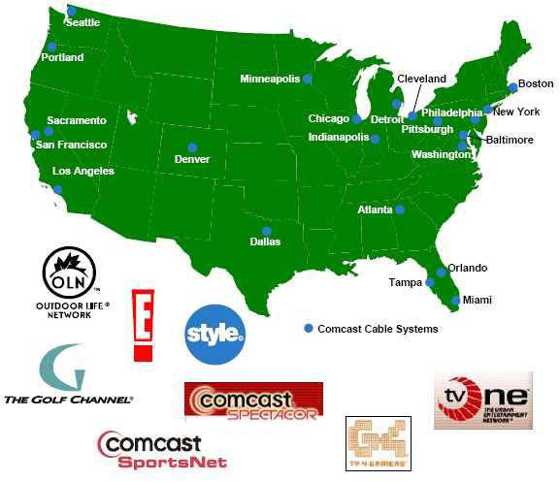

- 39.8 million homes passed

- 21.5 million cable subscribers

- 5.3 million broadband subscribers

- 1.3 million telephone subscribers

- Presence in 22 of top 25 markets

- 2003 Revenue: $18.3Bn

- 2003 EBITDA: $6.4Bn

4


Leading Entertainment Properties

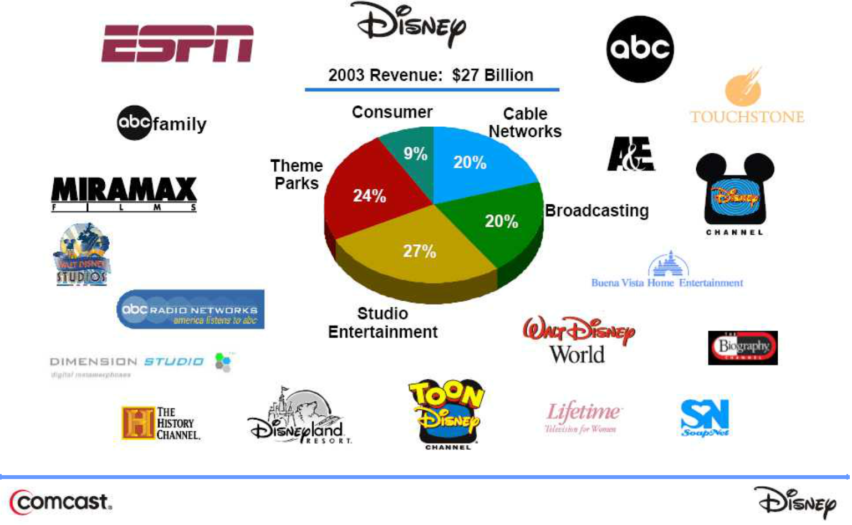

5

One of the World’s Premier Entertainment and Communications Companies

6

Stephen B. Burke

President

Comcast Cable

Compelling Value Creation for All Shareholders

Area

Estimated Year 3

Cash Flow Benefit

- Restore Disney’s Operating Results

— Bring ABC performance towards industry norms |  | $300 – $500MM
— | Increase cable network profitability towards Comcast levels | $200 – 300MM
— | Improve other business results | TBD

- Realize Opportunities from Combination

— | Cost savings and economies of scale | $300 – $400MM
— | New business opportunities | TBD
 | Total | $800 – $1,200MM
 |  | +TBD

8

Opportunity to Recapture Disney’s Potential

Significant Cash Flow Declines Since 1998

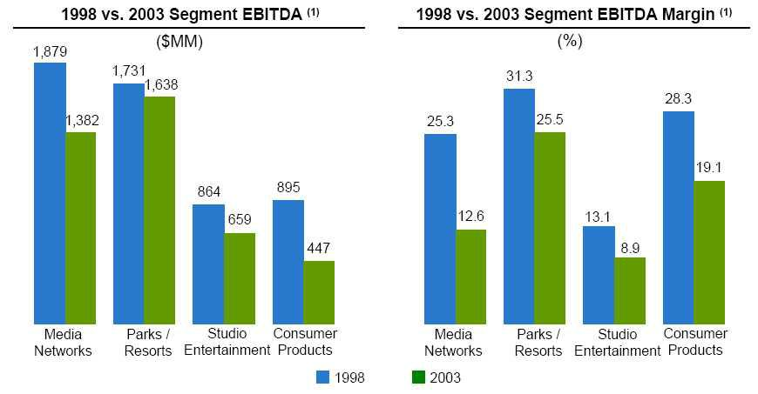

Note: (1) Source: Company SEC filings. Figures on an as reported basis. Internet segment excluded for 1998

9

Disney Segments Have Underperformed

Television Broadcasting

 | TV Network and Stations
 | Financial Performance ⁽¹⁾
 | EBITDA
 |  | ($MM)
NBC | 1,400
FOX | 900
CBS | 800
ABC | 0

Halfway to Third Place: $300–$500MM

Note: (1) Based on Company and Wall Street equity research estimates

10

Disney Segments Have Underperformed

Cable Networks

Selected Cable Network|

Financial Performance⁽¹⁾

 | 2003 EBITDA |  | Margin
 | ($MM) | (%)
E! | 156 | 48.9
Golf Channel | 81 | 46.0
Viacom Cable Networks | 2,368 | 41.9
Scripps Networks | 204 | 38.2
ESPN Channels⁽²⁾ | 950 | 25.0
Other Disney Cable Networks (Disney Channel, ABC
Family, SoapNet and Toon⁽²⁾ | 300 | 19.0

Halfway to Industry 40% Margins

Plus Incremental Distribution: $200–$300MM

Notes: (1) Fiscal Year EBITDA based on Company SEC filings, adjusted for one-time charges

(2) Based on Company and Wall Street equity research estimates

11

Improve Other Business Results

Reignite the World’s Greatest Entertainment Businesses

- Empower Disney animation team to build on legacy of success

— From 1991 to 1994, Disney released Beauty and the Beast (1991), Aladdin (1992) and The Lion King (1994), which collectively have generated over $1.5Bn in total box office receipts

— No Disney produced animated release has come close since 1999

— Animation success drives Consumer Products and Theme Parks

- The Disney theme parks are America's favorite vacation destinations

— Drive attendance via advertising and cross-promotion in all aspects of combined company

— Restore energy and creativity in attractions, hotels and concessions

All Upside to Projected Value Creation

12

Significant Cost Savings and Economies of Scale

- Eliminating duplicate corporate and divisional functions

- Eliminating overlapping operations (cable channels, Internet, advertising, etc.)

- Other savings due to scale and scope

Targeted Annual Expense Reduction: $300-$400MM

13

Significant New Business Opportunities

- Launch successful new cable channels

- Maximize interactive technologies for digital cable customers

— VOD movies in attractive windows

— Time shifted ABC programming

— ESPN interactive television features

- Develop new online content / services for broadband customers

— Disney, ESPN, ABC content for portal

— Streaming Internet video subscription packages

- Leverage cross-promotion opportunities

— Extend ESPN sports brand to Golf, Outdoor Life and Regional Sports Networks

— Theme park cross-promotion opportunities

14

Proven Merger Integration Track Record

AT&T Broadband Acquisition Case Study

- AT&T Broadband 1.5x the Size of Comcast When Acquired

- Far Exceeded Margin Improvement Guidance

- Immediately Reversed Basic Subscriber Loss

- Accelerated System Upgrades — Now 93% Complete

- Seamless Management Integration/Transition

- Significant Launch of New Products and Services

— Accelerated broadband deployment

— 2 new cable networks

— New regional sports network

— Expansive VOD offering

15

Brian L. Roberts

President and CEO

Comcast Corporation

Experienced World Class Management Team

- Proven Merger Integration Track Record

- Proven Track Record of Content Value Creation

- “Best of Both Companies” Management Approach

17

Proven Track Record of Content Value Creation

 |  |  |  |  |  | Value Today
 | n Average 18% OCF growth over 10 years
 | n 37% IRR on original investment |  |  |  |  | $14.1Bn
 |  | Subscribers |  | Increase Since 1999
 |  | 74MM |  |  | 28% | $1.75–2.00Bn
 |  | 30MM |  | 540% |  | $300–500MM
 |  | 50MM |  | 92 |  | $1.25–1.75Bn
 |  | 51MM |  | 176% |  | $700–1,000MM
 |  | 7MM |  | 18% |  | $400–600MM
 |  | 12MM |  |  | N/A | $200–300MM
 |  |  |  |  | Total | $18.720.3Bn








Opportunity to Enhance Disney Cable Network Performance and

Launch New Channels

Source: Wall Street equity research estimates. Value represents 100% of the equity for each entity

18

Consistent Shareholder Value Creation

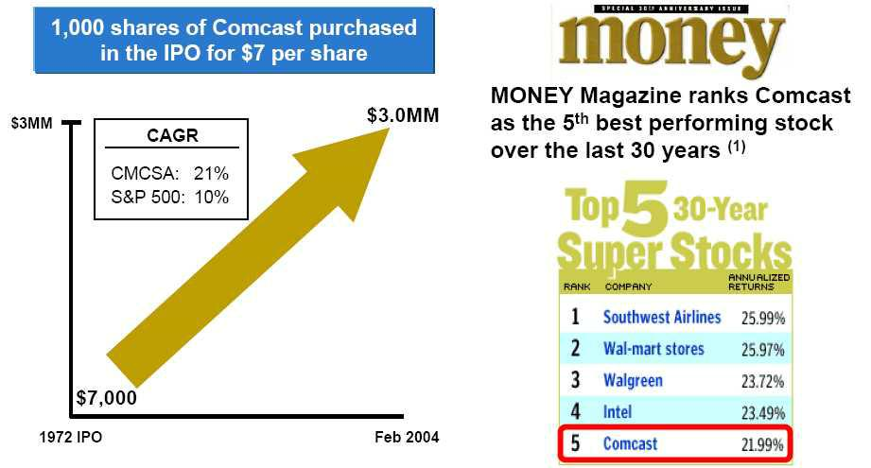

Note: (1) Published on September 27, 2002

19

Strong Combined Financial Position


 | ($Bn) | ($Bn) | ($Bn)
FY 2004 Consensus Estimates:
Revenue | $20.3 | $28.8 | $49.1
EBITDA | 7.5 | 4.6 | 12.0
Free Cash Flow | 2.0 | 1.7 | 3.7
Balance Sheet Summary:
Total Assets ⁽¹⁾ | $109.2 | $50.0 | $159.2
Total Net Debt ⁽¹⁾ | 21.1⁽²⁾ | 11.9 | 33.0⁽²⁾
Net Debt/FY 2003 EBITDA (x) | 3.3x | 3.1x | 3.2x

Notes: (1) Comcast as of December 31, 2003; Disney as of September 30, 2003

(2) Excludes exchangeables

20

A Powerful and Transforming Combination

n | Creates one of the World’s Premier Entertainment and
n | Communications Companies
n | Maximizes the Value of Content and Distribution
n | Compelling Value Creation for All Shareholders
n | Accelerates the Digital Future for Consumers
n | Experienced World Class Management Team
n | Strong Balance Sheet and Free Cash Flow Generation
 | 21
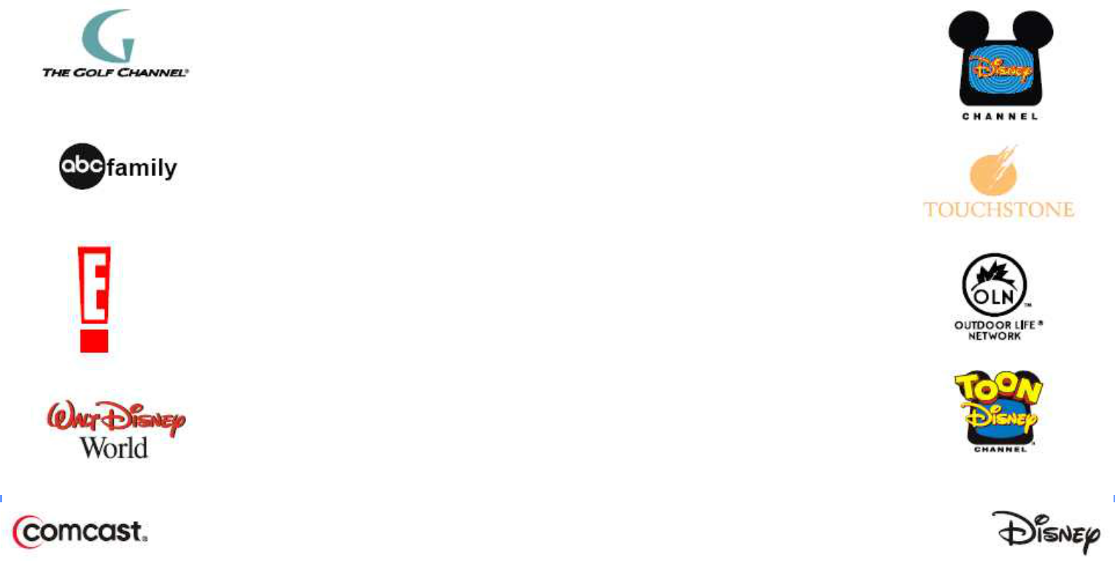

Note: the following notice is included to meet certain legal requirements:

FORWARD LOOKING STATEMENTS

This filing contains forward-looking statements within the meaning of the Private Securities Litigation Reform Act of 1995. In some cases, you can identify those so-called “forward-looking statements” by words such as “may,” “will,” “should,” “expects,” “plans,” “anticipates,” “believes,” “estimates,” “predicts,” “potential,” or “continue,” or the negative of those words and other comparable words. Comcast Corporation (“Comcast”) wishes to take advantage of the “safe harbor” provided for by the Private Securities Litigation Reform Act of 1995 and you are cautioned that actual events or results may differ materially from the expectations expressed in such forward-looking statements as a result of various factors, including risks and uncertainties, many of which are beyond the control of Comcast. Factors that could cause actual results to differ materially include, but are not limited to:

- the businesses of Comcast and The Walt Disney Company (“Disney”) may not be integrated successfully or such integration may be more difficult, time-consuming or costly than expected; (2) expected combination benefits from the Comcast/Disney transaction may not be fully realized or realized within the expected time frame; (3) revenues following the Comcast/Disney transaction may be lower than expected; (4) operating costs, customer loss and business disruption, including, without limitation, difficulties in maintaining relationships with employees, customers, clients or suppliers, may be greater than expected following the Comcast/Disney transaction; (5) the regulatory approvals required for the Comcast/Disney transaction may not be obtained on the proposed terms or on the anticipated schedule; (6) the effects of legislative and regulatory changes; (7) the potential for increased competition; (8) technological changes; (9) the need to generate substantial growth in the subscriber base by successfully launching, marketing and providing services in identified markets; (10) pricing pressures which could affect demand for Comcast or Disney services; (11) the ability to expand distribution; (12) changes in labor, programming, equipment and capital costs or availability; (13) the continued ability to create or acquire programming and products that customers will find attractive; (14) future acquisitions, strategic partnerships and divestitures; (15) international, political and military developments that may affect, among other things, travel and leisure businesses generally or Disney’s parks and resorts operations specifically, or result in increases in broadcasting costs or loss of advertising revenue; (16) adverse weather conditions or natural disasters, such as hurricanes and earthquakes, which may, among other things, impair performance at Disney’s parks and resorts; (17) general business and economic conditions; and (18) other risks described from time to time in Comcast’s periodic reports filed with the Securities and Exchange Commission (the “Commission”).

ADDITIONAL INFORMATION

Any information concerning Disney contained in this filing has been taken from, or is based upon, publicly available information. Although Comcast does not have any information that would indicate that any information contained in this filing that has been taken from such documents is inaccurate or incomplete, Comcast does not take any responsibility for the accuracy or completeness of such information. To date, Comcast has not had access to the books and records of Disney.

Investors and security holders are urged to read the disclosure documents regarding the proposed Comcast/Disney transaction, when they become available, because they will contain important information. The disclosure documents will be filed with the Commission by Comcast. Investors and security holders may obtain a free copy of the disclosure documents (when they are available) and other documents filed by Comcast with the Commission at the Commission’s website at www.sec.gov. The disclosure documents and these other documents may also be obtained for free from Comcast by directing a request to Comcast Corporation, 1500 Market Street, Philadelphia, Pennsylvania 19102-2148, Attention: General Counsel.

Comcast and certain of its directors and officers may be deemed to be “participants” in solicitations of proxies or consents from Comcast’s and Disney’s shareholders. A detailed list of the names, titles and interests of these persons is contained in a filing made by Comcast with the Commission pursuant to Rule 425 on February 11, 2004.

