Filed by Comcast Corporation

(Commission File No.: 001-32871)

Pursuant to Rule 425 of the Securities Act of 1933

and deemed filed pursuant to Rule 14a-12

of the Securities Exchange Act of 1934

Subject Company: Time Warner Cable Inc.

Commission File No. for Registration Statement

on Form S-4 filed by Comcast Corporation: 333-194698

The following blog post was posted on Comcast’s website:

US Senate Examines the Future of Video

By David L. Cohen, Executive Vice President and Chief Diversity Officer

This afternoon, the U.S. Senate Committee on Commerce, Science & Transportation is examining the future of the video marketplace at a very exciting time. Consumers are now enjoying what many are calling "a new golden age" of video services – more choices, new technologies and incredible content. There has been an explosion of innovation and technological changes, leading to more choices for consumers than ever before.

So what’s happening in the video marketplace today?

- During a typical week, nearly a quarter of adults watch downloaded or streaming video through their smartphones; and nearly half of game console users stream and watch video over those devices.

- Nielsen reports that YouTube reaches more U.S. adults ages 18 to 34 than any cable network. YouTube has 1 billion unique visitors a month. 100 hours of content are uploaded every minute

- Netflix has over 35 million domestic subscribers – more than Comcast and Time Warner Cable combined and has a $3 billion content budget – bigger than many cable networks.

- Amazon, Hulu, Netflix, Yahoo, and other websites are developing their own original series – including such successful shows as House of Cards, Orange is the New Black, and Alpha House.

- Cable’s share of the traditional multichannel video market has dropped form 87% in 1999 to 56% in 2012. And falling.

At the same time as this explosion of alternative video, traditional television viewing has remained essentially constant, with the average adult consuming more than 5 hours a day of live TV.

My written testimony details how government policies that removed barriers to competitive entry and reduced regulation have allowed the market to grow and flourish with more companies than ever before – both large and small – producing high-quality and diverse programming; competing to deliver that programming using an unprecedented array of innovative technologies and business models; and experimenting and competing in both the production and delivery of content.

This pro-competitive policy environment encouraged the $1.2 trillion that cable companies, phone companies, and wireless companies have invested to bring broadband Internet to every corner of America which his making this new age of video possible. Comcast alone offers high speed data

services to tens of millions of households, increasing speeds 13 times in 12 years, investing billions to double the capacity of our network every 18 months, and driving the price per Mbps down 92 percent since 2002.

Thanks to this investment in broadband networks, online video distribution has flourished. The number of online video subscribers more than tripled from 18.2 million in 2010 to approximately 54 million in 2013.

Video viewing options will continue to grow as even more companies, including such powerhouses as AT&T, Verizon, DirecTV, Dish, Amazon, Apple, Sony, Google, Netflix, and Facebook, compete for their attention and loyalty. The chart below details just the innovative announcements our competitors have made since our transaction with Time Warner Cable was announced. When we innovate and invest, so do our competitors.

All of this is great for consumers and our economy. And it will ensure that the "new golden age" of television extends well into the future.
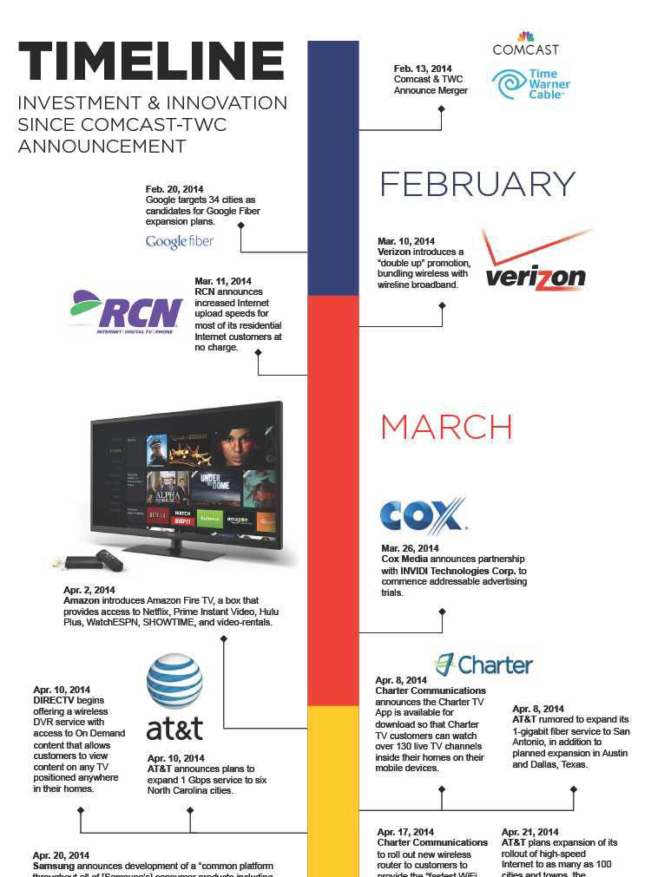

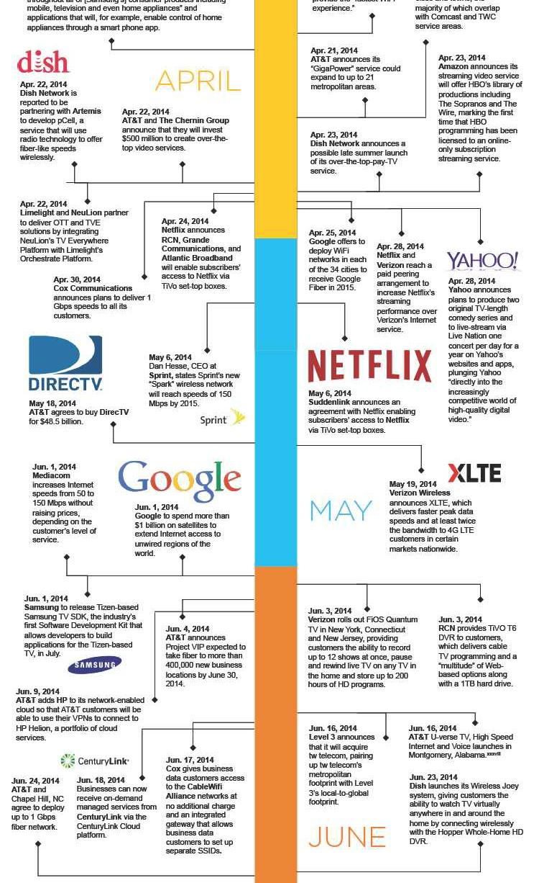

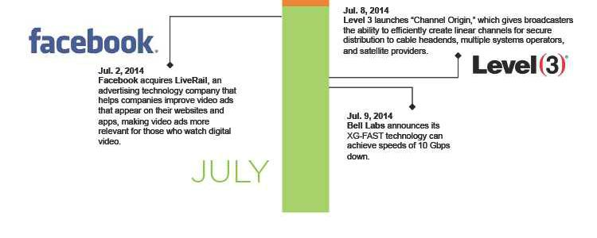

Important Information For Investors And Shareholders

This communication does not constitute an offer to sell or the solicitation of an offer to buy any securities or a solicitation of any vote or approval. In connection with the proposed transaction between Comcast Corporation (“Comcast”) and Charter Communications, Inc. (“Charter”), Charter will file with the Securities and Exchange Commission (“SEC”) a registration statement on Form S-4 that will include a proxy statement of Charter that also constitutes a prospectus of Charter, and a definitive proxy statement/prospectus will be mailed to shareholders of Charter. INVESTORS AND SECURITY HOLDERS OF COMCAST AND CHARTER ARE URGED TO READ THE PROXY STATEMENT/PROSPECTUS AND OTHER DOCUMENTS THAT WILL BE FILED WITH THE SEC CAREFULLY AND IN THEIR ENTIRETY BECAUSE THEY WILL CONTAIN IMPORTANT INFORMATION. Investors and security holders will be able to obtain free copies of the registration statement and the proxy statement/prospectus (when available) and other documents filed with the SEC by Comcast or Charter through the website maintained by the SEC at http://www.sec.gov. Copies of the documents filed with the SEC by Comcast are available free of charge on Comcast’s website at http://cmcsa.com or by contacting Comcast’s Investor Relations Department at 866-281-2100. Copies of the documents filed with the SEC by Charter will be available free of charge on Charter’s website at charter.com, in the “Investor and News Center” near the bottom of the page, or by contacting Charter’s Investor Relations Department at 203-905-7955.

In addition, in connection with the proposed transaction between Comcast and Time Warner Cable Inc. (“Time Warner Cable”), on May 23, 2014, Comcast filed with the SEC an amendment to the registration statement on Form S-4 that was originally filed on March 20, 2014, containing a preliminary joint proxy statement of Comcast and Time Warner Cable that also constitutes a preliminary prospectus of Comcast. The registration statement has not yet become effective. After the registration statement is declared effective by the SEC, a definitive joint proxy statement/prospectus will be mailed to shareholders of Comcast and Time Warner Cable. INVESTORS AND SECURITY HOLDERS OF COMCAST AND TIME WARNER CABLE ARE URGED TO READ THE JOINT PROXY STATEMENT/PROSPECTUS AND OTHER DOCUMENTS FILED OR THAT WILL BE FILED WITH THE SEC CAREFULLY AND IN THEIR ENTIRETY BECAUSE THEY CONTAIN OR WILL CONTAIN IMPORTANT

2

INFORMATION. Investors and security holders may obtain free copies of the registration statement and the joint proxy statement/prospectus and other documents filed with the SEC by Comcast or Time Warner Cable through the website maintained by the SEC at http://www.sec.gov. Copies of the documents filed with the SEC by Comcast are available free of charge on Comcast’s website at http://cmcsa.com or by contacting Comcast’s Investor Relations Department at 866-281-2100. Copies of the documents filed with the SEC by Time Warner Cable will be available free of charge on Time Warner Cable’s website at http://ir.timewarnercable.com or by contacting Time Warner Cable’s Investor Relations Department at 877-446-3689.

Shareholders of Comcast and Time Warner Cable are not being asked to vote on the proposed transaction between Comcast and Charter, and the proposed transaction between Comcast and Time Warner Cable is not contingent upon the proposed transaction between Comcast and Charter.

Comcast, Time Warner Cable, Charter and their respective directors and certain of their respective executive officers may be considered participants in the solicitation of proxies in connection with the proposed transaction between Comcast and Time Warner Cable, and Comcast, Charter and their respective directors and certain of their respective executive officers may be considered participants in the solicitation of proxies in connection with the proposed transaction between Comcast and Charter. Information about the directors and executive officers of Time Warner Cable is set forth in its Annual Report on Form 10-K for the year ended December 31, 2013, which was filed with the SEC on February 18, 2014, its proxy statement for its 2014 annual meeting of stockholders, which was filed with the SEC on April 29, 2014, and its Current Report on Form 8-K, which was filed with the SEC on June 13, 2014. Information about the directors and executive officers of Comcast is set forth in its Annual Report on Form 10-K for the year ended December 31, 2013, which was filed with the SEC on February 12, 2014, its proxy statement for its 2014 annual meeting of stockholders, which was filed with the SEC on April 11, 2014, and its Current Report on Form 8-K, which was filed with the SEC on July 1, 2014. Information about the directors and executive officers of Charter is set forth in its Annual Report on Form 10-K for the year ended December 31, 2013, which was filed with the SEC on February 21, 2014, its proxy statement for its 2014 annual meeting of stockholders, which was filed with the SEC on March 27, 2014, and its Current Report on Form 8-K, which was filed with the SEC on May 9, 2014. These documents can be obtained free of charge from the sources indicated above. Additional information regarding the participants in the proxy solicitations and a description of their direct and indirect interests, by security holdings or otherwise, are contained in the preliminary joint proxy statement/prospectus of Comcast and Time Warner Cable filed with the SEC and will be contained in the definitive joint proxy statement/prospectus of Comcast and Time Warner Cable and other relevant materials to be filed with the SEC when they become available, and will also be contained in the preliminary proxy statement/prospectus of Charter when it becomes available.

Cautionary Statement Regarding Forward-Looking Statements

Certain statements in this communication regarding the proposed acquisition of Time Warner Cable by Comcast and the proposed transaction between Comcast and Charter, including any statements regarding the expected timetable for completing the transactions, benefits and synergies of the transactions, future opportunities for the respective companies and products, and any other statements regarding Comcast’s, Time Warner Cable’s and Charter’s future expectations, beliefs, plans, objectives, financial conditions, assumptions or future events or performance that are not historical facts are “forward-looking” statements made within the meaning of Section 27A of the Securities Act of 1933, as amended, and Section 21E of the Securities Exchange Act of 1934, as amended. These statements are often, but not always, made through the use of words or phrases such as “may”, “believe,” “anticipate,” “could”, “should,” “intend,” “plan,” “will,” “expect(s),” “estimate(s),” “project(s),” “forecast(s)”, “positioned,” “strategy,” “outlook” and similar expressions. All such forward-looking statements involve estimates and assumptions that are subject to risks, uncertainties and other factors that could

3

cause actual results to differ materially from the results expressed in the statements. Among the key factors that could cause actual results to differ materially from those projected in the forward-looking statements are the following: the timing to consummate the proposed transactions; the risk that a condition to closing either of the proposed transactions may not be satisfied; the risk that a regulatory approval that may be required for either of the proposed transactions is not obtained or is obtained subject to conditions that are not anticipated; the parties’ ability to achieve the synergies and value creation contemplated by the proposed transactions; the parties’ ability to promptly, efficiently and effectively integrate acquired operations into their own operations; and the diversion of management time on transaction-related issues. Additional information concerning these and other factors can be found in Comcast’s, Time Warner Cable’s and Charter’s respective filings with the SEC, including Comcast’s, Time Warner Cable’s and Charter’s most recent Annual Reports on Form 10-K, Quarterly Reports on Form 10-Q and Current Reports on Form 8-K. Comcast, Time Warner Cable and Charter assume no obligation to update any forward-looking statements. Readers are cautioned not to place undue reliance on these forward-looking statements that speak only as of the date hereof.

4

