Filed by Comcast Corporation

(Commission File No.: 001-32871)

Pursuant to Rule 425 of the Securities Act of 1933

and deemed filed pursuant to Rule 14a-6(b)

of the Securities Exchange Act of 1934

Subject Company: Time Warner Cable Inc.

Commission File No. for Registration Statement

on Form S-4 filed by Comcast Corporation: 333-194698

The following third-party letters were made available on Comcast’s website:
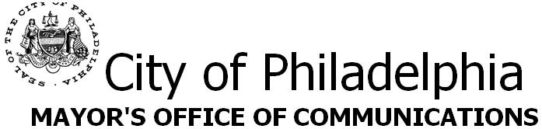

Michael A. Nutter, Mayor

Mark McDonald, Press Secretary

Office: 215-686-6210

Cell: 267-303-9248

Thursday, August 21, 2014 FOR IMMEDIATE RELEASE

MAYOR NUTTER, FIFTY-ONE U.S. MAYORS WRITE IN SUPPORT OF COMCAST – TIME WARNER CABLE MERGER

Philadelphia, August 21, 2014 – Mayor Michael A. Nutter and fifty-one other mayors from across the United States sent a letter to the Federal Communications Commission (FCC) supporting the proposed transaction between Comcast and Time Warner Cable. In the letter, the mayors detailed potential benefits of the transaction, including increased network investment, faster internet speeds, improved video options and more jobs.

“As Mayor of the city in which Comcast is headquartered, I proudly and enthusiastically support this business transaction because Comcast has always been a great corporate citizen in Philadelphia, and I thank my fellow mayors for joining me in supporting this crucial transaction,” said Mayor Nutter. “The merger of Time Warner Cable and Comcast will lead to improved services and increased investment in existing Comcast markets. Cities joining the Comcast service area will benefit from the expertise the company brings in delivering high-quality, reliable products and from its commitment to increased digital literacy.”

Comcast’s Internet Essentials program is an industry-leading model designed to address this challenge and has already increased residential internet access by 1.4 million homes. Expanded broadband adoption and increased digital literacy in the workforce will ultimately benefit the regional economies of the cities served by Comcast and more broadly, the entire U.S. economy.

The mayors’ letter to the FCC is attached.

###


1

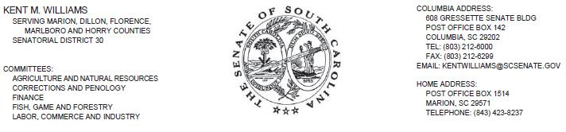

August 21, 2014

Marlene H. Dortch

Secretary

Federal Communications Commission

445 12th Street, SW

Washington, DC 20554

RE: MB Docket No. 14-57

Dear Ms. Dortch:

Every American, rich or poor, urban or rural, deserves economic opportunity. It is my duty as the State Senator for five rural counties here in South Carolina to empower my constituents to take on the future challenges and opportunities that face our community. We are currently covered by Time Warner, but will be covered by Comcast if the transaction is approved. The proposed Comcast-Time Warner Cable transaction presents a perfect chance to positively position my district and our country for whatever lies ahead.

It is no secret - knowledge is power. And in the 21st century, state-of-the-art Internet technology gives people access to knowledge of the entire world. That sort of access is often costly and unreachable for the rural areas I represent. The Comcast Internet Essentials program offers unparalleled Internet to low-income families, in addition to discounted computers and free training programs. If the transaction is approved, this program would broaden the horizons of my constituents to take into the whole world. Families and young people would get access to the technology link they need to thrive in our economy, no matter where they live or how much they make. Approval of the transaction will make this proposed link a daily reality.

Comcast employs 388 full-time workers in our state, which translates into $24 million in pay, benefits, tuition reimbursements and employee training. In 2013, it contributed more than $500,000 in donations and volunteering. South Carolina benefits from Comcast's presence.

I respectfully ask for your support and approval of this transaction. This transaction will provide substantial opportunities that will help to bring many Americans forward in communities across South Carolina and our country to face a more prosperous and equitable future, together.

Sincerely,

/s/ Kent Williams

Kent Williams

SC Senate District 30

Serving Marion, Dillon, Florence,

Marlboro and Horry Counties

2

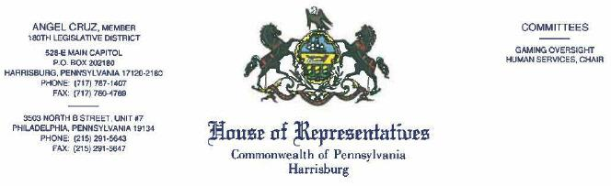

RE: MB Docket No. 14-57

In my decades of experience in public service, beginning as a Ward Leader in my hometown of Philadelphia now serving as a Representative in the Pennsylvania House of Representatives, I have had the opportunity to partner with dozens of companies and organizations in efforts to improve my community. No partnership has been more fruitful than our connection with the people of Comcast. Based on my years of experience working with this faithful, generous company, I pledge my full support for the proposed Comcast and Time Warner Cable transaction.

As a representative of Pennsylvania's 180th District, I serve a minority community with limited resources. As one of just two Hispanic legislators in the state, I feel it is my duty to promote the needs of our state's more than 780,000 Latinos. This has led me to become an active member of the National Hispanic Caucus of State Legislators (NHCSL). The NHCSL provides technical assistance and resources that will help legislators propose legislation and administrative actions to achieve a better quality of life. Our efforts focus on advancements in education, healthcare, housing, economic development, criminal justice, and employment and job training for the Hispanic community. Since Comcast became Chair of our Business Board of Advisors, we have been able to bring a fresh approach to building public/private partnerships with business and labor.

Between cable, broadband and digital voice service, Comcasrs capital investments in my state since 1996 total more than $8 billion - $2.4 billion of that came in 2013 alone. It provides jobs for almost 12,000 Pennsylvania residents. Comcast and NBCUniversal contributions also come in the form of considerable donations, volunteer work, scholarships, public service messages and programming for our students and other groups.

Comcast is also one of the preeminent companies to uniquely understand the value of my community and constituents, and to provide them critical opportunities. Through Comcast's Internet Essentials program, many of the most in-need students and their families can access essential computer and internet training. Free programming at community centers focused on digital literacy is also a benefit of Internet Essentials, which allows Spanish-speaking residents of our City to obtain the tools necessary to learn English, acquire job training skills, and help their children keep up with their studies. Without the support of Comcast's technicians and patient instructors, the youth and adults in my district would face a future of disadvantage.

Comcast is a company that understands the needs of its customers and constantly works to promote diversity in its corporate structure. I am proud to work with the group through NHCSL and on other legislative priorities that continue to have a major impact on the Hispanic community. Without Comcast, many of our neediest residents would continue to lack the basic resources to compete with their peers in the race towards a greater economic future. It is time to grant many more Americans the chance to access what this civic-minded company has to offer by approving the Comcast and Time Warner Cable transaction.

Sincerely,

/s/ Angel Cruz

Representative Angel Cruz

District 180 - Philadelphia County

Commonwealth of Pennsylvania

AC/cc

3

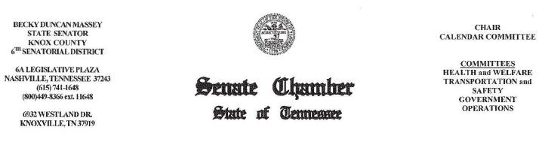

August 18, 2014

Dear Chairman Wheeler:

Chairman Tom Wheeler

Commissioner Mignon Clyburn

Commissioner Jessica Rosenworcel

Commissioner Ajit Pai

Commissioner Michael O'Rielly

Federal Communications Commission

445 12th Street, SW

Washington, DC 20554

RE: MB Docket No. 14-57

Dear Chairman and Commissioners:

I am writing to the Commission today to speak to the proposed Comcast and Time Warner Cable transaction. As a state senator in the Tennessee General Assembly, I come from a family with a long history of holding office in the community of Knoxville and beyond. And as the executive director for a Knoxville nonprofit, I serve mentally challenged and disabled individuals.

In both of these roles, I have become acquainted with and impressed by Comcast's company activities. The way that the company operates as a business and the manner in which it gives back to community are both exemplary. I would like to urge you to approve the proposed transaction.

Comcast has been a leader in developing products for Persons With Disabilities, such as the ground-breaking talking TV cable interface it debuted last year, its Smart Home products, and its customer service for those with disabilities.

Disability advocacy agencies have noted Comcast's trend-setting hiring practices that are inclusive of the disabled. The company made "Careers & the disABLED Magazine's" Top 50 Employers List in 2014 for the fourth straight year.

4

As someone who is married to a software developer, I am cognizant of the impact that Comcast's digital innovations have. It offers the industry's fastest expandable business Ethernet network. It brings creativity and accommodation to cable and video users. Its newest Xi platform allows entertainment content to be accessed instantly. Comcast programming runs the gamut and incorporates many independent minority-owned networks, Spanish language channels and endless On Demand options.

Tennessee is very involved in job recruitment efforts and developing a skilled workforce. Here again, Comcast has been a willing and able partner by offering free technology training, serving as a digital liaison between individuals and community groups, and awarding annual academic scholarships to local high school graduates. It also offers broadband service to the economically disadvantaged at a discount so that schoolchildren are able to access the Internet and develop the digital skills they will need for college and careers. The combined power of these programs, Digital Connectors and Internet Essentials, reaches millions nationwide. Already, more than 1.4 million individuals have connected to the power of home internet via the Essentials program. Many more could become eligible.

The many benefits Knoxville and Tennessee have enjoyed through an association with Comcast should be extended to other cities and states. Comcast is the kind of corporate partner that many more communities would welcome.

Respectfully,

/s/ Becky D. Massey

Senator Becky Duncan Massey

State Senator, 6th Senatorial District

5

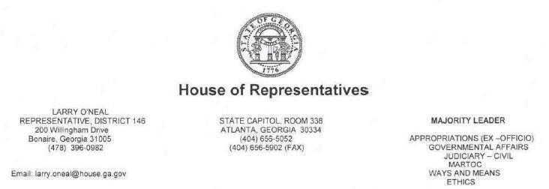

August 20, 2014

Chairman Tom Wheeler

Commissioner Mignon Clyburn

Commissioner Jessica Rosenworcel

Commissioner Ajit Pai

Commissioner Michael O'Rielly

Federal Communications Commission

445 12th Street

Washington, DC 20554

RE: MB Docket No. 14-57

Dear Chairman Wheeler and Commissioners:

As the Majority Leader for the Georgia House of Representatives and more importantly the representative for the 146th House District, I take the business of our state extremely seriously and enjoy hearing good news about good companies that operate in it. Thus, when I heard of the growth opportunities for Comcast and its local employees and our state, I was thrilled.

While the people of my district do not have access to the services of Comcast, I am aware of what the company offers, both in programming and community investment, in other parts of the state, including its capital city of Atlanta where I have a temporary residence during the legislative session. It is my privilege to support the proposed transaction between Comcast and Time Warner Cable.

I understand that in the last 20 years, Comcast has made broad investments in our state's infrastructure, totaling $4 billon. The company is also a great employer in our state for some 4,000 Georgians and is always looking at ways to support the economic engine with high paying technology salaries. The company has also made significant efforts to narrow the digital divide in Georgia by providing low-cost, high-speed Internet to underserved children and families through the Internet Essentials program. This program has been operational since 2011 and is already achieving results for many Georgians. If the proposed transaction is approved, Comcast will extend this program to many more.

6

Federal Communications Commission

August 20, 2014

Page 2

Georgia needs more programs like this that are focused on the success and advancement of our young people and I believe, like other state leaders, that education is the great equalizer. In addition to digital adoption, Comcast is a community partner, rooted in many regions of the state, and performing works of charity and volunteer service. In fact, thousands of Comcast employees and volunteers participate every year in what they call Comcast Cares Day at multiple sites where they can roll up their sleeves and give back in a big way to Georgia. While Comcast Cares Day is one of the largest days of volunteerism in the country, the philanthropic arm of the company is active year-round.

Finally, Comcast not only employs thousands of Georgians, it ensures that they have access to health benefits and tuition reimbursements so they can better themselves and this increases the economic prosperity of the state. The company is a leader in the corporate arena, and more businesses should follow its example. I support the proposed transaction to unite Comcast and Time Warner Cable and urge you to do the same.

Sincerely,

/s/ Larry O’Neal

Larry O’Neal

House Majority Leader

Georgia House of Representatives

7

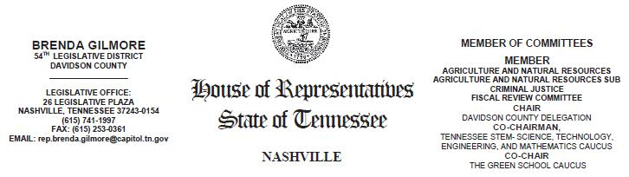

August 19, 2014

Tom Wheeler Chairman

Federal Communications Commission

445 12th Street, SW

Washington, DC 20554

RE: MB Docket No. 14-57

Dear Chairman Wheeler:

My name is Brenda Gilmore. Since 2007 I've represented Tennessee's 54th district in the Tennessee General Assembly. I am the former president of C.A.B.L.E - Tennessee's largest and most established network of diverse professionals connecting women and opportunity - and proudly hold membership of the executive board, National Caucus of Environmental Legislators (NCEL), chair elect of the Women’s network of National Conference of State Legislators (NCSL), member of the executive National Black Caucus of State Legislators (NBCSL) and member of National Organization of Black Elected Legislative Women (NOBEL Women).

I write you today to express my support and enthusiasm for the proposed transaction between Comcast and Time Warner Cable. In my time as a state legislator and member of the above organizations, I can personally attest to Comcast's commitment to good jobs and economic growth, promotion of diversity and inclusion in the workplace and our communities, and efforts to bridge the digital divide in Tennessee.

Comcast has been a vital source of employment in the state of Tennessee. The company accounts for approximately 3,000 full-time jobs here, providing solid health care benefits and on-the-job training to our residents. Comcast has also been a vital investor in our state's economy as well; since 1996, Comcast has invested over $2 billion in technology and infrastructure to benefit our state, its businesses and consumers. It owns and operates 131 properties here; including three call centers, and in 2013 generated around $128 million in annual state and local tax revenues. The way I see it, if the proposed transaction with Time Warner is approved, Comcast's new scale will allow it to generate new economic opportunity on top of what it has already made possible.

8

One of the main issues that I've concerned myself with in my career has been the advancement of women, low-income families, and people of color on the national, state, and local level. Comcast has proven its commitment to such advancement. By year's end in 2013, people of color accounted for 40% of Comcast's full-time employees. Diversity exists at all levels of the company; 25% of management is people of color.

Leveraging technology is another key issue for the advancement of people of color. In 2010 the Comcast Foundation made a $50,000 grant to the NBCSL to form the NBCSL/Comcast Broadband Legislative Fellowship, in order to increase efforts to conduct research and develop solutions regarding broadband adoption among African Americans, a worthy cause in my estimation.

After joining with NBC Universal in 2011, Comcast made several commitments to increasing minority participation in the media and communications landscape. To date, I understand that they have created four new minority owned cable networks; DreamIT, a venture capital fund focused on minorities and women; and- perhaps most importantly - Internet Essentials, a program for low-income families and communities that have had limited access to broadband. Though Internet Essentials was only intended to run for three years, Comcast recently decided to extend the program indefinitely.

Comcast's track record of investment, of honoring commitments, and of bettering communities leads me to believe that only more good things can come from its continued success as an American business and community leader. I therefore support the transaction between Comcast and Time Warner Cable, and hope your Commission does the same.

Sincerely,

/s/ Brenda Gilmore

Rep. Brenda Gilmore

Tennessee General Assembly, 54th District

9

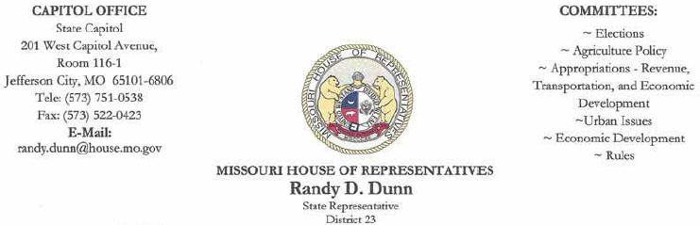

August 18, 2014

Mr. Tom Wheeler, Chairman

Federal Communications Commission

445 12th Street, SW

Washington, DC 20554

Dear Chairman Wheeler,

I am writing in support of the proposed Comcast/ Time Warner Cable (TWC) transaction. As Representative of the 23rd District in Kansas City, Missouri, I see the digital divide between the privileged and the underprivileged has steadily increased over the last few years. Our more affluent neighborhoods have modern technology in school classrooms and nearly 100% broadband access in homes. The less fortunate continue to lag behind with schools that struggle for basic resources and families that cannot afford a computer or internet subscription. Given the opportunities that broadband access offers to students and families, the digital divide is unacceptable as a matter of public policy to all our residents.

Tackling such an important goal like the digital divide will require the creativity and generosity of the private sector combined with the leadership and resources of the public sector. Comcast came to the same conclusion in 2011, when it began to develop a program in conjunction with major U.S. cities to make a significant impact in low-income schools and communities. The Intenet Essentials Program provides low-cost broadband service, full-service computers for under $150 and options for free digital literacy training in local commuruty centers and schools. The program is currently offered to families in Comcast service areas with children who qualify for free or reduced-price school lunches. Thousands of families in my community qualify if Comcast were to serve the 23rd District of Kansas City, Missouri.

Comcast is committed to improving the lives in the communities they serve. It is in the best interest of the community for the FCC to vote in favor of the proposed Comcast/TWC transaction as soon as possible.

Should you have any questions, please do not hesitate to call my office at (573) 751-0538.

Respectfully,

/s/ Randy D. Dunn

Representative Randy D. Dunn

District 23

10


STATE OF MARYLAND

OFFICE OF THE GOVERNOR

MARTIN O’MALLEY

GOVERNOR

STATE HOUSE

100 STATE CIRCLE

ANNAPOLIS, MARYLAND 21401-1925

(410) 974-3901

(TOLL FREE) 1-800-811-8336

TTY USERS CALL VIA MD RELAY

August 19, 2014

The Honorable Tom Wheeler

Chairman

Federal Communications Commission

445 12th Street, SW

Washington, DC 20554

RE: MB Docket No. 14-57

Dear Chairman Wheeler:

I am writing to highlight some of Comcast’s investments in Maryland. Comcast has invested aggressively in infrastructure throughout our state. In addition to employing almost 4,000 Marylanders, the company invests in Maryland community partnerships, charitable organizations, and scholarships for our youth. More than 2,500 individuals participate in our state’s Comcast Cares Day, the corporation’s banner day of community service.

I wanted to draw particular attention to the strides the company has made in serving our neediest citizens through the Internet Essentials program. This program provides premier broadband access for only about $10 a month to families whose children qualify for the National School Lunch Program. In Maryland, almost 7,500 households have taken advantage of this program.

I appreciate your willingness to consider the work Comcast has done in Maryland to enrich the lives of citizens in our State.

Sincerely,

/s/ Martin O’Malley

Governor

11

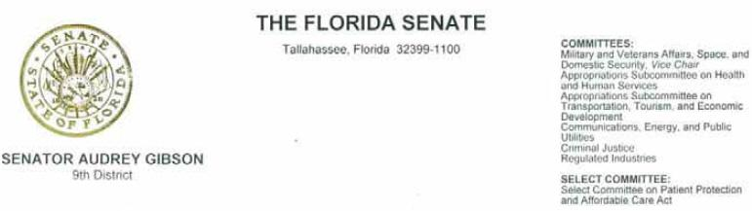

August 12, 2014

Tom Wheeler, Chairman

Federal Communications Commission
445 12th Street, SW

Washington, DC 20554

RE: MB Docket No. 14-57

Dear Chairman Wheeler,

As a long serving legislator in both the House and Senate, and as a current member of the Florida Senate Communications, Energy and Public Utilities Committee, I have seen the technology shift in our great state. Our citizens are benefitting, but more work needs to be done which is why I am writing today, to strongly encourage your approval of Comcast’s proposed merger with Time Warner Cable.

Comcast has demonstrated clear understanding of the needs and issues facing our communities including in my home district of Jacksonville. Last year in Florida, I understand that Comcast spent over $2.6 billion investing in its infrastructure, employees and our communities. This considerable investment is in addition to the other benefits to the community that the company undertakes, such as Comcast Cares Day where over 5,000 Comcasters in Florida give their time to rebuild schools, clean up parks, and beautify the community. An event in which I have had the opportunity participate.

For years, I have been a proponent of economic and workforce development championing the rebuilding of our communities hit hard by foreclosures, transportation, especially for seniors and the disabled, and the continuum of education particularly pre-K through 12. All of these issues which I continue to fight for, can benefit and be directly tied to affordable access to some type of technology. With access to low-cost internet through Comcast’s Internet Essentials program which provides home internet service at an affordable rate to those who qualify, looking for employment or avenues to increase skill set will be as easy as turning on the television, students of all ages and parents will have better access to teachers and lesson plans, and transportation can be arranged with a click instead of a long waiting call.

In Jacksonville, nearly 22,000 households are eligible for Internet Essentials. I can only imagine how many families there are across the country who would be eligible for this program. If the proposed transaction were to be approved, countless more families could have the opportunity to enroll in the Internet Essentials program, thus opening doors to knowledge, education and opportunity.

Chairman Wheeler, I speak not only for my constituents, but the many others who will benefit from a Comcast and Time Warner Cable union. I ask you and your fellow Commissioners to favorably approve this transaction.

Sincerely,

/s/ Audrey Gibson

Audrey Gibson, State Senator District 9
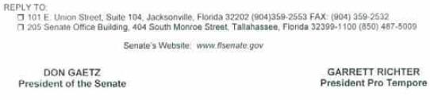

12

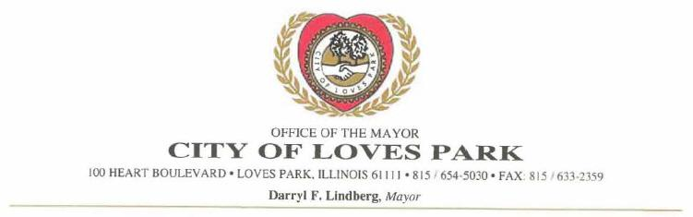

August 18, 2014

Chairman Tom Wheeler

Commissioner Mignon Clyburn

Commissioner Jessica Rosenworcel

Commissioner Ajit Pai

Commissioner Michael O'Reilly

Federal Communications Commission

445 12th Street, SW

Washington, DC 20554

RE: MB Docket No. 14-57

Dear Chairman and Commissioners:

I currently serve as Mayor in the City of Loves Park, Illinois, located about 80 miles northwest of Chicago with a population of around 24,000 people. I write you today because I have heard that the Federal Communications Commission is reviewing comments on the proposed transaction between Comcast and Time Warner Cable. I would like to take this opportunity to voice my full support for this transaction. As a longtime resident and public servant in Loves Park, which is a Comcast-served market, I can personally speak to Comcast's commitment to our communities and positive economic impact.

Comcast is a strong supporter of good jobs In Illinois, and It has been a consistent partner in supporting and positively impacting economic growth on both the state and local level. I have read that the company employs nearly 7,000 full-time workers in Illinois. The company owns and operates over 160 properties in the state, including a service center that is in close proximity to Loves Park and employs many of our residents.

Comcast has proven itself to be a committed partner in our local community, with several service programs that get our residents involved in positive activities that really make a difference. On April 26 of this year, for instance, Loves Park hosted our very own Comcast Cares Day, which is the nation's largest single-day corporate volunteer effort.

13

Page two.

Comcast/Time Warner

August 18, 2014

The event was a terrific success, as volunteers from Comcast and from our community joined together at various local sites, beautifying our neighborhoods and benefitting the Northern Illinois Food Pantry.

One of the most important reasons that I support the proposed transaction between Comcast and Time Warner Cable is because I know that Comcast follows through on its commitments. I could point to several examples, but I'll focus on one: Comcast's Internet Essentials Program. Comcast has been at the forefront of bridging the digital divide and devoting resources to ensure broadband adoption for low-income families who can't afford Internet access at home. Internet Essentials - launched in 2011 as a three-year experiment to promote digital literacy- provides affordable broadband Internet access to low-income families with children that qualify for free or price-reduced lunches under the National School Lunch Program. Comcast was under no obligation to extend this program after its initial three years, but it recently volunteered to do so indefinitely. I hear that Comcast has connected over 1.4 million Americans to the Internet. In the Rockford area, which includes Loves Park, Comcast has seen the number of connected low-income households jump from 171 in the first year to over 1,000 this past year.

I am very excited by the opportunities and commitments that Comcast has brought to Loves Park. But other areas of the country not currently within Comcast's footprint do not have the same access and opportunities provided by Comcast's economic investments, community involvement and digital literacy programs. If you approve the proposed transaction, Comcast will be able to bring the Internet to millions of new families.

I hope you will approve this transaction. Thank you for your consideration.

/s/ Darryl F. Lindberg

Darryl F. Lindberg

Mayor of Loves Park, Illinois

14



August 20, 2014

Tom Wheeler, Chairman

Federal Communications Commission
445 12th Street. SW

Washington. DC 20554

RE: MB Docket No. 14-57

Dear Chairman Wheeler:

In my time as Mayor of Nashua, NH. I have sought new ways to motivate and engage my fellow residents in our shared civic life, be it through volunteerism, serving on official boards and commissions or simply taking on active role in community development. As a corporate "resident," Comcast has been a leader in finding new ways to assist. I'd like to take a moment to share some of that experience as you consider approval of the company's merger with Time Warner Cable.

Comcast organizes one of the largest single-day volunteer events in Nashua each April - Comcast Cares Day · in which nearly every employee ventures out into the community to put in a day of service. This year. we collaborated on projects at The Nashua Boys and Girls Club, the Humane Society of Greater Nashua and Girls Incorporated. Comcast Cares Day engages not just Comcast employees but many of our major institutions — schools, libraries, parks — and their staff. It's a true community-wide event and sets a great tone for the spring and summer months.

Year-round, Comcast engages in meaningful projects centered around youth engagement. working with groups like the Boys & Girls Club, Big Brothers Big Sisters and Girls. Inc. These projects range from mentorship opportunities to training programs for technical and computer skills. This commitment to helping Nashua's next generation is incredibly valuable to us and speaks volumes about Comcast' corporate values.

As you weigh the costs and benefits of this proposed merger, please know that the cities and towns that stand to benefit from Comcast's entry into their communities will have the opportunity to work with a company that takes its civic responsibilities seriously and puts the full weight of the company behind reaching their goals.

Sincerely,

/s/ Donnalee Lozeau

Donnalee Lozeau

229 Main Street· PO Box 2019 · Nashua. NH 03061-2019

603.589.3260 · fax 603.594.3450 · NashuaMayor@NashuaNH.gov

15

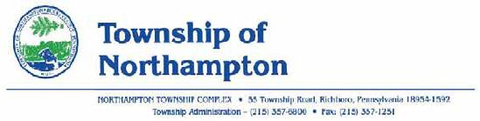

August 19, 2014

Tom Wheeler, Chairman

Federal Communications Commission
445 12th Street, SW

Washington, DC 20554

RE: MB Docket 14-57

Dear Chairman Wheeler:

I am the Chairman of the Board of Supervisors in Northampton Township, Bucks County, Pennsylvania. I am writing to express my support for the proposed Comcast and Time Warner Cable transaction, and to ask you to please approve the proposal.

Comcast has been a very important corporate member of our Commonwealth through the economically unstable times of recent years. The company supplies jobs along with supporting community activities. Many of our local citizens work for Comcast and enjoy its excellent service.

Comcast has invested billions of dollars here in Pennsylvania and around the United States in networks and technology that are world-class. The services the company offers puts it at the top of the industry. It is always a step ahead with efforts like its switch to all digital video services, and apps that allow customers to live stream video content anytime, anywhere. Comcast keeps up with changing audiences, too. As our country has become more diverse, Comcast has added new, independent and minority programming to its line-up, such as Spanish language networks like mun2 and El Rey.

We admire the standards Comcast has set for hiring employees from all backgrounds, including those with disabilities. In fact, a very tangible example of Comcast's commitment to those with disabilities can be found right in Northampton Township. One of our parks is home to the area's only baseball field and soccer field that can accommodate children and teens with physical and mental challenges. Kids from all over Bucks County, where we are located, come to the fields built by The Miracle League with help from Comcast and other businesses. Their wheelchairs and walkers are no impediment as they hit the ball and round the bases on a special rubberized surface. Last year, our Miracle League was chosen for a prestigious Service Group Award from the Pennsylvania Recreation and Park Society Inc., as a result of the fields it built here. These fields could not have been built without the financial and volunteer assistance to create this wonderful addition to our township.

16

Many nonprofits in the Northampton Township community are better for Comcast's involvement. We see Comcast workers out every spring during their Comcast Cares Day, where they go around to various nonprofit groups, churches, food pantries, day care centers and so forth. They paint, clean, stock pantries and complete whatever needs to be done.

We didn't see these charitable commitments or our Comcast service suffer with the acquisition of NBC Universal a few years ago. In fact, we have seen more opportunities come along as a result. A great new service, for example, is designed for those who haven't been able to afford to pay for Internet. Families who qualify can get Internet service for only $10 a month. With the inclusion of the Internet in our school curriculum, this service enables all of our students to have access to the Internet.

I firmly believe that the proposed Comcast and Time Warner Cable transaction will follow the same pattern, bringing more good things, economic and humanitarian, to communities. Please support this transaction.

Thank you for your attention to this important matter.

Very truly yours,

Eileen Silver

Chairman, Board of Supervisor

17

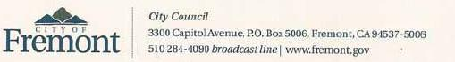

Chairman Tom Wheeler

Commissioner Mignon Clyburn

Commissioner Jessica Rosenworcel

Commissioner Ajit Pai

Commissioner Michael O'Rielly

Federal Communications Commission

445 12th Street, SW

Washington, DC 20554

August 21, 2014

RE: MB Docket No. 14-57

Dear Chairman and Commissioners:

As a Fremont City Councilmember, I represent a growing community of over 220,000 Californians. I also serve as President of the Asian Pacific American Municipal Officials Constituency Group of the National League of Cities (NLC) and Co-Chair of the Asian Pacific Caucus of the League of California Cities.

I am writing to urge you to approve the proposed transaction between Comcast and Time Warner Cable.

Comcast has been an ally for families in Fremont and around California, most specifically with the Internet Essentials program. The innovative effort to close the "digital divide" boosts online literacy among families who need it most - those with children eligible for the National School Lunch Program. Those families receive internet access for less than $10 per month, a savings of hundreds over the course of a year. Over 12,000 of families across the San Francisco-Oakland-Fremont metropolitan area have already enrolled.

Many of my NLC colleagues who represent areas served by Comcast have similar experiences with Internet Essentials. The proposed transaction will allow the program to take root in even more cities and towns - particularly in southern California, where many households are served by Time Warner Cable.

I have also been impressed by Comcast's commitment to diversity. The company is a national leader in engaging with the Asian/Pacific Islander community - not just through membership in organizations and chambers of commerce - but by hiring API employees and contracting with API vendors. Comcast truly works on diversity within the company; I understand that the number of people of color in VP positions or higher has grown by more than 30% since Comcast acquired NBCUniversal.

18

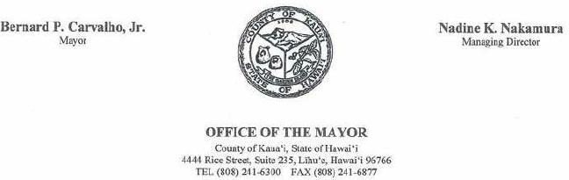

August 19, 2014

Mr. Tom Wheeler

Chairman

Federal Communications Commission
445 12th Street, SW

Washington, DC 20554

Re: MB Docket No. 14-57

Dear Chairman Wheeler:

Please accept my testimony in support of the cable television transter application which has been filed by Time Warner Cable and Comcast Corporation in the State of Hawai‘i.

Oceanic Time Warner Cable (OTWC) has been a responsible partner in providing reliable, affordable and accessible cable television access for residents of Kaua'i.

OTWC is also a generous supporter of numerous community events and charitable causes.

Recently, I had the opportunity to meet with representatives from Comcast Corporation and I feel confident that, should the transfer be approved, they will continue to serve our community in a consistent and responsible manner.

Mahalo nui loa for your consideration.

Best regards,

/s/ Bernard P. Carvalho, Jr.

Bernard P. Carvalho, Jr.

Mayor, County of Kaua'i

19

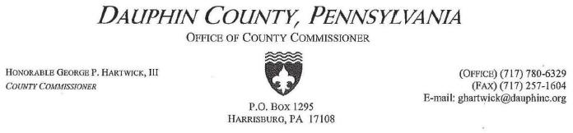

August 20, 2014

Mr. Tom Wheeler, Chairman

Federal Communications Commission
445 12th St., SW

Washington, DC 20554

RE: MB Docket No. 14-57

Dear Chairman Wheeler:

Throughout my tenure as an elected official in Pennsylvania - two terms as Mayor of Steelton and now in my third term as Dauphin County Commissioner - I've been privileged to partner with Comcast on many fronts to make Central Pennsylvania a better place to live. As lead commissioner for our county's Human Service agencies, Comcast has been a tremendous partner in our work to level the playing field for the economically disadvantaged. Hundreds of Dauphin County families most in need now have affordable home-based access to the riches of the web through the Internet Essentials program.

In Harrisburg, I was pleased to take part in the recent opening ceremonies of a new Comcast customer support center which created more than 600 new jobs. Harrisburg is an ethnically diverse city and it is gratifying to know that Comcast practices inclusive hiring policies that make it an employer of choice for minorities and persons with disabilities, as well as for veterans and women. These workers are provided with health care benefits - so crucial in today'seconomic environment - and tuition assistance, which is enhancing the education of our county residents.

And I give Comcast highest marks for engendering a spirit of community involvement among their employees - not only on Comcast Cares Day, but every day of the year as individuals who are encouraged to get involved and make their home communities better places to live.

Counties rely on good corporate citizens like Comcast. Should the Comcast-Time Warner transaction receive the necessary approvals, my counterparts throughout the United States will soon learn what my Pennsylvania colleagues already know - that Comcast is more than an excellent telecommunications provider, but also a company that knows the importance of partnership to make our communities more vibrant and better positioned for excellence.

Please consider my unqualified support for the proposal before you.

Sincerely,

/s/ George P. Hartwick, III

George P. Hartwick, III

Dauphin County Commissioner

Harrisburg, PA

www.dauphincounty.org

20

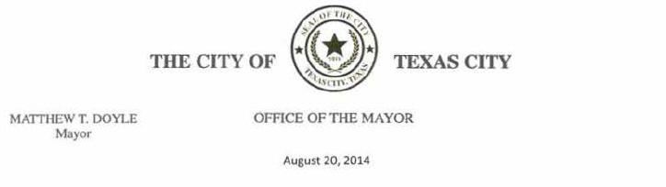

Chairman Tom Wheeler

Commissioner Mignon Clyburn

Commissioner Jessica Rosenworcel

Commissioner Ajit Pai

Commissioner Michael O'Rielly

Federal Communications Commission

445 12th Street, SW

Washington, DC 20554

RE: MB Docket No. 14-57

Dear Chairman Wheeler and Commissioners:

The City of Texas City has been served by Comcast cable services for many years. We feel, technology wise, they are leaders in this area . We see no downside to their merger with Time Warner since they cannot compete in the same markets anyway. Strengthening cable services through this merger may in fact increase competition for video services as well as data and telecommunications since cable systems are a smaller part of that arena than they were 10 years ago.

Cable systems are the only video service systems that provide a direct local P.E.G. channel. The City of Texas City relies on this channel for providing useful and critical information to its residents. We know this technology is possible for satellite and other systems to provide the same P.E.G. channels. If the other video and data service providers do not have to provide P.E.G. channels, then we need to keep the cable channels strong enough to compete. The merger would aid in this. Please look favorably on the merger.

Sincerely,

/s/ Matthew T. Doyle

Matthew T. Doyle

Mayor

21

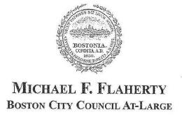

August 20, 2014

Tom Wheeler

Chairman

Federal Communications Commission

445 12th Street, SW

Washington, DC 20554

RE: MB Docket No. 14-57

Dear Chairman Wheeler:

Comcast's presence in Boston, Massachusetts has been most advantageous for the city. I believe New York would similarly benefit from the variety of good Comcast brings to the communities it serves. I encourage the Federal Communications Commission to consider these comments as it reviews the proposed Comcast and Time Warner Cable transaction.

One of my tasks as a Boston City Councilor is to oversee the city's public education program and bring fresh, innovative ideas to the table to counteract a lack of public financing options. One of the best options available to us is Comcast's Internet Essentials program. Having affordable broadband access and computers in the home is so important for many low-income famil ies who would otherwise lag behind. This program, which offers low-cost internet, computers, and free digital training services at local community centers, has helped to level the playing field across our education system. Bridging "gaps" via partnership is a Comcast trademark, and I look forward to doing what I can to ensure the continued success and growth of Internet Essentials in Boston.

As a lifelong resident of Boston I have witnessed the positive impact that Comcast's Community Investment Programs have had on our neighborhoods. Through events such as Comcast Cares Day, local Comcast employees help to brighten our local community centers and schools.

Through long-term partnerships with the United Way and Big Brothers Big Sisters, Comcast has reinvigorated local youth centers and fostered new relationships throughout Boston's non-profit world. One contribution that is especially unique and appreciated in our city is Comcast's participation in local St. Patrick's Day festivities. Each year, Comcast has provided media, family-friendly activities, and, for the last few years, has broadcast the St. Patrick's Day Parade across the world via NECN. Their efforts to recognize the importance of Boston's culture and traditions have not gone unnoticed or unappreciated.

22

New York residents deserve better choices in their cable and broadband providers, and I can vouch for Comcast as a top tier choice.

I hope the FCC takes note of Boston's experience and approves the proposed TWC/Comcast transaction.

Sincerely,

/s/ Michael F. Flaherty

Michael F. Flaherty

Boston City Councilor At-Large

23



August 19, 2014

Chairman Tom Wheeler

Commissioner Mignon Clyburn

Commissioner Jessica Rosenworcel

Commissioner Ajit Pai

Commissioner Michael O'Rielly

Federal Communications Commission

445 l2th Street, SW

Washington, DC 20554

Re: MB Docket No. 14-57

Dear Chairman and Commissioners:

I serve as Chairman of the Board of Aldermen in Manchester, New Hampshire, which routinely appears on lists of best cities in which to live and operate a business. The Equality of Opportunity Project last year ranked Manchester as the seventh best metropolitan area in the nation in terms of upward income mobility. That status is the result of fruitful partnerships with businesses and organizations in the city. A major partner here is Comcast. It is one of the largest employers in Manchester and an able and willing collaborator on city projects.

Comcast contributes significantly to the city and state economy, having spent many millions on its operations and community donations in New Hampshire last year. Comcast operations resulted in an injection of more than $26 million in taxes and fees to local and state treasuries. Comcast is a national leader in digital technology with its broadband and video services. The company also makes a powerful impact in the social services arena, improving lives of the less fortunate in our city of just over 110,000 residents. With these considerations in mind, I respectfully request that the Commission approve the proposed Comcast and Time Warner Cable transaction. I believe there would be measurable benefits for many.

Among other appointments, I serve as an alderman on the Community Improvement Committee for the city and the Special Committee on Alcohol & Other Drugs. I interact with innumerable businesses and their representatives as a result, and I see how Comcast is committed to and involved in such life-changing projects here as "City Year." Each year since 2000, AmeriCorps volunteers come to Manchester through City Year and work in classrooms in our poorest schools, coaching children and leading activities. I understand that Comcast has donated millions to City Year programs in the U.S., through cash and free airtime to promote the program. Students' performance has certainly increased, with 97 percent of third-through-fifth grade students in six Manchester elementary schools improving their raw literacy score through the program.

24

Page 2.

That's an impact Comcast has made through just one program here. It also is a significant donor to New Hampshire Families in Transition (FIT), which has, for 22 years, supplied safe and affordable housing as well as extensive social services to the homeless and those at risk of becoming homeless.

Comcast has consistently supplied us with fast Internet and a myriad of improving technology. It has stepped up when city projects were in need of assistance. We've come to expect community engagement from Comcast and I know that it would operate the same in any city in which it operated.

Please extend this potential for strong corporate-community partnership to new regions by approving the proposed transaction.

Sincerely.

/s/ Daniel O'Neil

Daniel O'Neil

At-Large Alderman

25

Comcast is a longtime and supportive business partner in the Allegheny County, the Township of South Park, where I serve as Chairman of the Board of Supervisors. I would like to express support for the proposed Comcast and Time Warner Cable transaction.

Over the years, I have interacted routinely with officials in the company and witnessed Comcast employees' efforts to contribute to and beautify our community. There are many examples of how Comcast adds to our community.

South Park is nearby Pittsburgh and I've seen the broad and positive impact that Comcast has had in improving technology-training opportunities for disadvantaged youth and in getting more low-income families connected to the Internet. Specifically, Comcast's Internet Essentials program, now in its fourth year, has made important strides in bringing Internet service to children whose families previously couldn't afford it. Times have changed in terms of how our children access information and complete school assignments. Having a home Internet connection is crucial. Comcast supplies this for about $10 a month along with free computer training so parents can be as technologically adept as their children.

Through my work as Chairman of the Friends of South Park, the Allegheny County Park, a citizen's advocacy group, I have seen the huge efforts made by Comcast employees on Comcast Cares Days. This past April, workers and their families led a volunteer, Great Spring Clean-Up of the Park event. They raked, cleaned and hauled brush and trash to prepare the park for our Girl Scouts' camp season. They made an enormous difference and the project couldn't have been achieved without their generous help.

Comcast is a perpetual sponsor of community activities and it funds many programs that help area nonprofits. I remember that when the company acquired NBC Universal, it promised that these community contributions would continue and that cable and Internet service would be enhanced. Well, I can say that has indeed been the case. I am convinced the same will be true with the current proposed transaction. I hope the Commission will approve the proposal.

26

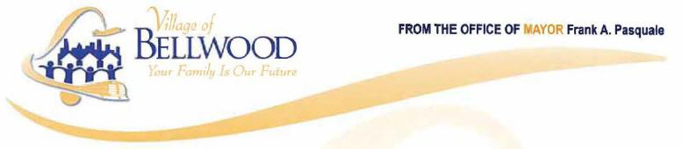

August 20, 2014
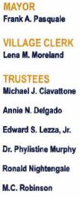

Tom Wheeler, Chairman

Federal Communications Commission
445 12th Street, SW

Washington, DC 20554

Re: MB Docket No. 14-57

Dear Chairman Wheeler:

As mayor of Bellwood, Illinois and a former retired educator, I understand the true impact and importance of education. Education equality is vital for creating informed citizens, fostering ideas and creating growth in our communities. In our increasingly digital lives, computer technology is necessary to educational success. With the help of Comcast, Bellwood has been able to provide safe learning spaces to our children to ensure that they have the tools they need to succeed. I personally support the proposed transaction between Comcast and Time Warner cable because I am grateful for the opportunities it has provided our community and would like to see those opportunities expand to more communities.

Since becoming mayor of Bellwood, I have worked to facilitate new and brighter ways of learning and engaging students. Comcast was a major partner for our Teen Zone, which is a state-of-the art, first-of-its-kind lab equipped with desktop computers, Internet and TV services. Here teenagers can work, study or socialize with friends. The Teen Zone has been hugely successful, providing teenagers a productive and safe space to escape. Sometimes students need a place where they can be engaged outside of their home or the classroom - and that is exactly what Comcast has helped to provide.

Students from low income families are truly able to benefit from living in a Comcast area of service as well, through the Internet Essentials program. In this program, students who qualify for free or reduced lunch can gain access to the Internet in their homes for under ten dollars a month. We can't expect our students to excel if we don't give them the proper tools they need to succeed. This program delivers the resources of the Internet affordably, along with free digital literacy training, as well. I just read recently the program has now connected close to 40,000 households in Illinois to the power of the Internet at home.

27

I am a Mayor who has been known to keep my promises, and I have seen Comcast keep its promises as well. Comcast is a true partner that empowers communities through technology and education, and has helped me to provide the best to my constituents. 1 hope you will approve the pending transaction so that they have the opportunity to empower many other communities across the United States.

/s/ Dr. Frank A. Pasquale

Dr. Frank A. Pasquale, Mayor

Village of Bellwood

28

As mayor of Baldwin Borough, Pennsylvania, I write today to testify to the ability of Comcast to serve the communities in which it operates. More importantly, I write to urge your approval of the proposed Comcast - Time Warner Cable transaction.

I know that Comcast has deep and strong roots in Pennsylvania and here in Baldwin Borough. Baldwin is the lucky home of a Comcast tech operations office and customer services center that employ over 70 people.

The company and its employees also engage in community service programs that help all of our residents. Comcast's annual service event, Comcast Cares Day, was held in our Borough with nearly 100 Comcast volunteers and made needed repairs to one of our community parks. Our area's children will benefit for years due to the painting, landscaping, and repair work completed by Comcast employees.

Moreover, Comcast's Internet Essentials program is helping to build that productive future for our neediest citizens. The program connects low-income families to Internet service and computer hardware technology. Our Baldwin-Whitehall School District students have been some of the lucky first beneficiaries of the program. Already, 86 students' households have been connected to the promise of the Information Age via the program.

Your approval of this transaction makes services like Internet Essentials possible. These programs will be pivotal in closing the Digital Divide to get all American children, rich or poor, the tools they need to succeed. I urge your approval of this transaction so that New York State can partner with Comcast to make these opportunities possible.

Sincerely,

David Depretis

29

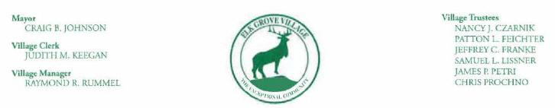

August 14, 2014

Tom Wheeler

Chairman

Federal Communications Commission

445 12th Street, SW

Washington, DC 20554

RE: MB Docket No. 14-57

Dear Chairman Wheeler:

My name is Crajg Johnson. I currently serve as Mayor of Elk Grove Village, Illinois. Elk Grove is a northwestern suburb of Chicago, home to 33,000 residents. As the Mayor of a community that benefits from Comcast's excellent service, I am wnting to express my sincere support of the proposed merger between Time Warner Cable and Comcast.

I've served as Mayor of Elk Grove Village since 1997 and I am also a lifelong resident. Elk Grove is in a shared market between Comcast and AT&T, and Comcast truly stands apart. The company's commitment to our community and its efforts to continually invest in technology here has gone a long way in improving our business climate and quality of life. If, by combining with Time Warner Cable, Comcast can broaden its reach and do for other communities what it has done for Elk Grove Village, then I wholeheartedly encourage this transaction to move ahead.

Comcast is invested in Elk Grove Village, and has shown time and time again that it is committed to offering quality and reliable service. 1 recall a period a few years ago, for instance, when an accident damaged one of Comcast's main cable lines and knocked out service for three days. The Village contacted Comcast and voiced our concern, whereupon Comcast agreed to provide a three day credit on the entire bill of all customers who experienced the outage. This is only one example, but shows how Comcast — a large national company — takes care of its customers.

Elk Grove is also home to the largest industrial park in North America. Comcast Business provides the Business Park with a modern and scalable data infrastructure that allows it to function with high levels of efficiency and flexibility. The park creates jobs and spurs economic development in our area and Comcast has been a vital part of making that growth possible.

Comcast has notably broadcast our Tour of Elk Grove international bike race every year. For the past several years, Comcast SportsNet has broadcast the event globally, bringing Elk Grove to viewers across the world, and helping establish our community as a tourism destination, which has a positive impact on our local economy.

30

Federal Communications Commission -2- August 14, 2014

Moreover, when Elk Grove lost four of its young people to the war on terror, Comcast stepped up to establish our Fallen Soldier Memorial Fund. This fund has assisted countless injured soldiers and their families, and it likewise provided college scholarship to assist community minded residents.

Comcast has been a committed partner to Elk Grove, and I hope that you will approve its proposed transaction with Time Warner Cable. It would not only help our small businesses and residents and, more importantly, spread to new communities the unique and exemplary service and commitment Comcast has shown to us for years.

Sincerely,

/s/ Craig B. Johnson

Craig B. Johnson

Mayor

- Commissioner Mignon Clyburn Commissioner Jessica Roscnworcel Commissioner Ajit Pai Commissioner Michael O'Reilly Marlene H. Dortch, FCC Secretary

31

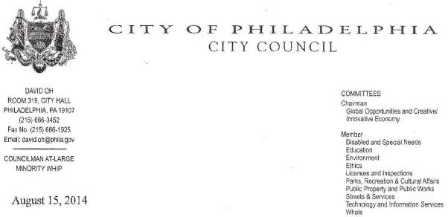

August 15, 2014

Chairman Tom Wheeler

Commissioners Mignon Clyburn, Jessica Rosenworcel, Ajit Pai, and Michael O'Rielly

Federal Communications Commission

445 12th Street, SW

Washington, DC 20554

SUBJECT: MB Docket No. 14-57

Dear Chairman Wheeler and Commissioners Clyburn, Rosenworcel, Pai, and O'Rielly,

As a Philadelphia City Councilman, I urge your commission to approve Comcast's extension of service within New York State. Our City sees the benefits of Comcast's corporate citizenship every day through excellent service, jobs, infrastructure, and social programs. Upon approval of the proposed Comcast-Time Warner Cable transaction, New York State will benefit as well.

Corncast's investments in Philadelphia don't represent a one-off, isolated partnership with our city. The company has invested $8 billion in Pennsylvania's infrastructure since 1996. This investment has enabled Comcast to increase broadband speeds and expand public access via the Xfinity hotspots. Comcast's Internet Essentials initiative demonstrates a commitment to the poor by connecting low-income students to low-cost internet, hardware, and training services across the country. The program has already connected 350,000 families to Comcast service. Comcast also has a commitment to hiring veterans—of which I am one. I am proud that Comcast is a part of our City's efforts to support our growing veteran population.

Comcast is a corporation interested in more than its bottom line—it is interested in the common good. As an elected official, I work every day to advance the common good. We've seen so much opportunity due to Comcast here in Philadelphia and in Pennsylvania. The Federal Communications Commission would advance the common good by extending Comcast service to New Yorkers.

Sincerely,

/s/ David Oh

David Oh

32

Re: MB Docket No. 14-57

Dear Chairman Wheeler:

As a Philadelphia City Councilman since 2012 and lifelong resident of South Philadelphia, I have been fully committed to making a positive difference in my city in any and every way possible. I have made the success of Philadelphia communities my priority, and I believe that Comcast shares these values. I write today to urge the FCC to move in favor of Comcast's transaction with Time Warner Cable.

I currently represent Philadelphia's First District, a diverse and growing area along the Delaware River, from South Philly across Center City, Chinatown, Northern Liberties, Fishtown, Kensington and Port Richmond. One of the projects I have personally undertaken is the ongoing improvement of the East Passyunk Business District, which is becoming one of the East Coast's most prominent emerging destinations for culture, dining, and nightlife. Like any up-and-coming urban neighborhood, its success depends on the availability of reliable services from companies such as Comcast. Comcast's broadband Internet, Wi-Fi hotspots, and advanced cable technologies are the types of services that this neighborhood and many other parts of our great city need to thrive.

Like many other urban cores, Philadelphia has families and schools struggling to find the resources needed to provide a quality education. Comcast has made the effort to fill that need. Its Internet Essentials program allows low-income families the opportunity to afford internet services for their home, so that children are able to continue learning outside of the classroom. It's a critical program addressing a critical need. I am proud that Comcast, a hometown company in Philadelphia, is responsible for such groundbreaking and important efforts to bridge the digital divide here and elsewhere.

33

I could go on and on about Comcast and its contributions to Philadelphia. It is a job-creator — it operates the Wells Fargo Center and Xfinity Live neither of which is in my council district but does employ many of my constituents. It is a do-gooder — I love to attend and participate in Comcast Cares Day. And it is an industry leader that is putting Philadelphia on the map as an East Coast hub for technology.

I fully support the transaction between Comcast and Time Warner Cable. We benefit each other and I only see better things on the horizon for our community and many others if Comcast can grow through this transaction.

Sincerely,

/s/ Mark F. Squilla

Mark F. Squilla

Councilman-First District

MFS/skm

34

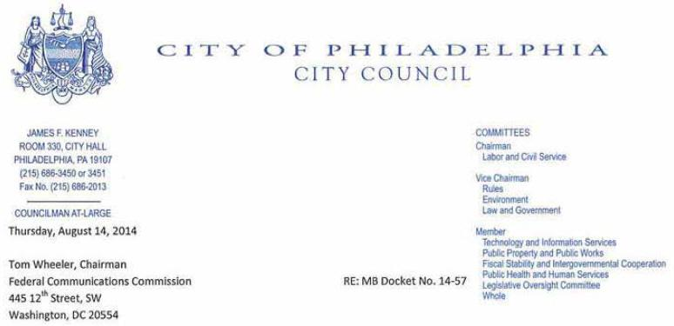

Dear Chairman Wheeler,

I am a lifelong resident of Philadelphia, and have served on City Council At-Large since 1992. In my decades of service, I have worked with hundreds of companies and organizations on workforce development and community empowerment programs, and Comcast is far and beyond the company making the greatest impact on these issues in my community. I support all efforts to boost Comcast’s impact and extend its footprint to other communities, thus I support the proposed Time Warner Cable/Comcast transaction.

One of the greatest outcomes of the Comcast and NBCUniversal Joint venture for Philadelphia residents was the creation of the Internet Essentials program. This program provides low-cost broadband service for $9.95 a month, full-service computers for under $150 and options for digital literacy training in local community centers and schools. The program is currently offered to families in Comcast service areas with children who are eligible for free or reduced-price school lunches.

In Philadelphia, over 9,000 families have taken advantage of this service, and Comcast recently completed a two-week push to increase sign-ups so the digital divide could continue to shrink. As a long-time city leader, I have been perennially frustrated that, as more information for jobs, resources and education goes digital, it has become increasingly challenging to break the cycle of poverty in Philadelphia. Fortunately, Comcast has proven itself to be a true partner in our city’s battle to bring more of our community up-to-date with the tools of the 21st century.

Speaking of community commitments, I do not think I have missed a Comcast Cares Day since 2001. This incredible undertaking leaves no stone unturned in our city, and is probably the largest day of corporate volunteerism seen in Philadelphia every year.

I have also been impressed with Comcast’s all-inclusive hiring practices and its long-term strategy for company-wide success. The last few years have been challenging for the typical American, yet Comcast continues to hire employees from every sector of our communities at all levels of the company, from technicians to sales reps to roles in the corporate division. With excellent benefits, it’s truly a great place to work. Through every challenge, Comcast has thrived due to its long-term policy of investing heavily in its employees and its continual efforts to modernize.

Comcast is 100% an American company, leading the world stage for broadband services and improving the lives of their customers at home. They are a true ambassador for corporate responsibility, and as a civic leader, I am proud to voice my support for the proposed transaction with Time Warner Cable. I hope the FCC will take my points into consideration and vote quickly in favor of the transaction.

Sincerely yours,

/s/ James Kenney

James Kenney, Councilmember At-Large

James.kenney@phila.gov

Philadelphia City Council

Room 330 City Hall

Philadelphia, PA 191070

35

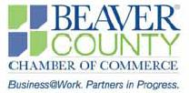

August 21, 2014

Tom Wheeler

Chairman

Federal Communications Commission

445 12th Street, SW

Washington, DC 20554

RE: MB Docket No. 14-57

Dear Chairman Wheeler:

I am writing to ask for your support for the transaction between Comcast and Time Warner Cable. Comcast has been a rock solid partner in our community for years.

This plan will help ensure the company remains in that role in the future.

Beaver County, Pennsylvania has a strong business community and the next few years offer the promise of tremendous growth. We hope that investments in natural gas along with a manufacturing renewal will launch our next chapter. But the groundwork for any new development is an advanced, reliable telecommunications network. Comcast has demonstrated its commitment to quality service in our area for years.

Even beyond providing quality Internet access to Beaver County, Comcast has invested in our community. I serve as President of the Beaver County Chamber of Commerce. The Chamber named Comcast its Business of the Year in 2013 as a reflection of the company’s commitment here - where many of their employees live and work. Comcast’s work with the Chamber - as well as nonprofits and charities - has been impressive. As part of Comcast Cares Day, they bring hundreds of helping hands to community organizations throughout Beaver County on a yearly basis, on top of ongoing support for numerous organizations in the county.

They have invested in our schools as well. Comcast’s Leaders and Achievers Scholarship Program connects the company with schools throughout Beaver County to honor high achieving students who are also excelling outside the classroom. Comcast has provided scholarships to County students over the past five years. Comcast has been an excellent corporate citizen in Beaver County. The proposed transaction would put the company in position to continue its excellent service and philanthropic support in Beaver County and in many other communities. I hope you will join me in supporting this plan.

Sincerely,

/s/ Erica Loftus

President, Beaver County Chamber of Commerce

798 Turnpike Street · Beaver, PA 15009-2132

- 724.775.3944 · F: 724.728.9737 www.bcchamber.com

36



August 13, 2014

The Honorable Tom Wheeler

Chairman

Federa1Communications Commission

445 12th Street, SW

Washington, DC 20554

RE: MB Docket 14-57

Dear Chairman Wheeler

The Chicago Chinatown Chamber of Commerce has been honored to partner with Comcast to serve the community of Chinatown for the last 10 years. We are big fans of the work of Comcast in the City of Chicago and support the Comcast Time Warner Cable merger.

The Chicago Chinatown Chamber of Commerce's mission is to expand business opportunities and foster education on the history, culture and diversity of the Chinese American community. Thousands of people visit our community every year to learn and experience the cultural richness.

As an organization, we have had the pleasure of partnering with Comcast on a number of initiatives to support the businesses of Chicago's Chinatown.

Since 2004, Comcast and the Chicago Chinatown Chamber of Commerce have partnered together on several important community initiatives that have benefited the people and businesses of Chinatown. They have hosted the annual Chicago Dragon Boat Race for Literacy, where over 25 teams compete in a dragon boat race along the Chicago River to promote literacy in our schools and libraries.

Comcast and the Chicago Chinatown Chamber of Commerce have also hosted the Chinatown Summer Fair, bringing over 50,000 people every summer to the streets of Chinatown. The Summer Fair has been a tremendously successful annual event to promote Chinatown's restaurants and stores to tourists who come from all over Chicagoland.

Over the past 10 years, Comcast and the Chicago Chinatown Chamber of Commerce have heavily invested in the infrastructure of the Chinatown community. Comcast has partnered with the Chamber of Commerce and other community-based organizations to develop capacity for our organizations and small businesses, provided new technology infrastructure to foster educational opportunities for our children, and shared innovative ways to continue to advocate and promote our community to a greater audience.

We are so thankful for the ongoing and continued support and partnership of Comcast. They have invested both financial and human capital into our community which has enabled our community to grow. We look forward to a continued partnership in the coming years.

Sincerely,

/s/ Darryl Tom

Darryl Tom

President


37



Tom Wheeler

Chairman

Federal Communications Commission

445 12th Street, SW

Washington, DC 20554

RE: MB Docket No. 14-57

Dear Chairman Wheeler,

Thank you for the opportunity to comment on the proposed merger between Time Warner Cable and Comcast. At Maine & Company, we believe that the proposed merger should be allowed to go forward and that state will benefit from the merger.

Currently, a small part of Maine is on the Comcast network while the majority of Maine is on the Time Warner Cable network. Combining those networks will allow businesses and consumers to have access to all the benefits of the larger network. Such benefits as login authentication and consistent access provide a tremendous benefit and reduce personal and professional hassles. The combined company offers a streamlined solution.

It is also clear that the proposed combined company has significant investment plans for Maine. Comcast has been a leader in delivering broadband on a wide scale. The combined company will have the capability to deploy broadband at a dramatically faster pace than Time Warner could as a stand-alone company.

For these reasons and others, we support the proposed merger and are excited for the impact that proposed company could have on Maine.

Best Regards,

/s/ Peter DelGreco

Peter DelGreco

President and CEO

Maine & Company

120 Exchange St., Portland ME 04101 207.871.0234 • maineco.org

38



The voice of Maine business

August 22, 2014

Chairman Tom Wheeler

Federal Communications Commission

445 12th Street, SW

Washington, DC 20554

Re: Comcast/Time Warner Cable Merger

Dear Chairman Wheeler:

The Maine State Chamber of Commerce is the voice of the Maine's business community representing a network of over 5,000 businesses across the state of Maine. Investment in advanced communications networks and services are important to the economic vitality of Maine businesses and citizens. I would like to share with you, our experience here in Maine with Comcast and why we believe the merger with Time Warner will help grow our economy and our communites.

Comcast's record of investment in Maine highlights its commitment to investing in the communities it serves to provide industry leading products and services. During the late 2000's Comcast purchased SusCom (Susquehanna Communications) which served 11 communities in the Bath-Brunswick and Freeport area which is approx. 85 miles from any other communities Comcast served. Comcast purchased a network which did not offer phone as a product, limiting the ability to offer the triple play. The network offered very limited Hi-Def video options, limited Hi-Def video channels and no ability to stream content inside or outside the house. Critically, the broadband offering for citizens and businesses was limited.

Over a three year period Comcast brought voice and the triple-play to customers in the area, broadband services were upgraded to the latest technology giving customers access to speeds of greater than 100Mbps. More recently Comcast has invested in wi-fi technology which enables businesses to offer encrypted secure networks as well as publically available wi-fi for the public. Wi-fi is becoming an ancillary service which customers expect and Comcast's investments in wi-fi is offering businesses a simple turn-key service which greatly improves our customer's experience.

Comcast's multi-year investments to upgrade and improve services in even the relatively far flung portions of its service territory is evidence of their commitment to providing the communities they have served in Maine advanced services and shows their commitment to invest in Time Warner's communities after the transaction closes. The combination of Comcast's service area with Time Warner Cable's in Maine will offer businesses in particular major efficiencies and benefits.

39

In addition to the investment Comcast has made in Maine, the merger will also give them the ability to offer services state wide that will benefit business with multiple locations throughout the state. Being a rural state, this is major benefit for a state like Maine. Previously, businesses with locations in Kittery, Freeport and Lewiston could not rely on either Comcast or Time Warner to connect their businesses. This ability to provide a common platform offers obvious operational efficiencies but it also offers increased security and added redundancy which is increasingly important to all types of businesses.

Even for business which only have a single or handful of locations the merger of Comcast and Time Warner companies in Maine has great benefits because having a common interconnected network with greater redundancy improves redundancy and dependability for Maine's business community. One example of this in the Bath-Brunswick-Freeport area which has been served by Comcast have long been connected by a single fiber loop which carries all traffic into and out of those communities because those communities are so far from the rest of the Comcast network. After the merger is approved Comcast will be able to connect directly to neighboring Time Warner communities significantly improving redundancy.

Thank you for your time and consideration on this important matter that has statewide impacts for the State of Maine. The Maine State Chamber of Commerce urges the commission to approve the merger and help in moving Maine's economy forward.

Best regards,

/s/ Dana Connors

Dana Connors

President

40

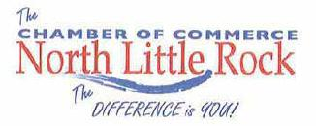

As the president and CEO of The North Little Rock Chamber of Commerce, I would like to express our support for the proposed transaction between Comcast and Time Warner Cable.

Our mission is to implement programs and services that stimulate economic, community and workforce development. As former mayor of North Little Rock, I don't take this mission lightly, and I expect our member companies to take it just as seriously. That's why I support companies like Comcast that double down on their commitment to improving the places in which they do business such as North Little Rock.

For example, consider Comcast's efforts to close the digital divide among low-income households. This is an issue that affects our current economic stability but also our future outlook. Families, especially children, are having more of their daily lives involve being online in one capacity or another. Whether it is researching a school project or signing up for little league, children are learning the digital literacy necessary to compete in the real world. When families don't have Internet access at home it sets them further back with each passing year. Comcast's Internet Essentials program has been a huge success to date, and we are proud to say they have connected over 1,000 families in Arkansas.

Comcast has been a friend and advocate for the families in our community and together we have worked to ensure the entire community prospers economically. The Chamber supports the proposed transaction between Comcast and Time Warner Cable, so that more communities might stand to benefit as ours has.

/s/ Terry Hartwick

Terry Hartwick

President & CEO

100 Main Street ● P.O. Box 5288 ● North Little Rock, AR 72119-5288 ● Phone: (501) 372-5959 ● Fax (501) 372-5955

www.nlrchamber.org ● E-mail: nlrchamber@nlrchamber.org

41



Federal Communications Commission

445 12th Street SW

Washington, DC 20554

Chairman Tom Wheeler

Commissioner Ajit Pai

Commissioner Mignon Clyburn

Commissioner Jessica Rosenworcel

Commissioner Michael O'Rielly

August 9, 2014

Re: Applications of Comcast Corp. and Time Warner Cable, Inc. For Consent to Assign or Transfer Control of Licenses and Authorizations. MB Docket No. 14-57

Dear Chairman Wheeler and Commissioners:

My name is Brian Terkelsen and I am the CEO of MediaVest, a division of Starcom Media Vest Group (SMO). In my role, I am responsible for overseeing the media planning and buying for global brands across numerous industries.

SMO has a strong history with Comcast. They have been, and continue to be, a true partner that innovates and collaborates with us to reach consumers in improved ways. SMG plans and buys media on behalf of our clients from Comcast. In addition, SMG is the media planning and buying agency of record for Comcast's Xfinity brand. We are excited about the possibility of deepening that relationship with the combined company after Comcast acquires Time Warner Cable.

We face increasing challenges in efficiently reaching consumers as they move across devices and consume content in a myriad of ways. Efficiency in media planning and buying is of utmost importance to us. Comcast/Time Warner will occupy a larger gcographic footprint including the important designated market areas of New York, Los Angeles and Dallas. The combined company will provide new opportunities for advertisers to reach these audiences efficiently including the ability to reach consumers with localized, better targeted messages that are more relevant to those consumers.

As SMG seeks more efficient methods to reach consumers across channels, we are intrigued by new ad products that can be deployed at scale as a result of the transaction. Comcast has experimented with new ad technologies such as dynamic ad insertion; however, such a technology/innovation requires not only significant investment, but the requisite scale for it to become a viable option for advertisers. We believe that the combined company will have the necessary subscriber base to invest in and deploy the ad technology such that it becomes a more plausible and attractive advertising vehicle for our clients. The real benefit for SMG, our clients, and consumers is

42

the flexibility that dynamic ad insertion provides to target and deliver more relevant media messages to segments of consumers that are increasingly engaging in time-shifted viewing and/or viewing on devices other than TV. The advertising industry as a whole will benefit from improved channels to reach consumers who demand content wherever and whenever.

In summary, I believe that the efficiency and effectiveness of media buys and targeted messaging will increase through the combined company, and that improved ad innovations will create new opportunities for advertisers to deploy spend in an engaging medium. As such, I fully support the merger of Comcast and Time Warner Cable.

Best,

/s/ Brian Terkelsen

Brian Terkelsen

43



August 20, 2014

Chairman Tom Wheeler

Commissioner Mignon Clyburn

Commissioner Jessica Rosenworcel

Commissioner Ajit Pai

Commissioner Michael O’Rielly

Federal Communications Commission
445 12th Street, SW

Washington, D.C. 20554

RE: MB Docket No. 14-57

Dear Chairman and Commissioners:

I'm writing in order to take advantage of the opportunity to comment on the proposed Comcast and Time Warner Cable transaction. My hope is for Commission approval of the transaction, so that cities currently without Comcast service can benefit from a dynamic and community-dedicated company.

I am the President and CEO of Choose DuPage, an economic development engine for the region. Our mission is to recruit and retain the best businesses for DuPage County, Illinois, so that DuPage can continue its role as a positive economic force in our state and nation. We have been very successful in spite of challenges including the economic downturn of recent years. Companies want to locate here for reasons including that DuPage County has the lowest unemployment rates in our region and ranks first in the state for educational attainment.

We are truly fortunate to have such a strong business climate, and among the most robust businesses we have is Comcast. It serves as a substantial business in its own right, but also as a stable and accomplished partner to our agency members. Jeff Cobb, a Comcast Director for the Chicago Region, is a member of our board of directors. He and other company officials are generous with their considerable enterprise expertise.

Comcast has supported our mission by hosting events such as business networking receptions and a contest for companies that could demonstrate the best use of technology to enhance the experiences of their customers and employees. I have been a guest on the Comcast Newsmakers show, providing Choose DuPage with a unique opportunity to convey the organization's mission and discuss our initiatives to a large viewing audience. Comcast has participated in our job fairs and has provided mentoring and technology skills training within the community. No less meaningful to Illinois are the economic benefits of having close to 7,000 workers employed in Comcast's more than 150 facilities in the state.

44

Choose DuPage particularly relishes hosting a company that has put our region on the cutting edge of digital technology. Comcast Internet speeds get faster each year and its network accommodates all the connecting and interacting our businesses need to thrive. Apps and other technology products are always evolving at Comcast and our businesses rely on innovations that are unique as well as reliable, such as Wi-Fi, HDTV, the fastest broadband, and more. Comcast's innovations in this space spur stronger broadband competition and that is a good thing for all of us.

Comcast has the kind of corporate energy and commitment that makes cities and states want to host them. My understanding is that the transaction will afford more cities and states this opportunity. Please give this transaction your approval.

Sincerely,

/s/ Greg Bedalov

Greg Bedalov

President and CEO

45

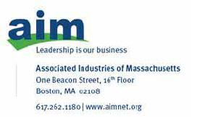

August 20, 2014

Chairman Tom Wheeler

Commissioner Mignon Clyburn

Commissioner Jessica Rosenworcel

Commissioner Ajit Pai

Commissioner Michael O’Rielly

Federal Communications Commission
445 12th Street, SW

Washington, DC 20554

RE: MB Docket No. 14-57

Dear Chairman and Commissioners:

Associated Industries of Massachusetts, (AIM) is the largest statewide employer association in Massachusetts. Our mission is to improve the competitiveness of Massachusetts and to improve the economic well-being of our members. Thousands of AIM member employers employ approximately 650,000 Massachusetts citizens.

I am pleased to voice the organization’s support of the proposed merger between Comcast and Time Warner Cable.

Comcast is a vibrant and consistent supporter of good jobs and economic growth in Massachusetts. The company employs more than 4,000 full-time employees who enjoy excellent benefits. The company is committed to education, job training, and leadership, as demonstrated by its investment of more than $2 million in on-job training and nearly $200,000 on tuition reimbursement for its employees in 2013 alone. Comcast invests in Massachusetts, its local economy, and its people, and is committed to business growth in the area.

I believe that by combining with Time Warner Cable, A Comcast combination with Time Warner Cable will ramp up competition among communication companies for customers among small and medium businesses and consumers. The result will mean innovation and cutting edge products and services for our consumers and businesses.

46

AIM hopes that you see potential benefit in the transaction between Comcast and Time Warner. The association remains optimistic that this deal will bring even more opportunity to the business community across the entire Commonwealth of Massachusetts.

Sincerely,

/s/ Richard C. Lord

Richard C. Lord

President and CEO

47

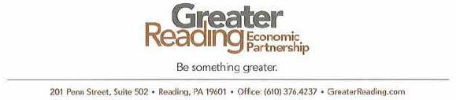

August 19, 2014

Tom Wheeler

Chairman

Federal Communications Commission

445 121h Street, SW

Washington. DC 20554

RE: MB Docket No. 14-57

Dear Chairman Wheeler:

I have been President and CEO of the Greater Reading Economic Partnership (GREP) in Pennsylvania since 2004, but before that, I spent 15 years working for Time Wamer Cable, first as President in its Eastern Pennsylvania division, and then as President of its Binghamton division. I believe that I truly have a unique perspective on the proposed transaction between Comcast and Time Warner Cable.

My current role has afforded me the opportunity to work with Comcast as a community partner. Comcast has been an investor in GREP since its inception in 2002. GREP's mission is to attract. retain and grow business by vigorously promoting, fostering and coordinating economic development in Greater Reading. It is focused on retaining businesses, stimulating local entrepreneurship and attracting new businesses In the area. Our partnership with Comcast has grown from within our mission. This relationship with Comcast has allowed us to promote Comcast Business Services to all businesses considering locating in Berks County. PA. It is my understanding that through a transaction with Time Warner Cable, the small- and mid-sized businesses in the Greater Reading area will have enhanced access to innovative and new services that a combination of the two organizations could provide. This will make Reading more competitive - a notion I welcome.

Over the last several years, I have had the opportunity to sit down with Jill Horner on Comcast Newsmakers and discuss our "Ride to Prosperity" initiative. This initiative links eight organizations together to work towards a common goal of identifying specific work areas that will have a positive impact on economic growth and development. Infrastructure is one of the identified areas that can have a direct influence on Reading's prosperity. Comcast has already invested significantly in technology and infrastructure here in Reading and across Pennsylvania. I hope that allowing the transaction between Comcast and Time Warner Cable to happen will make on even more enhanced broadband network available to current businesses and assist in solidifying our ability to attract new businesses.


48

Tom Wheeler, Cholrmon

Federal Communications Commission

RE: MB Docket No. /4 -57

August 19. 2014

Page 2

During my time at GREP. I have also had the pleasure of working with Elizabeth Sterner of Comcast. Liz serves on our Board of Directors and is Chairman of our Governance Committee. We have benefitted in many ways from her involvement with our organization. and she is an example of how Comcast hires quality people and encourages them to take active roles in the communities they serve.

As previously stated, my professional experience has given me a unique perspective as it pertains to this potential transaction. Having worked for Time Warner Cable in leadership positions and now alongside Comcast to provide economic growth and opportunity in Reading, I believe this union of two quality companies will benefit current and new markets in countless ways. I urge you to approve this transaction without delay.

Best regards,

/s/ Jon C. Scott

Jon C. Scott

President and CEO

49



August 19, 2014

Tom Wheeler

Chairman

Federal Communications Commission
445 12th Street, SW

Washington, DC 20554

RE: MB Docket No. 14-57

Dear Chairman Wheeler:

I am President and CEO of PRWT Services, Inc., and an executive committee member of The Urban League of Philadelphia and the Greater Philadelphia Chamber of Commerce. As such, I have been deeply involved with numerous organizations seeking to increase diversification in workforces and business opportunities. I strongly believe the promotion of diversity through civic engagement is critical to strengthening our economy and the bonds within our communities. As I have witnessed over the past several years in working with Comcast's internal Diversity Council, I fully believe Comcast shares my commitment to promoting diversity. I write today in support of the proposed transaction between Comcast and Time Warner Cable because this acquisition will enable Comcast to increase the scale and scope of its best-in-class diversity practices.

Several years ago, I began serving as co-chair of the Comcast National African-American Advisory Council to offer my experience on diversity issues and to work with Comcast in formalizing the institutionalization of diversity in its business practices. Those of us on the external Joint Diversity Council had high hopes for the company and we have not been disappointed. Brian Roberts, David Cohen and the rest of Comcast' s executive leadership have made the transformation of their diversity and inclusion practices a top priority and the measureable results have reflected the company's commitment.

Exhibit 9 of Comcast and Time Warner Cable's Public Interest Statement submitted in the above referenced Docket clearly delineates how Comcast has gone above and beyond their initial diversity commitments with respect to their workforce, procurement practices, programming, venture capital, and investments in community-based philanthropic organizations. Comcast's efforts to increase diversity amongst their suppliers have been particularly notable. In addition to making a full-fledged drive to establish relationships with diverse suppliers by attending every possible kind of diversity supplier event across the country, the company increased the amount of contracting activity with diverse suppliers by 44% over three years. This increase was fueled by new contracts with minority-owned vendors, which produced an astonishing 85% increase in spending with this group. Moreover, Comcast deepened its commitment in 2012 by launching

50

a diversity subcontracting (Tier II) initiative and increased the amount spent on diverse Tier II suppliers by almost 33% in only its first year.

While these results are profound, Comcast's internal Diversity Council and its leadership team would be the first to say the company can do more. My impression is that to Comcast, an idea such as supplier diversity is not just a catchphrase; it's something the company truly believes in as a way to strengthen the company and the communities which it serves. This is reflected in Comcast's constant measurement and evolving management of its diversity practices. To this company, it's not just about the input of how much it spent on diverse suppliers. It's about measuring and linking all of the inputs and outputs from these broad initiatives together to drive the company towards better products and a better community in which to work and live. Without a doubt, as Comcast continues to evolve as a company, it will implement the lessons learned from the detailed management of its diversity initiatives and expand upon them to the fullest of its ability.

Although I understand this proposed transaction is complex and that there are many things to consider, I strongly urge the Federal Communications Commission to give strong weight to the significant positive impact this merger would have on diverse suppliers as well as the accrual of other public interest benefits to more regions of the country.

Regards,

/s/ Harold T. Epps

Harold T. Epps

President & CEO

PRWT Services, Inc.

1835 Market Street

Suite 800

Philadelphia, PA 19103

Ph: 215.569.8810

Cell: 215.518.9313

Fax: 215.569.9893

Harold.Epps@PRWT.com

51

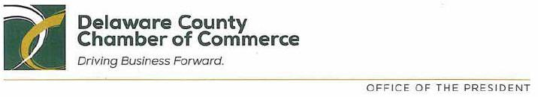

August 18, 2014

Tom Wheeler

Chairman

Federal Communications Commission
445 12th Street, SW

Washington, DC 20554

RE: MB Docket No. 14-57

Dear Chairman Wheeler:

The Delaware County Chamber of Commerce, located in eastern Pennsylvania near Philadelphia, was founded in 1887 and represents more than 1,100 members who operate businesses in and around Delaware County. Our Chamber members have the good fortune to be associated with Comcast, which offers innovative broadband and video services in our area and is a very active Chamber member.

Comcast makes a significant contribution to our area economy and works vigorously to improve life for members of our community. Comcast has shown itself to be a dependable Chamber partner in projects small and large. We support the proposed Comcast and Time Warner Cable transaction because of the benefits that a combined Comcast/Time Warner Cable would bring to our area and to areas which currently lack access to Comcast's services. Let me provide some specifics.

Our young people have benefited from Comcast's involvement in our Youth Leadership Academy (YLA). Comcast routinely involves the YLA in their Comcast Cares Day volunteer service events. Comcast managers have helped by leading roundtable discussions with youth panels on issues affecting Delaware County. These ongoing partnerships demonstrate Comcast's commitment to philanthropy beyond just sponsorship. Comcast engages deeply with communities to invest in their human capital.

And Comcast has stepped in to assist in very concrete ways during times of community crisis. Last year, when fires were set at Penn Wood High School, 140 Comcast employees turned out on a Saturday morning to paint the school bleachers at the school's Kerr Field, as well as the announcer's booth, a concession stand and some fencing. Students expressed their immense appreciation for the effort to help restore their school.

In June, Comcast hosted a Chamber member luncheon in which we honored State Representative Nicholas Micozzie with a Lifetime Achievement Award. And last year, Comcast helped fund a 1,270-

1001 Baltimore Pike, Suite 9LL | Springfield, PA 19064 | 610-565-3677 | FAX: 484-472-7809

www.delcochamber.org

52

square-foot conference room here that can be rented by Chamber members and those in the Delaware County community who need a modern space with high speed Internet, projection, and audiovisual capabilities.

Comcast is the sort of company that communities want operating in their midst. It brings value to business and strengthens nonprofit and education initiatives. Our members are pleased to have its first-class technology products available and they are just as glad to have a company that is invested in the success of every member of the community.

I encourage the Commission to approve the proposed transaction without delay.

Sincerely,

/s/ Alex Charlton

Alex Charlton

President

53

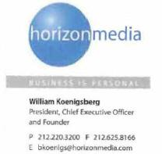

Federal Communications Commission

445 12th Street SW

Washington, DC 20554

Chairman Tom Wheeler

Commissioner Ajit Pai

Commissioner Mignon Clyburn

Commissioner Jessica Rosenworcel

Commissioner Michael O'Rielly

August 12, 2014

Re: Applications of Comcast Corp. and Time Warner Cable, Inc. For Consent to Assign or Transfer Control of Licenses and Authorizations, MB Docket No. 14-57

Dear Chairman Wheeler and Commissioners:

My name is Bill Koenigsberg and I am the founder of Horizon Media, an independent full service media agency that provides brand clients with complete communications planning and activation across all traditional and emerging channels.

Audience targeting is critical for Horizon Media to deliver programs for our clients in a meaningful way. Our clients seek to reach consumers on national, regional and/or local scale. Comcast and Time Warner Cable, through the merger, will have the necessary scale as a combined company to invest in new advertising products and deploy those products across their subscriber footprint. These advertising product innovations will allow my clients to more effectively and strategically reach their target consumer.

Horizon Media, Inc. ● 75 Varick Street ● New York, NY 10013

54

Addressable advertising is one such advertising product innovation that will enable our clients to reach their audience with greater accuracy than currently available targeting options (for example, demographic targeting versus geographic zone targeting). Addressable advertising has largely been difficult to achieve because of lack of reach. Through the merger, the combined entity would deliver the kind of scale required to make such hyper-targeting a viable advertising option.

Additionally, the proposed merger will also unlock the potential of dynamic ad insertion. As consumers continue to view content at their leisure (versus at the scheduled air time), it has become even more important to advertisers that their placements are guarded against time shifting. The merger of Comcast and Time Warner will provide the scale necessary for the combined company to invest in dynamic ad insertion, thereby giving advertisers additional efficient advertising opportunities, and ultimately for consumers to have more programming options.

I therefore strongly support the merger between Comcast and Time Warner Cable, as I believe such a transaction would accelerate the deployment of new advertising technologies and make cable a more efficient and attractive platform for our clients.

Respectfully,

/s/ Bill Koenigsberg

Bill Koenigsberg

Horizon Media, Inc. ● 75 Varick Street ● New York, NY 10013

55

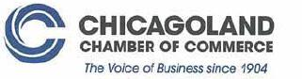

August 15,2014

Chairman Tom Wheeler

Commissioner Mignon Clyburn

Commissioner Jessica Rosenworcel

Commissioner Ajit Pai

Commissioner Michael O'Rielly

Federal Communications Commission
445 12th Street, SW

Washington, DC 20554

RE: MB Docket No. 14-57

Dear Chairman and Commissioners:

Thank you for this opportunity to register my support for the proposed Comcast and Time Warner Cable transaction.

I am President and CEO for the Chicagoland Chamber of Commerce. The 110-year-old, nonprofit Chicagoland Chamber of Commerce serves members in six Northeastern Illinois counties and parts of Indiana, Ohio and Wisconsin. Our mission is to make our area the most business-friendly region in the nation through public policy and economic growth initiatives. I interact with members in every business sector, in educational, nonprofit and charitable institutions and in government. I myself am a former, longtime public servant having worked in offices at the city, state and federal level.

Comcast is a Chicagoland Chamber member, and it provides impressive support to local businesses in a number of important ways. Comcast offers its video, broadband and business services in many of our neighborhoods and supports our Small Business Development Center and International Trade Center. Matthew Summy, a senior Comcast vice president, sits on our Board of Directors. As a result, Comcast has more than a brushing familiarity with issues which influence our communities, and is always at the ready to work with us to grow the regional economy.

We see Comcast adjust and expand its Business Class broadband and video offerings to accommodate business. Its ever expanding data network reach is beneficial to our member businesses that operate in multiple locations. Its advertising zones have been aligned so that our members can target the entire Chicagoland region with one ad, or by zone to reach their target audience.

The Chicagoland Chamber of Commerce is seeing progress on its comprehensive efforts to enhance the profile of the region as a hub for international business, and we know that Comcast's high-speed broadband and innovative digital services have been and will

56

continue to be critical to maintaining these developing, global commerce partnerships. Those same services also are the foundation to successful communications with and among the increasing number of Millennials who are choosing to call this region home.

I have worked throughout my career to improve the business climate and help create jobs, and much of my focus over more than the last decade has been in encouraging and supporting innovations, including in digital technology. Through the Illinois Innovation Index, we recently shared with our members new data that revealed the number of Illinois graduates with degrees in the fields of Science, Technology, Engineering and Mathematics (STEM). We follow these numbers closely (Illinois numbers are slightly below the national average) because STEM jobs are so important in fostering job growth.

In this area, Comcast plays an important role. Earlier this year, they staged the Innovations for Entrepreneurs competition, and two Chicago area organizations were winners. This program provides a valuable path to connect the dots between entrepreneurial ideas and the potential for business with a company like that Comcast - the kind of business that propels a young company to rapid growth.

Comcast is an established community leader, with respect to being a solid and invested business partner and in areas of caring for community. Please grant the transaction your approval so that this leader can continue and expand its beneficial programs to many more.

Regards,

/s/ Theresa E. Mintle

Theresa E. Mintle

President & CEO

57

The Honorable Tom Wheeler, Chairman

Federal Communications Commission

445 12th Street, SW

Washington D.C. 20554

FCC Docket 14-57

August 14, 2014

Dear Chairman Wheeler and Commissioners,

I write to express our support for the proposed acquisition of Time-Warner Cable by Comcast. As the Former Chief Technology Officer (CTO) for British Telecom and prior to that the Williams Companies, my understanding of the challenges and impacts a merger of this size brings is quite substantial.

Network communications and innovation in our country has led the world over the last several decades with incredible advancements in technology and business practices that have created great value for users and the companies which deliver and support the networks which deliver services. We have seen several successful mega-mergers and acquisitions over the last decade which have provided enhanced coverage and capabilities that were extended locally, nationally and globally and ultimately were not detrimental to the customers.

It is our opinion that the proposed Comcast acquisition of Time Warner Cable will provide a stronger platform for the advancement of a combined multimedia technology and operations framework (ecosystem) which will give the merged company greater leverage to fund and provide expanded delivery reach along with enhanced capacity and content options to its customers.

From a technology and business delivery standpoint the newly merged companies will have the ability to consolidate networks and operations, thus reducing their energy and carbon footprint while simultaneously stimulating new investments, funding new innovations and focus to align their processes and technology to provide a uniform high quality of service platform that is very competitive against offerings from other operators. In my professional experience, customers ultimately do benefit from this scale of combined operational focus and technology reach therefore I respectfully ask that the FCC committee supports this proposed acquisition.

Sincerely,

/s/ Matthew W. Bross

Matthew W. Bross

Chairman and CEO

Compass-EOS Inc.

698 Tasman Drive, Milpitas, CA 95035

FCC0814-CMP

58

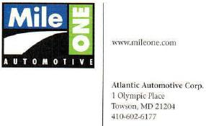
RE: MB Docket No. 14-57

John Stinebaugh

Strategic Enterprise, Account Executive

Comcast Business Services

August, 6th, 2014

Dear John,

Per our discussion our goal is to work closely with you and Comcast Business Services to convert our entire MileOne infrastructure and have you be our primary vendor is their ownership of the last mile to all of our facilities in Maryland.

The Time Warner Cable merger with Comcast would be beneficial to MileOne in two apparent ways:

- Larger footprint of last mile ownership that would be offered by Time Warner/Comcast and

- Single vendor point of contact for expansion of our data service needs.

In closing should you have any questions please do not hesitate to contact me at 410.427.5590 or via email: hlederer@mileone.com.

Sincerely,

/s/ Henry Lederer

Henry Lederer

Chief Information Officer

59

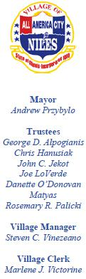
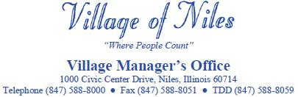

August 16, 2014

To Whom It May Concern:

I write today in support of the proposed Time Warner Cable/Comcast merger. Comcast has dedicated its energies toward advancing communications, technology, and service to the benefit of our community and to hundreds of communities throughout Illinois. The proposed merger will enhance telecommunications to more cities throughout America.

My community of Niles, Illinois recently achieved our long term goal of operating a municipal government access channel in order to keep our residents up to date on local government actions. We were fortunate to consult with our local Comcast representative to help us build the channel infrastructure, and we owe a great deal of its success to their help. Residents in our Village have two options to watch local Village Board meetings and other events on their home televisions, one of which is hosted by a local Comcast community channel.

The process of building our government access channel began in 2009 when we put together a committee to research the idea of government access programming. It was not an easy task; we needed to come up with the most cost-saving solution without a dedicated staff member to operate the system.

Thanks to tremendous assistance from Comcast, we were able to build our entire system around a Broadcast Pix Mica 2000 Video Production Center. Comcast helped us secure a high-speed fiber optic connection for distribution of our signal and worked with our local equipment vendors to assure a superior quality of system operation. Besides the government access TV channel, our residents can now additionally stream meetings through video-on-demand services on our website.

The Village of Niles government access channel would not have been possible in our community if we were not fortunate enough to be in a Comcast service area. Since 2009, our Village has received a substantial amount of franchise fees and access programming capital support from Comcast service. These fees and support funds paid for upfront costs and continued maintenance of the government access channel, much to the relief of our hard-working taxpayers.

Our community has benefitted immeasurably from our relationship with Comcast, and I support the proposed Time Warner Cable/Comcast merger so that these benefits can be extended for many others.

Sincerely,

/s/ Steven C. Vinezeano

Steven C. Vinezeano

Village Manager


60



April 7, 2014

Mr. Tom Wheeler

Chairman

Federal Communications Commission
445 12th Street SW

Washington, D.C. 20554

Dear Chairman Wheeler,

I am writing to express my support of the planned purchase of Time Warner Cable by Comcast. I personally feel this merger will benefit the consumer and competition. I have experience as a programmer on the Comcast system and have firsthand knowledge of Comcast's commitment to the communities it serves and its focus on local content.

JTV is a leased access programmer in Jackson, Michigan. Since 2000, we have served the community with 100% local and positive content utilizing the Comcast system. When JTV began, we approached Comcast with a request to access its viewers via the Leased Commercial Access provision of the Communications Act. The management of Comcast was completely cooperative and forthcoming in providing us with information, requirements, necessary equipment and other means we needed to establish our local station. While leasing a channel is a financial burden, Comcast has always been extremely cooperative and compassionate in negotiating our agreements. Comcast has indicated many times they feel local programming and content is important to their company and value JTV's service in the communities it serves. During the economic downturn following the banking and automotive crises, Comcast was creative and supportive in working with JTV to allow our programming to continue.

In discussions with other leased access programmers in other markets, I have discovered that other cable MSOs have not been easy to work with. Comcast has demonstrated their commitment to local content and independent programmers where others have not. Allowing Comcast to purchase Time Warner Cable would ensure these positive attitudes would provide these benefits to TWC communities. JTV is the ONLY 100% local leased access programmer in the country. And Comcast is the only MSO that ensures we exist.

Additionally, Comcast has been a very generous and involved corporate citizen in our community. Comcast has donated tens of thousands of dollars to our community's Martin Luther King Center, a recreation and education resource serving our community's minority population. The donations have been used to establish a media department and expand Internet access to the community. Comcast has been a sponsor for many years of our community's "Make A Difference" and anti-bullying programs in our middle schools. The company has also underwritten the cost of presentations and productions to allow these programs to reach a greater audience.

61

Most recently, Comcast has expanded their Internet access program "Internet Essentials" in our community, providing access to low income families. They have donated computers, iPads and other technology to our schools. The people of Comcast donate their time to volunteer in our community and serve on various non-profit and educational boards.

Comcast is the cable franchisee in several of our communities and have provided equipment and support to allow these communities to continue their Public, Educational and Government programming. Competitors of Comcast providing television service in our market do not provide either the same level of PEG access and nothing in the way of Leased Commercial Access.

JTV is a valued and highly regarded service in the greater Jackson community. We have donated immeasurable amounts of airtime, coverage and promotion to benefit our community. We provide jobs for more than a dozen residents and fill a void in an underserved media market. We would not be able to do any of this without the cooperation and help of Comcast.

When Comcast purchased NBC Universal, there were several requirements Comcast honor in the way of local programming and community service. It has been my observation that Comcast has always taken this seriously.

This planned business transaction has great benefit to our community and to our nation. We are living proof that Comcast is a company that values independent programmers, local content and the communities it serves.

I urge you to support Comcast as they grow to provide their great service to an even larger population. Having better access, and allowing this company to purchase Time Warner Cable, is a benefit to the entire nation.

Thank you.

Cordially,
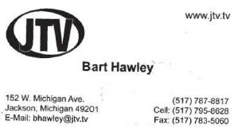

/s/ Bart Hawley

Bart Hawley

President

JTV, Inc.

152 West Michigan Avenue

Jackson, MI 49201

517-787-8817

bhawley@jtv.tv

62

August 18, 2014

Federal Communications Commission

FCC

445 12th Street S.W.

Washington, DC 20554

Re: MB Docket No. 14-57

Submitting Party: EdgeConneX, Inc.

Comments on Comcast-TWC Joint Application for Merger

FCC Public Notice dated July 10, 2014

Dear Representative of the FCC,

As the CEO of EdgeConneX, Inc. (EdgeConneX) I am writing to express our full support for the Comcast-Time Warner Cable merger. As you are aware, Comcast Corporation (Comcast) has the intention to merge with Time Warner Cable, Inc. (TWC) by acquiring 100% of TWCs equity and exchange certain markets with Charter Communications, Inc. It is our belief that the Comcast-TWC merger will be of great benefit at various different levels. Great synergies will flow from this transaction that will improve all digital systems.

EdgeConneX provides edge infrastructure solutions to providers and distributors of Internet content. We seek to optimize data delivery by deploying infrastructure as close as possible to an end users point of access, permitting a range of entities including broadband network operators, wireless carriers, and other service providers to deliver digital content with higher performance and lower latency and costs, to the ultimate benefit of end users everywhere.

Comcast has shown its commitment to fostering innovation and helping start-ups like EdgeConneX grow into successful businesses. EdgeConneX supports this transaction because it will only improve Comcasts ability to serve that important function. Comcast has been an invaluable partner in our success. Indeed, as a leading innovator itself, Comcast shares our vision of using cutting-edge technologies to improve the communications experience. In addition, as a Comcast Ventures portfolio company, EdgeConneX has benefitted not only from its minority equity investment, but also from its strategic insights, extensive network of entrepreneurs, and valued introductions to other innovative companies. This combination of tangible and intangible support has enabled EdgeConneX to provide services that in turn allow other providers to improve their own broadband offerings. In other words, by standing behind start-ups such as EdgeConneX, Comcast is driving a cycle of innovation throughout the communications marketplace. And through the increased scale that will result from the merger, Comcast will be in an even stronger position to invest in and support these emerging companies.

An additional reason for supporting this merger is that it will allow Comcast to be a more effective competitor in providing business services. Business services are important to us because we purchase high-bandwidth business broadband connections to deploy infrastructure closer to end users. It is critical that authorities look at both the residential and business broadband marketplaces when looking at this merger.

The impact of the Comcast-TWC merger is particularly important as it will create significant public interest benefits by enabling greater innovation in network infrastructure, as explained before.

Based on the foregoing, the FCC should not hesitate to approve the Comcast-TWC merger.

Sincerely,

____________________________

Randy Brouckman

CEO

Page 1

63

EdgeConneX, Inc.

- 1. The Commissions duplicating contractor, Best Copy and Printing, Inc., fcc@bcpiweb.com; (202) 488-5563 (facsimile)

2. Vanessa Lemme, Media Bureau, Vanessa.Lemme@fcc.gov; (202) 418-2053 (facsimile)

- Marcia Glauberman, Media Bureau, Marcia.Glauberman@fcc.gov; (202) 418-2053 (facsimile)

- William Dever, Wireline Competition Bureau, William.Dever@fcc.gov; (202) 418-1234

- Jim Bird, Office of General Counsel, at TransactionTeam@fcc.gov; (202) 418-1234 (facsimile)

Page 2

64

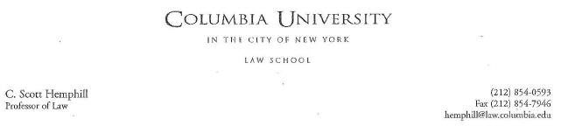

August 21, 2014

Marlene H. Dortch

Secretary

Federal Communications Commission

445 12th Street, S.W.

Washington, DC 20554

Re: Applications of Comcast Corp. and Time Warner Cable, Inc., MB Docket No. 14-57

Dear Ms. Dortch,

On May 8, 2014, I testified about the Comcast-TWC transaction in an oversight hearing held by the Subcommittee on Regulatory Reform, Commercial and Antitrust Law of the House Judiciary Committee. My written testimony is enclosed.

The testimony focused on several headline antitrust issues that have been discussed in connection with this acquisition. For purposes of this testimony, I did not attempt an exhaustive analysis, which would include an assessment of additional issues, such as video advertising, the limited programming assets contributed by TWC, and the efficiencies that the parties expect from the merger. I also recognize that the FCC's evaluation is governed by a different standard than that found in the Clayton Act, but offer this testimony in the thought that it might assist your analysis, to the extent antitrust principles are informative.

Sincerely,

/s/ C. Scott Hemphill

C. Scott Hemphill

Jerome L. Greene Hall 435 West 116th Street New York, NY 10027

65

Testimony of C. Scott Hemphill

Professor of Law

Columbia Law School

House Judiciary Committee

Subcommittee on Regulatory Reform, Commercial and Antitrust Law

Oversight Hearing on Competition in the Video and Broadband Markets: The Proposed Merger of Comcast and Time Warner Cable

May 8, 2014

Chairman Bachus, Ranking Member Johnson, and Members of the Subcommittee, I am Scott Hemphill, a Professor of Law at Columbia Law School. I write and teach about antitrust law, innovation, and competition. My research has considered the application of antitrust law to Internet service providers (ISPs) and video distributors.¹ I recently served the New York Attorney General as Chief of the Antitrust Bureau, which strives to protect competitive markets on behalf of New York consumers and businesses.²

I welcome the opportunity to testify today about the antitrust implications of the proposed merger of Comcast and Time Warner Cable (TWC). Antitrust law has a critical role to play in preserving competition. Competition benefits the economy through low prices, efficient production, and innovative new products and services. Antitrust law accomplishes this, in relevant part, by prohibiting mergers that may “substantially . . . lessen competition” or “tend to create monopoly.”³

- See, e.g., C. Scott Hemphill & Tim Wu, Parallel Exclusion, 122 Yale Law Journal 1182 (2013); C. Scott Hemphill, Network Neutrality and the False Promise of Zero-Price Regulation, 25 Yale Journal on Regulation 135 (2008).

- See, e.g., Proposed Final Judgment, United States and New York v. Verizon Communications Inc., No. 12-cv-1354 (D.D.C. Aug. 16, 2012).

- Section 7 of the Clayton Act, 15 U.S.C. § 18, provides: “[N]o person . . . shall acquire . . . the whole or any part of the stock or other share capital . . . [or the] assets of any other person . . . where in any line of commerce or in any activity affecting commerce in any section of the country, the effect of such acquisition may be substantially to lessen competition, or to tend to create monopoly.”

66

Some of the concerns raised about this merger are best framed as antitrust objections. Critics have charged that the deal will have anticompetitive effects by raising cable or broadband prices to consumers; by harming video programmers; or by foreclosing competition from online video distributors such as Netflix. A closer evaluation of competition in these markets, however, demonstrates that the merger is unlikely to have such anticompetitive effects.⁴ Let me take these points in turn.

Distribution

Most mergers that receive antitrust scrutiny are combinations of rivals. Such mergers are troubling because they eliminate head-to-head competition between the firms or lessen competition among the remaining market participants. Usually, the primary focus is products and services sold by the parties, so-called “output markets,” though mergers can also have an effect on the market for products and services purchased by the parties.

To evaluate output markets, antitrust analysis ordinarily adopts the perspective of a particular purchaser of the goods or services in question—for example, a purchaser of wireless service in New York City. Such buyers can choose among AT&T, T-Mobile, and other providers. A merger’s removal of a significant competitive choice, for a particular set of buyers, can harm competition through higher price and lower quantity, among other effects.

Or consider an individual who wishes to fly from Washington, DC, to Chicago. Such buyers can choose among US Airways, United, and other airlines. Here, once again, the removal of a competitive option for those local consumers threatens substantial harm. This reduction in competition, considered from a particular purchaser’s standpoint, was the central premise of the Justice Department’s antitrust lawsuits challenging the AT&T/T-Mobile and US Airways/American mergers.

The Comcast/TWC merger is nothing like that. A consumer in a particular New York City apartment seeking traditional “multichannel” video service chooses among TWC and other providers. Comcast is not an option unless she moves to another city. Similarly, consumers in Philadelphia can pick among Comcast and other options, but TWC is out. Before and after this merger, consumers would have the exact same number of options to choose from. This is true not only of video service, but also Internet access, telephone service, and bundles of all three.

- For purposes of my testimony, I have not attempted an exhaustive analysis of the transaction, which would include an assessment of additional issues, such as video advertising, the limited programming assets contributed by TWC, and the efficiencies that the parties expect from the merger.

67

Nor are Comcast and TWC plausibly potential competitors. Comcast has evinced no interest in building facilities to compete with TWC in TWC’s present territory, or vice versa.

The lack of overlap means that the usual concern of antitrust enforcement is completely absent. This is not to say that cable prices won’t rise anyway if the merger is approved. They might. ESPN, among other programmers, has achieved remarkable price rises in recent years in its negotiations with distributors, increases that distributors pass along to consumers. Comcast has a powerful incentive to bargain for lower prices, but programmers have considerable bargaining power. The key point is that the proposed merger has no tendency to affect consumer prices through any reduction in competition between the merging parties.

Video Programming

As noted above, mergers can have an effect not only in output markets, but also in markets for products and services purchased by the parties. For example, suppose the only two employers in a small, isolated town compete for labor. If they merge, the merged firm may thereby acquire increased “monopsony” power. A monopsonist may have an incentive to inefficiently reduce its hiring in order to drive down wages. Monopsony is thought to be a significant issue in labor and agricultural markets, because a cutback in the purchase of labor or agricultural commodities might plausibly reduce the price of those inputs.

Once again, the Comcast/TWC merger is nothing like that. Video programming is different from labor or grain. When a farmer sells grain to a buyer, that sale reduces the amount of grain left over for other buyers. By contrast, when ESPN sells programming to Comcast, nothing has been used up. ESPN remains free to make a similar deal with TWC or Cablevision. Comcast and TWC are not competing for the rights to a scarce resource. As a consequence, the merger provides no similar opportunity to economize on this input as a way to reduce its price.

A related concern is that a post-merger Comcast might have greater bargaining power with programmers, thanks to its enlarged subscriber base. Enhanced bargaining power, to the extent that it simply shifts profits among firms, is not an anticompetitive harm. But in any event, it is hardly clear that Comcast would be able to strike a better bargain. On the one hand,

68

the stakes would be higher for ESPN, compared to today, because ESPN could lose more revenue from lost viewers if its contract negotiations with an enlarged Comcast broke down. On the other hand, Comcast would have more to lose too, as more customers could plausibly complain or cancel their service in the event of a breakdown. To conclude that Comcast gains bargaining power on a per-subscriber basis, it is necessary to establish that there is some special, disproportionate consequence to the programmer in the case of bargaining failure.

One such disproportionate consequence might arise if the post-merger Comcast were so large that, without its business, a programmer would be unable to effectively function. But post-merger Comcast lacks the requisite scale. If we take as a starting point the Federal Communication Commission’s previously expressed view on this subject, a video distributor must have more than 30 percent of traditional video subscribers to pose such a risk.⁵ But the FCC’s view was likely too cautious when it was reached in 2007; indeed, it was rejected by the D.C. Circuit for understating the degree of competition in video markets.⁶ It is surely too conservative today. Among other developments, the rise of online video provides opportunities for programmers to reach viewers without selling their content to a traditional distributor. This transaction, which results in a share of traditional video distribution slightly less than 30 percent, is therefore unlikely to be of a sufficient size to make a meaningful difference in this respect.

Foreclosure of Online Video

A final possibility, raised by some mergers, is that a transaction might lessen competition by enabling foreclosure—that is, by undermining rivals’ ability to compete, resulting in consumer harm. The exclusion of competitors is potentially even more worrying than the distortion from changed prices, because it can slow new entry and thereby harm innovation. Under certain circumstances, a merger can increase the risk of foreclosure, by strengthening the resulting firm’s incentive and ability to exclude. A full antitrust analysis of the Comcast/TWC transaction therefore requires an evaluation of the prospects for foreclosure.

- FCC Fourth Report and Order, 23 F.C.C.R. 2134 (adopted Dec. 18, 2007; released Feb. 11, 2008).

- Comcast Corp. v. FCC, 579 F.3d 1 (2009).

69

In any complex business environment, it is possible to raise a speculative concern about an enormous number of theoretical foreclosure effects. Discussing them all is beyond the scope of my testimony, but let me focus on one prominently stated foreclosure concern, that a traditional video distributor such as Comcast might have an incentive to inhibit the competitive prospects of online video distributors. Netflix is the best-known example, but there has been enormous growth in this sector in recent years. Such firms threaten the traditional model of multichannel video distribution by enabling “cord-cutting.”

Cord-cutting is a misnomer, because consumers still rely on a broadband Internet connection to access online programming. The broadband connection is often supplied by traditional video distributors, using the same physical plant. That combination of businesses provides a potential opportunity to undermine online video, by choking off the Internet access on which it relies.

But it also furnishes a powerful reason not to do so. Online video is an important and increasing part of the value provided by broadband Internet. Harming a growing business to preserve a declining one is a costly and doubtful business strategy. That fact reduces the incentive to engage in foreclosure.

If Comcast nevertheless wished to foreclose competition, how would it do so? The most obvious routes are cut off by Comcast’s existing regulatory commitments, made as a condition of its NBC-Universal acquisition. These commitments include acceptance of the FCC’s Open Internet rule. Critics have focused on an interaction between online video distributors and Comcast not subject to the existing restrictions. ISPs are increasingly receiving payment for direct interconnection to the ISP network. This practice of “paid peering” has raised concerns that such payments might harm online video, resulting in a form of foreclosure.

Paid peering is an ineffective tool of foreclosure. Online video distributors are under no obligation to pay directly for interconnection. They are typically free to contract with middlemen, such as backbone providers and content delivery networks, that in turn deliver the content to the ISP. Those alternatives mean that an ISP is unable to degrade online video delivered in this fashion without also degrading other traffic delivered by the middleman. Such protection is particularly potent for smaller distributors that are more easily pooled with other traffic.

70

To be clear, the fact of payment is not in itself problematic. Online video distributors and other content providers have long paid for interconnection, and Comcast has long received payment for interconnection. Payment for interconnection has always been made using some mix of cash and reciprocal carriage of the other firm’s traffic. If a content provider or its agent takes on no reciprocal carriage, then cash is a natural alternative. In this respect, paid peering is a new variant of an old business practice.

Paid peering is best seen not as an instrument of exclusion, but as a means to put a price on the additional capacity demands resulting from the increased popularity of online video. It is efficient for the distributor and its end-users, considered collectively, to pay for that capacity, rather than spreading the expense among all ISP customers. Doing so better aligns use with cost and incentivizes both investment and economical use. Paid peering is not the only possible solution to that problem, of course. Surcharging heavy users, provided that the surcharge is not itself an instrument of foreclosure, is a viable alternative.

Comcast’s recent interconnection agreement with Netflix, far from suggesting an antitrust concern, is a sign that the market is working well. The proposed merger does not change that. In considering whether to impose a prophylactic restriction on Comcast’s ability to engage in paid peering, the current moment of experimentation seems a particularly inapt time. We should be particularly cautious about intervening in the absence of a demonstrated problem.

A thriving online video distributor requires, in addition to a broadband connection to users, access to programming. That fact suggests a second potential strategy for foreclosure, which is to inhibit access to programming. In particular, the traditional distributor, as part of its contract with a programmer, might insist upon restrictions in the programmer’s dealings with online video distributors. For example, Comcast might insist that Disney not make certain types of online content deals, or insert contractual clauses that have a similar but more indirect effect.

The Justice Department has reportedly investigated these contracts.⁷ I am unaware of public information about the prevalence of such contracts or their practical effect. A contract that disadvantaged online video might well be resisted by the programmer, who would prefer

- Shalini Ramachandran, “Favored Nations” Fight for Online Digital Rights, Wall St. J., June 14, 2012, at B3.

71

to make profitable sales to such firms, and therefore such a contract would be more costly to the distributor to secure. Overall, whether this is a profitable or likely foreclosure strategy is currently unclear.

The key question for present purposes, in any event, is whether the proposed merger worsens whatever foreclosure problem might exist. Comcast is prohibited from enforcing any such anticompetitive contracts by its NBC-Universal conditions.⁸ That prohibition would be extended to TWC if the merger is approved. That extension has the effect of strengthening existing protections against this potential form of foreclosure.

* * *

In conclusion, a merger between Comcast and TWC is unlikely to have several effects posited by critics. It is unlikely to affect prices for consumers; to have anticompetitive effects on programmers; or to incrementally foreclose competition from online video by impeding connectivity or access to programming. Thank you for the opportunity to discuss these issues with the Subcommittee.

- Modified Final Judgment § V.C, United States v. Comcast Corp., No. 11-cv-106 (D.D.C. Aug. 21, 2013), available at http://www.justice.gov/atr/cases/f300100/300146.pdf.

72

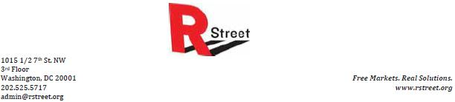

Federal Communications Commission

445 12th Street SW

Washington, DC 20554

VIA ELECTRONIC COMMENT FILING SYSTEM

Re: Comcast - Time Warner Cable, MB Docket 14-57

Aug. 21, 2014

Dear Commission Members:

On behalf of the R Street Institute, a Washington-based free-market think tank with offices in Sacramento, Calif., Austin, Texas, Columbus, Ohio, and Tallahassee, Fla., I write in support of approving the proposed merger between Comcast and Time Warner Cable (TWC). Our analysis of this merger is that it is a natural response to changing market conditions, offers significant potential benefits for consumers in both the residential and business markets and that potential harms are either minimal or mitigated by other existing regulations or market dynamics.

The proposed $45 billion merger takes place in an environment characterized by two trends that have hit cable television providers particularly hard in recent years – a shrinking subscriber base for pay-television services and the rising cost of content acquisition.

Comcast has been losing video customers, on net, for at least five consecutive years, down nearly 10 percent from 24.8 million at year-end 2007 to 22.5 million at the end of the second quarter of 2014. TWC has also lost net video subscribers in each of the past five years, falling more than 17 percent from 13.3 million at year-end 2007 to 11.0 million at mid-year 2014.

Cable companies also have seen rapidly escalating costs to acquire content, driven in part by competition from a profusion of video on-demand services like Netflix, Amazon Prime and Hulu, of which Comcast is a part-owner. Intense negotiations for content – including a 2013 dispute between TWC and CBS – also have led to a number of service blackouts, which unquestionably harm consumers. Reflecting trends across the industry, TWC has seen its per-subscriber content costs rise 24 percent since 2010, while Comcast has seen a 20 percent jump over the past two years.

73

Currently, nine companies – AMC, CBS, Discovery, Disney, Fox, Scripps, Time Warner Inc., Viacom and Comcast itself – control about 90 percent of the $45 billion market for television content. While the content creation market is not itself a monopoly, growing demand has contributed to higher prices. The market for sports content – provided by the likes of Comcast's own NBC Sports, as well as CBS Sports, Fox Sports, Time Warner's TNT and TBS and, especially, Disney's ESPN – has proven particularly thorny for cable companies. The trend toward "cord cutting," in which consumers eschew any pay-television service in favor of streaming video on-demand, has raised the stakes for cable companies to retain consumers of live broadcasts, tilting leverage further toward providers of sports content.

According to SNL Kagan, fees paid by distributors to carry cable channels are expected to grow from $31.7 billion in 2013 to $40.8 billion in 2016. The market is led by ESPN, which takes in about $5.54 per month per subscriber, compared to about $1 per month per subscriber paid to broadcast network affiliates for retransmission consent, another rapidly growing cost driver. SNL Kagan projects the broadcast networks – including Comcast's NBC and Telemundo – will pull in about $3 billion in retransmission consent fees in 2015, with the networks themselves taking roughly a $1.3 billion cut and network-owned affiliates getting the remaining $1.7 billion.

The additional negotiating power wielded by a combined Comcast-TWC could potentially serve as a check on rising content acquisition costs, both in carriage fees and retransmission consent agreements. It should be noted that the extent to which this would reverse the prevailing trend is uncertain and may depend partially on whether the combination spurs further media consolidation in response. To the extent that the combined company can negotiate across any of these markets to reduce fixed costs, it could translate into consumer benefits in the form of lower service bills.

Consumers also should benefit from operating efficiencies that reduce costs without reducing output, and from network upgrades, in particular to TWC's relatively older and slower service. Comcast has said it expects the combination initially to yield about $400 million in capital expenditure efficiencies and to save about $1.5 billion in operating expenses within three years. The company also has announced it will accelerate TWC's planned migration of at least 75 percent of its service footprint to all-digital service.

One under-appreciated consumer benefit of a combined Comcast-TWC is the role the larger company could play in the business services sector. While both Comcast and TWC have a modest presence in the market to provide broadband and voice service to small business, the firms are only marginal players in the market to serve large commercial enterprises. Because of the need for a large national service footprint, the business services market traditionally has been dominated by telecoms like Verizon and AT&T. A combined Comcast -TWC, with at least some footprint in all of the 50 largest markets, could for the first time become competitive, with benefits redounding to business services consumers.

74

Some have raised concerns that a combined company would have undue market power to discriminate in both the video and broadband markets, for instance by privileging its own content over that of competitors. Some of these concerns are relevant to the commission's own separate industry-wide deliberations on regulation on net neutrality, a subject on which R Street has not taken any formal position. However, it is incumbent on those who raise such concerns to demonstrate why a combined Comcast-TWC presents any new issues or heightens any existing issues that did not already exist with the companies operating separately.

Comcast is already bound by the FCC's program carriage rules not to privilege its own content. The company also has already pledged that the seven-year net neutrality agreement it consented to when it purchased NBCUniversal in 2011 would also apply to TWC. What's more, any incentive a combined Comcast-TWC would have

to discriminate against particular content providers operating on its platform would, by necessity, be balanced against consumer demand for that same content. This is a lesson already learned the hard way by TWC, which lost 300,000 customers during its blackout dispute with CBS.

Were it the case that a combined company would leave consumers with fewer choices, concerns about discriminatory treatment of content would have more force. But Comcast and TWC already do not compete with one another for customers in any market in the country. Moreover, Comcast also has stipulated as part of the terms of the agreement that it will divest 3.9 million residential video subscribers to Charter Communications. The combined Comcast-TWC would remain the largest provider of pay-television services, but it would control less than 30 percent of the market, with DirecTV and Dish Network – both of which do compete directly with Comcast and TWC -- having 20 percent and 14 percent, respectively. Other services, including the telephone providers that also compete directly with cable and satellite, comprise with the remaining 36 percent.

As believers in pragmatic, free-market solutions, we believe antitrust action should be limited in scope and focus on demonstrable harm to consumers. We do not believe the issues raised by the proposed Comcast-Time Warner Cable merger meet that threshold. We ask that you allow it to go forward without undue delay.

Respectfully submitted,

R.J. Lehmann

Senior Fellow

The R Street Institute

Eli Lehrer

President

The R Street Institute

75

August 16, 2014

Chairman Tom Wheeler

Commissioner Mignon Clyburn

Commissioner Jessica Rosenworcel

Commissioner Ajit Pai

Commissioner Michael O’Rielly

Fedderal Communications Commission
445 12th Street, SW

Washington, DC 20554

RE: MB Docket No. 14-57

Dear Chairman and Commissioners:

I am the Executive Director of the Mattapan/ Greater Boston Technology Learning Center, Inc. in Boston, Massachusetts, an adult IT training center. We offer leadership skills and training in personal computer repair, web design and database management, along with a number of other technology courses. Except for minimal registration and lab fees, our services are free. Our students are mostly Boston residents who come from very diverse ethnic backgrounds.

Comcast has been a dependable partner to our school. Its support helps us operate our classes that provide our participants with opportunities for job growth. Our partnership is invaluable and is one of the reasons I believe that the proposed Comcast and Time Warner Cable transaction deserves to be approved.

Comcast makes a significant, positive impact on our state’s economy. It employs more than 4,000 in Massachusetts. In fact, as an Internet Essentials training partner we currently work with Comcast to provide our beginning skills and core tech classes. So far, we have graduated 72 students. We also recently celebrated Comcast as our “Partner of the Year” at our annual graduation.

I know that many of the children in our city wouldn’t have Internet access or a computer in their homes without help from Comcast. Thousands of low-income families in the Boston area have taken advantage of Internet Essentials. It lets them pay only $9.95 a month for Internet. They can also buy a computer through Internet Essentials for about $150. Children who have Internet Essentials get their homework finished, research assignments and do so much more online that other children have taken for granted for

76

years. My understanding is that this program started as a short-term project but that now it is being offered indefinitely.

Anywhere Comcast operates, you will hear these same stories about community partnerships and efforts to keep children and adults exposed to, and trained on, the latest digital technology. I can only guess at the benefits awaiting cities and towns that would be new hosts to Comcast under the proposed transaction. Please give this your approval and permit those communities to benefit as we have in Massachusetts.

Thank you for taking the time to consider my position on this issue.

Sincerely,

/s/ Karrie Ann Jean

Karrie Ann Jean

Executive Director

77


Chairman Tom Wheeler

Commissioner Mignon Clyburn

Commissioner Jessica Rosenworcel

Commissioner Ajit Pai

Commissioner Michael O’Rielly

Federal Communications Commission
445 12th Street, SW

Washington, DC 20554

RE: MB Docket No. 14-57

Dear Chairman and Commissioners:

Education doesn't begin when the late bell rings for any of Independence School District's 14,000 students. Educating our children doesn't end when a school bus drops our last child off to their home. Education is a 24-7, 365-day-a-year project that lives in schools, homes, and our communities. In the 21st century, high-speed internet access is the best way to connect to the world beyond one's own community. As the Public Relations and Communication Director of the Independence School District, I urge you to approve the Comcast-Time Warner transaction to help make top-caliber, Digital Age education available to all of our children, at school and in the home.

In Independence, Missouri, we benefit from Comcast coverage and infrastructure. We also benefit from Comcast's Internet Essentials program, an initiative that provides low-cost Internet connection and computers to families that qualify for the National School Lunch Program. Our round-the-clock effort to educate children is often stalled by a very real Digital Divide - the disparity in Net access between rich and poor. The Internet Essentials program provides affordable, convenient, and speedy service to those who need it most.

Approval of the proposed union between Comcast and Time Warner will enable the expansion of this program. We have already seen the benefits in our school district.

We know that other communities, like Kansas City right next door, stand to benefit as well.

Comcast also empowers our students through considerate and committed corporate citizenship. The company consistently sponsors events like our district's annual Hispanic Community Connection Night, which connects our Hispanic students to the Web. That presence isn't unique to Independence.

78

Last year, Comcast gave over $170,000 in community investments throughout Missouri. Our children have been connected to a wealth of opportunity throughout Comcast's service to the Independence area. Children throughout the United States deserve the same access. Please help educators build stronger communities and further close the Digital Divide by approving this transaction.

Sincerely,

Nancy Lewis

Director of Public Relations and Communication

Independence School District

Independence, Missouri

816-521-5300

nancy_lewis@isdschools.org

79

 | Revere Public Schools
 | 101 School Street
 | Revere, Massachusetts 02151
 | Tel: 781-286-8226
Paul Dakin, Ed.D. | FAX: 781-286-8221
Superintendent of Schools | pdakin@revere.mec.edu


August 20, 2014

Tom Wheeler, Chairman

Federal Communications Commission
1445 12th Street, SW

Washington, DC 20544

Dear Chairman Wheeler:

RE: MB Docket No. 14-57

My name is Paul Dakin and I am the superintendent of Revere Public Schools in Revere, Mass., a historic community named for the Revolutionary War patriot. A diverse and hard-working population sends their children to our schools, where approximately 7,020 children receive education and enrichment in grades EC-12.

We are proud to acknowledge our exemplary partners, such as Comcast, which enhance our schools and communities in a genuine way. In my estimation, New York would be wise to embrace the proposed transaction between Comcast and Time Warner Cable.

To provide the best opportunities for all students, Revere Public Schools are focused on the future, and that cannot be discussed without mentioning technology and innovation. Our district is very focused on staying connected to students when they leave the classroom and at home. We do this by posting report cards, attendance records, homework and other important news and information on our website. Of course, in order to benefit from this resource a family or student needs to be able to access the Internet readily.

As a corporate citizen whose focus on equipping low-income students and their families with affordable broadband merits attention, we feel Comcast is working toward the closure of the Digital Divide, in Massachusetts and across the country.

In fact, nearly 9 percent of all eligible households in the Commonwealth are now enrolled in Internet Essentials, Comcast's landmark digital adoption program. This is a noteworthy achievement, considering that the initiative has been operational for only three years. In fact, Revere was among the first School Districts to offer support for the Internet Essentials program when it was launched in 2011 because, as stated above, we are not only taking advantage of online technology to communicate to students and parents, but because we know the learning opportunities it can afford them. I am proud to say Revere has one of the strongest rates of connection to the Internet Essentials program in Massachusetts.

For these and other reasons, I feel confident that New York would benefit greatly from a transaction of Comcast and Time Warner Cable. It is an encouraging thought to know that millions of additional families would be eligible for Internet Essentials throughout the state as a result of the transaction.

Sincerely,

/s/ Paul Dakin, Ed. D.

Paul Dakin, Ed. D.

Superintendent of Schools

80


Aurora Public Schools Foundation

15701 East First Avenue, #206

Aurora, Colorado 80011

303-326-2042

www.EducateAurora.com

August 20, 2014

Chairman Tom Wheeler

Commissioner Mignon Clyburn

Commissioner Jessica Rosenworcel

Commissioner Ajit Pai

Commissioner Michael O'Rielly

Federal Communications Commission

445 12th Street, SW

Washington, DC 20554

RE: MB Docket No. 14-57

Dear Chairman and Commissioners:

I am writing this letter to voice my sincere appreciation and gratitude for Comcast as a community partner for Aurora Public Schools (APS) and the Aurora Public Schools Foundation. Over the years, Comcast has proven to be a true long-term partner for our school district through their consistent engagement and support of programs that have had a positive impact on our more than 38,000 students, 4,200 teachers and staff, and 59 schools. We are grateful for Comcast's high levels of employee engagement seen in volunteer efforts across many years and their dedicated team members who serve as thought partners, helping us to strategically guide our work and assist in leveraging other community investment.

We are thrilled that Comcast partners annually with APS on projects for their Comcast Cares Day in the spring. This is Comcast's signature day of service, and Comcast teams have completed many different projects over the last several years benefitting our schools and our students. This year, the Comcast Cares Day activities were undertaken at Jewell Elementary School and Gateway High School. At Jewell Elementary Comcast employees worked on a wide variety of projects, helping to create a beautiful area for Jewell students to learn, play and grow. And at Gateway High School Comcast employees worked on such projects as painting classrooms, organizing the school's drama props & costume room, revamping the teacher lounges and workrooms, cleaning and bringing more school spirit to the varsity boys & girls locker rooms. These projects and projects like them in past years have had amazing impact.

We are equally inspired by Comcast's continued support of the "Fifth Block" summer school program, which helps thousands of students strengthen their skills and prepare for the new school year, and by the company's direct support of and investment in our APS Foundation efforts. This support has included helping us produce videos telling the Foundation's story as well as producing and donating air time to run a 30-second TV spot encouraging the Aurora community to engage in supporting Foundation programs. We have also benefited from having a Comcast leader volunteer as a member of our board of directors for several years, who was recently elected to serve as chair of the board.

81

Aurora Public Schools Foundation

15701 East First Avenue, #206

Aurora, Colorado 80011

303-326-2042

www.EducateAurora.com

We also are grateful that Comcast offers the Internet Essentials program, which helps low-income families afford home Internet service. This program is a great benefit to many APS families; more than 70% of our students qualify for free and reduced price school lunches, and this program makes it possible for students to have Internet and a computer in their homes to use as they complete their school work. The district increasingly utilizes e-mail, social media, and website tools to share important information with parents and students, so we have partnered with district leaders and Comcast staff on many occasions to help make families aware of the opportunities and benefits available to them through Internet Essentials. The program has gone a long way toward empowering APS students and families, and it is compelling to note that if allowed to merge with Time Warner Cable, Comcast would expand Internet Essentials to benefit more and more communities.

Comcast has set a strong example in our community of what deep and lasting partnership looks like. As we build and deepen private, public, non-profit and philanthropic partnerships in order to drive innovative programming and accelerate learning for every APS student every day, we are grateful for the inspirational path forged by Comcast and its employees.

In closing, I couldn't be more pleased to express my support for Comcast as a stalwart community partner. I urge the FCC to approve the proposed Time Warner Cable/Comcast transaction so other communities can benefit from Comcast's presence as we have.

Sincerely,

/s/ Paul Lhevine

Paul Lhevine

Executive Director

82



August 18, 2014

Tom Wheeler

Chairman

Federal Communications Commission

445 12th Street, SW

Washington, DC 20554

RE: MB Docket No. 14-57

Dear Chairman Wheeler:

As Head of School at 'Iolani School in Honolulu, the largest Episcopal school in the US, I am pleased to have learned about the proposed merger of Comcast Corporation and Time Warner Cable. Three years ago, I joined 'Iolani after serving as Head of the Harley School in Rochester, New York and prior to Harley I was a senior administrator at the Lawrenceville School in Lawrenceville, New Jersey where I witnessed first-hand the positive impact Comcast Corporation had on education and youth development in the greater Philadelphia area. I believe the addition of Comcast to the Hawai'i community will add similar support that will benefit many young people in our state.

Science, technology, engineering and mathematics (STEM) education is widely recognized as a key component for 21st century learning. More than ever, with expanding global competition and collaboration, our students need to be equipped with the skills and technology that will make them valued in the workplace of the future. The introduction of STEM curricula and associated professional development for our teachers needs strong corporate partners who are willing to support these emerging programs. Among peer companies, Comcast has an unparalleled record of supporting schools' technology needs and moving beyond this to many efforts that enhance students' digital literacy. They are highly commendable and this will be a great partnership for our school systems, public and private.

One of the main technical challenges facing schools is the integration of cloud-based systems, mobile devices and high bandwidth learning materials. Our students need real time access to video, file sharing and collaboration tools that are in many ways directly analogous to what high level professionals are using around the world. At 'Iolani this past year, we rolled out a 1:1 iPad initiative that added approximately 2,500 concurrent

83

connections to our WiFi network. The use of productivity Apps and paperless workflow are becoming a common part of the student experience. Fortunately, the school has the resources and knowhow to implement such a major academic technology project.

We are, however, in the minority in our state and it will take a dedicated corporate partner such as Comcast to make this level of academic technology the norm, and it is crucial for future generations and our economy that it does so. Comcast's planned investment in Time Warner Cable's network will allow it to offer Hawaii's schools high-performance broadband solutions with speeds ranging from 1 Mbps to 10 Gbps. Such technology will support the use of electronic records by enabling district-wide communication, allowing teachers to integrate data-intensive content like e-textbooks, video, and distance learning into their classrooms.

Comcast's record in this regard is well established. Its Digital Connectors program has equipped hundreds of community computer labs and trained thousands of high school students on basic digital literacy skills. Programs like these reach beyond the first circle of students and into the community at large. Distributed implementation models are powerful because the students themselves become the community leaders who can promote the importance of digital literacy to those around them.

Another initiative for which I have a great deal of optimism is Comcast's Internet Essentials program. Within this program, families with children are eligible for the National School Lunch Program home Internet service for only $9.95 per month, free digital skills training and the option to purchase a heavily-subsidized computer. At 'Iolani and our peer school, Punahou, we run summer learning programs for this precise demographic that have proven effective in closing the achievement gap and increasing high school graduation and college matriculation. One common challenge is the lack of technology in the home. The Internet Essentials program will directly address this technology gap and benefit this group of learners, which is in excess of 100,000 children in our state.

As I noted above, I have witnessed directly how Comcast Corporation's commitment to community and education positively impact the lives of many young people. From the perspective of the business sector in which I work - education - the children of the State of Hawai'i will benefit from our leaders choosing to support companies such as Comcast whose mission includes supporting education. I encourage you to take this point into strong consideration when considering approval of this transaction.

Sincerely,

/s/ Timothy R. Cottrell, Ph.D.

Timothy R. Cottrell, Ph.D.

Head of School, 'Iolani School

84



August 18, 2014

Tom Wheeler

Chairman

Federal Communications Commission
445 12th Street, SW

Washington, DC 20554

Re: MB Docket No. 14-57

Dear Chairman Wheeler:

My name is David Gaudi, and I am writing to you today as the head·of Saint Mark Lutheran School in Kāne'ohe, Hawal'i as well as a member of the board of directors for the Hawai'i Association of Independent Schools. It is my pleasure to take a few moments to share my support for Comcast Corporation as their proposed merger with Time Warner Cable is being considered.

It is clear to me that the Comcast Corporation has a special commitment to the community and has enhanced the lives of many children throughout the United States. I am convinced that their entrance into the Hawai'i market place will not only increase internet access and technology accessibility for Hawai'i's keiki but will also provide the opportunity for the formation community partnerships that will potentially benefit both public and independent schools in Hawai'i.

Among the many programs and services that Comcast offers, I am particularly impressed with their Internet Essentials and Digital Connectors programs as well as their commitment to increasing and improving the broadband performance for Hawai'i schools. These programs and services would be a welcomed addition to current offerings.

As the head of a small independent school, it is my hope and belief that Comcast will bring fair pricing to Hawai'i schools and will prove to be more than merely another conglomerate looking to capitalize in a new locale. It is my contention that Comcast will be a civically responsible, community partner who will continually work with educational leaders to explore meaningful and economically reasonable ways to serve Hawai'i's keiki while advancing Hawai'i's technological position as a bridge between the US mainland and Asia.

Comcast's dedicaton to expanding academic and professional opportunities for young people coupled with their collaborative nature, willingness to invest in the latest technologies, and promotion of civic responsibility, makes their entry into Hawai'i a very attractive proposition.

I hope you will consider these factors when weighing approval of this transaction.

Sincerely,

/s/ R. David Gaudi Jr., Ed.D.

R. David Gaudi Jr., Ed.D.

Head of School

85

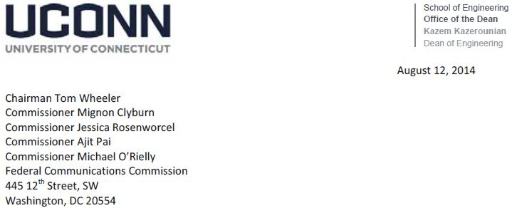

RE: MB Docket No. 14-57

Dear Chairman and Commissioners,

I submit this letter, in support of the Comcast-Time Warner Cable transaction. My support is based on the following observations.

For many years, Comcast has been a leader in cyber-technology and cyber-security. For the past few years, the University of Connecticut (UCONN) and Comcast have collaborated on multiple projects and initiatives on hardware security, and developing holistic approaches to address evolving cybersecurity challenges. Comcast has been a strong partner to UConn and shares its commitment to utilizing leading-edge tools, strategies, and protocols for preventing, detecting, deterring, and responding to cybersecurity threats.

As part of this collaboration, Comcast is a founding member the Center for Hardware Assurance, Security and Engineering (CHASE) at UConn. Other sponsors include the U.S. Department of Defense, National Science Foundation, and industry leaders such as Honeywell, Samsung, and CISCO as sponsors. In addition, in partnership with Comcast, UConn has initiated several research projects aimed at reducing costly operations and offshore manufacturing risks.

Significantly, in April of this year, UConn expanded its longstanding relationship with Comcast to form the Comcast Center of Excellence for Security Innovation (CSI). CSI unites the expertise of renowned scholars and researchers from UCONN and Comcast’s leadership in Internet systems security to develop robust detection systems and analytical tools to ensure that the computer chips and other hardware components vital to Internet broadband systems are shielded from malicious attacks, unauthorized access, and faulty or counterfeit products. CSI’s primary functions include: conducting leading-edge security related R&D based on a holistic approach to the cybersecurity framework as defined by the National Institute for Standards and Technology (NIST) and industry best practices; delivering unprecedented security that grows the standard framework for industry and government; advancing continuous monitoring of attacks and vulnerabilities through a national database; and developing the next generation of cyber risk management professionals.
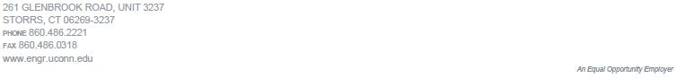

86

The Comcast Center of Excellence for Security Innovation is the first of its kind, with the best in class from both industry and academic institutions, when it comes to developing cutting edge security technologies, practices, and processes. To date, CSI is the only a dedicated security innovation lab at a university sponsored by a company. We are very proud of our joint effort, and are especially pleased to have had the opportunity to share it with your office firsthand when Mrs. Erika Olsen attended CSI’s launch event this past Spring.

UCONN’s academic-industry partnership with Comcast is an important example of how to proactively advance science and create a new generation of highly-skilled workers prepared to resolve current and future technological challenges. Already, our PhD students have taken advantage of internship opportunities at Comcast. Earlier this month, our University awarded one of Comcast’s leading experts a Professor of Practice which uniquely positions us to offer course work and certification based on NIST’s cyber security framework. In October, we will be jointly hosting a security awareness/ challenge week at UConn called CyberSeed. Our goal is to have over 50 Universities competing in multiple challenges. Comcast is once again leading efforts to bring experts to UConn and broaden our academic-industry engagements during that week.

Our mission in advancement of knowledge needed to secure the cyber-space has taken a new momentum with Comcast’s collaboration. Our current CSI research projects will have a transformative impact beyond the cable industry, and can translate to security solutions nationally and internationally. Comcast’s size and scale has enabled it to invest and to differentiate itself from other broadband providers in rolling out the best technological advances to keep consumers safe. The national scale created by its proposed merger with Time Warner Cable will enable Comcast to continue to invest in research and development, and ultimately enhance network security for millions more residential and business customers.

Given all this, I firmly support the TWC transaction and look forward to supporting the growth and opportunities that this transaction will bring to our shared commitment to cybersecurity.

Respectfully,

/s/ Kazem Kazerounian

Kazem Kazerounian

Dean & Professor

87



August 21, 2014

RE: MB Docket No. 14-57

As the executive director of the Boys & Girls Club of Westminster in Westminster, Md., I am proud to offer my support for Comcast's proposed transaction with Time Warner Cable.

For three consecutive years, Comcast has partnered with us on "Comcast Cares Day," the single largest day of corporate volunteerism in the country that occurs every April. We have been delighted to be on the receiving end of the hard work and determination of hundreds of Comcast volunteers, whose impact on and effort to improve Carroll County cannot be overstated.

Comcast has also supported our "Club Tech" program, a national digital literacy and technology skills initiative that is building our young members' computer skills and seamlessly integrating technology across our program areas.

Further, in March 2013, the Boys & Girls Club of Westminster was featured on "Comcast Newsmakers," a vehicle for news and information that spread the word about our mission, and in particular our summer camps, to a wider audience. This type of publicity raises our profile and ultimately helps us connect with the members, volunteers and supporters who make our work possible.

Finally, Comcast is working to support low-income students and families across Maryland, and many other states, by offering a comprehensive digital adoption program called Internet Essentials. This program is working to narrow the digital divide - wiring schools and libraries with broadband and offering affordable at-home Internet service to underserved children and families. Families with a child who qualifies for the National School Lunch Program are eligible, and the sign-up is quick and easy. In fact, I understand that more than 350,000 households across the nation are already enrolled.

According to recent data from the Census Bureau, 25 percent of American households do not have at-home Internet access. For those without it, one of the primary barriers to access is cost. Internet Essentials promises to circumvent this barrier and make the vast resources and opportunities of the Internet available to those who need it most.

I am confident that the proposed transaction between Comcast and Time Warner Cable would build on these good efforts and enable more communities to experience the benefits that good corporate citizenship provides.

/s/ Bonnae Meshulam

Bonnae Meshulam

Executive Director

Boys & Girls Club of Westminster, Inc.

Westminster • 25 Union Street • Westminster, Maryland 21157 • Tel 410.386.0135 • Fax 410.386.0024 • www.bgcwestminster.org

88



August 21, 2014

Tom Wheeler

Chairman, Federal Communications Commission
445 12th St., SW

Washington, DC 20554

Re: MB Docket No. 14-57

Dear Chairman Wheeler,

The Education Partnership is dedicated to addressing educational inequities by providing and enabling access to the tools and resources necessary to support teachers and enhance a student’s ability to learn and succeed. Comcast has been a longtime supporter of our organization, and I thought it would be helpful to the Commission as it considers the company’s proposed merger with Time Warner Cable to describe the nature of our partnership and how Comcast has worked to aid the public interest wherever it does business.

Our organization provides supplies to school and classrooms free of charge where at least 70% of the student body qualifies for the National School Lunch Program (NSLP). So you can imagine how perfectly our program goals fit with Comcast’s efforts like Internet Essentials that focus on students in similar economic situations. We were pleased that in 2012 the company enhanced its Internet Essential program by providing an instant approval process for students attending “Provision 2” schools and other schools validated by the National Center for Education Statistics to have at least 75% participation in the NSLP. This showed us that Comcast’s community engagement is driven by results and outcomes, not by positive press or kudos from local politicos. Comcast employees have also dedicated their time to this end as well, using their annual “Comcast Cares Day” events in recent years to help us gather and sort school supplies that our students so desperately need.

We are pleased to have Comcast as our partner in addressing the critical needs of at-risk youth in our communities, and we are certain that public interest groups in other cities across the country would have a similarly beneficial experience.

Sincerely,

/s/ Justin Brown

Justin Brown

Executive Director

89



August 21, 2014

Tom Wheeler, Chairman

Federal Communications Commission

445 12th Street, SW

Washington, DC 20554

RE: MB Docket No. 14·57

Dear Chairman Wheeler:

The Boys & Girls Club of South Valley would like to discuss some of the ways that Comcast has benefitted the children throughout the Salt Lake City community and to express our support for the proposed transaction with Time Warner Cable.

The mission of our organization is to provide a year round, positive, safe, healthy, fun and educational environment that prepares children in our community to become responsible, caring individuals through a series of different programs aimed at helping our Club Members pass their high school exit exams and continue on to college. Since 1967 we have strived to help nurture our Club Members to realize their talents and help broaden their horizons through partnerships with local organizations and companies.

As Executive Director for the Boys & Girls Clubs of South Valley, and lead organization in the Utah Alliance of Boys & Girls Clubs we are proud of the accomplishments we have achieved to benefit youth in Utah through our collaboration efforts with Comcast. Comcast has gone out of their way to work with us to create programs that help our Club Members, for example, we developed NetSmartz, a digital literacy program that helps children to gain a better understanding of computers and how to stay safe on the Internet, in a partnership with Comcast.

Comcast is an expert at helping organizations like ours develop programs that help young people succeed and earn an education. Because we are confident that Comcast will bring the same level of support to their new markets, we appreciate your consideration of our views.

Sincerely,

/s/ Bob Dunn

Bob Dunn

Executive Director

BD/kh


90

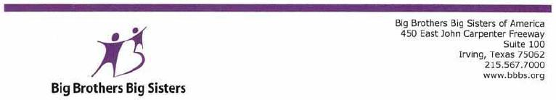

August 22, 2014

Tom Wheeler

Chairman

Federal Communications Commission

445 12th Street, SW

Washington, DC 20554

RE: MB Docket No. l4-57

Dear Chairman Wheeler,

I am writing today to share my experience working with Comcast Corporation in the hope that it informs your analysis of its proposed acquisition of Time Warner Cable.

As the CEO of Big Brothers Big Sisters of America - the nation's largest volunteer mentorlng program - I am concerned about our nation's youth. Giving young people who are facing adversity the guidance and tools they need to be on equal economic and social footing requires investments of time, resources and presence. In the cities and towns where we serve alongside Comcast, I can say that they have shared our passion for investing in the future or individuals and their communities.

Together with Comcast, we have developed the Beyond School Walls program, which is currently the nation's largest workplace mentoring program for young people. Last school year, some 300 "Littles" participated in the mentoring program in 13 Comcast offices nationwide, each paired with a Comcast "Big" whose time and guidance has led program participants to earn higher grades, post lower truancy rates, and increase graduation rates. I am impressed with Comcast's commitment to this program and their desire to see a meaningful outcome for each child.

One aspect that is perhaps the most integral to securing our future economic growth is diversity. In today's - and tomorrow's - workplace, the advantages that diversity brings are essential to driving innovation and creativity, promoting global competition, and advancing economic opportunity. Comcast is a leader in integrating diversity into the workplace. Time and time again Comcast has demonstrated their commitment to diversity by appointing women and people of color to the Board of Directors and by increasing minority hiring in both senior leadership positions and throughout all departments in the company.

The Commission has the responsibility of determining whether or not the proposed Comcast and Time Warner Cable transaction moves forward. I hope the Commission considers Comcast's efforts to invest in the futures of the communities it serves and urge the agency to support this transaction.

Best regards,

/s/ Pam Iorio

Pam Iorio

President and CEO

Big Brothers Big Sisters of America


Think of the possibilities. What will you start?

91

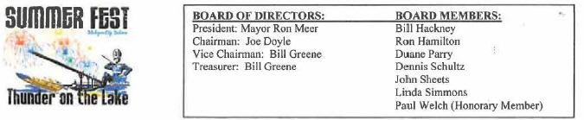

Michigan City Summer Festival P.O. Box 37, Michigan City, Indiana 46361 * (219) 874-3630

Marlene H. Dortch

Secretary

Federal Communications Commission

445 12th Street, SW

Washington, DC 20554

RE: MB Docket No. 14-57

Dear Ms. Dortch:

I am proud to submit this letter in support of the proposed Comcast/Time Warner Cable transaction. I am a Councilman-At-Large in Michigan City, Indiana. Our city, located 50 miles from Chicago, has been experiencing a renaissance of business development and residential growth. Comcast has been one of the major companies leading these developments through its commitment to community investment and improvements to broadband infrastructure. I trust Comcast to continue to expand its estimable local commitments if the transaction goes through.

I have been a member of City Council for over a decade, and take special pride in engaging the community through festivals and other celebratory events. Comcast has always been a reliable sponsor for many of these types of events, as its local employees recognize the importance of maintaining an involved community.

In 2014, Comcast employees along with volunteers from local area nonprofits planted grass and flowers and picked up litter to beautify the public travel roads that lead to Washington Park and Lake Michigan. Past events include cleanup projects and generous Comcast donations to the City Zoo and the City Senior Center. I am always appreciative of local businesses lending a hand to revitalize our city, and Comcast has proved itself to be one of our most reliable partners on many of our efforts.

Part of our efforts to increase business and economic growth in Michigan City include revitalizing old, dilapidated properties in the north end of the city. Plans are underway to improve infrastructure for business centers and to at least maintain and in some cases expand public parks. Digital broadband service will be the key to success for many of these projects. Comcast business services continue to offer some of the best options for offices looking to connect multiple users to a single network. The company's Business Ethernet service offers speeds of up to 10 Gbps with full-scalability, a service that matches the constantly expanding demand of our local clientele. Thanks to Comcast's commitment to creating an all-digital network in 2012, work can be done with faster speeds and greater reliability.

Comcast provides excellent business services and is one of the most trustworthy community partners for Michigan City. I support Comcast's efforts to continue to explore new technology frontiers and to partner with communities like my own. The transaction with Time Warner Cable will only increase these opportunities, thus I urge the FCC to swiftly approve the proposed transaction.

Sincerely,

/s/ Joseph W. Doyle

Joseph W. Doyle, Chairman

M.C. Summer Festival/City Councilman-At-Large

92


August 22, 2014

Chairman Tom Wheeler

Federal Communications Commission

445 12th Street, SW

Washington, DC 20554

RE: MB Docket Number 14-57

Dear Chairman Wheeler,

Communities should be defined by their hopes and strengths, not by their challenges or struggles. That's wisdom I've come to hold deeply throughout my career, first as a volunteer with Neighborhood Centers Inc. and now as Senior Vice President and Chief Strategy Officer for the agency. It isn't easy to find corporations and business partners that respect the promise of all our communities, even the most challenged and underserved. Fortunately, we've found an earnest and committed partner in Comcast. I urge you to approve the proposed Comcast-Time Warner transaction which will empower communities across the country by giving them access to the best the 21st century has to offer.

Neighborhood Centers stretches across the greater Houston region and throughout 60 counties in the state of Texas. We have 70 centers that together serve more than 525,000 people every year. We are the largest traditional nonprofit in Houston and focus on four areas of impact: direct community aid and initiatives, educational access, public sector problem solving, and services for senior citizens. Throughout each of these areas, the Internet is a pivotal resource that can transform lives. Without access at home, residents are isolated from educational, employment and medical opportunities. There is a pronounced digital divide in our country separating our neediest families from the opportunities of the 21st century.

Comcast is working hand in hand with organizations like ours to bridge that gap. The company's Internet Essentials program connects low-income students and their families to quality Internet service and computer hardware. Our community center in Pasadena was designated as an Internet Essentials Learning Zone this year. It has been an incredible opportunity to play host to this program, where families can use our center to learn about and take advantage of Comcast's program. Our center is but one piece of a bigger program. Across the nation, this initiative has already brought more than 350,000 families into the digital age - a milestone Comcast announced just at the beginning of the month. Your approval of this transaction can extend that progress to many new families in other areas.

The company's commitment to our communities also takes the form of sustained, dynamic partnerships with organizations like Neighborhood Centers. The company invested almost $5 million last year in organizations across the Lone Star State. Here in Houston, 17 young adults graduated from one of Comcast's innovative programs, the Digital Connectors initiative.

93

Students are trained in computer literacy and IT services from the best in the business. Comcast empowers these students to be independent digital advocates by teaching them how to best connect their neighbors and family to online opportunity. The nature of the program reflects Comcast's spirit of collaborative giving - residents are empowered rather than served. This investment in human capital can be expanded and furthered through approval of the proposed transaction.

Moreover, Comcast directly promotes our mission by offering PSAs to promote our financial literacy initiatives. The company has a dedication to community-sourced, diverse programming that extends their partnerships built through programs like Internet Essentials and Digital Connectors.

Neighborhood Centers and other organizations across the country are proud to call Comcast a true partner. I urge you to approve this transaction.

Sincerely,

/s/ Ray Chung

Ray Chung

Senior Vice President and Chief Strategy Officer

94

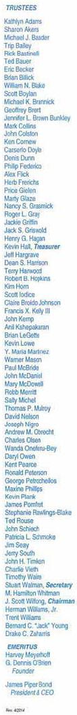


August 21 , 2014

Chairman Tom Wheeler

Commissioner Mignon Clyburn

Commissioner Jessica Rosenworcel

Commissioner Ajit Pai

Commissioner Michael O'Rielly

Federal Communications Commission
445 12th Street, SW

Washington, DC 20554

RE: MB Docket No. 14-57

Dear Chairman and Commissioners:

For twenty-nine years, Living Classrooms Foundation bas been a leader in conununity development, education and workforce development in the Baltimore-Washington region, earning local and national recognition for our results. Living Classrooms addresses some of the most challenging issues affecting disadvantaged children, youth, and young adults, and believes that every student can reach his or her potential, even those residing in distressed communities, if provided a continuum of resources and quality programming that is effective and structured.

The Children's Target Investment Zone is Living Classrooms' strategic Conunllllity Development Initiative aimed at providing effective, seamless solutions and evidence-based practices. The initiative encompasses community-based schools, programs, facilities, and resources serving children, youth and families in creating a holistic, sustainable cradle-through-college-to-career pipeline of support services to break the cycle of poverty in East Baltimore. Living Classrooms is concentrating its core competencies of Education, Workforce Development, and Health & Wellness in this area to create a coordinated effort between families, schools, and key partners to develop an effective community pathway of success.

Over the years, Comcast has been a significant partner of Living Classrooms' Children's Target Investment Zone Initiative. Most recently, Comcast supported the costs to outfit the Comcast Digital Lab at Living Classrooms' Patterson Park Youth Sports and Education Center, Powered by Under Armour. At the Comcast Digital Lab, Living Classrooms staff have taught digital literacy and helped to provide underprivileged students with access to 21st Century Technology.

Living Classrooms Foundation • 802 South Caroline Street • Baltimore. Maryland 21231

Phone (410) 685-0295 • Fax (410) 276-6347 • www.livingclassrooms.org

95

Not only has Comcast been generous in supporting programmatic costs, but Comcast employees have been extremely generous with their time. Through the Comcast Cares Day, Comeast employees have helped to do environmental clean-ups and helped students to build gardens and other green spaces outside of our Community Hubs and Educational Centers. Additionally, we are grateful for the opportunity to market our programming and fundraising efforts on Comcast's channel.

Comcast is a valued corporate partner of Living Classrooms Foundation in Baltimore and we look forward to continuing our partnership with Comcast in the years to come.

Sincerely,

/s/ James Piper Bond

James Piper Bond

President and CEO

96


25 Lowell Street

Manchester, NH 03101

Phone: 603.669.5365 • Fax: 603.645.6577

www.bbbsmanchester.org

August 21, 2014

Tom Wheeler, Chairman

Federal Communications Commission
445 12th Street, SW

Washington, DC 20554

RE: MB Docket No. 14-57

Dear Chairman Wheeler:

I am writing this letter on behalf of my agency in support of the proposed Comcast and Time Warner Cable, Charter and Spin Co. merger.

The Comcast Northeast Division Office, located in Manchester, NH, is Big Brothers Big Sisters of Greater Manchester’s biggest financial and program supporter. During the 2014 -15 program year, Comcast will contribute over $49,000 to our one-to-one mentoring program in the Greater Manchester Community. Comcast also holds toy and coat collections for the youth we serve each holiday season, contributing thousands more to our program through in-kind donations.

Additionally, 40 Comcast Northeast Division employees also serve as mentors to 40 elementary school students in Manchester. Every other Tuesday these students (Littles) take a bus to Comcast to meet with their mentors (Bigs) one-to-one and receive excellent mentoring. Several of these Littles also participate in Comcast’s Internet Essentials program as well, giving them access to resources their low-income status would not otherwise allow. This program has positively impacted these youth and has helped them achieve success in life. In fact, youth participating in Comcast’s Beyond School Walls one-to-one mentoring program achieved the following impacts in the 2013-14 school year:

- 100% of Comcast Littles trusted their Big

- 100% of Comcast Littles felt safe with their Big

- 94% of Comcast Littles reported that their Bigs helped them cope with a problem at home or at school

- 89% of Comcast Littles had an improved sense of future

- 93% of Comcast Littles’ parents reported a significant change in behavior at home

Additionally, on program days, the average attendance for Comcast Littles in school was 97%. The average attendance for Comcast Littles on school days following Comcast program days was 89% and the average attendance throughout the school year was 82%. This is significantly higher than the Manchester average school attendance rate!

We are very supportive of the work that Comcast does for every child and family in the Greater Manchester community. For our agency, supporting this merge means that Comcast can continue to impact communities at a larger scale, especially the support they provide for low income families and youth through Internet Essentials and the employee mentoring programs that often follow. In a community located in a state with the highest school dropout rates and where the average age of people involved in gangs is nine years old, programs like Internet Essentials and one-to-one mentoring have helped youth at least have a chance at success.

Thank you for considering my letter and good luck with your decision.

Respectfully,

/s/ Katie Orlando

Katie Orlando

Executive Director

Big Brothers Big Sisters of Greater Manchester

97



August 20, 2014

Tom Wheeler

Chairman

Federal Communications Commission
445 12th Street, SW

Washington, DC 20554

RE: MB Docket No. 14-57

Dear Chairman Wheeler:

As the Executive Director/CEO of the Boys & Girls Club of Danville, IL, I am writing to voice my support for the Comcast and Time Warner Cable transaction. I know, firsthand, the importance of innovation and investment in technology education for today's youth. Danville's Boys & Girls Club (BGCA) has seen the direct benefits of partnering with Comcast. I urge you to consider our Danville members and other BGCA members nationwide when considering Comcast's union with Time Warner Cable. I believe that together Comcast and Time Warner Cable will deliver the same benefits to many more students in our state and well beyond!

Through their involvement with the BGCA on a national level, Comcast has made a very clear pledge to improving how all children, especially at risk youth, are educated. Comcast supports the goal of supplying high-speed internet connections to the nation's classrooms, libraries, and learning centers. However, as after-school mentors, the staff at BGCA witnesses the importance of having that same high-quality internet access at home to continue learning. To aid in after-school education, Comcast provides cost effective broadband solutions to low-income families. The impact that this has on some of our BCA members truly makes a difference in the way that they learn and how they are growing and developing.

Comcast works with the BGCA through a nation-wide program titled "Club Tech" that aims to make technology not only accessible for children, but also fun and engaging. Club Tech engages in educating BGCA youth members in science, technology, engineering and mathematics (STEM) subjects. In Danville BGCA's newly renovated digital classroom, we have witnessed the improvement in our students' knowledge of technology as they progress through Comcast's STEM

98

curriculum. Today's companies often expect their workers to know that ins and outs of STEM prior to employment. Comcast is helping the BGCA set our members up for future success through Club Tech!

Comcast has maintained a strong partnership with the BGCA and I look forward to seeing how that partnership will continue to develop through the transaction with Time Warner Cable. On a larger scale, there is the potential to expand the Club Tech program, inspire more innovation, and provide more students with top notch broadband connections in many more cities around the United States. I look forward to the expanded partnerships and impact this transaction will offer.

Respectfully,

/s/ Rob Gifford

Rob Gifford

Executive Director/CEO

Boys & Girls Club of Danville, IL

99


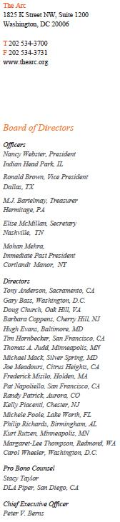

August 20, 2 014

Chairman Tom Wheeler

Commissioner Mignon Clyburn

Commissioner Jessica Rosenworcel

Commissioner Ajit Pai

Commissioner Michael O’Rielly

Federal Communications Commission

445 12th Street, SW

Washington, DC 20554

RE: MB Docket No. 14-57

Dear Chairman and Commissioners:

I am writing on behalf of The Arc, the nation’s oldest and largest community-based nonprofit organization that advocates on behalf of and serves people with intellectually and developmental disabilities (I/DD). While The Arc does not have a position on the pending Comcast and Time Warner Cable transaction, as such matters are outside the scope of our Public Policy Agenda, we would, nevertheless like to express our support and appreciation for Comcast’s commitment to diversity and, in particular, to people with disabilities. Comcast has gone above and beyond in including people with disabilities in their technology initiatives and we look forward to continuing to work with the company to advance mutual objectives.

This past February, The Arc announced a national partnership with Comcast. Comcast’s support makes possible the development of our new Tech Toolbox program and the launch of 12 Comcast and NBCUniversal Digital Literacy Learning Labs that will be operated by local chapters of The Arc. For the 675 chapters of The Arc across the country these new technology initiatives are important to protect the

100

human rights of people with I/DD as well as support their full participation and inclusion in their communities, regardless of their diagnoses. The Technology Toolbox and digital learning labs would not be possible without Comcast’s funding and support.

Our new partnership with Comcast allows for an online resource center to be developed to catalogue important digital resources, apps and software for people with I/DD. A 2010 survey we conducted found that only 32 percent of people with I/DD were reported to be using computers. Digital literacy is imperative to inclusion of the disabled, by putting them in a better position to gain employment or expand their social circle and becoming a part of an increasingly digital landscape.

Since establishing our new relationship with Comcast late last year, we have also learned that Comcast has previously supported people with visual and physical disabilities in their cable technology, too, through voice recognition software and other groundbreaking methods of communication for these populations. Comcast has long been a distinguished voice in the conversation about disability and inclusion, and has even repeatedly been ranked among the "Top 50 Employers List" by outlets like Careers & the disABLED magazine.

On behalf of all of us at The Arc fighting for equal opportunity for people with intellectual and developmental disabilities, we appreciate this opportunity to voice our support for Comcast. We look forward to continuing to work with Comcast to further spread its inclusive technologies and policies to many more whose lives will truly benefit.

We appreciate your consideration.

Sincerely,

/s/ Peter V. Berns

Peter V. Berns

Chief Executive Officer

The Arc

1825 K Street NW, Suite 1200

Washington, D.C. 20006

202-534-3700

101

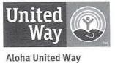

.July 16, 2014

Tom Wheeler

Chairman

Federal Communications Commission
445 12th Street. SW

Washington, DC 20554

RE: MB Docket No. 14-57

Dear Chairman Wheeler:

We are writing to express our support for the proposed transaction between Comcast and Time Warner Cable. We believe that Comcast's entrance into the Hawaii market would bring significant benefits to the islands and specifically to the families and children served by the Aloha United Way.

As a company, Comcast has an impeccable record of being a good community citizen who not only invests in its operations and infrastructure. but also in the people and communities which they serve. Comcast and its employees across the country have stepped up to support schools, rebuild parks and public places, and volunteered their time and efforts in the community.

However, it is Comcast's commitment to closing the Digital Divide that we at the Aloha United Way are most excited about. The Digital Divide is a very real issue here in Hawaii, and Comcast's Internet Essentials Program has the potential to have a real impact in closing that Divide. At its heart, Internet Essentials is a unique and powerful offer that will connect thousands of low income families with children in Hawaii to the Internet. Yet the impact of the program goes far beyond just those families to the hundreds of thousands of people in Hawaii who will benefit from Comcast's investment in digital literacy training programs and computer labs, allowing them for the first time to leverage the amazing power of the Internet to connect to education, family, health care, and social services.

While we understand that the proposed transaction between Comcast and Time Warner Cable is complex, we welcome a long-standing national United Way partner to Hawaii, so that we can work together to serve the needs of the community.

Sincerely,

/s/ Kim Gennaula

Kim Gennaula

President & CEO

Aloha United Way

102



413 NORTH CLEVELAND STREET • MEMPHIS, TENNESSEE 38104 • (901) 272-2491 • www.memphisul.org

August 19, 2014

Chairman Tom Wheeler

Commissioner Mignon Clyburn

Commissioner Jessica Rosenworcel

Commissioner Ajit Pai

Commissioner Michael O`Rielly

Federal Communications Commission

445 12th Street, SW

Washington, DC 20554

RE: MB Docket No. 14-57

Dear Chairman Wheeler and Commissioners:

As the President and Chief Executive Officer of the Memphis Urban League, a 71-year-old affiliate of the National Urban League, the oldest and largest community-based movement of its kind in the country, I wish to extend my support for the proposed transaction between Comcast and Time Warner Cable.

Comcast is a key partner to the Memphis Urban League and has supported our Education and Youth Development departments, which provide a continuum of youth education support services. Due to this partnership, students have access to the resources they need to attain high academic achievement in high school and are prepared for success in college, career and life.

Comcast is a corporate pioneer in the areas of talent diversity and inclusion, key platforms here in Memphis and at Urban Leagues nationwide. Comcast has proven to be committed to supporting the ascent of professionals of color within its workforce and is dedicated to supporting community-based programs that train minorities and other disadvantaged populations to enter and succeed in the workforce.

Memphis Urban League (www.memphisul.org) - Established in 1932, The Memphis Urban League is an affiliate of the National Urban League, this nation's oldest and largest community-based movement devoted to empowering African Americans and other disadvantaged groups to enter the economic and social mainstream. The Memphis Urban League fulfills its mission through its workforce development, job placement and supplemental educational services programs.

103

Comcast is an integral regional and national employer - it is my understanding that nearly 130,000 people are employed within its ranks including about 3,000 in our state.

Last year, I believe, Comcast spent about $188 million on its Tennessee employees' wages, benefits and payroll taxes.

In the Memphis community, Comcast's Internet Essentials initiative is helping low-income individuals and families receive high-speed Internet in their homes - an essential tool for 21st century jobs and education - and the program has already reached 1.2 million Americans, a number that keeps climbing and will hopefully climb further if the transaction before you is approved.

Finally, Comcast is empowering local communities in Memphis and across the country, by developing a network of partners that are mobilizing resources for the benefit of all. I understand that, thanks to its volunteering, donations and scholarships, Comcast made a $6 million charitable investment in Tennessee communities last year. Its civic-minded operations should be an example to other corporate citizens.

I strongly encourage the FCC to approve Comcast's proposed transaction with Time Warner Cable.

Sincerely,

/s/ Tonja Sesley-Baymon

Tonja Sesley-Baymon, President & CEO

Memphis Urban League

104

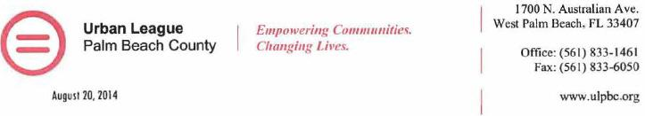

Marlene H. Dortch

Secretary

Federal Communications Commission
445 12th Street, SW

Washington, DC 70554

Subject: MB Docket No. 14-57

Dear Ms. Dortch:

The Urban league of Palm Beach County (ULPBC) would like to highlight the ways that Comcast's community investment work has benefited our region and our community. Our experience leads us to believe that a combined Comcast/Time Warner Cable will offer similar advantages to the new areas Comcast would serve.

In 2008 our organization was the beneficiary site of Comcast Cares Day. More than 500 Comcast employees and community volunteers turned out to paint landscape and provide awnings for our buildings; rewire our computer room; refurbish our restrooms; provide office cubicles; and install much needed outdoor lighting, among other improvements. Comcast gave a new lease on life to a landmark that had been built by local residents with their own hands and, in the process, forged on enduring bond with the community.

Since then, the company has remained an ongoing advocate and ally of the ULPBC through its support of programs and initiatives like the National Achievers Society, Senior Digital literacy Training, and the annual Youth Empowerment Forum.

In addition to being a champion of Comcast's Internet Essentials program, our organization is a founding partner and currently administers the Comcast Digital Connectors program in the Palm Beach County. In addition to being an anchor partner, the ULPBC will also be administering the Comcast Digital Learning Zones, the ULPBC will be implementing "Project CONNECT", a collaborative effort to the enhance broadband technology access and offer family·focused digital literacy training to young people, seniors and families with specific emphasis on workforce development framing the Net Literacy Curriculum.

The ULPBC currently provides comprehensive family services to more than 16,000 clients each year in the Palm Beach area. Our partnership with Comcast has enhanced the work our organization does to enable disadvantaged minorities to secure economic self-reliance through education, housing and employment.

Comcast leads by example when it comes to corporate citizenship and their support as essential to our work serving the community. Therefore, our organization supports the proposed transaction between Comcast and Time Warner Cable so that Comcast can expand the reach of their community investment to new markets.

Sincerely,

/s/ Patrick J. Franklin

Patrick J. Franklin

President & CEO

Urban League of Palm Beach County

- 833-3737 PJF mre

105

August 20, 2014

Tom Wheeler

Chairman

Federal Communications Commission
445 12th Street, SW

Washington, DC 20554

RE: MB Docket No. 14-57

Dear Chairman Wheeler:

As the President and CEO of the Urban League of Portland, I would like to encourage the Commission to support the proposed transaction between Comcast and Time Warner Cable so that more Americans can have access to Comcast's broadband adoption programs.

The Urban League of Portland, an affiliate of the National Urban League, is a non-profit organization that provides direct services to over 1,000 individuals and engages with over 8,000 individuals through our advocacy work. Our mission is to serve and empower African Americans and other Oregonians to create an equitable place to work and live.

We have a strong partnership with Comcast. We are currently running a Comcast Youth Summer Employment Program where young people are given access to the Internet in order to learn how to search for jobs, build resumes and find gainful employment. The access that Comcast has given to many individuals within our organization has enabled us to fulfill our mission by first ensuring that they have equal opportunities in both the classroom and the office and then empowering them to be productive, independent members of society.

We are proud of our partnership, but equally proud of Comcast's partnerships with diverse suppliers and employees across the country. Comcast/NBCUniversal has spent over $3 billion on diverse contracts since 2011. African Americans and minority economic leaders help make this possible. Comcast has been consistently rated one of the best and most inclusive places to work for women and minorities. People of color continue to move into dynamic leadership roles on the cutting edge of the company's progress. The number of people of color in VP positions or higher up the ladder has increased by more than 32% since Comcast merged with NBCUniversal.

Comcast's deployment of the Internet Essentials program to over 350,000 families is helping to ensure that all our citizens, no matter their background, can one day achieve their educational, professional, and financial goals. The low-cost Internet access and computer hardware links our neediest families to a world of opportunity that is often invisible to those on the wrong side of the so-called "Digital Divide." We hope that many new neighborhoods learn about and are empowered by the program upon approval of this transaction.

Urban League of Portland 10 North Russell Street, Portland, OR 97227 (503) 280-2600 www.ulpdx.org

106

Our long history working with Comcast has allowed us to further elevate the standard of living in historically under-served neighborhoods in Portland. We are confident that Comcast will bring the same level of support to their new markets if the proposed transaction is successful. We appreciate your consideration of our views.

/s/ Michael Alexander

Michael Alexander

President and CEO

Urban League of Portland

Urban League of Portland 10 North Russell Street, Portland, OR 97227 (503) 280-2600 www.ulpdx.org

107

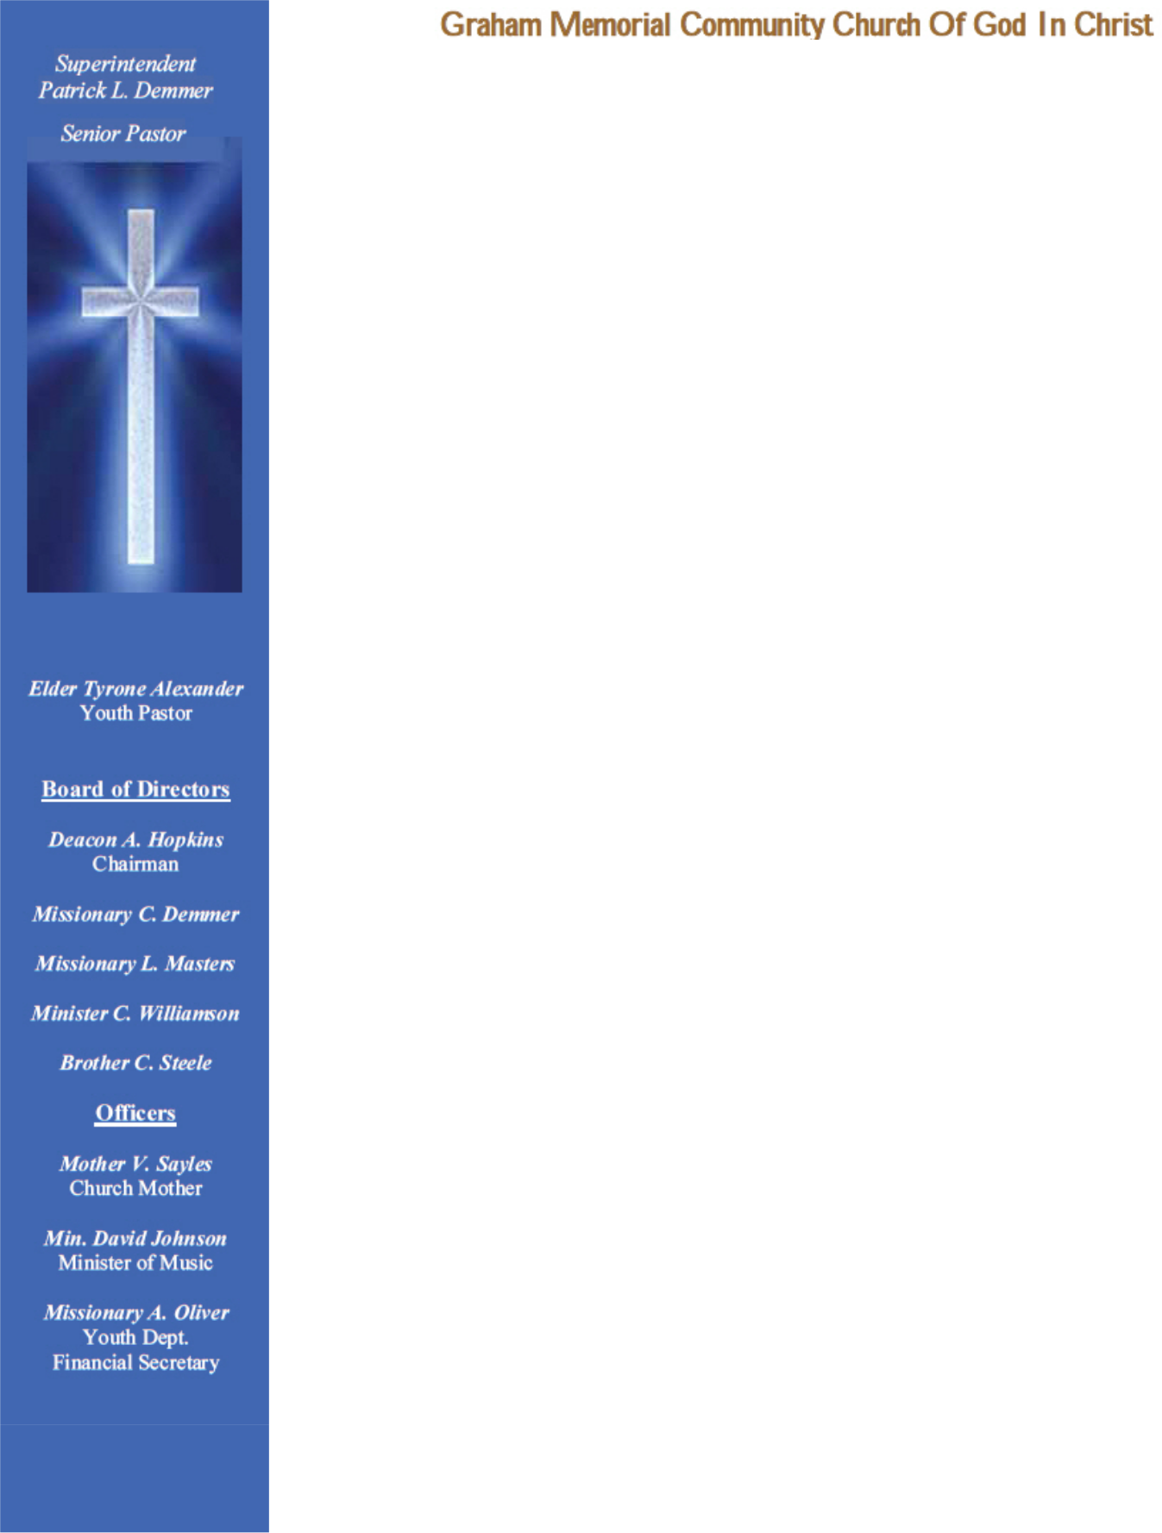
Tom Wheeler


Chairman

Federal Communications Commission
445 12th Street, SW

Washington, DC 20554

RE: MB Docket No. 14-57

Dear Chairman Wheeler:

I pen this letter to comment on Comcast’s proposed transaction with Time Warner Cable, which I understand is currently under review by the Federal Communications Commission. I have had the pleasure to witness firsthand Comcast’s commitment to promoting diversity in Denver and I sincerely support the opportunity for this respected corporation to continue to grow.

As senior pastor of the Graham Memorial Community Church of God in Christ and the former head of the Black Ministerial Alliance, I have been very impressed with Comcast’s commitment to promoting diversity and providing opportunities for minorities in our community. It is a fact that African-American neighborhoods are often left behind when it comes to technology and infrastructure investments, but Comcast has long demonstrated its commitment to our community by making meaningful investments to ensure our citizens have access to the highest quality service.

Since the successful joint venture with NBC Universal in 2011, I have partnered with Comcast to promote digital literacy and their broadband adoption program, Internet Essentials. Comcast has invested heavily in future generations of African Americans through Internet Essentials, so that they can have the same opportunities and choices in life. I believe that leveling the playing field for schoolchildren is the key to increasing diversity in the workplace moving forward because it increases the number of potential minority job applicants in the workforce.

I ask that you keep Comcast’s track record of supporting diversity in Denver and across the country as you review the transaction.

Respectfully,

/s/ Superintendent P. L. Demmer

Superintendent P. L. Demmer

5001 East Thrill Place Denver CO 80207 * 303-393-1333 * Grahammemorial@comcast.net

108

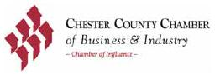

August 19, 2014

Mr. Tom Wheeler

Chairman

Federal Communications Commission
445 12th Street, SW

Washington, DC 20554

RE: MB Docket No. 14-57

Dear Chairman Wheeler:

Thank you for the opportunity to comment on the proposed transaction between Time Warner Cable and Comcast. Based on our experience with Comcast and its activities in Chester County, Pennsylvania, we hope that you will approve the proposed transaction.

Comcast is a significant contributor to the local and state economy. They employ nearly 12,000 Pennsylvanians, and its charitable contributions and the connections it builds within the business community are just as impressive.

Comcast has been a major supporter of the Chester County Chamber of Business and Industry as we work to improve the economic climate of our county.

Few businesses would survive these days without at least basic use of online services. In Chester County, we're fortunate to have access to Comcast's wide range of advanced broadband, network computing and video services which help our Chamber members communicate with constituents, handle operations and orders, and convey their messages in multiple digital formats. Comcast has boosted its Internet speeds every year for the past 12 years and is constantly matching products to the desires of our local businesses. The company’s most common tier of web service runs at 25 Mbps, 10 Mbps faster than the most common tier for Time Warner customers. Comcast’s technology is always evolving and its tools for business - including an adept and widespread Xfinity WiFi system and digital voice services - are among the world's best.

If the proposed transaction is approved, Comcast will have the opportunity to extend its cutting-edge services to new communities across the country. Those communities should have the opportunity to be served by Comcast, and we hope you will approve the transaction to make this a reality.

/s/ Guy Ciarrocchi

Guy Ciarrocchi

President & CEO

Chester County Chamber of Business & Industry

1600 Paoli Pike, Malvern, PA 19355 – Phone: 610-725-9100 – Fax: 610-725-8479 – www.cccbi.org

109

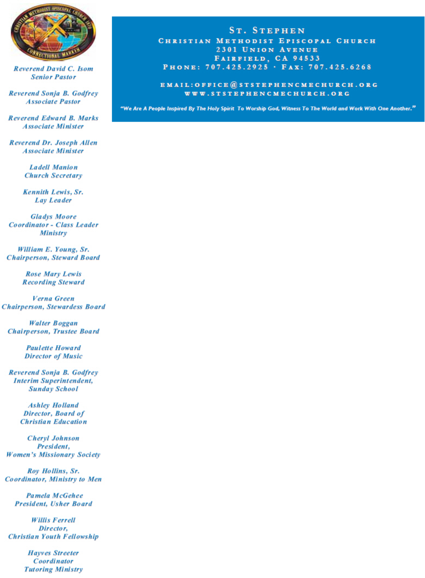

August 20, 2014

Tom Wheeler, Chairman

Federal Communications Commission

445 12th Street SW

Washington, DC 20554

RE: MB Docket No. 14-57

Dear Chairman Wheeler:

I am writing to express my support for Comcast’s proposal to merge with Time Warner Cable.

As the current Board President of the Fairfield-Suisun Unified School District and Pastor of the St. Stephen CME Church, I have dedicated my life to the betterment of my community, so I can appreciate the programs that Comcast has created that touches the lives of so many. Their investments go beyond improving their products and services; they work to improve the communities that they serve.

The Internet Essentials program is of particular interest to me. It is my understanding that over 350,000 families across the nation have crossed the digital divide as a result of the program. I have worked locally to help promote the program to needy families in my community, hosting informational sessions and even manning information booths at public events. I know that having an Internet connection at home would enable the students to establish a further grasp on what they learn in the classroom and better complete their assignments. In this modern era, it is imperative that each student has an equal opportunity to excel. Internet Essentials is opening those doors for more than 35,000 families just in Northern California, and this merger would bring the program deep into communities in the Greater Bay area.

Through programs like Internet Essentials, not to mention the various scholarship and mentor-ship programs aimed at helping young people succeed, Comcast demonstrates that, while corporations are not people, they are often made up of great people who care about the lives they touch and the impressions they leave. I hope that the Commission recognizes the importance of this kind of corporate citizenship.

Thank you,

/s/ Rev. David C. Isom

Rev. David C. Isom, Senior Pastor

110



August 20, 2014

Tom Wheeler

Chairman

Federal Communications Commission

445 12th Street, SW

Washington, DC 20554

RE: MB Docket No. 14-57

Dear Chairman Wheeler:

Thank you for this opportunity to weigh in on a proposal before the Commission. It is my belief that the Comcast and Time Warner Cable transaction is a marvelous proposal and deserves the Commission's wholehearted support. This transaction would expand premiere digital and video service to markets which currently are not served by Comcast. Here in the Philadelphia area, we consider ourselves most fortunate to be served by Comcast.

In my role as President and CEO of Pearl S. Buck International, I have had the pleasure of interacting closely with Comcast officials and employees, and I have firsthand knowledge of their products as well as their committed agency in issues that reach beyond commerce. Comcast is a corporation that truly lives in and works for the community.

Pearl S. Buck International connects families globally through child sponsorship, public programming, and the preservation of the Pearl S. Buck House. We have received countless accolades for our work and repeatedly have been named among the nation's top charities. However, our work could not be accomplished without the commitment of our board of directors. The Chairman of our Board of Directors is Comcast Senior Vice President David R. Breidinger. He carries the responsibility for leading a group which governs one of the nation's top charities. It is a role with endless behind-the-scenes duties, bringing far more demands than thanks. Yet, like the many other Comcast employees who come to our aid and the aid of those in the wider community, Dave is tireless in his dedication to the children and families we serve. And Pearl S. Buck is by no means Dave's only charitable work. Among a number of other activities, he is also a longtime and honored volunteer and Director of the Board for the Boys and Girls Club of Trenton and Mercer Counry. There are plenty of examples of Comcast employees who give like Dave here and elsewhere.

Each year, for instance, Comcast Cares Day brings something like 10,000 Comcast workers into Pennsylvania nonprofit and school organizations to rehab, clean, landscape and otherwise improve areas used by agency clients. This is an event that occurs in every community where Comcast currently operates and very often children are the main beneficiaries. Comcast employees also support us monetarily through their generous donations to the United Way, where we are a member agency.

111

RE: MB Docker No. 14-57 - PearlS. Ruck International® - Page 2

Along with this impressive volunteer effort for youngsters, Comcast also assist schools and students in gaining technology skills, exposure to professional mentors and the chance for college education through scholarships. Partnerships between corporations and their communities are crucial for building a solid economy but they are just as important in developing the next generation of leaders.

Comcast would be a committed community partner in any area it did business. I hope the Commission gives its approval to the proposed transaction because it promises to spread this way of doing business to many more communities.

Sincerely,

/s/ Janet L. Mintzer

Janet L. Mintzer

President & CEO

112

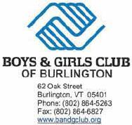
August 20, 2014

Chairman Tom Wheeler

Commissioner Mignon Clyburn

Commissioner Jessica Rosenworcel

Commissioner Ajit Pai

Commissioner Michael O'Reilly

Federal Communications Commission

445 12th Street, SW

Washington DC 20554

RE: MB Docket No. 14-57

Dear Chairman and Commissioners:

As the Executive Director of the Boys & Girls Club of Burlington, Vennont, I am writing in support of the proposed transaction between Comcast and Time Warner Cable.

Comcast is our long-term corporate supporter and has invested time and talent to forward the goals of the Boys & Girls Club to inspire all children and youth, especially those who need us most to realize their full potential as productive, caring and responsible citizens. Comcast has helped us to deliver our support to the children we serve in numerous ways. One such example is that we have worked for several years with the company on Comcast Cares Day, the largest single-day volunteer effort in the nation. The Comcast employee volunteers have enabled us to accomplish significant facility improvements that would otherwise not be affordable for us to undertake.

In addition, in June, the Comcast Foundation awarded us a multi-year grant to support "Club Tech," a national technology initiative that will be housed at our new Academic Tutoring Center. The program is teaching our young members critical computer skills and intemet safety and is introducing them to STEM-related careers.

Further, Tuck Rainwater, a Comcast employee, is a member of our board of directors, lending governance and leadership to the Boys & Girls Club of Burlington, which reaches approximately 1,000 children and youth each year.

Aside from being our laudable corporate partner, Comcast is using its resources to implement a comprehensive broadband adoption program, Internet Essentials, which is working to narrow the Digital Divide. As advocates for the development of our young people, the Boys & Girls Clubs know that developing skills in science, technology, engineering and math, otherwise known as STEM, is critical for college and career success. Access to the Internet is indeed essential for this. I understand that 1.4 million Americans have already received low-cost Internet access in their homes as a result.

ln addition to Internet Essentials, we understand Comcast is wiring schools and libraries for broadband access, actively connecting students and families to key resources, including jobs, education and health care. Comcast wired our new academic and tutoring center in a similar fashion, allowing us to deliver academic and tutoring support to many deserving children and youth in our neighborhoods.

113

The Boys & Girls Club of Burlington is proud to partner with Comcast, a corporation that exemplifies responsible stewardship and community investment, which is why I support Comcast's proposed transaction with Time Warner Cable.

Sincerely,

/s/ Mary Alice McKenzie

Mary Alice McKenzie

Boys & Girls Club of Burlington

114

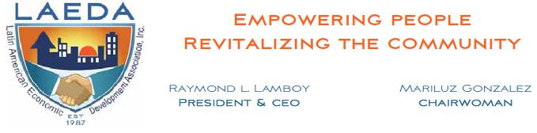

August 20, 2014

Tom Wheeler

Chairman

Federal Communications Commission

445 12th Street, SW

Washington, DC 20554

RE: MB Docket No. 14-57

Dear Chairman Wheeler:

As President and CEO of the Latin American Economic Development Association (LAEDA), I want to express my excitement for the pending transaction between Comcast and Time Warner Cable.

Our mission is to provide entrepreneurial training for disadvantaged, minority youth and adults in the Delaware Valley, primarily in Camden. Comcast has been one of our most important partners, particularly in recent years when America’s economic hardships hit Camden especially hard.

For the past six years, Comcast has partnered with us during its annual Comcast Cares Day, helping us help the people of Camden to revitalize our shared community. In working side-by-side with our neighbors, Comcast has both demonstrated its employees’ personal investment of time and labor in the community and helped us shine a light on the services we provide in the community, like our Entrepreneurial Development Training Program.

The company has also brought its new Internet Essentials broadband adoption program to Camden. I am proud to say that I have worked to raise awareness about the program throughout our area, encouraging eligible families to consider it. Through working with organizations like ours, Comcast has signed up more than 300 families and counting, and we expect increased Internet adoption in our area will lead to better educational performance from our students and a stronger economic base in the future.

I am certain that there are many cities in other parts of the country facing similar economic and educational challenges to Camden’s. I can say that Comcast’s dedication to improving the conditions in our area are sincere, and I believe they would be a valuable partner in other areas.

Should you have any questions, please do not hesitate to contact me directly.

Sincerely,

/s/ Raymond L. Lamboy

Raymond L. Lamboy

President & CEO

115

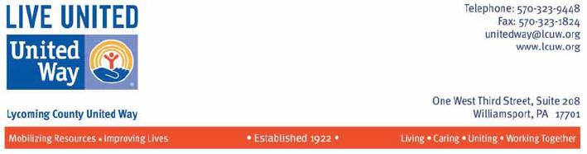

August 20, 2014

I am writing in support of the proposed transaction between Comcast and Time Warner Cable. Comcast has been a tireless supporter of the Lycoming County United Way (LCUW) in Pennsylvania and role model for good corporate stewardship.

I serve as Executive Director of the LCUW and I am proud of our community's work to support over 30 local programs and organizations, mostly focused on children. We originally got started nearly one hundred years ago, in 1922.

Our volunteers and staff serve on the front line of human services needs in our rural County and we are grateful to have a partner in Comcast.

The company's most innovative contribution to Lycoming families is Internet Essentials, a program that makes it easier for low-income families with children to access the Internet.

It goes without saying that digital literacy is a key skill for children at almost every grade level. But kids can only spend so much time in the computer lab at school.

Unless those skills are reinforced at home, they risk falling behind their peers.

In order to strengthen digital literacy - which, by the way, reinforces traditional literacy - Comcast provides the option for families whose children qualify for the school lunch program to have Internet for less than $10 per month. The program also includes options for subsidized computers.

Across the state of Pennsylvania, more than 14,000 families have had the opportunity to get their kids online as a direct result of Internet Essentials. That is a tremendous impact. The number will continue to grow here, and will certainly grow nationally if Comcast can bring this program to new cities by joining with Time Warner.

Comcast has supported the United Way directly, too. During a recent fundraising campaign, the company opened its doors to the United Way. More than 70 percent of local Comcast employees contributed - an impressive mark that demonstrates how much the company fosters a culture of giving and community involvement.

Comcast is a good corporate partner and a responsible member of our community. The transaction with Time Warner Cable will be good news for all the people in Lycoming County who call Comcast and its employees our neighbors, and to new customers and community partners alike in the company's expanded footprint.

Scott Lowery

116

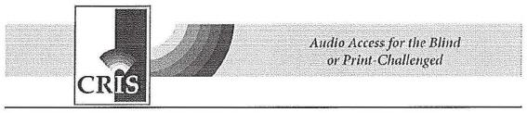

FCC

445 12th St., S.W.

Washington, D.C. 20554

RE: Application of Comcast Corp., Time Warner Cable, Charter Communications and Spinco: MB Docket No. 14-57

Aug. 13, 2014

To Whom It May Concern:

I write this letter to share with you the role Comcast played in helping Connecticut Radio Information System (CRIS) stream audio versions of children's magazines to each patient bed at Connecticut Children's Medical Center in Hartford, Conn . As a result of Comcast's donation of both technical expertise and some specialized equipment necessary for the project, CRIS named Comcast its Business of the Year in 2014, presenting the award at our annual gala in April 2014.

This initiative was very important to CRIS because it allowed us to provide a sense of inclusion for Connecticut Children's patients who are unable to read printed material, which we consider to be a valuable part of our mission. Without the support of Comcast, this project would unlikely have come to fruition.

Comcast was instrumental in helping CRIS find a way to stream audio versions of nearly 20 children's magazines to each patient room through the Connecticut Children's Medical Center's in-house television system for its patients who are unable to read or turn the pages of a magazine due to their condition or medical treatment.

The collaboration has been applauded by Connecticut Gov. Dannel P. Malloy, who stated, "Reading plays such an important role in a child's development, and this new program is sure to help bring a small sense normalcy to children who are facing tremendous challenges. Connecticut is fortunate to have such support for holistic care for children and their families."

"The initiative was also applauded by the hospital's president and CEO, Martin J . Gavin, who stated at the time of the CRISKidsTM launch at the hospital, "The

117

availability of CRISKidsTM in patient rooms will allow children to enjoy educational entertainment, which is an extremely valuable offering and can be a helpful component of the healing process."

CRISis a 36-year-old nonprofit based in Windsor, Conn. and records more than 70 newspapers and magazines, text featured in the Common Core State Standards, and other classroom materials for children and adults who are blind or print challenged, including those who are unable to read due to physical, learning, intellectual or emotional disabilities. CRIS operates with nearly 300 volunteers at its broadcast center in Windsor and four satellite studios located in Danbury, Norwich, Trumbull and West Haven.

Thank you for this opportunity to share with you Comcast's role to stream CRISKids to patients of the Connecticut Children's Medical Center.

Sincerely yours,

/s/ Diane Weaver Dunne

Diane Weaver Dunne

Connecticut Radio Information System, Inc.

315 Windsor Ave.

Windsor, CT 06095

860-527-8000- dwdunne@crisradio.org

www.crisradio.org

118



August 20, 2014

RE: MB Docket No. 14-57

To whom it may concern;.

The Hispanic Human Resources Council, Inc. (HHRC), a nonprofit community based organization in Palm Beach County, would like to take the opportunity to outline the ways that our relationship with Comcast has been fundamental to our organization's success. Because of the benefits we have received through that relationship, we feel that Comcast's planned merger with Time Warner Cable could provide similar benefits to other organizations like us in other communities across the country.

Our organization was founded in 1977 to address the social service needs of the community and to improve cultural awareness and understanding among the residents of the Palm Beach County community. We have been lucky that Comcast makes community investment a priority in all of its markets, including ours, so that our intergenerational and multicultural programs for members, including childcare and job training, can continue to thrive. Comcast has supported the organization's annual Hispanic Heritage Gala, the Hispanic Teacher of the Year Awards and the Community Back to School Bash, which provides school supplies for underprivileged students.

ln 2012, the HHRC was a Comcast Cares Day partner site and we continue to "pay it forward" by participating and recruiting volunteers each year. During Comcast Cares Day in 2012, volunteers established a digital literacy lab for the organization. Having access to a digital literacy lab was vita! to our members to ensure that they have the tools necessary to complete homework assignments, learn English and apply for jobs. In addition to our digital literacy lab, we have also been instrumental in facilitating the launch of Internet Essentials by Comcast in Palm Beach County and spreading the word to eligible Hispanic families. Internet Essentials is the most comprehensive broadband adoption program in the country. To date, Comcast has signed up more the 350,000 households and has agreed to extend the Internet Essential program beyond their initial 3 year commitment. In addition, they have announced they will offer six months of complementary service for eligible households who sign up before September 20th.

Comcast's support has helped the HHRC promote digital literacy and education, as well as improve the language, literacy, and employability skills of the growing Hispanic conununity in

119

Palm Beach County. If the proposed transaction between Comcast and Time Warner Cable is approved, we are confident that Comcast will bring the same level of community investment to their new markets.

Respectfully,

/s/ Jorge Avellana

Jorge Avellana

Executive Director, HHRC, Inc.

120


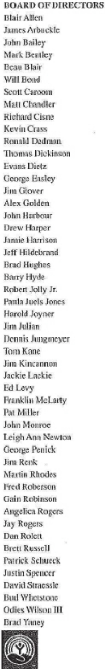

August 20, 2014

Tom Wheeler

Chairman

Federal Communications Commission

445 12th Street, SW

Washington, DC 20554

RE: MB Docket No. 14-57

Dear Chairman Wheeler:

As CEO of The Boys and Girls Club of Central Arkansas, I am writing to you to express my support for the pending merger between Comcast and Time Warner Cable. Our goal at the Club is to inspire and enable young people in need to realize their full potential as productive, caring, responsible citizens, and Comcast has been a longtime partner in helping us achieve our goal.

Educating youth is a key component of helping them to self-actualize, and with Comcast's help we have been able give young people the necessary digital training to succeed in today's technological world. Because of our partnership with Comcast, our Club members are able to perform better in school and be prepared for future employment.

Our work with Comcast's Internet Essentials program allows us to advocate Internet usage in the home and help our clients to obtain a means to connect to the rest of the world. We want to extend a child's connected experience from the school to the Club and, ultimately, to the home. Through digital training and promoting Internet usage, Comcast has helped us to bridge the digital divide between the haves and have-nots, opening up new economic opportunities for the young people in our program.

Comcast is a much invested member of our community and has helped us make great strides in achieving our goals. I urge the Commission to consider how these services would benefit young people across the country and to approve the merger.

Sincerely,

/s/ Cindy Doramus

Cindy Doramus

CEO

Hamilton ● Mitchell ● Penick ● Rose City ● Thrasher ● Wetherington ● Whetstone

121

TO: Chairman Tom Wheeler

Commissioner Mignon Clyburn

Commissioner Jessica Rosenworcel

Commissioner Ajit Pai

Commissioner Michael O’Rielly

Federal Communications Commission
445 12th Street, SW

Washington, DC 20554

RE: MB Docket N. 14-57

Dear Chairman and Commissioners

I serve as a program manager for Thornton Township’s Youth and Family Services department in Illinois as well as volunteer computer lab coordinator with the Thornton Township Youth Committee Program Inc. The committee is a non-profit entity devoted to providing services that enhance the quality of life for youth and families throughout our township, with a population of 170,000- is the largest in the state of Illinois. I write today to voice my support for the proposed Comcast and Time Warner Cable transaction.

As a longtime resident and community leader in Thornton Township, a Comcast-served market, I can personally attest to the commitment that Comcast has shown toward improving our communities, increasing digital literacy, and providing support for our students, so that they can grow into tomorrow’s leaders.

For the past 3 to 4 years, Comcast has partnered itself with the Youth Committee on several projects. With the help of the Comcast Foundation, we were able to upgrade our computer lab and purchase new equipment and educational software to support our after school tutoring program. In 2013, Comcast brought its largest day of national service- Comcast Cares Day- to Thornton, partnering with the Youth Committee to sponsor multiple projects ranging from community beautification to the organization of a food bank.

One of the most important contributions that Comcast has made to our township, which I’d like to highlight, is its Internet Essential Program. Since 2011, Comcast has provided affordable Internet, computers for $150 or less, and free digital literacy training classes to low-income families with children that qualify for free lunches under the National School Lunch Program.

This program has been essential to many lower-income families that cannot afford to

122

pay the full fee for Internet access for their children. Without this program, these kids would be at a disadvantage in classrooms that are increasingly utilizing electronic curriculums.

Thornton Township, and the larger Cook County which we are a part of, has experienced tremendous success with Internet Essentials. I’m proud to say that by 2013, Cook County had activated over 16,000 residents eligible for Internet Essentials, the largest number for any county in the country. Comcast has recognized our region’s success and continues to support it. Just this month, Comcast announced that it would be bringing an Internet Essentials Learning Zone to Thornton. Within this zone, Comcast will provide free indoor WiFi service, donate funds to enhance the community computer lab, create an additional computer lab, and provide free digital literacy training classes.

Our success in Cook County and Thornton Township has been great, but I know that other areas in the state and nation have serious room for improvement when it comes to bridging the digital divide. Comcast has said that it will expand its Internet Essentials program to newly-acquired markets if it is allowed to combine with Time Warner Cable. This would benefit millions of low-income families in major metropolitan markets currently served by Time Warner, including New York, Los Angeles, and Dallas, to name just a few.

I know that Comcast would be able to positively impact even more communities and economies if the proposed transaction were to be approved, and I hope that you feel the same.

Sincerely,

/s/ Larry Lawrence

Larry Lawrence

Program Manager

123


August 20, 2014

Tom Wheeler

Chairman

Federal Communications Commission
445 12th Street, SW

Washington, DC 20554

RE: MB Docket No. 14-57

Dear Chairman Wheeler:

I am writing to you today to share my perspective on the proposed merger between Comcast and Time Warner Cable. With Comcast’s commitment to invest in the communities it does business in, I believe this transaction helps to promote the kind of investment in our communities that the United Way of Fresno County (UWFC) is dedicated to serving.

UWFC brings resources together to address community issues through partnerships and unique approaches. Mobilizing people to commit to investing both money and time into their communities is one of our core approaches. To do this, we coordinate our efforts with organizations like Comcast. Comcast’s Movie in the Park day in downtown Fresno is a particularly good example of its public spirit. For the last five years, UWFC has partnered with Comcast and the City of Fresno to provide a free event to low income families during our annual Back to School Backpack Giveaway and Movies in the Park. Each year, more than 2,000 backpacks filled with school supplies and age appropriate reading books are distributed to students in Fresno County. Providing needy students with the materials they need to succeed academically displays a level of dedication that we not only share, but also admire. We endorse any transaction that could potentially expand these sorts of activities.

Comcast’s Internet Essentials program is another illustrative example of their positive influence and use of civic outreach activities to help promote important causes. Being able to connect to the Internet from both the home and classroom, along with the virtual educational materials offered under the program, is just as essential to students’ academic success as the pens, pencils, and paper that we give away during the annual Back to School Backpack Giveaway

124

and Movie-in-the-Park event. By giving lower income households the chance to get broadband access to the Internet in their homes at prices they can afford, Comcast is directly contributing to the welfare and future of the children in these homes. Internet Essentials is industry-leading and indicative of the company’s overarching values, which should be commended and supported.

United Way of Fresno County commends Comcast on the investment they have already committed to our community and look forward to more opportunities to help improve the quality of life in our communities. Please contact me directly at (559) 243-3679 or via email at rmalexander@unitedwayfresno.org if you or anyone should have any further questions.

Warm regards,

/s/ R. Michael Alexander

R. Michael Alexander

President & CEO

United Way of Fresno County

125



August 18, 2014

Tom Wheeler

Chairman

Federal Communications Commission

445 12th Street, SW

Washington, DC 20554

RE: MB Docket No. 14-57

Dear Chairman Wheeler:

I appreciate having the opportunity to declare my full support for the proposed Comcast and Time Warner transaction. 1 respectfully request that you approve this proposal.

Easter Seals has been a longtime communlty partner of Comcast and NBC Universal and we know first-hand the dedication these entities have to making the world a better, more accessible place for tbose living with a disability.

Each year, more than one million people nationwide are helped by Easter Seals. Our focus has grown from children, to all those with disabilities, whether they were born with a disabling condition or were disabled through injury or the aging process. Currently, some of our most robust programming is for children and adults with autism, and veterans and military families.

lt is truly amazing how the world of technology is closing the communication gap for people living with disabilities. Comcast knows this better than most technology companies and is at the forefront of the industry in making entertainment and communications services and products usable by all.

Easter Seals knows this because Comcast engages our constituents as testing groups to help the company better understand how to best adapt services for those with special needs. Accessible TV navigation options like voice command, closed captioning across platforms, and adaptation of mobile and web applications are among some of the things Comcast is offering or piloting to enrich user experience for all. Through a union with Time Warner Cable, many Americans living with disabilities would have newly gained access to these game-changing technologies.

126

Easter Seals often gives assistance to those we serve in the form of devices that make day-to-day tasks and communication easier. In cities where Comcast cable services are offered, we partner with the Comcast Foundation to provide assistive technology devices like special computer software to schools and children that benefit from it in the classroom. Close to 25,000 students have been impacted.

We also directly connect our clients to Comcast's "Internet Essentials" program through a link on the Easter Seals web site. Internet Essentials offers qualified applicants very affordable service. The expansion of Comcast service through a partnership with Time Warner would bring grants and services such as Internet Essentials to more communities that need them, like our underserved and challenged disabled persons community.

The possibilities for more advances and access for the disabled through a Comcast Time Warner partnership are exciting to think about. We ask you to approve the transaction so that the lives of many more individuals with disabilities are enhanced.

Sincerely,

/s/ James E. Williams, Jr.

James E. Williams, Jr.

President and CEO

Easter Seals, Inc .

127

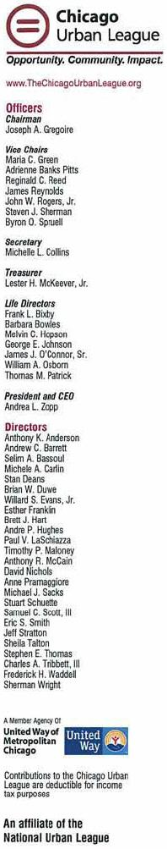
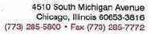
August 20, 2014

Tom Wheeler

Chairman

Federal Communications Commission
445 12th Street, SW

Washington, DC 20554

Re: MB Docket No. 14-57

Dear Chairman Wheeler:

I am writing today to request that the FCC approve the pending transaction between Comcast and Time Warner Cable. Comcast is a strong supporter of the Urban League movement throughout the country and of the Chicago Urban League, where I serve as President and CEO.

The Urban League is the oldest civil rights organization in the country. Our mission has always been to empower the African American community and help people of color achieve economic independence. Here in the Chicago affiliate, we offer Workforce Development and Human Capital Development to prepare people for jobs and then to mentor them and help them succeed when they have jobs.

Comcast assists us at every level. Their financial assistance enables us to serve a growing number of clients who need jobs, housing assistance and help with their small businesses.

In addition, Comcast is a pioneer when it comes to corporate diversity and inclusion. The company recruits minority candidates, mentors them and helps the talented candidates rise to executive levels. Comcast's Employee Resource Groups provide mentoring and assistance to minority employees and encourage retention.

Comcast's values of supporting diversity inclusion are seen even in the core business of providing high speed broadband and cable programming. Here, too, the company supports diversity and inclusion by offering programs and channels, such as BET and REVOLT, which interest minority viewers.

Comcast's lntemet Essentials initiative has been of great interest to the Urban League, as we strive to help low income students bridge the digital divide. This program enables families with one child in the National School Lunch Program to obtain broadband services at home for very affordable cost. What a wonderful opportunity this is! I am proud to report that in Chicagoland, almost 40,000 families have enrolled in this program.

128

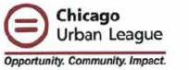

Comcast has committed to expanding the Internet Essentials program into the service areas in acquires in the merger with Time Warner Cable, and I would expect the company's community service orientation will have the same important impact in those areas as they have had on Chicagoland. I sincerely ask that you approve this transaction so that Urban Leaguers in those areas, and everyone else, can benefit.

Sincerely,

/s/ Andrea L. Zopp

Andrea L. Zopp

President and CEO

129

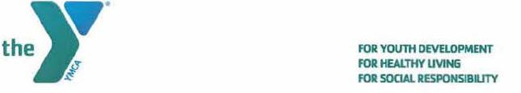

Chairman Tom Wheeler

Commissioner Mignon Clyburn

Commissioner Jessica Rosenworcel

Commissioner Ajit Pal

Commissioner Michael O'Rielly

Federal Communications Commission
445 12th Street, SW

Washington, DC 20554

RE: MB Docket No. 14-57

Dear Chairman and Commissioners:

Comcast has been involved with the YMCA of Reading & Berks County, Pennsylvania, for over 15 years, helping and assisting in our programs and with our community.

We wish to offer our support of their proposed merger with Time Warner Cable.

At the YMCA of Reading & Berks County we promote programs that assist with youth development, healthy living, and social responsibility. We offer transitional housing, youth programs, child care, health and wellness initiatives, and a wide range of community programs at our six branches. Everyone at the YMCA cares about our community and we are continually creating new programs to help support the health and well-being of our neighbors.

Throughout our 15 year relationship Comcast has assisted us with many programs. They have served as one of the top sponsors of our annual Breakfast of Champions for Youth every year since its inception in 1999. We have partnered with Comcast on Internet Essentials, spreading the word about the importance of broadband adoption to the families and individuals we serve daily. Comcast has also brought its employees to our downtown Reading location for its annual Comcast Cares Day event. And local government affairs director, Liz Sterner, was chairman of our board of directors and continues to play a key role on our board and with various committees. To us Comcast is more than a company; they are an active member of our community.

We know well Comcast's capacity to serve, and it is our hope that they are given the opportunity to extend this core value of giving back to the communities to others.

Sincerely,

/s/ Kim Johnson

Kim Johnson

President & CEO
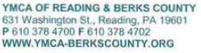

130

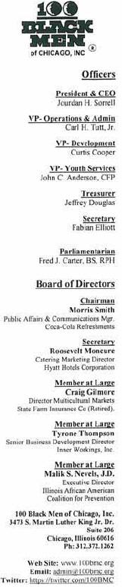
August 20, 20 14

Tom Wheeler

Chairman

Federal Communications Commission
445 12th Street, SW

Washington, DC 20554

Re: MB Docket No. 14-57

Dear Chairman Wheeler,

As the current President & CEO of the I00 Black Men of Chicago, Inc., I am a strong advocate for innovative mentoring and education programs. I write to ask you to approve Comcast's proposed transaction with Time Warner Cable. The combination of these two standout companies can only work to reinforce the work we are doing here at the 100 Black Men of Chicago and offer expanded positive reach to the population we serve in other major cities.

Our organization's mission is to help all young black men in the Chicago area realize their full potential. Without access to the right tools or guidance to recognize outstanding talent, many of our minority populations are unable to live up to their potential. Our "Four for the Future" platform, which consists of Mentoring, Education, Health and Wellness and Economic Empowerment, is the formula we use at the 100 Black Men of Chicago to help our young men secure scholarships and good career paths, as well as become entrepreneurs and overall productive citizens. Part of that formula also includes the participation of corporations like Comcast. Comcast's presence in our community has demonstrated on many levels its commitment to diversity.

Our motto at the 100 Black Men of Chicago is "Real Men, Giving Real Time." Comcast's ethnically diverse management team and employees, including two prominent African American Board members Kenneth J. Bacon and Jonathan A. Rogers, are the very role models we point to when encouraging and educating our young members. Additionally, 21% of Comcast's workforce nationwide is African American, with 7% working in management positions. Comcast has also created a Joint Diversity Advisory Council, which provides advice to senior executive teams regarding the development and implementation of diversity and inclusion issues.

I don't have to tell you that our minority populations, particularly young African American men, face a multitude of challenges in our big cities. The lure of crime and drugs is all too prevalent, coupled with the lack of good solid role models or the absence of one or both parents. Comcast is a company that recognizes these challenges and has reached into minority communities to recruit, train and promote. In Illinois, Comcast has roughly 7,000 employees, and diversity is reflected throughout its workforce. Our agency's mission coupled with Comcast's recognition of minority potential can only continue to be strengthened by this proposed transaction.

I hope the FCC will strongly consider approving the transaction so that more programs like ours can benefit from a partnership with Comcast, and so that more young black men can learn that anything is possible with encouragement, hard work, determination and hope.

Sincerely,

/s/ Jourdan H. Sorrell

Jourdan Sorrell

President & CEO

100 Black Men of Chicago, Inc.

131



Wednesday, August 20, 2014

Chairman Tom Wheeler

Commissioner Mignon Clyburn

Commissioner Jessica Rosenworcel

Commissioner Ajit Pai

Commissioner Michael O’Rielly

Federal Communications Commission
445 12th Street, SW

Washington, DC 20554

RE: MB Docket No. 14-57

Dear Chairman and Commissioners:

On behalf of Public Education & Business Coalition (PEBC) located in Denver, Colorado, I am writing in support of the Comcast/Time Warner Cable transaction. PEBC is a nonprofit partnership of Colorado education and business leaders who are dedicated to developing the intellectual and scholarly practices of educators across the continuum of their professional lives so that our schools are worthy of our students. Without a doubt, Comcast has been a leader in demonstrating a strong commitment to Denver and Colorado families by investing in a wide variety of programs and organizations that benefit Colorado students and schools. I am proud of the excellent work we have achieved in partnership with Comcast.

At PEBC, we provide customized professional learning to cultivate highly effective K-12 educators to elevate student growth and achievement. Product and service offerings, including preparation, instructional coaching and leadership development, span a teacher's entire career. Training our teachers to prepare students for a future in high-tech careers is of the utmost importance. Comcast's commitment to this strategy goes far beyond our organization and reaches deep into the community with their Internet Essentials program, giving families broadband Internet access at an affordable price. This program has clear, positive impact on our community and assuredly has allowed countless individuals and families to pursue their interests and professional goals through access to the Internet.

Besides Internet Essentials, Comcast has helped us promote student scholarship programs, which recognize students who have excelled, thanks to a stronger teaching environment. Every year, Comcast sponsors our fundraising luncheon to recognize Leaders & Achievers scholarship winners. Students receiving this scholarship have shown a high level of achievement.

Our strong, successful, multi-year partnership with Comcast has been exceptionally fruitful. Comcast is one of PEBC's most dedicated corporate sponsors. In turn, PEBC has partnered with Comcast on many initiatives including the promotion of Internet Essentials, as our community and organization have seen first-hand the program's positive impact. It is a successful, respectful partnership, and we are grateful that Comcast has extended the Internet Essentials program indefinitely. I understand that Comcast also will offer Internet Essentials to low-income families in the areas it acquires in the transaction with Time Warner Cable. This will be a great benefit for those families and their communities.

132

I strongly urge you to accept the proposed transaction. My organization and our community in Colorado have benefited from Comcast's presence in our own homes and its involvement in local-impact programs. I have witnessed for many years Comcast's steadfast dedication to community building, and many others would benefit from Comcast's presence in their communities. With this in mind, I urge the FCC to support the proposed Comcast/Time Warner Cable transaction.

Sincerely,

Rosann B. Ward

President

133

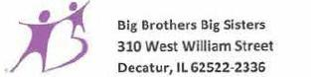
August 18. 2014

Tom Wheeler, Chairman

Federal Communications Commission
445 12th Street, SW

Washington, DC 20554

RE: MB Docket No. 14-57

Dear Chairman Wheeler:

On behalf of Big Brothers Big Sisters (BBBS) of Central Illinois, I am writing today to ask for your approval of the proposed transaction between Comcast and Time Warner Cable. For more than 100 years, BBBS has operated under the belief that every child has the ability to succeed and thrive in life. As the nation's largest donor- and volunteer-supported mentoring network, BBBS makes meaningful, monitored matches between adult volunteers and children in communities across the country. These matches develop positive relationships that have a direct and lasting effect on the lives of young people. We have a great corporate partner in Comcast who supports our mission.

Comcast has partnered with BBBS of Central lllinois on many events over the last four years. and its generosity has helped us engage more local youth and adults than ever before. Comcast also encourages its employees to become mentors though the Beyond School Walls, a program in which Comcast employee mentors get together with mentees every other week at Comcast facilities in more than ten cities across the country.

Here in Central Illinois, we have also worked right alongside Comcast employees during Comcast Cares Day. The national day of service was created in 2001 and has continued to grow since its inception. Every year, Comcast employees, friends and family members join forces with local organizations such as BBBS to work on community service projects. It is rare to see such a large corporate company demonstrate its impact to the local communities it serves in this way. I look forward to the event every year. Please approve the proposed transaction between Comcast and Time Warner Cable so that BBBS, Comcast, and their many other national philanthropic partners may expand these longstanding relationships.

Sincerely,

/s/ Jeanne Stahlheber

Jeanne Stahlheber

Chief Executive Officer


Think of the possibilities. What will you start?

134

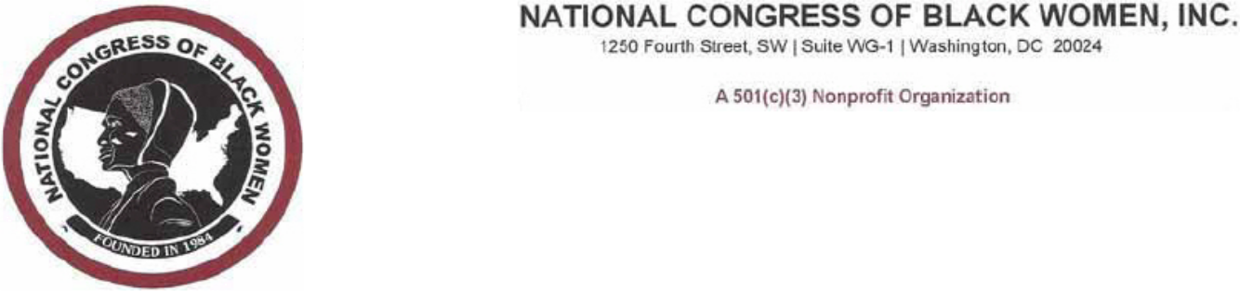

August 19, 2014

Chairman Tom Wheeler

Commissioner Mignon Clyburn

Commissioner Jessica Rosenworcel

Commissioner Ajit Pai

Commissioner Michael O'Rielly

Federal Communications Commission

445 12th Street, SW

Washington, DC 20554

RE: MB Docket No. 14-57

Dear Chairman and Commissioners:

I am writing you to share my thoughts on the proposed transaction between Comcast and Time Warner Cable.

The National Congress of Black Women has long held that access to broadband technology brings opportunities for better education and both personal and economic growth. It places the tools for individual professional success in the hands of our young people and spurs innovation and entrepreneurship in our communities. We support this proposed transaction for what we believe it will do to increase broadband adoption and digital literacy as well as the increased investment in more robust Internet networks that will reach every home in the expanded Comcast footprint.

I know that the Commission is well acquainted with the persistent Digital Divide that continues to keep about one-third of the country—mostly are low-income families and people of color—off of broadband. As low-income families are struggling to provide the most basic necessities to sustain themselves in a recovering economy, it is vital that we seize any opportunity to expand programs like Comcast' s Internet Essentials. NCBW is excited to see this program expand to cities like New York and Los Angeles, where thousands of school children and their families could be eligible.

The merger will also mean that the leadership Comcast has shown in its hiring practices will be replicated in more communities across the country. Since its transaction with NBCUniversal, female and minority hiring has skyrocketed to 45 percent and in 2013 Comcast won the Women in Cable Telecommunications' "Best Operators for Women" award. The company has promised to extend its best-in-class diversity program to Time Warner Cable, which is welcome news.
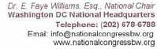

135

I believe that in the long term this combination will lead to financial prosperity, growth and education opportunities for our communities. We support its approval.

Sincerely,

/s/ Dr. E. Faye Williams, Esq.

Dr. E. Faye Williams, Esq.

President/CEO

136

August 18, 2014

Tom Wheeler

Chairman

Federal Communications Commission
445 12th Street, SW

Washington, DC 20554

RE: MB Docket No. 14-57

Dear Chairman Wheeler:

I am writing to express my support of Comcast. I work for a non-profit organization in Boston and which partners with Comcast for seven years. We appreciate the philanthropic support and corporate citizenship of Comcast.

Comcast has a strong interest in supporting young people as well as immigrant families. They provide funding to support immigrants parents and youth to enhance their access and comfort in using the technology. We have seen positive outcome of these youth in their leadership skills and confidence as a result of the technology program. In addition to financial contribution, Comcast also provides air time to help promote our organization.

Thank you for your consideration.

Sincerely,

/s/ Carmen Chan

Carmen Chan

467 Poplar Street

Boston, MA 02131

137



Tom Wheeler Chairman

Federal Communications Commission

445 12th Street, SW

Washington DC 20554

Re: MB Docket No. 14-57

Dear Chairman and Commissioners:

I write today to express to the FCC my enthusiastic support of the proposed Comcast and Time Warner Cable transaction. I have a long history of working with Comcast in my local community of Huntingdon County, Pennsylvania. Comcast has been a long-time supporter of my organization, Huntingdon County PRIDE, where I am a member of the board of directors and a past president. We have been fortunate to have such an excellent corporate partner, and I expect many similar organizations to benefit nationwide if this transaction is approved.

PRIDE clients are those with mental and physical disabilities. At our center, we help them access critical services such as speech and occupational therapy and loans of such equipment as wheelchairs and lifts. For our senior citizen members, PRIDE runs errands, makes meals, washes windows and completes many other services seniors can't perform on their own. We serve a large segment of the population, and heavily rely on community businesses and volunteers to help us ensure our clients get the best service possible.

Comcast's local employees have been instrumental in putting together productions for our organization. Each year, our local Comcast outpost sponsors our major telethon fundraiser that airs on a local Comcast channel. Thanks to the steadfast dedication of Comcast, each year has been more successful than the last. This past fundraiser raised more than a third of our annual budget. Comcast also partners with many national organizations that we admire and respect, such as Easter Seals and The Arc. Later this month, Comcast is planning to sponsor the National Veterans Wheelchair Games, bringing media attention and critical fundraising dollars to an organization that deserves great esteem.

Our employees consistently strive to guide young adults and children who use our services to see their potential for making a significant contribution to society through some kind of vocation. I have been consistently impressed with Comcast's dedication to diverse hiring practices, which include people with disabilities. The company's inclusive hiring and worker retention practices are commendable: people with disabilities are employed in management and throughout all of Comcast's local and national divisions. Comcast and NBC Universal are also bringing more diverse programming to television channels, including increased coverage of the Paralympics this year.

As you can see, Comcast is a leader in supporting and enabling those with physical and mental challenges, and it celebrates diversity and inclusion through its entertainment options and its corporate structure. It is my hope that the FCC approves the proposed transaction with Time Wamer Cable so more can be done to advocate for Americans with disabilities.

Sincerely,

/s/ Dan Varner

Dan Varner, Board of Directors

Huntingdon County PRIDE Inc.

Huntingdon County, PA

138



Tom Wheeler

Chairman

Federal Communications Commission
445 12th Street, SW

Washington, D C 20554

RE: MB Docket No. 14-57

August 15, 2014

Dear Chairman Wheeler:

We write to you today, on behalf of the Latin American Community Center (LACC) in Delaware, to share our perspective on Comcast's proposed acquisition of Time Warner Cable.

Over the years, Comcast has shown real commitment to the Spanish-speaking customers it serves. The company airs independent, community-based programming that reflects the multiculturalism of modern America. In Delaware, for instance, Comcast airs its "Newsmakers" series in multiple languages and provides specific focus on educating viewers about local community issues. By working with organizations like ours to produce the show (we host a Spanish version), Comcast ensures that local voices have a platform to reach the community in any language.

The company's Internet Essentials Program is similarly laudable and another example of the positive role Comcast plays within the Latino community. Comcast prepared materials in Spanish to promote the program in neighborhoods in which the decision makers in the family may only speak English as a second language. LACC has participated in the program by distributing these materials within the community.

We have benefitted from Comcast's commitment to the Hispanic community and believe that with the merger Hispanic communities across the country will benefit too. We hope you take our experiences into consideration when evaluating the merits of the proposed merger.

Sincerely,

/s/ Maria Matos

Maria Matos

President and CEO

139

Tom Wheeler

Chairman

Federal Communications Commission
445 12th Street, SW
Washington, DC 20554

RE: MB Docket No. 14-57

Dear Chairman Wheeler:

Too few people have the opportunity to engage with young adults, invest in their education, and watch it impact their lives. As the Teen Director at the YMCA in Martha’s Vineyard, Massachusetts, my job allows me to do just that.

I think a key component to growing up in the 21st century is having opportunities to explore and learn about new technology. With the implementation of several programs backed by Comcast Corporation, I believe Martha’s Vineyard’s teens will experience top-notch technology education. I am writing to you in support of the Comcast and Time Warner Cable transaction because I recognize the potential it will provide for youth across many communities in the U.S.

Our teens are able to learn, grow and develop at the Alex’s Place Teen Center. This facility houses a state-of-the-art studio – Studio 57 – that was fully equipped by Comcast. Studio 57 is outfitted with many different resources that allow our members to utilize their creative skills in the areas of recording and production. Without Comcast’s incredible contribution to the teen program at the YMCA, this program would not be possible. Should the transaction between Comcast and Time Warner Cable be approved, Comcast could bring programs like these to new communities. Their involvement in the community would pique interest in technology and engage students in a hands-on learning approach not readily-available in schools alone.

The Martha’s Vineyard YMCA has also partnered with Comcast’s Digital Connectors initiative. In this program, Martha’s Vineyards teens are exposed to premier digital literacy and IT training so that they can expand their knowledge of technical skills. Digital Connectors has helped to emphasize to our members the importance of IT training as they seek additional educational and occupational opportunities. Without Comcast as a partner, I am not sure that teens in our area would have such excellent chances to learn outside of the classroom. I think Digital Connectors has the potential to flourish and include more areas and levels of IT training not readily available to students.

140

In my years as an educator and now as the Teen Director of the Martha’s Vineyard YMCA, I have had very positive experiences with Comcast. It is obvious that Comcast does not simply give in the short term. Comcast’s contributions are community investments.

I look forward to seeing how Comcast and Time Warner Cable will complement the other’s investments and markets.

Sincerely,
/s/ Tony Lombardi | Digitally signed by Tony Lombardi
Tony Lombardi | DN: cn=Tony Lombardi,
Director, Alex's Place at the YMCA of Martha's Vineyard | o=YMCA of Martha's Vineyard Inc.,
www.alexsplace.net | ou=Alex's Place.
 | email=tlombardi@ymcamv.org.
 | c=US
 | Date 2014.08.19 15:22.41– 04'00'

141

Chairman Tom Wheeler

Commissioner Mignon Clyburn

Commissioner Jessica Rosenworcel

Commissioner Ajit Pai

Commissioner Michael O’Reilly

Federal Communications Commission
445 12th Street, SW

Washington, DC 20554

RE: MB Docket No. 14-57

Dear Chairman and Commissioners,

I devote myself to my city both because it’s my job as President and CEO of Pittsburgh’s Urban League and because I was born and raised in Pittsburgh. I look for similar commitment from others and I haven’t had to look twice to see that dedication in Comcast. This corporation’s work to lift others up is very evident here and across Pennsylvania.

I’d like to see more areas of the country enjoying the strong bonds we have with Comcast. For that reason, I respectfully ask the Commission to approve the proposed Comcast and Time Warner Cable transaction.

A prime example of the assistance Comcast provides in the communities is the 2011 announcement that would offer low-cost Internet service to low-income families with children who qualify for free or reduced-price school lunches. This service is just $9.95 a month and turns the tables on assumptions that one must be financially comfortable in order to join the digital world. More than 2,500 eligible families had signed up for Comcast’s Internet Essentials program by the end of last year in Pittsburgh. Having a home computer (which is also offered at a huge discount through the program) and Internet service means that disadvantaged children can do their homework, prepare term papers and interact with their teachers throughout the school year as well as their more affluent peers. This is a basic need and Comcast is filling it not just here but around the country. Over 350,000 households have already enrolled nationwide.

Beyond its community service, Comcast’s hiring practices serve as a countrywide model. Its workforce is representative of the communities it serves, with people of color making up something like 40 percent of its staff. Minorities and women not only hold management and senior executive positions for which they are qualified, Comcast develops their leadership skills so they can pursue yet greater status in the company. This is an example of how a corporation should operate.

Comcast’s cable programming also reflects its commitment to diversity. Comcast recognizes that racial, ethnic and cultural diversity is the order of the day, not an aside for a handful of silly sitcoms. Comcast systems carry over 160 independent program networks, many of them minority-owned. Comcast offers intelligent documentaries, devotes programming time to celebrations of African-American and other heritages, and provides diverse program option on its On Demand and online platforms. The company also is the nation’s largest provider of Spanish language networks.

Comcast has built partnerships in many locations it currently serves, and the proposed transaction would extend the same connections to new communities. Please make this possible by approving the proposed transaction.

/s/ Esther Bush

Esther Bush

President and CEO

Urban League of Greater Pittsburgh

142



August 19, 2014
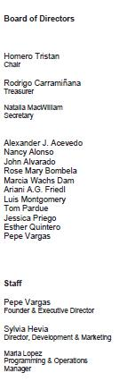

Tom Wheeler

Chairman, Federal Communications Commission

445 12th Street, SW

Washington, DC 20554

RE: M B Docket No. 14 - 57

Dear Chairman Wheeler:

The International Latino Cultural Center of Chicago is a Pan-Latino, multidisciplinary organization dedicated to cultivating and promoting awareness of all Latino cultures through a wide variety of art forms, including film, music, dance, comedy and theater. We could not bring the voices of our community to the world without impactful and sustained partnerships with companies like Comcast.

Please approve the proposed Comcast - Time Warner Cable transaction so that many new areas can benefit from the company's multicultural, far-reaching community investments and collaborations.

In 2010, our organization launched the Chicago Latino Filmmaker Program in partnership with Comcast. The company's implementation of this program demonstrates the hallmark of Comcast service that we have seen in Chicago - a holistic service that integrates the diversity and strength of our communities with world-class technology. The company's On Demand service started offering short sample reels from local filmmakers, all of who had previously participated in our Chicago Latino Film Festival. These six filmmakers gained nationwide exposure from the program. The initiative demonstrates Comcast's devotion to independent, diverse programming. I can attest that his commitment is not just present for Chicago organizations, but for communities and voices across the country.

We understand that Comcast's millions of subscribers have access to tens of thousands of cable programs every day. These programming choices stretch beyond the options available to Time Warner customers. Comcast carries over 160 independent networks. The wide array of offerings empower minorities by allowing them access to content for and by them. We can aid artists in creating and spreading their craft here in Chicago, but Comcast's reach enables greater access to our country's cultural vitality.

Please approve the Comcast - Time Warner Cable transaction so that Comcast can expand and deepen its commitments and improve many more communities. Thank You!

/s/ Pepe Vargas

Pepe Vargas

Executive Director

International Latino Cultural Center of Chicago

676 North LaSalle Street - Suite 520 • Chicago, IL 60654 - USA

Tel (312) 431.1330 • Fax (312) 786.0126 • www.LatinoCulturalCenter.org

143



August 19, 2014

Tom Wheeler

Chairman

Federal Communications Commission

445 12th Street, SW

Washington, DC 20554

RE: MB Docket No. 14-57

Dear Chairman Wheeler:

City Year was founded in 1988 as a service-based organization harnessing the idealism of young people. Today, we partner with public schools in high-poverty communities to help bridge the gap between what students need and what schools are designed to provide. Each year, a corps of idealistic young people works with students to reach their full potential and to keep them in school and on track to succeed, thus building the nation’s urban graduation pipeline in communities all across America. City Year has more than 20,000 alumni who have contributed more than 33.5 million hours of service reaching more than 1.2 million children.

City Year would not be able to make such a significant impact in the lives and communities we serve without the support of our corporate partners, especially Comcast and NBCUniversal. As a company, Comcast and NBCUniversal has a deep commitment to corporate social responsibility— one that sets it apart from many others. The company’s dedication to our mission has been remarkable.

Comcast and NBCUniversal has been a loyal and dedicated partner of City Year for nearly 14 years. During that time, City Year has grown from about 700 corps members to a corps nearly quadruple that size (2,800+), empowering students in 25 cities across the country. Today, Comcast and NBCUniversal supports 11 City Year teams in 10 cities. More than 150 City Year corps members proudly wear the Comcast and NBCUniversal logo on their signature red jackets, representing the enduring community support Comcast and NBCUniversal has shown us, and the students we serve. In addition, Comcast and NBCUniversal has generously provided public service announcements, bringing the City Year message to audiences nationwide, raising awareness of the issue and encouraging them to join us in taking action.

Comcast and NBCUniversal is also City Year’s Leadership Development and Training partner, supporting programs and recognizing the accomplishments of City Year alumni who have continued their dedication to community service through the annual Comcast and NBCUniversal Leadership Awards. In addition, Comcast and NBCUniversal is the presenting sponsor of our National Opening Day ceremonies, our National Leadership Summit and our annual training academy. Comcast and NBCUniversal continues to make these investments because they have seen the difference City Year makes in the schools and students we serve.
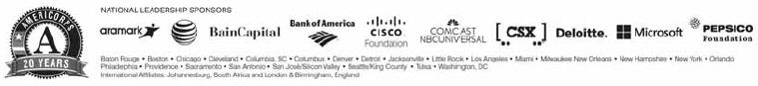

144

Together, City Year and Comcast and NBCUniversal are addressing one of our nation’s most critical issues – the high school dropout crisis. Comcast and NBCUniversal believes that access to technology, and the education to use it effectively, are critical to ensuring that children can reach their full potential. Comcast and NBCUniversal’s Internet Essentials program has connected more than 350,000 low-income households, or 1.4 million Americans, to the power of the Internet at home, most of them for the first time. With City Year’s help, they have spread the word about this program across 4,000 school districts and 30,000 schools nationwide.

Comcast and NBCUniversal staff members have rolled up their sleeves – literally – and helped clean and repair school buildings where our corps members work. This year alone, Comcast and NBCUniversal worked with City Year and more than 600 of our corps members in 15 cities across the country to volunteer alongside their employees, friends, families and other community partners. This was a momentous year as our efforts mobilized a company record – more than 95,000 volunteers participating in Comcast and NBCUniversal Cares Day. Together, we are bettering communities and improving the futures of our young people.

Comcast and NBCUniversal’s investment in City Year makes it possible for thousands of corps members to help improve the lives of students while creating sustainable solutions for social change.

We are tremendously proud to have Comcast and NBCUniversal as a strategic partner of City Year and pleased to share our shared story with you.

Sincerely,

/s/ Michael Brown

Michael Brown

CEO and Co-Founder

City Year, Inc.

145

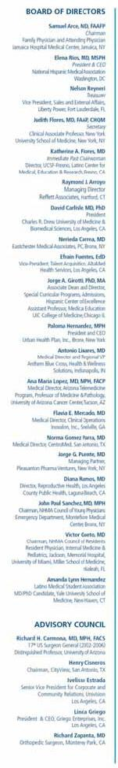

August 19, 2014

Tom Wheeler

Chairman

Federal Communications Commission
445 12th Street, SW

Washington, DC 20554

RE: MB Docket No. 14-57

Dear Chairman Wheeler:

On behalf of the National Hispanic Medical Association (NHMA), I am writing to endorse the proposed Comcast-Time Warner Cable transaction.

Established in 1994 in Washington, DC, the NHMA is a non-profit association representing the interests of 45,000 licensed Hispanic physicians in the United States. The mission of the organization is to empower Hispanic physicians to lead efforts to improve the health of Hispanic and other underserved populations in collaboration with the state Hispanic medical societies, resident and medical student organizations, and other public and private sector partners. NHMA commends Comcast for its diversity practices and a proven commitment to improve the lives of Latinos with programs like Internet Essentials.

Internet Essentials has been an important lifeline for low income families that qualify for the National School Lunch Program. With Internet Essentials, these families have access to at-home broadband and online resources to improve health and wellness, economic opportunity, and educational attainment. Today more than 350,000 families have connected with Internet Essentials, more than 1.4 million people. Also, Comcast has sold more than 23,000 computers to program participants for less than $150.

Comcast’s commitment to bring Internet Essentials to more Latinos in New York City, Los Angeles, and Texas cities like Austin, Dallas, and San Antonio, means more families will get online to access health information and make informed choices about health. Recent events around the Affordable Care Act and rapid advancements in the telehealth space have shown the importance of Internet access for healthcare purposes.

In addition to Internet Essentials and connectivity for underserved communities with the greatest health inequities, Comcast has a strong record for diversity and Hispanic programming. Comcast is the largest cable provider of Latino programming network packages, with a distribution platform that delivers more than 60 cable networks on the majority of its cable systems.

As part of Comcast’s commitment to ethnic and independent programming, Comcast launched BabyFirst Americas. BabyFirst Americas is an English language channel designed for Latino children and their parents, emphasizing the importance of early development of verbal and motor skills. Programming like this is an important first step to help close the gap and improve the quality of life for Latino families.

NHMA asks the Federal Communications Commission to consider the public benefits of Comcast’s Internet Essentials program and commitment to diversity and programming for the quality of life of the Latino communities it serves.

Sincerely,

/s/ Elena Rios

Elena Rios, MD, MSPH

President & CEO

146

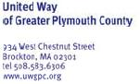


August 18, 2014

Chairman Tom Wheeler

Commissioner Mignon Clyburn

Commissioner Jessica Rosenworcel

Commissioner Ajit Pai

Commissioner Michael O’Rielly

Federal Communications Commission
445 12th Street, SW

Washington, DC 20554

RE: MB Docket No. 14-57

Dear Chairman and Commissioners:

On behalf of the Board of Directors, the volunteers, the staff and the countless numbers of men, women and children who have been helped by, United Way of Greater Plymouth County, I write to express our deepest admiration and appreciation for Comcast as one of our strongest community partners.

Since 1922, our local United Way has endeavored to assess the needs of our neighbors in the greater Plymouth County area, and then to encourage local businesses and individual citizens to contribute resources, both financial and human, to meeting those urgent needs. We are so thankful that Comcast has become an essential part of our United Way achieving its mission with its employees contributing significantly to our annual United Way campaign.

As the old adage goes, “time is money” and in this respect Comcast also contributes priceless human resources to the United Way cause. Over the years this generous company has allowed many of its top performing employees and senior managers to offer their time and talents to so many United Way activities. We are truly fortunate to have had both Ms. Rebecca Fracassa, Comcast’s Community Relations Manager & Ms. Lisa Walsh, Comcast’s Senior Director of Human Resources. Several years ago Comcast local community cable access specialists, including Ms. Judy Lea Eustace, Comcast’s Area Access Supervisor and Ms. Michelle Derochers, Comcast’s Access Coordinator, filmed and produced a first rate, United Way video that has helped us to tell our organization’s story to the general public. These vital human resources have provided needed expertise, energy and direction to our efforts to “improve lives by mobilizing the caring power of communities”.

Our United Way of Greater Plymouth County and the tens of thousands of people who benefit directly from our efforts are squarely and happily in the debt of Comcast. We hope that the Federal Communications Commission will provide Comcast with every reasonable consideration to allow them to continue to thrive in their industry and to continue their philanthropic endeavors. Our communities are better places because Comcast is here!

With deepest appreciation,

/s/ Dennis P. Carman

Dennis P. Carman

President & CEO

147

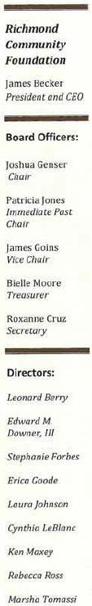

August 18, 2014

Chairman Tom Wheeler

Commissioner Mignon Clyburn

Commissioner Jessica Rosenworeel

Commissioner Ajil Pai

Commissioner Michael O' Rielly

Federal Communications Commission

445 12th Street, SW

Washington, DC 20554

RE: MB Docket No. 14-57

Dear Chairman and Commissioners:

The Richmond Community Foundation (RCF) is excited to support the merger between Comcast and Time Warner Cable. Comcast has done so much for the Richmond, California community where RCF is located.

The Richmond Community Foundation works to build the capacity of the Richmond community by serving as a Community Leader, Collaborator, and Broker, and by leveraging assets of all kinds in order to create and sustain a strong, healthy city. Comcast has proven that it is a responsible corporate citizen in Richmond, by providing affordable services to low-income families through the Internet Essentials Program and most recently, by co-hosting a regional summit on creating equity in education and technology for boys and men of color.

Through its Internet Essentials program, Comcast has sought to close the digital divide, especially in communities of color. RCF has served as an Internet Essentials partner, working Comcast to bring computers and broadband access to the students at our local middle school. Your approval of the proposed Comcast-Time Warner Cable merger will help make it possible for Comcast to bring the benefits of Internet Essentials to low-income residents in current Time Warner Cable markets.

RCF is grateful to have as our partner, a company whose programs extend to the homes of those we serve. I hope that organizations in other communities will be able to take advantage of similar collaborations following approval of the Comcast-Time Warner Cable transaction

Sincerely,

/s/ James A. Becker

James A. Becker

President and CEO

148

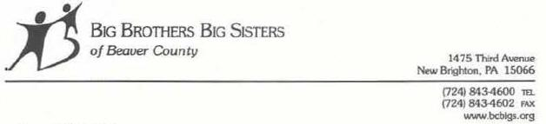

August 18,2014

Marlene H. Dortch

Secretary

Federal Communications Commission
445 12th Street, SW
Washington, DC 20554

RE: MB Docket No. 14-57

Dear Ms. Dortch:

Big Brothers Big Sisters of America has been a national leader in youth mentoring since its inception in 1904. Our mission is to provide children facing adversity with strong and enduring, professionally supported 1-to-1 relationships that change their lives for the better. A 1995 nationwide research study of Big Brothers Big Sisters demonstrated that adolescents in structured BBBS 1-to-1 mentoring relationships were less likely to use drugs or alcohol, less likely to hit someone, more likely to attend and do better in school and more likely to get along with peers and family members.

Comcast has been a reliable. longtime partner and supporter of our mentoring programs nationwide. As Executive Director of the Beaver County, Pennsylvania chapter of Big Brothers Big Sisters, I have seen the tremendous effect that Comcast has made on our organization and our children by providing volunteer, in-kind and monetary support. Having worked with many nonprofits and their corporate partners in the past, I feel that Comcast stands out for its community-based mindset and strong corporate citizenship. As such, I am writing to lend my support to Comcast's transaction with Time Warner.

Comcast routinely supports our local chapter of Big Brothers Big Sisters. We have twice been selected as the site of Comcast Cares Day, the company's annual day of giving. Comcast has also routinely made contributions to our organization through the donation of airtime for public service announcements that help us engage new volunteers, families, donors and supporters and other support.

Comcast's Internet Essentials program provides extremely low-cost Internet service, subsidized computers and offers digital literacy training to low-income families. The ability for our mentees to have high-quality Internet access in their homes assists our organization as we strive to increase the opportunities for them to achieve their educational and social goals. This is an important program that is tackling a tough issue

149

and making good progress. Hundreds of focal families are enrolled in Beaver County and thousands are enrolled across Pennsylvania.

Comcast is an actor that other corporate organizations should emulate when it comes to community involvement. I support the Comcast and Time Warner transaction because I am sure that Comcast's entrance into new regions will quickly bring the same positive results as we have experienced in Beaver County.

Respectfully,

/s/ Lynell Scaff

Lynell Scaff

Executive Director

Big Brothers Big Sisters of Beaver County – Agency 0338

150



August 18, 2014

Mr. Tom Wheeler

Chairman

Federal Communications Commission
445 12th Street, SW

Washington, DC 20554

RE: MB Docket No. 14-57

Dear Chairman Wheeler:

At Big Brothers Big Sisters of the Greater Chesapeake, we are committed to helping children and youth reach their fullest potential through professionally supported mentoring relationships and a broad range of services with quality standards and measurable impact. Our agency provides these services in Central, Southern, and the Eastern Shore of Maryland where we seek to provide services that bring about social, emotional, and academic improvement.

In order to provide these services we rely on funding from multiple entities, including corporate funders such as Comcast, which has played an essential role in funding our agency through sponsorship as well as our Beyond School Walls program. The program utilizes Comcast employees to meet with children from a local elementary school on a bi-weekly basis at a local Comcast office focusing on age-appropriate curricula on entrepreneurship, business communication, and professionalism. Comcast has fully funded this program and provided the mentors necessary to make this a successful program on top of sponsorship dollars that they provide to make our fundraising campaign successful.

I am writing to you today to convey our support of the Comcast/Time Warner Cable merger. As a result of this merger, more children and youth and their families will have access to the Internet Essentials program, a crucial tool that is being used to help facilitate a number of resources online that may not be accessible otherwise. Online access, particularly pertaining to educational tools, is a resource that every child should have access to. Comcast is leading the way in helping to make achieving this goal possible. Due to this and the company's continued support of our work, we encourage you to fully support this merger as well.

Thank you for your consideration.

Sincerely,

Terry F. Hickey, Esq.

President and CEO

Cc:

Marlene H. Dortch, Secretary

Mignon Clyburn, Commissioner

Jessica Rosenworcel, Commissioner

Ajit Pai, Commissioner

Michael O'Reilly, Commissioner

Brad Palazzo, Director, External Affairs
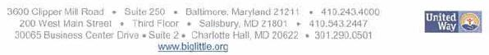

151



August 18, 2014
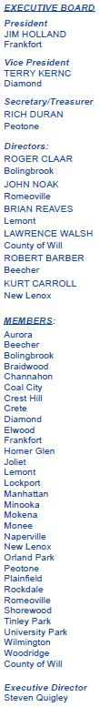

Tom Wheeler

Chairman

Federal Communications Commission

445 12th Street, SW

Washington, DC 20554

RE: MB Docket No.14-57

Dear Chairman Wheeler:

At the Will County Governmental League (WCGL) in Illinois, we pride ourselves on giving the 675,000 citizens in our municipalities a forum to discuss and resolve any issues of local concern as well as growing our communities through technical assistance and services. I am currently the Executive Director of this not-for-profit organization, where I have had the pleasure of navigating these issues and partnering with various corporations, including Comcast and other utility providers. Comcast has had a positive impact on our 30 municipalities through its commitment to making technological development and innovation available for all. I support the proposed transaction between Time Warner Cable and Comcast because I believe that the combined company would be in a position to offer positive development to other communities as well.

Throughout the past several years, WCGL has partnered with with Comcast, to provide our communities with digital learning seminars. Thanks to this kind of support and partnership from Comcast, we are able to offer our American Public Works Association (APWA) employees professional continuing education programs. Click, Listen and Learn webcast trainings have been highly utilized and are sponsored by Comcast. This partnership has helped us to ensure that we can equip our constituents with the trained workforce they need.

Comcast’s passion for digital literacy expands well beyond the WCGL. The company has demonstrated that it understands the impact that technology can have on our communities through the Internet Essentials program, which provides discounted broadband to low income families. Broadband adoption throughout low income communities is necessary now more than ever. Children without home Internet access are put at a huge disadvantage in the classroom. Programs like these work towards the ultimate goal of closing the digital divide, and can empower the vulnerable among us. Already, the Internet Essentials program has connected over 350,000 families nationwide, 40,000 of which are here in Illinois. I believe the ongoing transaction with Time Warner Cable, if approved, would bring positive benefits to many more municipalities across the country.

Comcast has also demonstrated a strong commitment to advancing technology that helps spur economic growth on the local level. I understand the company has invested heavily here in Illinois to improve infrastructure that delivers high speed Internet and leading business services for small to mid-sized companies. With this support and investment, our citizens and businesses are competing more effectively in the global marketplace.

Comcast has demonstrated that it is dedicated to rolling out top-tier technologies, and working to make them available to everyone. I hope the FCC will support the proposed transaction between Comcast and Time Warner Cable so that Comcast can become a stronger company and more regions can gain from what the company delivers.

Best Regards,

/s/ Steve Quigley

Steve Quigley

Executive Director

152

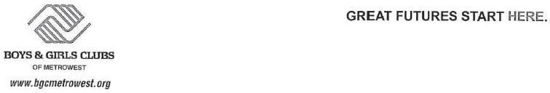

August 18, 2014

Tom Wheeler

Chairman

Federal Communications commission
445 12'^{th} Street, SW
Washington, DC 20554

RE: MB Docket No. 14-57

Dear Chairman Wheeler:

On behalf of the Boys & Girls Clubs of MetroWest, I am pleased to write this letter in support of the Comcast/Time Warner Cable merger.

Comcast is a wonderful supporter of Boys & Girls Clubs and has a great presence in the MetroWest Massachusetts community. They provide tremendous support to the Boys & Girls Clubs of MetroWest both financially and with their in-kind donation of gifts and services. A significant number of Comcast employees have volunteered at our clubhouses as part of the Comcast Cares Program every year.

Comcast is a great corporate partner and we support their business efforts in merging with Time Warner.

Sincerely,

/s/ Francis X. Hurley

Francis X. Hurley

President
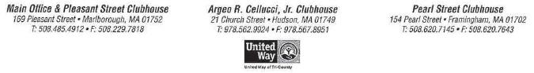

153



Aug. 18, 2014

Mr. Tom Wheeler

Chairman

Federal Communications Commission

445 12th Street, SW

Washington DC 20554

RE: MB Docket No.14-57

Dear Chainnan Wheeler:

May this letter serve as my expression of strong support and commendation for Comcast's community investment, advocacy and leadership, as demonstrated by its long-term commitment to providing employment to people with disabilities and related challenges at Anixter Center in Chicago. In addition, the enthusiasm and dedication of Comcast employees for volunteering to improve the community around them is truly amazing. It is no surprise that Comcast is one of our most valued community partners.

I am the CEO of Anixter Center, one of the largest and oldest nonprofit organizations in the Chicago area that serves people of all ages with disabilities and related challenges. Each year Anixter Center and its three divisions (CALOR, Chicago Hearing Society and Lekotek) help approximately 8,000 children, teens and adults by providing residential, educational, employment, socialization and health services.

All of those we serve have one disability or health-related challenge, and many face multiple disabilities. In addition, most struggle with living well below (-200%) the federal poverty level. Despite these challenges, what is truly amazing about our participants is their strong desire to achieve—to live, learn, work and play as independently as possible in the community. It is our privilege to help them achieve those goals, but we couldn't do it without the critical support of strong partners, such as Comcast.

There are two areas in which Comcast has been, and continues to be, a valued supporter of Anixter Center—employment, support and volunteer service.

For more than 50 years, Anixter Center's Packaging Services unit has provided jobs for adults with disabilities by contracting for a range of packaging and assembling services need by businesses headquartered in the United States. For the past 12 years, Comcast has been one of our most loyal

Lester and Rosalie Anixter Center

2001 N Clybourn Avenue, Suite 300 | Chicago, IL 60614·4036

Voice 773-973-7900 | Fax 773-973·5268 | TTY 773.248.9174

154

customers, providing Anixter Center with packaging contracts that have meant jobs for an average of 125 adults with disabilities each week.

This is unique in the world of contractual work for people with disabilities. Most businesses that use our packaging services do so in a seasonal cycle or through short-term project work, which makes it hard for us to provide steady employment. Comcast's civic interest in helping to support jobs for people with disabilities and its consistent commitment to our program means we can offer our workers steady employment. Not only does this mean jobs they can count on but also all the benefits that employment provides—a source of income, self-esteem, personal satisfaction and independence, to name just a few.

More than 70 percent of adults with disabilities and related challenges are either underemployed or unemployed, despite their ability, desire and willingness to work. According to the Bureau of Labor Statistics, the percentage of working-age people with disabilities in the labor force is about one-third that of persons with no disability. Because of Comcast' s commitment to providing people with disabilities work, Anixter Center has been able to grow its packaging revenue, becoming less dependent on government funding. In addition, this program bas become a stepping-stone so that people with disabilities can build work skills, confidence and a resume, giving them a chance to move on to competitive employment.

Without Comcast's leadership, belief in making a sustainable difference in the lives of people with disabilities and ingrained culture of community investment, Anixter Center's packaging program would not be in the position it is today to have so many workers. Comcast and NBC Universal have created opportunities that have changed the lives of those we serve for the better. In doing so, they have become a role model to other employers. Because of Comcast, Anixter Center's Packaging Services has attracted the interest and investment of other employers who are willing to take a risk and employ a diverse workforce, including those with disabilities.

Comcast Success Story-Carlos

Carlos has worked on the Comcast business for 4 years. Carlos commutes from his home on Chicago's South Side, taking a bus and train to get to work. His goal in coming to Anixter Center was to make a better life for his family, and he says that his Anixter Center job keeps him busy and provides the resources he needs to get things done around the house, invite others to visit and do a little traveling.

"If I weren't working, I'd be home watching television," he says. "I'd rather work to make my own money, and I like the people, too. " He works all day, five days a week. "!am on time and I do a good job. That's what 's expected from me, and I am always trying to improve. "

Because of the work provided by Comcast, Carlos has the confidence, success, and independence to live out his dream of providing for his family.

While Comcast's commitment to helping people with disabilities find work is critically important, I would be remiss if I did not mention the scope and depth of Comcast's corporate philosophy to be a good community partner. The company truly walks the talk. And as a result, thousands and thousands benefit.

155

Perhaps this commitment is best exemplified by the annual Comcast Cares Day—a day of extraordinary volunteerism and good work around the world. This past spring Anixter Center was one of many recipients in the Chicago area of this signature celebration of service and the nation's largest single-day corporate volunteer effort.

For several days in April, culminating with a massive effort on the official Comcast Cares Day, more than 130 Comcast volunteers descended on Anixter Center's flagship building at 2032 N. Clybourn Ave. in Chicago. This mammoth 100-year-old manufacturing building is loved by clients and staff alike for its spaciousness, open areas and character. But, due in part to state funding cuts, the building has been in a slow state of decline. And Chicago's worst winter on record didn't help. The four-floor building was in desperate need of painting and renewal almost everywhere—far more work than our small staff could do.

But the legions of Comcast volunteers were up to the task. They prepared walls and lockers, painted and made repairs as necessary. Their good-natured energy and enthusiasm were infectious and transformative. In countless cases, they stayed longer than their assigned shifts (or came back an extra day) to be sure the job was done. They took personal pride in their work and making this tired building look refreshed.

Through it all they had fun, and that made it fun for our staff and progrrun participants as well. These volunteers tweeted friends about what they were doing and sent pictures of the people with disabilities they were meeting and helping. It became a wonderful way for Comcast employees to truly get to know us and show how much they cared. And by sharing their volunteering efforts and pictures with their friends, more people got to know about Anixter Center as well.

The result was not only a much refreshed building, but some wonderful personal connections between the Comcast volunteers and people with disabilities. It also gave our participants and staff a renewed sense of pride and self-esteem. They saw people who cared enough to volunteer their hours to make Anixter Center a nicer place to come to every day. In short, Anixter Center staff and participants were reenergized by the enthusiasm of the volunteers.

What is most amazing is that our story is just one of many such stories as Comcast volunteers served countless organizations around the world that day. That is truly a commitment to make the world better, not only by the Comcast volunteers but by the Comcast leadership that fosters and encourages such commitment.

In closing, Anixter Center leadership, staff, volunteers and program participants truly appreciate Comcast's community commitment and vision as well as its dedication to helping others around the world. We are fortunate to have them as a business and civic partner.

Sincerely,

/s/ Kevin Limbeck

Kevin Limbeck

President & CEO

Anixter Center

156



August 18, 2014

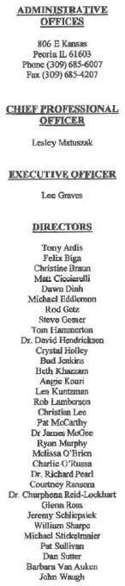

Dear Chairman & Commissioners:

Marlene H. Dortch, Secretary

Federal Communications Commission
445 12th Street, SW

Washington, DC 20554

RE: MB Docket No. 14-57

Dear Ms. Dortch:

As CEO for the Boys & Girls Clubs of Peoria. a local affiliate of the Boys & Girls Clubs of America, I am writing to express my support for the Comcast and Time Warner transaction. Our organization's primary mission is to enable all young people, especially those in at-risk circumstances, to realize their full potential and become responsible, productive, caring citizens. Our local chapter gives support, guidance and hope to over 1,500 youths from the ages of 6-18 years old in and around Peoria, lllinois.

The help and support Comcast has provided for Boys & girls Clubs around the nation, and locally within Peoria, have had a tremendously positive impact, and I know that Comcast is committed to providing bright futures and equal learning opportunities for all children through this proposed transaction. Comcast has been extremely involved in Peoria's Boys & Girls Clubs. Since 2008, we've hosted four Comcast Cares Days, bringing the nation's largest single-day corporate volunteer event tour kids and facilities.

Further, Comcast has devoted itself to the cause of fostering digital literacy and bridging the digital divide. Not only bas Comcast been extremely supportive of the Boys & Girls Clubs' national efforts in promoting digital literacy, but in Peoria specifically, we've been a partner to bring Comcast's Internet Essentials program to our low-income students. The Internet Essentials program — groundbreaking digital literacy initiative — has been a tremendous success, connecting over 1.4 million families to the Intemet in the three years since it has been in existence. In Central Illinois, including Peoria, over 1,000 families have been connected to the Internet through Internet Essentials. And recently, the Comcast foundation provided our Boys & Girls Clubs a grant for a new computer lab, which will serve as an Internet Essentials Learning Zone, where people from our communities can come for free digital literacy training classes.

If the transaction is approved Comcast will expand Internet Essentials to many more low-income families in current Time Warner Cable territories. The impact has the potential to be significant. I am also confident that the company will continue its partnership with the Boys & Girls Clubs and expand it to our other local chapters in Time Warner Cable markets across the U.S.

l hope the FCC sees the potential benefits that this transaction offers and will allow it to become a reality.

Sincerely,

/s/ Lesley Matuszak

Lesley Matuszak

Chief Professional Officer

LRM/llf

157

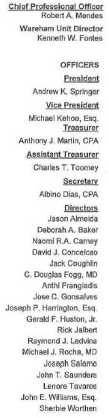

August 15, 2014

Tom Wheeler, Chairman

Federal Communications Commission
445 12th Street, SW
Washington, DC 20554

RE: MB Docket No. 14-57

Dear Chairman Wheeler,

On behalf of the Boys & Girls Club of Greater New Bedford/Wareham, in New Bedford, Mass., I am writing in appreciation of Comcast Corporation, a valued partner of our Club, which is the third oldest in the nation. Comcast is a model of community-oriented corporate citizenship, so I am proud to extend my support for the proposed transaction between Comcast and Time Warner Cable.

On multiple occasions, including last April, Comcast volunteers have served our Club on Comcast Cares Day, the single largest day of corporate volunteerism in the nation. In addition, we have been fortunate to receive substantial financial support from Comcast to help sustain our programs and ultimately create greater opportunity for our young people.

Comcast is also focused on an issue that is central to the future prosperity of our youth. Broadband access, critical for 21st century jobs and educational opportunities, must be available for all of our young people and their families. To that end, Comcast's Internet Essentials program, known as " Internet Basico" in Spanish, promises to narrow the Digital Divide by providing free training and affordable service in the homes of low-income children and their families. Households that participate also have the opportunity to purchase cost-effective hardware that maximizes benefits for the entire family.

In Massachusetts, 8,000 households are participating in this initiative – and it has already reached 1.4 million Americans nationwide.

Moreover, cross sector advocates are needed to prioritize the potential of our low-income and minority students, which will be shaped by access to and
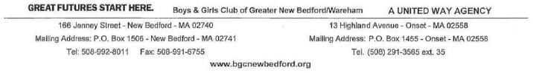

158

knowledge of the internet. Young people are our greatest national resource, after all, and Comcast is a company that recognizes this.

I believe that the FCC should approve the proposed transaction between Comcast and Time Warner Cable, which would ebhance broadband service in communities across Massachusetts and many other states.

Respectfully,

/s/ Robert Mendes

Robert Mendes

Chief Professional Officer

Boys & Girls Club of Greater New Bedford

159

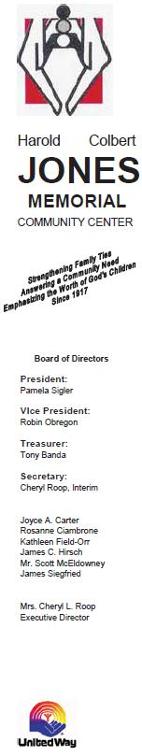
August 15, 2014

Tom Wheeler, Chairman

Federal Communications Commission
445 12th Street, SW

Washington, DC 20554

RE: MB Docket No. 14-57

Dear Chairman Wheeler:

For 95 years, the Harold Colbert Jones Memorial Community Center (Jones Center) based in Chicago Heights has been a beacon of hope and comfort for many of our residents. Although our programs have evolved and changed over the years, what has not changed is our mission and ability to touch the lives of many people. Presently, Jones Center offers after-school and summer programs for school-aged children, computer classes for all ages, and senior programs. Also, we provide several emergency services such as a food pantry and used clothing closet. Jones Center’s presence in our community has been a mainstay thanks to great partners like Comcast. With that in mind, I am writing today to ask for your support of the proposed transaction between Comcast and Time Warner Cable.

Comcast partnered with Jones Center on a Comcast Cares Day project in 2012 and provided our organization with hours of volunteer service helping to improve our facility inside and out. Additionally, we would not have been able to upgrade our very out-of-date computer lab without Comcast’s partnership. That upgrade has helped us provide the current technology that our community members need to succeed in our 21st century world.

Jones Center also proudly promotes Comcast’s Internet Essentials program. You are probably aware, but this program provides eligible families with home Internet service for only $9.95 per month, free digital skills training, and the option to purchase a heavily-subsidized computer. Many of our clients who do not have that technology in their homes can now realize an opportunity that didn’t exist before. In fact, Internet Essentials has already provided nearly 40,000 homes in Illinois with that access. We understand that there are over 200,000 homes in the state that are eligible right now, and the only way to get the word out is through the collaborative efforts of Comcast with organizations like ours. Our clients, most of them low income, look to us for resources and information of which they might otherwise not be aware.

Our computer learning center has become a central and integral focus of our programming here at Jones Center. From our kids program that offers hands-on computer training utilizing several software programs and online capabilities to our adult program utilizing MS Office
2007 and online services, we can give young and older adults the tools they need to succeed in school and find jobs, thanks in large part to the generosity of Comcast.

I urge you to approve this transaction so that other communities in big cities are given the opportunity to form this kind of partnership.

Sincerely,

/s/ Cheryl L. Roop

Cheryl L. Roop

Executive Director

160

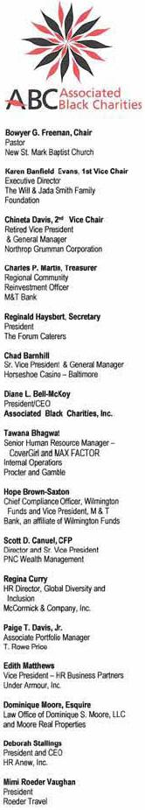
August 14, 2014

Chairman Tom Wheeler

Commissioner Mignon Clyburn

Commissioner Jessica Rosenworcel

Commissioner Ajit Pai

Commissioner Michael O'Rielly

Federal Communications Commission
445 12th Street, SW

Washington, DC 20554

RE: MB Docket No. 14-57

Dear Chairman and Commissioners:

On behalf of Associated Black Charities (ABC), located in Baltimore, Maryland, I am writing to express support for the proposed merger of Comcast and Time Warner Cable.

The support is based upon our existing partnership with Comcast in Maryland and their continuous willingness to find solutions that benefit the community especially low wage/no wage adults and their families. Their support has been financial but it has also included in-kind support and lending of their intellectual capital to help problem solve in these same communities.

Comcast, as they are currently structured, is certainly able to help us make a difference as we focus on closing the health and wealth gaps in the State of Maryland. However, it is our firm hope that a combined organization of Comcast and Time Warner can lend so much more in terms of resources, both financial and intellectual, that even greater change can be achieved in these communities.

One of the largest barriers to opportunities for low wage/no wage and families of color in general, is access to knowledge, relationships and simply "know how" to create pathways for themselves. Technology can be a core equalizer in this equation. Technology and resources which increase access can be made available to not just families and children, but also to organizations that are under-resourced and seek to move those families up the ladder.

161

Chairman Tom Wheeler

Commissioner Mignon Clyburn

Commissioner Jessica Rosenworcel

Commissioner Ajit Pai

Commissioner Michael O'Rielly

August 14, 2014

Page 2

A corporation providing services to the public must understand that their success and sustainability is directly related to the success and sustainability of the communities they serve. We believe that this is both the perspective and the values to be represented in the combined organization.

Sincerely,

/s/ Dianne Bell-McKoy

Dianne Bell-McKoy

President and CEO

DBM:ct

162



August 14, 2014

Tom Wheeler

Chairman

Federal Communications Commission
445 12th Street, SW

Washington, DC 20554

RE: MB Docket No. 14-57

Dear Chairman Wheeler:

On behalf of Philadelphia’s Urban Affairs Coalition (UAC), I am writing today to request that the FCC approve the proposed Comcast/Time Warner Cable transaction. I have been with the UAC for 15 years and currently serve as President and CEO.

During this period, I have watched Comcast grow from a local cable company into a global media provider. It has been an astonishing transformation. What has proved to be even more astonishing is Comcast’s continued commitment to Philadelphia and to helping the nonprofit organizations that abound in our city.

The UAC can best be described as a helper organization – we provide back of the house services for nonprofit organizations so they are free to concentrate on their core missions. In 2013 our network of more than 55 partner organizations served more than 150,000 children, teens and adults. These services address the most important issues of our communities; we provide free tax services as well as programs addressing issues such as youth development, adult education, digital literacy, job training, small business development, anti-predatory lending, economic inclusion, HIV/AIDS prevention and other health-related issues.

To bridge the digital divide in Philadelphia, UAC managed the Freedom Rings Partnership, a $25M multi-year citywide initiative, in partnership with the City of Philadelphia, Drexel University, and over 50 other community-based organizations. This effort connected low-income Philadelphians to the Internet by establishing “KEYSPOTs” throughout the city where residents could learn how to use a computer and browse the Internet. This has been an enormously successful effort, but we could never have succeeded to such an extent without Comcast’s assistance.

Comcast installed Internet connections at many of the KEYSPOTs, lowering the cost of this very ambitious and expensive program.

Comcast’s Digital Connectors program supported our KEYSPOTs effort by working with young people and teaching them how to repair computers, use them for business purposes. The Digital Connectors program includes leadership training and financial literacy classes, which are of great help to young people from financially distressed families.

163

Comcast’s Internet Essentials program has also been a blessing to many of the families in our programs. Internet Essentials enables any family with one or more children in the National School Free Lunch program to obtain broadband service at home for just $9.95 a month. About 9,000 Philadelphia families have signed up and we won’t stop there.

Comcast is committed to corporate responsibility, in its hometown of Philadelphia and wherever else it sets up shop. I cannot commend the company enough. I hope you will approve the transaction between Comcast and Time Warner so that other areas with nonprofit agencies can benefit as we do.

Sincerely,

/s/ Sharmain Matlock-Turner

Sharmain Matlock-Turner

President & CEO

Urban Affairs Coalition

164

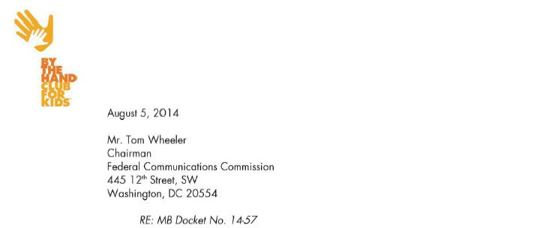

Dear Chairman Wheeler,

By The Hand Club For Kids has partnered with Comcast over the past six years to help meet the most pressing needs for the education and safety of children living in at-risk neighborhoods of Chicago.

Overview of By The Hand

By The Hand is an after-school program that started with 16 kids in Cabrini-Green in March 2001. Today it serves 1,000 students from 1st grade through college in Cabrini-Green, Altgeld Gardens, Austin and Englewood. We literally and figuratively take our kids by the hand and walk with them, meeting all their educational, physical and emotional needs so that as adults they can walk successfully on their own and realize their full potential.

However with the help of Comcast and many others we are seeing great results. By The Hand was able to report many outstanding academic achievements from the 2013-2014 school year including:

- 87% of students passed math and reading.

- 45% of students achieved all As, Bs and Cs.

- 182 of students are on the honor roll.

- 100% of seniors graduated and 89% enrolled in college this fall.

- 2 Bill Gates Millennium Scholars who are both pursuing Science careers.

Partnering with Comcast

Comcast has been a great partner to us over the last six years.

- Comcast sponsored the 2008 By The Hand Club For Kids Spring Benefit.

- In the fall of 2008, Comcast awarded By The Hand a $40,000 grant over two years for our education and literacy programs.

- By The Hand began using Comcast as our internet provider and also began providing free internal service to one of our sites, Altgeld Gardens.

165



- In April 2009, 50 Comcast employees served at our Englewood site for the Comcast Cares Day. They cleaned, painted, repaired old lights and landscaped our yard.

- In 2011, By The Hand was awarded an $30,000 grant to help us upgrade and provide new computers for our students. This enabled many students to write papers and do research online thus improving their grades.

- Comcast gave us the opportunity to appear on their Newsmakers Program to grow awareness of By The Hand.

- Comcast partnered with us to provide some of our families with affordable internet at home through Internet Essentials.

- In 2013, By The Hand was awarded a grant of $30,000 to help us enhance our technology efforts allowing us to roll out a new blended learning program incorporating computer reading software to help individualize learning for our children. Comcast helped us pilot this program this past year and already we have seen on average our kids grow in reading by 1.2 grade levels.

We are so thankful for the ongoing, loyal support of Comcast over the years. They have kept their financial and volunteer commitments to us which has enabled us to change the lives of many children in Chicago. We look forward to growing our partnership with Comcast in the coming years.

Sincerely,

/s/ Donnita Travis

Donnita Travis

Founder and Executive Director

166

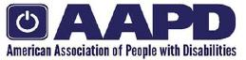

July 8, 2014

Ms. Marlene H. Dortch

Secretary

Federal Communications Commission

445 12th Street SW

Washington, DC 20554

In the Matter of Applications of Comcast Corporation and Time Warner Cable, Inc. for Consent to Assign Licenses or Transfer Control of Licensees, MB Docket 14-57

Dear Ms. Dortch,

The American Association of People with Disabilities (AAPD) submits the following comments regarding the matter above.

I. Introduction

AAPD is the nation's largest cross-disability organization. We promote equal opportunity, economic power, independent living, and political participation for people with disabilities. Our members, including people with disabilities and our family, friends, and supporters, represent a powerful force for change. We have a long history of working on the technology issues facing people with disabilities, from hosting the monthly Technology Forum, whose members include both technology firms and disability groups, to housing the Coalition of Organizations for Accessible Technology in order to advocate for accessibility and usability of technology for people with disabilities. AAPD’s interest in this matter is in both maintaining and ensuring greater accessibility and usability for persons with disabilities in the services provided not only by the entities involved, but by all Internet service providers.

II. Comcast has Demonstrated a Commitment to Developing Accessibility Features for Their Customers with Disabilities

In considering this venture, a significant virtue relates to the accessibility of the equipment and services offered by the proposed entity. Comcast has shown a fine commitment to devoting resources towards developing accessibility features for their customers with disabilities. Not only are they the only cable

167

provider to have an office dedicated full-time to accessibility,¹ but Comcast has also created a product and development lab,² working to ensure that that they are researching and developing best practices in this field.

Comcast’s Accessibility Lab, which is both a working lab for the development of accessible products and features and a showcase of assistive technologies used by people with disabilities to interact with mainstream user interfaces, focuses not just on sensory disabilities, but also on people with physical disabilities.³ While there lacks a focus on people with intellectual and developmental disabilities, we note that Comcast is using the lab for focus groups and usability testing with key communities of people with disabilities to learn more about how customers can use its services as well as to help educate its employees about accessibility.⁴

In addition, Comcast is planning to launch their most recent accessibility device this year, cable TV’s first talking program guide.⁵ This talking TV interface will deliver a more meaningful TV experience to millions of blind or low vision customers.⁶

There is still much work to be done by Comcast and other Internet service providers in ensuring the accessibility of their products to all customers with disabilities, yet these recent advancements demonstrate a step forward in discovering best practices to enhance accessibility in equipment and services.

III. Time Warner Cable Has Not Made a Similar Investment into Developing Accessibility Features for Customers with Disabilities

AAPD does not believe that Time Warner Cable has made a similar investment of resources to enhance the experience of their customers with disabilities.

Time Warner Cable currently supports many vital accessibility services, including large-button remotes, channel lineups in Braille, and closed captioning, to help their customers with disabilities better access

- Comcast Accessibility Fact Sheet, Coalition of Organizations for Accessible Technology, available at www.coataccess.com (last visited June 18, 2014). ² Comcast Debuts Accessibility Support Team and Product Lab, Comcast, available at www.corporate.comcast.com (last visited June 18, 2014).

³ Id.

⁴ Id.

- A Television Experience Tailored for the Blind, Comcast, available at www.corporate.comcast.com (last visited June 18, 2014). ⁶ Id.

168

their products.⁷ Additionally, the company has been proactive in engaging representatives of the disability community towards promoting a culture of inclusion and accessibility at the company.

However, Time Warner Cable does not offer many of the accessibility features and support systems that Comcast has invested in, including a dedicated support staff, an accessibility lab, a talking TV program guide, and support for third-party assistive technology. By virtue of these facts, Time Warner Cable’s accessibility infrastructure does not demonstrate the highest level of best practices in the field.

IV. Time Warner Cable Customers Would Benefit from the Accessibility Infrastructure in Place at Comcast

Time Warner Cable’s customers with disabilities are not yet able to experience the most recent and innovative services in the field of accessibility technology as can currently be made available by Internet service providers. AAPD believes it would stand to reason that, through the process of the merger, Comcast would be able to leverage Time Warner Cable’s foundation to deploy new assistive technologies and support to Time Warner Cable’s customers, who would certainly benefit from the accessibility infrastructure in place at Comcast.

V. Conclusion

As much as Comcast has demonstrated a commitment to developing an accessibility infrastructure, we believe that all Internet service providers should devote significant resources to making their products and services accessible to the diverse customer base that comprises the market of people with disabilities. While Time Warner Cable, as stated, could benefit from Comcast’s innovations, it is also true that by the two providers merging resources, Comcast will be able to access Time Warner Cable’s foundation and resources, and the newly formed entity could reach a new level of innovation for customers with disabilities.

While we often think of vision and hearing-related sensory disabilities when considering accessible technology, there is a growing customer base of people with physical limitations and physical and cognitive disabilities, and great strides are still required toward developing applications for these customers. A commitment by Internet service providers to making applications more accessible for all of their customers is something we hope to see more of.

- Solution for Everyone, Accessibility, Time Warner Cable, available at http://www.timewarnercable.com/en/residential-home/support/accessibility.html (last visited June 24, 2014).

169

We thank you for the opportunity to bring to the Commission’s attention the continuing and growing need for accessibility and usability in new technologies and content for our nation’s over fifty million people with disabilities.

Respectfully submitted on behalf of AAPD,

/s/ Mark Perriello

Mark Perriello,

President and CEO

170



Tom Wheeler

Chairman

Federal Communications Commission
445 12th Street, SW

Washington, DC 20554

RE: MB Docket No. 14-57

Dear Chairman Wheeler:

It has come to my attention that Comcast intends to merge with Time Warner Cable and certain markets with Charter.

We are a Premier Comcast customer with close to 50 connections throughout Central California. Although, no ISP is perfect, Comcast has solidified itself as the premier provider with their uptime, high connection speeds and affordable pricing. We are a telecommunications provider (VoIP) and our phone service always works best on a Comcast data connection.

The need for a free market not only lowers the pricing for all customers, it gives customers the options they deserve when choosing their service providers. Free markets and competition is one of the greatest things in our country. It gives the control to the customer…where it belongs.

I want to give my support of Comcast’s intent to merge with TW Cable and Charter markets. Comcast has proven itself as a leader in the industry. Their growth and expansion will only make them better, prices lower and availability to high speed internet, phone service, TV service, etc. more accessible to a larger number of customers.

Sincerely,

/s/ Christopher Rawn

Christopher Rawn

VP of Operations

BCT Consulting, Inc.

440 W. Fallbrook Ave., #111

Fresno, CA 93711

(559) 322.1989

www.bctconsulting.com

171

August 14, 2014

Tom Wheeler

Chairman

Federal Communications Commission

445 12th Street, SW

Washington, DC 20554

RE: MB Docket No. 14~57

Dear Chairman Wheeler,

My name is Matt Parks, and I am a current customer of Time Warner Cable in Portland, Maine. I am writing you this letter due to the proposed transaction between Comcast and Time Warner Cable. I was thrilled to hear of the proposal and wanted to use this venue to express my excitement about Comcast's impending arrival.

Before moving to Maine in 2012, I worked for two years as a Corporate Relations Manager for City Year, Boston. During my time in Boston, I was able to experience the innovative technology and service that Comcast offers. Even more importantly, as a person dedicated to serving others, I cannot help but think of how Comcast's community involvement worked in Boston and how it will benefit the people of Maine. My personal experience with Comcast in Boston proved to me that Comcast is truly unique in its status as a major corporation that goes above and beyond to bring a positive impact to the communities they serve.

Comcast was a key partner and sponsor of City Year during my tenure with the organization. City Year, which was founded in 1988 in Boston, works with its corps members to help them become tutors, mentors, and role models during a year of service in predominantly at-risk, urban schools. Our mission is to keep students on track to graduate and reach their potential through the power of education. Comcast sponsors 11 City Year teams, including the Boston team that I was a member of.

Each year, the company hosts corps members for a Human Resources Development Day. This is a one-day program designed to strengthen corps members' skill sets and competencies to prepare them for success after City Year. Comcast further fosters future leaders committed to helping communities by sponsoring City Year's annual national conference, where five outstanding City Year alumni are recognized with the Comcast Leadership Award.

I am also extremely excited by Comcast's potential move to Portland because of the great service I know it will bring to both homes and businesses. I currently work as a Director of Development at Maine Medical Center, and am sure that companies and organizations like mine will benefit from Comcast's Business services. I also look forward to availability of Xfinity On Demand and the multi-platform access I will have with Xfinity.

In closing, as someone who has personally experienced the company's commitment to community involvement and its excellent service, I am very excited for the proposed transaction to close. I am hopeful that you will allow the transaction to proceed, so that Comcast can come to Portland.

Sincerely,

/s/ Matthew C. Parks

Matthew C. Parks

172

August 22, 2014

Marlene H. Dortch

Secretary

Federal Communications Commission

445 12th Street, SW

Washington, DC 20554

RE: MB Docket No. 14-57

Dear Ms. Dortch:

As CEO of Chicago’s and the nation’s largest tech startup center, I am a natural advocate for America’s future innovators. 1871, the incubator, which I oversee, provides workspaces for digital entrepreneurs. 1871 was named as a reflection and a recollection of a brilliant moment in Chicago’s history. The Great Chicago Fire of 1871, although a tragedy, provided for the collaboration of the city’s pioneer engineers, architects and inventors to create the next great metropolis. Comcast has long been a supporter of our enterprise and the business community at-large in Chicago. This on-going commitment has been a valuable resource to help spur innovation and growth in our next-generation startups. For this reason, I write today to urge the FCC to approve the Time Warner Cable Comcast transaction.

Through my decades of experience in Chicago’s education and business sectors, I’ve become adept at implementing new systems through the theory of disruptive innovation. At 1871, we work to support businesses that use the concept’s principles to improve a product or service in ways that the market does not expect, typically first by designing for a different set of consumers in a new market and later by pressing for prices in the existing market.

Comcast not only supports our business goals but serves as a prime example of this philosophy itself as well. Comcast revitalized their network by sticking to a plan that created an entirely new all-digital network in 2012. Consumers and business have inestimably benefited from the faster downstream broadband speeds this network creates; Comcast customers typically have access to service with download speeds of 25 megabits per second. For current subscribers, it’s never been easier or faster to connect to the digital world - a particular advantage to businesses, especially small ones.

Comcast was one of the first corporate companies we sought to work with in order to provide business class service to drive technology innovation at our start-up hub. We currently serve over 250 companies in our 75,000 square foot workspace, with additional plans underway to expand our center to encourage more growth in the Chicago business community. Fortunately, Comcast business services has provided critical services to keep work and innovation flowing. The Ethernet Service has been particularly useful as it allows all our users to connect at multiple points to a national fiber-optic network. The service offers speeds of up to 10 Gbps with full-scalability, a service that matches the demands of our entrepreneurs.

173

In addition, I am fascinated by Comcast’s digital literacy programs that have already made a significant impact in Chicago’s low-income communities. The combined community investment and groundbreaking service Comcast offers through programs such as Internet Essentials are highly admirable. I look forward to seeing more of what this charitable, altruistic company can do in new service areas.

Comcast is a company of the future and many startups and incubators will benefit if it can begin delivering its services to new communities. I hope the FCC will take note and approve the transaction with Time Warner Cable.

/s/ Howard Tullman

Howard Tullman

174

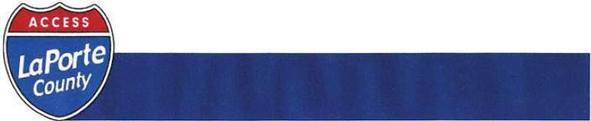

Marlene H. Dortch
Secretary
Federal Communications Commission
445 12th Street, SW
Washington, DC 20554

RE: MB Docket No. 14-57

Dear Ms. Dortch:

Access La Porte County (ALCO) has managed public, educational, and government access (PEG) programming since 2002 and provides PEG programming for all of La Porte County, Indiana, including the cities of Michigan City and La Porte. ALCO supports the proposed merger of Comcast and Time Warner Cable because of Comcast’s track record in working with us.

After the NBCUniversal transaction in 2011, Comcast followed through on its promised commitment to PEG programming by strengthening its relationships with local programmers. ALCO has a strong working relationship with Comcast, and they have helped us resolve multiple issues including internal wiring problems and equipment integration.

We have also worked with Comcast on several community outreach efforts, including Comcast Cares Day projects and the Annual Michigan City SummerFest Comcast has proven that they are a community-based organization that values working with local programmers and investing in communities.

I am confident that Comcast will bring the same level of respect for local programmers in other markets if the proposed transaction between Comcast and Time Wamer Cable is successful.

Sincerely,

/s/ Mike Dempsey
Mike Dempsey

175



August 22, 2014

Tom Wheeler
Chairman
Federal Communications Commission
445 12th Street, SW

Washington, DC 20554

RE: MB Docket No. 14-57

Dear Chairman Wheeler:

When I co-founded Accolade Inc. in 2007, we had a vision: make it easier for people to do the right thing to get the right healthcare the first time, and they will. Accolade makes navigating the healthcare system less confusing and less costly by streamlining the fragmented array of member services, nurse lines, disease management and care management programs typically deployed with one integrated service that’s focused on the consumer. Today, we have over 500 employees, Forbes named us one of America’s Top 25 most promising companies, and we are were named Inc. 500’s fastest-growing private healthcare company. We personify the innovation that is at the heart of America’s broadband economy.

I support the Comcast-Time Warner Cable deal because Comcast’s commitment to innovation has been instrumental to our success and I know it can help grow other innovative start-ups into thriving businesses. I speak from personal experience. Comcast saw promise in us and was the first company to provide our services to their families. Comcast Ventures saw promise in pioneering new ways of looking at old problems to evolve and develop new business models. When considering investors, we chose to work with Comcast Ventures because they intuitively understood the problem we were trying to solve and committed to leverage their own resources to support our success. I am pleased to say that we chose well.

Comcast has a great history of supporting companies, like Accolade, across a broad category of platforms including new media, enterprise, cloud technologies, consumer, as well as healthcare. It’s our assumption that a larger footprint and additional scale will only help us and others build for the future. We are grateful for Comcast’s strong and steady partnership in advancing health care and are happy to write in support of Comcast’s merger with Time Warner Cable.

Sincerely,

/s/ Tom Spann
Tom Spann CEO
Accolade Inc.

660 West Germantown Pike, Suite 500, Plymouth Meeting, PA 19462
- 610.834.2989 f: 888.560.0903 AccoladeInc.com

176

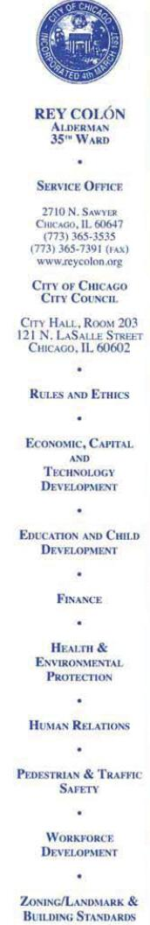

August 22, 2014

Tom Wheeler
Chairman
Federal Communications Commission
445 12th Street, SW
Washington, DC 20554

RE: MB Docket No. 14·57

Dear Chairman Wheeler,

I am Chairman of the Chicago City Council Latino Caucus, as well as a Chicago City alderman since 2003. My career has been focused on serving families and children, as the Executive Director for the YMCA of Metropolitan Chicago and Executive Director for the Boys and Girls Clubs of Chicago. In my roles I have had multiple interactions with Comcast and I have found the company to be a stalwart supporter of Chicago area organizations and initiatives and in sync with the missions we serve.

The proposed transaction between Comcast and Time Warner Cable promises to extend Comcast's service-minded philosophy to more communities, and for that reason, I respectfully request that the Commission approve the proposed transaction.

Allow me to elaborate on the kinds of activities I have personally witnessed Comcast taking part in, here in Chicago:

Last year, Comcast lent the city one of its own top professionals to work on our Plan for Economic Growth and Jobs. Christopher Nelson, Comcast's Manager of Government and Regulatory Affairs for the Greater Chicago Region, worked for us fulltime as part of our new Fellows program, whereby companies in the area lent us professionals with economic expertise for as long as six months.

As Chairman of the Latino Caucus, I am in regular contact with our Hispanic entrepreneurs and business owners. Comcast devotes a significant portion of its budget on contracts with Hispanic suppliers. And its offerings in Hispanic programming are extensive. Comcast has more than 60 Spanish language networks and offers Xfinity Latino, which carries all the popular Hispanic channels. As far as entertainment goes, you can't do much better than Hispanic Video on Demand, with films, TV, music and children's programming. In fact, Comcast's programming for children in Hispanic communities is very popular with families.

I have devoted myself to improving opportunities for our children and here Is where Comcast really shines. Its employees spend hours mentoring high school students. During my time at the Boys and Girls Club, Comcast stepped up with donations of computers, software and digital skills training, and their staff served on the

177

organization's board, among other contributions. Comcast worked hard to get the word out a few years ago, when it started the Internet Essentials program for low-income families. In fact, last fall, more families in the Chicago area had enrolled in Internet Essentials than any other city in the nation. That means that more of our children now have computers and internet in their homes. They are better connected to their schools and teachers, and their parents are able to get online and follow their children's progress as well as apply for jobs.

Comcast has also been a generous sponsor of many of the City's community events and cultural celebrations and programs. This summer, Comcast was a sponsor for the Rahm's Readers Summer Learning Challenge at Chicago Public Library's Douglass Branch, in which children are trying to set records for the number of books read and time spent reading. Comcast is a backer of the Milwaukee Avenue Arts Festival in Logan Square, which is located in the ward I represent.

This kind of collaboration between community and corporate citizens is a model for all regions. I know that wherever Comcast services are offered, there also are benefits for children, families, schools and businesses. My hope is that more communities have the opportunity to experience what we here in Chicago have experienced. I anticipate and welcome the Commission's support of the proposed transaction.

Respectfully,

/s/ Rey Colón

Rey Colón

Alderman, 35th Ward

178

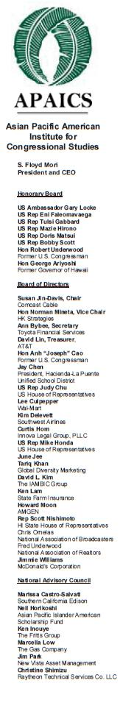

August 22, 2014

Mr. Tom Wheeler

Chairman

Federal Communications Commission
445 12th Street, SW

Washington, DC 20554

RE: MB Docket No. 14-57

Dear Chairman Wheeler:

As you consider the proposed Comcast-Time Warner Cable transaction, I wanted to let you know that Comcast has been in the forefront in developing programs that reach out to the Asian American and Pacific Islander and provide greater access to the community. I have worked closely with Comcast as the former CEO of the Japanese American Citizens League and in my current position as CEO of the Asian Pacific American Institute for Congressional Studies (APAICS). I currently work closely with Asian American and Pacific Islander elected officials at all levels of government, providing them with leadership training and having them participate in policy round table discussions.

APAICS is a national non-partisan, non-profit 501(c)3 organization dedicated to promoting Asian American and Pacific Islander participation and representation at all levels of the political process, from community service to elected office. Our basic objective is to create a more robust pipeline for Asian American and Pacific Islanders to pursue public office.

Comcast has been a strong partner in this endeavor. They have supported our programs in leadership development, including Congressional internship and fellowship programs, leadership academies in Washington, DC and in various regions in our nation. In addition, Comcast has been a leader in supporting voter registration in the Asian American and Pacific Islander communities where electoral participation has been traditionally low.

Comcast has an excellent record of identifying the critical needs of our community and taking proactive steps to address them. The merger will allow the company to expand its access friendly policies to regions that have high Asian American Pacific Islander populations. We strongly support this merger and urge the Commission to approve this merger on the basis that more of the special needs of our communities and thus bring benefits to more communities throughout the nation.

Sincerely,

/s/ S. Floyd Mori

S. Floyd Mori

President and CEO

1001 Connecticut Ave., Suite 320 Washington, DC 20036 | (202) 296-9200 | @APAICS | http://on.fb.me/APAICSFB | http://apaics.org

179



August 22, 2014

Marlene H. Dortch
Secretary
Federal Communications Commission
445 12th Street, SW
Washington, DC 20554

RE: MB Docket No. 14-57

Dear Secretary Dortch:

As President and CEO of Associated Industries of Florida, I travel around the world promoting our state and encouraging businesses to expand and relocate here. One company that continues to create jobs and opportunities for Floridians, and bring technology to businesses is Comcast Corporation. I believe that any community would be fortunate to have Comcast operating in their borders, which is the reason I am writing today to encourage you to approve Comcast's transaction with Time Warner.

Comcast offers extremely fast high-speed broadband and over 500 channels. With Xfinity, small businesses can get connected to the Internet and sell their products any place in the world - right from Florida.

Comcast has made a huge investment in our state - almost $9 billion in infrastructure and technology since 1996. Comcast has five call centers in Florida, and the company has over 18,000 full time employees - not counting contractors and suppliers. All of its employees receive a living wage, healthcare benefits, tuition reimbursement and training. Is there any state that would not want these kinds of jobs for its residents?

One of Orlando's biggest draws - Universal Studios - is also a Comcast subsidiary. Thousands of tourists visit every year, creating additional jobs throughout the region.

Comcast is a dedicated community partner through programs like Comcast Cares Day. Last year, 5,000 Comcast employees and volunteers refurbished schools and youth centers throughout the state.

The business environment is more healthy and competitive with companies like Comcast, who continue to innovate and deliver new technologies to empower consumers and businesses.

I hope I have convinced you that Comcast has brought a tremendous ability to stimulate the economy in Florida. I urge you to approve the Time Warner transaction.

Sincerely,

/s/ Tom Feeney
Tom Feeney
President and CEO
Associated Industries of Florida

cc:
Chairman Tom Wheeler
Commissioner Mignon Clyburn
Commissioner Jessica Rosenworcel
Commissioner Ajit Pai
Commissioner Michael O'Rielly

516 North Adams Street • Post Office Box 784 • Tallahassee, Florida 32302-0784 • Phone: (850) 224-7173 • Fax: (850) 224-6532 • Email: aif@aif.com • www.aif.com

180

Officers

Board Chair
Terrance Ransfer
ARAMARK

Board Secretary
Martha Navarro
Community Volunteer

Directors

Juan Alonso
HEB

Rueben C. Cásarez Wells Fargo & Co.

Trung Doan
Studio Red Architects

Raul Dominguez Concur Technologies

Sonya R. Francois
Shell Oil Company

Benjamin Hernandez City of Houston

Eric E. Marin
WG Consulting

Arturo Michel
Thompson & Horton, LLP

Daniel Morales
Walmart

Camilo Rojas, III
Silver Eagle Distributors

Vanessa Sola
Frierson, Sola, Simonton & Kutac,

PLLC

Director Emeritus Maria (Cris) Garza (Deceased)

President and CEO Beatrice G. Garza

August 22, 2014
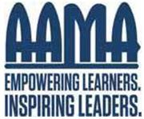

Tom Wheeler

Chairman

Federal Communications Commission
445 12th Street, SW

Washington, DC 20554

RE: MB Docket No. 14-57

Dear Chairman Wheeler:

On behalf of the Association for the Advancement of Mexican Americans (AAMA) in Houston, Texas, I write to share our experiences with Comcast and to support their proposed merger with Time Warner Cable.

Since 1973, AAMA’s mission has been to inspire and empower at-risk Latinos to pursue their potential and achieve success. Our efforts are focused in the areas of education, workforce readiness, and leadership development. Comcast has been a partner with us and the Houston Hispanic community for many years assisting in our programs and helping to build the Latino Community.

Comcast shares our passion for improving digital literacy and broadband adoption, and so we have become natural allies in this endeavor. They have assisted with our Adelante Program, which provides digital literacy training to the Hispanic Adult community. Comcast launched the Digital Connectors Program with our organization and we served as a partner for the first two years of the program.

I am proud that for more than four decades, AAMA has been one of the most effective organizations to help Latino families in the community. We are grateful for the support Comcast has given us to achieve our goals and believe that Comcast can extend the good it does even further with this successful merger.

Sincerely,

/s/ Beatrice G. Garza

Beatrice G. Garza

President and CEO

181



8/22/2014

Marlene H. Dortch

Secretary

Federal Communications Commission

445 12'hStreet, SW

Washington, DC 20554

RE: MB Docket No. 14-57

Dear Ms. Dortch:

I am the president and CEO of the Back ofthe Yards Neighborhood Council. We have considerable economic and social challenges in this Chicago neighborhood. We are a working class community with broad diversity in our residents, many who work in the city. I am also a member of the Cook County Latino Advisory Council, which was just formed in June by the Cook County Board of Commissioners.

1 feel I am in a good position to write on behalf of our residents about the importance of Comcast in our community, and the value Comcast would bring to communities where its services would be extended through the transaction.

The Neighborhood Council is one of the nation's oldest nonprofits, founded in 1939. We work hard to make sure that the Latino community in Back of the Yards is represented in policy-making. We strive to bring our residents better access to health care and we do all we can to provide opportunities for our youth and cut down on the number who enter the criminal justice system. In these and all of our efforts, we seek to improve the lines of communications and that often requires making sure that our Spanish-speaking constituents have the interpretation and education services they need to be involved. Advancing educational opportunities has been a priority, as has providing services to our older residents including a free shuttle bus.

Comcast's corporate philosophy matches our Council priorities on many fronts: Comcast also emphasizes education, it has a multitude of Spanish-language cable shows and its broadband services are the essential tool which many rely on for every type of communication. Yet, Comcast does far more than just offer needed services.

Comcast sets examples for our community through concrete action. For instance, we teach the children we serve how important it is that they give back to their community. In Comcast, we have an example we can point to. We can point to the legion of Comcast employees who go out in the community and pick up paint brushes and mops and brooms when needed. In April, for

"We the people will work out our own destiny"

182



example, Comcast sent about 7,000 employees to Chicago's communities for a day of volunteering. Many of them came to Back of the Yards and picked up litter, removed graffiti and painted walls, and filled planters with beautiful flowers.

Our Council offers people computer literacy training, but we know that they won't get to use new skills at home if they can't afford to buy a computer or pay for Internet.

Thanks to Comcast's Internet Essentials program, they can get both at a very low cost. Also, we encourage our community's cultural dance talents with a dance program.

Comcast has given us screen time and a real boost to dance participants by hosting Back of the Yards' "Ballet Folklorico" on its Comcast Newsmakers program.

In these and so many other ways, Comcast is a strong partner in a community which it could easily overlook if all it cared about were profits. I ask the Commission to approve the Comcast and Time Warner Cable transaction because I know this action will help bring Comcast to new communities that need its community caring, too.

Sincerely,

/s/ Craig Chico

Craig Chico

"We the people will work out our own destiny"

183

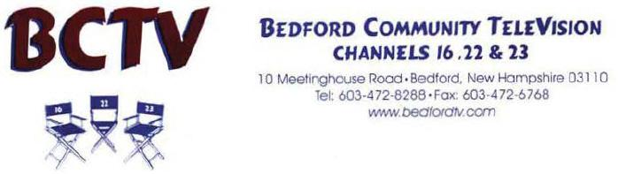

[

August 22, 2104

Mr. Tom Wheeler

Chairman

Federal Communications Commission

445 12th Street, 5W

Washington, DC 20554

Re: MB Docket No 14-57

Dear Mr. Chairman:

On behalf of Bedford Community Television, I am writing to request that the FCC approve the proposed transaction between Comcast and Time Warner Cable. As the manager for BCTV, the technical and administrative support that we have received from Comcast has been outstanding.

Our success as a station does not happen without the continued support that I’ve witnessed in the 15 years I have been running the Town’s cable station.

For the residents of Bedford, community and public access TV channels are more important than ever. As commercial news stations focus on high profile crime and sensationalistic stories, BCTV continues to provide our citizens with informative programming that shines a light on the issues that impact their daily lives.

Not only does Comcast provide the cable capacity for our three channels, they also make certain that we have the highest quality signal. In fact, they often upgrade our signal without us having to ask. This support reflects Comcast’s dedication to our community. Comcast is not just a company that comes to town, lays down the cable and vanishes.

I’m also quite impressed with some of the great things Comcast does in our town and surrounding communities, I have a few friends who live in town that work for Comcast and they take great pride in their community volunteer programs through the Comcast outreach program. Donations and in kind services for some of the local non-profit camps and organizations in town as well as surrounding communities makes it possible for many of these organizations to provide educational and entertainment services to those less privileged.

Sometimes big companies get a “Bad Rap” simply because they are “Big”. I do not put Comcast in that category at all. My experience working with Comcast has always been positive and they have always been supportive. Simply put, Comcast is a great corporate citizen and very much interested in supporting our town and local community television station.

I believe that if Comcast is permitted to extend into current Time Warner service areas, it will bring this spirit of community service along. Those new communities will be impressed. I urge the FCC to approve this transaction.

Sincerely,

/s/ William V. Jennings, Jr.

William V. Jennings, Jr.

Station Manager

184

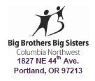

August 22, 2014

Tom Wheeler

Chairman

Federal Communications Commission

445 12th Street, SW

Washington, DC 20554

RE: MB Docket No. 14-57

Dear Chairman Wheeler:

The Columbia Northwest chapter of the national Big Brothers Big Sisters (BBBS) organization is one of the largest in the country. As CEO, I oversee programming for 1,800 “Littles” in the Portland, Oregon and Southwest Washington regions. Those constituents are uppermost in my mind as I write to request that the Commission approve the proposed Comcast and Time Warner Cable transaction. Witnessing the powerful impact Comcast has had on children’s lives compels me to make this request.

Comcast started the well-regarded Beyond School Walls program with BBBS in cities around the U.S. It works like this: Professionals in various Comcast offices volunteer as “Bigs” to be paired with BBBS children who are transported to those offices every week during the workers’ lunch hours. The pairs share a meal as well as their dreams and hopes. Children see their mentors succeeding in a professional setting, and they get to interact with other Comcast workers who encourage them to do well in school and cultivate leadership traits.

Comcast sets an example with this mentorship curriculum and now other Portland-area businesses have followed suit, starting Beyond School Walls programs at their company offices. To further advance the effort, Comcast also awards scholarships to BBBS staff for leadership training through Comcast University.

A huge assist to our agency came when Comcast chose us to receive free Internet and cable TV services. Money that we would have spent on those services now goes into funding efforts like our Second Chance program, which pairs youths aged 12 to 17 who are in the juvenile justice system with volunteers whose meaningful friendship and guidance encourage more healthy behaviors and decisions. What’s more, Comcast offers a very inexpensive - just under $10 monthly - Internet service to families with at least one child eligible to participate in the free and reduced school lunch program. This comes with an inexpensive computer, computer training, and computer virus protection.

185

It is so meaningful to me that Comcast has not only developed premier broadband tools, but shares them with groups like BBBS and individuals who have no other resource to get digitally connected. I hope my request for approval of the proposed transaction makes an impact. I know the outcome would be enhanced digital products and additional community partners with whom Comcast would share its innovations.

Sincerely,

/s/ Andy Nelson

Andy Nelson, CEO

186

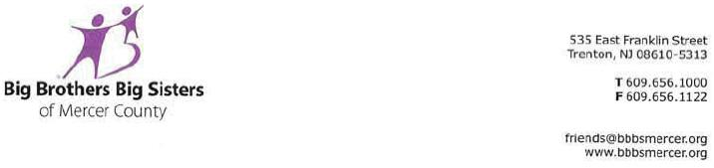

August 22, 2014

Chairman Tom Wheeler

Commissioner Mignon Clyburn

Commissioner Jessica Rosenworcel

Commissioner Ajit Pai

Commissioner Michael O’Rielly

Federal Communications Commission

445 12th Street, SW

Washington, DC 20554

RE: MB Docket No. 14-57

Dear Chairman and Commissioners:

On behalf of Big Brothers Big Sisters of Mercer County (BBBS-Mercer), please accept this letter of support for Comcast in hopes that our experience in working with Comcast will help the Federal Communications Commission choose to approve the merger between Comcast and Time Warner Cable.

BBBS Mercer is the local affiliate of Big Brothers Big Sisters of America. Since our founding in 1973 by a group of educators and concerned citizens, we have positively impacted the lives of local at-risk children, ages 6-18, by recruiting and vetting very special committed adults in our community to become personal mentors and role-models to children who need guidance and someone to believe in them. Our mission is to provide children facing adversity with strong and enduring, professionally supported one-to-one mentoring relationships that change their lives for the better, forever. Comcast has played a strong role in the success of our mission by providing support and resources needed to meet the needs of the youth that we serve.

Comcast’s strong support of our Trenton, NJ school-based mentoring programs has allowed us to achieve great success in helping our youth graduate from high school and attain advanced educations. Because of Comcast’s long time commitment, BBBS-Mercer recently named one of its Trenton youth mentoring programs after Comcast. This particular program is designed to encourage participants who are from families with no education beyond high school, to complete secondary school and graduate from institutions of postsecondary education.


187

In addition to providing support for Trenton mentoring programs, Comcast has allowed me to recruit Comcast employees to serve as volunteer mentors. I am also frequently invited, along with many other local non-profits, to participate in Comcast Newsmakers which allows me to discuss BBBS-Mercer’s needs in five minute televised segments which air in our local community. For BBBS-Mercer, many of these segments focus on our youth who are waiting for a Big Brother or Sister, and on events and other volunteer opportunities so that we can help more deserving children in the greater Trenton area.

I believe that Comcast will provide valuable community engagement wherever they provide service, and that this merger will expand their commitments to diverse and low income communities by extending their reach to new communities. For these reasons, I urge the Commission to approve this transaction.

Yours Truly,

/s/ Susan M. Dunning

Susan M. Dunning

Executive Director

188

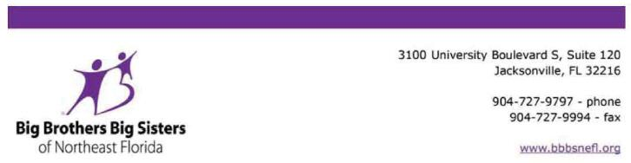

August 22, 2014

Mr. Tom Wheeler, Chairman

Federal Communications Commission

445 12th Street SW

Washington, DC 20554

Re: MB Docket No. 14-57

Dear Chairman Wheeler:

As CEO of Big Brothers Big Sisters of Northeast Florida, I am writing to express my support of the proposed transaction between Comcast and Time Warner Cable.

Big Brothers Big Sisters help children realize their potential to build their future. For the last four years, we have partnered with Comcast in their Beyond School Walls program, which is a unique workplace mentoring program that connects students with Comcast employees and the workplace. Exposing students to successful adults in this manner help to inspire them as they chart the course for their own futures.

Another program that has greatly benefitted children is Internet Essentials. In just two short years, 40,000 low-income Florida families have been connected to broadband Internet that helps to facilitate our youth and their families entering the digital world. This opens up more opportunities for them to move forward in life.

Comcast continues to find ways to invest in the community while it continues to improve and expand the programs it offers. I would appreciate the Commission keep this in mind as it decides on the proposed Comcast/Time Warner Cable transaction.

Sincerely,

/s/ Warren M. Grymes, Jr.

Warren M. Grymes, Jr.

Chief Executive Officer
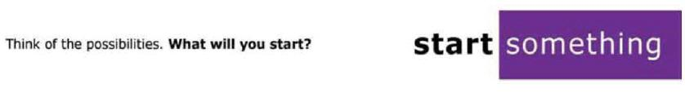

189

Chairman Tom Wheeler
Commissioner Mignon Clyburn
Commissioner Jessica Rosenworcel
Commissioner Ajit Pai
Commissioner Michael O’Rielly
Federal Communications Commission
445 12th Street, SW
Washington, DC 20554

RE: MB Docket No. 14-57

Dear Chairman and Commissioners:

Internet access shouldn't be a black or white, rich or poor issue. Yet far too often, Black Americans lack access to the information and communications technologies that set any citizen up for success in the 21st century. This gap in opportunity is called the Digital Divide. My organization, the Black Family Technology Awareness Association (BFTAA), is doing its best to close that gap. The Comcast Corporation is doing its best as well. I am writing with the hopes that you approve the proposed Comcast - Time Warner transaction so that the Digital Divide can be decisively closed.

The Internet Essentials program represents Comcast's effort to connect underserved communities to the web. As the Executive Director of BFTAA in Kansas City, Missouri, I work with local and state government, local businesses, and corporations to link African Americans and digital resources they need to compete and succeed. The Digital Divide won't close itself; we need infrastructure and continued investment. Comcast recently indefinitely extended the Internet Essentials program, and this extension, combined with the proposed transaction, would bring more families in Missouri and beyond into the communications age. Your commission's approval of the transaction makes that expansion possible.

I ask that you approve the proposed transaction to strengthen all American families through access to affordable digital technology, regardless of skin color or income.

Sincerely,

/s/ Lewis Walker

Lewis Walker
Executive Director

Black Family Technology Awareness Association

190

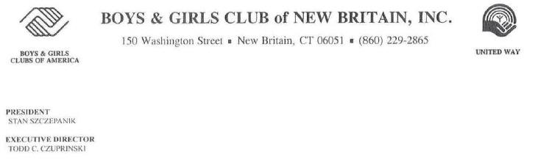

Tom Wheeler

Chairman

Federal Communications Commission

445 12th Street, SW

Washington, DC 20554

Re: MB Docket No. 14-57

Dear Chairman Wheeler:

I am the executive director of the Boys & Girls Club of New Britain, and I am writing to encourage the Commission to approve the proposed transaction between Comcast and Time Warner Cable.

Our mission is to enable all young people, especially those who need us most, to reach their full potential as productive, caring, responsible citizens. Working side-by-side with Comcast, we have been able to reach many of our goals.

Comcast has always strongly supported our effort to improve digital literacy in our community. You’re familiar with Comcast’s Internet Essentials program, with which Clubs around the country have assisted by melding our existing afterschool tech programs with Comcast’s digital literacy curriculum. But Comcast has also ensured that our Club has access to the latest technologies so that our Internet Essentials workshops for disadvantaged families run smoothly and participants are experiencing the full potential of the Internet.

Without a doubt Comcast is a fully engaged leader in our community, and policymakers should encourage their brand of community investment in as many places as possible. I appreciate your taking my views into account during your merger review.

Sincerely,

/s/ Todd Czuprinski

Todd Czuprinski

Executive Director

Boys & Girls Club of New Britain, Inc.

191



August 21, 2014

Chairman Tom Wheeler

Commissioner Mignon Clyburn

Commissioner Jessica Rosenworcel

Commissioner Ajit Pai

Commissioner Michael O’Rielly

Federal Communications Commission

445 12th Street, SW

Washington, DC 20554

Re: MB Docket No. 14-57

Dear Chairman and Commissioners:

As the president and CEO of the Boys and Girls Club of Rockford, Illinois, I am writing today to request the FCC’s approval of the pending transaction between Comcast and Time Warner Cable.

The Boys and Girls Clubs throughout the country are dedicated to helping young people, especially disadvantaged young people, succeed in school and life. We offer mentoring, homework assistance and summer camping programs. We make the difference in the lives of thousands of children and teens between six and 18 by providing a safe haven where they are free to learn and play. The club in Rockford serves more than 6,500 at any one time at five locations in Winnebago County.

We know that these young people are the future of our country, and we need to do everything in our power to see that they develop in a way that turns them into productive citizens. Comcast believes that, too.

Comcast supports our community through the company’s volunteer activity. I understand that Comcast Cares Day is the largest corporate day of service in the country.

Hundreds of Comcast employees, their friends and family members rolled up their sleeves to help Boys and Girls Clubs and other worthy organizations throughout Illinois.

The Boys and Girls Clubs provide computers and training for our young people because we realize that without these skills, our students will not be able to compete in the digital age. For the last three years Comcast has provided thousands of dollars in grants to enhance and support our digital arts program. Additionally, Comcast is on the cutting edge with its Internet Essentials program. Many of our participating families are eligible for Internet Essentials, which offers a broadband connection at home for less than $10 a month to many families with at least one child in the National School Lunch Program. This is a fantastic deal. And it doesn’t end there. Families can also purchase a computer for $150 or less and receive training for the adults as well as the students. Comcast launched this program as a three-year program in 2011, but the company has recently announced that it will extend it indefinitely to enable more families to take advantage of it.

To us, Comcast is more than a global telecommunications giant. It is an excellent corporation citizen dedicated to social responsibility. Many of the beneficiaries of Comcast Cares Day and other financial support from the Comcast Foundation are not even customers of Comcast’s core services. We are grateful for everything that Comcast contributes to our community. I believe that they would extend these good works into the areas now served by Time Warner. This could only benefit the many children in those areas who need help from organizations like the Boys and Girls Club. Because of this, I urge you to approve this transaction.

Sincerely,

/s/ Clifford J. Stoner

Clifford J. Stoner

President/CEO


192

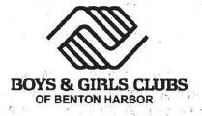

August 15, 2014

Marlene H. Dortch

Secretary

Federal Communications Commission
445 12th Street, SW

Washington, DC 20554

RE: MB Docket No. 14-57

Dear Ms. Dortch

Due to Comcast’s support and in-kind partnerships with both the Boys & Girls Clubs of America and our Club in Benton Harbor, Michigan, I write to support Comcast’s transaction with Time Warner.

For more than a century, the Boys & Girls Clubs of America have helped put young people on the path to great futures. Our organization serves nearly four million young people annually, through membership and community outreach in some 4,000 Club facilities throughout the country and on U.S. military installations worldwide.

Comcast has been a committed community partner of the Boys & Girls Clubs of Benton Harbor. As the Chief Executive Officer, I have worked closely with Comcast and learned it is an organization we can rely on to support our programming initiatives. In 2013 Comcast sponsored a computer building program as part of our “Power Hour” program which helps members in grades 1 to 8 develop academic, behavioral, and social skills through homework completion, provide fun, grade specific high-yield learning activities, and academic tutoring assistance. One objective of Power Hour is to Integrate technology into these activities to prepare young people for a technology-based work environment.

I would also like to emphasize my support of Comcast’s Internet Essentials effort. The Internet Essentials program provides connection to the Internet at very affordable cost, subsidized computers, and offers Internet-literacy training to low-income families. Comcast has partnered with us to promote the program throughout the Benton Harbor community. I also commend Comcast for announcing that it will continue the Internet Essentials program for an Indefinite period. That is a sustainable commitment to our members and their families which assures they have internet access that is essential to learning technology and attaining academic success. I understand about 17,000 families In Michigan are now connected to Internet at home.

600 Nate Wells Senior Drive ● Benton Harbor, Michigan 49022 ● Tel. 269-926-8766 ● www.bgcbh.com

GREAT FUTURES START HERE.

193

I support the Comcast and Time Warner transaction because I am confident that Comcast will continue to enhance our local community, as well as continue to support and sponsor our youth development activities and programs specifically designed for young people to graduate from high school, build character and leadership, and encourage healthy lifestyles.

Respectfully,

/s/ Brian W. Saxton

Brian W. Saxton

Chief Executive Officer

194



August 15, 2014
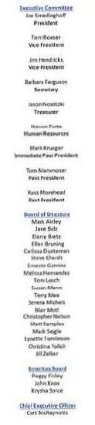

Tom Wheeler

Chairman – Federal Communications Commission
445 12th Street, SW

Washington, DC 20554

RE: MB Docket No. 14-57

Dear Chairman Wheeler,

At the Boys & Girls Clubs of Dundee Township, we believe that kids each have the right to their own spirit of self-determination. Our seven (7) school based sites and Teen Center serve nearly 700 at-risk Club Members per day, and over 1,700 youth throughout the year with after-school enrichment and life-skill building activities in the Carpentersville and Dundee communities. Comcast is a supporter of Boys & Girls Clubs across America, and has provided generous grants and volunteer efforts at our chapter. I support the proposed Time Warner Cable / Comcast transaction as I believe more chapters will have the chance to benefit like ours has if the proposed is approved.

In 2011, Comcast developed a service that revolutionized the way low-income families and students can gain access to the Internet. This program, Internet Essentials, has become one of the most successful public/private partnerships in Illinois. Here In Dundee Township, eligible families whose children qualify for the National School Lunch Program are welcome to apply. These families can receive high-quality home Internet service for $10/ month with the option of purchasing a computer for $150.00. Having internet in the home is extremely beneficial for local students and can open their eyes to new ideas and new worlds yet explored.

One of the best aspects of this program is Comcast’s commitment to engaging the community through digital training workshops and centers. In schools and libraries all over Illinois, Comcast maintains hotspot centers for residents to pick up computer and Internet skills. Their Digital Connectors program equips school computer labs and helps students pick up basic digital literacy skills in connection with coursework. Early childhood education using the latest technology tools available will not only help students engage their creativity, but will give them the best chance for a brighter economic future.

With support of Comcast, our Teen Center now boasts free computer access directly through our Club Tech program. This program builds technical competency and teaches Internet safety to help our kids master new skills, improve their critical thinking, and prepare for a 21st Century workforce. This program allows our youth to access the Internet at home so they can continue building on what they’ve learned at Club Tech.
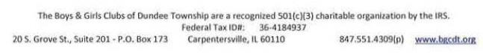

195

We have also had the opportunity to volunteer with Comcast employees at our centers for Comcast Cares Day. I’ve been told that this volunteer event is the largest single-day corporate volunteer effort in the United States. Every year for the last few years, Comcast joined with local volunteers for landscaping and painting projects at the Dundee-Highlands Elementary School. One the event’s 10th Anniversary, Comcast employees, family members, and volunteers partnered with our staff and Club members on a fun-filled day of Olympic style “Field Day” events. Each year, Comcast finds a project that will make a substantial impact in the lives of the kids we serve. It is just one of the many ways that Comcast shows its commitment to our organization and our Township.

I urge the FCC to pass the proposed TWC/Comcast transaction to spread the wealth of knowledge to more communities that stand to benefit. There are dozens of Boys & Girls Clubs located in the Time Warner Cable footprint that would greatly enjoy the chance to expand their services and programming through Comcast's support should the transaction be approved.

Best wishes and warmest regards,

/s/ Curt McReynolds

Curt McReynolds

President & CEO

Boys & Girls Clubs of Dundee Township

196



Mr. Tom Wheeler

Chairman

Federal Communications Commission

445 12th Street, SW

Washington, DC 20554

RE: MB Docket No. 14-57

Dear Chainnan Wheeler:

As CEO of Boys and Girls Clubs of Marin & Southern Sonoma Counties, I write today to urge the Federal Communications Commission to approve the proposed transaction between Comcast and Time Warner Cable.

Boys & Girls Clubs of Marin and Southern Sonoma Counties serves more than 5,100 youth in Marin and Sonoma Counties ages 6 through 18. We provide a safe place where youth can interact with caring adults who help them to develop a sense of belonging, usefulness, influence and competence.

Over the years I have been impressed with Comcast's commitment to the communities that they serve and their efforts to support education, diversity and digital literacy. Our club has worked very closely with Comcast on the implementation of its Internet Essentials program in our footprint by partnering with Comcast and the local school districts to make sure our club members and students are aware of the low-cost home internet, affordable computers and training that are available via the program to make sure youth from all walks of life have the tools they need to succeed.

Comcast has also invested in our club members and technical training by suppotting our Digital Connector program that that teaches our club members about broadband technologies, and how to put that knowledge to work in.a wide range of community service activities. In the last three years, over 100 members have participated in the program and have had a great time while gaining valuable technical experience that they can take with them out in the world.

Finally, this year, Comcast hosted a Comcast Cares Day, it's corporate volunteer day, at our Davidson Middle Site in San Rafael, CA. It was inspiring to be a part of this event where scores of Comcast employees and their families came out and worked together with our club members to improve and beautify our site. Now, our Davidson clubhouse is an even more inviting place for our members to come and find safe haven to learn, play and grow after school.

Comcast's long history of partnership, investment and service has been great benefit to our community and the youth and families that we serve. I urge you to recognize Comcast's community oriented attitude and recognize how other communities could benefit from Comcast serving their areas.

Sincerely,

/s/ David L. Solo

David L. Solo

President & CEO

203 Maria Drive • Petaluma, CA 94954-2301 • Tel 707-769-5322 • Fax 707-769-5310 • www.petaluma-marinbgc.org

197

Administrative Office


1518 Walnut Street

Suite 712

Philadelphia, PA 19102

Tel (215) 735-8818

Fax (215) 735-8549

www.bgcphila.org

August 19, 2014

Chairman Tom Wheeler

Commissioner Mignon Clyburn

Commissioner Jessica Rosenworcel

Commissioner Ajit Pai

Commissioner Michael O’Rielly

Federal Communications Commission
445 12th Street, SW

Washington, DC 20554

RE: MB Docket No. 14-57

Dear Chairman and Commissioners:

We are writing today regarding the pending transaction between Comcast and Time Warner Cable. As the Chief Executive Officers of the Boys and Girls Clubs of Philadelphia, we have found Comcast to be a staunch ally and the ultimate corporate good citizen. Comcast is a global communications leader that is headquartered here in Philadelphia. As its operations have expanded to other major cities, Comcast has not forgotten its roots. Comcast is committed to connecting youth to the world by providing opportunities for them to access an environment that supports their physical, intellectual and social development. Comcast’s commitment comes at a time when public resources are disappearing for Philadelphia’s youth. At the Boys & Girls Clubs of Philadelphia we appreciate that Comcast has stepped up when the city’s children are most in need of additional support by providing critical resources for our organization and many other local nonprofits. Since 1887, the Boys and Girls Clubs have provided a safe haven for Philadelphia’s children to learn and develop into productive and responsible citizens of our city, state and nation. Our afterschool programs not only keep kids from the negative influences of the streets, but transform lives. Located in Philadelphia’s most severely distressed neighborhoods, the Boys & Girls Clubs of Philadelphia is committed to make a BOLD CHANGE FOR KIDS, altering their environment to create positive spaces for high performance learning, while strengthening and developing their physical and social skills, and providing them with opportunities to connect

Contributions are tax deductible to the extent permitted by law. A copy of the

Official registration and financial information of Boys & Girls Clubs of

Philadelphia, Inc. may be obtained from the Pennsylvanian

Department of State by calling toll-free, within Pennsylvania, 1-800-732-0099.

Registration does not imply endorsement

FACILITIES: Bridesburg · Fairmount · Germantown · Northeast Frankford · Shane Victorino-Nicetown · Solis-Cohen · Sullivan · Vaird · Wayne Avenue West Kensington · Wilson Park · Wissahickon

198

to the world. Most importantly, our Boys & Girls Club professional staff serves as mentors for the children in our neighborhoods. Every year we serve more than 13,000 children from all ethnic backgrounds.

Comcast has been a longtime supporter. This year, our Germantown Club was the local signature project for Comcast Cares Day – and we were featured on the Today Show! More than 400 volunteers, mostly Comcast employees, painted and refurbished our building, renovated our arts and crafts room, cleaned up our commercial kitchen and spruced up our athletic fields. These volunteers are also role models for our children and provide an opportunity for young people to give back to their community by rolling up their sleeves to transform our club. As part of this event, Comcast not only donates the labor – it supplies all of the materials. Additionally, Comcast donated thousands of dollars to the Club and continually provides us with in-kind services such as valuable exposure on television for our programs and fundraising. This is well-rounded corporate social responsibility at its highest level.

We know that we are not the only beneficiaries of Comcast’s generosity. We believe that a company as committed to community service as Comcast deserves our support and our gratitude. We are confident that if Comcast extends its footprint into the areas now served by Time Warner Cable, nonprofit agencies in those communities will reap the benefits.

We strongly urge you to support this transaction.

/s/ Joseph and Lisabeth Marziello

Joseph and Lisabeth Marziello

Chief Executive Officers

Comcast/Time | Boys & Girls Clubs of Philadelphia
Warner | 1518 Walnut Street, suite 605
- Philadelphia, PA 19102

199

August 21, 2014
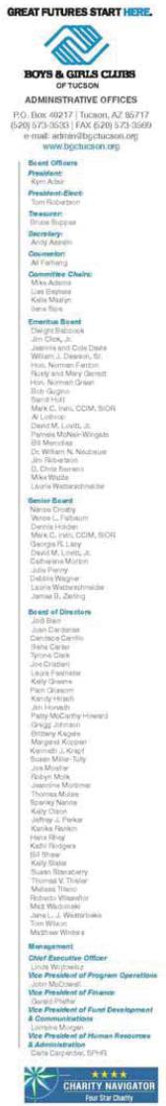

Mr. Tom Wheeler, Chairman
Federal Communications Commission
445 12th Street SW

Washington, DC 20554

RE: MB Docket No. 14-54

Dear Chairman Wheeler:

As the vice president of communications & fund development for the Boys & Girls Club of Tucson, Ariz., which aims to provide programs, professional staff, and a safe environment to help youth develop self-esteem and values, I am thankful for the support which we have received from Comcast and look forward to sustaining this relationship when Comcast and Time Warner Cable merge.

I have firsthand knowledge of Comcast’s interest in equipping Tucson’s youth with the skills for college and career success. The company has partnered with the Boys & Girls Club for years, and more recently, it supported our technology labs, complete with up-to-date computers and software. In addition to digital literacy, our young members also learn computer safety skills — key for optimal and safe Internet use.

In Arizona and across the country, Comcast is helping to narrow the Digital Divide by providing low-cost, high-speed broadband service to underserved children and families. I understand that the program — Internet Essentials — has already benefitted more than 1.4 million Americans.

Here in Tucson, residents can register for in-person training, provided by Comcast and housed at community-based locations. These free sessions provide information on Internet safety, finding and applying for jobs, and an introduction to Microsoft Office software. The best part is that everyone is eligible — participants do not have to be Comcast customers to take advantage of Internet Essentials.

The Boys & Girls Club of Tucson is proud to partner with Comcast, an exemplary corporate citizen that is addressing the needs of our constituents through the provision of innovation and technology, community-focused programs, and a deep and genuine investment in the communities it reaches.

So that future communities in Arizona and elsewhere can also benefit, I encourage the FCC to approve the proposed transaction between Comcast and Time Warner Cable.

My very best regards,

/s/ Lorraine Morgan
Lorraine Morgan
Vice President of Fund Development and Communications
The Boys & Girls Clubs of Tucson

200

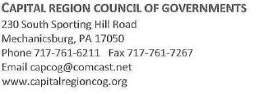

August 22, 2014

Chairman Tom Wheeler

Federal Communications Commission
445 12th Street, SW

Washington, DC 20554

RE: MB Docket No. 14-57

Dear Chairman Wheeler:

Local governments require two qualities in the cable companies that serve them and their residents — responsiveness and supportiveness. As executive director of the 40-member Capital Region Council of Governments (CapCOG) and as a former elected borough council official, I can professionally say that Comcast excels at both.

Because municipal governments are the franchising authorities in Pennsylvania, residents often contact local public officials with questions or technical issues for resolution. Comcast representatives have a long history of following up with those residents promptly and addressing any Issue they may have in a professional manner. They then advise the locality of their results. In short, Comcast’s dedication makes elected and appointed officials look good!

Comcast has supported the Capital Region COG’s mission of promoting inter-municipal cooperation and communication for the mutual benefit of all members. Comcast is a trusted business partner that keeps our members up to date on technology issues and facilitating the dialog that helps all of us succeed.

Of particular interest, it should be noted that Comcast faces significant competition in Central Pennsylvania, from both wired and satellite providers. I am happy to report that Comcast stands apart from its competitors as a responsible, responsive provider.

As executive director or a large municipal consortium in an area served by Comcast, it will be beneficial to COGs in markets served by Time Warner to benefit from a transaction of two exemplary companies. Please allow my fellow community leaders elsewhere in the country to have the same productive experience we have had here in Capital Region. I urge your support of the Comcast-Time Warner merger.

Respectfully,

/s/ Ann Simonetti

Ann Simonetti

Executive Director

Capital Region council of Governments

201

Tom Wheeler
Chairman
Federal Communications Commission
445 12th Street, SW

Washington, DC 20554

Re: MB Docket No. 14-57

Dear Chairman Wheeler:

As CEO of Center on Halsted, I am writing today to indicate my support of Comcast's proposed transaction with Time Warner Cable. Located In the heart of Chicago's Lakeview Neighborhood, Center on Halsted is the Midwest's most comprehensive community center dedicated to advancing community and securing the health and well-being of the Lesbian, Gay, Bisexual, Transgender and Queer (LGBTQ) community. More than 1,000 community members visit the Center every day. Jack Segal, Comcast's Vice President of Media and Public Relations, serves on our board of directors, thus showing a venerable display of Comcast's support of our mission. Both Comcast and Time Warner Cable have demonstrated their above and beyond commitment to LGBTQ causes.

As Center on Halsted's CEO for the past seven years, I have been stunned to see a massive shift In the average citizen's understanding of and empathy for the sensitive and sometimes misunderstood issues the LGBTQ community faces. I am proud to have been a voice in bringing about legislative action on everything from same sex marriage to same sex partner benefits. Comcast has been a corporate leader at the forefront of these issues. We have them to thank for employing so many LGBTQ citizens.

Did you know that, for the second year in a row, Comcast earned a 100% score on the Human Rights Campaign (HRC) 2014 Corporate Quality Index, and the company Is listed on HRC's top places to work? Additionally, in 2013 Comcast implemented a voluntary, confidential LGBT self-identification survey to inform diversity and Inclusion practices. These are merely two examples of many that demonstrate Comcast's willingness to address a special population's needs and concerns. Comcast also offers same sex partner benefits, a sticking point with so many employers throughout our nation.

Furthermore, Comcast's programming has consistently been on the forefront of inclusivity, featuring openly gay journalists like Rachel Maddow and shows that portray gay content such as Watch What Happens Live with Andy Cohen. Thanks to the 50,000 options offered on Xfinity On Demand, more and more programs like these can reach a bigger fan base than ever before.

All these examples I cite are due to Comcast's recognition of the unique perspective of our LGBTQ communities and its commitment to partnering with organizations like ours. I encourage the FCC to approve this transaction so that all LGBTQ citizens in Chicagoland and elsewhere can enjoy Comcast's diverse and inclusive programming, as well as benefit from its unwavering commitment to hiring members of our population.

Sincerely,

/s/ Modesto "Tlco" Valle
Modesto "Tlco" Valle

202

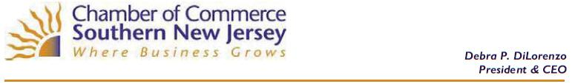

August 22, 2014

The Honorable Tom Wheeler
Chairman
Federal Communications Commission
445 12th Street, SW

Washington, D.C. 20554

Re: MB Docket No 14-57

Dear Chairman Wheeler:

The Chamber of Commerce Southern New Jersey supports of the merger between Comcast and Time Warner. As you may know, Comcast is a world class technology and media company who has set the tone for regional cooperation in economic development in and around Southern New Jersey, Greater Philadelphia and northern Delaware, where our 1,000-plus members are located. We support the organization’s entrance into New York and the opportunity it would create for our members to work across state lines.

Comcast products and services have done much to advance our region economically and technologically. Its infrastructure and high-speed Internet service are critical girders in the foundation upon which the communities it serves are expanding and flourishing.

Comcast’s investments are real. Advanced broadband service removes barriers to interactive communications for businesses with multiple offices. Increased bandwidth allows for faster downloads, better record-keeping and more efficient day-to-day communication. And being part a powerful telecommunications network stems the brain drain in our smaller communities by enabling new opportunities for residents in these communities to telecommute for a distant firm that needs their skills.

Comcast also demonstrates an admirable commitment to having a workforce in which women and minorities are fairly represented. Comcast actively seeks those from diverse backgrounds who have great potential. Then, it develops employees' talents through such programs as its Comcast Women in Leadership Program at University of Pennsylvania's Wharton School.

We also applaud Comcast for exceeding its goal to hire 2,000 military veterans over several years. It set the goal in concert with the U.S. Chamber of Commerce Foundation's "Hiring Our Heroes" initiative.

4015 Main Street • Voorhees, NJ 08043 • P: 856.424.7776 • F: 856.424.8180 • www.chambersnj.com

203

The Honorable Tom Wheeler
Page 2
August 22, 2014

Comcast and NBCUniversal have launched a "Next Steps for Vets" web portal that features online resources to assist veterans and military spouses with career and school opportunities as they transition from military to civilian life. This service is the perfect marriage between best-in-class technology and a strong, corporate conscience.

Lastly, working with public educators is important at the Chamber of Commerce Southern New Jersey. For 23 years, we have conducted the South Jersey Summer Institute for Educators, which exposes area teachers to information on our local economy and the skills their students will need to be successful in the workforce. Comcast shares this commitment and is helping young students prepare for 21st century jobs. It operates technology training programs at schools and community centers and reaches out to low-income families with a special program for those who can't afford a computer and Internet service. This assures that many more children can be exposed to the digital world, where so much learning now takes place.

I urge the Federal Communications Commission to approve the proposed Comcast and Time Warner Cable transaction, so that communications technologies which serve our area so well, can be extended to New York City and state. Thank you for this opportunity to share my experiences with Comcast. I believe the proposal marks a promising new chapter for a company that has proven its economic and compassionate steadfastness.

Sincerely,

/s/ Debra P. DiLorenzo
Debra P. DiLorenzo
President & CEO

204



August 22, 2014

Mr. Tom Wheeler

Chairman

Federal Communications

Commission
445 12th Street, SW

Washington, DC 20554

Re: MD Docket No. 14-57

Dear Chairman Wheeler:

I currently serve as the chief executive officer of the Chicago Southland Chamber of Commerce. The Chamber provides regional leadership, advocacy, strategic alliances and programs to unite businesses and communities, and creates an environment where businesses of all sizes and diversity will thrive. We represent the suburban region south and southwest of Chicago, made up of about 70 municipalities, and our members are businesses of all sizes from 85 communities in this region.

I write you today to express my enthusiastic support of the proposed transaction between Comcast and Time Warner Cable. As a long-time resident of a Comcast service market, I feel that I am in the position to personally testify to Comcast’s commitment to economic growth and its investment in the community.

Comcast has proven itself to be important job creator and supporter of our local and state economies here in Southern Chicago. I read recently that Comcast employs nearly 7,000 full-time Illinois workers and provides basic video services to over 1.7 million customers in the state generating roughly $263 million in annual state and local tax revenues. The company not only has a robust cable and broadband operation here, but also owns and operates NBC and Telemundo affiliated stations in Chicago. It’s a diverse company with local economic impact in many sectors and industries.

Illinois is the fifth largest industrial state and we are home to several dynamic and successful businesses that drive a diverse economy. But our record on job creation has been poor since the economic recession; state unemployment rates now average between 9% and 10%, and we recently ranked 48th in the nation in terms of job creation. I cite these numbers to show how vital Comcast’s strong track record on job creation had been for our state. I believe that with the proposed transaction, Comcast would grow more efficient and strong and would continue to invest in our state, spurring positive economic growth on the local level.

The Chamber of Commerce recognizes that one of the keys toward economic rejuvenation will be the education of our future business leaders, and Comcast has shown serious commitment to this goal through its community outreach programs. Just last month, I read about the two Greater Chicago Region winners of Comcast’s “Innovations 4 Entrepreneurs”

920 W. 175th St. Suite 3 Homewood, IL 60430 Tel: 708-957-6950 Fax: 708-957-6968 Website: www.chicagosouthlandchamber.com

205

competition, which rewards regional businesses for their uses of technology to enhance employee and customer experiences. Each winner receives a cash award and complimentary Comcast Business Internet and TV service for two years. This type of program emphasizes innovation and technology as keys to business success in the 21st century, and incentives local businesses to adapt to current landscapes in order to produce more successful business plans.

Another great Comcast community program is its Leaders and Achievers Scholarship initiative. In 2014, over 160 students in the Greater Chicago Region received scholarships to recognize their commitment to leadership in the classrooms and communities of Chicago. Programs like there (only two of many) show Comcast’s commitment to local community development. If the proposed transaction between Comcast and Time Warner Cable is approved, Comcast can take its efforts to Time Warner Cable markets, helping them reach many more potential leaders and achievers, and small businesses focused on utilizing technology to establish innovative approaches that will spur our economy.

Comcast has helped to grow Chicago Southland’s economy, create jobs in Illinois, and build leaders across the nation for our future. The company, through a transaction with Time Warner Cable, will only bring our region and many others more prosperity. I hope that you see things as I do and will approve this transaction.

Sincerely,

/s/ David Hinderliter

David Hinderliter, IOM, ACE

President & CEO

920 W. 175th St. Suite 3 Homewood, IL 60430 Tel: 708-957-6950 Fax: 708-957-6968 Website: www.chicagosouthlandchamber.com

206

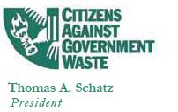

August 22, 2014

The Honorable Thomas Wheeler, Chairman

The Honorable Mignon Clyburn, Commissioner

The Honorable Ajit Pai, Commissioner

The Honorable Jessica Rosenworcel, Commissioner

The Honorable Michael O’Rielly, Commissioner

Federal Communications Commission

525 12th Street, SW

Washington, D.C. 20005

Re: In the matter of Applications of Comcast Corp. Time Warner Cable, Inc., Charter Communications, Inc., and SPINCO to Assign and Transfer

Control of FCC Licenses and other Authorizations

MB Docket No. 14-57

Dear Chairman Wheeler, and Commissioners Clyburn, Pai, Rosenworcel, and O’Rielly:

On behalf of the more than 1.2 million members and supporters of Citizens Against Government Waste, I offer the following comments in general support for the pending applications of Comcast Corporation, Time Warner Cable, Inc., Charter Communications, Inc. and SPINCO (MB Docket No. 14-57).

On April 4, 2014, Comcast Corporation and Time Warner Cable, Inc. filed with the Federal Communications Commission (FCC) their intent that the two companies would merge following approval by the FCC and the Department of Justice. In addition, on April 28, 2014, Comcast and Charter Communications announced that following the approval of this proposed transaction, Comcast would divest 3.9 million television subscribers to Charter Communications, which would reduce Comcast’s post-transaction residential customer base total to less than 30 percent of the total number of multichannel video programming distributors (MVPD). ¹

- David L Cohen, “Comcast Reaches Agreement with Charter,” Comcast Corporation, April 28, 2014, http://corporate.comcast.corn/comcast-voices/comcast-reaches-agreement-with-charter-to-divest-3-9-million-customers-marking-an-important-milestone-toward-comcasts-merger-with-time-warner-cable.
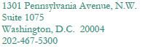

207

The Comcast/Time Warner Cable transaction stands to bring consumers appreciable benefits such as faster Internet service, more video programming options, and, potentially, a check on increasing prices. I encourage you to consider the benefits that such a merger will bring to consumers, including the potential expansion of Comcast’s popular Internet Essentials program, which provides low-cost broadband Internet to families that could not otherwise afford to access the Internet.

These companies do not currently operate in the same geographical markets; and therefore consumers will face no loss of competitive choice for the video, telephone, or Internet services they offer. The proposed transaction therefore poses no harm to consumers or any worrisome accumulation of market power. Critics worrying about either a lack of competition or one company becoming too large should be reminded that there are many competitors in these markets. For example, Google is expanding its fiber optic network to 34 new markets, while AT&T and Verizon have introduced fiber optic cable and Internet services to other markets. As a result of the increasingly competitive market, 98 percent of Americans can choose from three or more multichannel video programming distributors today.² No one can predict what the market will look like in the next decade, but it is likely to remain extremely competitive.

If the FCC limits its review of the transaction solely to its impact on the cable or pay TV industry, it would be mischaracterizing the video marketplace. National online content competitors such as Amazon, Hulu, Netflix and YouTube are expanding their footprint, aided in part by their significantly lower overhead costs. A host of others including iTunes, Roku, and Vudu video streaming have also entered this space. The FCC has already noted the “tremendous growth” in online video, for which revenues have tripled in the last three years.³ Government should encourage, not hinder such competition and investment.

Post-transaction, Comcast will have less than 30 percent of the pay TV market. The federal courts have twice said that the FCC’s previously imposed limit of a 30 percent market share for any single pay TV provider was unjustified; yet Comcast will nonetheless have a share lower than that figure.

The proposed transaction poses no loss of competition; instead, it promises improvements to consumer choice, service quality, and options. The record shows a strong, well-functioning, and fluid market with many large and successful firms actively competing for customers. CAGW encourages the FCC to approve the proposed merger.

Sincerely,

/s/ Thomas A. Schatz

Thomas A. Schatz

President

- Will Rinehart, “Comcast-Time Warner Cable: An Overview of Relevant Markets,” American Action Forum, February 19, 2014, hnp://americanactionforum.org/insights/comcast-time-warner-cable-an-overview-of-the-relevant-markets.

- “Fact Sheet: Internet Growth and Investment,” Statement by Federal Communications Commission Chairman Tom Wheeler on the FCC’s Open Internet Rules, Federal Communications Commission, February 19, 2014, http://www.fcc.gov/document/fact-sheet-internet-growth-and-investment.

208

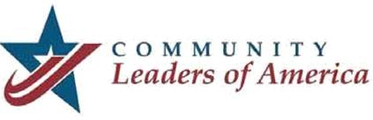

August 22, 2014

Chairman Tom Wheeler

Commissioner Mignon Clyburn

Commissioner Jessica Rosenworcel

Commissioner Ajit Pai

Commissioner Michael O`Rielly

Federal Communications Commission

445 12th Street, SW

Washington, DC 20554

RE: MB Docket No. 14-57

Dear Chairman Wheeler and Commissioners:

My name is Richard Berry and I serve as the Mayor of Albuquerque. In my capacity as Chairman of Community Leaders of America (CLA), the largest caucus of Republican mayors and other local elected officials in the country, I am writing this letter to you today.

Comcast is recognized as a premier provider of cable services, giving households across the nation access to connectivity. In my experience as Mayor, Comcast has demonstrated itself to be a good community partner, in keeping with their core values.

The CLA believes that if the transaction between Comcast and Time Warner Cable is approved, the combined company has the potential to spur economic growth. It is our understanding that consumers and small to mid-sized businesses in particular stand to benefit from the combination. This merger could provide an opportunity for Comcast’s standing investments in new technology that support high speed internet and entertainment platforms to become available to more Americans.

The company is also supportive of local communities, like the ones our members are elected to represent, and programs like its signature Internet Essentials initiative have provided low-cost, high-speed Internet access to more than 1.2 million Americans — narrowing the digital divide in a very real way.

Comcast is helping to shape the future of media and technology, and is positively impacting communities on a day to day basis. CLA’s philosophy is to allow the private sector to succeed while keeping constituents safe. Private sector investments are the backbone of our national

209

economy, and we encourage and appreciate companies risking their capital to contribute to the growth of our economy. If Comcast can give Americans the opportunity to choose a cable and internet provider that is providing a quality service, the FCC should support them in that.

Sincerely,

/s/ Richard J. Berry

Richard J. Berry

Mayor

City of Albuquerque

*Community Leaders of America*

*1005 Congress Avenue, Suite 305, Austin, TX 78701*

210

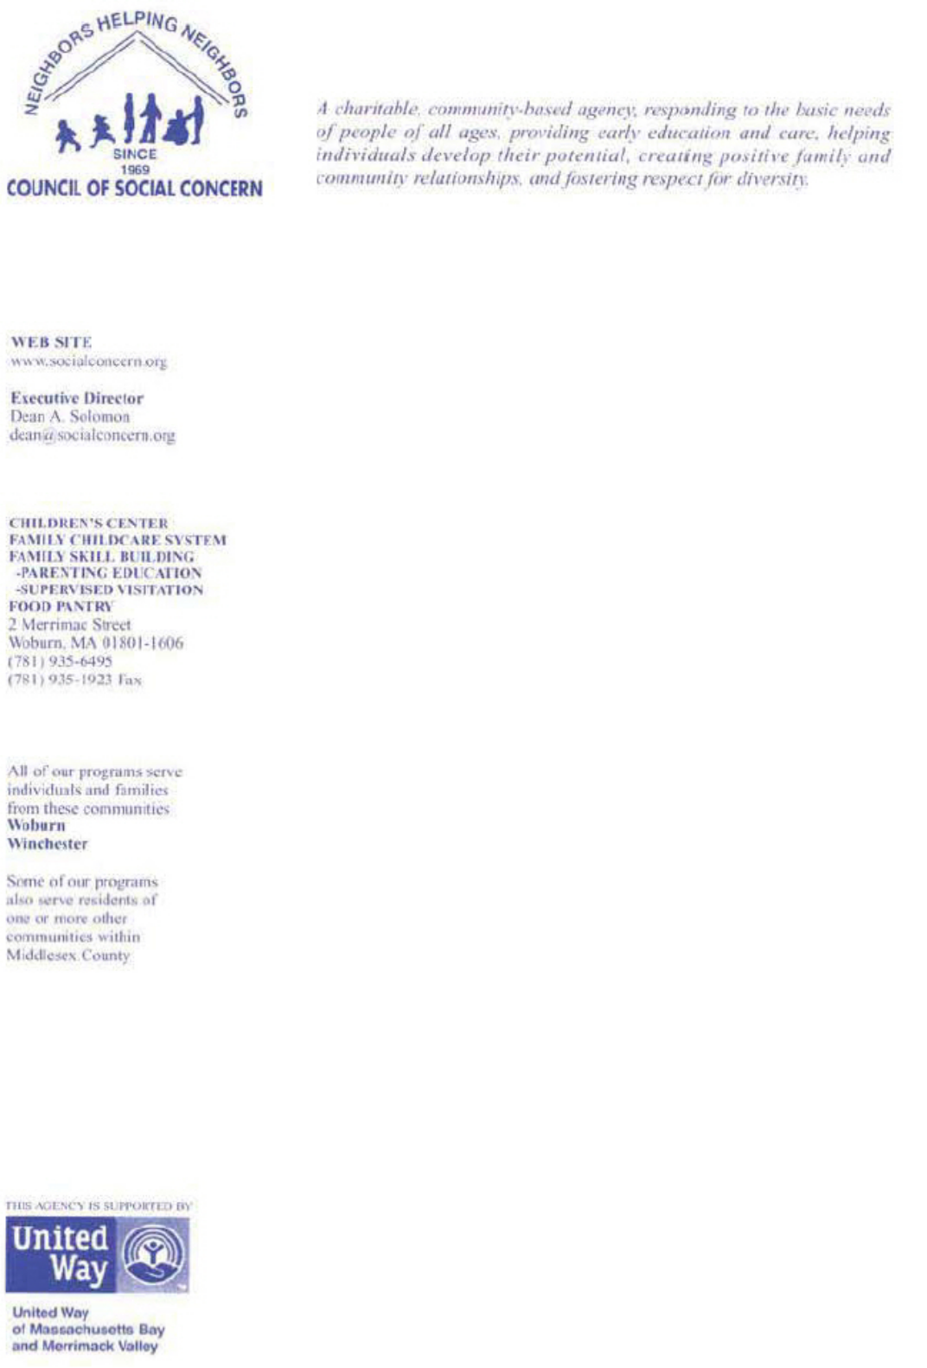

August 25, 2014

Tom Wheeler

Chairman

Federal Communications Commission

445 12th Street, SW

Washington, DC 20554

RE: MB Docket No. 14-57

Dear Chairman Wheeler:

Having a computer with Internet access is a very important factor in allowing people to advance educationally and economically. Without this, it is nearly impossible to complete homework assignments, apply for jobs, or compete in a competitive employment market. Here in Woburn, Massachusetts, like so many other cities across the country, the less fortunate, including the portion of the community that our agency serves, lag behind more affluent households in their ability to afford a computer or internet subscription.

My organization, the Council of Social Concern, in Massachusetts, serves local low-income individuals and families and works to provide them with first-rate early childhood education, parenting education, and emergency food assistance. The support we have received from Comcast Corporation has helped to make these services possible. I have seen the true value that Comcast brings to the communities we serve and hope that a merger with Time Warner will allow other non-profits to have similar access to its support.

Helping to provide access to tackling the digital divide will require the generosity of the private sector combined with the efforts of non-profits like the Council of Social Concern. In 2011, Comcast developed its Internet Essentials program that provides low-cost broadband service for $9.95 a month, full-service computers for under $150 each and options for digital literacy training in local community centers and schools. The program is currently offered to families in Comcast service areas with at least one child who is eligible for free or reduced-price school lunches. At the Essential program’s inception Comcast engaged our agency to spread the word to low-income hard-to-reach families, which we did through our early childhood education programs and Food Pantry.

Comcast is a generous contributor to our agency, makes the communications possible for our annual telethon, and is a sponsor of our annual auction. Funds support our Food Pantry, Family Childcare System, Children’s Center, Parenting Education, and Supervised Visitation programs. Comcast Division Vice President of Customer Care, Paul D’Arcangelo is a past President of our Board of Directors, a current member of the Board’s Executive Committee, and a long-time supporter of Council of Social Concern.

211

It is my hope that a merger of Comcast and Time Warner will play a significant role in bringing the type of support to other low-income communities and non-profits that Comcast has provided to our agency and its clients. As such, I urge the FCC to favorably consider Comcast’s significant role in providing support to low income households in need of computers and low cost internet access and its support of charitable non-profits when voting on the proposed Comcast/Time Warner Cable merger.

Sincerely,

/s/ Dean Solomon

Dean Solomon

Executive Director

Council of Social Concern

212

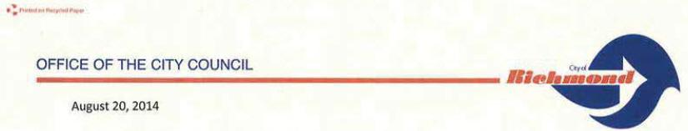

Tom Wheeler
Chairman
Federal Communications Commission
445 12th Street, SW

Washington, DC 20554

RE: MB Docket No. 14-57

Dear Chairman Wheeler:

In my more than 40 years of service to the City of Richmond, California, I have sought to build a better community for today and the future. I have tirelessly advocated on behalf of growth and development through partnerships between the public and private sector.

As a Councilman and former Mayor, I write in support of the proposed transaction between Comcast and Time Warner Cable because Comcast has always been a valued partner and good corporate citizen in our community.

When the company acquired cable systems in Northern California from AT&T over a decade ago, Silicon Valley, the most technologically advanced part of the world, had an Internet network that was years out of date. Com cast spent over $1 billion to upgrade the cable lines. But while the company's investment in technology is impressive, even more significant is Comcast's investment in our community.

The Internet Essentials program has provided tremendous benefits for families In Richmond. The program, which was launched by Comcast in 2011, allows low-income families to sign up for Internet access for less than $10 per month. What that means for these families is that their children, who before were left on the sidelines, can now participate fully in our new economy.

Over 35,000 families have signed up for Internet Essentials in the parts of California where Comcast operates. The nationwide program has brought over 1.4 million individuals up to speed. If the transaction is approved, Comcast will expand the Internet Essentials program into areas in which it acquires Time Warner Cable systems and enable many more to take advantage of the opportunity to get online.

I support the proposed transaction because Comcast Is a good partner for our community and I want to see them continue their work here and in many locations elsewhere.

Sincerely,

/s/ Nathaniel Bates
Nathaniel Bates, Senior Councilmember
and former Mayor
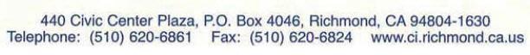

213

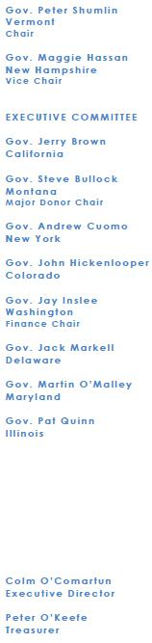

August 22, 2014

Hon. Tom Wheeler

Chairman

Federal Communications Commission

445 12th Street, SW

Washington, D.C. 20554

RE: MB Docket No. 14-57

Dear Chairman Wheeler,

On behalf of the Democratic Governors Associations (DGA), I am writing to emphasize the crucial role Comcast Corporation has played in business and communities all across America.

Comcast’s record of infrastructure innovation helps residents and businesses meet the constantly evolving challenges of the 21st century. The company has invested billions in technology improvements over the last 20 years. These improvements benefit all of their customers, and improve the playing field for other citizens through the American spirit of competition for service excellence. In the years ahead, Comcast will work to strengthen the mission of supporting an economy built to last in every state.

If we’re going to ensure that all Americans can play a part in moving our country forward in the 21st century, we know that citizens in every corner of the country need access to the tools of the 21st century, namely the Web. Comcast’s Internet Essentials program closes the gap in access between rich and poor by offering affordable Internet and computer literacy partnerships to families across the country. Comcast has played a pivotal role in rebuilding the middle class by providing more Americans the resources they need to start a business, connect with medical advice and services, or simply turn in their homework and keep moving towards higher education.

I urge you to consider Comcast’s impressive body of work and all that they do in helping strengthen the middle class and investing in our nation’s infrastructure.

Sincerely,

/s/ Colm O’Comartun

Colm O’Comartun

Executive Director

Democratic Governors Association

[p214c]

214

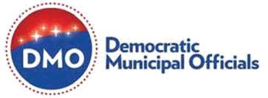

August 22, 2014

Tom Wheeler
Chairman
Federal Communications Commission
445 12th Street, SW

Washington, DC 20554

RE: MB Docket No. 14-57

Dear Chairman Wheeler:

I am writing to share the Democratic Municipal Officials’ (DMO) views on the proposed merger between Comcast and Time Warner Cable.

I believe that this transaction will be beneficial. Comcast will bring new investments and economic opportunities to communities across the nation and will help to bridge the digital divide by offering more low-income families affordable Internet access, bringing an overall improvement to our neighborhoods. Comcast has proven to be a reliable corporate citizen who keeps their promises to the public. Through the merger of these two companies, I foresee advantages for all involved.

This transaction stands to produce new investment in infrastructure that will enhance video and Internet service in our communities. Comcast has always sought to improve their services and has consistently brought innovative new technologies to the communities they serve. If this merger goes through Comcast will improve Time Warner Cable’s networks, including increasing speeds and improving reliability. The impact of these improvements goes beyond being able to stream a video in your home—these improvements will entice new businesses to move to our communities, potentially creating an influx of new jobs.

The merger will also help struggling communities to transcend the digital divide. Through Comcast’s Internet Essentials program, Comcast helps low-income families by offering Internet access for $10 a month to families whose children qualify for free school lunches. I cannot stress enough how important it is for all of our families to have access today. Students need broadband to complete assignments, compile research, and apply to college. The Comcast-Time Warner Cable union would extend this program to more families in more areas, improving the lives of many students and their families.

Municipalities in Comcast’s expanded footprint can look forward to working with an outstanding corporate citizen that invests heavily at the local level wherever they do business. For instance, Comcast works with Boys & Girls Clubs around the country to provide young people with hands-on digital literacy training that teaches technical skills. Comcast also supports a scholarship program that has awarded close to $ 20 million dollars to nearly 20,000 students. And each spring, Comcast rallies its employees, their families, friends, and community partners to do volunteer work in their local communities on Comcast Cares Day. Extending these and other civic projects to new markets offers unquestionable public interest benefits.

Democratic Municipal Officials understands the value of strong public-private partnerships and good corporate citizenry. We are confident that this merger will benefit our communities, and recommend

215

the Commission approve the transaction.

Sincerely,

/s/ Cindy Lerner
Cindy Lerner
President DMO
Mayor, Pinecrest, FL
Democratic National Committee Executive Committee Member

216

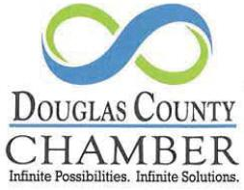

August 22, 2014

Tom Wheeler
Chairman
Federal Communications Commission
445 12th Street, SW
Washington, DC 20554

RE: MB Docket No. 14-57

Dear Chairman Wheeler:

I am writing today in support of the pending merger between Comcast and Time Warner Cable. The Douglas County Chamber of Commerce is celebrating 70 years of serving the community and helping businesses thrive. To be successful In the global marketplace, our residents, schools, institutions and businesses must be connected to the world via modern broadband networks.

Further, continual technology Innovation contributes to our ability to retain our businesses, attract new prospects and the overall quality of life enjoyed by our citizens. With Comcast, businesses in our community can have internet speeds up to 10 gigabits per second. The company has also created a wifi network and mobile video apps to allow customers to take their products with them practically anywhere.

Beyond providing critical infrastructure needs for Douglas County, Comcast is an actively engaged corporate citizen. They support non-profit institutions like the Inner Harbour Youth Villages and the local Boys and Girls Club both financially and through significant volunteer hours, as well as serving as leaders within the business community.

We are happy to have Comcast as part of our community and look forward to their continued investment to support its economic vitality. It is our belief that other communities will similarly benefit by have an excellent partner as their broadband service provider, for this reason I encourage you to approve the proposed merger with Time Warner Cable.

Sincerely,

/s/ Kali Kirkham Boatright
Kali Kirkham Boatright
President and CEO

6658 Church Street • Douglasville, GA 30134

(770) 942.5022 • Fax (770) 942.5876 • www.douglascountygeorgia.com

217

Dear Chairman Wheeler,

As part of your review of the proposed transaction between Comcast and Time Warner Cable, I encourage you to consider the impact that Comcast’s corporate citizenship and community investment will have across additional communities.

Nationally, the Comcast Foundation and Easter Seals have established “The Comcast Assistive Technology Fund at Easter Seals,” which provides assistive technology training and services to individuals with disabilities. Since 2012, the fund has helped an estimated 25,000 Americans and is a tangible example of the transformative power of technology.

For Easter Seals of Western and Central Pennsylvania, Comcast has helped us to tell our story and raise visibility and support. Comcast employees also recently volunteered to serve as mentors for disabled women, ages 15 to 26, at the inaugural “Day of Dignity” in July 2014. The event was an opportunity to introduce young women to professional role models, strengthen their networking skills, and develop the competencies to pursue employment.

Comcast is committed to inclusion and diversity, including the application of technology to support those with disabilities in the home, classroom and workplace. Comcast’s ongoing initiatives include mobile and Web apps embedded with assistive technologies, and broad access to programming with video description and closed captions.

The power of technology and innovation is limitless, and Easter Seals is proud to call Comcast our partner. The proposed Comcast-Time Warner Cable transaction would certainly enrich additional markets as Comcast’s presence has done in our community.

/s/ Michelle Mertz

Michelle Mertz

218

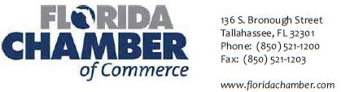

August 21, 2014

The Honorable Marlene H. Dortch
Secretary, Federal Communications Commission
445 12th Street, SW
Washington, DC 20554

Re: MB Docket No. 14-57

Support of the Proposed Transaction Between Comcast and Time Warner Cable

Dear Secretary Dortch:

The Florida Chamber of Commerce is pleased to support the proposed transaction between Comcast and Time Warner Cable. At the Florida Chamber, our goal is to secure Florida’s future through private-sector job growth and by making our state more competitive.

Comcast and its affiliated companies are some of Florida’s top corporate citizens. They have a proven track record of investing in the Sunshine State, supporting communities and jobs as well as providing outstanding cable, broadband and voice services.

In today’s global economy, high-speed broadband service is essential for economic development, education and entertainment. Comcast has invested almost $9 billion since 1996 to maintain and upgrade Florida's technology and infrastructure. Access to the latest robust networks and technology is a key consideration for businesses to consider relocating to Florida or for expanding current operations. Additionally, Comcast is one of Florida’s largest employers. More than 18,000 Floridians are earning good wages, and have access to a competitive benefits package, including tuition reimbursement.

As good corporate citizens, Comcast also works to expand digital literacy through its Internet Essentials program which helps low-income families bridge the digital divide. For only $10 a month, families with one child in the National School Lunch Program can obtain Comcast's high quality broadband service at home. About 40,000 Florida families have enrolled in the program, and for adults looking for employment or students looking for college scholarships, this is an important bridge to bettering their future.

Children also benefit from Comcast's Digital Connectors program, which places supplemental teachers in schools to teach digital literacy. The merger with Time Warner Cable will enable Comcast to expand these programs into new service areas, helping children, adults and the communities they serve.

Comcast is not a company who is content to be an onlooker. With six million more people coming to Florida by 2030, a solid communication backbone will be essential for us to grow. Time Warner customers stand to benefit from the additional strength of Comcast’s network being added to their communities. I encourage you to approve this transaction. Thank you for your consideration.

My best,

/s/ Mark Wilson
Mark Wilson
President and CEO

Securing Florida’s Future

219

- Chairman Tom Wheeler Commissioner Mignon Clyburn Commissioner Jessica Rosenworcel Commissioner Ajit Pai Commissioner Michael O'Rielly

220

Securing Florida’s Future



August 22, 2014

Chairman Tom Wheeler
Commissioner Mignon Clyburn
Commissioner Jessica Rosenworcel
Commissioner Ajit Pai
Commissioner Michael O'Rielly
Federal Communications Commission
445 12th Street, SW
Washington, DC 20554

RE: MB Docket No. 14-57

Dear Chairman and Commissioners:

I am the founder of Food Genius, an award-winning technology and services company made up of people who are passionate about food. I am writing in support of the proposed transaction between Comcast and Time Warner Cable.

Food Genius graduated from the 1871 tech incubator in Chicago, of which Comcast has been an important partner since its founding just over 2 years ago, so I speak from personal experience when I say that Comcast is devoted to fostering growth and innovation in small businesses.

At Food Genius, we use proprietary data technologies to drive innovation by making data and insights accessible and easily digestible, and have grown into a company that serves nationally recognized restaurant chains, convenience store and grocery retailers, consumer packaged goods manufacturers and food distributors. Comcast's high-quality services have been important to our success, not only at 1871 but since we moved to our own office in 2013.

High speed Internet, reliable connections, and 24/7 support are just a few of the benefits my company has received as a Comcast Business Class customer. We were exposed to those services while we were a fledgling startup "incubating" at 1871, and we continue to benefit from them now as our business has matured. In fact, Comcast's support is an important component in our ability to expand. Its technology - especially the opportunity to scale the services and support we need - is critical to growing our business.

I think consumers - and especially small to mid-sized businesses - will win if Comcast and Time Warner Cable combine. Not only will Comcast's high-quality business class offerings become available in more metro areas (where start-ups like Food Genius tend to be located), but broadband competition will thrive. That is a good thing for all of us from a competitive standpoint.

Please move forward in favor of this transaction.

Sincerely,

/s/ Justin Massa
Justin Massa
Founder & CEO

221

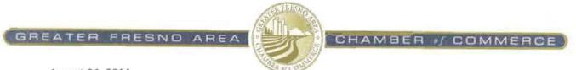

August 21, 2014

Tom Wheeler

Chairman

Federal Communications Commission

445 12th Street, SW

Washington, D.C. 20554

RE: MB Docket No. 14-57

Dear Chairman Wheeler:

On behalf of the Fresno Chamber of Commerce, I write to you today to express my support for the potential merger between Comcast and Time Warner Cable. As the fifth largest Chamber of Commerce in California, we aim to promote a strong local economy and help businesses grow. Throughout my experience working with Comcast, I can confidently say that this merger has potential to help businesses and communities across the country.

Comcast has been a tremendous benefit to the growth of business in our area. It has invested close to $10 billion in infrastructure over the past 20 years in California. Comcast’s commitment to innovation will improve our business climate for its 2-million-strong customer base and all Californians. Businesses served by Comcast can enjoy competitive and top-tier broadband speeds of 25 megabits-per-second on the most popular segment of service.

Comcast also has powerful solutions that could help businesses looking to efficiently market their products here in the county and across the state. Comcast helped in the launch of LotPath, which is Fresno’s technology incubator for start-up businesses.

This past April, Comcast employees joined with Fremont Elementary students and parents to give the Fresno school a full makeover by planting flowers, painting the building, and installing new benches, among other things. I believe that Comcast’s commitment to its communities shows that the company is more than a broadband supplier — it is a good neighbor.

For these reasons, I support the potential merger and offer my assistance in any way it can be of value.

Sincerely,

/s/ Al Smith

Al Smith

President & CEO

222

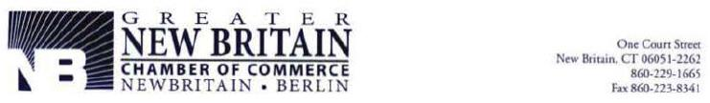

Tom Wheeler

Chairman

Federal Communications Commission

445 12th Street, SW

Washington, DC 20554

RE: MB Docket No. 14-57

Dear Chairman Wheeler,

It is my pleasure to write to you on behalf of the Comcast Corporation and Time Warner Cable transaction. The Greater New Britain Chamber of Commerce (GNBCC) has been the business voice of our city for over a century and we take pride in knowing that we have a great company such as Comcast supporting us throughout our endeavors. Here at the GNBCC, we are very familiar with the philanthropic practices of Comcast and have been fortunate enough to have them as a member for quite some time.

New Britain is an old industrial city that takes great pride in its manufacturing history, but with an economic development eye toward the future, including the health care industry. New Britain is home to two of Central Connecticut’s major medical facilities. To encourage the growth of those facilities, the City continues to build a strong educational foundation, including the creation of the Health Academy at New Britain High School. Through a generous donation from Comcast in 2013 to the Health Academy, the academy was able to purchase iPads for the students to conduct medical research and explore different health institution sites as part of the curriculum. This donation not only helped our students gain access to information, but also helped them expand their knowledge of opportunities outside of New Britain’s city borders. This is just one example of how Comcast invests in its communities, but also leverages technology to improve the lives of many residents.

Comcast also understands that in order to strengthen an economy, people must have access to knowledge and commerce in their homes. That is why Comcast’s Internet Essentials is such a critical tool for our low-income residents, many of whom take advantage of this program. Internet at home keeps them connected to educational and work-related opportunities.

The good that Comcast has done spreads far beyond GNBCC. Since 1996, Comcast has invested upwards of $1 billion in Connecticut’s technology infrastructure. This benefits not just residential customers, but small to medium sized business customers, too. In fact, Comcast’s excellent Business Service is a major benefit to our chamber and its members. It keeps everyone competitive in our global marketplace. New Britainites have produced over 1,447 great and innovative ideas, like the wire coat hanger and the mousetrap to name a few, so we need innovative services to keep us moving those ideas forward. We would be glad to see this transaction come to fruition and benefit other communities like New Britain. Thank you for offering this opportunity to offer our opinion on the matter.

/s/ Tim Stewart

Tim Stewart

President, Greater New Britain Chamber of Commerce

223

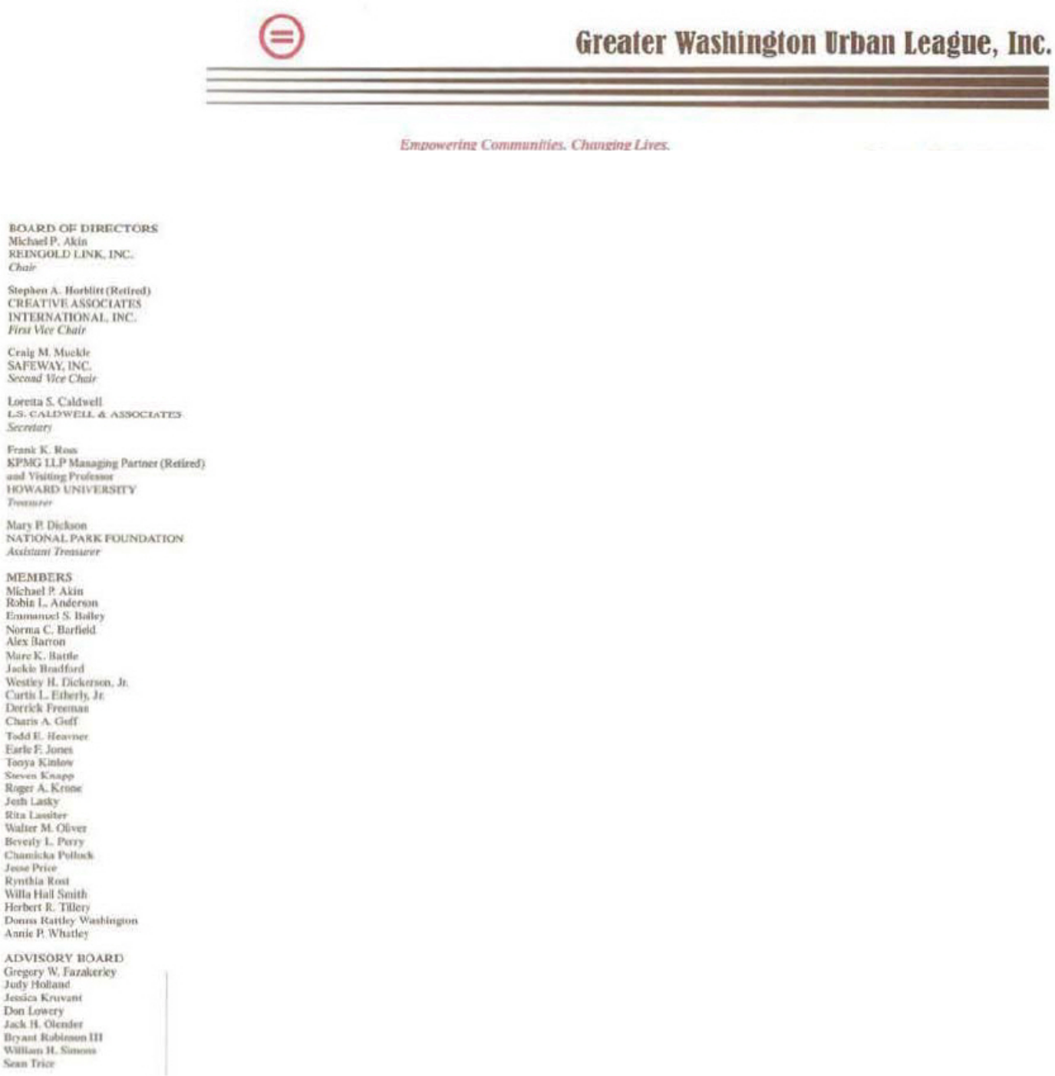

George H. Lambert, Jr.

President & CEO

August 20, 2014

Tom Wheeler

Chairman

Federal Communications

Commission

445 12th Street, SW

Washington, DC 20554

RE: MB Docket No. 14-57

Dear Chairman Wheeler:

My name is George Lambert. I currently serve as the President and CEO of the Greater Washington Urban League. The Urban League is a major interracial, nonpartisan, nonprofit social services and civil rights organization with a mission to increase the economic and political empowerment of blacks and other minorities. We provide direct services and advocacy to more than 65,000 individuals.

I am writing to express my full support for the Time Warner Cable Company and Comcast proposed transaction. I can speak first hand to the commitment that Comcast has shown toward improving our communities, promoting diversity and inclusion, as well as creating sound economic impacts and employment opportunities. The company is also an exemplary video and broadband provider inside the Beltway.

Comcast has dedicated itself to advancing organizations like ours through financial support and partnerships. Comcast has supported us in the promotion of digital literacy, community service, and leadership programs for students that will build our future. Our digital literacy education program is focused on helping local youth gain knowledge of, and access to, computers through a series of interactive workshops that take place throughout the school year. We were also able to purchase tablets and e-readers for these youth enabling them to so that they can keep up with current trends in education toward electronic curriculums, and “anytime anywhere” access to educational materials.
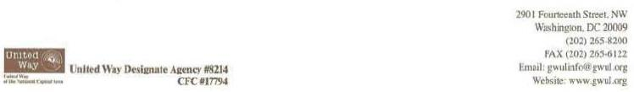

224

Cont. pg. 2

Comcast’s commitment to the Greater Washington Urban League is part of a larger narrative in the effort toward expanding broadband adoption and decreasing the digital divide, which disproportionately affects families of color in low-income neighborhoods. Since 2011, Comcast’s groundbreaking Internet Essentials Program has worked to provide affordable access to broadband internet to low-income families. Internet Essentials, intended only as a three-year experiment, has recently been extended indefinitely due to the overwhelming success it has experienced. Since launching, the program has connected around 300,000 families to the interact, many for the first time.

In District of Columbia, 127 households were connected to the program in its first year. That number has increased to over 1,000, and continues to grow. I can’t stress how important it is that we continue to do everything in our power to ensure that children nationwide gain access to the Internet, and are educated to be digitally literate. If the transaction is approved, Comcast will be able to apply its Internet Essentials program to many thousands of families in Time Warner Cable markets, like New York, Los Angeles, and Dallas, to name a few.

The low-income families in these areas deserve the same opportunities that Comcast provides for communities and families currently within its markets. If approved, the transaction will allow Comcast to expand its philanthropic reach to many more communities across the nation. I know that Comcast is committed to decreasing the digital divide, and I am optimistic and excited for the future.

Sincerely,

/s/ George H. Lambert, Jr.

George H. Lambert, Jr.

President and CEO

225

GroupM 498 Seventh Avenue New York, NY 10018
T: +1 212 297 8100 F: +1 212 297 8120 www.groupm.com

Irwin Gotlieb

Global Chairman

Federal Communications Commission
445 12th Street SW
Washington, DC 20554

Chairman Tom Wheeler
Commissioner Ajit Pai
Commissioner Mignon Clyburn
Commissioner Jessica Rosenworcel
Commissioner Michael O’Rielly

August 22, 2014

Re: | Applications of Comcast Corp. and Time Warner Cable, Inc. For Consent to Assign or Transfer Control of Licenses and Authorizations, MB Docket
 | No. 14-57

Dear Chairman Wheeler and Commissioners:

I am the Global Chairman of GroupM, an operating unit of WPP. GroupM is the parent company to global media networks such as Mindshare, MEC, Mediacom and Maxus among others. In my role, I oversee the strategy and operations of our agencies representing roughly $104 billion in global billings, as reported by RECMA.

We have always been of the view that vertical integration and defragmentation of the media landscape has positive impact on our industry. I wrote to the commission several years ago in favor of what was then a Comcast/NBCU merger and felt that this would prove beneficial in the advance of the TV landscape i.e., VOD/dynamic ad insertion, addressability. We believe that the impact of that merger has been very positive and now believe that defragmentation in the cable infrastructure area will also be of significant benefit.

The prospective merger of Comcast and Time Warner Cable will benefit the advertising industry as a whole, in two key areas:

- Greater efficiency in ad buying – A media company’s goal is to deliver the most efficient ad buys for its clients – via global, domestic or local placements. The combined Comcast/Time Warner Cable footprint will provide a larger, more efficient platform to execute local ad buys, with a post-transaction presence in 19 of the top 20 designated market areas (DMAs). A single vendor with consistent capabilities and protocols over such a broad geography would be very helpful to the ability to execute sophisticated client plans.


A WPP Company

226

- Innovation and implementation in advanced TV products like dynamic ad insertion and addressability – In today’s context, media companies are required to stitch together multiple MSO’s each of whom operate with different business rules and different technologies. To the extent that the combined entity will represent 19 of the top 20 DMAs, it will provide greater opportunity for the advancement of technologies that otherwise wouldn’t flourish. For instance, dynamic ad insertion helps guarantee that commercials shown during television programs are shown despite being viewed at a time other than its original airing; while Comcast and Time Warner Cable have both experimented with the concept, deploying it at such scale would help make it an industry standard, thereby reinstating advertiser confidence that their ads are being viewed.

Additionally, the post-merger entity would advance addressable advertising, which allows advertisers to pinpoint consumers based not just on zip code (today), but by more sophisticated demographic and behavioral data. Comcast has always led the industry in this space and their larger footprint would consequently benefit the advertising industry. Television, therefore, becomes a much more attractive platform for advertisers currently shifting dollars to alternatives that are perceived to be more accountable than linear TV.

For the two important reasons stated above, we fully support the merger between Comcast and Time Warner Cable.

Please feel free to contact me with any questions you may have.

Sincerely,

/s/ Irwin Gotlieb
Irwin Gotlieb
Global Chairman

A WPP Company

227

Hispanic Chamber of Commerce of Central Pennsylvania
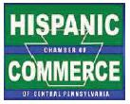

August 22, 2014

Marlene H. Dortch, Secretary
Federal Communications Commission
445 12th Street, SW

Washington, DC 20554

RE: MB Docket No. 14-57

Dear Ms. Dortch:

I am the president of the Central Pennsylvania Hispanic Chamber of Commerce, the primary purpose of which is to advocate for local Hispanic businesses and entrepreneurs. I am writing today to express my endorsement of the proposed Comcast and Time Warner Cable transaction. Please give this proposed transaction your approval.

I personally have interacted with Comcast leaders in our area and have seen the contributions they make to commerce, government and education. For instance, I sit on the Dauphin County Redevelopment Authority and the Dauphin County Land Bank boards with Frank Lynch, Comcast's regional vice president for government affairs. These agencies work to eliminate blighted areas.

Comcast has backed Hispanic Chamber events and the company has reached out to us in its employee recruiting efforts. Comcast demonstrates that it understands the desirability of inclusive hiring practices and of doing business with minority-owned businesses, two causes we at the Chamber strongly promote. It has worked with the United States Hispanic Chamber of Commerce in seeking to utilize small Hispanic-owned businesses for supplies and services. Comcast is also a major presence at regional charity events and fundraisers for diverse groups, further proving its commitment to inclusion.

Our youngest and neediest citizens benefit greatly from Comcast's high-speed digital Internet. Kids whose families cannot afford a digital connection can get online at home through Comcast's Internet Essentials program. The Internet access is only $ 10 a month and they can purchase a computer for $150. The Chamber applauds this program because, in a way, we are helping to prepare our workforce of tomorrow in the process. If the proposed transaction is approved, this important program will be made available in more communities around the country.

It's clear that Comcast doesn't sideline special groups or leave our youngest learners behind. We count on its stable presence and its contributions to communities in Central Pennsylvania. Thank you for allowing me to share our experiences and to encourage you to expand these experiences to others. I ask that you approve the transaction.

Sincerely,

/s/ Paul J. Navarro
Paul J. Navarro
President

Hispanic Chamber of Commerce of Central Pennsylvania

112 Market Street, Suite 415 Harrisburg, PA 17101
www.HispanicChamberCentralPA.org

228


August 21, 2014

Chairman Tom Wheeler
Commissioner Mignon Clyburn
Commissioner Jessica Rosenworcel
Commissioner Ajit Pai
Commissioner Michael O'Rielly
Federal Communications Commission
445 12'" Street, S.W.
Washington, DC 20554

RE: MB Docket No. 14-57

Dear Chairman and Commissioners:

INSP, LLC wishes to express its strong support for Comcast and Its proposed merger with Time Warner Cable. As one of the nation's leading independent cable television networks, INSP has had the opportunity to work with Comcast for many years. Our endorsement of the merger is based upon this extensive experience.

Founded in 1990, INSP has emerged as one of the leading providers of family-focused television entertainment. According to Nielsen, INSP was the fastest growing cable network in 2013 in terms of ratings. This growth has been catapulted by providing "lunge-free" content: wholesome programming throughout our schedule that is suitable for every member of the family (so viewers don't need to "lunge" for the remote when faced with objectionable content).

Although we are now viewed in a universe of more than 80 million households, as an independent network INSP has faced an uphill battle in gaining distribution. However, one significant reason for our substantial growth has been the consistent support we have received from Comcast.

Comcast and INSP have a long-standing and successful relationship. Comcast has been pro-active in its support of wholesome entertainment and value-based content, and has demonstrated this commitment by doubling the number of subscribers that can access INSP since 2011.

In recent years Comcast has launched INSP in Its Big South region, making INSP's programming available to subscribers in Atlanta, Nashville and various areas in Mississippi, as well as its West Division, where INSP is now available to an additional 1.8 million subscribers in California (San Francisco, Fresno, San Jose and Sacramento), Washington (Seattle) and Minnesota (Minneapolis and St. Paul). At present, INSP is available in more than 14 million homes served by Comcast.

229

August 21, 2014
Page Two

Some distributors, particularly DBS, have been less than cooperative. They frequently display reluctance and even opposition to independent networks like INSP, and are dismissive of the importance of family-oriented content. Comcast, by contrast, has always treated INSP fairly and reasonably, and has rightfully gained the reputation as a leading supporter of independent programming for which there is an audience.

Further, Comcast recognizes that family-oriented entertainment is an essential part of the American media and cultural landscape, and that such content helps distributors attract and retain subscribers in an increasingly competitive consumer marketplace. In this regard, Comcast has supported the entrepreneurial spirit that has characterized the important role independent networks have played in the evolution of the television industry. This stands in stark contrast to certain other national distributors who periodically drop independent networks or make unreasonable demands as the quid pro quo for carriage.

Some concern has been expressed that the merger of Comcast and Time Warner will nesult in too much concentration of control, which in tum will stifle innovation and hurt consumers. However, based on our extensive experience in working with Comcast we feel that such fears are without merit. In fact, Comcast has a strong record of launching viable, independent networks.

In short, we believe Comcast's merger with Time Warner Cable will be a great development for independent networks, and that it will usher in a new, exciting era for our industry and the American viewing public. Comcast has clearly earned its leadership position and the respect of INSP and others throughout the industry for its professionalism, business acumen, and management expertise. We believe Comcast wlil continue to set the standard after its merger with Time Warner Cable Is finalized.

It is for all of these reasons that we are confident the proposed merger will serve the public interest and that we voice our unequivocal support for its approval.

We would be happy to answer any questions the Commission might have about this matter, or help in any other way.

Sincerely,

/s/ David Cerullo
David Cerullo
Chairman & CEO

3000 WORLDREACH DR | INDIAN LAND, SC 29707 | P 803-578-1000 | INSP.COM

230

Testimony


August 20, 2014

Tom Wheeler, Chairman

Federal Communications Commission

445 12th Street, SW

Washington, DC 20554

RE: MB Docket No. 14-57

The Kauai Chamber of Commerce is in support of the transfer of the application.

On behalf of the Chamber, as President/CEO and, J. Robertson, Chair-Elect, Board of Directors, and, Chair, Public Relations & Promotions Committee, we met with representatives of the companies to discuss the application regarding the impacts of the transfer of the application from Time Warner Communications to Comcast Corporation. During the course of the meeting, it was clear to us that both companies would work collaboratively in the best interest of our Kauai consumers and State of Hawaii in order to provide services that will ultimately benefit not only the public, but, also the business community. This is equally important as our island economy continues to strengthen in economic and workforce development due to the gradual business expansion of the economy, post-recession.

While there clearly will be issues both anticipated and unanticipated regarding any new business, whether brand new, merger, etc., we are confident that the public and private sectors will be best served given the success of Oceanic Time Warner Cable’s history on Kauai and, in the state. This is especially true regarding the rural communities served on-island and, the added and improved cost-effective services that we have benefitted from as a result of the innovations of Oceanic Time Warner Cable LLC’s Hawaii franchise in this very isolated, technologically oriented and, highly competitive business environment.

Please do not hesitate to contact me should you need additional information and assistance. Aloha.

Sincerely yours,

/s/ Randall Francisco

Randall Francisco

Kauai Chamber of Commerce

231



August 19, 2014

To:

Chairman Torn Wheeler

Commissioner Mignon Clyburn

Commissioner Jessica Rosenworcel

Commissioner Ajit Pai

Commissioner Michael O’Rielly

Federal Communications Commission

445 12th Street, SW Washington, DC 20554

RE: MB Docket No. 14-57

Dear Chairman and Commissioners:

As the Executive Director of La Voz Latina, I am committed to helping our Latino population here in Rockford, IL. Our mission is to promote the progress and the needs of Latinos in our region. We maintain a strong focus on education through English and GED classes, programming for youth, health and family education, and community awareness. We have a strong and reliable corporate partner in Comcast. I am writing today to ask for your help in approving the company’s proposed transaction with Time Warner Cable. We could not continue the necessary work we do to help Hispanics succeed without the backing and assistance of companies like Comcast in our Region.

La Voz Latina has been working for over 40 years to provide outreach, resettlement orientation and personal counseling. This has been a winning formula in our effort to make our Hispanic population assimilate and has helped thousands of local Hispanics increase their skills, prepare for a better job, and lead healthier lives in Illinois.

Our organization has been growing by leaps and bounds and thanks to United Way seed money offered to La Voz Latina back in 1984, we were able to open a Hispanic Resource Center. As a result, we have been able to expand our vocational training, education and referral service, and needs based outreach. One such need is digital literacy training for populations that use English as a second language. Thanks to Comcast, we have been able to offer more digital literacy training opportunities to the young people and adults we serve in Spanish.

232

Three years ago, Comcast launched Internet Essentials — or Internet Basico as we call it here. What seemed ambitious has truly made an impact, and La Voz Latina is proud to play a role in helping Comcast connect nearly 40,000 Illinois families to the program. We’ve also helped to train residents in Internet usage best practices and online safety procedures for free. Additionally, we are very grateful for Comcast’s support of our annual awards ceremony that provides recognition of our client’s outstanding achievements each year.

I would like to see more organizations similar to La Voz Latina thrive. Partners like Comcast make that possible. Please help to bring Comcast’s partnership to our sister programs in cities like Los Angeles, Dallas and New York City by approving its transaction with Time Warner Cable.

Thank you for your time and attention,

/s/ Luz Ramirez

Luz Ramirez

Executive Director

La Voz Latina

233

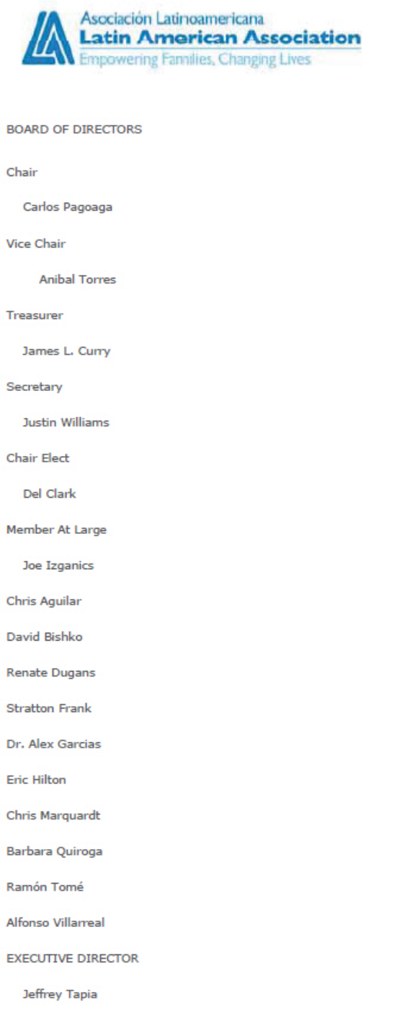

August 21, 2014

Chairman Tom Wheeler

Commissioner Mignon Clyburn

Commissioner Jessica Rosenworcel

Commissioner Ajit Pai

Commissioner Michael O’Rielly

Federal Communications Commission

445 12th Street, SW

Washington, DC 20554

RE: MB Docket No. 14-57

Dear Chairman and Commissioners:

The Latin American Association’s (LAA) mission is to empower Latino individuals and families to achieve their educational, social and economic aspirations. Our vision is ‘Access. Education. Opportunity.’ Founded in 1972 to serve Atlanta’s then emerging Latino population with transition and resettlement programs, the LAA has grown along with Atlanta’s Hispanic demographic over the past four decades to become the region’s leading agency representing Latino issues. Impacting nearly 38,000 individuals each year, the LAA’s culturally and linguistically appropriate programs and services provide the support, knowledge, tools and resources Latinos need to remove barriers, transform their lives and ultimately strengthen the greater Atlanta community.

Companies such as Comcast provide the LAA with the support necessary to expand our programs each year as the issues facing Latinos increase. Knowing how much partnering with Comcast has benefited diverse, community-based organizations like the LAA, the LAA supports actions that allow Comcast’s community investments to be expanded to other areas and organizations in need.

234

Comcast has been a strong supporter of the LAA for many years. The Comcast Foundation has provided significant grants to the LAA for our Youth Academic Achievement Initiative, providing academic and other support empowering Latino young people to graduate from high school and college. Through their Internet Essentials program, the LAA and Comcast created a partnership providing free internet access and computers for our students and families, who are all low income and have numerous barriers to accessing education and information. Comcast Cares volunteers have completed projects that greatly enhance our ability to serve the community.

As the Latin American Association grows and expands, we continue to call on our partners to invest in the community with us. Comcast answers that call with financial, technical, and volunteer support, and I look forward to seeing how their growth, and ours, will continue to help Latinos in the years to come. Please consider the potential benefits of the proposed Comcast and Time Warner Cable transaction, and what the combined company can bring to diverse communities across the country.

Sincerely,

/s/ Jeffrey Tapia

Jeffrey Tapia

Executive Director

Latin American Association

235

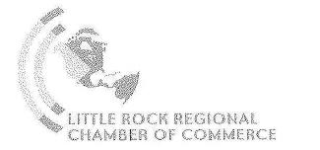

Tom Wheeler
Chairman
Federal Communications Commission
445 12th Street, SW

Washington, DC 20554

RE: MB Docket No. 14-57

Dear Chairman Wheeler:

On behalf of the Little Rock Regional Chamber of Commerce, I would like to extend our support for the merger between Comcast and Time Warner Cable.

We have worked with Comcast for many years and believe this merger will only further the benefits our organization has experienced.

We are proud to say that Kiplinger's recently named Little Rock the number one place to live in America. We feel that our organization played a small role in that ranking, working to promote our businesses and maintain our stable and growing economy. We currently represent over 2,000 businesses and organizations and are the Regional leader in economic development.

Comcast provides Little Rock with services that help boost our businesses. Comcast Business Services are top-notch. Their multi-megabit speed Internet is a premier offering and helps give companies a competitive edge. They are stimulating competition in Little Rock, leading to better service, better value and pricing for our members.

Our organization's main goal is to keep Little Rock great and support our member companies to the best of our ability. Working with Comcast has proven to be in our best interest and benefits businesses in other regions as well.

Sincerely,

/s/ Jay Chesshir
Jay Chesshir,
President & CEO
Little Rock Regional Chamber of Commerce

One Chamber Plaza ● Little Rock, Arkansas 72201

501-374-2001 ● Fax 501-374-6018 ● http://www.littlerockchamber.com ● chamber@littlerockchamber.com

236

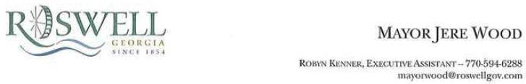

August 21, 2014

Chairman Tom Wheeler·

Commissioner Mignon Clyburn

Commissioner Jessica Rosenworcel

Commissioner Ajit Pai

Commissioner Michael O'Rielly

Federal Communications Commission

445 12th Street, SW

Washington, DC 20554

RE: MB Docket No. 14-57

Dear Chairman and Commissioners:

Serving my fifth term as Mayor for· the City of Roswell, Georgia, I strive to make my city a world-class place to live and visit. We are the eighth largest city in Georgia, with over 88,000 residents and are growing each day. Through the years, our community has been recognized as a great place to live, work and visit. My hope is that the Roswell area will continue to grow and maintain that same high standard of living.

I am writing this letter in support of the Comcast Corporation and Time Warner Cable transaction. I believe that Comcast has already done an outstanding job providing high quality cable TV and internet services that Roswell residents use daily. What has impressed me even more is the company's deep interest in further technological development to benefit its many subscribers. Comcast boasts some of the fastest in-home internet speeds and best home entertainment features in the country. With Time Warner Cable as a partner, and investments in many technology-based organizations, Comcast will be able to provide even more advanced services for our community and many others in the future.

Comcast makes it possible to bring the latest advancements in home entertainment to smaller cities - like Roswell - and does not limit its services to large metropolitan areas.

Additionally, it is clear from its many community initiatives that Comcast has a clear commitment to efforts that make local neighborhoods

237

Page 2

better. When Comcast makes a promise to act, it is comforting to know that they will always follow through. This is the type of attitude that makes Roswell proud to be involved with such a company. Comcast Cares Day is a perfect example. This annual day of philanthropy, mobilizing Comcast employees, their families, and local volunteers nationwide, is just a glimpse of how much Comcast invests in each community it serves. As Roswell continues to prosper economically, it is this land of service that I want the children in our neighborhoods to witness and be a part of.

I believe the Comcast Corporation and Time Warner Cable will work together to ensure that their customers continue to receive top-notch professional entertainment services. And with this partnership, Comcast will go above and beyond for new communities through improved technology and their charitable efforts.

Our city has a relationship with Comcast and our residents are happy with the services it has provided and continues to provide each day. I ask that you take these points into consideration when you are making your decision and approve the transaction.

If you should have any questions or if I can be of any further assistance, please do not hesitate to contact my office.

Sincerely,

/s/ Jere Wood
Jere Wood

238

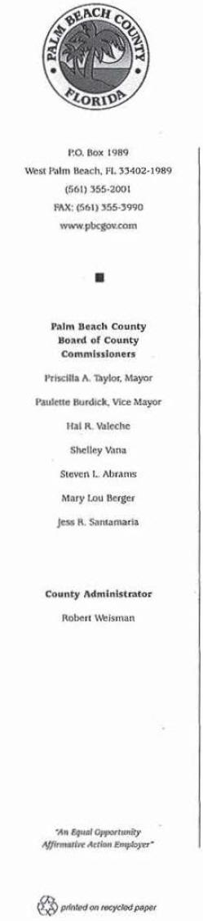

August 20, 2014

Tom Wheeler, Chairman

Federal Communications Commission

445 12th Street, SW

Washington, OC 20554

RE: MB Docket No. 14-57

Dear Chairman Wheeler:

With more than 1.33 million residents, Palm Beach County is home to vibrant, growing communities where diversity and development are encouraged. As Mayor of the Palm Beach County Board of Commissioners, I'm proud of the economic and community developments we have seen here, especially among minority and women-owned businesses.

The investments necessary to keep Palm Beach County and its 38 municipalities thriving require continued partnerships with similarly growing companies and organizations. That is why, as mayor, I see the value in the proposed Comcast and Time Warner Cable transaction and encourage you to do the same.

Comcast has a long-time partnership with Palm Beach County, due in part to its strong business presence in our communities and its broadband adoption projects, like Internet Essentials (IE). The company's ongoing support of Palm Beach County is an excellent example of its corporate citizenship. Because or Comcast's reputation for keeping its promises, our business owners, community organizations, and families know they can count on it.

Even in a thriving area like Palm Beach, some residents remain underserved by technology, which Comcast seeks to remedy with its Internet Essentials program. IE reaches more than a million individuals nationwide with affordable Internet access and computers, giving them the resources necessary to succeed in their education or enter the workforce.

239

Tom Wheeler, Chairman
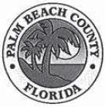
Page 2

RE: MB Docket No. 14-57

Comcast's community investment does not end there. The initiatives it brings to the community, such as Comcast Cares Day, sets a high standard for corporate citizenship in our area. In a community where economic development is encouraged, especially among our diverse minority populations, Comcast's partnership has proven valuable for all stakeholders. With time and continued growth, the benefits can only increase.

Therefore, I am advocating that you would take into consideration the breadth and depth of Comcast's community investment in Palm Beach. County and support the expansion of these efforts through the Comcast and Time Warner Cable transaction.

Sincerely,

/s/ Priscilla A. Taylor, Mayor

Palm Beach County Board of County Commissioners

240



Marlene H. Dortch

Secretary

Federal Communications Commission

445 12th Street, SW

Washington, DC 20554

RE: MB Docket No. 14-57

Dear Secretary Dortch:

As Mayor of Richton Park, Illinois since 2001, I have seen our community positively change and grow as a result of Comcast's investment in our community. As the town's leader and a member of the South Suburban Mayors and Managers Association, I know firsthand the challenges we face to continue providing our citizens with opportunities, housing, access to parks where their children can play, libraries and a variety of resources that make our town a viable place to live and raise a family. I am writing today to ask that you approve the proposed Comcast and Time Warner Cable transaction. It is companies such as Comcast that have given our community the opportunity to thrive.

Comcast held it's first-ever Comcast Cares Day here in Richton Park and the hundreds of volunteers from Comcast that turned out were an overwhelming testament to Comcast's commitment to community. From painting and improvement projects to cleaning up parks and packing food pantry boxes, the volunteers provided hours of service to local agencies that cannot even be measured in dollars.

Since that time I have been a true proponent of the company and its commitment to community. In fact, I supported Comcast's successful efforts to merge with NBCUniversal, a business union that has yielded ground breaking community investment programs like Internet Essentials.

Small towns face a multitude of challenges, mainly in offering citizens access to quality services, good housing, transportation, and solid educational opportunities. Comcast's Internet Essentials program bolsters and complements the work we do as civic leaders to make sure our community's next generation is able to participate in the 21st century economy and workplace by getting low-income students online at home. In Illinois alone, I understand that the program has enrolled close to 40,000 families and many more would benefit if it could be extended to new communities in Illinois and to big cities like Los Angeles, Dallas, and New York City. That would be achieved if the Comcast and Time Warner Cable transaction goes through.

As a small business owner, lifelong resident of Richton Park and a longtime supporter of Comcast, I hope you will favorably consider the Comcast and Time Warner Cable transaction. I have seen the positive change Comcast has brought to our community and its good work deserves to spread well beyond our borders.
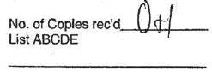

/s/ Rick Reinbold
Rick Reinbold

Village President

241

- Chairman Tom Wheeler Commissioner Mignon Clyburn Commissioner Jessica Rosenworcel Commissioner Ajit Pai Commissioner Michael O'Rielly

242

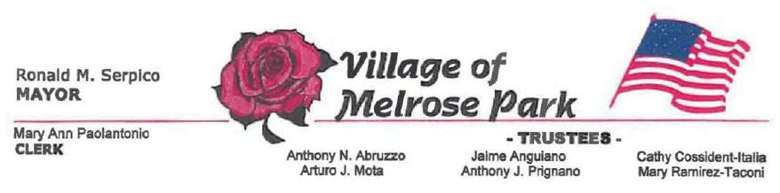

August 22, 2014

Tom Wheeler

Chairman

Federal Communications Commission

445 12th Street, SW

Washington, DC 20554

RE: MB Docket No. 14-57

Dear Chairman Wheeler:

As Mayor of Melrose Park, a suburb of Chicago, and a longtime Comcast supporter, I am very happy to report we signed a multi-site fiber deal with Comcast just last year, and our businesses are taking full advantage of all the services Comcast has to offer. I am writing to ask for your support of the proposed transaction between Comcast and Time Warner Cable so that other communities can benefit from the enhanced service we have.

Because Comcast provides the ultimate advanced communication solutions, our local companies are reporting an increase in their bottom lines and greater employee productivity. I cannot emphasize enough the important role that Internet speed and efficiency have played in assisting our local business owners with high tech, high performance tools to enhance their work.

Melrose Park is a small but thriving community and is home to the second largest food festival in Illinois. The Taste of Melrose Park typically draws over 200,000 visitors a year, offering food from hundreds of local vendors and restaurants. Comcast is an important partner of that event, and without their help we could not facilitate such a large undertaking. The annual boost to our economy, coupled with Comcast's corporate presence, provides the essentials to make this a yearly success. In fact, an important by-product of the Taste festival is the monies raised by the event. The event's proceeds are turned over to local charities, schools, senior organizations, and youth groups. Comcast's partnership not only supports one of the largest food festivals in Illinois, but also helps to raise money for many worthy organizations.

243

I hope you will strongly consider approving the proposed transaction between Comcast and Time Warner Cable. Melrose Park depends on companies such as Comcast to provide our community with high end technology as well as the corporate and philanthropic commitment that small communities like ours need. It would be wonderful to see these same opportunities delivered to more cities and municipalities as a result of this transaction.

Sincerely,

/s/ Ron Serpico

Ron Serpico

Mayor

244

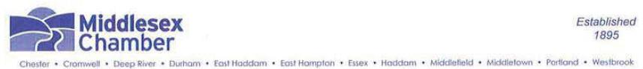

August 21, 2014

Tom Wheeler

Chairman

Federal Communications Commission

445 12th Street, SW

Washington, DC 20554

RE: MB Docket No. 14-57

Dear Chairman Wheeler:

The Middlesex County Chamber of Commerce in Connecticut is a dynamic business organization with over 2,350 members that collectively employ over 50,000 people. As the largest free standing chamber in Connecticut, we strive to promote the business community throughout Middlesex County and its surrounding areas through a variety of services, programs and events. Comcast is a valued member of our Chamber and an important player in the economy of Connecticut. I write today to urge approval of its proposed transaction with Time Warner Cable.

Comcast's investment in infrastructure in Connecticut ensures reliable and scalable communications services so that we can attract and retain new members of the business community on an ongoing basis. Comcast's services, including their broadband internet and Comcast Business support, have played a large role in helping to maintain and grow our members' businesses. Furthermore, Comcast is a large employer in our state with 2,300 full-time workers that are contributing members of our economy and community. Comcast supports the work of our organization in many ways. Comcast supports our Business Expo, an event that showcases products and services presented by over 100 local, state and national vendors, as well as our Middletown Summer Youth Employment Program. We are also very pleased to have Comcast Regional Vice President for Public Affairs, Kristin Roberts, bring her expertise to our Board of Directors.

Comcast's corporate citizenship has also reached beyond the Chamber of Commerce to our entire community, with initiatives such as Comcast Cares Day, the Leaders and Achievers Scholarship Program, and partnerships with Boys and Girls Clubs and Big Brothers Big Sisters. Comcast has proven to be a company that over-delivers on economic impact and civic partnership. It's the type of company and member that any chamber loves to see engaged. I urge the FCC to approve the Comcast and Time Warner Cable transaction so that Comcast's corporate impact and citizenship can grow and thrive.

Sincerely,

/s/ Larry McHugh

Larry McHugh

President
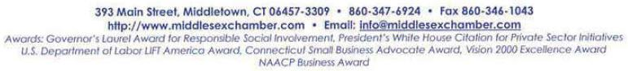

245

August 22, 2014

Tom Wheeler

Chairman

Federal Communications Commission
445 12th Street, SW
Washington, DC 20554

RE: MB Docket No. 14-57

Dear Chairman Wheeler:

On behalf of the National Black Chamber of Commerce (NBCC), I am writing to you to express my support for the potential Comcast-Time Warner Cable merger.

NBCC is dedicated to economically empowering and sustaining African American communities through entrepreneurship and capitalistic activity, working with chapters and member companies in 140 communities. In our experience, Comcast consistently makes and upholds commitments made to improve the quality of life in the communities it serves by enhancing opportunities for minority-owned businesses and employees of color.

Comcast is regularly rated as a top place to work for both women and minorities, who make up 40% of the company’s workforce and nearly half of all new hires. It was also one of the few companies that didn’t shed jobs during the massive layoff waves of the Great Recession. Since the transaction with NBCUniversal, Comcast has increased its spending with minority-owned suppliers and vendors by 20% and continues to work to increase supplier diversity.

Comcast’s vow to increase investments in the networks it acquires in this transaction will only expand the reach and quality of its services, stimulating economic development in areas across the country. These investments will bring Comcast’s business class high-speed Internet and voice services to more markets, offering better services and promoting competition in those markets. Also, in a deal like this where the two companies operate in different geographic areas, the risk of local job loss is essentially non-existent. Therefore, we expect this merger will generate economic growth for the benefit of businesses of all sizes.

Just as Comcast invests in its employees and in its networks, so too does it invest in the future of the local workforce in each community. Programs like Internet Essentials and Digital Connectors, along with its many mentorship and scholarship programs, are helping to equip both students and adult workers with the skills necessary to contribute to the 21st Century digital economy.

There are a number of factors for the Commission to consider in this proposed transaction, and each should be given due scrutiny. But I can say with full confidence that this proposed deal offers several real public interest benefits for minority-owned businesses and for the communities that Comcast intends to serve post approval, and I am hopeful that the deal is ultimately approved.

246

Sincerely,

/s/ Harry C. Alford

Harry C. Alford

President/CEO

247

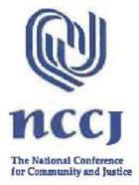
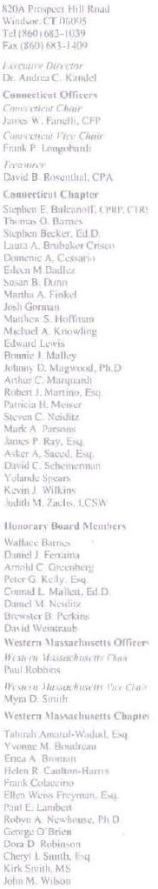

Re: MB DocketNo. 14-57

August 22, 2014

Dear Chairman Wheeler;

I write this letter on behalf of the National Conference for Community and Justice (NCCJ), a human relations organization dedicated to fighting bias, bigotry and racism, and promoting understanding and respect for all people in America. Through advocacy, education and conflict resolution initiatives, NCCJ remains strongly committed to working with leaders and decision-makers to make America more inclusive and just. I am proud to be associated with companies and organizations that stimulate understanding and respect among all people through workplace policies and civic engagement. Comcast is one of the best examples of such a company.

NCCJ, which currently operates in Connecticut and Western Massachusetts, was formed in 1927 as the National Conference for Christians and Jews. in the 1990's, the name was changed to better reflect the scope of our mission, the growing diversity of our country and our need to be more inclusive. We run dozens of community action programs each year and work to highlight leading members in our society who show support for our principles through leadership by example. Local Comcast employees, including the company's founder Ralph J. Roberts, have served on our board of directors over the years and Comcast was awarded our Corporate Community Diversity Award in 2006. Respecting the individuality and dignity of others is deeply rooted in Comcast history, and we are happy to see so many examples of diversity, inclusion and acceptance in its workforce.

One of our most important goals as an organization is to increase social awareness and inclusion through programs with local youth. One of our more recent program launches has been our Anti-Bullying Program, which is an age appropriate anti-bullying program for youth and adults who support them. Comcast was an early partner on this program, and used their technological expertise to help us create a number of PSAs to promote our organization and this new campaign. I find it extremely laudable that Comcast takes an active interest in ensuring the safety and harmony of our nation's youth, and their help with this program allowed us to reach new kids and communities desperately in need of some social change.

248

Comcast has also been a reliable sponsor and promoter of all our local events and award receptions. For the last few years, Comcast has taped our awards dinners and helped us edit the footage to use for internal and promotional services. Over the years, it has also supported our ANYTOWN and CAMP ANYTOWN projects, which are community building programs for teenagers. Every time we need some extra support, Comcast is always there to give us a hand. It is a wonderful partnership that we share, and as Comcast continues to be a strong example of a company committed to our credo of workplace equality and inclusion, I expect it to continue for many years to come.

Comcast is a company that reflects the social, ideological makeup of modem day America. It is also a reliable community partner. I am happy to support Comcast in any way possible including their future endeavors.

Sincerely,

/s/ Andrea C. Kandel

Andrea C. Kandel; Ed.D.

Executive Director

249



Chairman Tom Wheeler

Commissioner Mignon Clyburn

Commissioner Jessica Rosenworcel

Commissioner Ajit Pai

Commissioner Michael O’Rielly

Federal Communications Commission

445 12th Street, SW

Washington, DC 20554

RE: MB Docket No. 14-57

Dear Chairman and Commissioners:

As Chair of the National Foundation for Women Legislators (NFWL), I’m writing to offer our support for the proposed transaction between Comcast and Time Warner Cable based on the ways that Comcast has worked to strengthen diversity and shrink the gender gap in the cable industry.

The mission of the National Foundation for Women Legislators (NFWL) is to provide strategic resources to elected women leaders for leadership development and effective governance. Our programs are available to the 4,000+ elected women in the United States on the state, county and municipal levels.

Comcast’s efforts have allowed them to lead by example to encourage other organizations to make diversity and inclusion a priority. Their work toward increasing diversity in the workplace has been recognized throughout the industry: Comcast is tied for first place among Women in Cable Telecommunications 2013 Best Operators for Women and NBCUniversal is in first place for Women in Cable Telecommunications 2013 Best Programmers for Women in Cable. The company’s Joint Diversity Council was ranked third in the nation by the Association of ERGs and Councils for their fifth consecutive year on the Top 25 list.

If the proposed transaction is successful, Comcast will be able to implement and expand many of the diversity programs and initiatives to Time Warner Cable that were originally established after the NBCUniversal transaction in 2011. Comcast’s new approach to recruitment, leadership training programs, and innovative engagement initiatives has led to an increase in the number of women in leadership positions by 21% since 2010. Comcast also established the Diversity Joint Council, consisting of four external Diversity Advisory Councils and their internal Diversity Council, with representatives from minority organizations and groups. The Diversity Joint Council, which meets twice annually, ensures that everyone’s voices and needs are heard, including women.

The proposed transaction between Comcast and Time Warner Cable would bring many of the diversity and inclusion programs that Comcast is known for to new markets. At NFWL, we appreciate how important it is to expand female representation and diversity not only in government, but also in all industries and fields. We hope that the proposed transaction is successful so that Comcast can continue to increase diversity and inclusion in the cable industry.

Sincerely,

/s/ Senator Diane Allen

Senator Diane Allen

Chair, National Foundation for Women Legislators
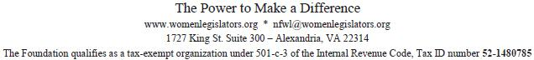

250

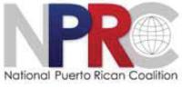
August 22, 2014

Chairman Tom Wheeler

Commissioner Mignon Clyburn

Commissioner Jessica Rosenworcel

Commissioner Ajit Pai

Commissioner Michael O’Rielly

Federal Communications Commission

445 12th Street, SW

Washington, DC 20554

RE: MB Docket No. 14-57

Dear Chairman and Commissioners:

On behalf of the board of directors of the National Puerto Rican Coalition, Inc. (NPRC), I am writing to express support for Comcast’s proposed acquisition of Time Warner Cable.

At the National Puerto Rican Coalition, I have worked closely with Comcast Corporation through leadership organizations including the Hispanic Association on Corporate Responsibility and the National Hispanic Leadership Agenda. NPRC's mission is to systematically strengthen and enhance the social, political, and economic well-being of Puerto Ricans throughout the United States and in Puerto Rico with a special focus on the most vulnerable. In the past 37 years, NPRC has emerged as one of the most respected and effective organizations advocating for the concerns of the more than 8 million Puerto Ricans.

Comcast has demonstrated a sincere commitment to the Latino community, upholding the promises made during the NBCUniversal transaction with respect to community investment, governance, programming, supplier diversity, and workforce. As of year-end 2013, people of color accounted for approximately 40% of Comcast and NBCUniversal’s full-time U.S. employees, and 25% of management employees. While these numbers can be improved, they represent a serious commitment to advance women and communities of color, and exceed the norms in the technology sector.

Comcast’s engagement with the NPRC has focused on Hispanic inclusion in the workforce, governance, and community investment. Comcast’s expansion into New York and other Hispanic population centers across the country will extend Comcast’s commitment to advance Hispanics. By hiring, retaining, and promoting a Hispanic workforce, and developing communities where Comcast employees live and work, Hispanic families will benefit.

1444 I Street, NW Suite 800 Washington DC 20005 Tel. 202-223-3915 www.nprcinc.org

251

NPRC is a proud partner of Internet Essentials, a unique program to encourage low-income families to adopt broadband technology at home. Comcast leadership has demonstrated their sincere commitment to this program time and again, having now connected 350,000 households, more than 1.4 million people to Internet Essentials in three years. Hispanic families have benefited from the considerable information and educational resources available in Spanish language, promoted in community centers, schools, churches, and service organizations. Comcast’s commitment to bring Internet Essentials to New York City and new communities in the Time Warner Cable territory will benefit many Hispanic families, both bringing them affordable at-home broadband at $9.95 per month, as well as digital literacy training to promote educational, entrepreneurial, and healthcare applications.

NPRC has a seasoned history working on technology and telecommunications issues with Hispanic consumers. Our longstanding commitment in support of advancing broadband adoption, and promote innovation to help schools, businesses, and community empowerment.

In the area of talent, shows like Bravo’s “Real Housewives of Beverly Hills” and “Million Dollar Listing New York” have given a positive depiction of Puerto Ricans. With the addition of cast members Joyce Giraud and Luis Ortiz, respectively, these shows have served as a tremendous educational tool by highlighting our culture, our people, and our Island.

In addition, NBC’s “Crossbones” and Golf Channel’s “Big Break NFL” are some of the many production examples that have contributed positively to the local economy of Puerto Rico. A much needed boost given the economic struggle that the island has been facing for the last eight years.

We urge the Commission to consider Comcast’s strong record for promoting diversity and commitment to groundbreaking programs like Internet Essentials to approve this transaction.

/s/ Rafael A. Fantauzzi

Rafael A. Fantauzzi

President & CEO

1444 I Street, NW Suite 800 Washington DC 20005 Tel. 202-223-3915 www.nprcinc.org

252

August 21, 2014

I am writing today to express my support for the proposed Comcast/Time Warner Cable transaction. Before becoming President and CEO of the Northwest Health Foundation in Portland, Oregon, I served for eleven years as executive director of the Native American Youth and Family Center. I remain a member of the National Urban Indian Family Coalition because issues pertaining to Native Americans are very important to me.

These issues are also important to Comcast, a company that supports diversity and inclusion in every aspect of its business. I have served on Comcast's Joint Diversity Advisory Council, and I was privileged to be a panelist at the 2012 biannual meeting in Philadelphia along with several leaders of the Native American community. We discussed the challenges that Native Americans continue to face in the media both in front of the camera - finding appropriate, non-stereotypical roles-and behind the camera.

Although it is impossible to find instant solutions to problems that have plagued the Native American community for hundreds of years, we feel that Comcast is making a strong, sincere effort to tum the tide. Its diversity hiring practices provide opportunities for minorities to get a foot in the door, provide input and hold leadership positions. Once minority employees are hired, Comcast provides mentoring and Employee Resource Groups to retain them and help them advance in the company.

Education is critical to moving Native American youth into the professional world. Comcast partners with the American Indian College Fund to provide a scholarship/internship for two students attending a tribal college or university. Native American students are also among recipients of Comcast's Leaders and Achievers Scholarships.

Bridging the digital divide is another Native American concern, and Comcast has been extremely proactive in helping our youth become computer literate. The Digital Connectors program was launched in Portland in 2009 in partnership with NAYA Early College Academy. This program trains young people for careers in math, science, engineering, technology and production.

Comcast's Internet Essentials picks up where the training leaves off by offering families with one child in the National School Lunch Program broadband service at home for $9.95 a month. This amazing program allows the children to use the skills they are learning at school on their home computers. More than 5,000 Portland families are enrolled in the program at last count.

Why am I telling you all of this? I want to explain that Comcast is more than a provider of entertainment and Internet services; it is a corporate partner that strives to help underserved communities and make them stronger. As Comcast expands into new markets, the benefits of a company engaged in socially responsible programs will help other minority communities.

I urge you to approve the transaction.

/s/ Nichole June Maher

Nichole June Maher

National Urban Indian Family Coalition Board member

253

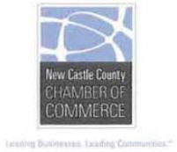

August 22, 2014

Mr. Tom Wheeler

Chairman

Federal Communications Comission
445 12th Street, NW
Washington, DC 20554

RE: MB Docket No. 14-57

Dear Chairman Wheeler:

Innovation and investment: two words I commonly use to describe what we need to keep Delaware's business economy moving forward. Comcast, which operates a large service area in this state, has achieved its success mostly by following these same principles. This kind of business model is what helps to drive the economy forward on both a local and national level. In addition, Comcast has become an important part of our business and civic community by their involvement and support of many local organizations.

As President of the New Castle County Chamber of Commerce, I support the proposed TWC/Comcast transaction because I believe it has the potential to spur additional growth in Delaware and beyond. Comcast is one of the most dynamic technology companies currently operating in Delaware. Some of its latest developments are incredible advancements in the world of home entertainment and broadband. The new X1 operating system is just one example: the program enables viewers to control their TVs across live and on-demand viewing options with just the sound of their voice. Xl is also powered by the Cloud, which means that updates and new system features can be made instantaneously, rather than requiring the installation of a new cable box.

As exciting as these advancements are, I am most impressed by Comcast's commitment to and investment in infrastructure. Comcast has invested billions in its network, and has increased broadband speeds 13 times in the last twelve years. I read recently that it doubles the capacity of its network every 18 months. I consistently tout the benefits of Improving old infrastructure to make way for faster and more innovative services in Delaware, and it's helpful to point to Comcast as a prime example of success. In fact the Chamber worked very closely with Comcast to install a new internet connection for our Emerging Enterprise Center (EEC) which helps early stage companies grow and create jobs right here in New Castle County. They provided a great deal of technical support and service on a voluntary basis to the small businesses involved with the EEC.

On a local level, Comcast is a key business advocate for creating the type of environment for businesses both small and large to grow. Comcast has been a major supporter of the New Castle County Chamber of Commerce and continually supports Initiatives to improve the quality of life for the people of New Castle County. Comcast also has a member that serves on our Board of Directors. It is clear

254

Chairman Tom Wheeler

August 22, 2014

Page Two

that Comcast is eager to be a dependable partner as local economies work to recover and create new, valuable jobs right at home.

Comcast's expanded capacity after a union with Time Warner Cable could have a real and measurable impact on economic growth in the communities it already serves and in new communities, too. A stronger company will foster competition as other broadband providers are forced to step up.

I encourage the FCC to move in favor of this transaction so that Comcast can continue to Invest and support the economy in Delaware and elsewhere.

Sincerely,

/s/ Mark Kleinschmidt

Mark Kleinschmidt

President

New Castle County Chamber of Commerce

255



August 22, 2014

Chairman Tom Wheeler

Commissioner Mignon Clyburn

Commissioner Jessica Rosenworcel

Commissioner Ajit Pai

Commissioner Michael O’Rielly

Federal Communications Commission
445 12th Street, SW
Washington, DC 20554

RE: MB Docket No. 14-57

Dear Chairman and Commissioners:

I write on behalf of Nutmeg Big Brother Big Sisters to share with you our community collaborations with Comcast, and to explain why I support its proposed merger with Time Warner Cable.

Nutmeg Big Brothers Big Sisters is Connecticut's largest volunteer mentoring organization. We help children from low-income, single-parent and no-parent homes reach their highest potential. We do this by creating and maintaining one-on-one relationships between children in need and professionally screened, inspirational adult volunteers. We serve thousands of youngsters in 132 of the state’s 169 municipalities.

Comcast has been a strong supporter of our agency and the work that we do. One of our most successful programs, Beyond School Walls, is made possible only through our partnership with Comcast. The program allows Comcast employees in Connecticut to volunteer their time mentoring students from Lincoln Elementary School. The employees and their young mentees eat lunch together, do homework, play games and sports and have valuable one-on-one time together. Comcast has also coordinated St. Patrick's Day, Thanksgiving and Halloween parties for the students, which are enjoyed by employees and students alike. Beyond School Walls celebrated its 5th anniversary this year.

Comcast has also helped Nutmeg Big Brothers Big Sisters in others parts of the state, working to ensure that we connect with the public and key potential partners so that we can reach and serve more children.
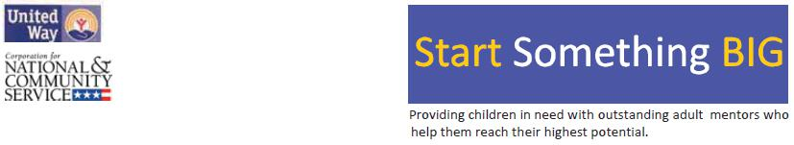

256

If the proposed merger is approved, Comcast will be able to serve 28 additional communities in Connecticut – 24 of which fall within the Nutmeg Big Brothers Big Sisters service area. Which means that, in 24 more communities, we will gain a strong partner in our efforts to raise awareness about our programs and partner with key local agencies.

Few companies that Nutmeg Big Brothers Big Sisters work with are as dedicated to helping the community – and children in need in particular – as Comcast is. We are grateful for Comcast's help and support over the years; it’s clear they share our belief that, with the right kind of support, all children can achieve great things.

From our perspective, if Comcast serves more Connecticut cities and towns, it’s likely that, working together, we will be able to reach and serve more children who need our help. It is for this reason that I write in support of Comcast’s merger application; thank you for your consideration.

Sincerely,

/s/ Andrew Fleischmann

Andrew Fleischmann

President and CEO

257


August 21, 2014

Mr. Tom Wheeler

Chairman

Federal Communications Commission

445 12th Street, SW

Washington, DC 20554

RE: MB Docket No. 14-57

Dear Chairman Wheeler:

On behalf of the Parent Institute for Quality Education (PIQE), I would like to express our sincere support for the proposed merger between Comcast and Time Warner Cable.

What began in 1987 as a series of discussions among parents of a predominantly Latino elementary school in San Diego, CA led to the founding of the Parent lnstitute for Quality Education-PIQE, an organization running 11 regional offices in California and parent engagement in education programs in K-12 schools in nine other states. It all started with one program offering workshops targeted for parents of K-12 children. We bave since grown and developed PIQE's signature program, the "Parent Engagement Education Program", a nine-week curriculum offered to parents in their primary language and aimed at helping them become educational advocates for their children. ln addition to the original program, we now offer 8 more programs for parents and teachers.

PIQE 's mission is to connect families, schools and community as partners to advance the education of every child through parent engagement.

Comcast has been a supportive member of our community in helping PlQE "Create a College-Going Culture". They are demonstrating a commitment to our mission through their various digital literacy programs, particularly Internet Essentials, aimed at disadvantaged youth. We appreciate that a company is so committed to the well-being of a community that that they develop and offer meaningful support programs to address the needs of the community.

Comcast shares our goal and dedication to helping all children succeed in academics and have the option of a post-secondary education. If given the opportunity to expand their network, they will do the same on a larger scale in more communities across the country. For these reasons, we urge prompt approval of the proposed merger.

Should you have any questions or comments, please do not hesitate to contact me at 619-420-4499 or dvalladolid@piqe.org.

Sincerely,

/s/ David Valladolid

David Valladolid

National President & CEO
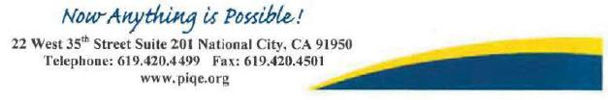

258



August 22, 2014

Mr. Tom Wheeler – Chairman

Federal Communications Commission

445 12th Street, SW

Washington, DC 20554

RE: MB Docket No. 14-57

Dear Chairman Wheeler,

I am writing to you as Chair of the Board of PBS Hawaii to express my support for the proposed transaction between Comcast and Time Warner Cable.

As you know the connection between our cable franchisee and Hawaii's only public broadcasting station has been very strong for over two decades. Making sure that public television, and in particular PBS Hawaii, is available to everyone and that it remains a vital community resource is a mission which we work hard to preserve and promote.

I have met with the representatives of Comcast and came away with their strong assurance that they appreciate the role of public television; that they understand that while Hawaii would be a small part of their overall franchise, that it has unique qualities that will make it an especially important part of their franchise; and that they intend to make investments in the franchise to take services here to the next level. Their goal to provide best-in-class technology to improve the quality and capability of this critical communications path is laudable and very important to Hawaii, and needs our support. I was impressed that the representatives I spoke with had a real appreciation for Hawaii and the specialness of what we have to offer.

I was also specifically impressed with their focus on broadband capability and on features that make it easy for viewers to find the programming they want– including the quality non-commercial education, arts, and entertainment programming that PBS Hawaii delivers to the children and adults in our state.

As the cable industry continues to evolve, the future of television and its relationship with its customers is changing as well. Hawaii needs investments from a company like Comcast to change with it. And Hawaii needs a company that will make the commitment to the special parts of Hawaii that Comcast has made to us.

Sincerely yours,

/s/ Robbie Aim

Robbie Aim

Board Chair

PBS Hawaii

259

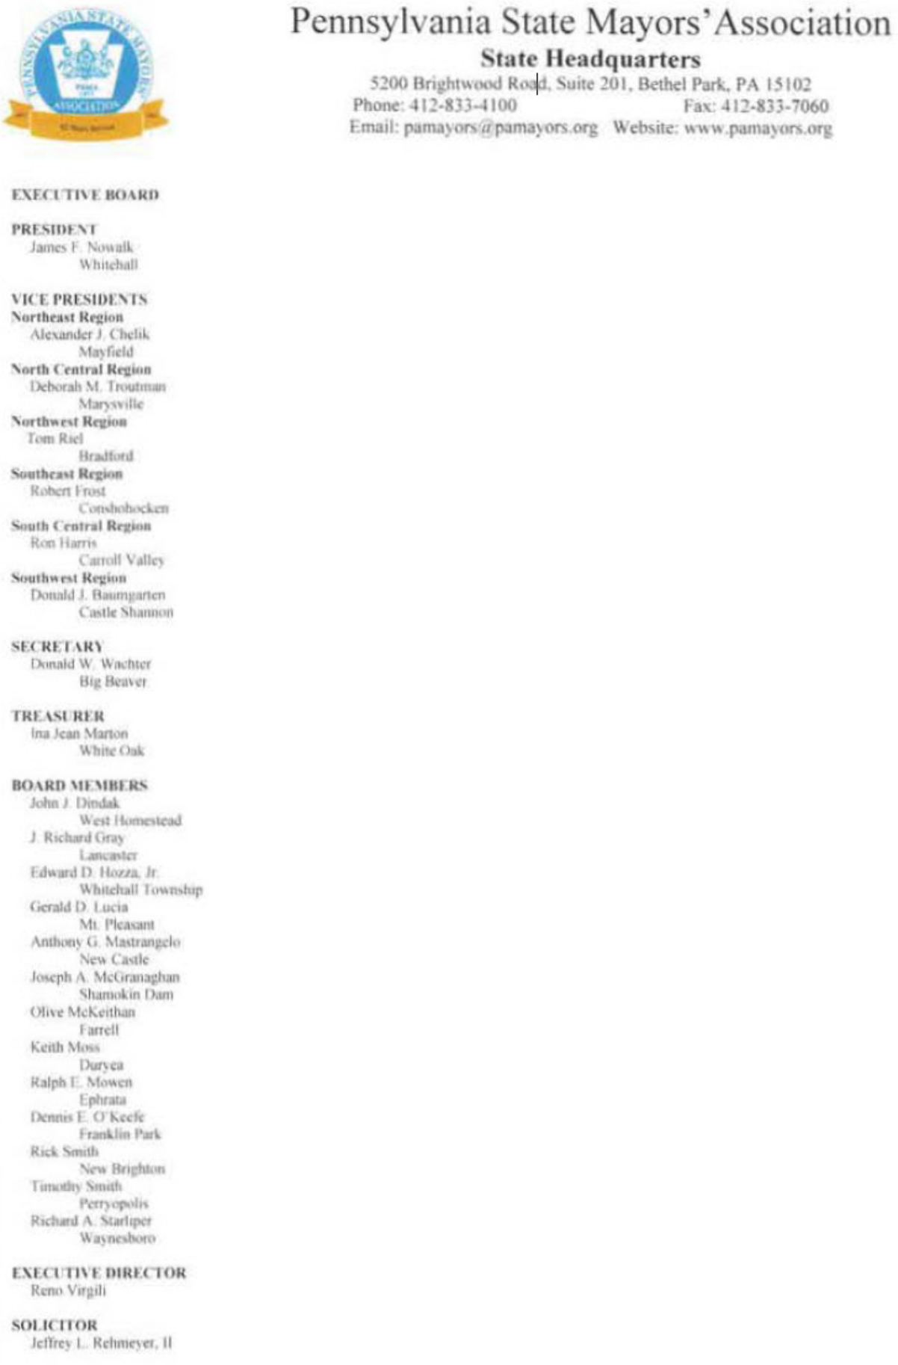

August 21 , 2014

To Whom This May Concern·

As the mayor of Whitehall Borough, Pennsylvania and the President of the Pennsylvania State Mayors' Association, I have had the opportunity to observe and interact with Comcast in my opinion, Comcast has been an exceptional corporate sponsor which has given substantial support to my municipality and mayoral association.

Additionally, because of Comcast, Whitehall Borough and the surrounding areas have speedy and accessible Internet service, an all-digital network, and competitive services for small and large businesses alike. In my municipality, Comcast has been committed to closing the digital divide. The Baldwin-Whitehall School District has benefited from the Internet Essentials program. Already, over 80 students have gotten Internet service that they may otherwise have been unable to afford. These students can access educational programs. job and training offerings, and a world of information previously closed off to them in the 21st century, the Internet is a valuable resource. It should be open to all citizens. Comcast's program has already helped make that possibility a reality in Whitehall and other Pennsylvania municipalities.

For all of the above reasons. I would urge you to consider the proposed transaction between Comcast and Time Warner Cable.

Sincerely,

/s/ James F. Nowalk, President

James F. Nowalk, President

260

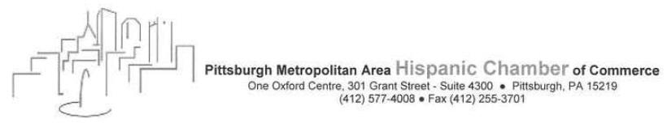

August 22. 20 14
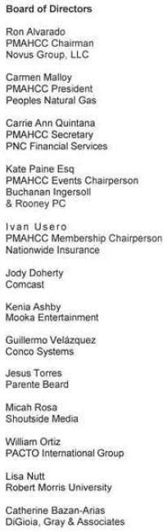

Chairman Tom Wheeler

Commissioner Mignon Clyburn

Commissioner Jessica Rosenworcel

Commissioner Ajit Pai

Commissioner Michael O'Rielly

Federal Communications Commission
445 12th Street, SW
Washing, DC 20554

Re: MB Docket No. 14-57

Dear Chairman and Commissioners:

The Pittsburgh Metropolitan Area Hispanic Chamber of Commerce (PMAHCC) is the principal regional advocate for the Hispanic business community's civic and commercial interests and provides regional business opportunities for economic development.

Comcast was an early corporate supporter of PMAHCC and has senior executive board representation. Comcast also provides the resources that aIlow our voice and message to be heard. This messaging was not just for the Latino community but also to the Pittsburgh corporate leadership. other non-profit influencers and elected officials. All the while updating, educating and advising Hispanic business owners and professionals.

Our partnership with Comcast has enabled us to create great social and business opportunities with the high visibility for the PMAHCC. Part of this successful partnership has been special events, from small mixers to grand events such as: The Three Kings and Hispanic Heritage Month galas.

Since its inception in 2011, the PMAHCC Foundation has raised thousands of dollars to provide financial assistance to local residents of Hispanic descent. In just three years, over 25 scholarships have been awarded.

Comcast has demonstrated that its dedicated involvement in our region and across the country. It is helping to drive economic growth and increasing diversity and inclusion opportunities, as well as tangible investments in our communities. That is why we support the proposed transaction between Comcast and Time Warner Cable.

Sincerely,

/s/ Ron Alvarado

PMAHCC Chairman

261



August 22, 2014
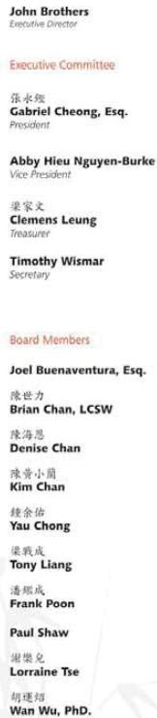

Tom Wheeler

Chairman

Federal Communications Commission
445 12th Street, SW
Washington, DC 20554

RE: MB Docket No. 14-57

Dear Chairman Wheeler:

As the executive director of Quincy Asian Resources, I am writing to express my support for the proposed transaction between Comcast and Time Warner Cable.

Our organization works to foster and improve the social, cultural, economic and civic lives of Asian Americans and their families to benefit Quincy, MA and its neighboring communities. Comcast has shown support of our mission by providing grant funding for our youth leadership program and local support for our teen initiatives including a series of computer classes led by our youth leaders.

Comcast has also made significant investments in Massachusetts and has demonstrated what a responsible corporate citizen looks like. It supports the widespread use and implementation of high-speed broadband in schools and libraries — efforts that promise to create learning environments that bring global resources to the classroom.

Moreover, Comcast’s digital adoption program, Internet Essentials, is a low-cost solution that is helping to narrow the digital divide. Since 2011, the program has provided free training and service to low-income families, offering affordable broadband service that has benefited many Bay Staters. QARI has been a proud to partner with Comcast to deliver digital literacy classes to the Quincy community with the support of the Internet Essentials program. I understand that in 2013, more than 7,600 households in Massachusetts have received service via Internet Essentials. This exemplary program is a tangible example of the company’s commitment to increase the accessibility of the Internet, and the merger with time Warner Cable will extend the program to new areas and provide benefits to many more families.

As an organization focused on providing opportunities for immigrant families, we understand the Internet is a powerful tool capable of connecting our families to the education and careers of the future. It also provides resources to maximize their health and well-being, benefits that underserved populations cannot afford to be excluded from. For these and other reasons, I support Comcast’s proposed transaction with Time Warner Cable.

Sincerely,

/s/ John Brothers

John Brothers, Executive Director

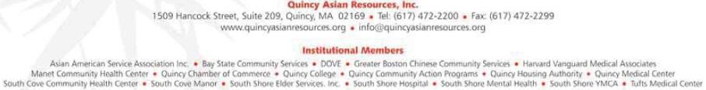
262

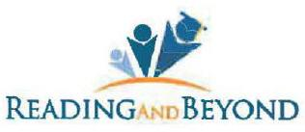

August 22, 2024

Marlene H. Dortch

Secretary

Federal Communications Commission

445 12th Street, SW

Washington, DC 20554

RE: MB Docket No. 14-57

Dear Ms. Dortch:

On behalf of Reading and Beyond, I write to express support for the proposed transaction between Comcast and Time Warner Cable. Our mission is to empower children and families to achieve productive self-sufficient lives. Although children are the focus of our attention, we cannot ignore the parents and the community If we want the children to succeed.

We at Reading and Beyond are impressed with Comcast's dedication to improve community life. We seek to prepare youths in our community for a brighter future through tutoring and college preparation and job training for parents. While Comcast is a large company, it still cares about the community and shows it through their many community-based programs. Through its actions, Comcast has shown that the company understands the importance of investing in our youth's future.

Reading and Beyond has worked with Comcast to help Implement their Internet Essentials (IE) program since its inception. When we heard about this program we signed up to help because we saw the value for the families we serve. In just three years, the IE program has connected 9,250 Fresno families and over 35,000 California families to affordable home broadband - most of them for the very first time. These are families that otherwise would not have been able to afford the regular price of Internet access that other companies charge. Under the IE program, the "price is right," and the enrollment process is straightforward.

We know that to be able to access the Internet at home is more than a luxury for families - it has now become a necessity in their lives. Many of the families we serve are now able to do Important tasks such as monitoring their children's academic progress and searching for jobs, all because they are able to afford Internet access under Comcast's IE program.

Reading and Beyond supports programs such as Comcast's IE because we see their value and impact on our high need communities. We believe that the expansion of Comcast into Time Warner Cable areas will extend similar benefits to other communities. Thank you for taking our perspective into consideration.

/s/ Luis Santana

Luis Santana, MSW

Executive Director

4670 E. Butler Ave. ● Fresno, CA 93702 ● Phone (559) 600-6185 ● FAX (559) 600-7639

E-Mail info@readingandbeyond.org ● Web-Site www.readingandbeyond.org

263


Tom Wheeler

Chairman

Federal Communications Commission
445 12th Street, SW
Washington, DC 20554

RE: MB Docket No. 14-57

Dear Chairman Wheeler,

On behalf of the Redwood City-San Mateo County Chamber of Commerce, I would like to express our support for the merger between Time Warner Cable and Comcast. We are interested in the benefits that this merger could have for our members.

The Foundation of our Chamber of Commerce is built upon a strong program of economic development and helping to create a path where successful and sensible growth can take place. As a representative of 1000 Business Member and 60,000+ employees throughout the San Mateo County Community we recognizes the challenges that businesses can face when looking to move, build, relocate, or development and the impediments that often stand in the way of their ability to bring a project to fruition.

If this merger is successful, we predict it will offer many advantages for our members. The entry of Comcast’s business offerings into more markets where our members operate will create new competition for telecom services. As a result, our members will have more choices of providers for high-end services, and our larger business members with locations in both the northern and southern parts of the state will be able to better integrate their operations, thus increasing efficiency and lowering operating costs.

Our goal is to make sure our members have access to an improving and hospitable climate for business. We believe this merger creates just that, and we support it.

All the best,

/s/ Amy N. Buckmaster

Amy N. Buckmaster

President & CEO

264

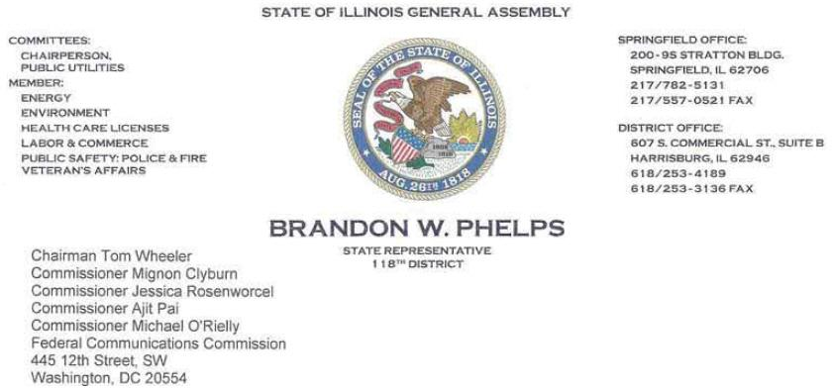

Dear Chairman and Commissioners:

RE: MB Docket No. 14-57

Thank you for this opportunity to express to you my support for the proposed Comcast and Time Warner Cable transaction and all that such a business collaboration would bring to the State of Illinois, and beyond. As a fifth-term legislator in Illinois, having served as a Representative for the 118th District since January 2003, my request for your approval of this transaction stems from direct knowledge of the implications for our state's businesses and for Illinois families.

While my district currently does not enjoy Comcast video or broadband service, as Chairman of the Illinois Public Utilities Committee. I know well the positive impact Comcast's Industry-leading services have had on Illinois businesses and consumers.

Comcast has been a proven investor In Illinois communities for nearly two decades. I understand that In 2013 alone, Comcast spent over $1.3 billion in our state on capital expenditures, taxes and fees, employee investment, and community investment. The company operates dozens of facilities In Illinois. It employs close to 7,000 of our residents with a demonstrated commitment to employ our nation's military veterans. The additional economic opportunities a combined Comcast and Time Warner Cable could generate are exciting to think about.

The transaction would also extend Comcast’s ongoing commitment to a free and open Internet. I have long promoted the kind of technology Innovation, job creation and business growth that an open Internet cultivates. The proposed transaction would push an open Internet to millions more cable customers.

I am also excited that this transaction could deliver Comcast's broadband speed increases and new technologies like next generation TV, live TV streaming, and neighborhood hotspots for Xfinity WIFI to the communities throughout the state.

We see the partnerships that Comcast has formed in Illinois, whether through business, education, or the many volunteer activities carried out in our communities. We want those partnerships to be bolstered by a stronger Comcast, and for more Illinois residents to benefit from the advanced, quality services that the company has proven it can deliver. For these reasons, I sincerely ask that the Commission approve this merger.

Sincerely,

/s/ Brandon W. Phelps

Brandon W. Phelps

State Representative
118th District

265

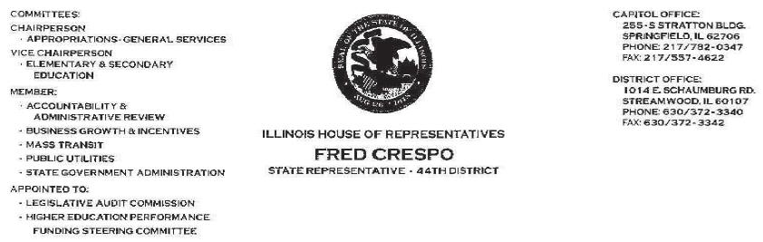

Chairman Tom Wheeler

Commissioner Mignon Clyburn

Commissioner Jessica Rosenworcel

Commissioner Ajit Pai

Commissioner Michael O'Rielly

Federal Communications Commission

445 12th Street, SW

Washington, DC 20554

RE: MB Docket No. 14-57

August 21, 2014

Dear Chairman and Commissioners:

I have dedicated my political career to improving life for the residents of Illinois, first as a Trustee for the Chicago suburb, The Village of Hoffman Estates, and as an Illinios State Legislator since 2007. Education in particular has been my passion and that is a significant part of the reason I am contacting the Commission and asking its members to approve the Comcast and Time Warner Cable transaction.

Comcast and NBCUniversal share my commitment to spotlighting education issues. NBCUniversal's annuaI "Education Nation" Summit, which was launched in 2010, offers a public dissection of aII the issues involved with education while explaining what 21st century learning requires of students and teachers. An important outcome of those workshops, speakers and town hall gatherings has been the awareness of technology's increasing role in how, when and what our students learn.

In today's world, access to the best technology is one of the most the critical features of a top education. Students who can connect digitally have a world of opportunity literally at their fingertips. Yet, many children still lack the basic equipment and Internet access they need to perform to national standards and to compete with their international peers. Here in Illinois, there have been efforts to close the so-called Digital Divide and no company has done more to connect children to computers and the Internet than Comcast and its Internet Essentials program. Families who cannot afford computers and Internet service are able to get both at deep discounts. In Illinois, this program has helped bring Internet access at home to tens of thousands.

Comcast and NBC Universal have also invested in scholarships, grants, volunteer hours and programs like Digital Connectors, and this commitment to community partnerships gives me great optimism. Moreover, I understand that the combined entity will serve more communities throughout the country than ever before upon approval of the transaction. The expansion of Comcast service into new markets will not just represent the expansion of infrastructure or technology. It will represent the expansion of community partnerships and positive corporate relationships.

Just as important are the potential technological innovations and economic opportunity it can bring as well. Illinois already benefits from the robust operations Comcast has based here, including owned and operated NBC and Telemundo affiliates, close to 7,000 local employees, and millions in infrastructure investments.

I witnessed the vast community improvements that came with the Comcast and NBC Universal partnership and I can only imagine the positive benefits that will result from expanded presence of those companies under the proposed agreement.

I urge you to approve this transaction.

Sincerely,

/s/ Fred Crespo

Fred Crespo

Illinois State Representative, 44th District

266



August 22, 2014

Tom Wheeler

Chairman

Federal Communications Commission

445 12th Street, SW

Washington, DC 20554

RE: MB Docket No. 14-57

Dear Chairman Wheeler:

As a member of the Georgia House of Representatives, it is my honor to work on behalf of the people of our state, and in particular, the citizens of the 107th District it is also my responsibility to apprise myself of opportunities that with help advance Georgians, and for this reason, I respectfully suggest that you approve the transaction between Comcast and Time Warner Cable.

In Georgia, Comcast is a pioneering corporate citizen that has planted roots In our state. It has made broad Investments and its presence has impacted Georgians for the better. Comcast is developing strong partnerships and using Innovative techniques to add res$ challenges in our state and our nation.

I understand that Comcast's Internet Essentials program, the largest and most comprehensive digital adoption initiative in the country, is bringing free training and low-cost high-speed Internet into the homes of close to 25,000 low-income Georgia families.

It is my understanding that over one million people in Georgia call Comcast their service provider. I believe that the company's transaction with Time Warner Cable would strengthen Comcast as a telecommunications industry leader and generate additional benefits for these and other consumers through faster and more exciting innovations.

As a model corporate citizen, employer and Innovator, Comcast Is committed to the future of Georgia. In my opinion, the company's proposed transaction with Time Warner Cable should be approved. I hope you agree.

Sincerely,

/s/ David Casas

David Casas

Representative of the 107th District
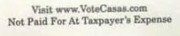

267

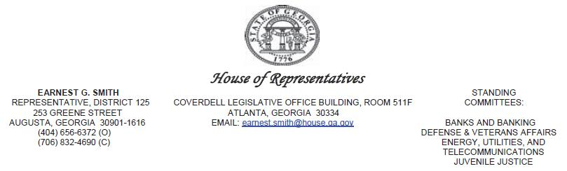

August 20, 2014

Chairman Tom Wheeler

Commissioner Mignon Clyburn

Commissioner Jessica Rosenworcel

Commissioner Ajit Pai

Commissioner Michael O’Rielly

Federal Communications Commission
445 12th Street
Washington, DC 20554

RE: MB Docket No. 14-57

Dear Chairman Wheeler and Commissioners:

As a member of the Georgia House of Representatives and a devoted public servant, the prosperity and welfare of our citizens, especially those in Augusta, Georgia, is my highest priority.

Because of the integrity and values that Comcast has demonstrated in Georgia, in particular in Augusta, I am pleased to support its proposed transaction with Time Warner Cable a union that will surely generate real and tangible benefits for the consumer.

From my experience, Comcast is a prime example of the businesses that we need to cultivate and attract here.

Comcast contributes to the communities in which it lives and works. Comcast and NBC Universal spent $716 million in Georgia in the last year, a figure that reflects capital projects, taxes and fees, and employee and community investments.

Comcast has also delivered its Internet Essentials program to the Georgia communities it serves, bringing free training and low-cost Internet services to the homes of low-income families. More than 8,200 Georgia households benefitted from this program last year, making a significant difference in the lives of low-income students and their families.

268

While Augusta has benefited from its relationship with Comcast, there are markets elsewhere in Georgia that could also benefit tremendously, and the combination of Comcast and Time Warner Cable will deliver unparalleled, industry-leading service, not to mention increased community investment and economic development.

On behalf of my constituents, whose best interests are first and foremost, I support Comcast’s proposed transaction with Time Warner Cable, and I recommend its swift approval.

Sincerely,

/s/ Earnest Smith

Rep. Earnest G. Smith, AAE, PMP

Senior Executive Stakeholder Strategist

Savannah River Nuclear Solutions

269

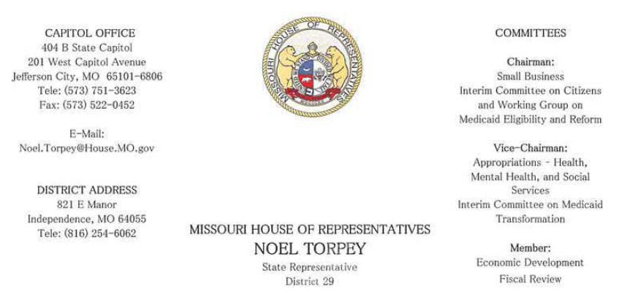

August 22, 20I4

Tom Wheeler

Chairman

Federal Communications Commission
445 12th Street, SW
Washington, DC 20554

RE: MB Docket No. 14-57

Dear Chairman Wheeler:

Nothing is more serious than ensuring every child in every community across the country has access to a great education. I say this is as the husband of a public school teacher, as well as a Representative for the 29th District of Missouri. The battle for more education funding continues to play out on all levels of our government, and the participation and sponsorship of companies in the private sector is more important than ever before. Luckily for me, my cable provider, Comcast, has demonstrated a commitment of providing tools to local schoolchildren to help them succeed in the classroom and beyond. My support of the Time Warner Cable/Comcast transaction is primarily for that reason, and I look forward to the endless possibilities a union of these two companies would bring to the Kansas City community.

As technology advances rapidly across the world, it is our children who will be responsible for keeping us current and competitive. We need to be training them now for careers that will help advance these ideas here at home. Missouri schoolchildren are falling behind in the subjects that they need to excel in. In my home school district in Independence, 56.2 percent of local high school students displayed proficiency in science while only 41.9 percent of students were determined proficient in mathematics last year. Our students will not be able to compete on a world stage without strong corporate partners who are willing to support new skills and

270

technology programs that will help them improve. My wife, a kindergarten teacher in the Independence School District, believes early childhood education that capitalizes on the latest educational tools will prepare our kids for the brightest futures. Fortunately for us, Comcast has shown a commitment to sponsoring more technology for classrooms and breaking the mold to enhance students' digital literacy.

Internet Essentials, one of Comcast's signature programs, has become the shining example of just how great an impact these public/private partnerships can have. While the material elements of the program are great (home Internet service for $9.95/month and the option to purchase a heavily-subsidized computer), it's the free digital training options that are the most revolutionary. In my experience, it is extraordinary for a company to use its resources to set up free training centers in local communities to patiently help students and families learn about the Internet.

Comcast also has committed resources to advance learning directly in the classroom through their Digital Connectors program, which provides the facilities for students and young adults to develop their skills in using computers, applications and the Internet. Comcast has given so much to their communities, and they show no signs of slowing down. We should only encourage that kind of corporate citizenship. I have personally engaged in Comcast community projects-I was invited to help hand out 10 $1,000 scholarships to high school students as part of Comcast's Leaders & Achievers program and I also participated in a community clean-up project through Comcast Cares Day. I cannot think of a better company to partner with as we work to prepare our community for a brighter future.

I encourage the FCC to approve the Time Warner Cable/Comcast transaction to help keep this excellent work moving forward.

Sincerely,

/s/ Noel Torpey

Representative Noel Torpey

District 29- Jackson County

State of Missouri

271

I write this letter in support of the proposed Time Warner Cable/Comcast transaction. As the Executive Director of an Access Management Organization, I have had the distinct pleasure of working with Comcast on new initiatives to enhance public broadcasting. We represent a large, rural area of Vermont and connecting residents through access to local programming can be imperative. Thanks to Comcast's innovative solutions and commitments to its cable subscribers, we are more connected than ever before.

Rutland Region Community Television is an independent non-profit organization that promotes public, educational and governmental (PEG) cable access to the community. We currently have three channels dedicated to these topics airing over Comcast cable. Our center operates and maintains studio and portable video production facilities that any certified person may use to create a television presentation that is to be cablecast over the public access channel. Programs range from political talk shows, municipal meetings and arts programs to school talent shows, student produced programs to health service PSAs. Generally, we connect our far-flung residents with news and videos of what's happening across our broad service network.

Comcast recognized our unique, rural setting and offered to pilot an IP-based video return line technology for remote origination (live remote shoots). We had been looking for ways to feature content from residents who were unable to travel to our center for filming, so we began a year-long test run with Comcast to solidify the return line across our network. Our staff worked hand in hand with some of Comcast's top engineers and equipment teams to set up the exact program

272

that would fit our needs. This is now the exclusive way we get remote shoots back to our studio, a technology that will be able to be deployed throughout the state to increase public access opportunities in a cost effective way .

Through this new technology, we have a new way for rural families and communities to share news with residents tens of miles away. Comcast

was most impressive not only in engineering a new technological feat, but tailoring this discovery directly to the needs of the communities in rural, central Vermont. The local Comcast team was patient and honest with us through the whole process, trusting our judgment and respecting the conventions and values of our local programs. Comcast went beyond the normal standard of a broadband company/local cable relationship and became a true partner in public access development. Without their assistance, we would still be struggling to connect all of our residents to our united network of local programs.

I encourage the FCC to take notice of this example of Comcast's commitment to community and PEG programming as it considers the proposed Comcast/TWC transaction. It is time that more public access providers have such a dependable corporate partner as Comcast.

/s/ Michael J. Valentine

Michael J. Valentine

Executive Director - RRCV

273

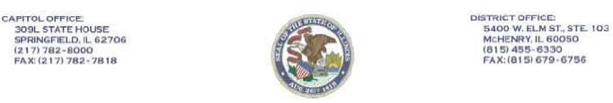

PAMELA J. ALTHOFF

STATE SENATOR ● 32ND DISTRICT

REPUBLICAN CAUCUS CHAIR

Chairman Thomas Wheeler

Commissioner Mignon Clyburn

Commissioner Jessica Rosenworcel

Commissioner Ajit Pai

Commissioner Michael O’Rielly

Federal Communications Commission

445 12th Street, SW

Washington, DC 20554

RE: MB Docket No 14-57

August 21, 2014

Dear Chairman and Commissioners.

I am writing to provide information which I believe the Commission will find valuable in its deliberations on the proposed Comcast/Time Warner Cable transaction. I wholeheartedly support the proposed merger and hope the comments provided assist the Commission in making positive recommendation in support of the merger.

My support is based on my diverse experience, including my years as an educator of developmentally disabled children, owner and operator of a small cable system, and an elected official at both the local and state levels. I am currently a sealed Illinois state senator serving in leadership since 2012. I was appointed as state senator in 2003. elected in 2004 and have maintained this position through the present day. Prior to my state service, I was elected to the position of Mayor of McHenry, Illinois. My fields of expertise include economic development, tax reform, education funding and transportation.

Personally and professionally, I have seen the growing role that technology and communications play in business and government. I know the benefits communities stand to gain when they embrace the kinds of technological innovation and growth promised by the proposed transaction. Here in Illinois, I am aware that since 1996, Comcast has already invested $6.4 billion in infrastructure and technology improvements. It is safe to assume that other states and markets will benefit from Comcast’s long standing dedication to continually improve their service standards.

As a former educator and current elected official I am a staunch proponent of easy and full access to existing and developing technology. I acknowledge and applaud Comcast’s dedication to providing programs to disadvantaged populations who can’t afford Internet access much less the hardware and devices that deliver internet services. Comcast’s “Internet Essentials” in particular, has opened a door to the digital world for 1.2 million people in our nation through discounted services. Thousands of low-cost computers have been made available, along with free training on using computers and the Internet. Job training and 21st century communication are now available to those folks, enhancing their career competitiveness and community ties. But most of all, it is my understanding that 98 percent of those who qualified for Internet Essentials said their children use the Internet to succeed in school! Without that essential resource, kids can be left behind from their wealthier, better-connected peers. We can’t shut out a substantial portion of our children from growth and success.

Comcast has also demonstrated a commitment to another population, one whose needs I have also championed - our veterans. As I was in the midst of sponsoring a bill last year that would create a Homeless Veteran Protection Task Force, with the aim of learning how we can better protect our homeless vets here in Illinois. I was approached by Comcast who offered to provide assistance in developing internet services for homeless veterans. Comcast was revising its corporate goal of hiring 1,000 veterans within three years. Having reached its goal early, the company set a revised goal of 2,000 veteran hires. It took just months to hit that second target. I wish my Homeless Veteran Protection Task Force bill would have passed with such ease!

In Illinois, we value corporate commitments that take into account the needs of its workforce, the business needs of the communities in which it operates, and the needs of those whose voices often go unheard. We welcome the expansion of such efforts in other communities across the U.S., which would occur with the Comcast and Time Warner Cable transaction.

Sincerely,

/s/ Pamela J. Althoff

Pamela J. Althoff

Illinois State Senator, District 32

PJA/cd

RECYCLED PAPER ● SOYBEAN INKS

274



August 21, 2014

Tom Wheeler

Chairman

Federal Communications Commission

445 12th Street, SW

Washington, DC 20554

RE: MB Docket No. 14-57

Dear Chairman Wheeler:

As the current President and CEO of SER-Jobs for Progress, and former Chair of the Hispanic Association on Corporate Responsibility (HACR), I am optimistic about the potential benefits of Comcast’s acquisition of Time Warner Cable. Comcast has proven to be a solid corporate citizen on matters of import to the Latino community, and I believe those values and practices would greatly benefit people of color in the new markets the company would enter.

Throughout my work with HACR, I monitored Comcast’s progress as the company attempted to bring more people of color into its workforce. Comcast’s increase of nearly 30% in minority hiring at the VP level and above from 2010-2013 is an impressive achievement and a trend I expect to see continue. The company has generally been a top rated place to work for women and minorities – who, the company reports, make up about 60% of Comcast’s total workforce. This suggests that Comcast not only makes the effort to recruit a diverse workforce but also fosters an environment of inclusion that develops and retains that talent.

Comcast’s efforts to bridge the digital divide are also having a profound impact on communities of color. Internet Essentials is preparing the next generation of the Hispanic workforce, not to mention their parents and caregivers, with the digital skills that will help them qualify for higher quality jobs. We believe it critical that Hispanics not be left out of the careers of the 21st Century due to lack of technical know-how, and expanding programs like Internet Essentials to more markets is an unquestionable benefit of this proposed merger.

I ask that you seriously consider the benefits Comcast has brought to Hispanic communities – and would continue to bring to even more communities – as you consider approval of this transaction.

Sincerely,

/s/ Ignacio Salazar

Ignacio Salazar

President & CEO

SER-Jobs for Progress National, Inc.

275

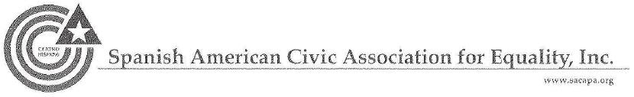

August 22, 2014
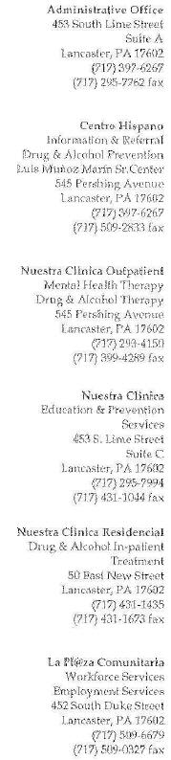

Tom Wheeler

Chairman

Federal Communications Commission
445 12th Street, SW
Washington, DC 20554

Re: MB Docket No. 14-47

Dear Chairman Wheeler:

Comcast has been involved in the city of Lancaster and with the Spanish American Civic Association for many years. We would like to reach out to the FCC and express our support for the merger between Comcast and Time Warner Cable.

The Spanish American Civic Association (SACA) has long been committed to the empowerment of the Latino community in Lancaster County. Lancaster is flourishing as a city, we have a new convention center, a vibrant arts community, and the development of the northwest corridor. But all of these achievements can obscure the fact that many individuals live in poverty and the unemployment rate is staggering. It is our hope that through our work we will be able to help reshape the community and enable those in poverty to succeed in a career.

For over a decade Comcast has been serving our community, partnering with SACA on many events and helping with programs. For eight years Comcast has supported us through their Comcast Cares Day event, getting out in the community to help make improvements.

Comcast has teamed up with our organization to help train the people of the community in digital literacy as a part of its "Internet Essentials" offering. We are ardent supporters of the Internet Essentials program and have signed on to be training partners, bringing the program's digital skill-building components deeper into our communities. We know that Internet access in the home can simplify processes like applying for jobs; we need to continue to make this case to the people we serve every day. Low income families are far more likely to not have home access to the internet.

Internet Essentials helps level the playing field by ensuring that even the neediest Americans can have access to the internet.

276

Poverty is not something you can extinguish overnight, but these past ten years with Comcast's help have certainly made a difference. They are a strong corporate citizen who supports the communities they serve. If the merger with Time Warner Cable is approved, we are confident that more organizations like ours will benefit.

Sincerely,

/s/ Carlos Graupera

Carlos Graupera

President

277

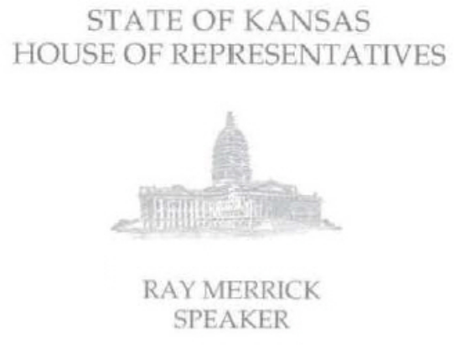
Tom Wheeler

Chairman

Federal Communications Commission
445 12th Street, SW
Washington, DC 20554

RE MB Docket No. 14-57

Dear Chairman Wheeler:

As Speaker of the Kansas House of Representatives and longtime resident of Kansas, I am deeply committed to bringing the best resources to my constituents. Not only have I been an elected official since 2000, but I've gone to school and raised a family in my district, and I understand the impacts that businesses like Comcast can make on our communities. Time Warner Cable currently holds the majority of the market here In Kansas City.

I support the proposed transaction between Comcast and Time Warner Cable, because I am hopeful that a combined company can build upon the good already done in our community. In the House, I have worked continuously to grow business opportunities and avenues for expansion. Comcast has repeatedly shown that it is a trustworthy company that cares about its customers by delivering industry leading service and improving those services time and time again. We'd love to have those services throughout all of the Kansas City market.

An additional benefit of expanded Comcast services would be a larger rollout of low cost broadband through the Internet Essentials Program into new communities. This program recognizes the digital shift in education, and how imperative digital literacy is to our children's success. Comcast has helped bring computers and internet access into the homes of children who without it would be at a great disadvantage. We've also seen how the impacts of digital technology are important for communication, healthcare and employment.

Through the developments that we’ve seen here in Kansas, it’s clear that the cable technology industry is constantly evolving. Comcast should be given the ability to adapt to the changing marketplace and continue to grow its innovative services. From a competitive perspective, it benefits all of us, particularly our small to mid-sized businesses that need innovative services to drive their operations in the global economy.

For these reasons, I encourage you to approve the proposed transaction between Comcast and Time Warner Cable.

Sincerely,

/s/ Ray Merrick

Ray Merrick

Speaker, Kansas House of Representatives

278



August 25, 2014

The Honorable Thomas Wheeler, Chairman

The Honorable Mignon Clyburn, Commissioner

The Honorable Ajit Pai, Commissioner

The Honorable Jessica Rosenworcel, Commissioner

The Honorable Michael O’Rielly, Commissioner

Federal Communications Commission

445 12th Street, SW

Washington, DC 20554

In the Matter of

Comcast - Time Warner Cable,

MB Docket 14-57

Dear Chairman Wheeler, Commissioner Clyburn, Commissioner Pai, Commissioner Rosenworcel, and Commissioner O’Rielly:

The Taxpayers Protection Alliance (TPA) writes today to urge the Federal Communications Commission (FCC) to approve the pending transaction between Comcast and Time Warner Cable. TPA believes that this combination will lead to increased investment in critical infrastructure at no cost to American taxpayers and will also achieve other Commission policy goals without wasting public funds or introducing onerous regulations on the vibrant broadband industry.

TPA is a non-profit, non-partisan organization dedicated to educating the public through the research, analysis and dissemination of information on the government’s effects on the economy. With that mission in mind, the pending transaction between Comcast and Time Warner Cable should be allowed the due process of examination by the government, and the FCC in particular. However, there should be no doubt that this merger will respect the principles of choice and competition that TPA believes in, while allowing for increased opportunities and better service for consumers.

TPA believes that the proposed merger will potentially produce hundreds of millions of dollars in broadband infrastructure investment from the private sector in the near term. This presents a number of public interest benefits. First, the deal means a faster upgrade of broadband communications facilities for consumers and, perhaps more importantly, for American businesses. Promoting private investment that yield high returns for American consumers and businesses should be the Commission’s guiding policy principle, and approving this transaction would send a strong signal to companies and investors.
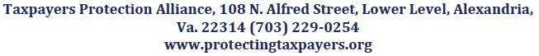

279

Second, the merger has the potential to vastly improve business output in a number of markets. Comcast’s entry into new markets will increase competition for business services and offer firms with operations in multiple cities across the country an option that deeply integrates communications and IT functions. The results are cost savings through competitive responses and greater efficiency. These benefits also increase the output capabilities of smaller and mid-sized firms that rely on Comcast to “host” virtual phone service and file-sharing collaborative software that has previously been available only to the largest firms.

Finally, the transaction helps to achieve through the private market key Commission goals that would other otherwise call for massive use - and potential waste - of public funds. With Comcast’s faster service available in more markets, millions of additional households would have broadband connections of - on average - 25 Megabits per second. And the Gigabit speeds that would be available to businesses in new markets would seem to obviate the absurd notion that state and local governments should fund their own risky and costly broadband networks to achieve the same results.

The world is constantly changing and the rules and regulations that are in place must take into account the advances in technology that have been made in the last few decades. The FCC shouldn’t operate based on an outdated model for what the market is and what options are available to the public in terms of how they choose to get their content legally. Along with those realizations, the pending transaction between Comcast and Time Warner Cable must be examined in a light that reflects the evolution of technology and commerce and where we are today. The transaction poses no competitive threat in any market and will lead to several public benefits without ambling down the perilous road of massive taxpayer waste. TPA urges the Commission to approve it without delay. Thank you for your time.

Regards

/s/ David Williams

David Williams

President

Taxpayers Protection Alliance

280

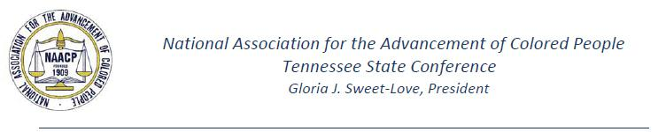

August 20, 2014

Chairman Tom Wheeler

Commissioner Mignon Clyburn

Commissioner Jessica Rosenworcel

Commissioner Ajit Pai

Commissioner Michael O`Rielly

Federal Communications Commission

445 12th Street, SW

Washington, DC 20554

RE: MB Docket No. 14-57

Dear Chairman Wheeler and Commissioners:

As President of the Tennessee Conference NAACP for the last two decades, my goal has been not only to represent our state organization with integrity, but to serve as an advocate for our many communities of minority residents. With that goal in mind, I write to encourage the Federal Communications Commission to approve Comcast's proposed merger with Time Warner Cable.

It should not surprise you to know that the NAACP seeks to promote diversity in all ways. It therefore should not surprise you to know that the Tennessee Conference NAACP has a true appreciation for Comcast and its efforts to build a more diverse and inclusive workforce. Bringing this good business practice to more communities through a union with Time Warner Cable will be a good thing for us all.

As a committed corporate partner in Tennessee, Comcast last year donated grants and volunteered many hours at community agencies worth a total of $6 million. It also employed almost 3,000 of our residents.

But more importantly, I want to emphasize our appreciation for what Comcast is doing to bring disenfranchised populations into the digital age and how significant that is for all communities.

Our organization strongly supports Comcast's Internet Essentials, a low-cost internet access program available to low-income families that qualify for school lunch programs. This corporate initiative is in line with our own NAACP National Education program, which builds equal access for everyone through training, policy, and network development.

Internet Essentials provides access to a wealth of information and opens the door to educational opportunities, while also providing assistance to populations often shut off from technology, based on affordability alone. With education comes opportunity and with opportunity comes empowerment. Internet Essentials will give so many citizens we serve and represent the ability to live that concept every day.

27 Brentshire Square, Suite A • Jackson, Tennessee 38305

Phone: (731) 660-5580 • Fax: (731) 660- 5002 • Email: tnnaacp3@bellsouth.net

281

Without vital programs like Internet Essentials and corporate partners like Comcast, the NAACP's marginalized populations cannot realize their full potential. I sincerely look forward to the combination of Comcast and Time Warner Cable as I believe it will expand the scope of such opportunity to many others. Your approval of the transaction can make that happen.

Sincerely,

/s/ Gloria J. Sweet-Love

Gloria J. Sweet-Love

State President

NAACP-Tennessee

27 Brentshire Square, Suite A • Jackson, Tennessee 38305

Phone: (731) 660-5580 • Fax: (731) 660- 5002 • Email: tnnaacp3@bellsouth.net

282

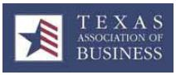

August 22, 2014

Chairman Tom Wheeler

Commissioner Mignon Clyburn

Commissioner Jessica Rosenworcel

Commissioner Ajit Pai

Commissioner Michael O’Rielly

Federal Communications Commission
445 12th Street, SW
Washington, DC 20554

RE: MB Docket No. 14-57

Dear Chairman Wheeler and Commissioners:

As president of the leading business association in Texas, I voice my support of the proposed Time Warner Cable - Comcast transaction. As the state chamber of commerce, the Texas Association of Business is the most influential and dominant voice for public policy issues affecting business in Texas. Through proven results-oriented advocacy and member services, TAB develops a climate in Texas which enables more than 4000 business members and their 600,000+ employees to operate efficiently and profitably, thus creating new jobs.

Time Warner Cable has a long history of service to our association and the Texas community-at-large. It is our belief that a merged Time Warner Cable and Comcast will strengthen our core initiatives and allow for additional investment to advance new, state-of-the-art technology that will help keep a healthy Texas economy on a successful path.

Comcast's commitment to constantly improve its infrastructure is evidenced by the billions of dollars it has invested in its network, allowing increases in broadband speeds 13 times in the last 12 years. We appreciate that Comcast has doubled the capacity of its network every 18 months and their pursuit to extend fiber optic connections into new territories is encouraging as the population of Texas continues to grow. This type of connectivity will enhance business productivity across Texas and will open new doors for workplace creativity.

On a local level, Comcast has been a key business advocate for creating an entrepreneurial ecosystem that spurs job creation in many communities across our state. In other states and cities across the country, Comcast has joined with thousands of local companies and chambers of commerce in delivering leading services that foster 21st century competition. All indications show that Comcast is eager to grow as a dependable partner in Texas as local economies work to create new, valuable jobs.

Finally, I have learned that Comcast's broadband adoption program Internet Essentials, which offers low-cost Internet access and affordable computers to families with kids eligible for free or reduced-price school lunches, will be extended to areas served by Time Warner Cable. The careers of tomorrow are likely to heavily rely on workers with high-tech science and math skills, and this program would empower thousands of Texas's most disadvantaged children and families. It is to the benefit of all of us

283

that a company like Comcast takes such an active interest in digitally connecting our low-income communities.

It is my hope that the FCC will support this proposed transaction between Comcast and Time Warner Cable. I look forward to what I'm sure will be an excellent partnership for all of Texas. Thank you for your consideration and please call on me if I can provide additional information.

Sincerely,

/s/ Chris E. Wallace

Chris E. Wallace

President

Cc: Ms. Marlene H. Dortch, Secretary, Federal Communications Commission

284



August 20, 2014

Mr. Tom Wheeler

Chairman

Federal Communications Commission
445 12th Street, SW
Washington, DC 20554

RE: MB Docket No. 14-57

Dear Chairman Wheeler:

The United Neighborhood Organization (UNO) Is one of the largest Hispanic organizations in the greater Chicago area and serves over 20,000 individuals annually. Since 2009, UNO has partnered with Comcast In support of our Youth Leadership Development Program at the Hector P. Garcia, M.D. campus. This program has been a critical neighborhood-based approach, mentoring high school students.

Comcast's commitment to diversity and educational opportunity could not be more evident. Consider that UNO's 16 Charter Schools serve over 7,500 students, with over 90% of those students qualifying for low-income lunch programs. We are convinced that Comcast understands our vision and respects the aspirations of our community and therefore are a strong supporter of Comcast and the Comcast Time Warner Cable merger.

Overall, Comcast has been a strong partner to UNO over the last five years.

- In 2009, Comcast awarded UNO a $30,000 grant over a three year period for UNO's Youth Leadership program, mentorlng over 450 students.

- In April 2012, 80 Comcast employees were present at UNO's Bartolome de las Casas campus for the Comcast Cares Day. With volunteers from Comcast, UNO families and community members, the campus was landscaped, the exterior fence was painted and the playground area was revitalized.

- In August 2012, UNO partnered with Comcast to announce Internet Essentials and kick off its second year at the Veterans Memorial campus.

- In 2012, Comcast gave UNO the opportunity to appear on their Newsmakers Program to help raise further awareness of UNO's mission and vision.

UNO is very grateful for Comcast's support over the years. We wish the company all the success and look forward to discovering new ways to partner with this dynamic, committed company in the future.

Sincerely,

/s/ Jesse Estrada

Jesse Estrada

Interim Chief Executive Officer

285

To Whom It May Concern

The United Way of Tucson and Southern Arizona’s mission is to “build a better community by uniting people, resources and ideas.” We work through a collective impact model in the areas of Education, Income and Health with strategies and resources to change community conditions for children, youth and families. As the Senior Vice President for Community Development, I am writing to support the proposed transaction between Comcast and Time Warner Cable.

Comcast has been a true community leader and supporter of United Way of Tucson and Southern Arizona and our partner agencies. Through significant funding used in matching our Diamond Challenge Fund for First Focus on Kids, we were able to help more children to become eager to learn and ready to succeed in Kindergarten and in life through increasing the quality of their child care experiences, supporting parents to better guide child development, and support professional development of early educators.

In Arizona and across the country, Comcast is helping to narrow the Digital Divide by providing low-cost, high-speed broadband service to underserved children and families. I understand that the program — Internet Essentials — has already benefitted more than 1.4 million Americans.

Additionally, Comcast created a PSA for our United Way that was shared with thousands of customers to increase knowledge about the importance of early care and education

Here in Tucson, residents can register for in-person training, provided by Comcast and housed at community-based locations. These free sessions provide information on Internet safety, finding and applying for jobs, and an introduction to Microsoft Office software. The best part is that everyone is eligible — participants do not have to be Comcast customers to take advantage of Internet Essentials.

United Way of Tucson and Southern Arizona is grateful for Comcast Campaign that inspires nearly 100% of Comcast employees to donate to United Way. These employee contributions are matched by Comcast’s corporate office, doubling the impact of the gift that is used to fund partner agencies in the community to provide needed services for children and families.

To expand the reach of Comcast’s community contribution in Arizona and elsewhere, I encourage the FCC to approve the proposed transaction between Comcast and Time Warner Cable.

Sincerely,

LaVonne Douville,

Senior Vice President Community Development

286



Tom Wheeler, Chairman

Federal Communications Commission

445 12th Street, SW

Washington, DC 20554

RE: MB Docket No. 14-57

Dear Chairman Wheeler:

This letter is in regards to the application under consideration to transfer the cable television franchise in the State of Hawaii from Oceanic Time Warner Cable (OTWC) to Comcast Corporation.

The University of Hawaii (UH), in partnership with the State of Hawaii Information and Communication Services Division (ICSD) of the Department of Accounting and General Services and the Hawaii Department of Education (DOE) has had a positive and productive relationship with OTWC to create a statewide Institutional Network (INET) capability that allows the state partners to provide essential services to the citizens of Hawaii. Through the formal franchise orders and collaborations among the State of Hawaii Department of Commerce and Consumer Affairs and Time Warner Entertainment (TWE) Company (the parent company of OTWC), the ICSD, the DOE, and the UH, and now the Hawaii State Public Library System, have access to dark fiber on all major Hawaiian Islands as well as interisland fiber optic capacity (lambdas) on fiber utilized by OTWC. This has enabled the creation and operation of a remarkable INET capability to connect schools, university campuses and research facilities, libraries and state government offices on a statewide basis.

OTWC has been an exemplary participant to this agreement, working proactively with the three state partners to maintain a high level of service. The INET is an invaluable element of Hawaii’s public infrastructure and a stellar example of a public-private partnership that has worked to the benefit of all. This capability is available only while TWE/OTWC holds cable franchises for the provision of cable service to the State of Hawaii.

In addition, the University participates in the Public, Education and Government (PEG) channels set aside as part of the OTWC franchise agreements. This provides vital educational programming to citizens on all islands over the OTWC cable system. UH participates in this activity in partnership with the Hawaii Educational Networking Consortium (HENC), which is composed of the State of Hawaii Department of Education, the University of Hawaii and the Hawaii Association of Independent Schools (HAIS).

2520 Correa Road, Information Technology Center

Honolulu, Hawai'i 96822

An Equal Opportunity/Affirmative Action Institution

287

Chairman Tom Wheeler

August 21, 2014

Page 2

The University of Hawaii strongly encourages the Federal Communications Commission to mandate that a franchise transfer to Comcast Corporation institutionalize the availability of dark fiber for the INET on each island, institutionalization of the interisland fiber optic capacity to interconnect on-island INET capacity along with the associated necessary co-location facilities, and continuation of the PEG capability on all islands. Loss or diminution of these capabilities would significantly reduce citizen access to public education, public libraries and government services. We would also welcome the opportunity to explore new opportunities should Comcast Corporation be awarded this franchise.

I will be happy to provide further information if needed concerning these comments.

Respectfully,

/s/ Steven L. Smith

Steven L. Smith

Interim Vice President for Information Technology and

Chief Information Officer

288



August 22, 2014

Tom Wheeler

Chairman

Federal Communications Commission
445 12th Street, SW
Washington, DC 20554

RE: MB Docket No. 14-57

Dear Chairman Wheeler:

As President and CEO of the Urban League of Broward County in Florida since 2006, I have made it my personal commitment to empower Florida communities in areas such as education, employment, safe housing and health care. The Urban League has greatly benefited from the longtime support of Comcast, and that is why I am today writing in support of the Comcast transaction with Time Warner Cable, in hopes that more communities will have access to the types of services that have so positively influenced our community.

As mentioned, Comcast has been a longtime supporter of the Urban League of Broward County initiatives, including our annual Equal Opportunity Day gala and our annual back to school events. The Urban League of Broward County was also proud to host the Comcast Internet Essentials Back to School Launch Event in September 2012, and to have been one of the first "bulk opportunity" partners to supply Internet Essentials service and computers to 100 client families in the community.

Comcast has assisted the Urban League of Broward County in carrying out its mission through support including in-kind airtime with PSAs and opportunities to highlight programs through Comcast Newsmakers interviews. Comcast's support has enabled the Urban League of Broward County to highlight key education initiatives, including the National Achievers Society and the opening of a Comcast Digital Lab for our clients. With more than 20 computers, the Comcast Digital Literacy Lab serves as an Internet Essentials training site, and a place for Urban League of Broward County clients to access the internet.

The Urban League of Broward County has also regularly participated in Comcast Cares Day, an event that our community has greatly enjoyed for many years especially because it improves minority neighborhoods and communities. A few of the most outstanding events in Broward County so far included major volunteer efforts at Sam

289

Delevoe Park, Sunland Park Elementary School and Walker Elementary School.

The amount of support we have received from Comcast for our community-based efforts has been significant and immensely appreciated. It is my hope that Comcast can grow and prosper in new communities, and I therefore request the FCC's approval of the Comcast and Time Warner Cable transaction.

Sincerely,

/s/ Germaine Smith-Baugh

Germaine Smith-Baugh, Ed.D

President and CEO

290



August 22, 2014
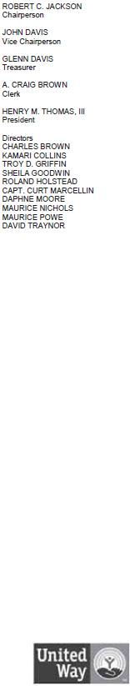

Tom Wheeler

Chairman

Federal Communications Commission
445 12th Street, SW
Washington, DC 20554

RE: MB Docket No. 14-57

Dear Chairman Wheeler,

Per your request below is a draft summarizing our discussion:

As the President and CEO of the Springfield (Massachusetts) Urban League, I’ve been privileged to work with community partners, both large and small, that support our mission of empowering minorities, embracing diversity, and securing economic self-reliance. That’s why I was happy to learn of the proposed Comcast/Time Warner Cable transaction, which will see one of our most successful partners grow and expand its reach in communities just like ours.

The mission of the Springfield Urban League is to empower African-Americans, other emerging ethnic groups and those who struggle to secure economic self-reliance, parity, power, and civil rights. This requires two things: empowerment of others and support from others.

We empower civic engagement and social justice, economic and workforce development, and educational success. In turn, Comcast empowers us by supporting and sponsoring our various efforts. It has been a vital partner and a robust supporter of our work. Its reach has had a direct impact on the lives of many in Western Massachusetts, especially young people who attend the Urban League’s Camp Atwater program.

One such impact is evident in our partnership with Comcast’s Internet Essentials program, which offers Internet service for less than $10 per month to qualified families. It is hard to find a more effective program to bring internet to those young people who depend on access for school work more and more every day. The youth and families we serve have also benefitted from Comcast’s Digital Connectors program, Comcast Cares Day, as well as their many scholarship programs and other philanthropic endeavors.

291

As a community leader, I can say with full confidence that the Springfield Urban League is in a better position to carry out its core mission because of Comcast’s partnership. I look forward to seeing what can be accomplished as a result of the Comcast and Time Warner Cable transaction, and I encourage you to support this proposal.

/s/ Henry Thomas

Henry Thomas

President & CEO

292

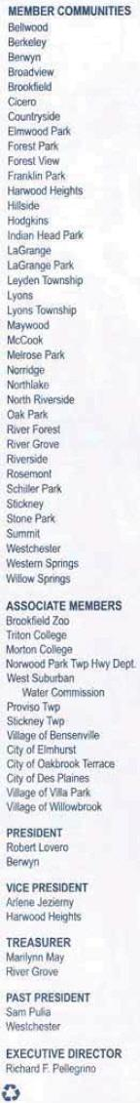
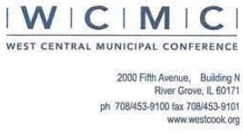

August 22, 2014

Tom Wheeler

Chairman

Federal Communications Commission

445 12th Street, SW

Washington, DC 20554

RE: MB Docket No. 14-57

Dear Chairman Wheeler:

The West Central Municipal Conference (WCMC) is a Council of Government that represents 51 municipalities and townships throughout western Cook and eastern DuPage County in Illinois. The WCMC area spans over 200 square miles and is home to over 600,000 residents.

In this regard, one of the most important things I've learned as director of The West Central Municipal Conference (WCMC) is the mutually beneficial outcome when both government and businesses work together. Comcast has bolstered our regions' connectivity, technological literacy, and service, all of which have been beneficial to our businesses and residents. I support the proposed transaction between Comcast and Time Warner Cable because I have seen the impact Comcast can have in the communities it serves.

In today's fast paced business world, every second is valuable. As WCMC just recently became a Comcast Internet customer, I can speak firsthand to its leading service. By investing in infrastructure to supply high speed connectivity, Comcast is pushing the envelope on technology and speed and continues to impress business customers like myself. WCMC has also been lucky enough to have Comcast as an active partner throughout the past couple years, where it has become a "Platinum Member" of our Affiliate Member group of businesses. That means Comcast has gone above and beyond in its support of us and our mission.

293

As well as supporting the business economy of our region, Corneast has also done a great deal to invest in the well-being of our community. Its roll-out of the Internet Essentials program, which provides discounted broadband and computers to low income families, was begun in Chicago and has been hugely successful in Illinois, connecting close to 40,000 families to the Internet at home. This year the greater Chicago area even received Comcast's "gold medal" recognition for having the most families enrolled in the program of any other major cities served by Comcast. As I am sure the FCC is very aware, digital literacy is now imperative for education, and children without computer access at home are put at a disadvantage for things like research, applying to college and jobs, or even finishing a simple homework assignment. Without Comcast's program, thousands of children would go without this Internet access in western Cook and eastern Du Page Counties. Beyond the children benefitted, Comcast's Internet Essentials program also helps their parents by enabling them to participate more effectively in our digital economy, including providing better access to job opportunities.

Comcast is a company that cares about the future, something evident in its work to drive technological innovation and close the digital divide. WCMC cares about the future, too, and I believe both Comcast and our organization have benefitted by working closely together. If Comcast joins Time Warner Cable, many more municipalities and townships will enjoy Comcast's strong partnership.

I urge you to approve the Comcast and Time Warner Cable transaction.

Sincerely,

/s/ Richard F. Pellegrino

Richard F. Pellegrino

Executive Director

294

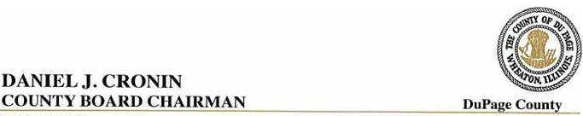

August 21, 2014

Mr. Tom Wheeler

Chairman

Federal Communications Commission
445 12th Street, SW

Washington, D.C. 20554

RE: MB Docket No. 14-57

Dear Chairman Wheeler:

Thank you for this chance to weigh in on the proposed Comcast and Time Warner Cable transaction that is before you. I am currently Chairman of the DuPage County Board, Illinois, having been elected in 2010. I also served in the Illinois Legislature for 20 years.

1 respectfully ask Commission members to approve the proposed transaction, in order to see the extension of Comcast’s progressive activities in the broadband and video field to other communities. We have experienced faster Internet speeds each year with Comcast. We have watched its business class services grow and expand to meet the needs of a wide variety of enterprises in DuPage. Its technology keeps evolving and new features appear regularly, making Comcast a market leader in its business. A quick check reveals that Comcast fields an amazing 136 million emails, 142 million phone calls, 12 million voicemails and 15 million Xfinity On Demand requests on a daily basis.

I understand that Comcast invested more than $1.3 billion in Illinois last year, including employee payroll, state and local taxes and upkeep of its facilities. That number includes scholarships, in-kind donations and employee contributions to regional United Way agencies, including the United Way of DuPage/West Cook. Also last year, Comcast expanded its fiber network in three business hubs in the Chicago area to accommodate an additional 1,600 businesses in its Business Class Ethernet and other business services. The added information technology infrastructure is benefiting our local businesses.

It has also been a pleasure partnering with Comcast on initiatives which improve public education and the quality of life for our residents. Comcast several years ago started a program that is allowing our poorest students to get Internet connections in their homes for only $10 a month. The company’s professional employees also volunteer to mentor youth, helping them develop basic career skills and expertise in basic technology. And, Comcast Cares Day is a well-known yearly tradition in DuPage, where Comcast employees and their family members give a day’s labor to a long list of community organizations.

I appreciate the opportunity to share my community’s experiences with Comcast. I hope that I have adequately articulated why it is a company that garners respect in DuPage and beyond. Clearly, Comcast has a lot to offer in digital technology as well as in being a proponent of the community. Your approval of the pending Comcast/Time Warner Cable transaction will bring these benefits to new areas of the country, and for that reason, I urge you to act quickly to approve this transaction.

Sincerely,

/s/ Daniel J. Cronin

Daniel J. Cronin

Chairman, DuPagc County Board

295

August 21, 2014

Tom Wheeler

Chairman

Federal Communications Commission
445 12th Street, SW

Washington, DC 20554

RE: MB DOCKET NO. 14-57

Dear Chairman Wheeler:

Baytown, Texas, is adjacent to the world’s fifth-largest industrial park, with access to multiple transportation modes, including a barge dock that handles transport of goods from the Port of Houston. This summer, the Cedar Crossing Industrial Park got an additional competitive business boost when Comcast extended its fiber-optic network in to the park.

The logistics and distribution companies there now have access to Ethernet-dedicated Internet lines and network services, and connectivity at bandwidth that scales up to 10 Gbps. The speed and efficiency with which businesses there can now operate has elevated the desirability of the site to potential new tenants, and buttressed its reputation as a major player in intermodal logistics facilities worldwide.

As Baytown’s mayor, I see the network playing a pivotal role in our area’s economy. Local economic development leaders have praised the diversity and capacity of the network extension. With the importance that technology and digital communication play in today’s economy, I can’t imagine a better investment. Under the proposed Comcast and Time Warner Cable transaction, other communities would stand to benefit from similar Comcast investments in fiber optics. I believe this transaction should be approved.

Comcast is also a proven community partner with the City of Baytown as well as other community and nonprofit organizations. For instance, the company donates money to support our Summer Youth Jobs Program. This program supplies opportunities for at risk students to work as paid interns for the City of Baytown. This program reduces the dropout rate in our community by providing students with an opportunity to excel, as well as to receive valuable work experience and learn responsibility.

Comcast Newsmakers gives city officials and business leaders a public forum to address important topics that affect our residents. Comcast also hosts the city’s government access Channel 16, and Comcast has selected students who attend Goose Creek Consolidated Independent School District as recipients of its Leaders & Achievers Scholarships.

www.baytown.org

296

In addition, economically disadvantaged children here are benefiting from a Comcast plan called Internet Essentials. This plan offers a low monthly rate of $10 for Internet access and a computer for $150 to families whose children receive federally subsidized school meals. The rate is guaranteed to stay at $10 a month and the families are offered free computer and Internet training. So far in Texas, about 14,000 households now have Internet access as a result.

The proposed transaction will provide businesses and families with the digital connection they need to create more opportunity. I hope that the Commission approves this transaction, and I thank you for allowing me the opportunity to make this request.

Sincerely,

/s/Stephen DonCarlos

Stephen DonCarlos

Mayor

www.baytown.org

297

Important Information For Investors And Shareholders

This communication does not constitute an offer to sell or the solicitation of an offer to buy any securities or a solicitation of any vote or approval. In connection with the proposed transaction between Comcast Corporation (“Comcast”) and Time Warner Cable Inc. (“Time Warner Cable”), Comcast has filed with the Securities and Exchange Commission (“SEC”) a registration statement on Form S-4, including Amendments No. 1, 2, 3, 4, 5 and 6 thereto, and a definitive joint proxy statement of Comcast and Time Warner Cable that also constitutes a prospectus of Comcast. INVESTORS AND SECURITY HOLDERS OF COMCAST AND TIME WARNER CABLE ARE URGED TO READ THE DEFINITIVE JOINT PROXY STATEMENT/PROSPECTUS AND OTHER DOCUMENTS FILED OR THAT WILL BE FILED WITH THE SEC CAREFULLY AND IN THEIR ENTIRETY BECAUSE THEY CONTAIN OR WILL CONTAIN IMPORTANT INFORMATION. Investors and security holders may obtain free copies of the registration statement and the definitive joint proxy statement/prospectus and other documents filed with the SEC by Comcast or Time Warner Cable through the website maintained by the SEC at http://www.sec.gov. Copies of the documents filed with the SEC by Comcast are available free of charge on Comcast’s website at http://cmcsa.com or by contacting Comcast’s Investor Relations Department at 866-281-2100. Copies of the documents filed with the SEC by Time Warner Cable are available free of charge on Time Warner Cable’s website at http://ir.timewarnercable.com or by contacting Time Warner Cable’s Investor Relations Department at 877-446-3689.

In addition, in connection with the proposed transaction between Comcast and Charter Communications, Inc. (“Charter”), Charter will file with the SEC a registration statement on Form S-4 that will include a proxy statement of Charter that also constitutes a prospectus of Charter, and a definitive proxy statement/prospectus will be mailed to shareholders of Charter. INVESTORS AND SECURITY HOLDERS OF COMCAST AND CHARTER ARE URGED TO READ THE PROXY STATEMENT/PROSPECTUS AND OTHER DOCUMENTS THAT WILL BE FILED WITH THE SEC CAREFULLY AND IN THEIR ENTIRETY BECAUSE THEY WILL CONTAIN IMPORTANT INFORMATION. Investors and security holders will be able to obtain free copies of the registration statement and the proxy statement/prospectus (when available) and other documents filed with the SEC by Comcast or Charter through the website maintained by the SEC at http://www.sec.gov. Copies of the documents filed with the SEC by Comcast are available free of charge on Comcast’s website at http://cmcsa.com or by contacting Comcast’s Investor Relations Department at 866-281-2100. Copies of the documents filed with the SEC by Charter will be available free of charge on Charter’s website at charter.com, in the “Investor and News Center” near the bottom of the page, or by contacting Charter’s Investor Relations Department at 203-905-7955.

Shareholders of Comcast and Time Warner Cable are not being asked to vote on the proposed transaction between Comcast and Charter, and the proposed transaction between Comcast and Time Warner Cable is not contingent upon the proposed transaction between Comcast and Charter.

Comcast, Time Warner Cable, Charter and their respective directors and certain of their respective executive officers may be considered participants in the solicitation of proxies in connection with the proposed transaction between Comcast and Time Warner Cable, and Comcast, Charter and their respective directors and certain of their respective executive officers may be considered participants in the solicitation of proxies in connection with the proposed transaction between Comcast and Charter. Information about the directors and executive officers of Time Warner Cable is set forth in its Annual Report on Form 10-K for the year ended December 31, 2013, which was filed with the SEC on February 18, 2014, its proxy statement for its 2014 annual meeting of stockholders, which was filed with the SEC on April 29, 2014, and its Current Report on Form 8-K, which was filed with the SEC on June 13, 2014. Information about the directors and executive officers of Comcast is set forth in its Annual Report on Form 10-K for the year ended December 31, 2013, which was filed with the SEC on February 12, 2014, its proxy statement for its 2014 annual meeting of stockholders, which was filed with the SEC on April 11, 2014, and its Current Report on Form 8-K, which was filed with the SEC on July 1, 2014. Information about the directors and executive officers of Charter is set forth in its Annual Report on Form 10-K for the year ended December 31, 2013, which was filed with the SEC on February 21, 2014, its proxy statement for its 2014 annual meeting of stockholders, which was filed with the SEC on March 27, 2014, and its Current Report on Form 8-K, which was filed with the SEC on May 9, 2014. These documents can be obtained free of charge from the sources indicated above. Additional information regarding the participants in the proxy solicitations and a description of their direct and indirect interests, by security holdings or otherwise, are contained in the definitive joint proxy statement/prospectus of Comcast and Time Warner Cable filed with the SEC and other relevant materials to be filed with the SEC when they become available, and will also be contained in the preliminary proxy statement/prospectus of Charter when it becomes available.

Cautionary Statement Regarding Forward-Looking Statements

Certain statements in this communication regarding the proposed acquisition of Time Warner Cable by Comcast and the proposed transaction between Comcast and Charter, including any statements regarding the expected timetable for completing the transactions, benefits and synergies of the transactions, future opportunities for the respective companies and products, and any other statements regarding Comcast’s, Time Warner Cable’s and Charter’s future expectations, beliefs, plans, objectives, financial conditions, assumptions or future events or performance that are not historical facts are “forward-looking” statements made within the meaning of Section 27A of the Securities Act of 1933, as amended, and Section 21E of the Securities Exchange Act of 1934, as amended. These statements are often, but not always, made through the use of words or phrases such as “may”, “believe,” “anticipate,” “could”, “should,” “intend,” “plan,” “will,” “expect(s),” “estimate(s),” “project(s),” “forecast(s)”, “positioned,” “strategy,” “outlook” and similar expressions. All such forward-looking statements involve estimates and assumptions that are subject to risks, uncertainties and other factors that could cause actual results to differ materially from the results expressed in the statements. Among the key factors that could cause actual results to differ materially from those projected in the forward-looking statements are the following: the timing to consummate the proposed transactions; the risk that a condition to closing either of the proposed transactions may not be satisfied; the risk that a regulatory approval that may be required for either of the proposed transactions is not obtained or is obtained subject to conditions that are not anticipated; the parties’ ability to achieve the synergies and value creation contemplated by the proposed transactions; the parties’ ability to promptly, efficiently and effectively integrate acquired operations into their own operations; and the diversion of management time on transaction-related issues. Additional information concerning these and other factors can be found in Comcast’s, Time Warner Cable’s and Charter’s respective filings with the SEC, including Comcast’s, Time Warner Cable’s and Charter’s most recent Annual Reports on Form 10-K, Quarterly Reports on Form 10-Q and Current Reports on Form 8-K. Comcast, Time Warner Cable and Charter assume no obligation to update any forward-looking statements. Readers are cautioned not to place undue reliance on these forward-looking statements that speak only as of the date hereof.

298

